A screenshot of the output of the final walkthrough cell, the git log line showing your commit.
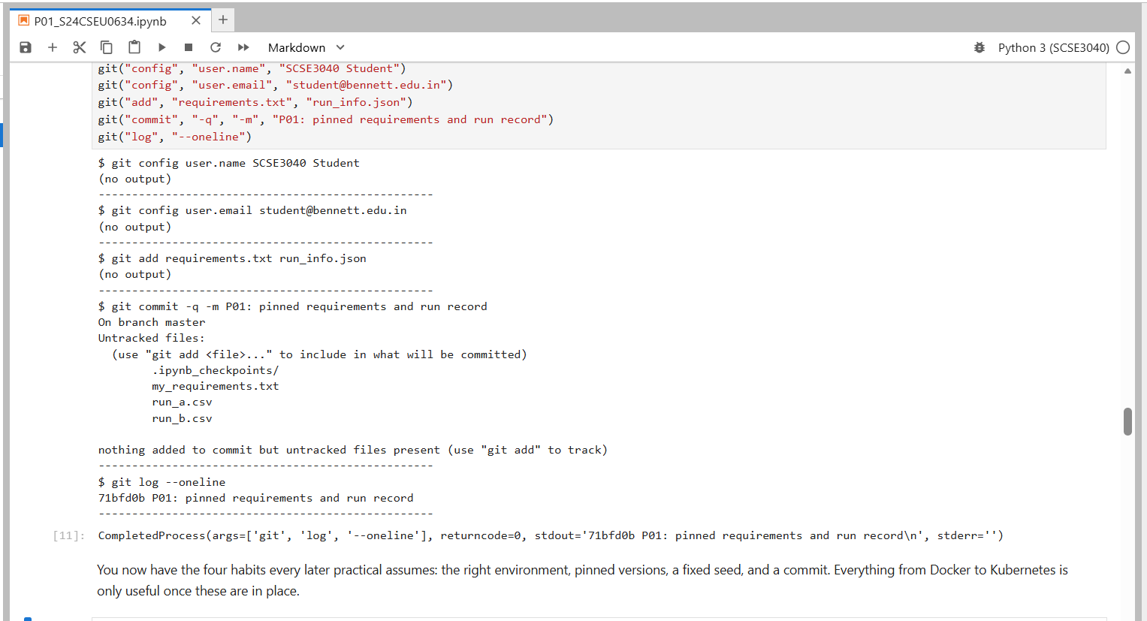

Submitted by Anmol Tyagi
(S24CSEU0634)

