Your results table: MAE for the mean baseline, MAE for the median baseline, and MAE for your linear regression model, all measured on the test set.
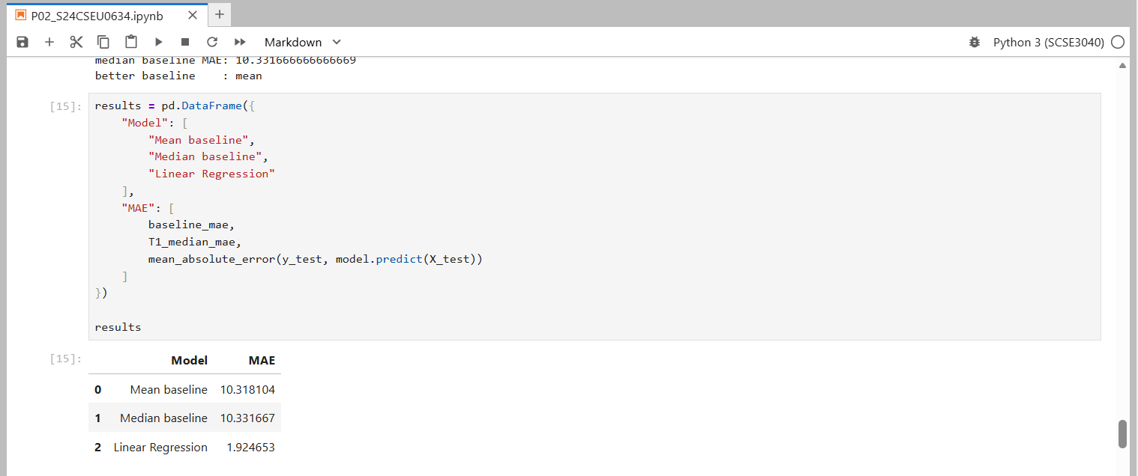

Two sentences answering Task T2: did the 70/30 split with seed 7 change your conclusion, and what does that tell you about how much to trust a single split?
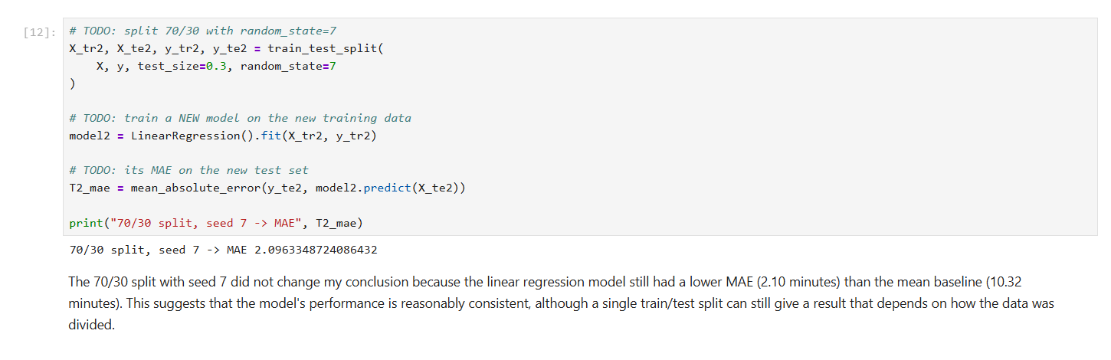

Submitted by Anmol Tyagi
(S24CSEU0634)

