To run the application, navigate to the folder **tictactoe** wherein **manage.py** file exists.

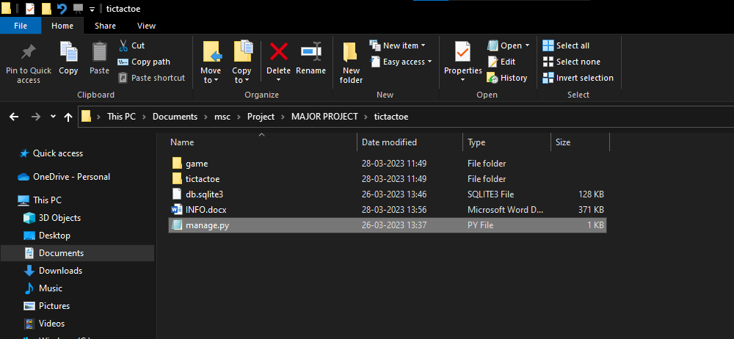

Then, open the terminal and run the following command:

**python manage.py runserver**

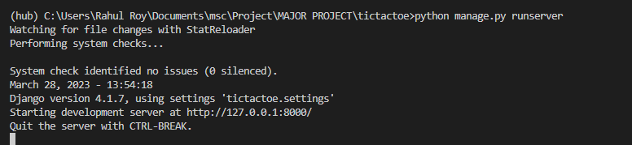

I have done this in my virtual environment named hub.

Make sure, you have Django installed in your system, you can do that by following command:

**pip install django**

Once, ran the server you can visit the link: **localhost:8000**  to view the web application.

Here are the screenshots of the outputs:

The basic **home** page.

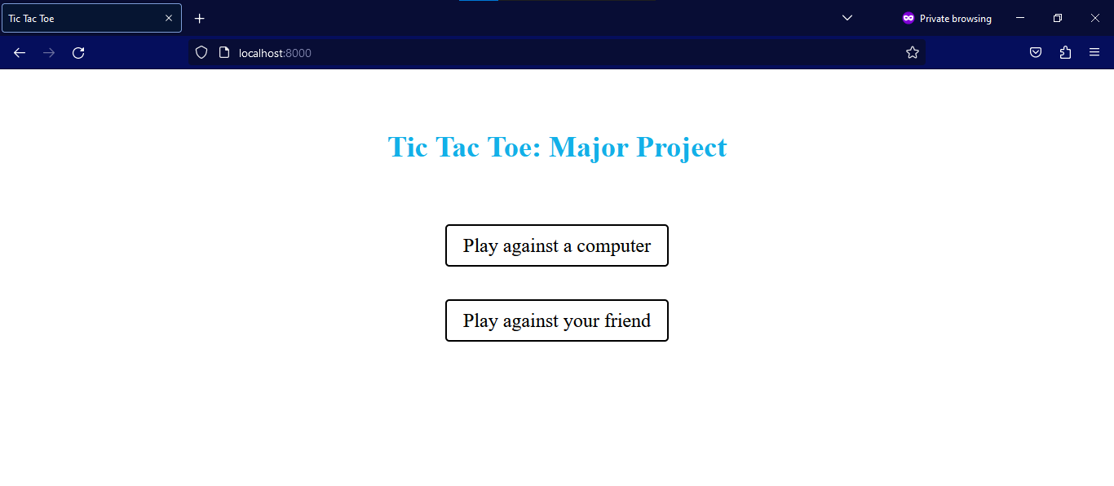

Let’s first **play against your friend.**

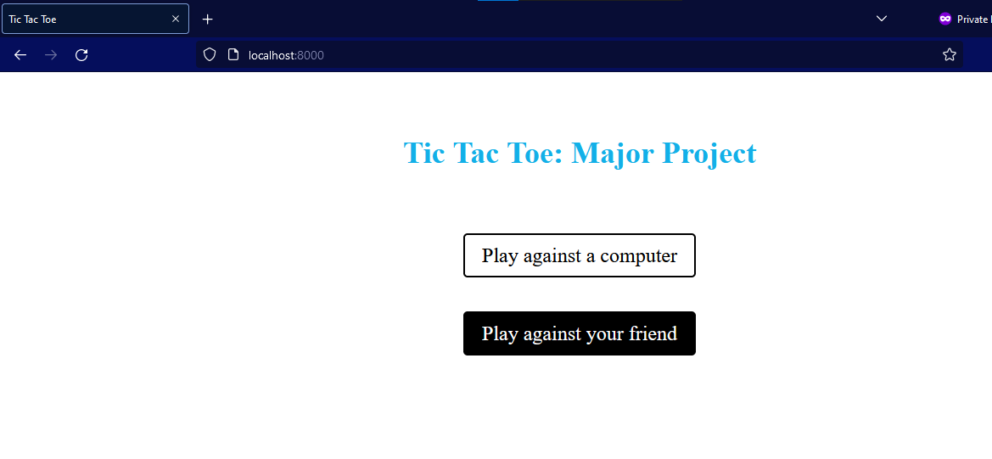

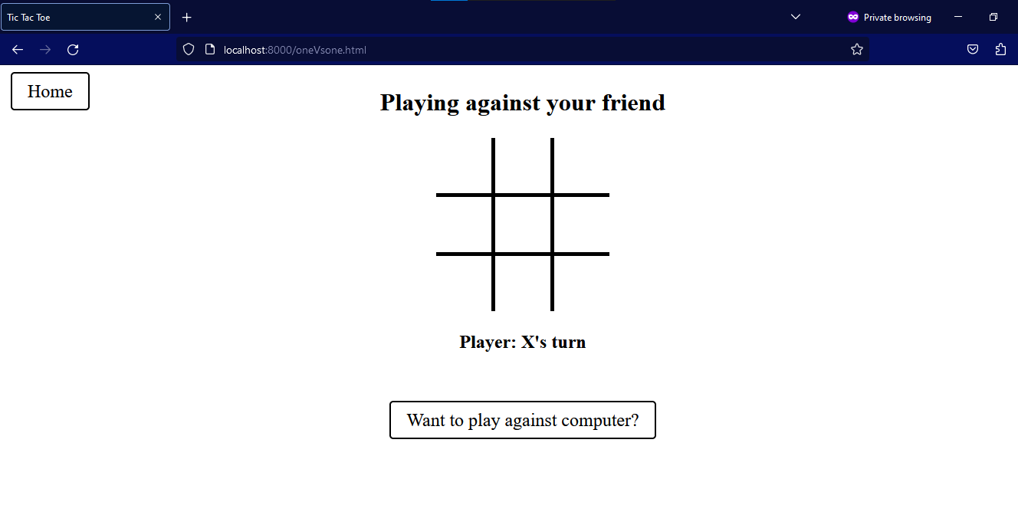

Let’s make **x win.**

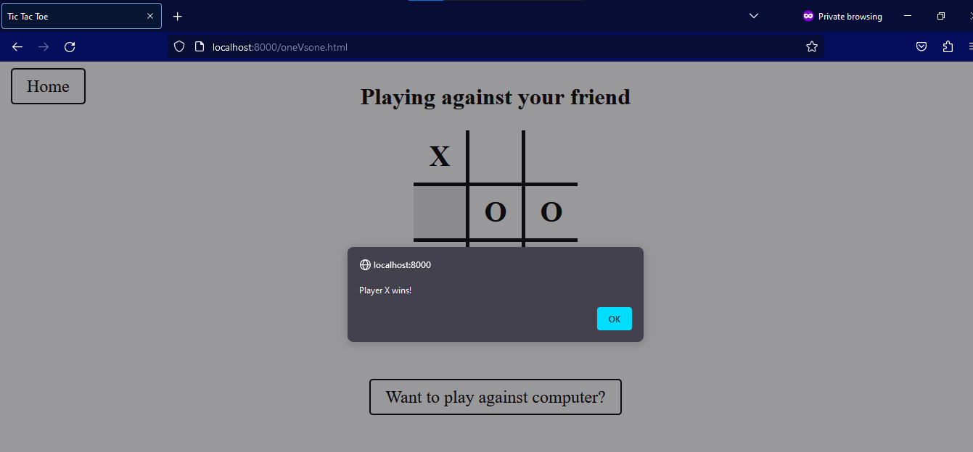

Let’s make **o win** .

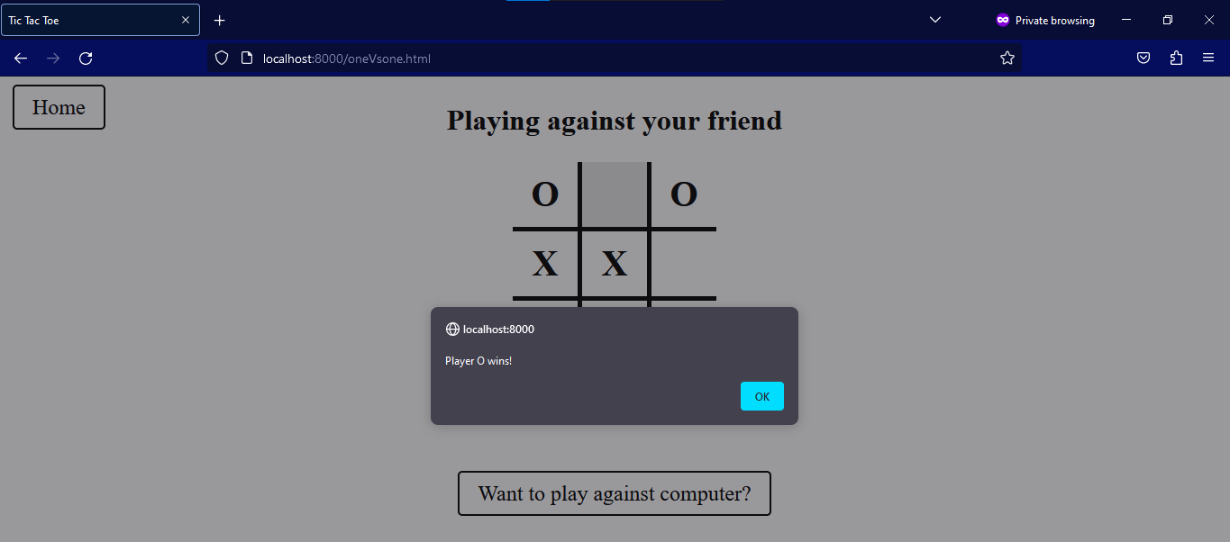

Let’s make **a tie**

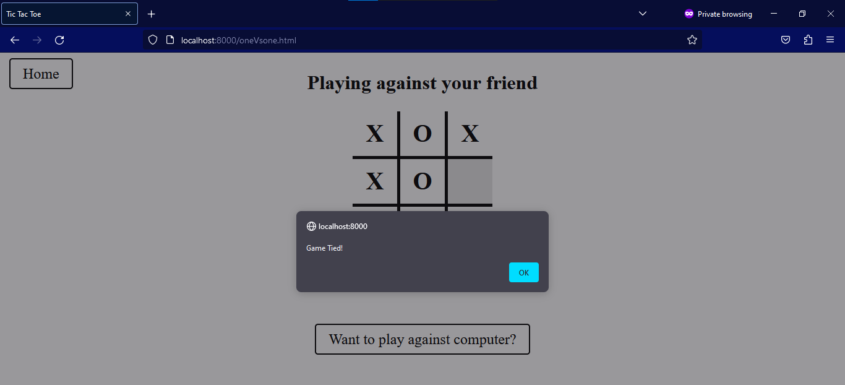

Let’s hit back **home** and **play against computer**

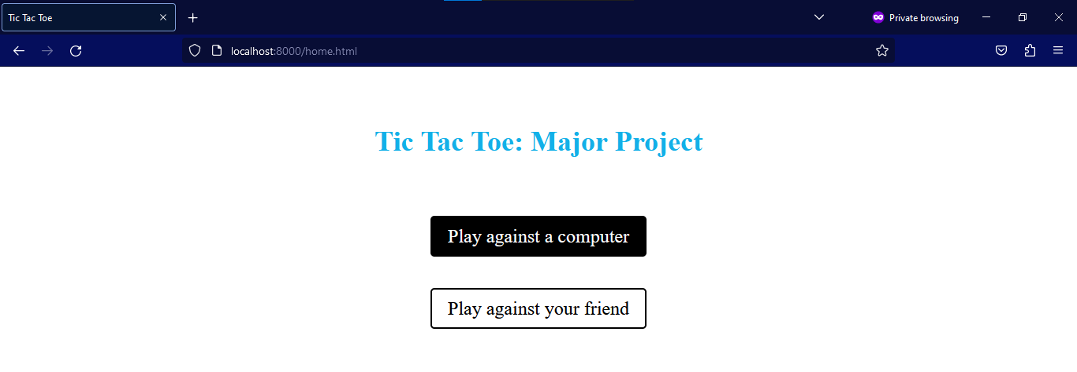

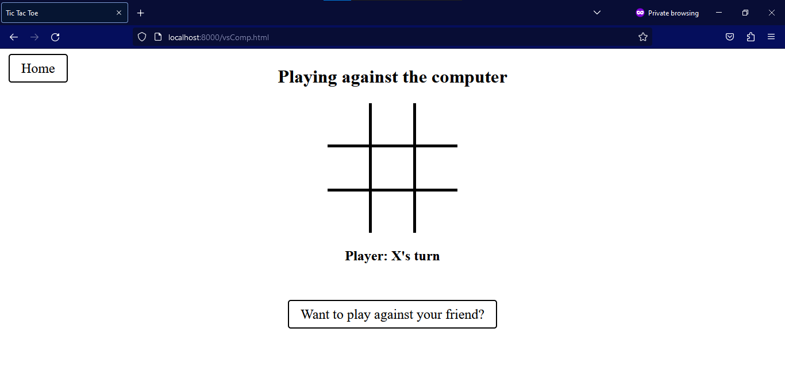

Let **us win**

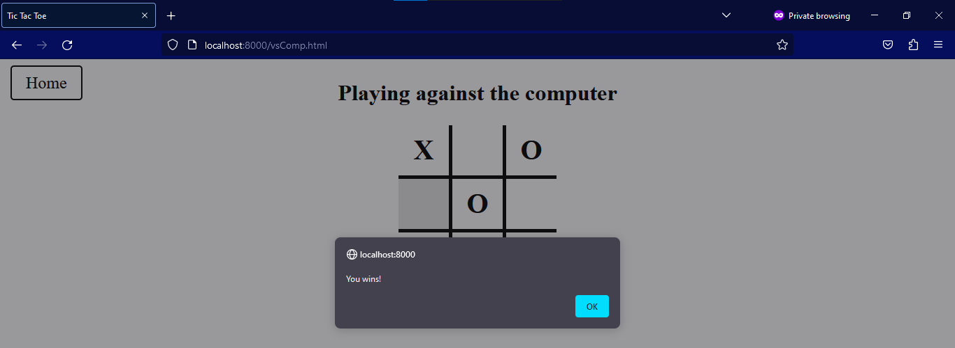

Let **computer win**

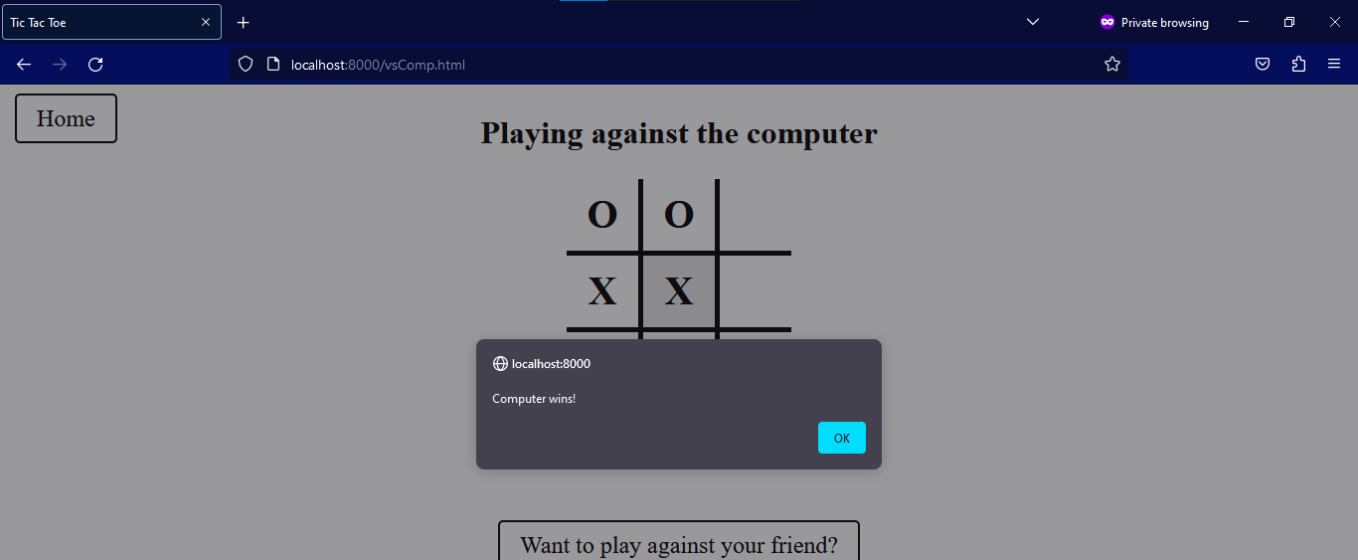

Let’s make **a draw**

