■Add two text boxes and a Submit button to a HTML form. Invite the user to enter a first name and surname. When the button is clicked, print out the person's full name. Don't worry about what is in the text boxes after the button is clicked.

■ Using the same form as the previous exercise, display the first name and surname in the textboxes, instead of printing them out.

■Suppose your web site has only 5 users. Create a HTML form to check if a visitor is one of the 5 users. Display a suitable message.

■ Write a PHP script to generate the electricity bill using if-else

■ Write a PHP script to generate arithmetic calculator using switch-case

■ Write a PHP script to find the factorial using for loop

■ Write a PHP script to print the current date in the following format

■ 2020/09/25

■ 20.09.25

■ 25-09-20

■ Write a PHP script to print the current date in the  following format

■ 25/09/2020

■ 25-09-2020

■ 25.09.2020

■ 24.Sep.2017/Fri

■ Write a PHP script to display time in a specified time  zone.

■ Write a PHP script to calculate the difference between two dates

■ Write a PHP script to calculate a number of days between two dates

■ Write a PHP script to calculate the current age of a person

■ Write a PHP script to count the number of days between current day and birthday

■ Write a PHP script to add/subtract the number of days from today's date.

■Form Validation

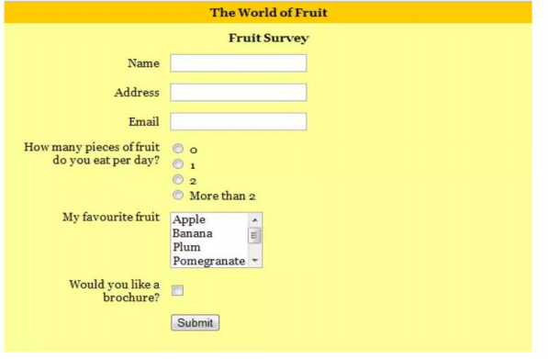

Rules:

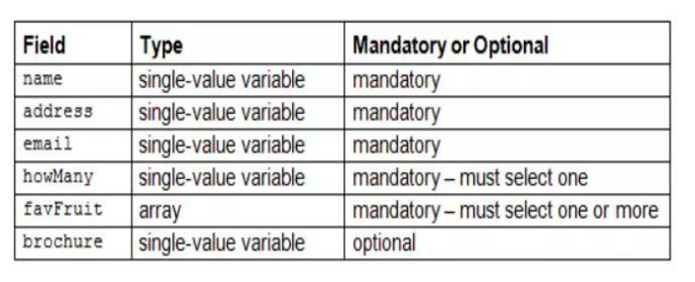

■ Using the relationship DISTANCE = SPEED \* TIME, write a function that calculates distance given the speed and time. Use this function to find the distance traveled by an aircraft departing from London, England, at 9:30 P.M. and arriving in Bombay, India, at 11 A.M. the next day. Assume the aircraft flies at 910 km/hr and the time difference between London and Bombay is 4.5 hours

■ Determine the GCF of two numbers with and without using recursive function

■ Generate Fibonacci series with and without using recursive function

■ Print the numbers from 10 to 1 with and without using the recursive function.

■ Design a HTML page to accept 10 students data and store it in an array gradually, Display the students data in an sorted order based on USN

■ Demonstrate how to draw user’s attention to downloaded text by changing its colour red.

■ Demonstrate how to draw user’s attention to downloaded text by changing its font from Verdana to Arial.

■ Demonstrate how to draw user’s attention to downloaded text by changing its font- style.

■ Demonstrate how to draw user’s attention to downloaded text by changing its font-weight.

■ Demonstrate how to draw user’s attention to downloaded text by changing its colour red for half second

■ Develop a script to demonstrate the usage of AJAX in fetching a file pink.txt from server and displaying its contents on a page using GET method.

■ Develop a script to demonstrate the usage of AJAX in fetching the result after sending the required values using POST and GET method.

■ Given the XML document FoodMenu.xml fetch the calories of French Toast and display it to the user using AJAX.

■ Using AJAX develop a script which updates the element "demo" with the HTML table built by extracting XML data.

■ Using PHP AJAX, develop an application so that when a user types a name in the input field, all the similar names are displayed from a file student .txt.

■ Implement Ajax based code using GET method to connect to the server and display the response from server in a <div>

■ Implement Ajax based code using POST method to connect to the server and display the response from server in a <div>

■ Implement Ajax based code to send data to the server using GET method and return the response from server based on the data sent to the server

■ Implement Ajax based code to send data to the server using POST method and return the response from server based on the data sent to the server

■ Implement Ajax based code to check whether the username is already existing in the database. Read user name using HTML form.

■ Using MySQL, AJAX, and PHP create an application which helps to communicate with a database and display interactive data.

■ Explain how to access and sort data using a AJAX MySQL connection.