# **DOCUMENTATION**

**Netflix: Streaming Subscribers and Genre Worldwide**

**INTRODUCTION:**

Netflix, Inc. is an American provider of media services. Its subscription-based streaming service offers online streaming of a library of movies and television programs, including in-house productions. The Production Organization's headquarters are in Los Gatos, California. Reed Hastings and Marc Randolph founded it in 1997 in Scotts Valley, California. Netflix was not as popular in the past as it appears to be at present. I can observe an increase in the number of subscriptions regardless of whether I compare the current number of subscribers to that of the past few years.

Netflix only streamed movies and TV shows produced by others before 2012. Since 2012, Netflix has been more involved in TV and movie production and distribution than just streaming. Netflix started offering "Netflix Original" content online after that. Netflix now operates in 180 countries and has released 126 original series. It gained popularity as it produced more movies and TV shows. This greatly increased subscribers and revenue. Netflix is in many countries, so I need to collect and format data from them. I chose this topic because I was curious about Netflix's subscriber growth, revenue, and most-watched countries. I examined revenue, subscribers, and global genre preferences for this analysis.

**AMBITIOUSNESS:**

In total, I used three different data sets for this project. The name of the country is the consistent field across all three data sets. The ultimate purpose of this project is to determine where Netflix should concentrate its efforts in order to achieve optimal performance.

**RESEARCH QUESTIONS:**

I have decided to take the following questions to create worksheets, dashboards and a story based on the output.

1) Did the no. of subscribers increased or decreased?

2) What is the share of revenue every country?

3) Are revenue and subscription interlinked?

4) Which country has the highest no. of subscribers?

5) In which countries are the Netflix services accessible?

6) What are the ratings of the various genres?

7) Which genres are most popular?

8) What is the relation between movies released and subscribers’ growth?

**METHODOLOGY:**

I was looking for a dataset that characterizes the issues and arrangements across various websites. I located the **Netflix_Subscribers** dataset on [Comparitech](https://www.comparitech.com/tv-streaming/netflix-subscribers/), as well as the **Netflix_titles** and **Netflix_data** datasets on [Kaggle](https://www.kaggle.com/datasets/shivamb/netflix-shows). In my primary dataset i.e., **Netflix_Subscribers** I needed data across years, so the information has been separated from Comparitech website utilizing Power Query into Microsoft Excel. The information was practically perfect and there was very little data to be eliminated. At that point, information has been cleaned and eliminated unwanted data. Presently, data is accessible in Excel. The Information is in table arrangement with appropriate headings (columns and rows).

There are numerous columns in **Netflix_Subscribers** dataset such as Name of the country, Number of subscribers in 2018, Average monthly revenue per paying membership, total yearly revenue from paid memberships (2018), Number of subscribers (first half of 2019), Total revenue from paid memberships (first half of 2019), Number of subscribers (second half of 2019), Total revenue earned from paid memberships (second half of 2019) and Total estimate revenue by the end of 2019.

**Netflix_titles** dataset contains fields like

show id – Unique id given for each show

type – indicates either it is a TV Show or a Movie

titles – Title of the film

director – Name of the director

country – from which country is the content originated from

rating – rating given for the movie,

**Netflix_data** dataset consists of fields like show_id, type, director, date added, release year, genre.

Genre – which category does the movie belong to like drama, actions, comedy etc.

**Relation between datasets:**

With my primary dataset i.e., **Netflix_Subscribers** I have done below visualizations.

1. Number of Subscriber in 2019 by country
2. Total Estimated Revenue by end of 2019 by Country
3. Number of subscribers in 2018
4. Total yearly revenue from paid memberships 2018
5. Highest Number of Subscribers
6. Number of Subscribers in Dec 2019 Vs Subscribers in 2018 By Country
7. Country Vs Estimated Revenue by End of 2019

I attempted to join the Netflix Subscribers dataset with other datasets, such as Netflix titles andNetflix data, but the resulting visualizations made no sense and deviated from my intended purpose. And therefore, I was required to use this singular dataset for above visualizations

I have combined all three datasets **Netflix_Subscribers,** **Netflix_titles** and **Netflix_data** using inner join and made appropriate visualizations as follows.

1. Genre preferences of subscribers by country
2. Count of Ratings by Genre
3. Popular Genres
4. Trend of Movies Released Over the Years

**EXPLORATORY DATA ANALYSIS USING TABLEAU:**

1. **Did the number of subscribers increased or decreased?**

I found that a line chart is the most effective visual representation of the growth or decline in the number of subscribers in a country. Associating multiple data points along a single line, a line chart graphically displays the asset's price movement over time. To easily compare the data, I use a line chart that shows the total number of subscribers over the past two years. In order to make a comparison, two separate lines are used. One line represents 2018 data and another of 2019.

**Figure-1: Comparing the number of subscribers in 2018 and 2019.**

As I must compare the number of subscribers for 2018 and 2019, I can do so using the preceding line graph. According to the graph, there were 58 million subscribers in the United States in 2018 and 62 million in 2019. Thus, I can conclude that the number of subscribers in the United States increased between 2018 and 2019. Similarly, the number of subscribers in Australia and the United Kingdom in 2018 was 11 million and 10 million, respectively, whereas in 2019 it is 14 million and 11 million, respectively. I can therefore conclude that the number of subscribers in Australia and the United Kingdom increased between 2018 and 2019. Similarly, by examining the graph, I can determine whether the number of subscribers increased or decreased in different countries.

1. **What is the share of revenue and its subscribers of every country?**

I have used a Bar Chart to identify the countries that generates high revenue since one can understand just by looking at it. The data classifications are appeared on the vertical axis and the data values are appeared on the horizontal axis for better representation.

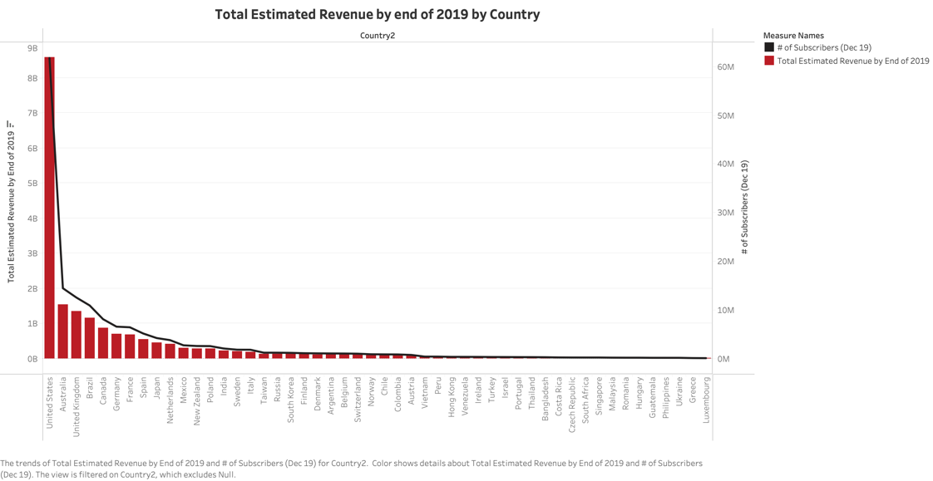

**Figure-2: Revenue shared by each country.**

Each bar in the preceding bar chart represents the revenue generated by each country. The height of the bar depends on each country's revenue. According to the outline, the United States shared revenue of $8.5 billion while Australia and the United Kingdom shared revenues of $1.5 billion and $1.3 billion, respectively. With these visuals, I can easily identify the countries that generate the most revenue for Netflix.

1. **Are revenue and subscription interlinked?**

Here I have used a combo chart (Pie and circle chart) to represent both the number of subscribers also, revenue generated for every country for a single year. The Column chart shows the revenue while the line chart addresses the number of subscribers. I have enabled data label with values, so that the actual value will be seen on the chart. Different colors for values have been used to have better look.

**Figure-3: Comparison of subscription and revenue for 2019**

I can see from the above graph that there are 61.7 million subscribers in the United States and that the estimated revenue is $8.6 billion, which is a very normal amount. In any case, when I consider Australia, the number of subscribers is fourteen million, and the estimated revenue is only one and a half billion dollars, which is extremely low. In addition, if I consider countries such as the United Kingdom and Brazil, the number of subscribers is 12.5 million and 11 million, respectively, but the estimated revenue is only $1.3 billion and $1.2 billion, which is quite strange. The reasons behind this might be because of different plans given by the Netflix at different costs and furthermore a few members may have subscription but that might not be active. Considering the previous visualizations, I can conclude that there is no relationship between the number of subscribers and the revenue.

1. **Which country has the highest no. of subscribers?**

As I dug deeper into the dataset in search of a more suitable visualization to discuss the distribution of subscribers across countries, I realized that a scatterplot is optimal for comparing massive amounts of data across different time periods. I can see how many subscribers we have in each country in one convenient bubble chart. There are more subscribers in the country with the biggest bubble. In a simple and comprehendible visual, this chart shows us which country, relative to others, has the most Netflix subscribers.

**Figure-4: Number of subscribers across different countries**

The United States has the largest bubble, followed by Australia and the United Kingdom, as seen in the above chart. The United States has 61,761,843 subscribers, while Australia and the United Kingdom have 14,439,047 and 12,537,980, respectively. Based on this data, I can conclude that the United States has the most subscribers, followed by Australia and the United Kingdom.

1. **In which countries are the Netflix services accessible?**

given that we are aware that Netflix is available internationally. A Map Chart is ideal for this purpose because it not only locates the location of the country but can also be readily understood.

**Figure-5: Access of Netflix services across different countries**

According to the above map, I can make out some distinct groups of countries. Based on our visualization, I can be certain that Netflix is available in each of these regions. The number of subscribers is represented by the map's color scheme. More subscribers are represented by darker maroon color and less subscribers by green color. Hence, based on the data presented, I can conclude that Netflix is available everywhere apart from China, Syria, North Korea, and some countries in Africa. Using this map, I can quickly and easily identify the locations where Netflix is available.

1. **Which Genres are most popular around the world?**

According to the bubble chart that was just presented, the documentary genre is the most popular category on Netflix all over the world. After that, stand-up comedy is in the second spot, followed by comedy drama and international films, all of which are equally popular among users.

1. **What is the relation between movies released and subscribers’ growth?**

We can see from the dashboard that is displayed above that there was a significant increase in the number of movies that were released in the year 2017. If we look at the number of subscribers, we can see that there has been very massive growth in 2018, right after the company started uploading more movies the following year, which is when the number of subscribers reached an all-time high. We can derive from this that there is a connection between the number of newly released movies and the total number of subscribers. The greater the total number of releases, the greater the total number of subscribers.

**DASHBOARDS:**

I have created three dashboards. They are:

1. Country subscribers and revenue.
2. Subscribers and its revenue from paid memberships 2018
3. Number of movies uploaded Vs Number of subscribers increase
4. **Country subscribers and Revenue:**

**Figure-6**

From the above chart, I can see that the number of subscribers in the United States are 62 million and the revenue estimated is 8.6 billion which is very common. In any case, when I consider Australia, the number of subscribers is fourteen million and the estimated revenue is only one and a half billion dollars, which is extremely low. Moreover, in countries such as the United Kingdom and Brazil, the number of subscribers is 13 million and 11 million, respectively, but the estimated revenue is only $1.3 billion and $1.2 billion.

1. **Subscribers and its revenue from paid memberships 2018:**

**Figure-7**

The United States has approximately 60 million subscribers and a revenue of approximately $7,646,647,000 in 2018, followed by Australia with 11 million subscribers, the United Kingdom with 10 million subscribers, and their respective revenues of $1,274,407,920 and $1,106,448,000.

**OUR STORY:**

**TITLE: NETFLIX SUBSCRIBERS AND REVENUE**

The below story describes about the total estimated revenue by the end of 2019 by country, the number of subscribers in 2019 in comparison to the number of subscribers in 2018 by country, and the number of subscribers in 2019 compared to the number of subscribers in 2018.

**Figure-8**

The first visualization of the story is explained with the help of Maps, and it describes the number of subscribers in 2019 by country. The number of subscribers in the United States are 61761843, whereas there are 14439047 and 12537980 number of subscribers in Australia and United Kingdom, respectively. In this way, I can say that the United States has the most number of subscribers followed by Australia and United Kingdom.

**Figure-9**

The total estimated revenue by the end of 2019 is segmented by country in the second visualization of the story, which is explained with the help of a bar graph. The United States of America brings in the most revenue with an amount of 8,597,254,048, followed by Australia and the United Kingdom with amounts of 153,846,467,337 and 1,336,015,855 respectively.

**Figure-10**

The third representation of the story is a line graph that compares the number of subscribers in 2018 to the number of subscribers in 2019 by country.

I can see from the graph above that there were 58 million subscribers in the United States in 2018, and 62 million in 2019. Thus, I can conclude that the number of subscribers in the United States increased from 2018 to 2019. Similarly, Australia and the United Kingdom had 11 million and 10 million subscribers in 2018, but 14 million and 11 million subscribers in 2019, respectively. I can therefore assume that the number of subscribers in Australia and the United Kingdom grew between 2018 and 2019. Similarly, by examining the graph, I can determine whether the number of subscribers in various countries increased or decreased.

**STORY 2:**

**Analysis on Various Genres**

Second Story has 3 charts, they are:

1. Count of Ratings by genre
2. Genre preferences of subscribers by country
3. Popular Genres

The second story features visualizations on genres. In which we can see three genres that are currently the most popular: documentaries, dramas, and mysteries. Also, which locations' subscribers are watching which genres. For example, in Russia viewers are particularly interested in drama. Additionally, in the third chart, we did a count of Ratings, which shows the rating that was given to each genre.

**CONCLUSION:**

Using these charts, I can find out about the number of subscribers in every country and how much revenue is generated. From the first hypothesis, I discovered that the number of subscribers is increased in certain countries and decreased in certain countries from 2018 to 2019. From the second hypothesis, I discovered the revenue generated by every country in 2019 and concluded that the United States generated most revenue among any remaining countries. From the third hypothesis I have discovered that there is no connection between the number of subscribers and revenue generated. From the fourth hypothesis, I have discovered the countries that has most number of subscribers and reasoned that the United States has most number of subscribers. From the fifth hypothesis, I found that Netflix has its services across the world except for a few countries. Using these charts one can comprehend in which countries Netflix is driving or slacking and furthermore the relationship between subscribers and revenue has been explained. With the Increase in library of movies there is a spike in subscribers. With these Visualizations we can conclude that there are various strategies for Netflix to improve its business, one such strategy is to promote location specific content based on the most viewed genre in that location. Also adding more movies frequently will effectively increase the subscriber count. Netflix can without much of a stretch comprehend where it needs to improve their business.

**FUTURE WORK:**

As this whole process is automated, it can be easily extended, and charts can be produced without any problem. This work can be extended every year and generate charts without any problem. Similarly reports can be generated for quarterly or half-yearly likewise to have better analysis and compare between them. These charts can have better effect, as it shows improvement or gradualness in subscriptions showing where Netflix can make expected moves to broaden their business and furthermore give more services among different countries.

**ADDITIONAL RESEARCH QUESTIONS:**

1. What is the relation between subscription rate vs No. of Subscribers?
2. What is the subscription cancellation rate and reasons?

**REFERENCES:**

Netflix subscribers and revenue by country-- <https://www.comparitech.com/tv-streaming/netflix-subscribers/>

Number of Netflix paying streaming subscribers worldwide--

https://www.statista.com/statistics/250934/quarterly-number-of-netflix-streaming-subscribers-worldwide/

Netflix Revenue and Usage Statistics (2020)-- https://www.businessofapps.com/data/netflix-statistics/