

Title of the Project


(Replace with your image)

Submitted by:
Student’s Full Name 1, NIU 1
Student’s Full Name 2, NIU 2
Student’s Full Name 3, NIU 3

Course Name
Date of submission
1. Introduction (font size: 16)
Provide a brief overview of the project, including the motivation, objectives, and main goals. Clearly outline the key issues or challenges the project addresses. Include a short review of the techniques/methods that could be used to address the challenge.
All references should be properly cited throughout the document. For example, “We used Python [1] to implement this project.” (font size: 12).
All Figures and Tables must be referenced in the text and have descriptive explanations of the contents. Make sure that the size of the text in figures is large enough for reading it and that image quality is good without blurring or pixelized areas.
  - Goals (font size: 14)
Explain the main goal of the challenge, as well as, the specific objectives/tasks that lead to achieve such a goal.
2. Methology (font size: 16)
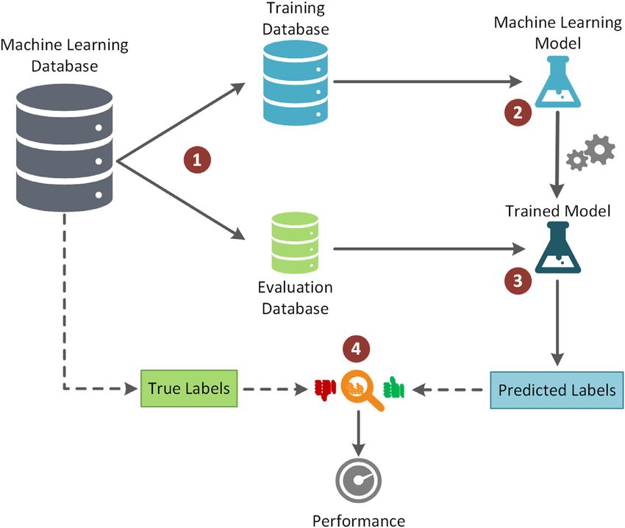
This section should include the detailed description of each stage of your methodologies you have used to solve the challenge. First, explain the general workflow relevant to your project. Include a descriptive figure of the method pipeline with a text describing the main steps of the pipeline. Afterward, describe your project's specific workflow and include another figure. All figures must be referenced in the text, for example, “Our workflow is illustrated in Figure 1.”
Figure 1. WorkFlow of the Methodology
Explanations should allow to reproduce the methods. Avoid implementation details and general explanations of known SoA algorithms. Include a reference for SoA methods used.
2.1 Step1 (font size 14)
Describe the methods used in your project. For each method, include citations and explain the method's advantages.
Method1
Provide an explanation of Method 1 [2] and its advantages. Include a scheme with text explanations of the method main steps and workflow.
Method2
Provide an explanation of Method 2 [3] and its advantages. Include a scheme with text explanations of the method main steps and workflow.
…
2.2 Step2 (font size 14)
Describe the methods used in your project. For each method, include citations and explain the method's advantages.
Method1
Provide an explanation of Method 1 [2] and its advantages. Include a scheme with text explanations of the method main steps and workflow.
Method2
Provide an explanation of Method 2 [3] and its advantages. Include a scheme with text explanations of the method main steps and workflow.
…
3. Experimental Design (font size: 16)
Describe the dataset (including number of samples, and annotations), goals of the experiments, methods that are compared, hyperparameters of the methods and training configuration, partition in train and test, validation metrics and statistics used to assess performance.
3.1 Dataset Description. (font size 14)
Describe the dataset used, including its source, key characteristics, and annotation process. You might include a figure with some samples of the data set. Figures 4.1 illustrates sample of the dataset.


Figure 2. This figure shows samples of the dataset

3.2 Experiments and Metrics (font size 14)
Explain each of the tests you have carried out to assess the method, including comparison to other approaches and/or the different approaches you have proposed. You might also include an ablation study [2] on the impact of the method main steps.
Explain the quality metrics used to evaluate the different methods, including their equations and definitions of each variable. The metrics described here must be consistently used in the tables and/or figures presented in the Results section. For each metric, explain the concept, include its equation, and describe each component. Describe the training configuration and hyperparameters of each of the tested methods, as well as, the splitting into train/test. You might include a figure to better illustrate the partition if it includes several levels of generalization.
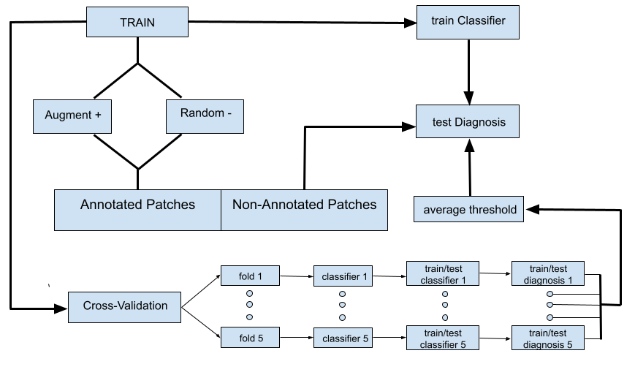
Figure 3. Data Split
Finally, describe the statistical tests and summarizing plots you have used to report and compare metrics across the different methods and/or configurations.
4. Results (font size: 16)
For each experiment, report the results obtained for the different methods. Report descriptive statistics of each metric considered in your experimental design. Report the p-values and CIs of the statistical tests used to detect significant differences across method’s performance. Support Tables with descriptive plots (eg. Boxplots, histograms, ROC curves,…) for the comparison of the metrics.
All Tables and plots must have a descriptive explanation and interpretation of the metrics (eg. best/worst performers, analysis of factors with impact on performance). This is mandatory.
4.1 Experiment 1 (font size 14)
Tables including metrics that were described previously. Report at least descriptive statistics in a Table, like the example of Table 1. Highlight in the text the main findings, best and worse performers, most stable metrics across folds.
Model | Metric1 | Metric2 | Metric3
model1 | 0.9 +/- 0.01 | 0.9 +/- 0.01 | 0.9 +/- 0.01
model2 | 0.9 +/- 0.01 | 0.9 +/- 0.01 | 0.9 +/- 0.01
Table 1. Descriptive Statistics of Experiment1

You might also include confusion matrices for the different models (see Figure 4).
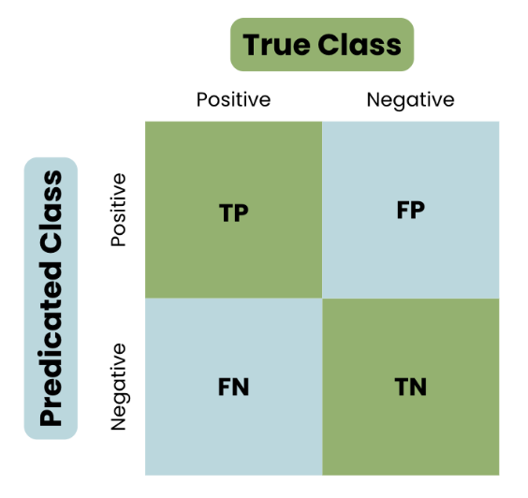
(a) | (b)
Figure 4. Confusion matrices of Method1, (a), and Method2, (b).
4.3 Experiment 2 (font size 14)
Include descriptive graphics of metrics for visual comparison like the boxplots shown in Figure 5.
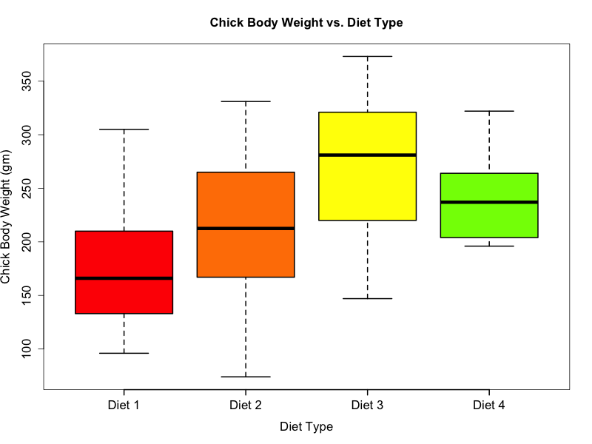
Figure 5. Boxplots
Report the p-values and CIs of the statistical tests used to detect significant differences across method’s performance. You can use a Table, with its corresponding explanations, to report them. Take into account that statistical tests detect what methods are significantly performing worse than others and, thus, should be consistent with descriptive statistics.

5. Discussion and Conclusions
Analyse and interpret the results and their implications, addressing any noteworthy findings. Summarize the project's outcomes and suggest possible areas for improvement.

6. References (font size: 16, maximum 1 page)
(List all sources cited throughout the report using appropriate citation style.)
[1] Python, www.python.org, Date accessed: September 27, 2024
[2] Meyes, R., Lu, M., de Puiseau, C. W., & Meisen, T. (2019). Ablation studies in artificial neural networks. arXiv preprint arXiv:1901.08644.

