A3 - Community detection

We applied community detection to the passing networks of both teams, separately, using four different methods: Louvain, Greedy, Infomap, and Stochastic Block Model (SBM) with a minimum description length (MDL) objective. The results are summarized in the following table.

Team | Detection method | Nodes | Edges | No. of communities | Community sizes | Modularity
Barcelona | Louvain | 11 | 51 | 3 | 6, 3, 2 | 0.061619
Barcelona | Greedy | 11 | 51 | 3 | 6, 3, 2 | 0.061619
Barcelona | Infomap | 11 | 51 | 1 | 11 | 0
Barcelona | SBM | 11 | 51 | 1 | 11 | 0
Manchester United | Louvain | 11 | 48 | 2 | 7, 4 | 0.158562
Manchester United | Greedy | 11 | 48 | 2 | 6, 5 | 0.161674
Manchester United | Infomap | 11 | 48 | 1 | 11 | 0
Manchester United | SBM | 11 | 48 | 1 | 11 | 0

First, we can see that there are two main groups in terms of the detection method used. The modularity-based methods, Louvain and Greedy, identified more than 1 community for both teams, while Infomap and SBM returned a single community in each.

In FC Barcelona, Louvain and Greedy identified a weak partition into 3 communities (with sizes 6, 3, and 2), with a very low modularity value (~0.06). This suggests that there might be some local clustering but not a strong modular structure in the network. In contrast, Infomap and SBM both returned a single community containing all 11 players, which can be interpreted as Barcelona’s passing structure being best described as an integrated system with no strictly distinct subgroups. In other words, during the game, the ball circulation is broadly distributed across all Barcelona’s players. The communities detected are shown graphically in the following image.

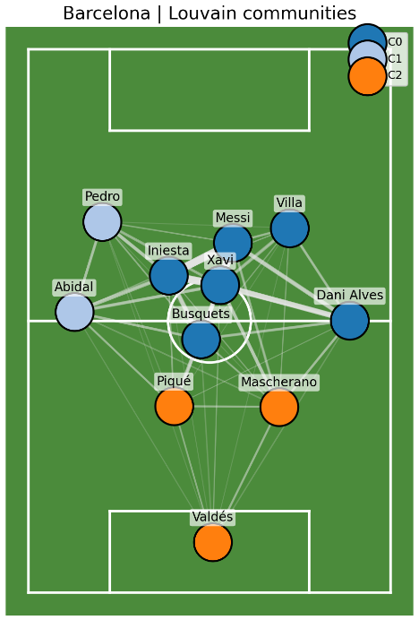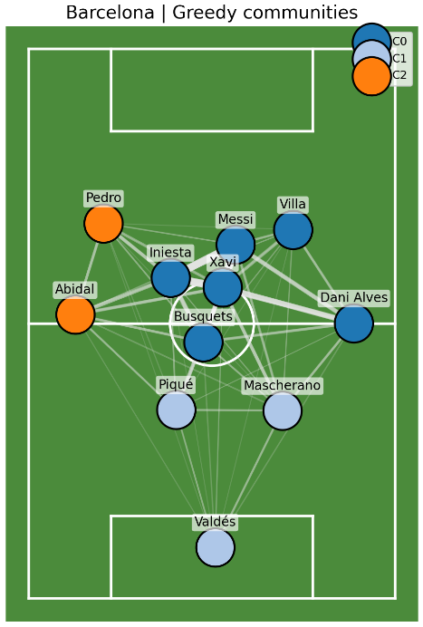
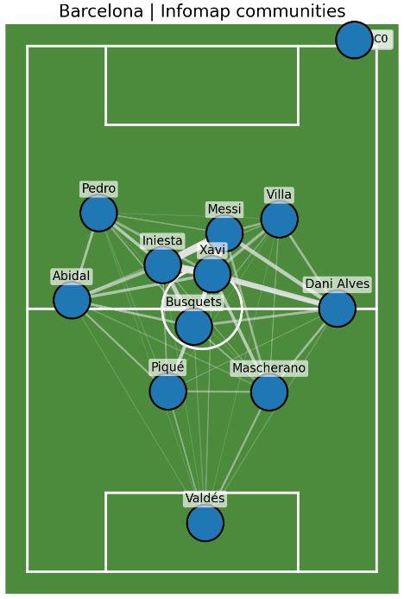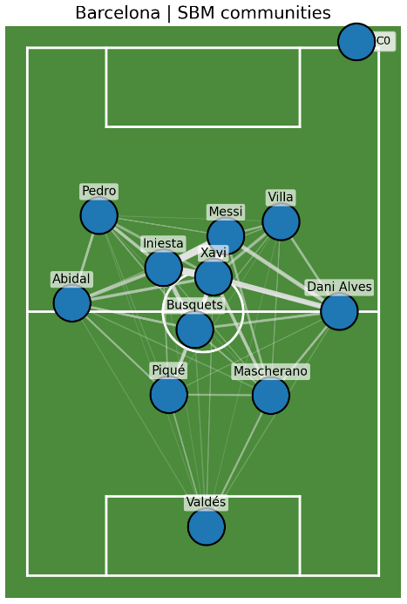

On the other hand, Louvain and Greedy methods detected two communities (sizes 7 and 4, or 6 and 5), with substantially higher modularity values (~0.16) in Manchester United’s network. This indicates more segmented passing structure within the team, likely corresponding to tactical units, like the defensive and attacking blocks that can be seen in two different shades of blue in the image below.

However, Infomap and SBM identified a single community, so while Manchester United’s network might be more modular than Barcelona’s under modularity-based criteria, the separation is not strong enough to form statistically independent blocks.

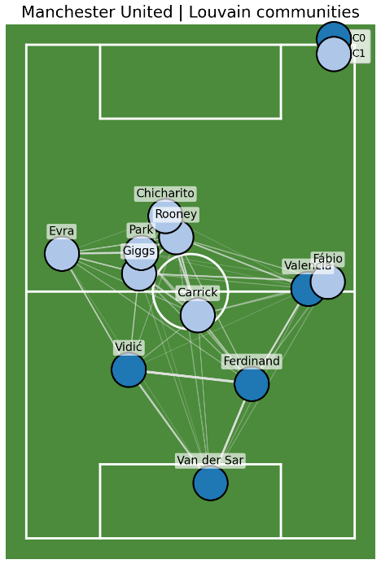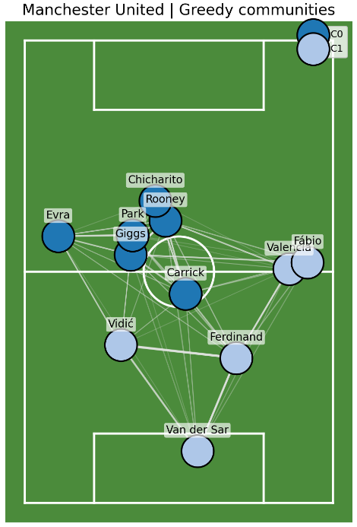
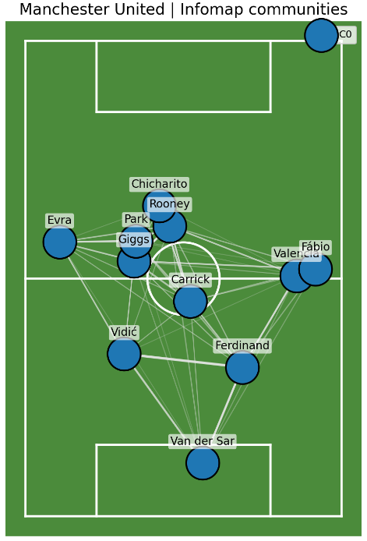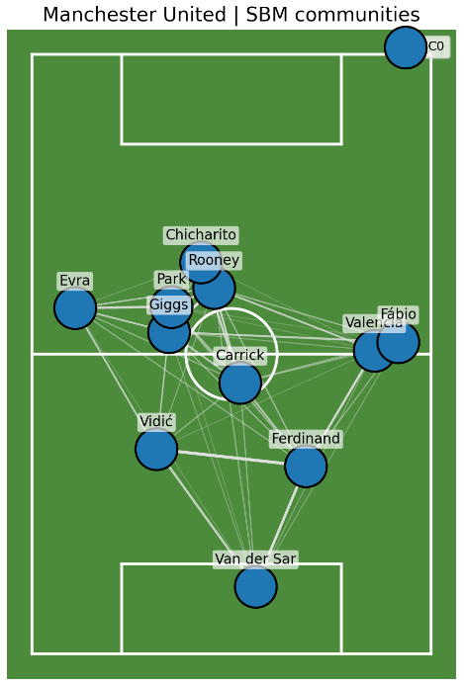

To further amplify this analysis, the networks’ community structure was analyzed considering only the data from one period or half of the match at a time. In general, the overall patterns observed in the full-match analysis remain true. The next table and images summarize the results for FC Barcelona.

Period | Detection method | Nodes | Edges | No. of communities | Community sizes | Modularity
H1 | Louvain | 11 | 45 | 3 | 5, 3, 3 | 0.070465
H1 | Greedy | 11 | 45 | 3 | 5, 3, 3 | 0.070465
H1 | Infomap | 11 | 45 | 1 | 11 | 0
H1 | SBM | 11 | 45 | 1 | 11 | 0
H2 | Louvain | 11 | 45 | 3 | 4, 4, 3 | 0.084344
H2 | Greedy | 11 | 45 | 3 | 4, 4, 3 | 0.084344
H2 | Infomap | 11 | 45 | 1 | 11 | 0
H2 | SBM | 11 | 45 | 1 | 11 | 0

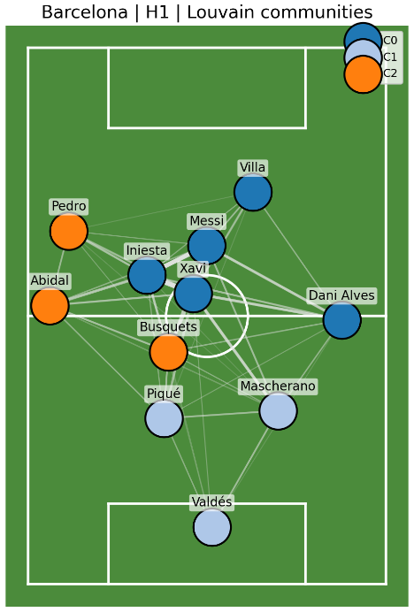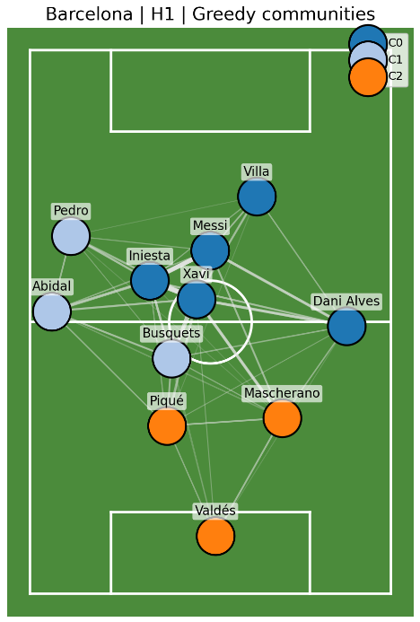
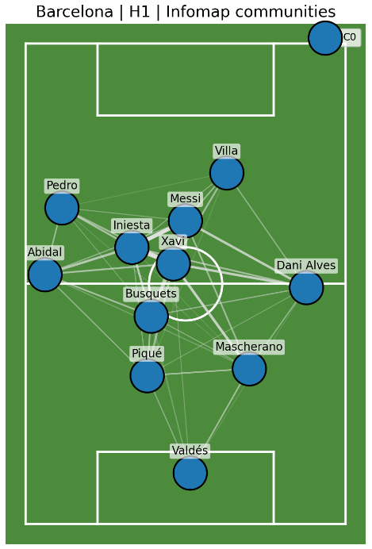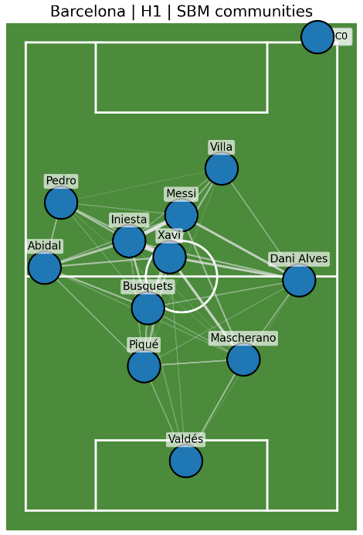
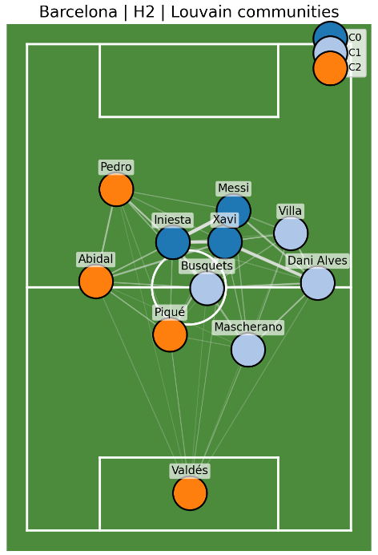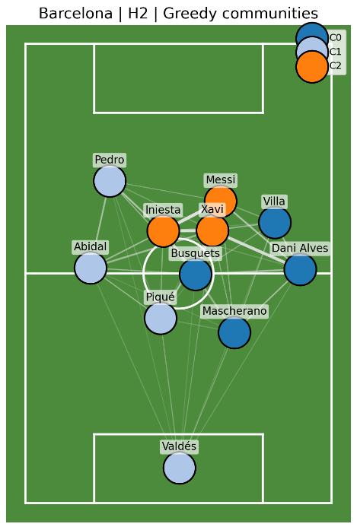
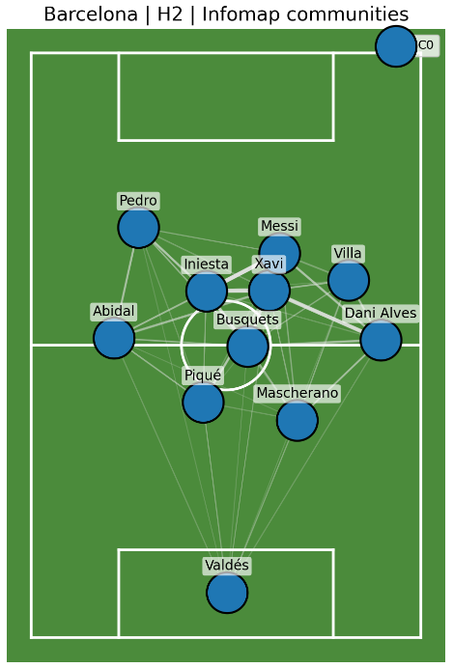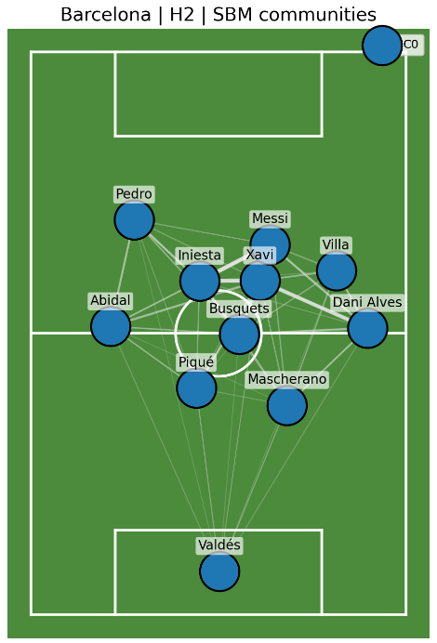

For FC Barcelona, both Louvain and Greedy methods identified 3 weakly defined communities in the first half (sizes 5, 3, and 3), with a low modularity value (~0.07), and 3 in the second half (sizes 4, 4, 3) with a slightly higher modularity (~0.08). The small increase in modularity could suggest a minor reorganization of passes after the break, but the modularity value is still quite low, supporting the idea that Barcelona’s network still behaved as a highly integrated system. Additionally, Infomap and SBM identified a single community in both halves, reinforcing that idea.

In contrast, the Manchester United’s half-based results shown below, reveal clearer and more persistent modular structure. In the first period, Louvain and Greedy detected 3 communities (sizes 6, 3, 2) with a modularity of approximately 0.19, while in the second, the network simplifies into 2 communities (sizes 6, 5) with a bit higher modularity (~0.20). This change could indicate a more segmented structure in the second period, consistent with the team becoming more compact and role-segregated when defending. As in the full-match analysis, Infomap and SBM identify only 1 community in both halves, suggesting once more that although Manchester United’s passing network is more modular than Barcelona’s under modularity-based criteria, the separation is not sufficiently strong or stable to be captured by the other methods studied.

Period | Detection method | Nodes | Edges | No. of communities | Community sizes | Modularity
H1 | Louvain | 11 | 47 | 3 | 6, 3, 2 | 0.193701
H1 | Greedy | 11 | 47 | 3 | 6, 3, 2 | 0.193701
H1 | Infomap | 11 | 47 | 1 | 11 | 0
H1 | SBM | 11 | 47 | 1 | 11 | 0
H2 | Louvain | 11 | 39 | 2 | 6, 5 | 0.203829
H2 | Greedy | 11 | 39 | 2 | 6, 5 | 0.203829
H2 | Infomap | 11 | 39 | 1 | 11 | 0
H2 | SBM | 11 | 39 | 1 | 11 | 0

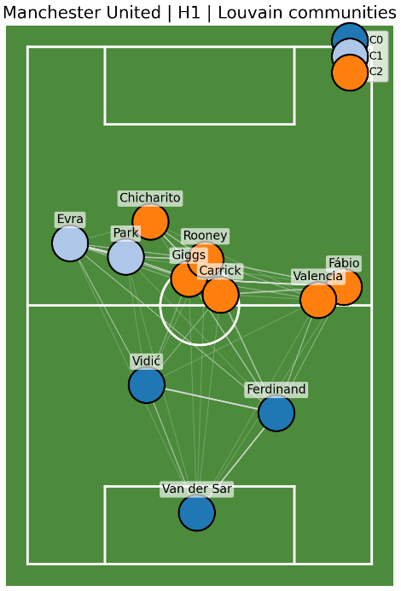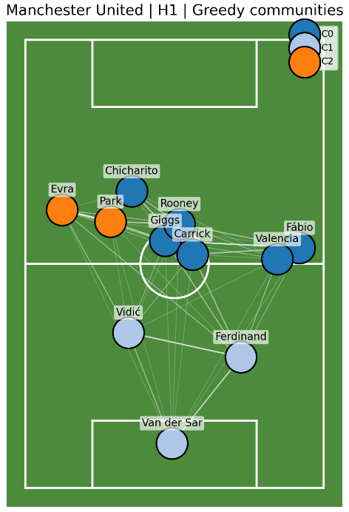
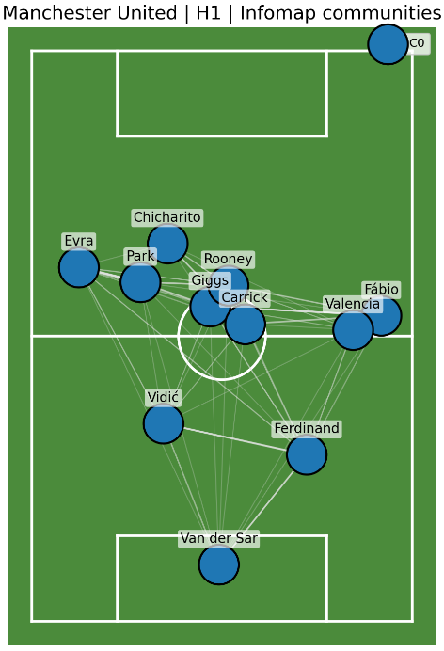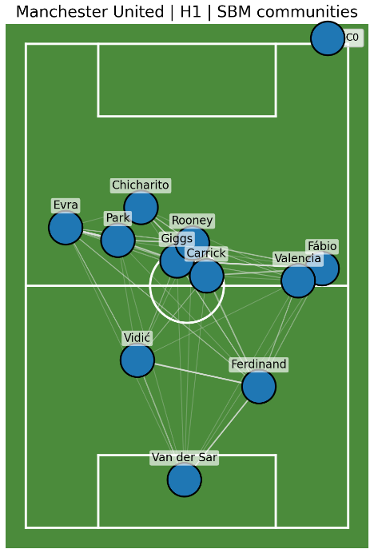

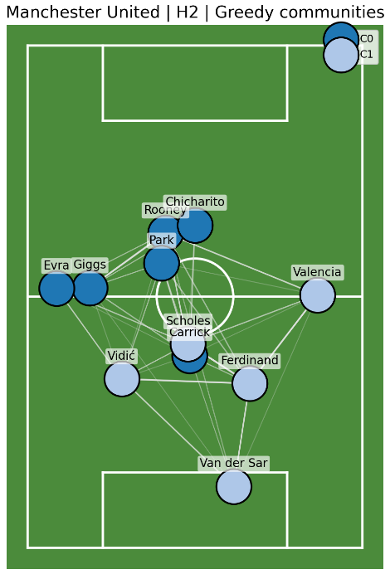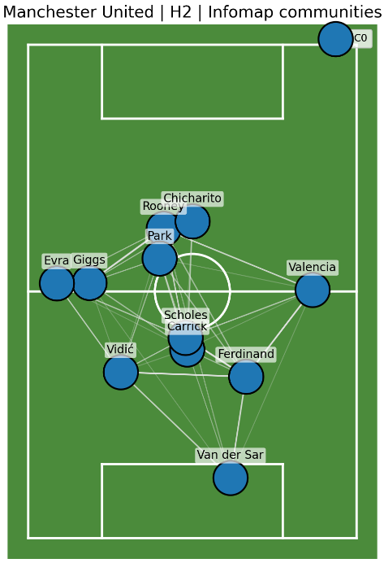
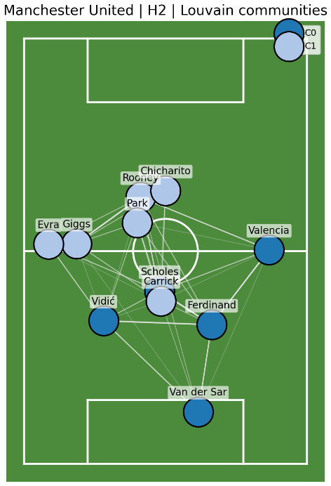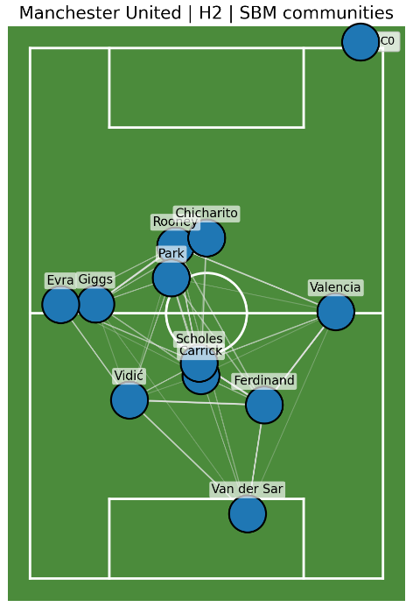

Finally, these half-by-half results show that aggregating the entire match slightly smooths over the temporal variation observed between periods, but it does not change the main conclusions: Barcelona showed weak modularity and high global integration, while Manchester United showed stronger and more interpretable modular separation.

These findings align closely with the tactical realities of the 2011 Champions League Final. Barcelona’s Tiki-Taka system, characterized by constant position changes and short circulating passes, leads to a cohesive network with collective involvement, rather than compartmentalized roles, supporting the hypothesis of a highly integrated small-world-like architecture.

Differently, Manchester United displays a more rigid and segmented structure, consistent with a more reactive and positional approach. The fact that this segmentation is visible to modularity-based methods, but not to Infomap or SBM, highlights the methodological differences between algorithms and also the limited strength of United’s internal cohesion relative to Barcelona’s dominance in possession and control.

