Folder Structure in Flutter
- Ease of reusability in other projects
- Beneficial for team work to keep conversations clear.
- Costly operations to keep finding files and folders if no specific folder structure is used.
2 types of folder structure
- Layer based folder structure
- Feature based folder structure

Themes in Flutter
- Default Theme and theme data
- Theme Light and Dark Mode
- Setup Professional custom theme for light and dark mode
  - Text Theme
  - Button Theme
  - Textfield theme
  - Chip Theme
  - AppBar Theme
  - CheckBox Theme
  - Bottom Sheet Theme

# UTILITY and HELPER Functions:
# Flutter native Splash
Install flutter_native_splash using pub get
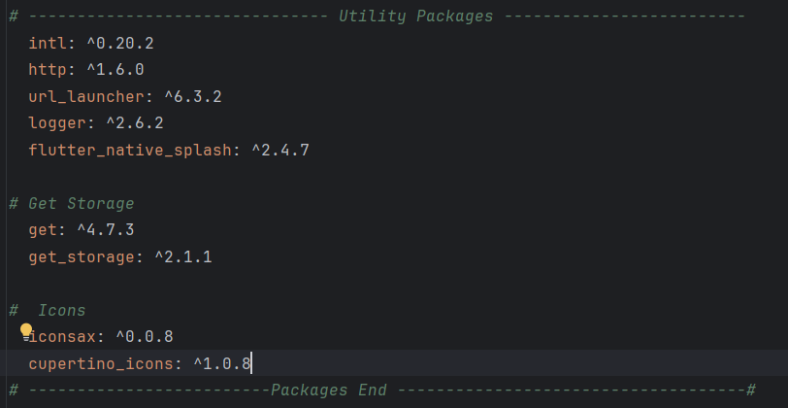
At the root level create a yaml file for splash screen named it splash.yaml

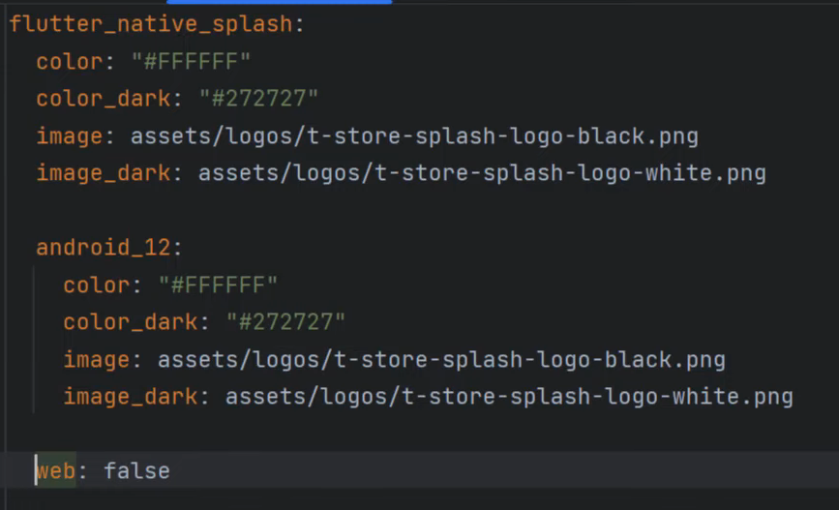

We define the background color for both light and dark mode using color and color_dark attribute, similarly we define the splash logo using image and image_dark attribute

In order to run the splash screen above android 12 we have to manually define that as shown in the above image.
Now run the command
Flutter pub run flutter_native_splash:create –path=splash.yaml
To remove the splash screen run the below command
Flutter_native_splash:remove

# Flutter Onboarding Screen

The instructor used the high quality GIF files but I am unable to arrange some good high quality GIF’s so I used Lottie JSON files
Add the files inside the desired folder which is assets/images/onboarding_lottie_animation/

Now we will add all of our lottie json files here inside lib/utils/constants we had an file image_strings.dart inside the model class RAppImages add the lottie strings as shown

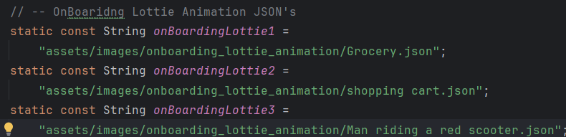

CUSTOM CLIP PATH
This is complex thing so let it understand completely before proceeding to the next Step’s

CUSTOM APP BAR

CTRL + ALT + O => to delete all dead imports

🛒 1️⃣ Groceries (Core Category)
- Fruits & Vegetables
- Dairy, Bread & Eggs
- Atta, Rice & Pulses
- Cooking Oils & Ghee
- Masalas & Spices

🥤 2️⃣ Snacks & Beverages
- Chips & Namkeen
- Biscuits & Cookies
- Chocolates & Candy
- Cold Drinks
- Juices
- Tea & Coffee

🍜 3️⃣ Ready to Eat / Instant
- Maggi & Noodles
- Frozen Foods
- Ready-to-Cook Mixes
- Breakfast Cereals

🧴 4️⃣ Personal Care
- Shampoo & Soap
- Toothpaste
- Deodorants
- Face Wash & Creams
- Sanitary Products

🏠 5️⃣ Household Essentials
- Detergent
- Dishwash
- Floor Cleaners
- Garbage Bags
- Tissues

👶 6️⃣ Baby Care
- Diapers
- Baby Food
- Wipes
- Baby Lotion

🐶 7️⃣ Pet Care
- Dog Food
- Cat Food
- Pet Shampoo
- Treats

💊 8️⃣ Health & Wellness
- Multivitamins
- Pain Relief
- Masks
- Sanitizers

⚡ 9️⃣ Instant Needs (Impulse Category)
- Ice Cream
- Energy Drinks
- Party Snacks
- Cigarettes (if allowed regionally)

🛠 10️⃣ Emergency / Utility
- Batteries
- Mobile Chargers
- Extension Boards
- Light Bulbs
Flutter Carousel Slider with Dots
From pub.dev add carousel_slider package

