**Cucumber ->**

**File Structure:-**

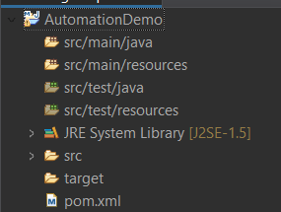

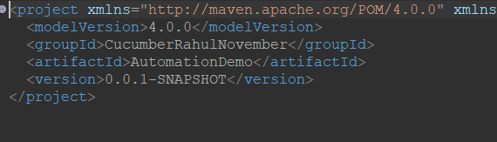

Download Cucumber JVM Java and Cucumber TestNG for Maven and paste it in POM.xml:-

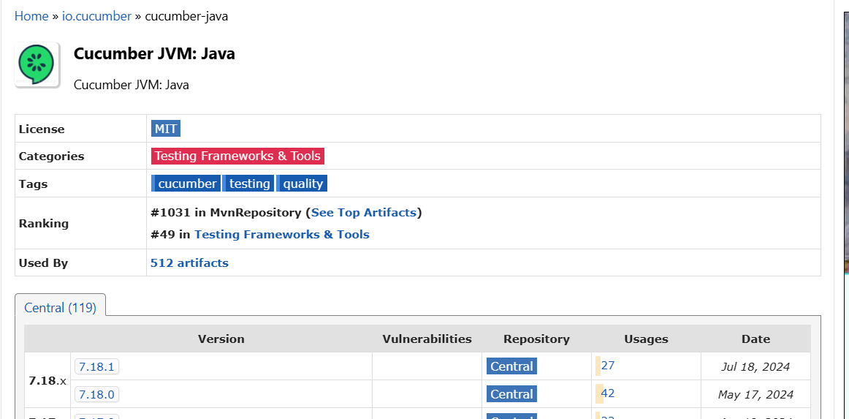

<!-- https://mvnrepository.com/artifact/io.cucumber/cucumber-java -->

<dependency>

<groupId>io.cucumber</groupId>

<artifactId>cucumber-java</artifactId>

<version>7.18.1</version>

</dependency>

**Sample POM.xml:-**

<project xmlns="http://maven.apache.org/POM/4.0.0" xmlns:xsi="http://www.w3.org/2001/XMLSchema-instance" xsi:schemaLocation="http://maven.apache.org/POM/4.0.0 https://maven.apache.org/xsd/maven-4.0.0.xsd">

<modelVersion>4.0.0</modelVersion>

<groupId>CucumberRahulNovember</groupId>

<artifactId>AutomationDemo</artifactId>

<version>0.0.1-SNAPSHOT</version>

<dependencies>

<!-- https://mvnrepository.com/artifact/io.cucumber/cucumber-java -->

<dependency>

<groupId>io.cucumber</groupId>

<artifactId>cucumber-java</artifactId>

<version>7.18.1</version>

</dependency>

<!-- https://mvnrepository.com/artifact/io.cucumber/cucumber-testng -->

<dependency>

<groupId>io.cucumber</groupId>

<artifactId>cucumber-testng</artifactId>

<version>7.18.1</version>

</dependency>

</dependencies>

</project>

Junit and TestNG helps in running Java Test in Cucumber.

//TestNG is used much mostly.

**Syntax/Files Needed:-**

Feature File : –

Feature:

Scenario:

Given

When

Then

Step Definition File:-

Test Runner:-

Junit/TestNG

**File in src/test/java:-**

**File extension is .feature**

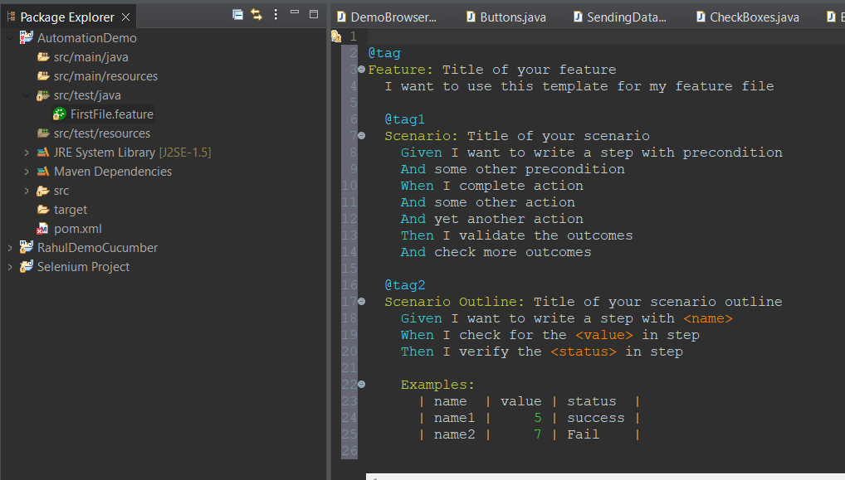

**Entire File Structure:-**

**Created Package and separation for all 3 essential files.**

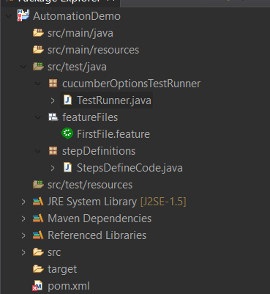

**Feature File:-**

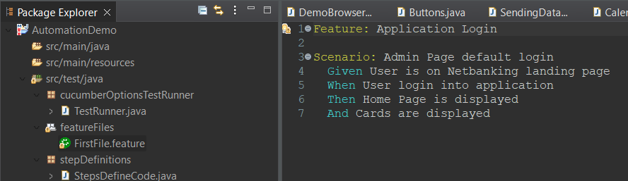

**TestRunnerFile:-**

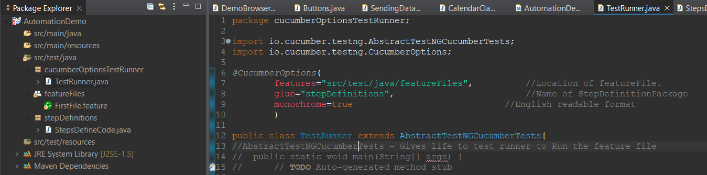

We have empty step Definition file as of now.

Undefined Step error when no StepDefinition present.

Runs Cucumber Scenarios

io.cucumber.testng.UndefinedStepException: The step 'User is on Netbanking login page' and 3 other step(s) are undefined.

You can implement these steps using the snippet(s) below:

@Given("User is on Netbanking login page")

public void user_is_on_netbanking_login_page() {

// Write code here that turns the phrase above into concrete actions

throw new io.cucumber.java.PendingException();

}

@When("User login into application")

public void user_login_into_application() {

// Write code here that turns the phrase above into concrete actions

throw new io.cucumber.java.PendingException();

}

@Then("Home Page is displayed")

public void home_page_is_displayed() {

// Write code here that turns the phrase above into concrete actions

throw new io.cucumber.java.PendingException();

}

@Then("Cards are displayed")

public void cards_are_displayed() {

// Write code here that turns the phrase above into concrete actions

throw new io.cucumber.java.PendingException();

}

**StepDefinitionFile and it’s Output:-**

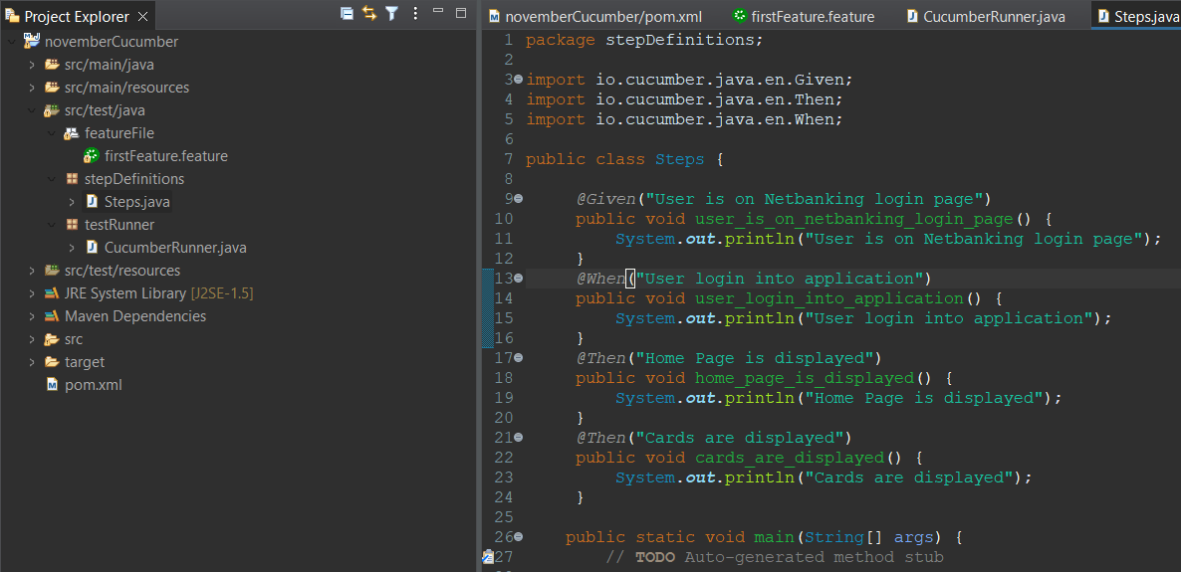

[RemoteTestNG] detected TestNG version 7.10.2

User is on Netbanking login page

User login into application

Home Page is displayed

Cards are displayed

PASSED: io.cucumber.testng.AbstractTestNGCucumberTests.runScenario("Admin Page default login", "Application Login")

Runs Cucumber Scenarios

===============================================

Default test

Tests run: 1, Failures: 0, Skips: 0

===============================================

===============================================

Default suite

Total tests run: 1, Passes: 1, Failures: 0, Skips: 0

===============================================

**Code Reusability:-**

**Feature File:-**

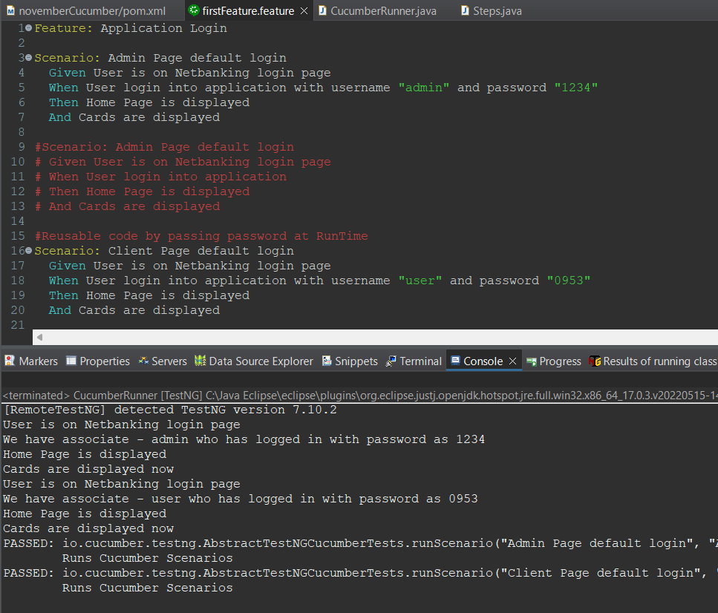

**StepDefinitionChanges:-**

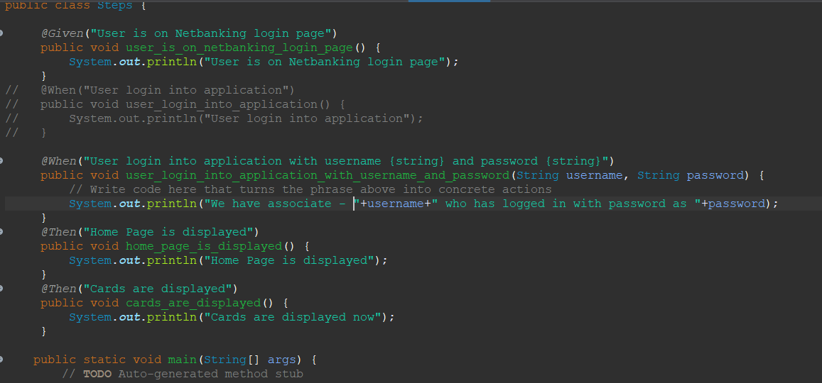

**Scenario Outline:- To use Parametrization for using multiple steps with same step definitions.**

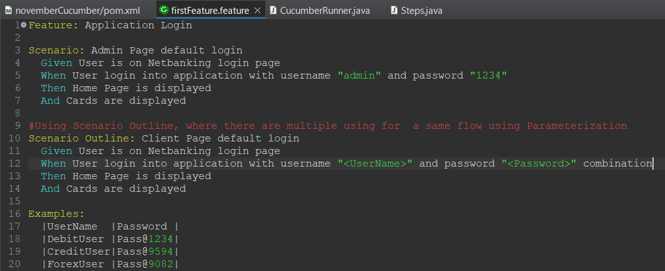

**StepDefinition:-**

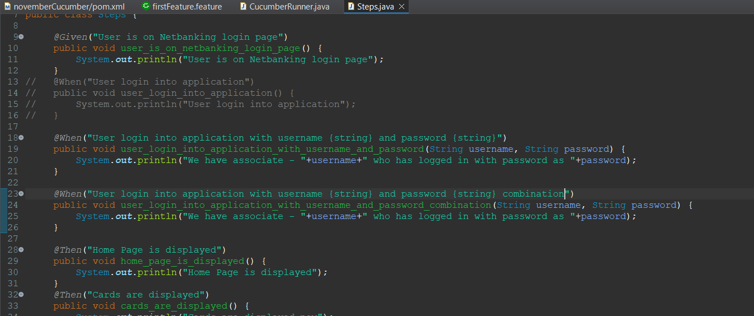

**Using Regex:- This is used to send any kind of data without specifying data Type.**

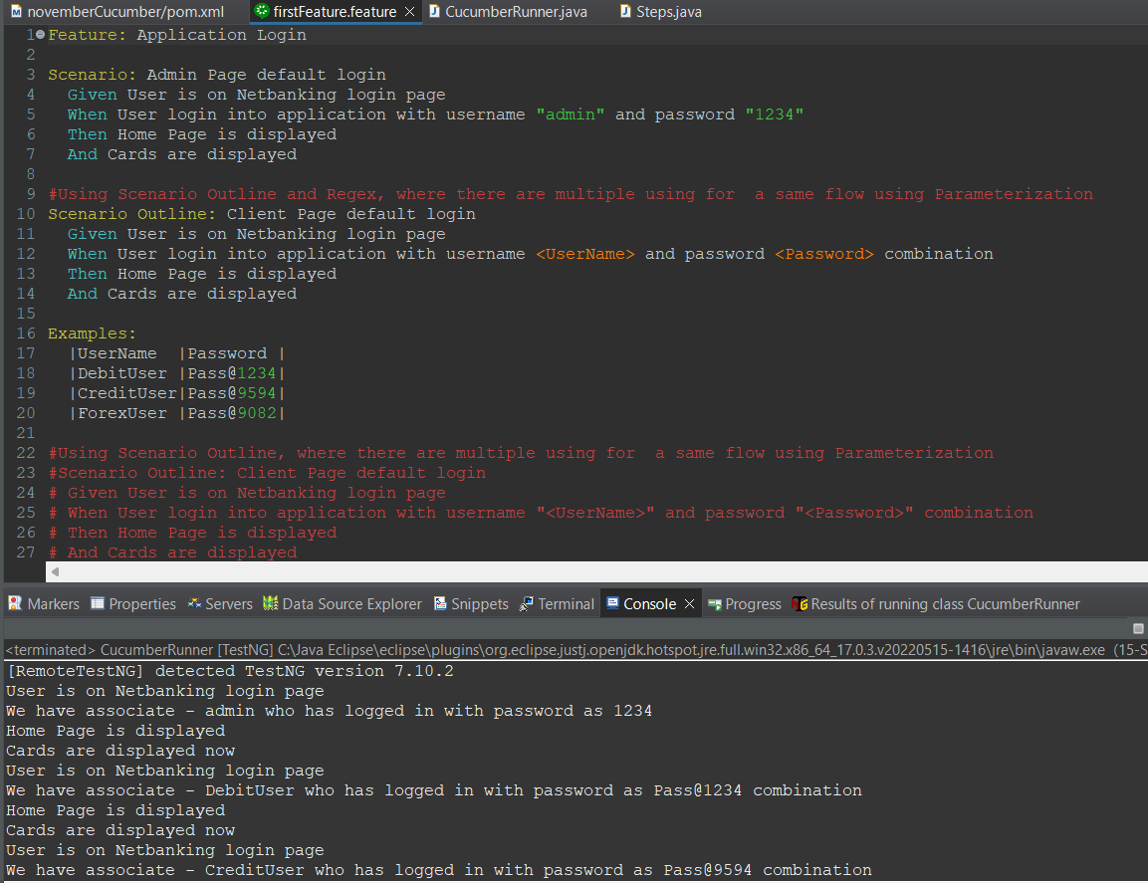

**StepDefinition Using Regex - ^$ and(.+)**

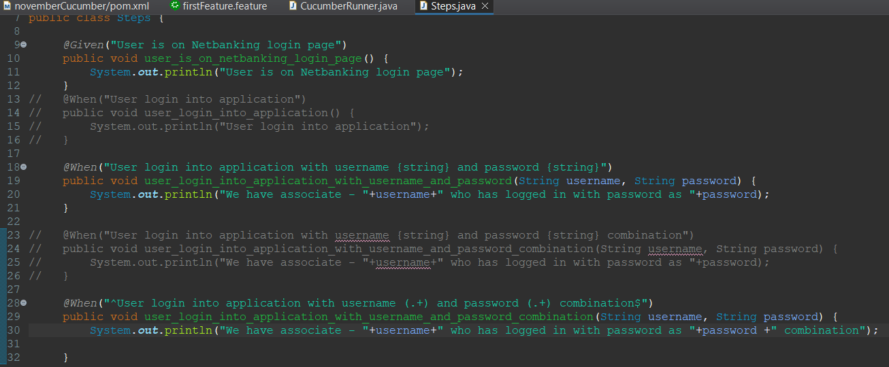

**DataDriven Testing:-**

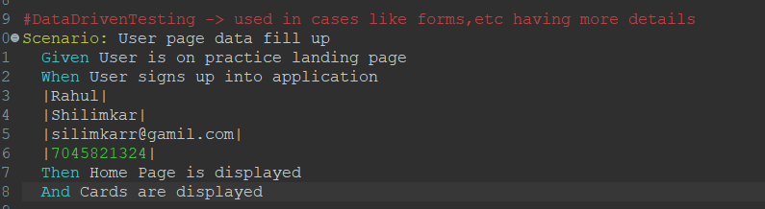

**StepDefinition:-**

**List is used since we are getting multiple value’s in it.**

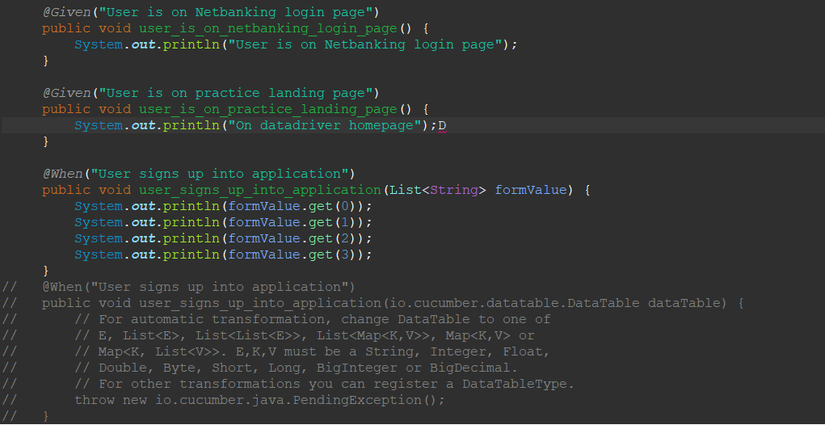

**Tags:- This are used to select the specific tests to run**

**Feature File:-**

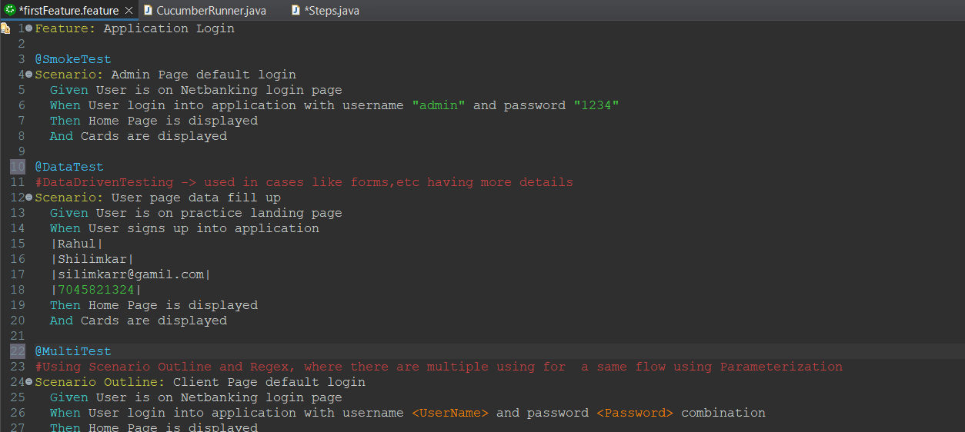

**TestRunner File:-**

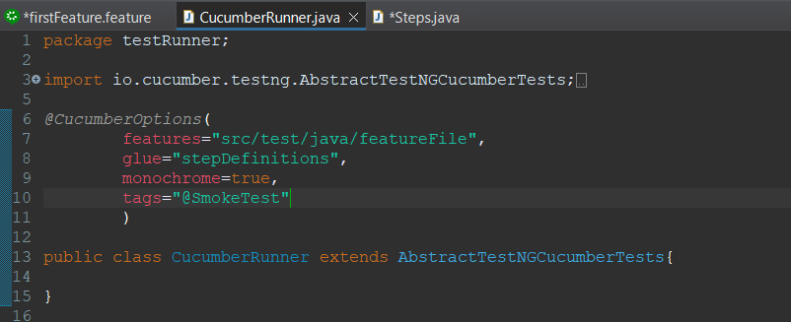

**Output:- This will run only One test @SmokeTest**

**Multiple Tags:-**

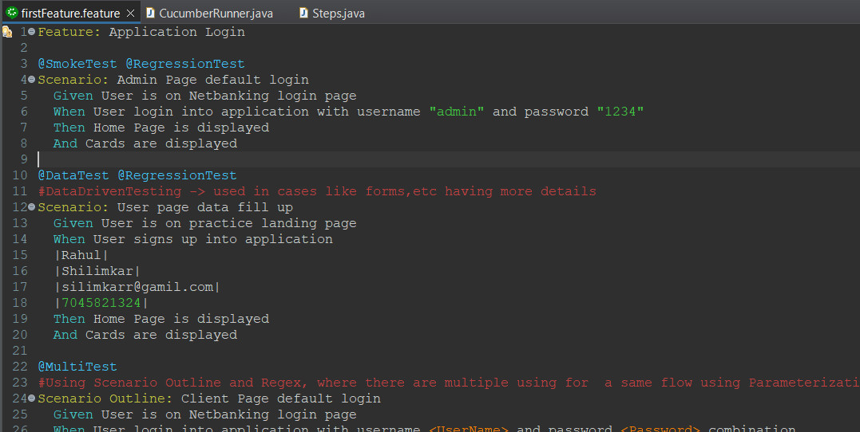

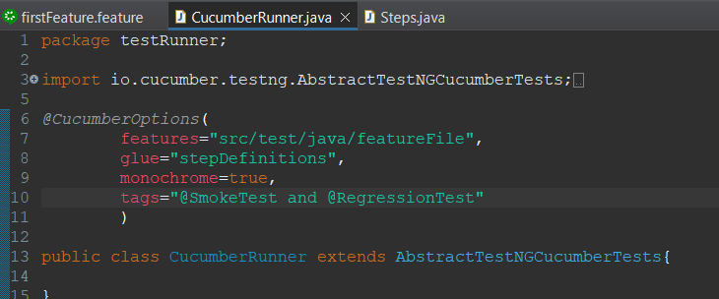**This will run only first Scenario having both smoke and regression**

**Using “OR” - OR will run both first and Second usecase**

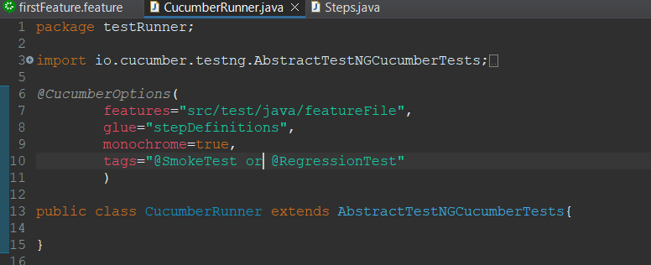

**Using NOT:- This will skip the test’s having given Tags.**

