DigiGarage

Project Report

Submitted as Partial Fulfillment of

Master of Computer Application Semester-VI

**Developed at**

**Gateway Group of Companies.**

**Developed by**

**Ezhava Prijitha Unnikrishnan (201900721010013)**

**Under Guidance of**

Dr. Krupa Mehta, FCT &

Gateway Technical Team

Faculty of Computer Technology (GLSICT) GLS University

Ahmedabad-380 006

# Project Profile :

|  |  |  |  |  |  |
| --- | --- | --- | --- | --- | --- |
| Project Title: | DigiGarage | | | | |
| Description: | A system which is being developed for the administrative staffs of a vehicle service center to maintain their data digitally on computer systems. | | | | |
| Aim: | Digitalization of the physical/paper process of the vehicle service centers | | | | |
| Category: | Web Site | | | | |
| Tools Used / Required: | Development side   * Software:   + Operating System: Windows 10   + Front End: HTML, CSS, Bootstrap, Razor HTML,   + Back End: Asp.net, SQL   + IDE: Visual Studio 2019, Microsoft SQL Server Management Studio 18   + Framework: .Netframework   + Report Generation Tool: Crystal Reports 8 * Architecture: Multi-tier MVC | | | | |
| Developed at: | Gateway Group of Companies, Ahmedabad | | | | |
| Developed By: |  | Enroll No. | Name | Institute | Contribution |
| 20190072  1010013 | Ezhava Prijitha Unnikrishnan. | FCT | Designing Database, maintaining repositories at back end and front end |
| Guided By: |  | Internal at Institute | | External at company | |
| Name: Dr. Krupa Mehta Designation: Assistant Professor | | Name: Gateway Technical Team | |
|  | | | | |

### Certificate

**This is to certify that**

**Ezhava Prijitha Unnikrishnan, 201900721010013**

**Student of MCA semester VI of**

Faculty of Computer Technology (GLSICT)

## has successfully completed the full-time project work entitled

***“DigiGarage”***

## developed at “Gateway Group of Companies”

**as a partial fulfillment of the study of**

**Master of Computer Application**

|  |  |  |
| --- | --- | --- |
| (Internal Guide) Internal Guide | (Dr. Krupa Mehta) Project Coordinator | (Dr. Bhushan Trivedi) Director/Dean |
|  | (Prof. R. P. Soni) Campus Director(CE) |  |

***April 2021***

## Acknowledgment

My journey towards achieving the destination for the design and functionality development of **DigiGarage** has finally come to a fruitful culmination. However it would have not been possible without the kind of support and help of many individuals. I would like to extend my sincere thanks to all of them.

I am highly indebted to ‘**Dr. Krupa Mehta**’ for her guidance and supervision as well as for providing necessary information regarding the same.

I would also like to thank **‘Gateway Technical Team’** for their precious training and guidance for developing this project.

My thanks and appreciations also go to my friends and teammates who helped me out with their abilities.

## Abstract

Today the world is considered as a competitive world where everybody seeks for accuracy in least time.

Earlier paper work was the means to keep various records. It was very time consuming and not even that accurate. Also the records maintained in the form of paper has a very high chance of both data loss and data breach. So we decided to design and develop the project called **‘DigiGarage’** which eliminates the paper work, made easy access of data and reduced redundancy to a great extend. As the data has been stored digitally the security and backup of data can be achieved.

**‘DigiGarage’** mainly deals with maintenance of the records of the customers and their vehicles, mechanics, booking service requests and payments. There are two categories of users at administrative level in this project -

1. Super Admin
2. Departmental Heads.

Where the Super Admin will have access to the entire system. He can access, modify and enter data of any entities in the system. While the Departmental Heads can only have access to the data records of their respective departments.

|  |  |  |
| --- | --- | --- |
| **Sr. No** | **Particular** | **Page No** |
| **1** | **Cover Page** | **i** |
| **2** | **Project Profile** | **ii** |
| **3** | **Acknowledgement** | **iii** |
| **4** | **Abstract** | **iv** |
|  |  |  |
| **Chapter 1** | **Introduction** |  |
| 1.1 | Company Profile |  |
| 1.2 | About DigiGarage |  |
| 1.3 | Benefits of DigiGarage |  |
|  |  |  |
| **Chapter 2** | **About Technology** |  |
| 2.1 | About ASP.NET MVC |  |
| 2.2 | About SSMS |  |
| 2.3 | About HTML |  |
| 2.4 | About Boostrap |  |
|  |  |  |
| **Chapter 3** | **Software Requirement Specifications** |  |
| 3.1 | Problem Statement |  |
| 3.2 | Existing System |  |
| 3.3 | Proposed System |  |
| 3.4 | Development Tools and Technology |  |
|  |  |  |
| **Chapter 4** | **Project Modules** |  |
| 4.1 | Super Admin |  |
| 4.2 | Washing Department Admin |  |
| 4.3 | Repairing Department Admin |  |
| 4.4 | Maintenance Department Admin |  |
|  |  |  |
| **Chapter 5** | **Data Dictionary** |  |
|  |  |  |
| **Chapter 6** | **UML Diagrams** |  |
| 6.1 | Use Case Diagram |  |
| 6.2 | Activity Diagram |  |
| 6.3 | Class Diagram |  |
|  |  |  |
| **Chapter 7** | **UI Screenshots** |  |
|  |  |  |
| **Chapter 8** | **Future Enhancement** |  |
|  |  |  |
| **6** | **References** |  |

## Index

## Chapter 1: Introduction

### Company Profile:

|  |  |
| --- | --- |
| Company Name | Gateway TechnoLabs Pvt. Ltd. (Gateway Group of Companies) |
| Website | [https://www.thegatewaycorp.com](https://www.linkedin.com/redir/redirect?url=https%3A%2F%2Fwww.thegatewaycorp.com&urlhash=2J2t&trk=about_website) |
| Address | B-81 Corporate House, Judges Bungalow Road, Bodakdev, Ahmedabad, Gujarat 380054, IN |
| Industries | Computer Software |
| Company size | 1001 – 5000 employees |
| Headquarters | Ahmedabad, Gujarat |
| Type | Privately Held |
| Founded | 1997 |
| Specialties | Software Development, Global Sourcing Solutions, Technology & Consulting Services, Software Product Engineering, BPO Services, Enterprise Mobility, Enterprise Business Solutions, Digital Marketing & Multimedia, Cloud Computing & Big Data, and Independent Testing |

## About DigiGarage:

DigiGarage enables the garage owners to keep track of all the activities of a garage. It is a web based application for garage management which is mainly developed keeping in mind for administrative purpose only [B2B]. This system provides the facility of managing the data of a garage’s customers and their vehicles, mechanics, service booking details, payment details digitally, thus avoiding the procedure of paper and manual work for storing and retrieving data completely.

### 1.3 The benefits of developing DigiGarage:

* + - Managing data becomes easy.
    - Chances of Data breach, data loss and redundancy made reduced to a great extent.
    - Paper and manual work of managing data and tracking the activities within the garage have been avoided completely.
    - The admin can assign the mechanic for a particular service of their respective department.
    - Past booking service details is also made available to the admin.
    - Admin can generate bill for booking digitally and can email the customer the invoice generated.

**Chapter 2 About Technology:**

Here we give a brief about the technologies being used in the current project.

**2.1 ASP.NET MVC:**

ASP.NET MVC is Microsoft Web development framework targets .NET Framework.

MVC stands for Model-View-Controller. It is a software architecture pattern that separates the representation of information from the user’s interaction with it.

* Controller: The controller is an input control. It first executes when the user sends any request. It is the job of controller to decide which view is to be shown. It connects both the View and Model.
* Model: A model is associated with View and Controller. It produces the updated output on the view. The Model objects retrieve data from the database and stores data to the database.
* View: View are components that display the application’s User Interface (UI), in other words it manages the display of information.

**2.2 About SSMS:**

SQL Server Management Studio(SSMS) is an integrated environment for managing any SQL infrastructure. SSMS is used to access, configure, manage, administer and develop all components of SQL Server, Azure SQL Database and Azure Synapse Analytics. SSMS provides a single comprehensive utility that combines a broad group of graphical tools with number of rich script editors to provide access to SQL Server for developers and database administrators of all skill levels.

**2.3 About HTML:**

HTML stands for **H**yper**t**ext **M**arkup **L**anguage, and it is the most widely used language to write Web Pages. **Hypertext** refers to the way in which Web pages (HTML documents) are linked together. Thus, the link available on a webpage is called Hypertext. As its name suggests, HTML is a **Markup Language** which means you use HTML to simply "mark-up" a text document with tags that tell a Web browser how to structure it to display. Originally, HTML was developed with the intent of defining the structure of documents like headings, paragraphs, lists, and so forth to facilitate the sharing of scientific information between researchers.

**2.4 About Bootstrap:**

Bootstrap was developed by *Mark Otto* and *Jacob Thornton* at *Twitter*. It was released as an open source product in August 2011 on GitHub. Bootstrap is a sleek, intuitive, and powerful, mobile first front-end framework for faster and easier web development. It uses HTML, CSS and JavaScript.

We use Bootstrap for the following reasons:

* **Mobile first approach** − Bootstrap 3, framework consists of Mobile first styles throughout the entire library instead them of in separate files.
* **Browser Support** − It is supported by all popular browsers.
* **Easy to get started** − With just the knowledge of HTML and CSS anyone can get started with Bootstrap. Also the Bootstrap official site has a good documentation.
* **Responsive design** − Bootstrap's responsive CSS adjusts to Desktops, Tablets and Mobiles. More about the responsive design is in the chapter [Bootstrap Responsive Design.](https://www.tutorialspoint.com/bootstrap/bootstrap_responsive_utilities.htm)

## Chapter : 3 Software Requirement Specifications:

## 3.1 Problem Statement:

* + - Domain: Gateway Digital
    - The Board Scope: Digitalization of the physical/paper process of the industry or the process of work
    - Target Audience: B2B Users

## 3.2 Existing System:

* + - Currently in garages the employees aren’t distributed properly.
    - There isn’t any systematic approach of storing data which results in loss of data.
    - There are many cases where employees feel that they are not proper bonus or promotions etc.
    - The standard at which work is done is not upto mark.
    - There was no maintenance history of all the vehicles that were serviced in the garage.
    - The service dates had to be tracked manually and that was a difficult task.

## 3.3 Proposed System:

* + - To solve the above problems, there is need for the current manual system to be computerized.
    - With this keeping in mind, the system will be an online web based

system that will enable automation of most of the garage process.

* + - The system will also provide a database for storing data of customers and their vehicles along with their vehicle service system, the staffs and the payment.

## 3.4 Development Tools and Technology:

### Hardware and Software used:

* 1. **Client Side:**
     + Software Required:
       - Operating System: Windows 7 or above
       - Web-browser: Chrome/Explorer/Mozilla/Firefox.
     + Hardware Required:
       - Processor: 2GHz
       - RAM : 2 GB
       - Hard disk: 2 GB free space

### Server Side:

* + - Software Required:
      * Operating System: Windows 7 or above
      * Web-browser: Chrome/Explorer/Mozilla/Firefox.
      * IDE: Visual Studio Community 2019 and SQL Server Management Server 2019

## Chapter 4 : Project Modules

The modules show the users and functionalities present in the system.

**Users:**

* + - Here in the proposed system there are four kinds of users who use different functionalities of the system.

1. Super Admin
2. Washing Department Admin
3. Repairing Department Admin
4. Maintenance Department Admin
   * + All the users of our system holds their own importance and performs specific functions in the system.

**4.1 Super Admin**

* + - Super admin has the right to access every single module of the system.
    - Super Admin can login into the system, can manage customers, vehicles and mechanics.
    - Super admin can add booking requests and accept them.
    - Super Admin can assign mechanic of all departments.
    - Super admin can generate bill and view payment list.

**4.2 Washing Department Admin**

* + - Washing department admin is the head of the washing department.
    - He can login to the system and can view the list of vehicle washing services
    - He can also assign mechanic belonging to the same department.

**4.3 Repairing Department Admin**

* + - Repairing department admin is the head of the repairing department.
    - He can login to the system and can view the list of vehicle repairing services
    - He can also assign mechanic belonging to the same department.

**4.4 Maintenance Department Admin**

* + - Maintenance department admin is the head of the maintenance department.
    - He can login to the system and can view the list of vehicle maintenance services
    - He can also assign mechanic belonging to the same department.

## Chapter 4: Data Dictionary

### Login

|  |  |  |
| --- | --- | --- |
| **Data Field** | **Data Type** | **Constraints** |
| Id | Int | Primary Key |
| Email | nvarchar(30) | Not Null |
| Password | nvarchar(10) | Not Null |

* 1. **Roles**

|  |  |  |
| --- | --- | --- |
| **Data Field** | **Data Type** | **Constraints** |
| Id | Int | Primary Key |
| UserId | Int | Foreign Key |
| UserRole | nvarchar(15) | Not Null |

* 1. **Customers**

|  |  |  |
| --- | --- | --- |
| **Data Field** | **Data Type** | **Constraints** |
| Id | Int | Primary Key |
| Name | nvarchar(30) | Not Null |
| Address | nvarchar(30) | Not Null |
| City | nvarchar(20) | Not Null |
| PhoneNo | nvarchar(11) | Not Null |
| Email | nvarchar(50) | Not Null |
| Password | nvarchar(10) | Not Null |

* 1. **Vehicles**

|  |  |  |
| --- | --- | --- |
| **Data Field** | **Data Type** | **Constraints** |
| Id | Int | Primary Key |
| LicenseNo | nvarchar(30) | Not Null |
| Color | nvarchar(10) | Not Null |
| FuelType | nvarchar(10) | Not Null |
| Brand | nvarchar(30) | Not Null |
| Model | nvarchar(30) | Not Null |
| RegistrationDate | Date | Not Null |
| ChassisNo | nvarchar(20) | Not Null |
| EngineNo | nvarchar(15) | Not Null |
| CustomerId | Int | Foreign Key |

* 1. **Mechanics**

|  |  |  |
| --- | --- | --- |
| **Data Field** | **Data Type** | **Constraints** |
| Id | Int | Primary Key |
| Name | nvarchar(30) | Not Null |
| PhoneNo | nvarchar(11) | Not Null |
| EmailID | nvarchar(50) | Not Null |
| Brand | nvarchar(30) | Not Null |
| DeptId | Int | Foreign Key |

* 1. **Booking**

|  |  |  |
| --- | --- | --- |
| **Data Field** | **Data Type** | **Constraints** |
| BookingId | Int | Primary Key |
| VehicleId | Int | Foreign Key |
| ServiceId | Int | Foreign Key |
| BookingDate | Date | Not Null |
| Status | Int | Not Null |
| DepartmentId | Int | Foreign Key |
| Description | nvarchar(MAX) | Not Null |

* 1. **Booking History**

|  |  |  |
| --- | --- | --- |
| **Data Field** | **Data Type** | **Constraints** |
| HistoryId | Int | Primary Key |
| BookingId | Int | Foreign Key |
| ServiceId | Int | Foreign Key |
| VehicleId | Int | Foreign Key |
| DepartmentId | Int | Foreign Key |
| MechanicId | Int | Foreign Key |

* 1. **Payment**

|  |  |  |
| --- | --- | --- |
| **Data Field** | **Data Type** | **Constraints** |
| PaymentId | Int | Primary Key |
| BookingId | Int | Foreign Key |
| ServiceId | Int | Foreign Key |
| VehicleId | Int | Foreign Key |
| TotalAmount | decimal(8,0) | Not Null |
| Date | Date | Not Null |

* 1. **Services**

|  |  |
| --- | --- |
| Service ID | Service Name |
| 1 | Washing |
| 2 | Repairing |
| 3 | Maintenance |
| 4 | Washing and Repairing |
| 5 | Maintenance and Washing |

* 1. **Status Of Booking**

|  |  |
| --- | --- |
| Service ID | Service Name |
| 1 | Pending |
| 2 | Accept |
| 3 | Completed |
| 4 | Generated |

* 1. **Department**

|  |  |
| --- | --- |
| Service ID | Service Name |
| 1 | Washing |
| 2 | Repairing |
| 3 | Maintenance |

**Chapter 5: UML Diagrams**

* 1. **Use Case Diagram :**
     + Use case diagram provide a simple and fast means to decide and describe the purpose of a project.
     + It is one of type of interaction model and it is describe how object interact to produce useful result.
     + At high level use case describes how a system interacts with outside actor.
     + Each use case represents functionality of a system along with users.
     + A system involves a set of use cases and a set of actors.
     + Each use case represent functionality of the system and set of use cases represent the complete functionality of system.

In this system there are two different use cases

1. Super Admin

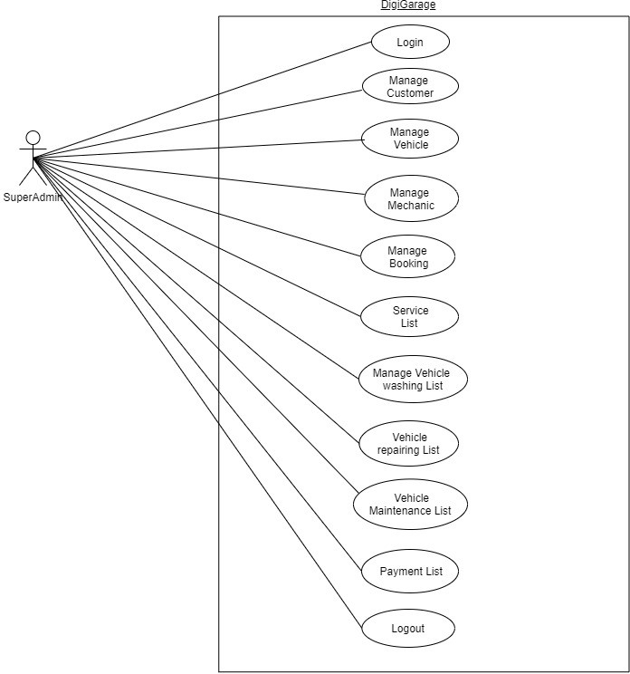

1. Departmental Heads

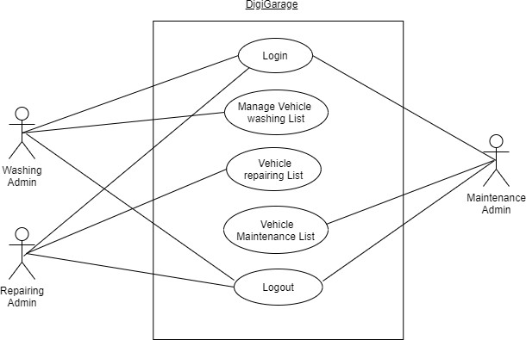

### Activity Diagram:

* It is the equivalent of flow chart diagram.
* It showing flow of control from activity to activity.
* It is used for modeling the logic captured by a single use case scenario.
* Activity diagram is used for simple & perspective illustration of what happens in a work flow, what activities can be done in parallel & whether there are alternative path through the work flow.
* It shows the work flow from a start point to the finish point detailing the many decision paths that exists in the progression of events contain in the activity.

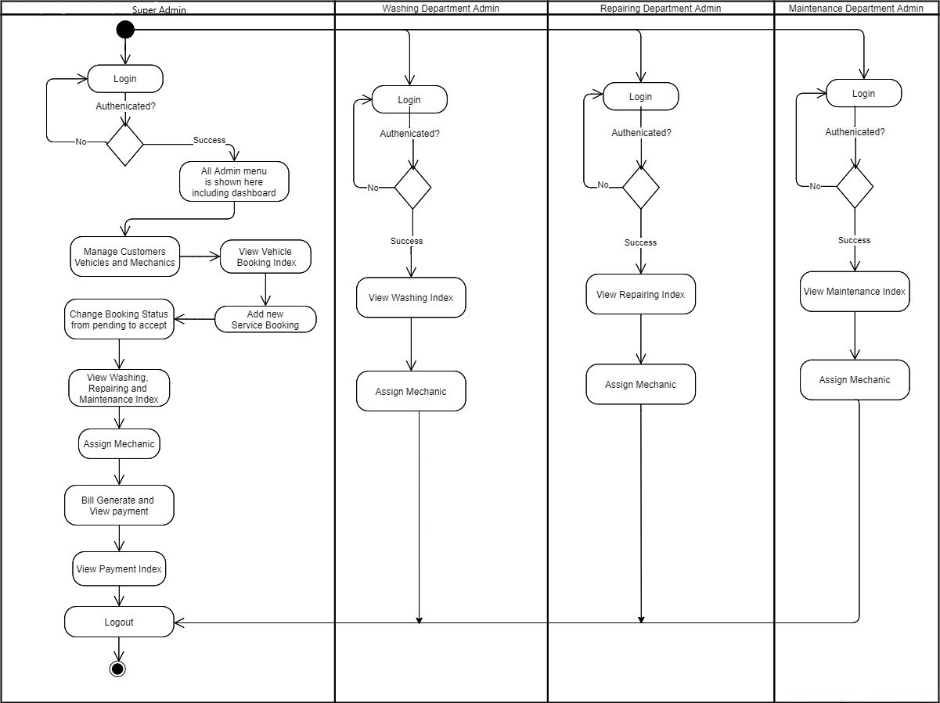

* 1. **Class Diagram**
* The purpose of class diagram is to show the static structure of the system being model.
* It represent the classes & relationship in the system.
* The class diagram have mainly 2 purpose.
* Understanding the requirements
* Describing the detail design

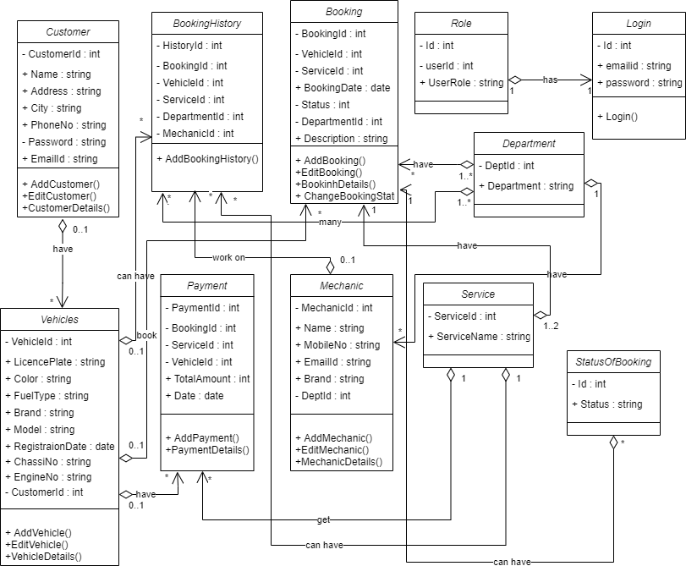

**Chapter 6: UI Screenshots:**

1. **Login**

Admins need to login first to access the system

Here, super admin is being logged in.

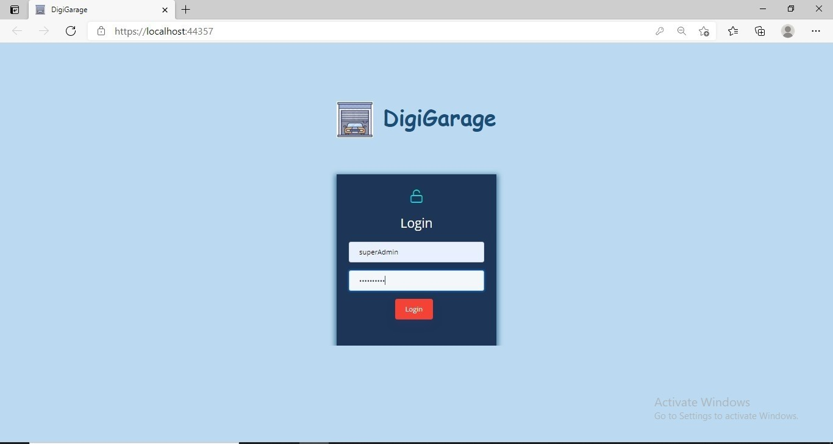

### Dashboard

After successful login, dashboard will be appeared to super admin.

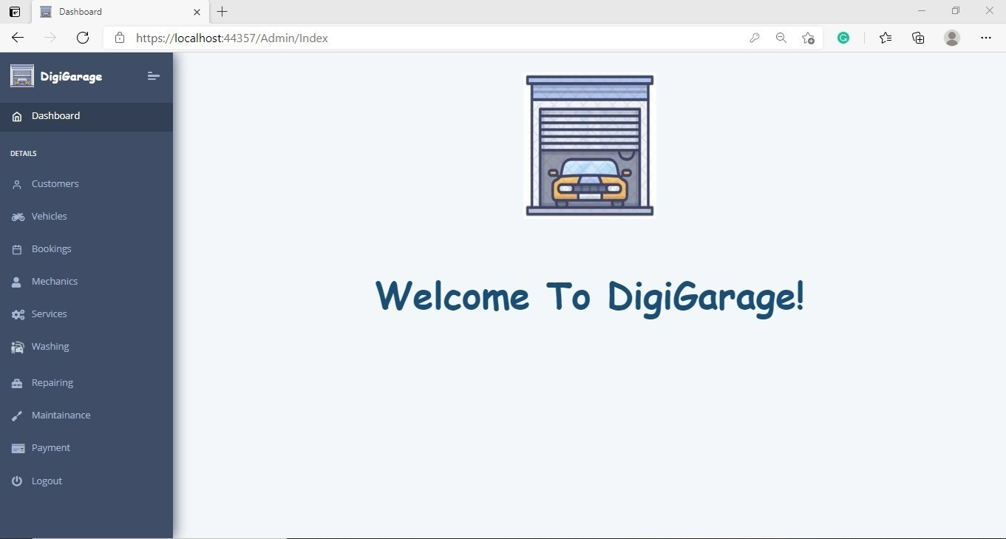

### Customers List

From Dashboard, super admin can access Customers section

On clicking on Customers from menu, the following screen will appear.

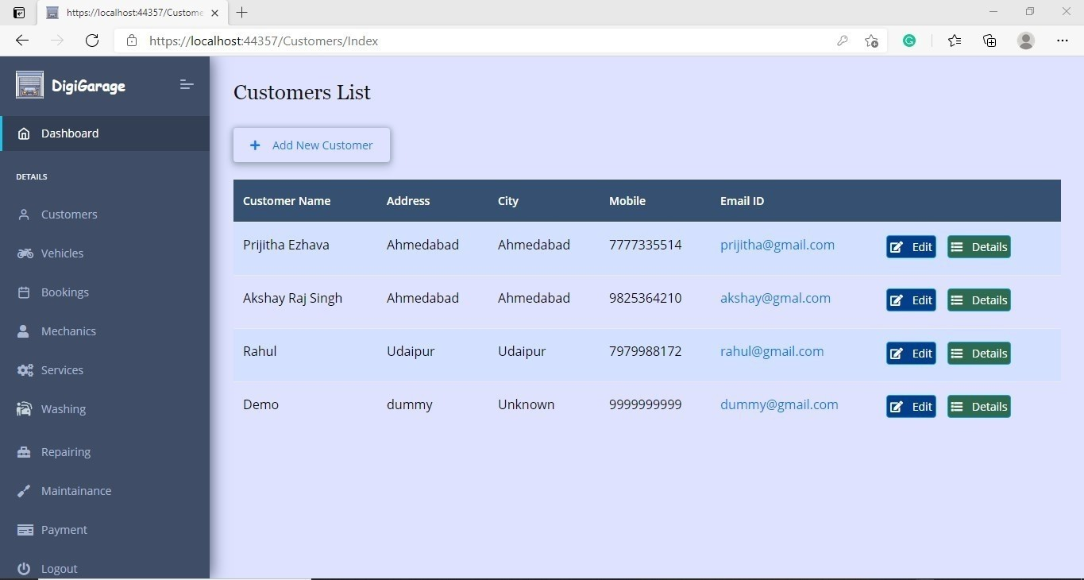

**Edit Customer**

**View Customer**

**details**

### Add Customer

From here super admin can add customer details into the system. On clicking on “Submit” button the data will be saved into the database.

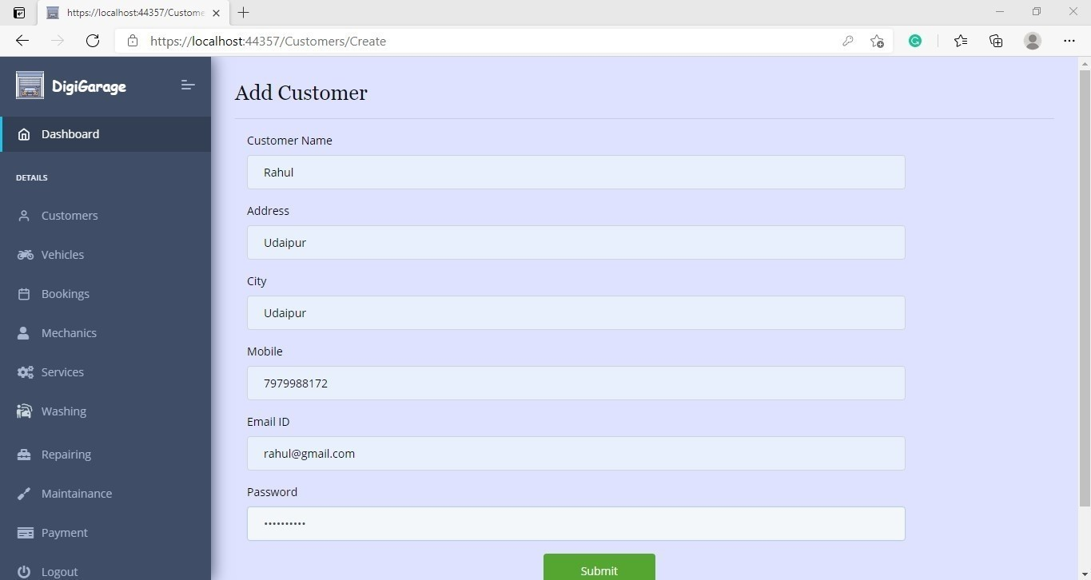

### Edit Customer

Super Admin can edit customer data here.

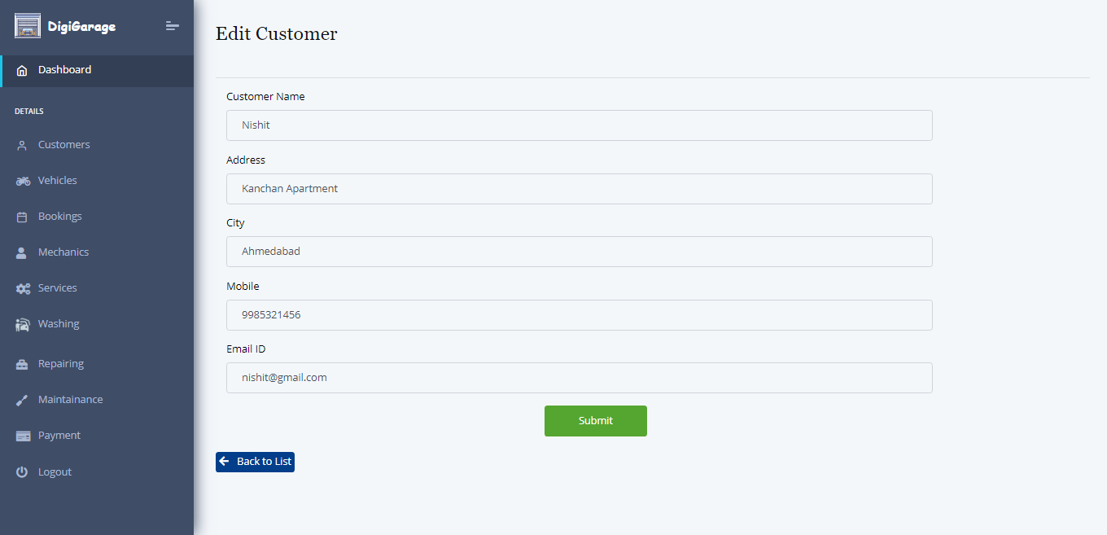

Save edited data

### Customer Details

**Customer Details**

Details of one particular customer can be viewed here.

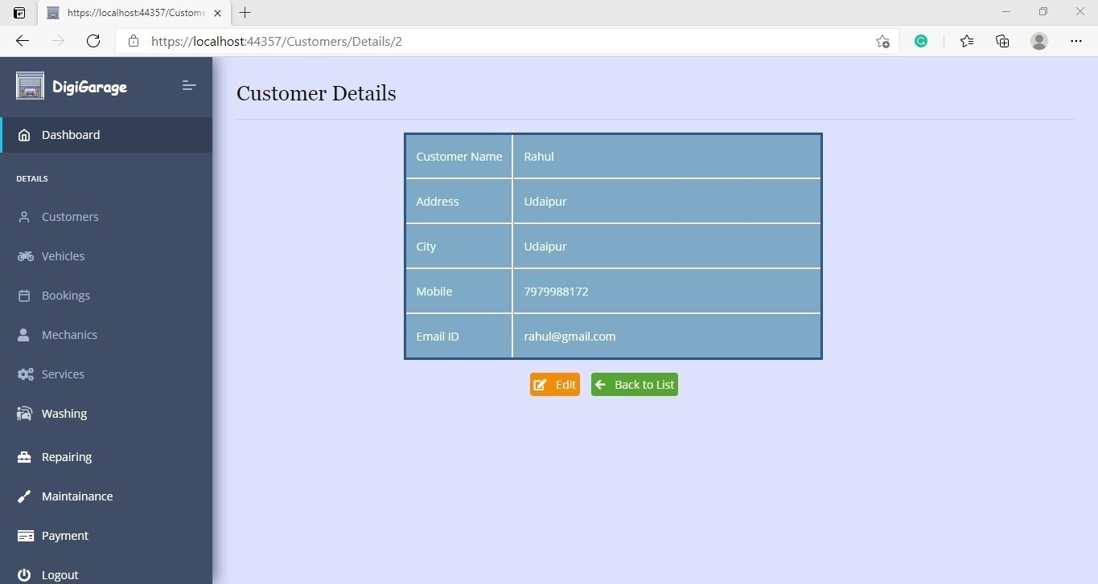

### Vehicle List

On clicking on Vehicles from menu, the following screen will appear.

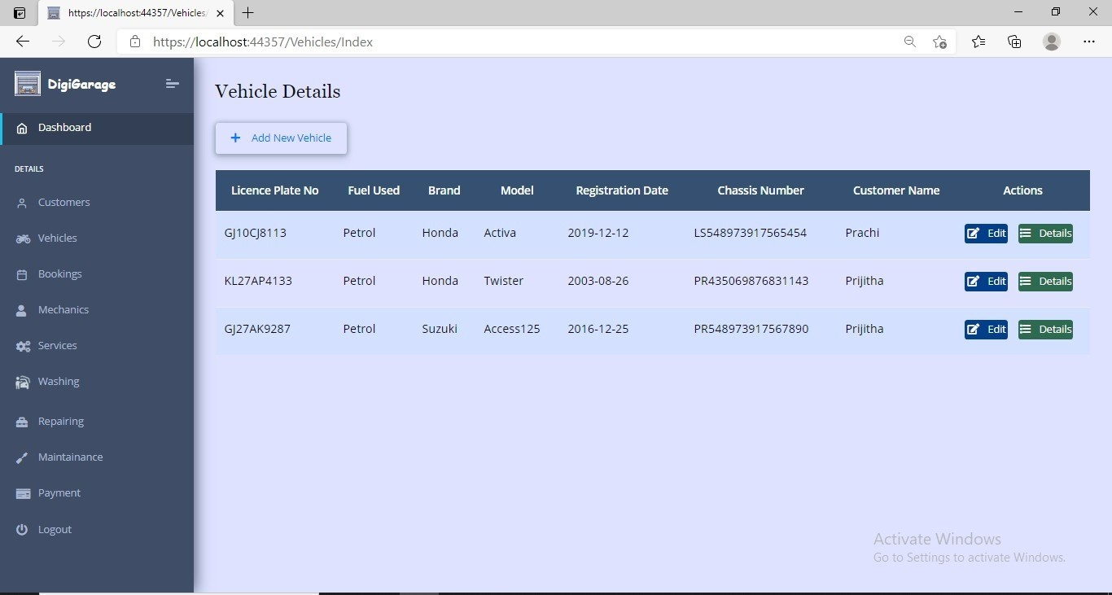

Add new Vehicle

Edit Vehicle View

Vehicle Details

### Add Vehicles

From here super admin can add vehicle details into the system.

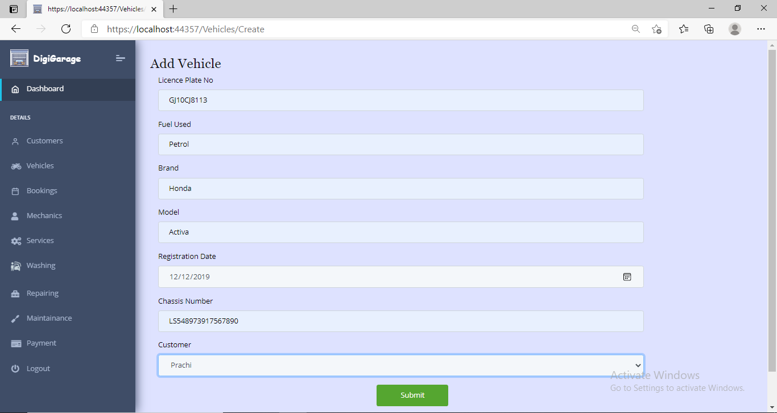

**Save Vehicle data**

### Edit Vehicles

Super Admin can edit vehicle data here.

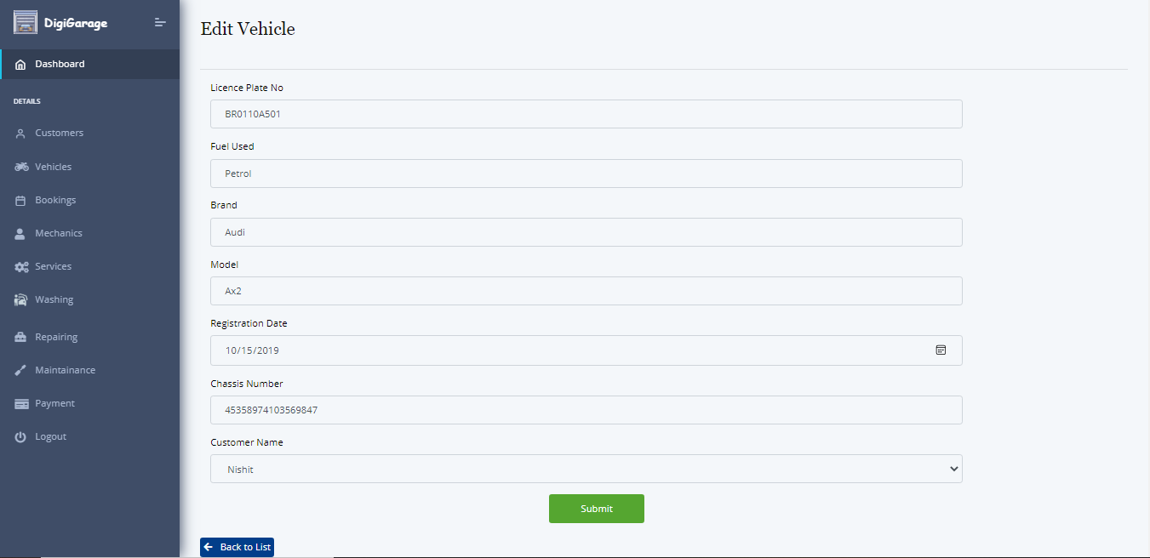

Save edited data

### Vehicle Details

Details of a particular vehicle is being displayed here

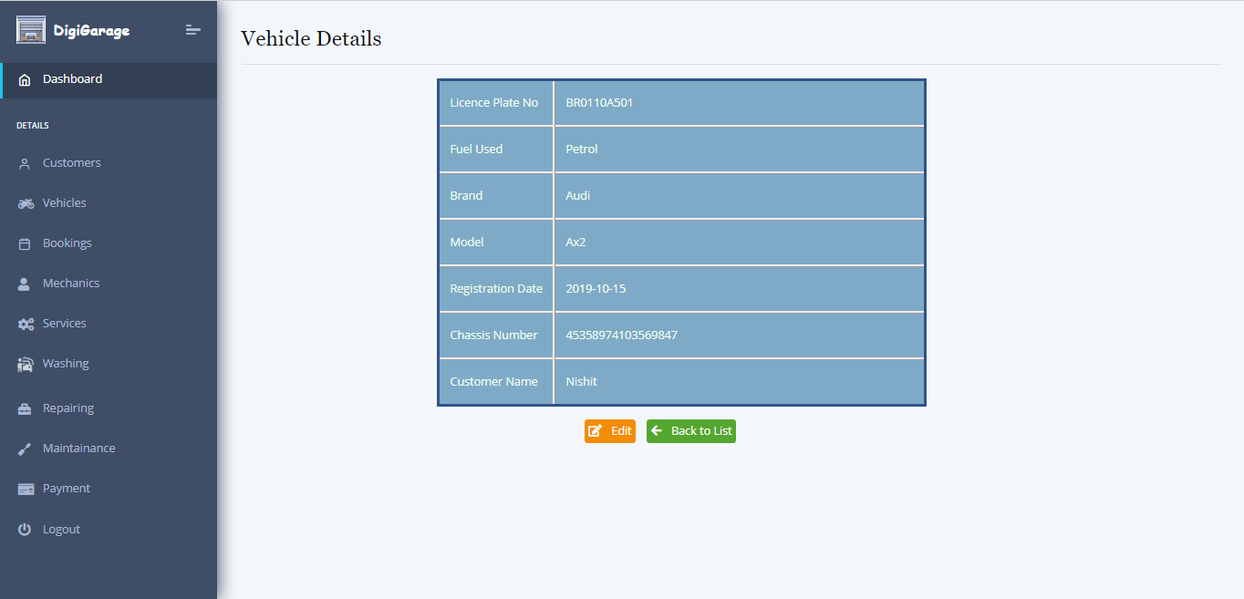

### Mechanics List

On clicking on Mechanics from menu, the following screen will appear.

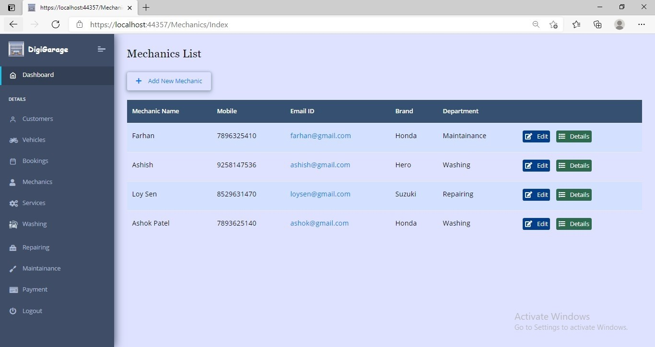

Add new Mechanic

Edit Mechanic data

View Mechanic details

### Add Mechanic

From here super admin can add mechanic details into the system.

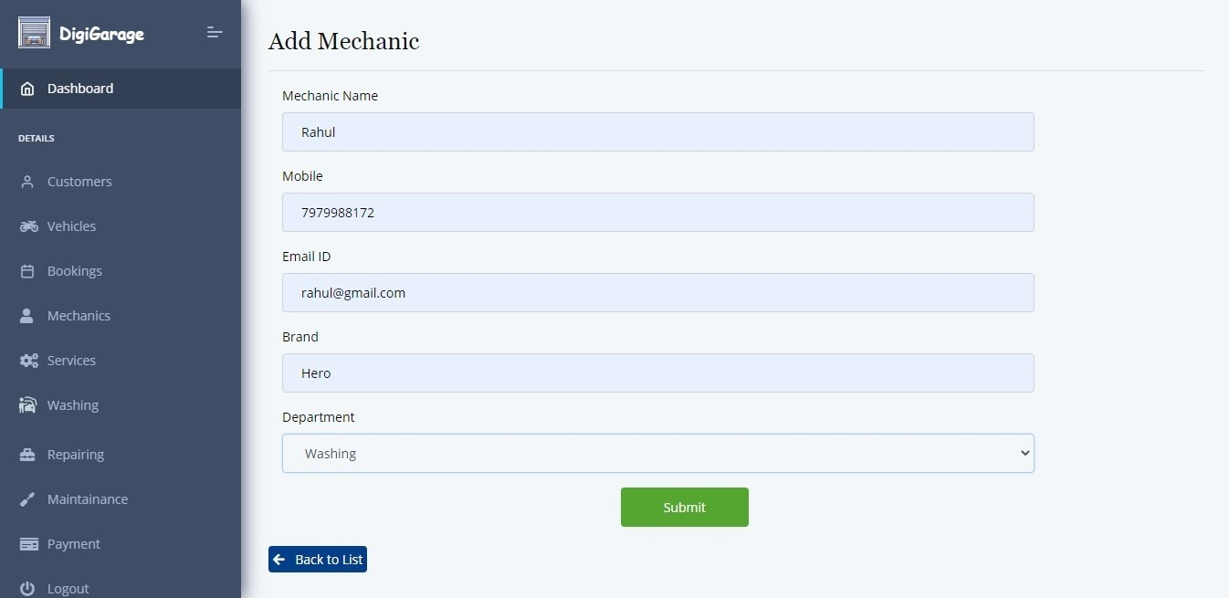

Save

New Mechanic data

### Edit Mechanic

Super Admin can edit mechanic data here.

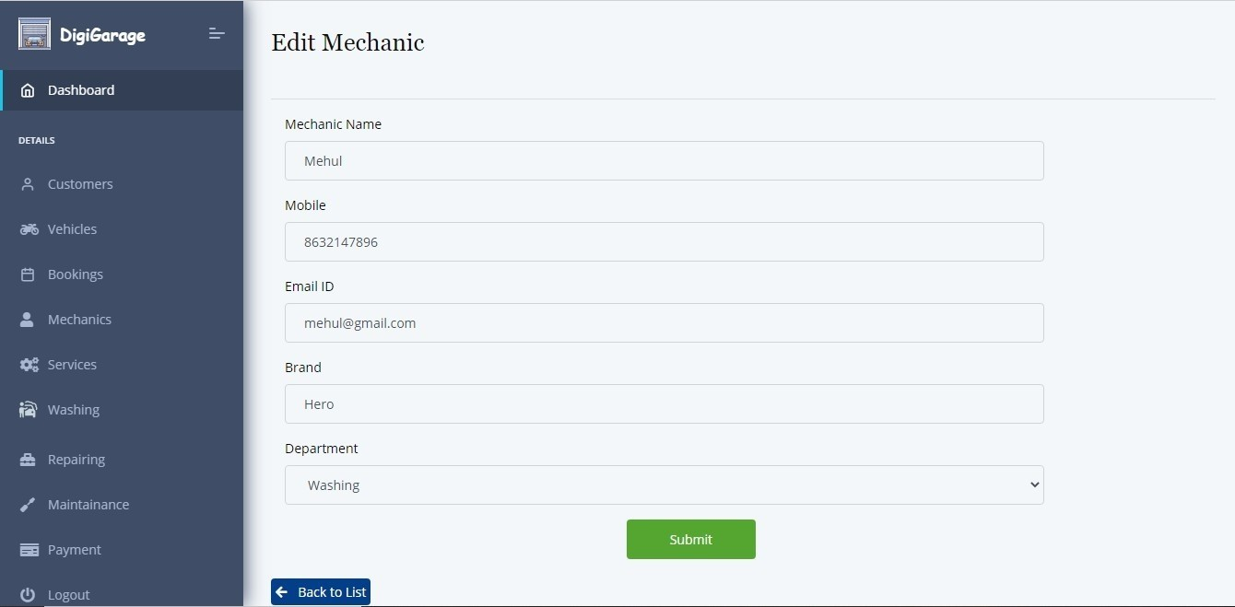

Save

updated Mechanic data

### Mechanic Details

Details of a particular mechanic is being displayed here

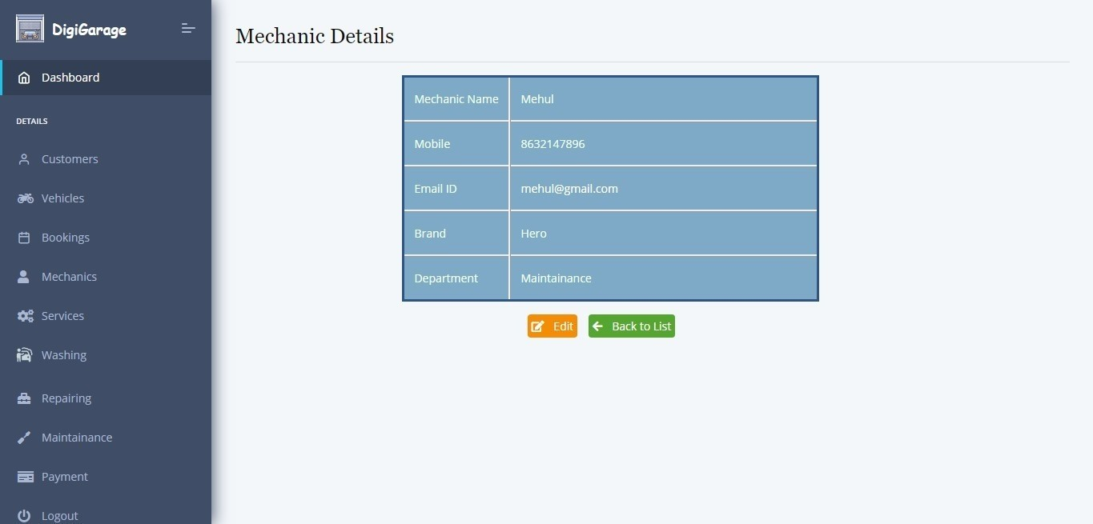

### Booking List

On clicking on Booking from menu, the following screen will appear.

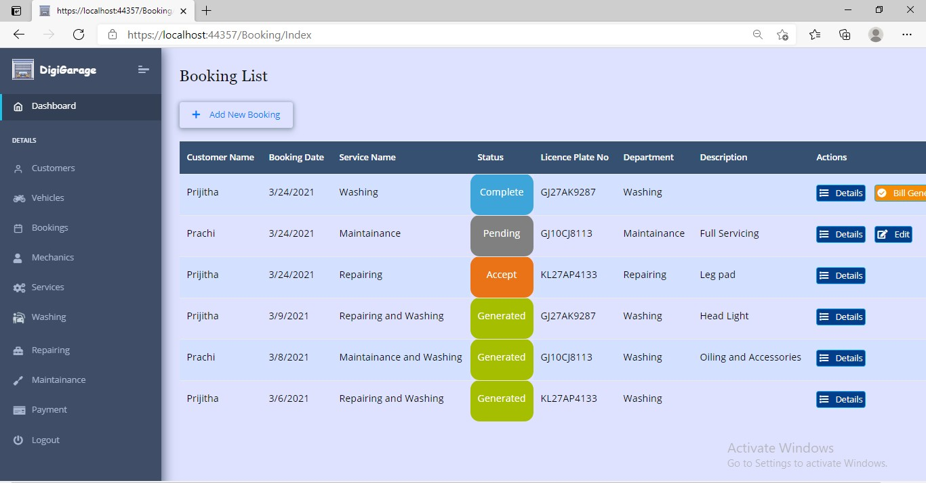

Different Status of Booking

### Add Booking

From here super admin can add booking details into the system.

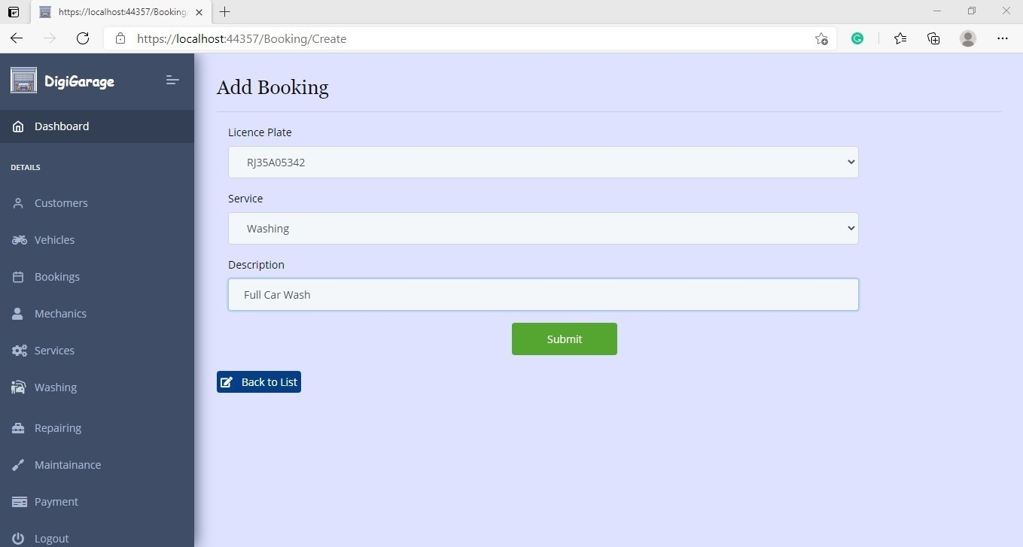

**Save**

**New Booking data**

### Pending Status of Booking

When a new service booking will be added by the super admin it will be in “pending” state initially.

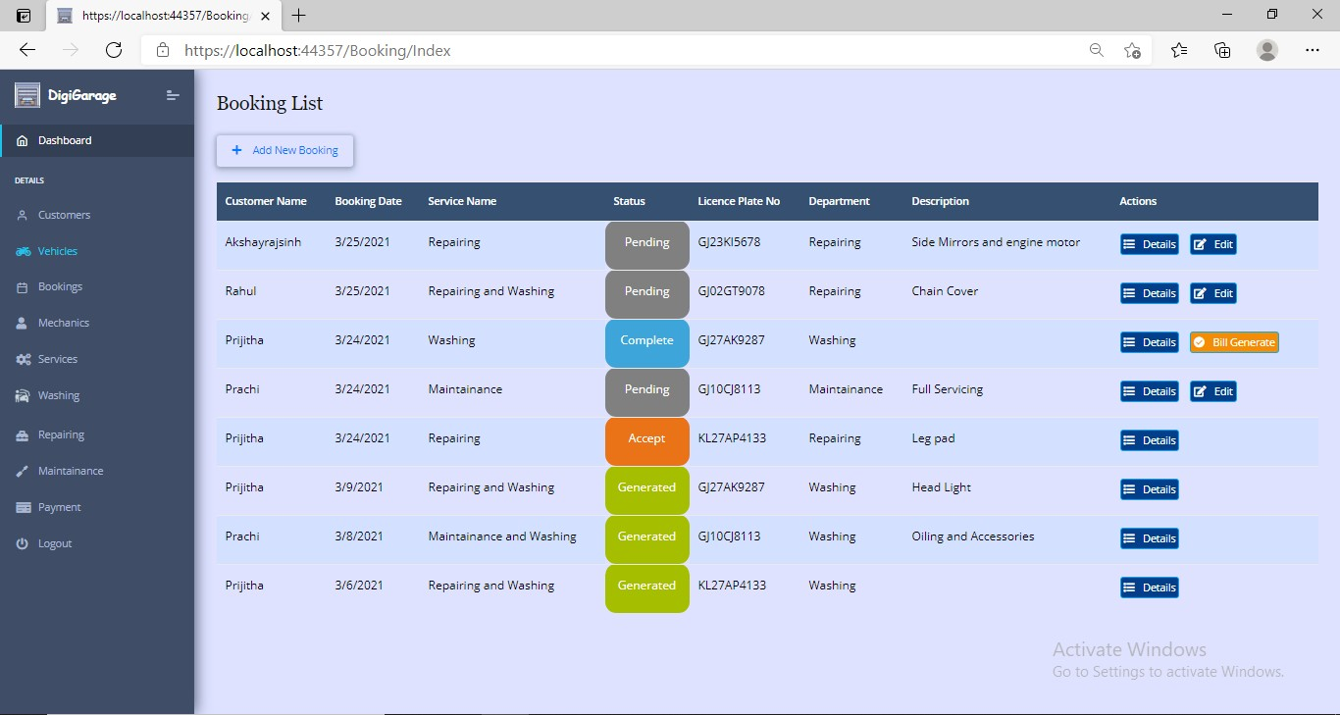

new booking of requests in pending state

Can edit or view the details of booking

### Accept Booking

### Request

Super Admin can now approve the booking request by changing status to “Accept”.

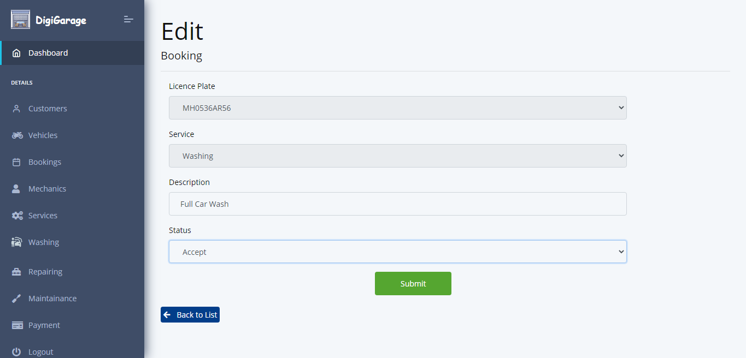

**Accept Booking Request**

### Vehicle Maintenance List

On clicking on Booking from menu, the following screen will appear.

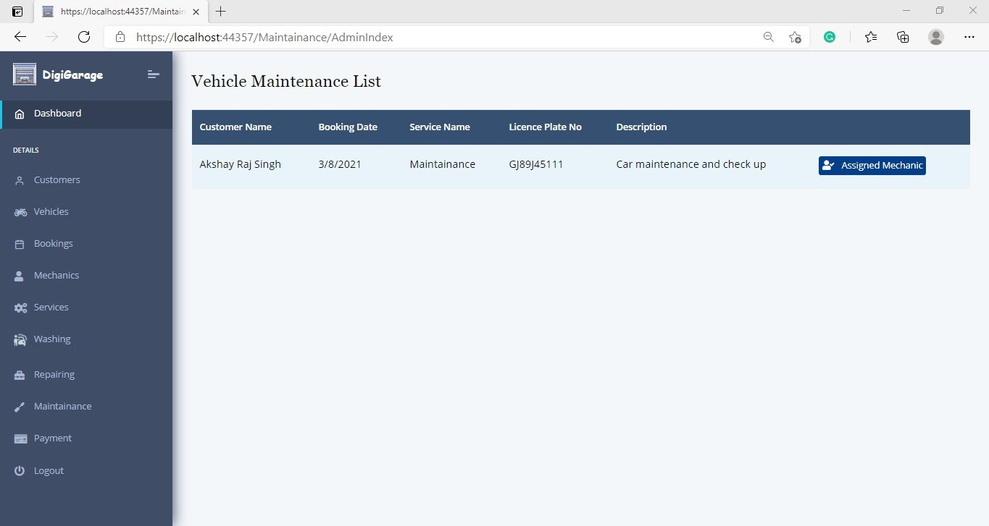

Assign Mechanic from here

### Assign Mechanic

Super Admin can now assign mechanic belonging to the same service department.

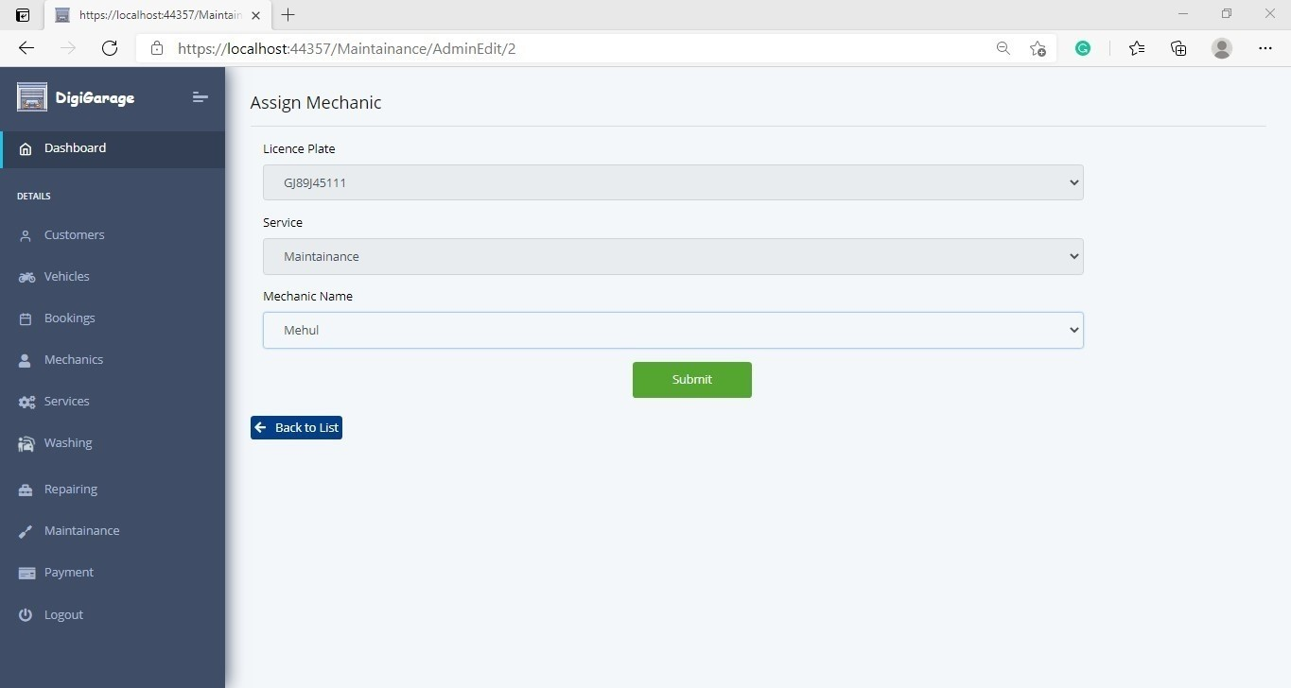

Select Mechanic from drop down.

### Service Completed

After service has been done its status will change to “Complete” and then bill generation button will get appeared.



### Billing Section

Here the super admin will be able to add the billing amount and on clicking on “Save” button the invoice will be mailed to that customer.

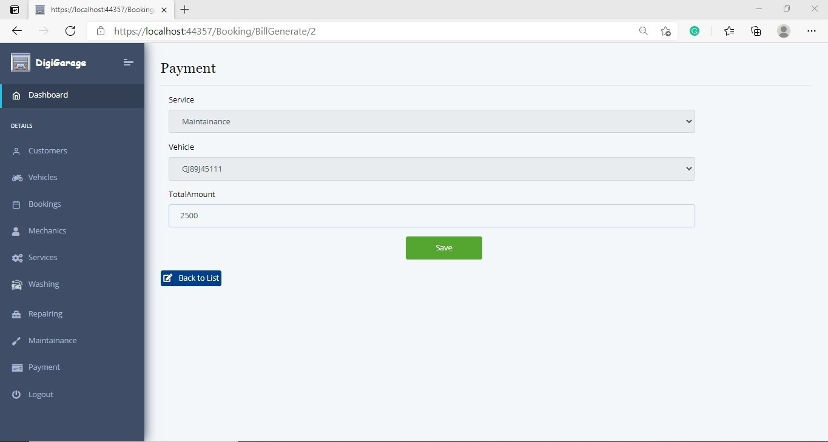

### Invoice sent through mail.

1. **Payment List**

All the payment received till date will be visible to super admin as listed here

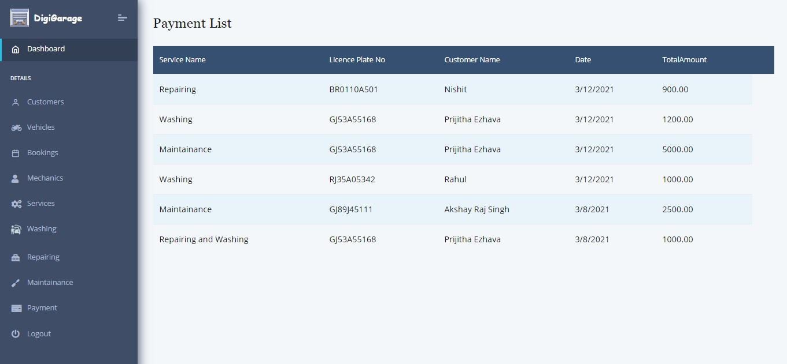

### Logout

On clicking on logout, super admin will be able to log out of the system.

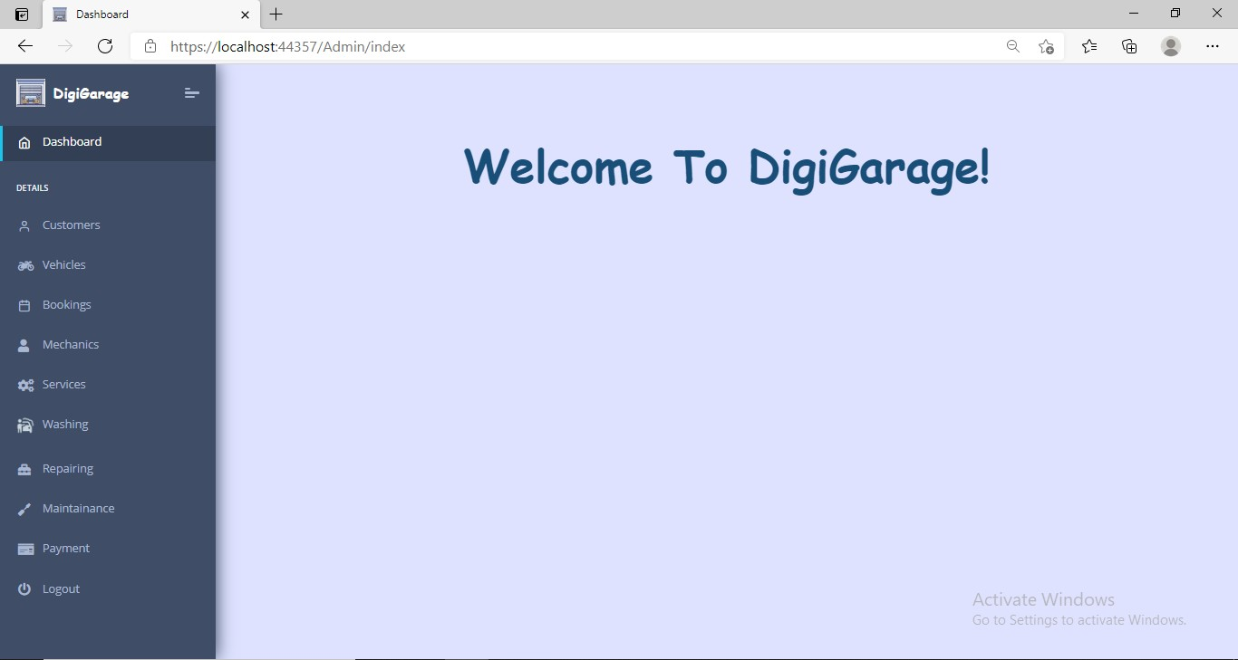

**Chapter 7 Future Enhancement**

1. Customers will also be one of the users of our website.

Their Roles would be:-

* + Able to access their past vehicle service reports.
  + Can track status of their vehicle services.
  + They will be getting gentle reminder for upcoming vehicle services.
  + Will also be able to contact our mechanics in case of emergency.

1. Payment Gateway will be added at customer side.
2. Particular credentials of each mechanic will be provided to retrieve the information about their work and their details about their given services only.

**REFERENCES**

1. <https://docs.microsoft.com/>
2. <https://www.c-sharpcorner.com/>
3. <https://www.tutorialsteacher.com/mvc/asp.net-mvc-tutorials>
4. <https://github.com/>
5. <https://medium.com/>
6. <https://getbootstrap.com/>
7. <https://fontawesome.com/>
8. <https://www.w3schools.com/>