1) Domain: Gateway Digital
2) The Board Scope: Digitalization of the physical/paper process of the industry or the process of work.
3) Target Audience: B2B Users

1. Understanding the Project Definition:-
- This project is basically refers to the load of physical/paper work of industry.
- We are going to design a platform which will help most of the businesses (mainly Garage industry) to shift their work from physical/paper work to digital.
- It will provide speed to every type of business sector and other sector as well.

2. Benefits:-
- Database Management
- Security
- Speed
- Less human interaction and less effort.
- Social Distancing and less hand interaction which is most important in this COVID-19 pandemic.
- We can sort out any data from millions of data in very less time.
- We can keep and extract data in various categories as well for much ease.
- No more need to build separate record rooms and to hire extra staffs to maintain files.
- Separate logins for:-
      - Admin
      - Customers
      - Staffs

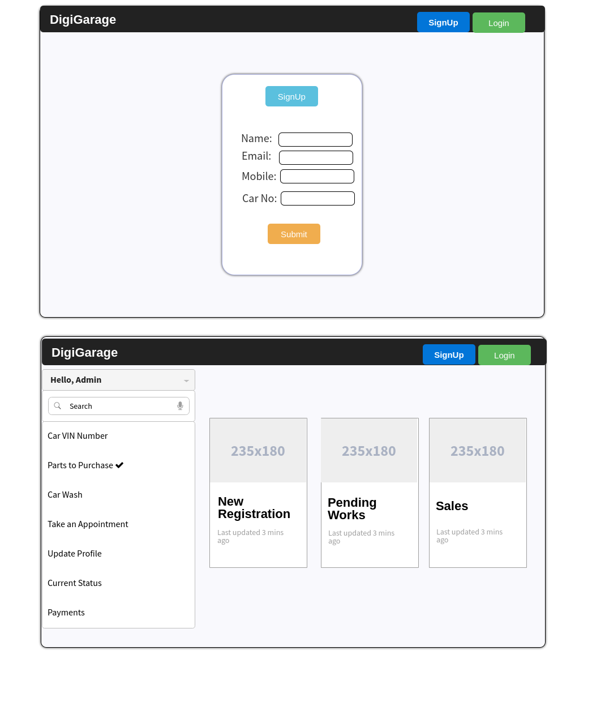
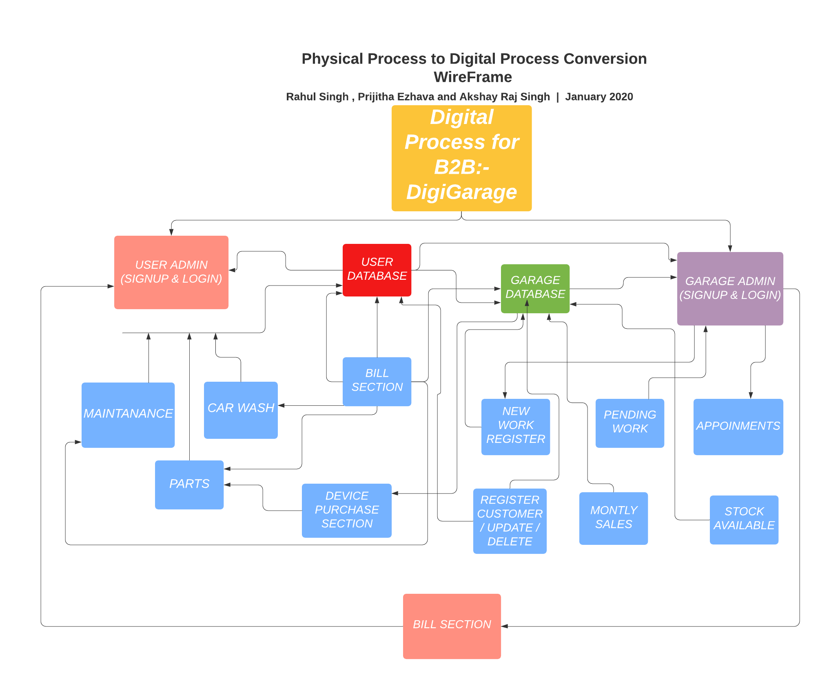

Modules of DigiGarage:-
1. Customer
2. Vehicle
3. Services
4. Delivery
5. Booking
6. Mechanic
7. Payment

Feature List:-
 1.Book online car service

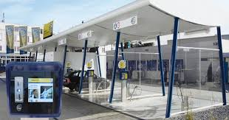 2. Digital process of Car Wash, No need to stay hours in queue.
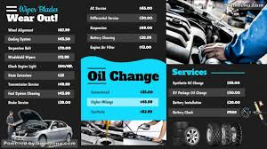 3. Check from home whether any service or parts available in nearby garage.

 4. Track records of your all old services, appointments, next service dates, pending services, etc.

