Acknowledgement

I have taken efforts in this Seminar Report. However, it would not have been possible without the kind support and help of many individuals. I would like to extend my sincere thanks to all of them.
I am highly indebted to Mr. Manesh Patel for her guidance and supervision as well as for providing necessary information regarding the Seminar.
I would like to thank Mr. Akshay Chaudasma also for his precious suggestions for the Seminar report.
I would like to express my gratitude towards my lovely Parents for their kind co-operation and encouragement which help me in completion of this Seminar Report.
My thanks and appreciations also go to my friends who helped me out with their abilities.

Raghvendra Singh (1129)

Abstract

The word “Project” it self has a lot deep and realistic sense in its own right. Truely speaking for a fresher project work is the first milestone not for achievement but for sustaining it’s realism for all his/her future endeavor.
My project introduces railway reservation system with an objective to make the reservation system more efficient, easier and fast. This project explores how computer technology can be used to book the ticket of user. The main objectives provided by this website are as follows:
You Can Register/Login.
You can enquire about availability of trains
You can reserve and cancel your seats.

Index:
CHAPTER | PARTICULAR | PAGE NO
1 | Introduction | 1
1.2 | Company Profile | 5
1.3 | Project Profile | 6
2 | About Technology | 7
2.1 | Overview of XAMPP | 7
2.2 | Overview of HTML | 8
2.3 | Overview of PHP | 8
2.4 | Overview of Bootstrap
3 | System Requirement Specification | 9
3.1 | Existing System | 9
3.2 | Proposed System | 9
3.3 | Development Tools and Technology | 10
4 | Modules | 11
4.1 | Users | 11
4.2 | Sub Modules | 13
5 | Analysis | 14
5.1 | System Flow Diagram | 15
5.2 | UML Diagrams | 16
5.2.1 | Use Case Diagram | 16
5.2.2 | State Chart Diagram | 19
5.2.3 | Activity Diagram | 21
5.2.4 | Sequence Diagram | 24
5.2.5 | Class Diagram | 26
5.3 | Data Flow Diagram | 28
5.4 | Entity Relationship Model | 30
6 | Design | 32
6.1 | Data Dictionary | 32
6.2 | Screens | 35
7 | Future Enhancements | 43
8 | Conclusion | 43
9 | Bibliography | 43
Chapter: 1 Introduction
  - Company’s Profile:

Company Name : Silverwing Technologies Pvt. Ltd

Address : 1st Floor, Parshwa Tower, Above Kotak
Mahindra Bank, S.G Highway,
Bodakdev, Ahmedabad, Gujarat -380054

Working Technology : Java, PHP, .Net, IOS, Android, Python

Company Contact Person : Mr. Dhaval Hadvani.

Email : contact@silverwingtechnologies.com

Website : www.silverwingtechnologies.com

Contact : +91-8401888243

Technology : PHP

Provided Project : Railway Reservation System

Project Guide : Mr. Akshay Chaudasma

Project Duration : 1 year

  - Project’s Profile:

Company Name | : | Silverwing Technologies Pvt. Ltd.
Website | : | www.silverwingtechnologies.com
Project Title | : | BookMyJourney – Railway Reservation System.
Objective Of System | : | Railway Reservation System will allow a new user to register and after successfully registration user can use this Website. After completing registration users can search trains between Stations and book his/her seats.
Operating Systems | : | Microsoft Windows 10
Hardware Requirement | : | CORE 2 DEO PROCESSOR WITH 2.4 GHZ  4 GB RAM
Software Requirement | : | XAMPP and SubLime.
Front End | : | HTML,CSS and BootStrap.
Back End | : | PHP, MySQL and AJAX.
Others | : | - Microsoft Visio  - Clickcharts  - RF Flow
Guided By | : | Mr. Akshay Chaudasma

Chapter: 2 About Technology:
Here we give a brief about the technologies being used in the current project.
2.1 Overview of XAMPP
XAMPP is a free and open-source cross-platform web server solution stack package developed by Apache Friends, consisting mainly of the Apache HTTP Server, MariaDB database, and interpreters for scripts written in the PHP and Perl programming languages. Since most actual web server deployments use the same components as XAMPP, it makes transitioning from a local test server to a live server possible.
2.2 Overview of HTML
HTML stands for Hypertext Markup Language, and it is the most widely used language to write Web Pages.
Hypertext refers to the way in which Web pages (HTML documents) are linked together. Thus, the link available on a webpage is called Hypertext.
As its name suggests, HTML is a Markup Language which means you use HTML to simply "mark-up" a text document with tags that tell a Web browser how to structure it to display.
Originally, HTML was developed with the intent of defining the structure of documents like headings, paragraphs, lists, and so forth to facilitate the sharing of scientific information between researchers.

2.3 Overview of PHP
PHP is a server-side scripting language that enables you to build dynamic web pages. PHP pages may contain text, HTML, and script blocks. When a browser requests a PHP page, the PHP script is executed on the web server, and the resulting HTML is displayed in the browser.
A PHP page must have a PHP-supported extension. Typically, a PHP file ends with .php, although other PHP extensions such as .php4 and .phtml also exist. However, .php is the most common extension.

2.4 Overview of Bootstrap
Bootstrap was developed by Mark Otto and Jacob Thornton at Twitter. It was released as an open source product in August 2011 on GitHub.
Bootstrap is a sleek, intuitive, and powerful, mobile first front-end framework for faster and easier web development. It uses HTML, CSS and Javascript.
We use Bootstrap for the following reasons:
- Mobile first approach − Bootstrap 3, framework consists of Mobile first styles throughout the entire library instead them of in separate files.
- Browser Support − It is supported by all popular browsers.
- Easy to get started − With just the knowledge of HTML and CSS anyone can get started with Bootstrap. Also the Bootstrap official site has a good documentation.
- Responsive design − Bootstrap's responsive CSS adjusts to Desktops, Tablets and Mobiles. More about the responsive design is in the chapter Bootstrap Responsive Design.

Chapter: 3 System Requirement Specifications:

3.1 Existing system:
- The Existing System in the clients place is totally manual.
- They own the system but they still use Spreadsheet to store the data.
- It is very difficult task to store and manage this kind of data.
- It needs Expert of Spreadsheet to work on this system.
- The user need to go to the physical Railway Stations in order to get their train tickets.
- None of the website allows user to choose the seats of their desires. It just permits the user to set the preference of the seats.
- So, it is time consuming plus costly.

3.2Proposed system:
- The PROPOSED SYSTEM is developed to overcome the drawbacks of the existing system.
- The system is totally based on the Website.
- So it becomes very easy to carry on the procedure of booking of reservation tickets of train in very fast and easy manner.
- Hence, the reports are accurate and generate the reliable information.
- The user can look for schedule of trains without going anywhere , sitting at home using the website.
- The users are permitted to select the seats of their desire in the proposed system.
- No experts are required to use this system, as this system is user friendly.
- This system saves time as well as less expensive.

3.3 Development tools and technologies:

- Software Requirement :

  - Front End:
    - HTML
    - CSS
    - Bootstrap

  - Back End :
    - MySQL
    - PHP ( For Web Services )
    - AJAX
  - Tools:
    - Draw.io
    - MS Word
    - MS PowerPoint
    - Sublime
    - localhost/8080

Chapter 4 Modules:
The modules shows the users and category present in the current project.
4.1 USERS:
- Here in the current PROPOSED SYSTEM , there are 3 types of users who use different functionalities of the system.
  - ADMIN
  - USER
  - VISITOR.
- All the USERS of our system holds their own importance and performs specific functions in the system.

- ADMIN:

- Admin visits website, login into admin panel and can modify stations whenever any station are made.
- Admin add new trains.
- Admin can modify station name, train name train schedule train time etc.
- Admin can modify train fares
- .Admin will manage refund of your cancelled ticket.
- Admin will manage the website, if there any kind of changes required in website.
- Admin will manage user, admin can modify user details and can contact to the user directly.

- USER :

- User logs into the website also he is permitted to search trains and view its schedule without being logged into the system.
- User login into website, can search trains and make enquiry about seat availability.
- User can select train, select class and book ticket, after choosing class and then will be redirected on payment page where he pay total fare.
- User can view his/her profile and can see their previous booked ticket.
- User can select previous booked ticket and cancel it whenever he want.
- User can contact helping team for any type of query like refund of website error.
- User are allowed to logout from website when they are done.

- Visitor:

- Visitor can visit website.
- Visitor can do registration.
- Visitor can search trains between stations.
- Visitor can enquiry about seat availability.
- Visitor can contact our helping team.

- Train Schedule:

- Admin can add data related to the schedule of the trains into the Train Schedule.
- User or the visitor can access Train Schedule to access the train they wanted for by simply searching them by using the ‘Train Name’ or ‘Train Number.
- Admin can perform the delete operations on the Train Schedule.

Chapter 5: Analysis:

The Analysis part consist of the following diagrams:
- System Flow Diagram
- UML Diagrams:
  - Use Case Diagram.
  - State Chart Diagram.
  - Activity Diagram.
  - Sequence Diagram.
  - Class Diagram.
- Class Diagram.
- Data Flow Diagram
- Entity Relationship Diagram.

5.1 SYSTEM FLOW DIAGRAM:

  - It is used to define and analyse the processes.
  - It is used to build a step-by-step of the process for analysis, discussion or communication.
  - It is must for better documentation of a complex program.
  - It is a type of diagram that represents an algorithm workflow or process, showing the steps as boxes of various kind and their order by connecting them with arrows.
  - It represents a flow or set of dynamic relationship in a system.

Symbols of System Flow Diagram


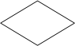
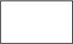
Terminator
Decision
Process
Connector

Fig. 5.1 System Flow Diagram

5.2 UML Diagrams
- Use Case
- Activity Diagram
- Sequence Diagram
- Class Diagram
- State Chart Diagram

5.2.1 USE CASE DIAGRAMS:
- Use case diagram provide a simple and fast means to decide & describe the purpose of a project.
- It is one type of interaction model & it is describe how object interact to produce useful result.
- At high level use case describes how a system interacts with outside actor.
- Each use case represents functionality of a system along with users.
- A system involves a set of use cases and a set of actors.
- Each use case represent functionality of the system & set of use cases represent the complete functionality of system.

Symbols of Use-Case Diagram:


Use-case
Actor
System Boundary
Relationship

Railway Reservation System
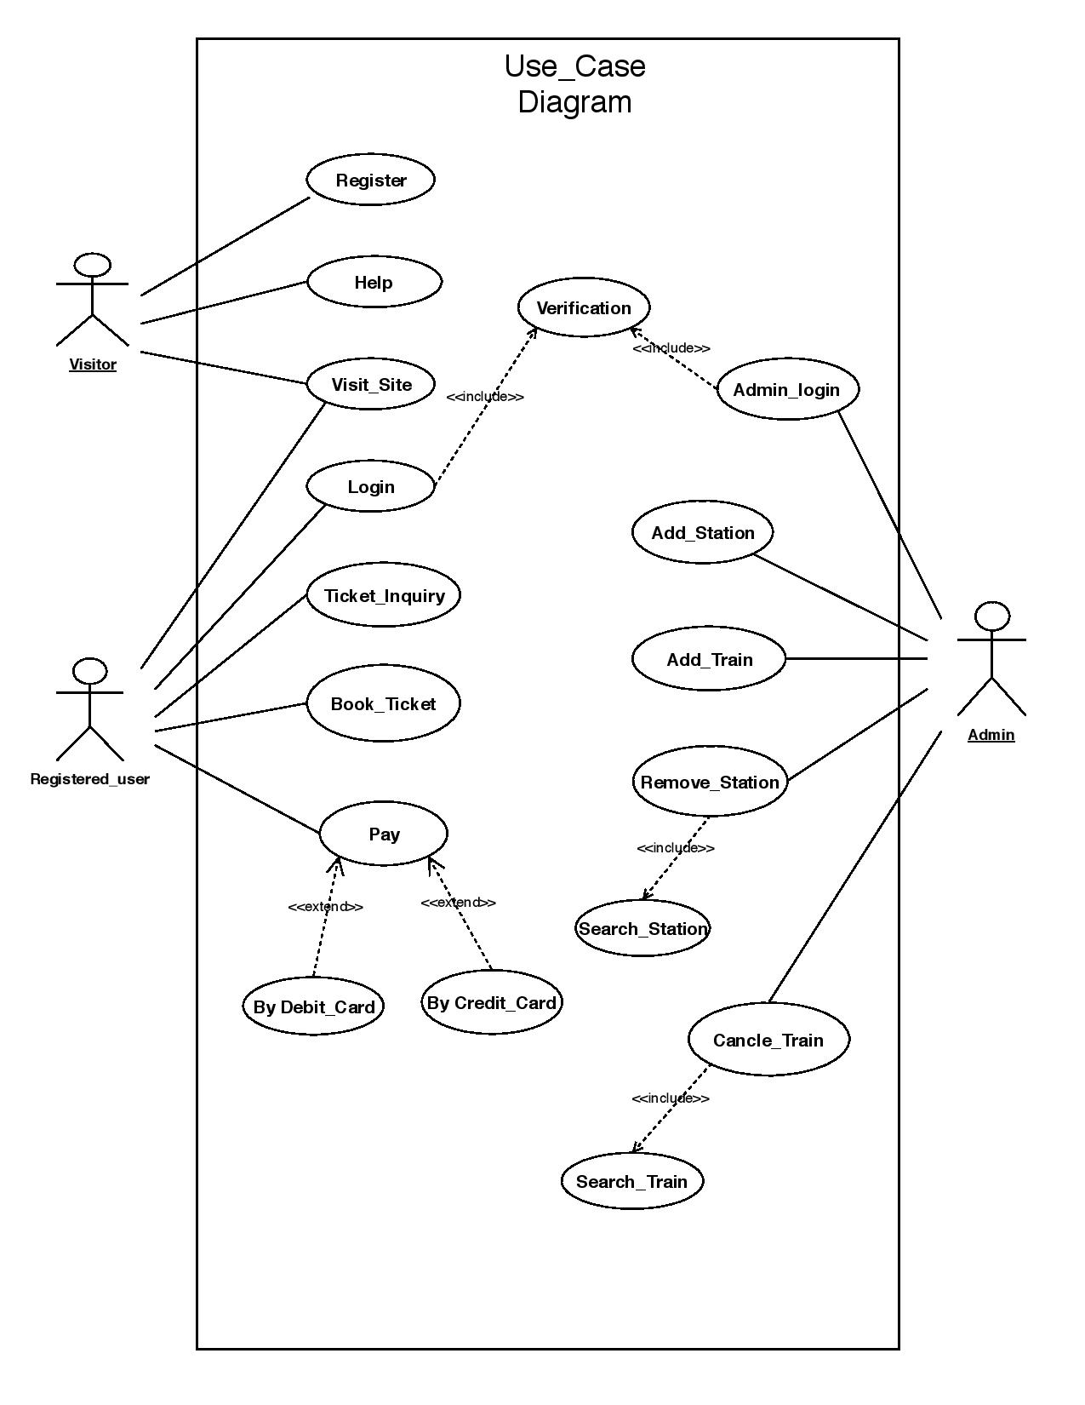
Fig. 5.2.1 Use Case Diagram

5.2.2 State Chart Diagram:

- It describes the states of an object or system as well as the transition between state.
- It also known as state diagram, state machine diagram & state transition diagram.
- A state represents a stage in the behavior pattern of an object and like UML activity diagrams it is possible to have initial states and final states.
- It is drawn to explore the complex behavior of a class, actor, subsystem or component.
- Initial state known as creation state.

Symbols of State-Chart Diagram


Initial state
Final state
State (action)
Transition

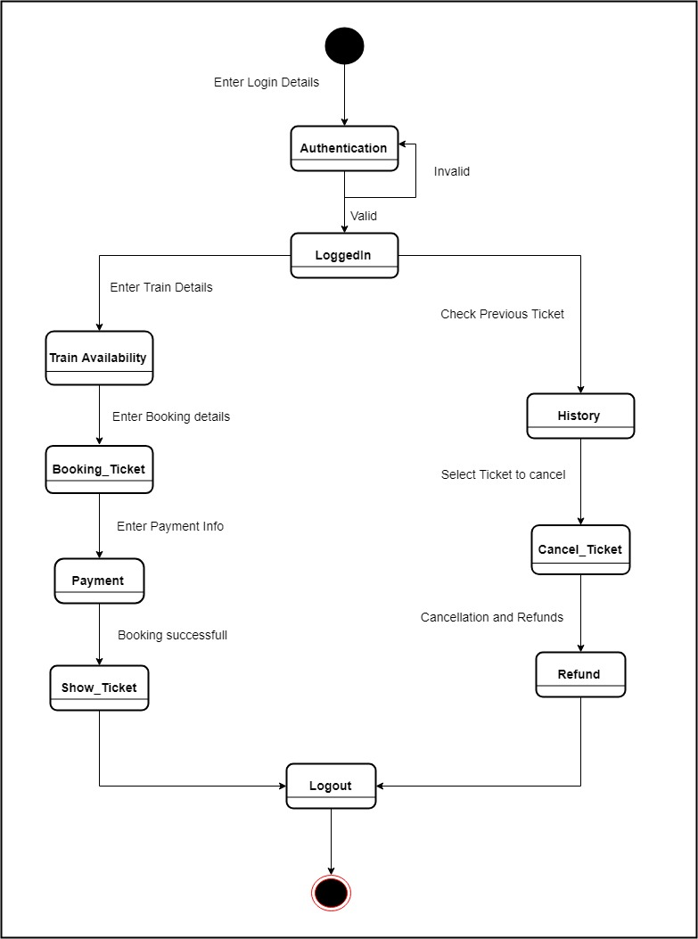
Fig. 5.2.2 State Chart Diagram

5.2.3 Activity Diagram:

- It is the equivalent of flow chart diagram.
- It showing flow of control from activity to activity.
- It is used for modeling the logic captured by a single use case scenario.
- Activity diagram is used for simple & perspective illustration of what happens in a work flow, what activities can be done in parallel & whether there are alternative path through the work flow.
- It shows the work flow from a start point to the finish point detailing the many decision paths that exists in the progression of events contain in the activity.

Symbols of Activity Diagram

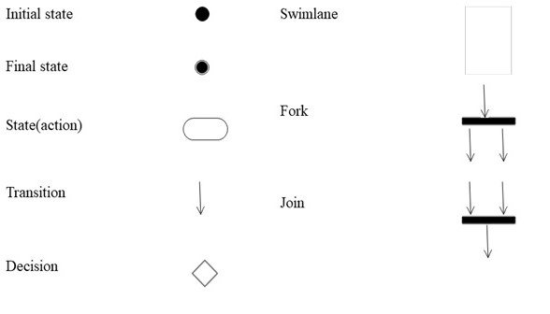

- Activity Diagrams Without Swim lanes:
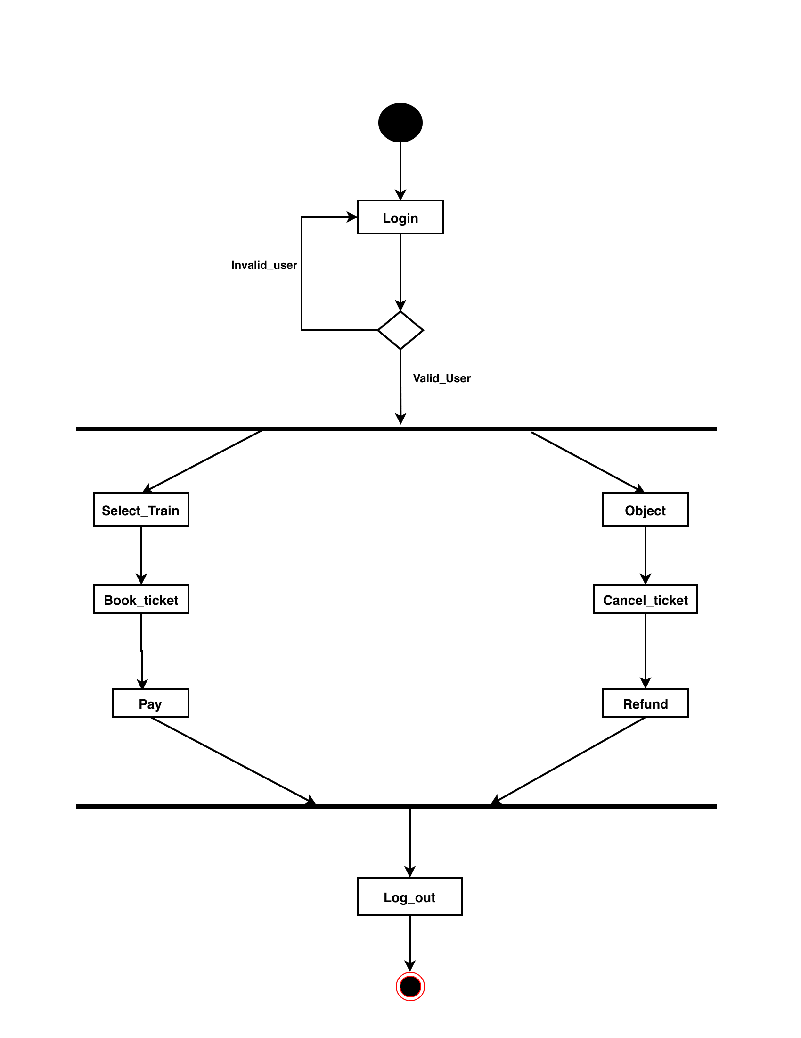

Fig. 5.2.3Activity Diagram

- Activity Diagrams With Swim lanes:

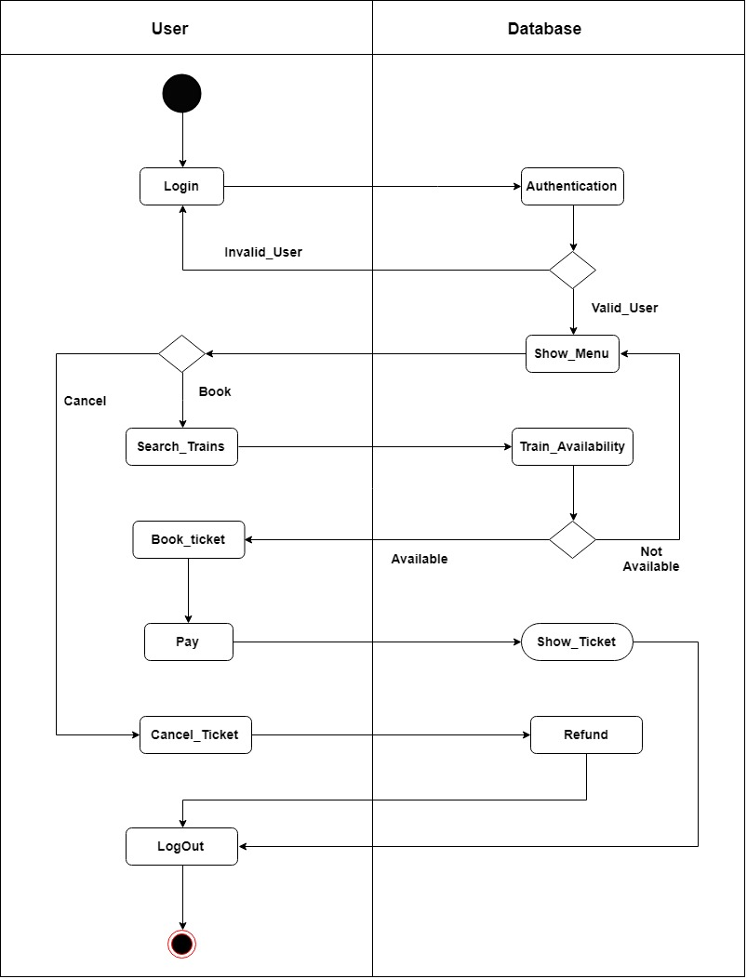
Fig. 5.2.3Activity Diagram

5.2.4 Sequence Diagram:
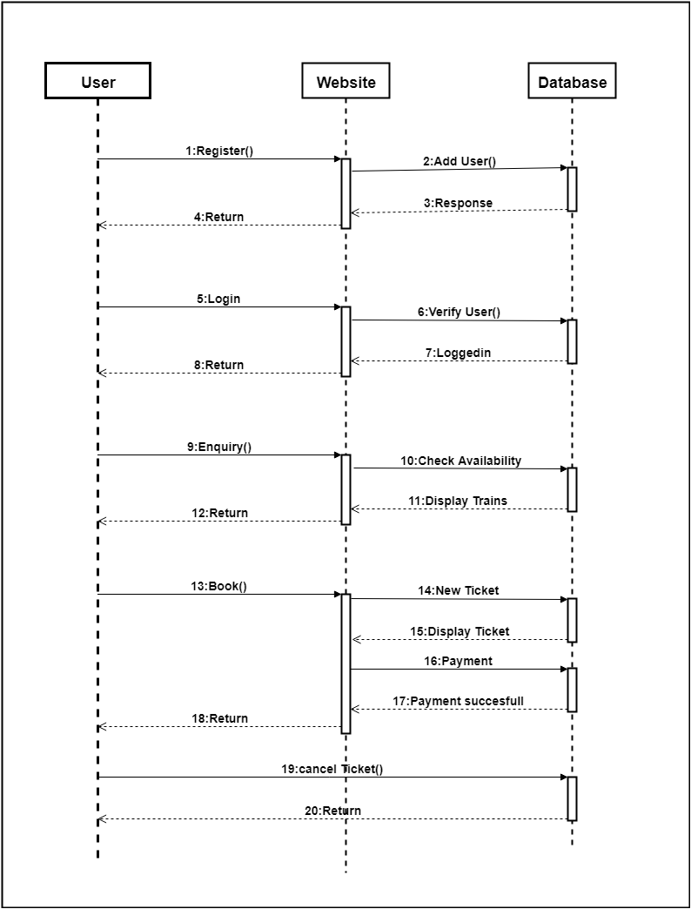

5.2.5 Class Diagram
- The purpose of class diagram is to show the static structure of the system being model.
- It represent the classes & relationship in the system.
- The class diagram have mainly 2 purpose.
  - Understanding the requirements
  - Describing the detail design
- There are two types of class diagram
- Analysis class diagram
- Design class diagram

Symbols of Class Diagram
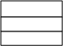
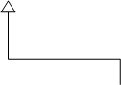
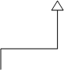
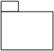
Class
Generalization
Package
Interface

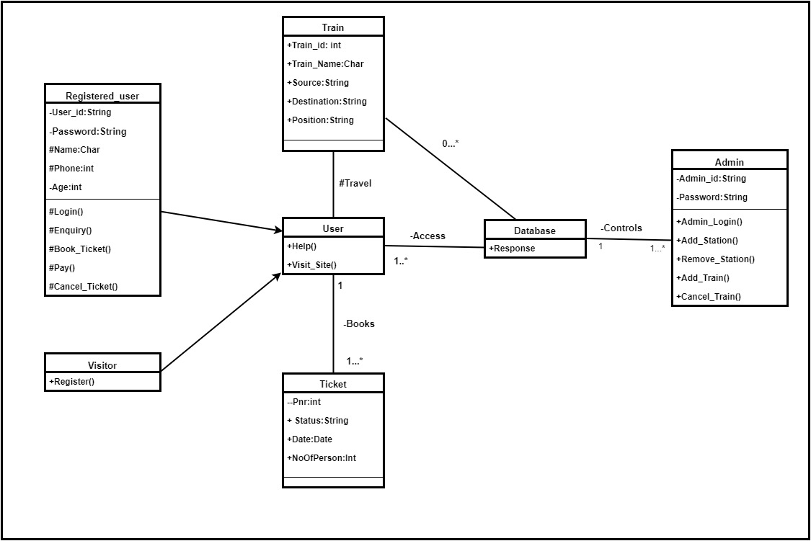

Fig. 5.2.5 Class Diagram

6.1 DATA DICTIONARY:

- Table: Admin
Description: Contains the ____________ details of the admin.
Primary Key: admin_id.

Fields | Datatype | Constraints | Description
admin_id | int(11) | Primary Key
Username | varchar(20) | Unique
Phone | varchar(13) | Unique
Email | varchar(30) | Unique
Password | varchar(30) | Not Null
Register_date | timestamp | Not Null
Update_date | timestamp | Not Null

- Table: User
Description: Contains the details of the User.
Primary Key: user_id.

Fields | Datatype | Constraints | Description
user_id | int(11) | Primary Key
Username | varchar(20) | Unique
Phone | varchar(13) | Unique
Email | varchar(30) | Unique
Password | varchar(30) | Not Null
Register_date | timestamp | Not Null
Register_update | Timestamp | Not Null

- Table: Query
Description: Contains the ___________ details of the Query.
Primary Key: query_id.
Foreign Key: admin_id

Fields | Datatype | Constraints | Description
query_id | int(11) | Primary Key
admin_id | int(11) | Foreign Key
query_title | varchar(50) | Not Null
query | text | Not Null
answer | text | Null Allow
name | varchar(50) | Not Null
email | varchar(50) | Not Null
mobile | varchar(13) | Not Null
Status | varchar(1) | Not Null
created_date | datetime | Not Null
updated_date | datetime | Null Allow

- Table: Query
Description: Contains the ___________ details of the Query.
Primary Key: query_id.
Foreign Key: admin_id
Fields | Datatype | Constraints | Description
role_id | int(11) | Primary Key
admin_id | int(11) | Foreign Key
role_type | varchar(30) | Unique
active_flag | varchar(1) | Not Null
created_date | datetime | Not Null
updated_date | datetime | Null Allow
6.2 Screens:
1) Welcome Page
2) Login Page
3) Sign up
4) Home Page
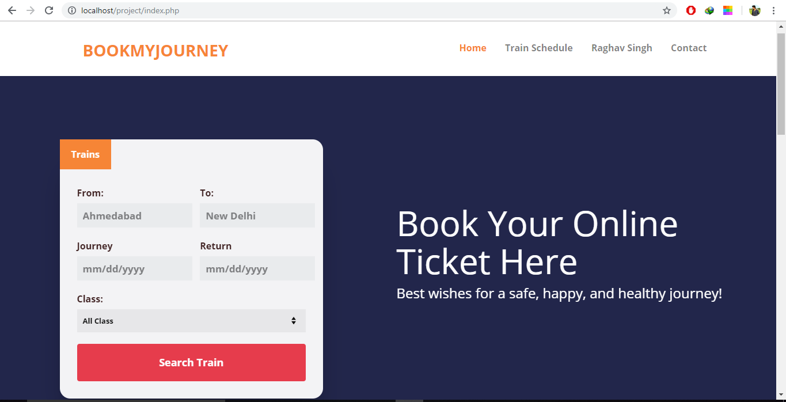
Page Feature:
- This is website’s home page/welcome page.
- Here you can search train between two stations.
- First your choose from station and after it you choose to station after that you click-on search train button.
- All trains between your searched stations will display on next div under search form.

All trains between your searched Stations

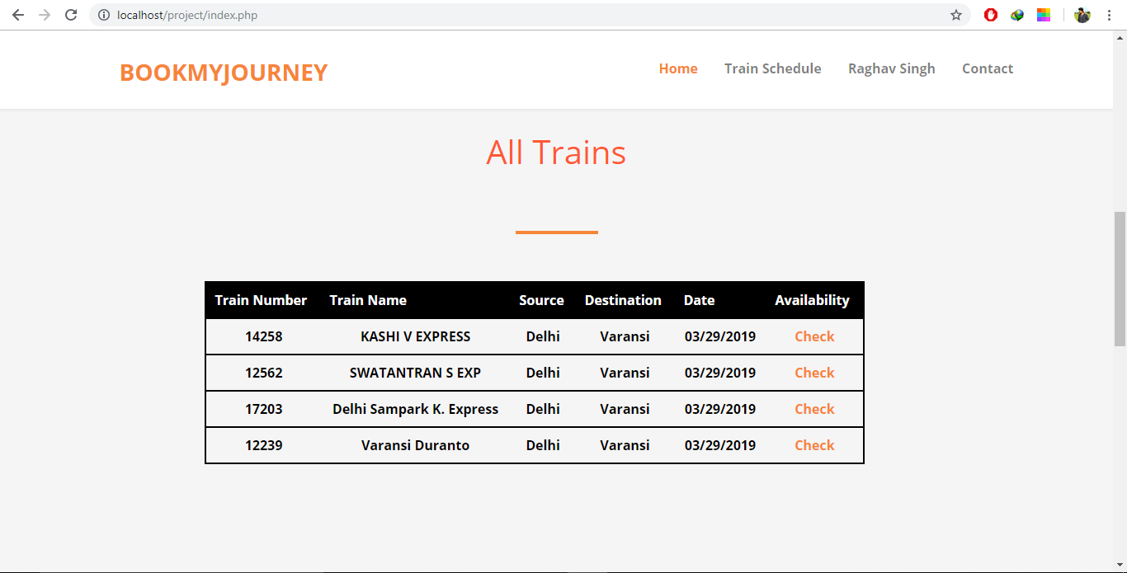

Page Features-
- This page is on index page.
- This page display all trains between your searched station.
- If you want to check seat availability then you have to click on check link.

**Bookform.php**

*Fill Passenger Details*

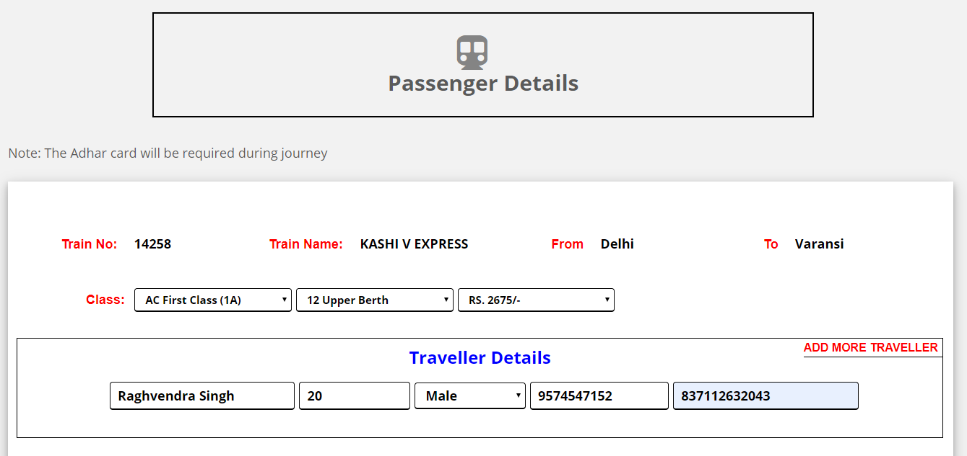

Page Feature-
- After clicking on BOOK button you will be redirected to this page.
- Here you have fill details about the passenger that is going to travel in this train.
- Adhar number is mandatory for passenger.
- After filling the details you click on submit button.
- After clicking submit button you will be redirected to payment page.

**Schedule.Php**

*See the schedule of any train*

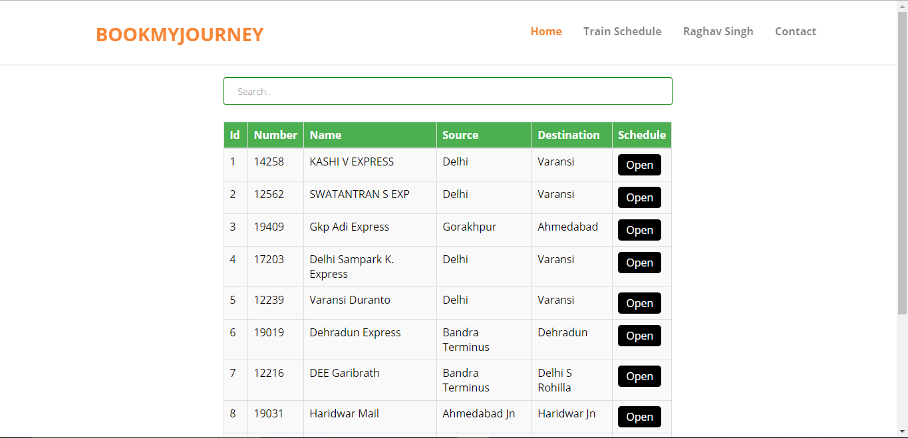

Page Feature-
- This is train schedule page.
- Here you can see any train schedule.
- Just search any train number or name in search box and click on OPEN button to view its schedule.

**LoginSignup.Php**

*Get more things done with Login Platform*

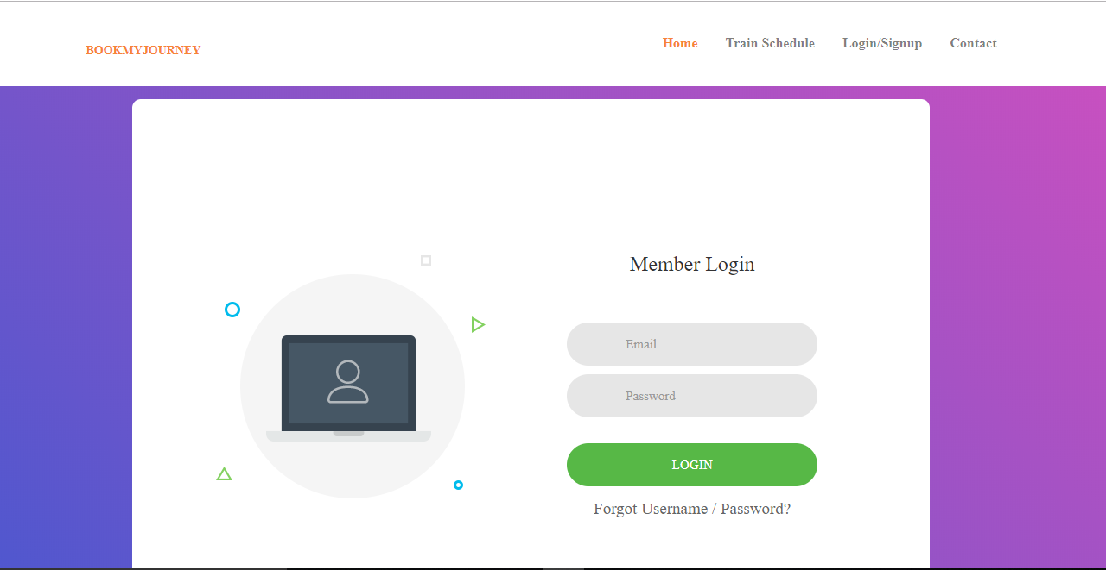

Page Feature-

- If you are registered on this page then you can login successfully.
- If you are not registered you have to register first.
- If you are not logged in the on booking page then if you click on BOOK button ..you will be redirected to login page.
4.After login you can visit your profile page and you can see your about and booked tickets.
**Loginsignup2.Php**

*Get more thigs done with Signup platform*

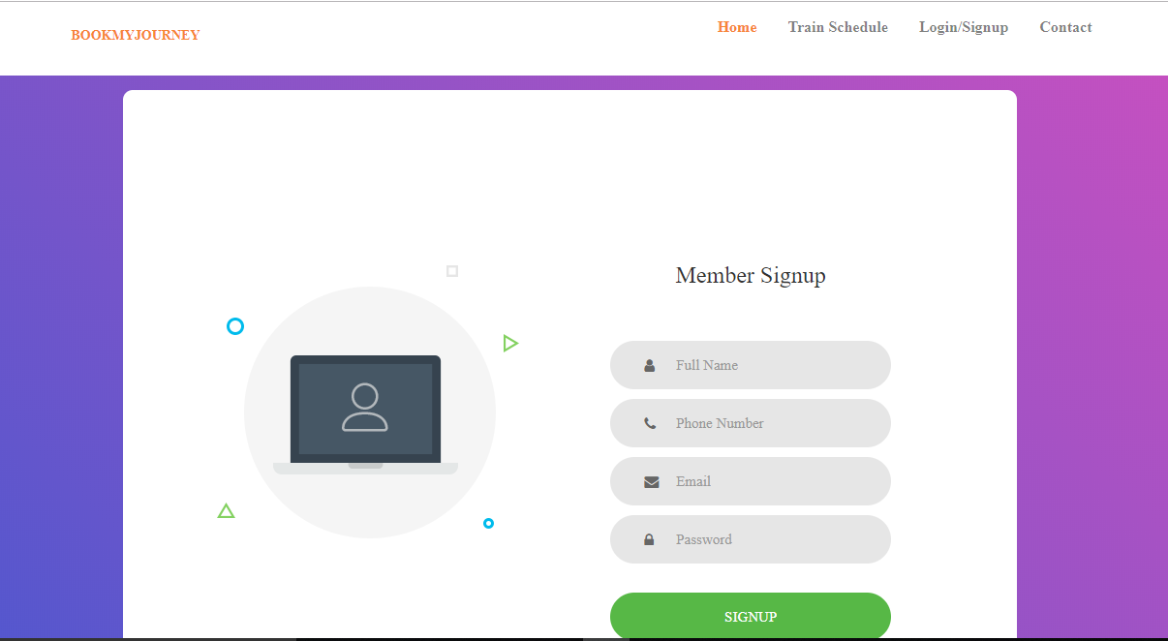

Page feature-
- Register yourself on this page and get more feature.
- You have to fill this registration page.
- After registration you will be redirected to login page.

**Profile.Php**
*Your personal details and Booked tickets*

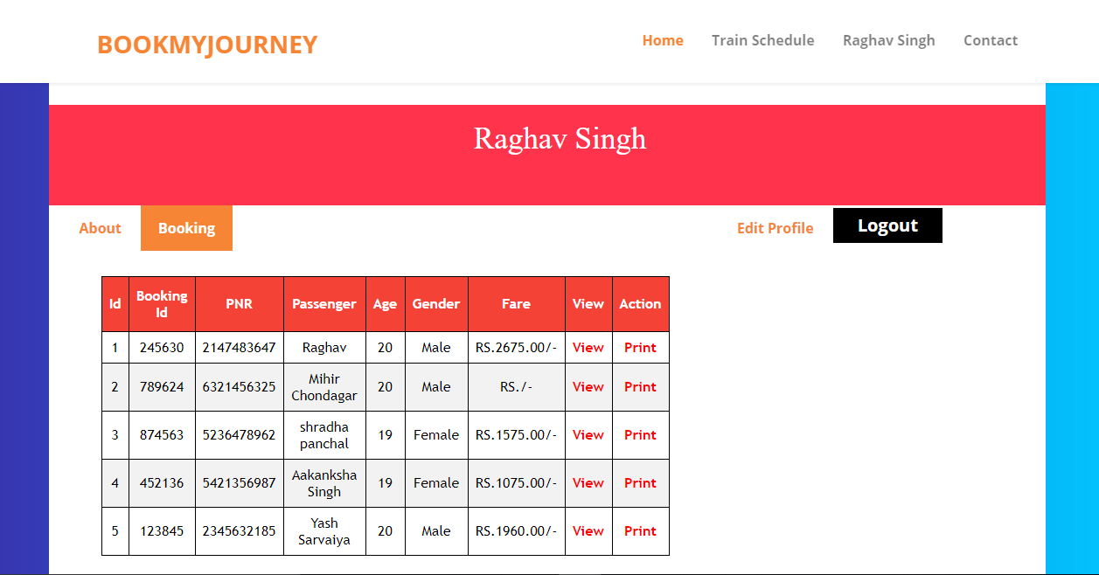

Page Feature-
- After login you can visit your profile page.
- Your username will be display at top of your profile.
- There are two button here ABOUT and BOOKING.
- On clicking ABOUT button, it will show your personal details.
- On clicking BOOKING button, it will display your all bookings.
- There are two extra buttons view and action.
- View button will display ticket details.
- Print button will print a pdf file of your ticket.
- Edit-Profile button can edit your personal details.
10.Logout button will end your session and get you logged out.
**Contact.Php**

*Contact our helping team*

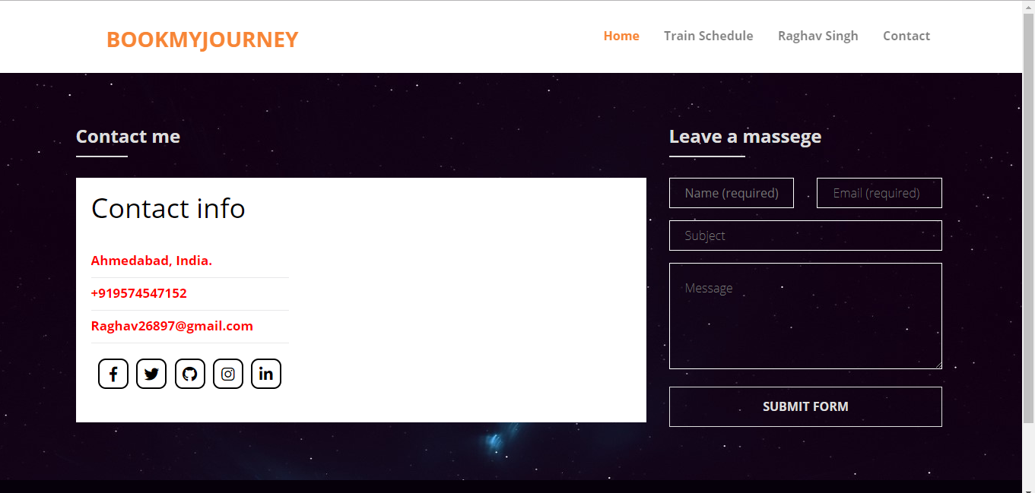

Page Feature-
- Contact our helping team.
- If you have any query our any suggestion you can leave a message.
- Here many type of options and social links to contact our team.

