Functions

A function is a block of organized, reusable code that is used to perform a related action. Functions provide better modularity for your application and a high degree of code reusing.

Functions are categorized into two categories they are

1. Built in functions
2. User defined functions

1.Built in functions

The Python interpreter has a number of functions built into it that are always available. They are listed here in alphabetical order.

Built in functions information we can find out by using python manual

Along with the python installation python manual also will come

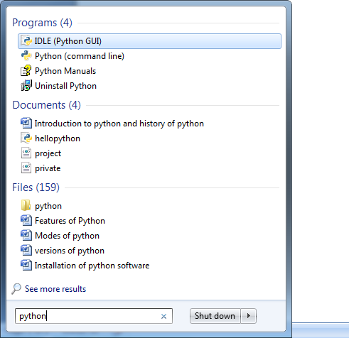

Click on python manual

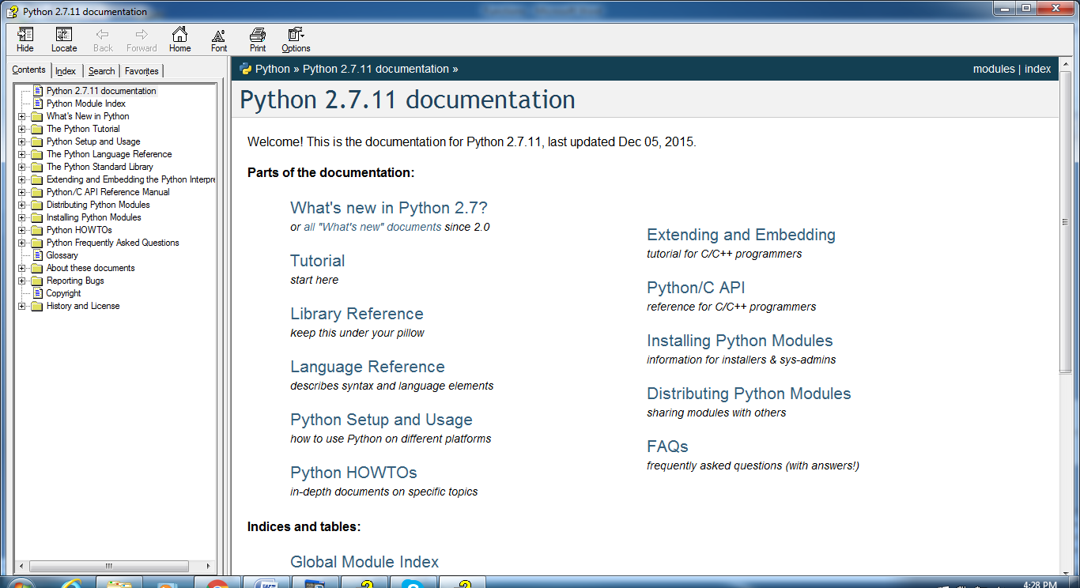

Expand python standard library

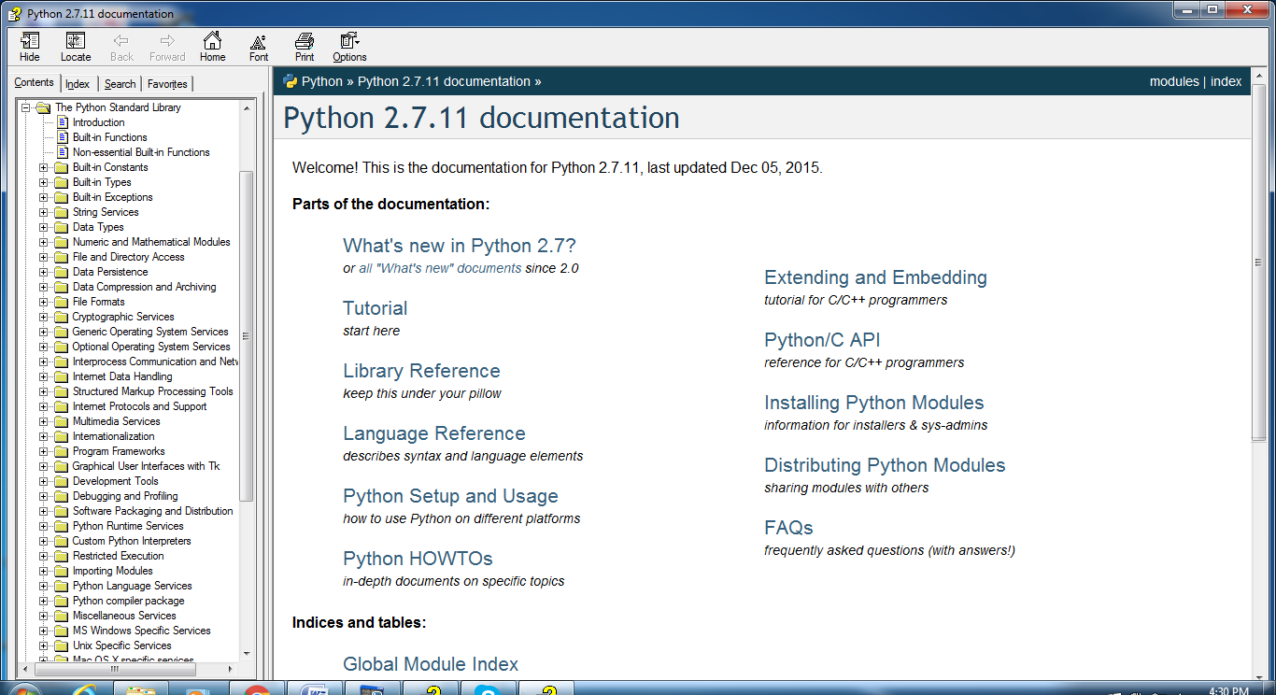

Click on built-in functions

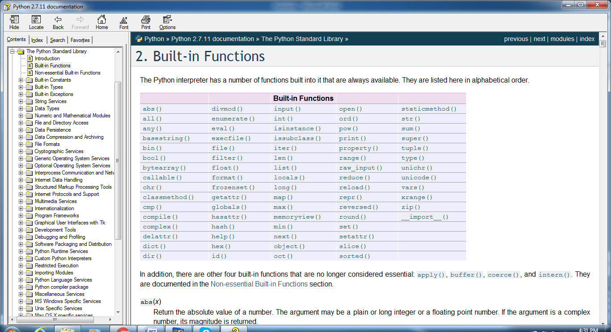

1.Print

Print objects to the stream file.

X=1234

Print x # 1234

Print “hello world” # hello world

I=123

J=234

Print “ sum of “,i,” and “,j,” is: “,i+j # sum of 123 and 234 is: 357

2.raw_input()

It is used to read the data from key board.

This function reads the data in the form of string format

X=raw_input(“enter fno ”)

Enter fno 1000

Print x # 1000

Print type(x) # str

3.type()

This function is used to know the data type of the variable.

Eg1:

X=123

Print type(x) # int

Eg2:

Y=123.123

Print type(y) # float

4.Id()

This function is used to know the address of the variable

Eg1:

X=123

Print id(x) # 4689356

5. Type conversion functions

Type conversion functions are used to convert the string represented data in the form of corresponding data type format

1.Int()

2.long()

3.float()

4.complex()

5.bool()

Eg1:

X=”12345”

Print type(x) # str

Print type(int(x)) # int