Python Multiple Inheritance

Multiple inheritance is possible in Python unlike other programming languages. A class can be derived from more than one base classes. The syntax for multiple inheritance is similar to single inheritance.

Python Multiple Inheritance Example

class Base1:

pass

class Base2:

pass

class MultiDerived(Base1, Base2):

pass

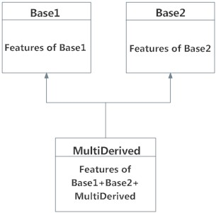

The class MultiDerived inherits from both Base1 and Base2.

Multilevel Inheritance in Python

On the other hand, we can inherit form a derived class. This is also called multilevel inheritance. Multilevel inheritance can be of any depth in Python. An example with corresponding visualization is given below.

class Base:

pass

class Derived1(Base):

pass

class Derived2(Derived1):

pass

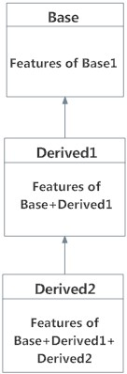

class X: pass

class Y: pass

class Z: pass

class A(X,Y): pass

class B(Y,Z): pass

class M(B,A,Z): pass

print(M.mro())

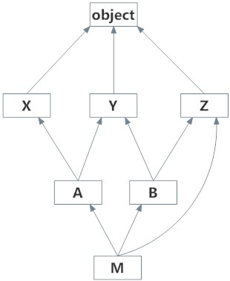

**Output**

[<class '__main__.M'>, <class '__main__.B'>, <class '__main__.A'>, <class '__main__.X'>,<class '__main__.Y'>, <class '__main__.Z'>, <class 'object'>]