Strhand1.py

str = "Sathya Tech"

print ("captilize() ",str.capitalize())

#print ("casefold() ",str.casefold()) # python 3.3

print ("swapcase() ",str.swapcase())

print ("title() ",str.title())

print ("lower() ",str.lower())

print ("upper() ",str.upper())

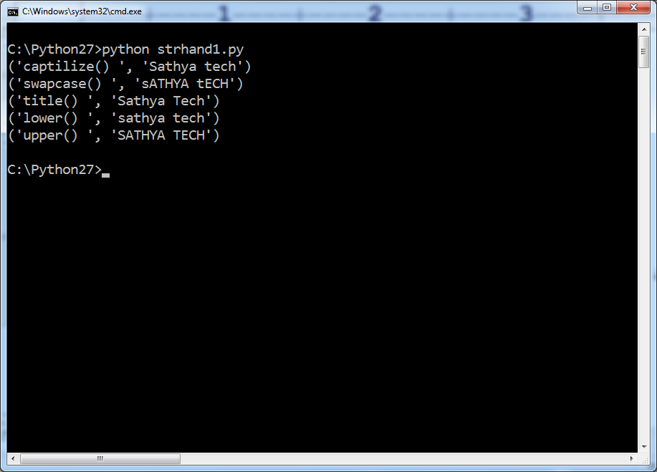

Strhanh2.py

str2 = "Hello world"

str3 = "Hello2world"

str4 = "World"

str5 = "hello"

str6 = "PYTHON"

dec1 = "10"

dec2 = "10 USD"

print ("Checking if a string contains alpha numeric string or not:")

condition1 = str2.isalnum();

condition2 = str3.isalnum();

if condition1:

print (str2," is an alphanumeric string")

else:

print (str2," is not an alphanumeric string or contains space")

if condition2:

print (str3," is a alphanumeric string")

else:

print (str3," is not an alphanumeric string or contains space")

print ("Checking if a string contains alphabets only:")

condition3 = str2.isalpha();

condition4 = str3.isalpha();

condition5 = str4.isalpha();

if condition3:

print (str2," is an alphabetic characters")

else:

print (str2," is not a valid alphabetic characters")

if condition4:

print (str3," is an alphabetic characters")

else:

print (str3," is not a valid alphabetic characters")

if condition5:

print (str4," is an alphabetic characters")

else:

print (str4," is not a valid alphabetic characters")

print ("Checking if a string contains digits only:")

condition8 = dec1.isdigit();

condition9 = dec2.isdigit();

if condition8:

print (dec1," is valid digit(s)")

else:

print (dec1," is invalid")

if condition9:

print (dec2," is valid digit(s)")

else:

print (dec2," is invalid")

print ("Checking if a string contains lower case characters:")

condition12 = str4.islower();

condition13 = str5.islower();

if condition12:

print (str4," is valid lower case string")

else:

print (str4," is not a valid lower case string")

if condition13:

print (str5," is valid lower case string")

else:

print (str5," is not a valid lower case string")

print ("Checking if a string contains upper case characters:")

condition14 = str4.isupper();

condition15 = str6.isupper();

if condition14:

print (str4," is valid upper case string")

else:

print (str4," is not a valid upper case string")

if condition15:

print (str6," is valid upper case string")

else:

print (str6," is not a valid upper case string")

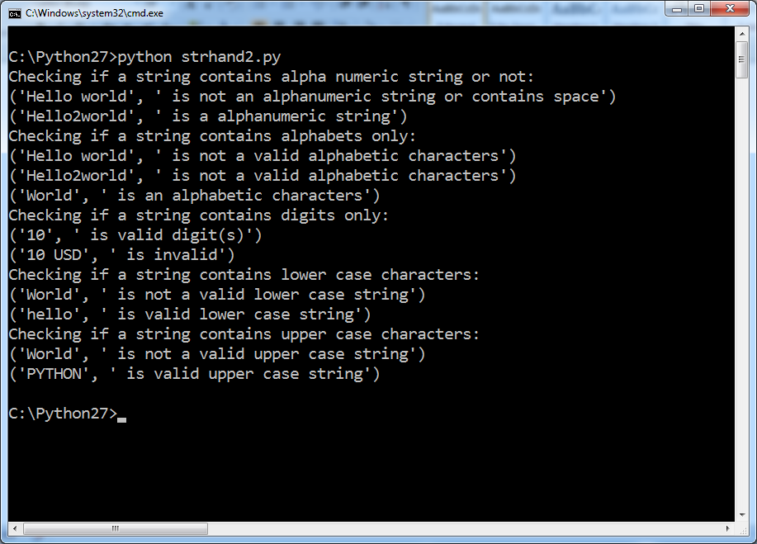

Strhand3.py

str="Test"

print ("zfill():")

print ("150: ","150".zfill(5))

print ("-150: ","-150".zfill(5))

print ("ljust(s) :",str.ljust(10,"x"))

print ("rjust(s) :",str.rjust(10,"x"))

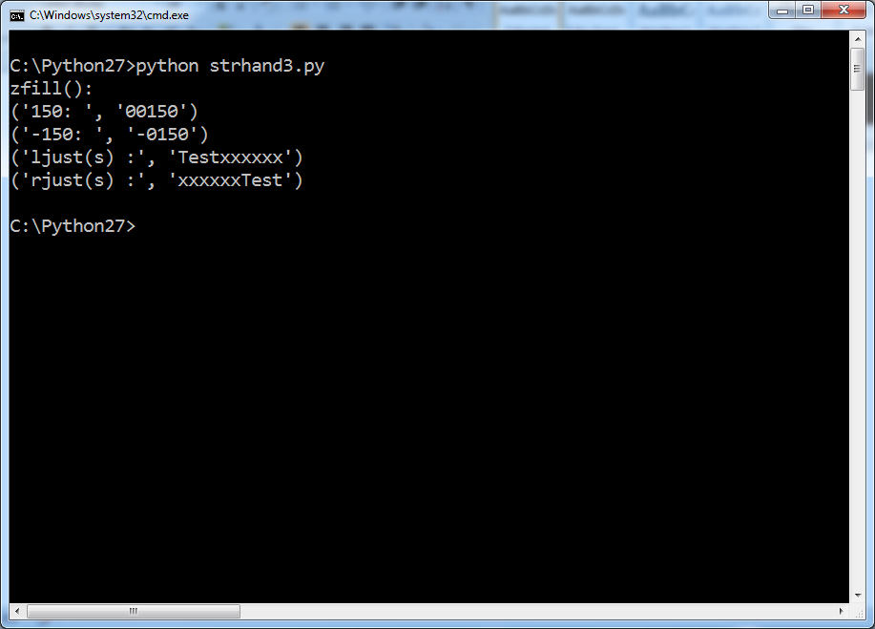

Strhand4.py

str1 = "sathya tech"

str2 = "python is a language"

str3 = "ab c\n\nde fg\rkl\r\n"

str4 = " hyderabad telangana "

str5 = "python python java java"

print ("String: ",str1)

print ("count('t') ",str1.count('t') )

print ("find(t) ",str1.find("t"))

print ("find(s) ",str1.find("s"))

print ("rfind(t) ",str1.rfind("t"))

print ("replace() ",str1.replace("tech","technologies"))

print ("split() ",str2.split(' '))

print ("split('1') ",str2.split(' ', 1 ))

print ("splitlines()",str3.splitlines())

print ("splitlines(True) ",str3.splitlines(True))

print ("lstrip()",str4.lstrip())

print ("lstrip('idiot')",str5.lstrip("idiot"))

print ("rstrip()",str4.rstrip())

print ("rstrip('java')",str5.rstrip("java"))

print ("index('python')",str5.index("python"))

print ("index('python',5)",str5.index("python",5))

print ("rindex('t')",str1.rindex("t"))

print ("rindex('t',5,8)",str1.rindex("t",5,8))

