Before working with queries and cursors, a connection to the database needs to be established. The credentials and data source names can be supplied in one of several ways, with similar results.

import cx_Oracle  
 db = cx_Oracle.connect('dbusername', 'dbpwd', 'ipaddofthecomputerwheredatabaseisinstalled:portno/databaseservicename')

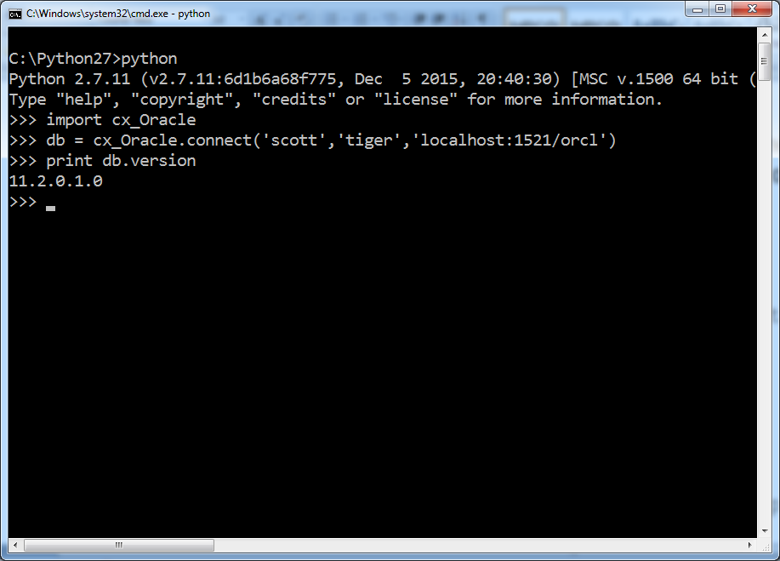

(OR)

import cx_Oracle  
 db=cx_Oracle.connect('dbusername/dbpwd@ipaddofthecomputerwheredatabaseisinstalled:portno/databaseservicename')

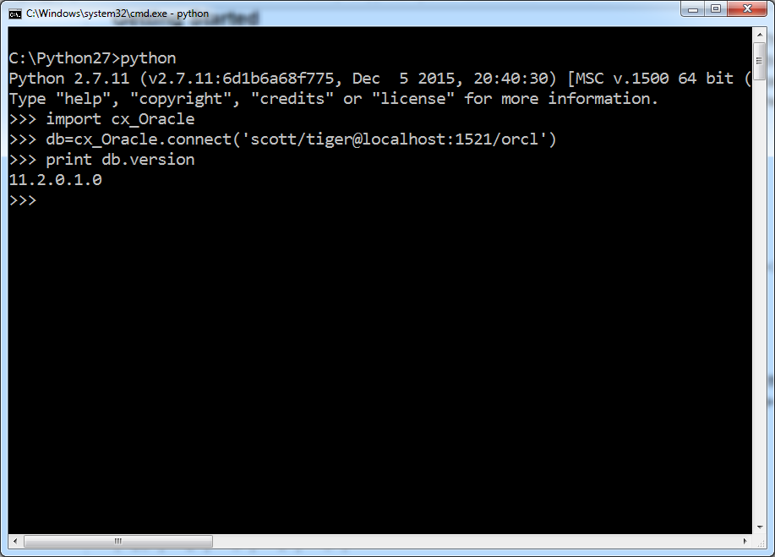

import cx_Oracle

db=cx_Oracle.connect('scott', 'tiger','localhost:1521/orcl')

cursor = db.cursor()  
cursor.execute('SELECT * FROM dept')

for row in cursor:

print row

cursor.close()

db.close()

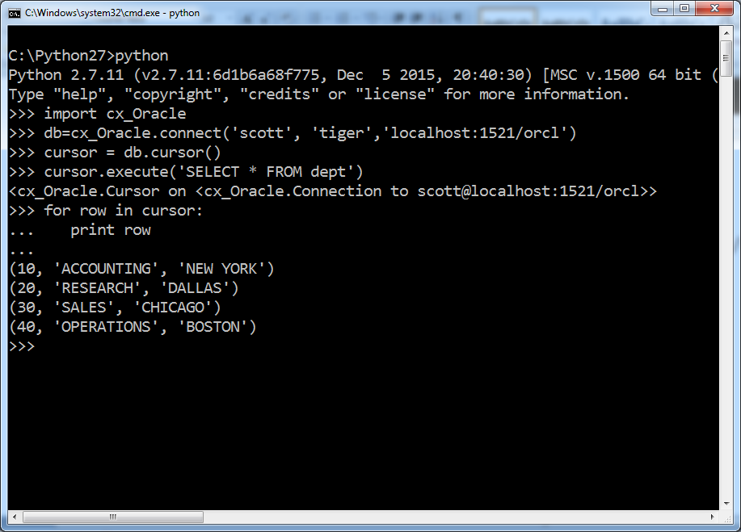

import cx_Oracle

db=cx_Oracle.connect('scott', 'tiger','localhost:1521/orcl')

cursor = db.cursor()  
cursor.execute('SELECT * FROM dept')

row=cursor.fetchone()

print row

row=cursor.fetchone()

print row

cursor.close()

db.close()

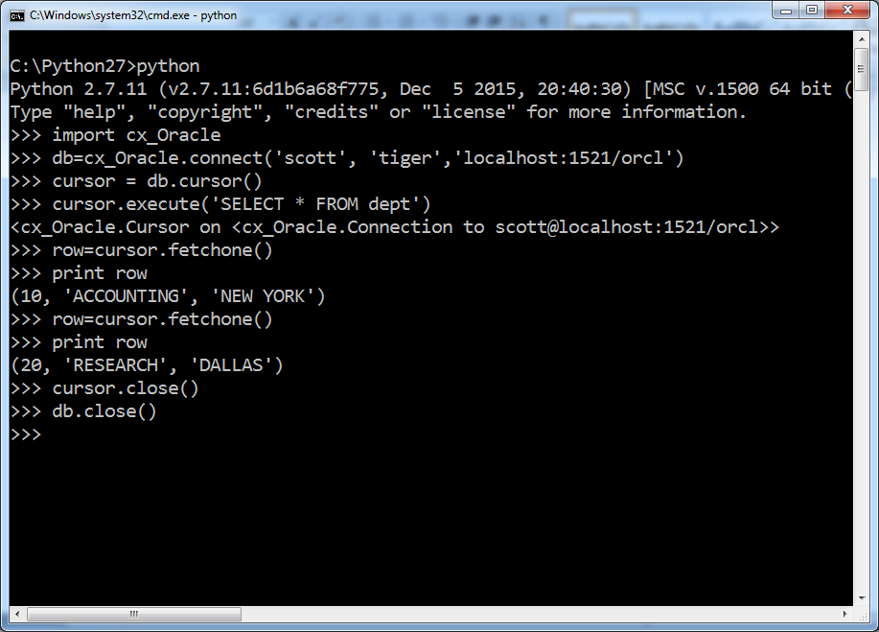

import cx_Oracle

db=cx_Oracle.connect('scott', 'tiger','localhost:1521/orcl')

cursor = db.cursor()  
cursor.execute('SELECT * FROM emp order by sal desc')

row=cursor.fetchmany(3)

print row

cursor.close()

db.close()

