* **Medlife:** Providing medicines to 22,000+ pin codes across India
* **Netmeds:** Providing medicines to 19,000+ pin codes across India
* **Pharmeasy:** Providing medicines to 22,000+ pin codes across India
* **Myra:** Providing medicines in Bengaluru & Mumbai
* **CareOnGo:** Providing medicines in NCR, Bengaluru, Hyderabad, and Kolkata
* **Tata1mg**
* [1. Capsule Pharmacy](https://www.syscreations.com/top-pharmacy-apps-2021/#capsule)
* [2. RiteAid](https://www.syscreations.com/top-pharmacy-apps-2021/#riteaid)
* [3. NowRx](https://www.syscreations.com/top-pharmacy-apps-2021/#nowrx)
* [4. OptumRx](https://www.syscreations.com/top-pharmacy-apps-2021/#optumrx)
* [5. Tata 1mg](https://www.syscreations.com/top-pharmacy-apps-2021/#1mg)
* [6. Medscape](https://www.syscreations.com/top-pharmacy-apps-2021/#medscape)
* [7. Drugs.com](https://www.syscreations.com/top-pharmacy-apps-2021/#drugs)
* [8. Epocrates](https://www.syscreations.com/top-pharmacy-apps-2021/#epocrates)
* [9. MedPlus](https://www.syscreations.com/top-pharmacy-apps-2021/#medplus)
* [10. Netmeds](https://www.syscreations.com/top-pharmacy-apps-2021/#netmeds)
* [11. Patient Access](https://www.syscreations.com/top-pharmacy-apps-2021/#patientaccess)
* [12. Express Plus Medicare](https://www.syscreations.com/top-pharmacy-apps-2021/#express)
* [13. NHS App](https://www.syscreations.com/top-pharmacy-apps-2021/#nhs)
* [14. MedAdvisor Medications Manager](https://www.syscreations.com/top-pharmacy-apps-2021/#medadvisor)
* [15. Healthera NHS Prescription App](https://www.syscreations.com/top-pharmacy-apps-2021/#healthera)
* [16. Medsmart Meds & Pill Reminder](https://www.syscreations.com/top-pharmacy-apps-2021/#medsmart)
* [17. Weedmaps: Cannabis, Weed & CBD](https://www.syscreations.com/top-pharmacy-apps-2021/#weedmaps)
* [18. PharmEasy - Healthcare App](https://www.syscreations.com/top-pharmacy-apps-2021/#pharmaeasy)
* [19. Medinet](https://www.syscreations.com/top-pharmacy-apps-2021/#medinet)
* [20. Medisafe Medication Management](https://www.syscreations.com/top-pharmacy-apps-2021/#medisafe)

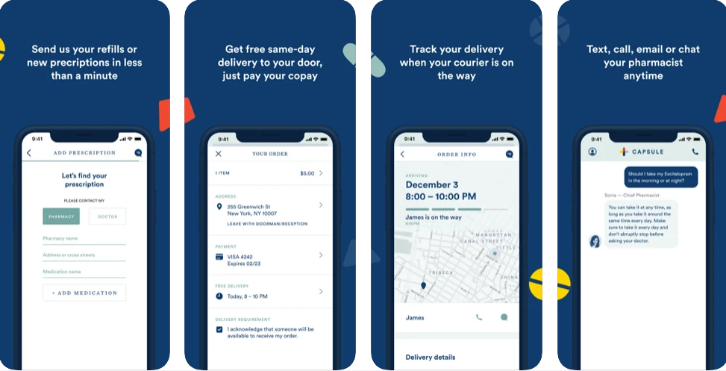

iOS rating- 4.8

Working with the motto of Meds made it easy.

The capsule pharmacy app is a product of Capsule Corporation.

Free to use it is one of the smartest, user-friendly, and hand delivers your medications the same day.

Their motto of same-day deliveries revolutionized the pharmaceutical market and they became one of the most successful top pharmacy app startups with a recent valuation of $1 billion since their inception in New York City in 2

mediquick-pharmacy/

├── public/

│ ├── index.html

│ └── ...

├── src/

│ ├── components/

│ │ ├── Home.js

│ │ ├── Login.js

│ │ ├── Prescription.js

│ │ ├── Profile.js

│ │ ├── Consultation.js

│ │ ├── Order.js

│ │ └── ...

│ ├── services/

│ │ ├── api.js

│ │ └── auth.js

│ ├── App.js

│ ├── index.js

│ └── ...

└── package.json