- Medlife: Providing medicines to 22,000+ pin codes across India
- Netmeds: Providing medicines to 19,000+ pin codes across India
- Pharmeasy: Providing medicines to 22,000+ pin codes across India
- Myra: Providing medicines in Bengaluru & Mumbai
- CareOnGo: Providing medicines in NCR, Bengaluru, Hyderabad, and Kolkata
- Tata1mg
- 1. Capsule Pharmacy
- 2. RiteAid
- 3. NowRx
- 4. OptumRx
- 5. Tata 1mg
- 6. Medscape
- 7. Drugs.com
- 8. Epocrates
- 9. MedPlus
- 10. Netmeds
- 11. Patient Access
- 12. Express Plus Medicare
- 13. NHS App
- 14. MedAdvisor Medications Manager
- 15. Healthera NHS Prescription App
- 16. Medsmart Meds & Pill Reminder
- 17. Weedmaps: Cannabis, Weed & CBD
- 18. PharmEasy - Healthcare App
- 19. Medinet
- 20. Medisafe Medication Management
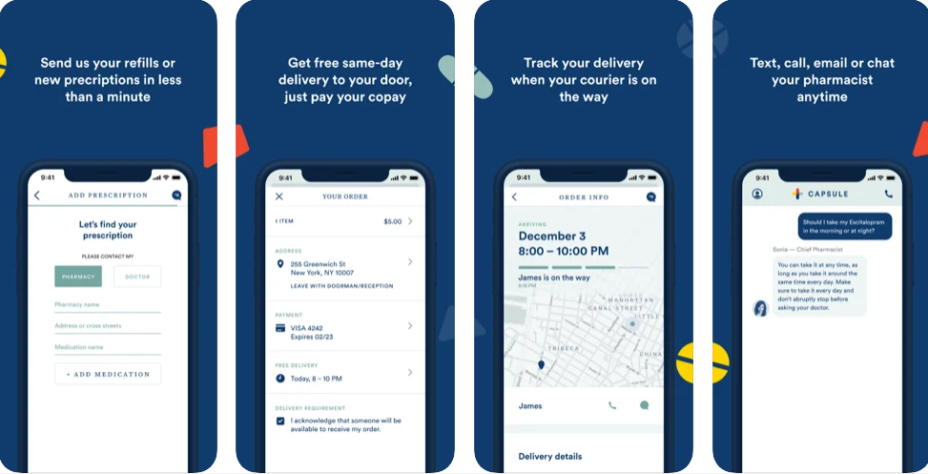
iOS rating- 4.8
Working with the motto of Meds made it easy.
The capsule pharmacy app is a product of Capsule Corporation.
Free to use it is one of the smartest, user-friendly, and hand delivers your medications the same day.
Their motto of same-day deliveries revolutionized the pharmaceutical market and they became one of the most successful top pharmacy app startups with a recent valuation of $1 billion since their inception in New York City in 2

