Sdm assignment

AWS

1. GO TO EC2
2. LAUNCH INSTANCE
3. GIVE NAME AND ALWAYS USE FREE VERSION FOR EVERYTHING

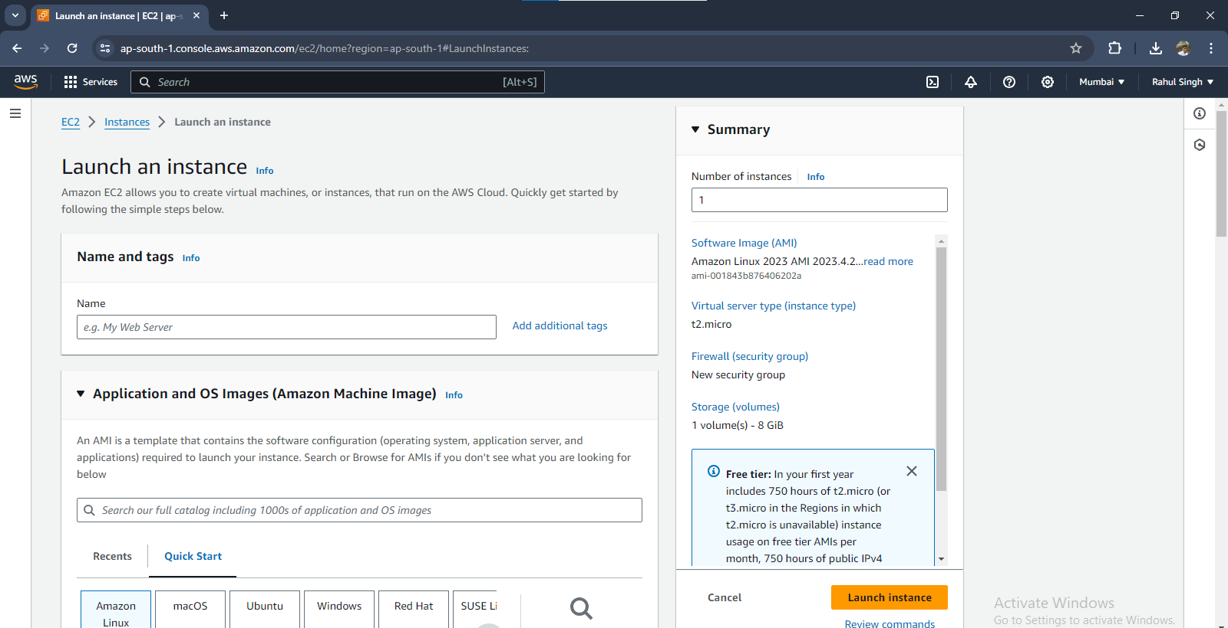

SET KEY

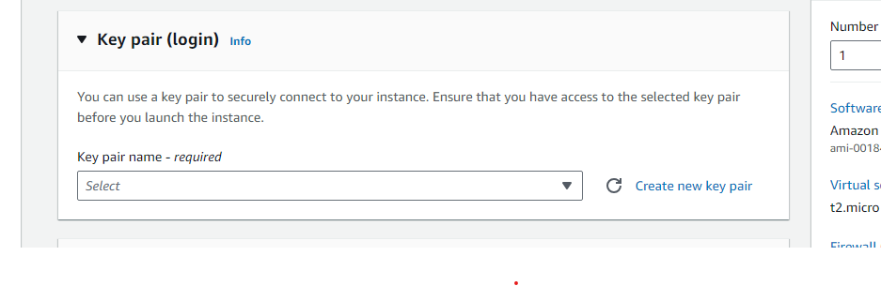

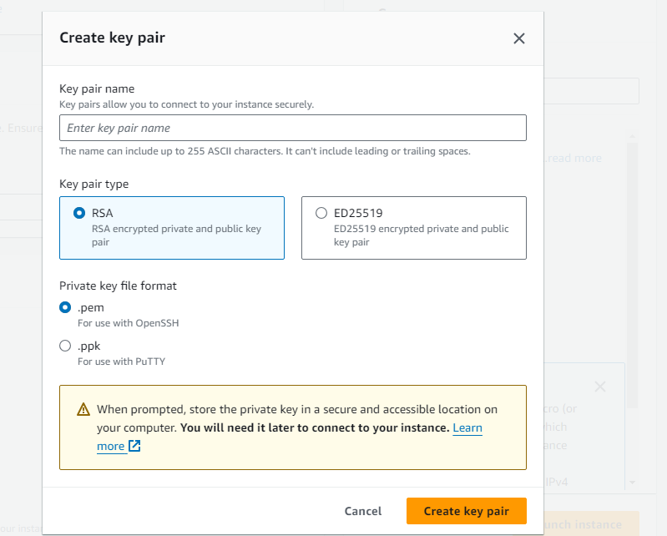

MAKE THE INSTANCE

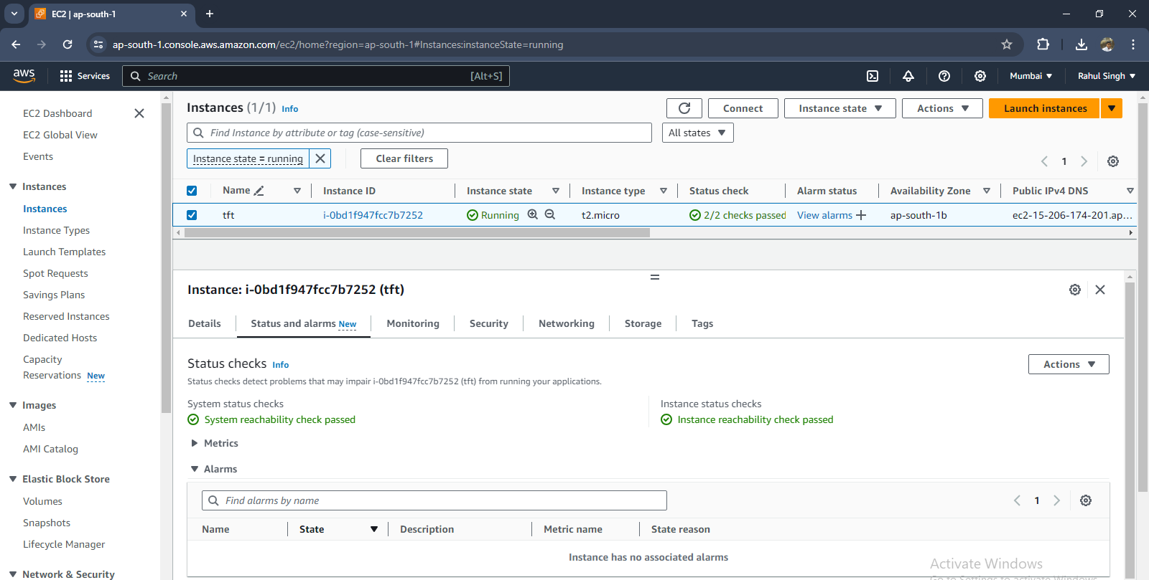

SET INBOUND RULE BY ADDING NEW RULE

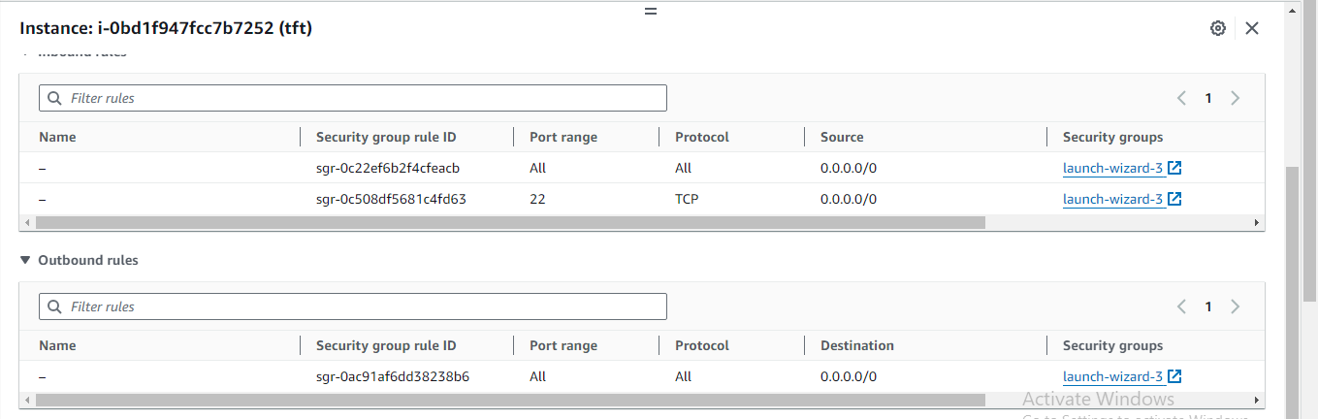

OPEN PUTTY

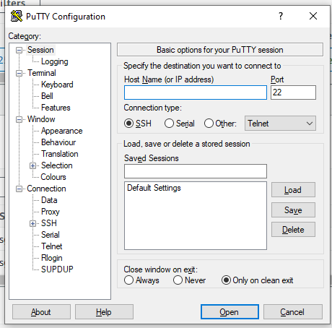

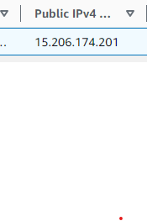

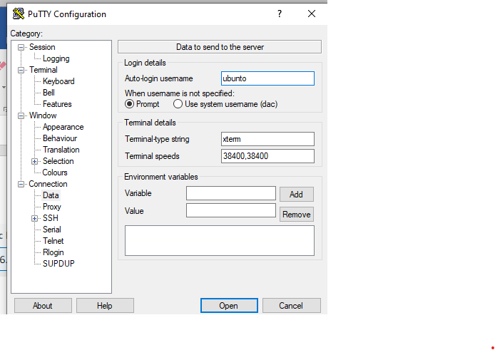

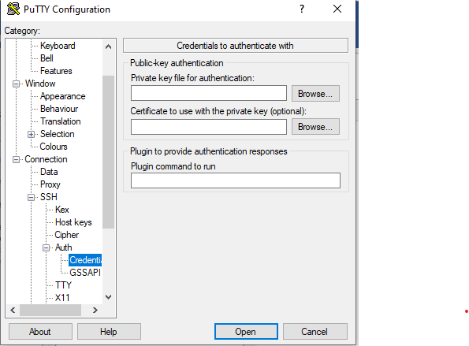

Open here which will create a server running in Mumbai

Now

Commands

1. Sudo apt update (for updating local access and ubuntu)
2. Sudo apt install docker.io
3. Sudo systemctl status docker

4.git5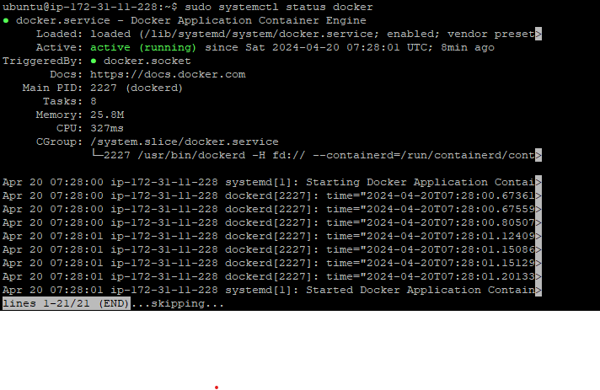

4. git clone ….url…..

5.cd tftworld

6. sudo docker build –t tflimage .

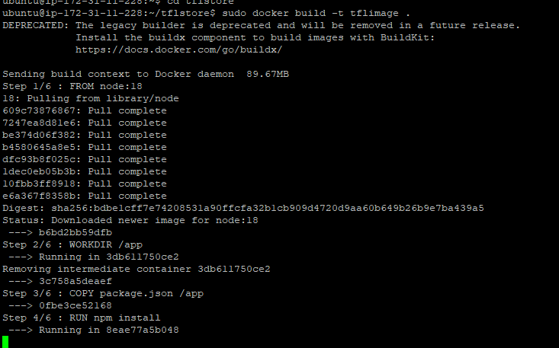

7. sudo docker run –name vv –d –p 8000:8000 tflimage



Now for website

Then always terminate the instance after use

Sdm Assignment using npm

Command

1]sudo apt update

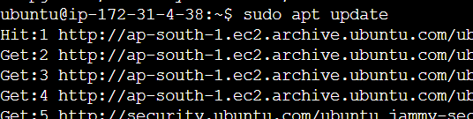

2]sudo apt install nodejs

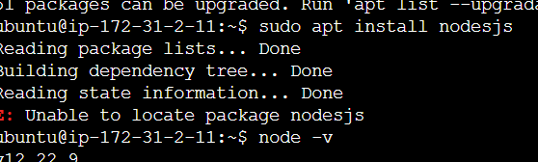

3]sudo apt install npm

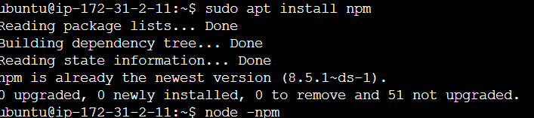

3]git clone <git code url>

4]cd tflstore

5] npm install

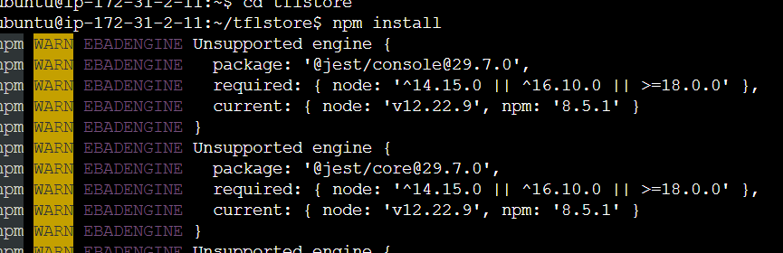

6]node server.js

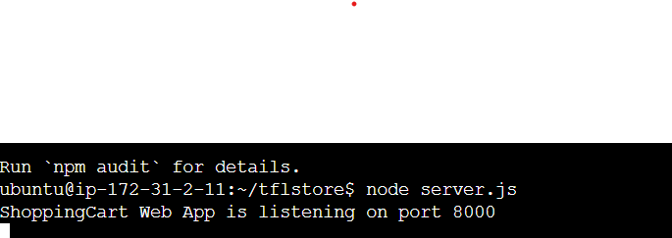

OS

All commands for operating system

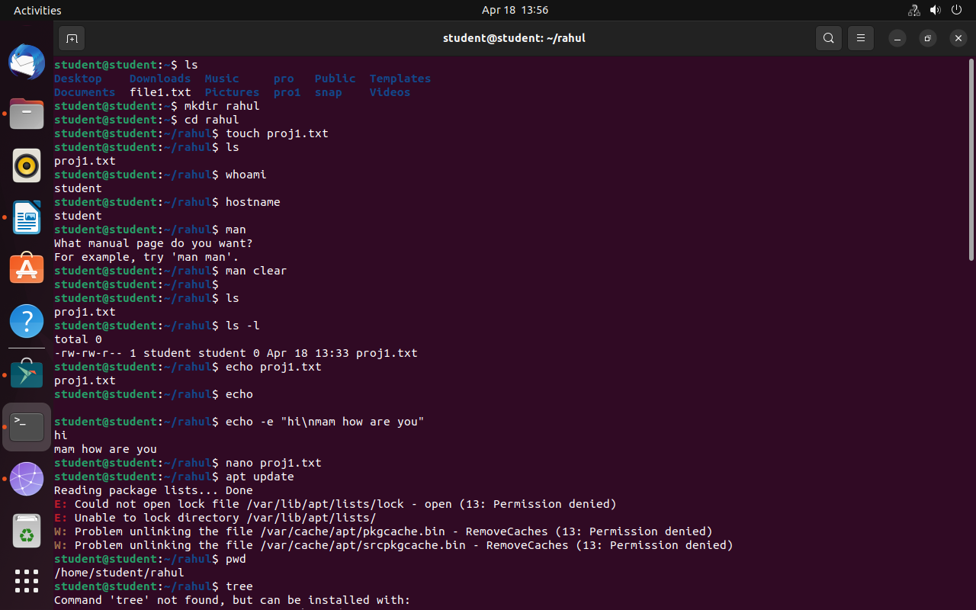all basic commands

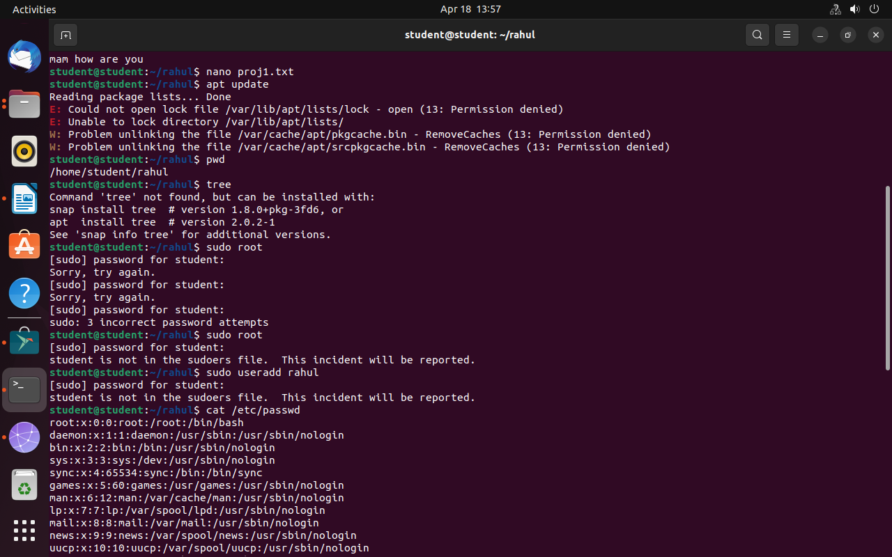for finding somethin always use grep



