Self-Declaration letter on UAN & KYC

# For Campus Hires / Hires without any previous PF/EPS membership):

I certify that the below particulars are true to the best of my knowledge.

1. My Name, Date of Birth, and Gender are completely updated in all my KYC documents (i.e., Bank, PAN, and Aadhaar).
2. My Name, Date of Birth, and Gender are consistent across all my KYC documents (i.e., Bank, PAN, and Aadhaar)
3. The Aadhaar, PAN, and Bank Account details, wherever applicable, belong to me.

I authorize Deloitte to use my Aadhaar for verification/ Authentication/ E-KYC for regulatory compliance purposes only.

I understand that in case of any issues with my KYC or incorrect details provided by me, Deloitte can take disciplinary action against me.

# For Experienced Hires / Hires with a previous PF/EPS membership):

I certify that the below particulars are true to the best of my knowledge.

1. My three KYC details (i.e., Bank, PAN, and Aadhaar) are linked with my existing UAN.
2. My Name, Date of Birth, and Gender are completely updated in all my KYC documents (i.e., Bank, PAN, and Aadhaar).
3. My Name, Date of Birth, and Gender are consistent across all my KYC documents (i.e., Bank, PAN, and Aadhaar).
4. The Aadhaar, PAN, and Bank Account details, wherever applicable, belong to me.

I hereby attach the screenshot of my UAN member profile available on the UAN member portal having personal details, UAN number, and KYC details (with mapping status).

I authorize Deloitte to use my Aadhaar for verification/ Authentication/E-KYC purposes for regulatory compliance purposes only. I understand that in case of any issues with my KYC or incorrect details provided by me, Deloitte can take disciplinary action against me.

Below is the supporting screenshot from my UAN member profile: (below is the example for your reference and steps to follow for taking a screenshot)

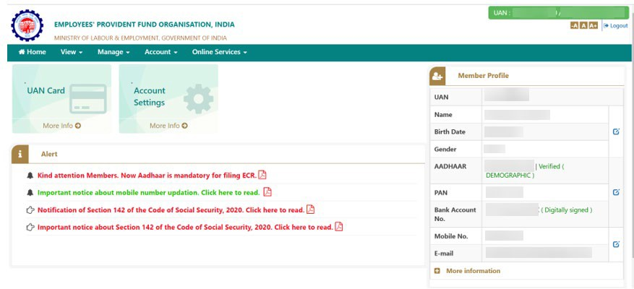

## Note: You have to replace this screenshot with your member profile details taken from UAN member portal.

Date: 03-09-2022 Sign:

Place: Ghansoli, Navi Mumbai Name: Rahul Vilas Sonune

## Steps to take a screenshot from the UAN portal.

1. You need to log in to the [EPFO member portal](https://unifiedportal-mem.epfindia.gov.in/memberinterface/) using your UAN number.
2. Once logged in, you will be able to see the member profile with KYC details (updated/verified/unverified) on the right side of the screen.
3. You can take a screenshot of the home page and paste it above your signature.