Data Cleaning and Preliminary Analysis: Airbnb Listings in Amsterdam
Rahul Jadhav
11 October 2026
Table of Contents
1. Introduction 2
2. Dataset Overview 2
3. Initial Inspection 3
4. Data Quality Audit 8
5. Data Cleaning 9
5.1 Fix data types 9
5.2 Remove duplicates and invalid values 11
5.3 Missing values 11
5.4 Outlier detection 15
5.5 Normalization 18
5.6 Encoding categorical variables 19
6. Exploratory Analysis 20
6.1 Descriptive statistics 20
6.2 Price distribution 21
6.3 Listing mix 21
6.4 Price by room type and neighbourhood 22
6.5 Price versus size and quality 25
6.6 Geography 28
6.7 Correlations 29
6.8 Statistical tests 30
7. Key Insights 31
8. Challenges and Conclusion 32
Appendix: Reproducibility 32

1. Introduction
Objective. Clean, preprocess and explore the Inside Airbnb Amsterdam listings dataset using R, and extract initial insights into what drives nightly price.
Tools. R, tidyverse (wrangling and ggplot2), janitor (name cleaning), naniar (missing-data visuals), skimr (summaries), corrplot (correlations).
library(tidyverse)
library(janitor)
library(naniar)
library(skimr)
library(corrplot)
library(knitr)

2. Dataset Overview
Source. Inside Airbnb (https://insideairbnb.com/get-the-data/), Amsterdam, the detailed file listings.csv.gz (16 Sep, 2026).
Why this dataset. It is real scraped data, with text-formatted numbers ($1,200.00, 95%), genuine missing values, extreme price and minimum-night outliers, and a mix of numeric, binary and categorical variables.
Columns used. The original file has 90 columns, most of them free text, URLs and IDs. I selected 22 that are relevant to pricing and listing quality. Five of these (bathrooms, host_response_time, host_response_rate, host_acceptance_rate, instant_bookable) turned out to be completely empty in this snapshot and are dropped during cleaning.
Variable | Type | Description
price | Numeric (text in file) | Nightly price in USD, target
room_type, property_type | Categorical | Kind of listing
neighbourhood_cleansed | Categorical | Amsterdam neighbourhood
accommodates, bedrooms, beds | Numeric | Capacity and size
minimum_nights, availability_365 | Numeric | Booking rules and availability
number_of_reviews, reviews_per_month, review_scores_rating | Numeric | Review activity and quality
host_is_superhost | Binary (t/f) | Whether the host is a Superhost
host_listings_count | Numeric | Listings owned by the host
latitude, longitude | Numeric | Location

3. Initial Inspection
raw <- read_csv("listings.csv.gz", na = c("", "NA", "N/A")) %>% clean_names()
cat("Original size:", nrow(raw), "rows x", ncol(raw), "columns\n")
## Original size: 10612 rows x 90 columns
keep_cols <- c("id", "price", "room_type", "property_type", "neighbourhood_cleansed",
"accommodates", "bedrooms", "beds", "bathrooms", "minimum_nights",
"availability_365", "number_of_reviews", "reviews_per_month",
"review_scores_rating", "host_response_time", "host_response_rate",
"host_acceptance_rate", "host_is_superhost", "instant_bookable",
"host_listings_count", "latitude", "longitude")
df <- raw %>% select(any_of(keep_cols))
dim(df)
## [1] 10612 22
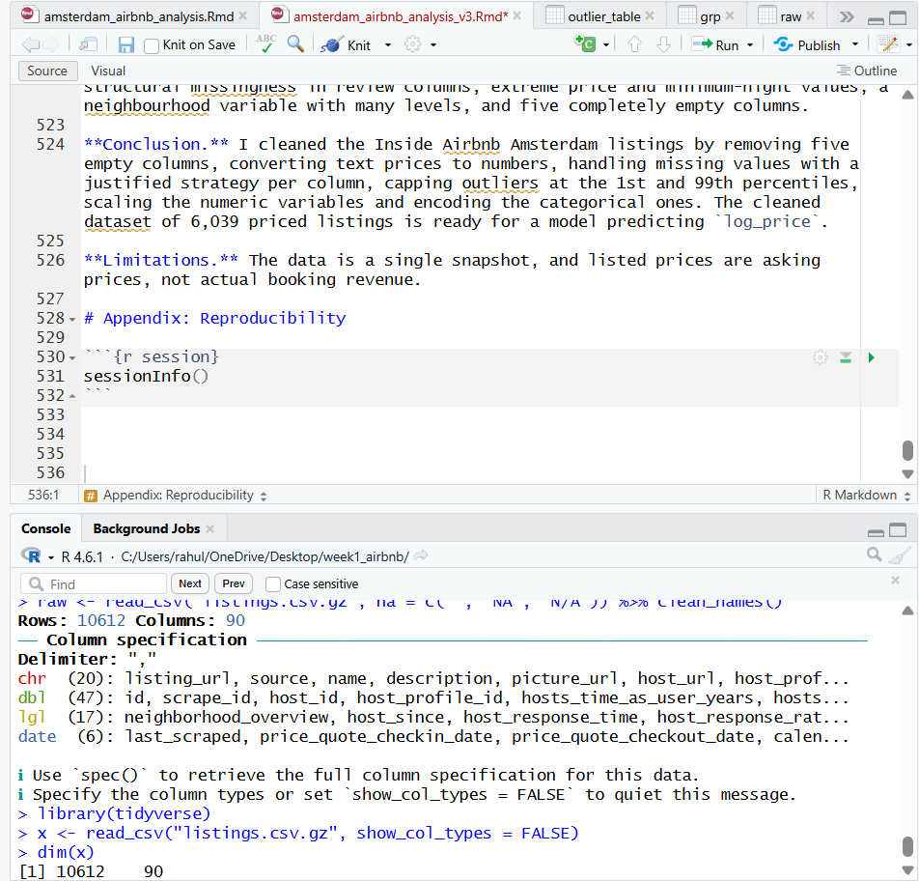
Figure A: Amsterdam listings loaded in RStudio (10,612 rows, 90 columns).
str(df)
## tibble [10,612 × 22] (S3: tbl_df/tbl/data.frame)
## $ id : num [1:10612] 28871 29051 44391 48373 49552 ...
## $ price : chr [1:10612] "$97.00" NA NA NA ...
## $ room_type : chr [1:10612] "Private room" "Private room" "Entire home/apt" "Entire home/apt" ...
## $ property_type : chr [1:10612] "Private room in rental unit" "Private room in condo" "Entire rental unit" "Entire rental unit" ...
## $ neighbourhood_cleansed: chr [1:10612] "Centrum-West" "Centrum-Oost" "Centrum-Oost" "Buitenveldert - Zuidas" ...
## $ accommodates : num [1:10612] 2 2 4 4 3 2 3 4 2 1 ...
## $ bedrooms : num [1:10612] 1 1 2 2 2 1 1 2 1 1 ...
## $ beds : num [1:10612] 1 1 2 2 2 1 2 2 1 1 ...
## $ bathrooms : logi [1:10612] NA NA NA NA NA NA ...
## $ minimum_nights : num [1:10612] 2 2 3 3 1 1 1 3 3 3 ...
## $ availability_365 : num [1:10612] 49 0 0 0 270 268 0 0 13 0 ...
## $ number_of_reviews : num [1:10612] 815 929 42 5 667 656 12 96 39 241 ...
## $ reviews_per_month : num [1:10612] 4.16 4.92 0.22 0.13 3.45 3.43 0.12 0.5 0.2 1.28 ...
## $ review_scores_rating : num [1:10612] 4.86 4.82 4.71 5 4.94 4.86 5 4.86 4.89 4.77 ...
## $ host_response_time : logi [1:10612] NA NA NA NA NA NA ...
## $ host_response_rate : logi [1:10612] NA NA NA NA NA NA ...
## $ host_acceptance_rate : logi [1:10612] NA NA NA NA NA NA ...
## $ host_is_superhost : logi [1:10612] TRUE TRUE FALSE FALSE TRUE TRUE ...
## $ instant_bookable : logi [1:10612] NA NA NA NA NA NA ...
## $ host_listings_count : num [1:10612] 2 2 1 1 1 1 1 1 1 4 ...
## $ latitude : num [1:10612] 52.4 52.4 52.4 52.3 52.4 ...
## $ longitude : num [1:10612] 4.89 4.89 4.91 4.88 4.89 ...
summary(df)
## id price room_type property_type
## Min. :2.887e+04 Length :10612 Length :10612 Length :10612
## 1st Qu.:3.050e+07 N.unique : 3100 N.unique : 4 N.unique : 59
## Median :8.339e+17 N.blank : 0 N.blank : 0 N.blank : 0
## Mean :7.315e+17 Min.nchar: 6 Min.nchar: 10 Min.nchar: 4
## 3rd Qu.:1.304e+18 Max.nchar: 10 Max.nchar: 15 Max.nchar: 34
## Max. :1.775e+18 NAs : 4573
##
## neighbourhood_cleansed accommodates bedrooms beds
## Length :10612 Min. : 1.000 Min. : 0.000 Min. : 1.000
## N.unique : 22 1st Qu.: 2.000 1st Qu.: 1.000 1st Qu.: 1.000
## N.blank : 0 Median : 2.000 Median : 1.000 Median : 1.000
## Min.nchar: 4 Mean : 2.929 Mean : 1.532 Mean : 1.831
## Max.nchar: 38 3rd Qu.: 4.000 3rd Qu.: 2.000 3rd Qu.: 2.000
## Max. :16.000 Max. :17.000 Max. :33.000
## NAs :29 NAs :385
## bathrooms minimum_nights availability_365 number_of_reviews
## Mode:logical Min. : 1.000 Min. : 0.00 Min. : 0.00
## NAs :10612 1st Qu.: 2.000 1st Qu.: 0.00 1st Qu.: 3.00
## Median : 2.000 Median : 14.00 Median : 11.00
## Mean : 3.793 Mean : 93.62 Mean : 53.89
## 3rd Qu.: 3.000 3rd Qu.:178.25 3rd Qu.: 35.00
## Max. :800.000 Max. :365.00 Max. :5732.00
## NAs :268
## reviews_per_month review_scores_rating host_response_time host_response_rate
## Min. : 0.010 Min. :1.000 Mode:logical Mode:logical
## 1st Qu.: 0.190 1st Qu.:4.800 NAs :10612 NAs :10612
## Median : 0.390 Median :4.920
## Mean : 1.092 Mean :4.849
## 3rd Qu.: 0.930 3rd Qu.:5.000
## Max. :90.080 Max. :5.000
## NAs :1002 NAs :1002
## host_acceptance_rate host_is_superhost instant_bookable host_listings_count
## Mode:logical Mode :logical Mode:logical Min. : 1.00
## NAs :10612 FALSE:8890 NAs :10612 1st Qu.: 1.00
## TRUE :1722 Median : 1.00
## Mean : 4.31
## 3rd Qu.: 1.00
## Max. :1192.00
##
## latitude longitude
## Min. :52.29 Min. :4.756
## 1st Qu.:52.36 1st Qu.:4.864
## Median :52.37 Median :4.887
## Mean :52.37 Mean :4.889
## 3rd Qu.:52.38 3rd Qu.:4.908
## Max. :52.43 Max. :5.028
##
skim(df)
Data summary
Name | df
Number of rows | 10612
Number of columns | 22
_______________________
Column type frequency:
character | 4
logical | 6
numeric | 12
________________________
Group variables | None
Variable type: character
skim_variable | n_missing | complete_rate | min | max | empty | n_unique | whitespace
price | 4573 | 0.57 | 6 | 10 | 0 | 3100 | 0
room_type | 0 | 1.00 | 10 | 15 | 0 | 4 | 0
property_type | 0 | 1.00 | 4 | 34 | 0 | 59 | 0
neighbourhood_cleansed | 0 | 1.00 | 4 | 38 | 0 | 22 | 0
Variable type: logical
skim_variable | n_missing | complete_rate | mean | count
bathrooms | 10612 | 0 | NaN | :
host_response_time | 10612 | 0 | NaN | :
host_response_rate | 10612 | 0 | NaN | :
host_acceptance_rate | 10612 | 0 | NaN | :
host_is_superhost | 0 | 1 | 0.16 | FAL: 8890, TRU: 1722
instant_bookable | 10612 | 0 | NaN | :
Variable type: numeric
skim_variable | n_missing | complete_rate | mean | sd | p0 | p25 | p50 | p75 | p100 | hist
id | 0 | 1.00 | 7.314719e+17 | 6.409643e+17 | 28871.00 | 30500029.00 | 8.339275e+17 | 1.303882e+18 | 1.774618e+18 | ▇▂▃▃▅
accommodates | 0 | 1.00 | 2.930000e+00 | 1.270000e+00 | 1.00 | 2.00 | 2.000000e+00 | 4.000000e+00 | 1.600000e+01 | ▇▁▁▁▁
bedrooms | 29 | 1.00 | 1.530000e+00 | 8.800000e-01 | 0.00 | 1.00 | 1.000000e+00 | 2.000000e+00 | 1.700000e+01 | ▇▁▁▁▁
beds | 385 | 0.96 | 1.830000e+00 | 1.360000e+00 | 1.00 | 1.00 | 1.000000e+00 | 2.000000e+00 | 3.300000e+01 | ▇▁▁▁▁
minimum_nights | 268 | 0.97 | 3.790000e+00 | 1.575000e+01 | 1.00 | 2.00 | 2.000000e+00 | 3.000000e+00 | 8.000000e+02 | ▇▁▁▁▁
availability_365 | 0 | 1.00 | 9.362000e+01 | 1.236200e+02 | 0.00 | 0.00 | 1.400000e+01 | 1.782500e+02 | 3.650000e+02 | ▇▁▁▁▂
number_of_reviews | 0 | 1.00 | 5.389000e+01 | 1.477000e+02 | 0.00 | 3.00 | 1.100000e+01 | 3.500000e+01 | 5.732000e+03 | ▇▁▁▁▁
reviews_per_month | 1002 | 0.91 | 1.090000e+00 | 2.570000e+00 | 0.01 | 0.19 | 3.900000e-01 | 9.300000e-01 | 9.008000e+01 | ▇▁▁▁▁
review_scores_rating | 1002 | 0.91 | 4.850000e+00 | 2.500000e-01 | 1.00 | 4.80 | 4.920000e+00 | 5.000000e+00 | 5.000000e+00 | ▁▁▁▁▇
host_listings_count | 0 | 1.00 | 4.310000e+00 | 4.288000e+01 | 1.00 | 1.00 | 1.000000e+00 | 1.000000e+00 | 1.192000e+03 | ▇▁▁▁▁
latitude | 0 | 1.00 | 5.237000e+01 | 2.000000e-02 | 52.29 | 52.36 | 5.237000e+01 | 5.238000e+01 | 5.243000e+01 | ▁▁▇▅▁
longitude | 0 | 1.00 | 4.890000e+00 | 3.000000e-02 | 4.76 | 4.86 | 4.890000e+00 | 4.910000e+00 | 5.030000e+00 | ▁▃▇▂▁
Interpretation. The raw file has 10,612 listings and 90 columns, of which 22 were selected. price arrives as text (for example “$97.00”), and several columns are already visibly empty. summary() shows very large maximum values for minimum_nights and number_of_reviews, which points to strong right skew and outliers, and the NA counts show that price and the review columns are the main gaps.

4. Data Quality Audit
# 4.1 Missing values per column
miss_var_summary(df) %>% filter(n_miss > 0) %>%
kable(digits = 1, caption = "Columns with missing values (raw)")
Columns with missing values (raw)
variable | n_miss | pct_miss
bathrooms | 10612 | 100
host_response_time | 10612 | 100
host_response_rate | 10612 | 100
host_acceptance_rate | 10612 | 100
instant_bookable | 10612 | 100
price | 4573 | 43.1
reviews_per_month | 1002 | 9.44
review_scores_rating | 1002 | 9.44
beds | 385 | 3.63
minimum_nights | 268 | 2.53
bedrooms | 29 | 0.273
# 4.1b Columns that are completely empty
all_na <- names(df)[colSums(is.na(df)) == nrow(df)]
cat("Columns that are 100% missing:", paste(all_na, collapse = ", "), "\n")
## Columns that are 100% missing: bathrooms, host_response_time, host_response_rate, host_acceptance_rate, instant_bookable
# 4.2 Duplicate listings
cat("Duplicate listing IDs:", sum(duplicated(df$id)), "\n")
## Duplicate listing IDs: 0
# 4.3 Text-formatted numbers
head(df$price, 5)
## [1] "$97.00" NA NA NA "$424.29"
# 4.4 Category check
table(df$room_type)
##
## Entire home/apt Hotel room Private room Shared room
## 8579 24 1987 22
table(df$host_is_superhost, useNA = "ifany")
##
## FALSE TRUE
## 8890 1722
Findings. There are no duplicate listing IDs. Five columns are 100% missing (bathrooms, host_response_time, host_response_rate, host_acceptance_rate, instant_bookable). Price is missing for 4,573 listings (43.1%), the review columns for 1,002 (9.4%), and beds, minimum_nights and bedrooms have small gaps (3.6%, 2.5% and 0.3%). Price is stored as text. Room types are heavily dominated by entire homes (8,579), followed by private rooms (1,987), with only 24 hotel rooms and 22 shared rooms.

5. Data Cleaning

5.1 Fix data types
Why. price is stored as text like "$97.00", so no calculation is possible until it is converted. The superhost flag is recoded to 1/0.
Dropping empty columns. The audit found columns that are 100% missing in this snapshot (bathrooms, host_response_time, host_response_rate, host_acceptance_rate, instant_bookable). There is nothing to impute from, so they are removed. This is the extreme case of the rule “drop columns with more than about 50% missing”.
to_bin <- function(x) {
case_when(as.character(x) %in% c("t", "TRUE") ~ 1L,
as.character(x) %in% c("f", "FALSE") ~ 0L,
TRUE ~ NA_integer_)
}
df <- df %>%
select(-all_of(all_na)) %>%
mutate(
price = parse_number(as.character(price)),
host_is_superhost = to_bin(host_is_superhost),
across(c(room_type, property_type, neighbourhood_cleansed), as.factor)
)
glimpse(df)
## Rows: 10,612
## Columns: 17
## $ id <dbl> 28871, 29051, 44391, 48373, 49552, 50523, 53921…
## $ price <dbl> 97.00, NA, NA, NA, 424.29, 225.00, NA, NA, 187.…
## $ room_type <fct> Private room, Private room, Entire home/apt, En…
## $ property_type <fct> Private room in rental unit, Private room in co…
## $ neighbourhood_cleansed <fct> Centrum-West, Centrum-Oost, Centrum-Oost, Buite…
## $ accommodates <dbl> 2, 2, 4, 4, 3, 2, 3, 4, 2, 1, 2, 2, 4, 2, 2, 2,…
## $ bedrooms <dbl> 1, 1, 2, 2, 2, 1, 1, 2, 1, 1, NA, 1, 4, 1, 1, 1…
## $ beds <dbl> 1, 1, 2, 2, 2, 1, 2, 2, 1, 1, 1, 2, 4, NA, 1, 1…
## $ minimum_nights <dbl> 2, 2, 3, 3, 1, 1, 1, 3, 3, 3, 1, 2, 3, 2, 2, 3,…
## $ availability_365 <dbl> 49, 0, 0, 0, 270, 268, 0, 0, 13, 0, 8, 285, 1, …
## $ number_of_reviews <dbl> 815, 929, 42, 5, 667, 656, 12, 96, 39, 241, 341…
## $ reviews_per_month <dbl> 4.16, 4.92, 0.22, 0.13, 3.45, 3.43, 0.12, 0.50,…
## $ review_scores_rating <dbl> 4.86, 4.82, 4.71, 5.00, 4.94, 4.86, 5.00, 4.86,…
## $ host_is_superhost <int> 1, 1, 0, 0, 1, 1, 0, 0, 0, 0, 1, 0, 1, 0, 1, 0,…
## $ host_listings_count <dbl> 2, 2, 1, 1, 1, 1, 1, 1, 1, 4, 1, 2, 1, 1, 1, 1,…
## $ latitude <dbl> 52.36775, 52.36584, 52.37168, 52.32781, 52.3802…
## $ longitude <dbl> 4.890920, 4.891110, 4.914710, 4.876800, 4.89089…

5.2 Remove duplicates and invalid values
n0 <- nrow(df)
df <- df %>% distinct(id, .keep_all = TRUE)
cat("Duplicates removed:", n0 - nrow(df), "\n")
## Duplicates removed: 0
# A price of 0 or less is not a real nightly rate
cat("Listings with price <= 0:", sum(df$price <= 0, na.rm = TRUE), "\n")
## Listings with price <= 0: 0
df <- df %>% mutate(price = ifelse(price <= 0, NA, price))

5.3 Missing values

5.3.1 Detect and visualize
miss_var_summary(df) %>% filter(n_miss > 0) %>%
kable(digits = 1, caption = "Missing values after type fixing")
Missing values after type fixing
variable | n_miss | pct_miss
price | 4573 | 43.1
reviews_per_month | 1002 | 9.44
review_scores_rating | 1002 | 9.44
beds | 385 | 3.63
minimum_nights | 268 | 2.53
bedrooms | 29 | 0.273
gg_miss_var(df, show_pct = TRUE) + labs(title = "Missingness by variable")
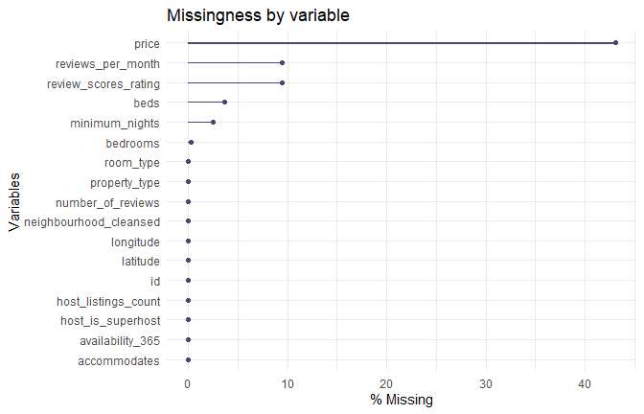
Percentage of missing values per column
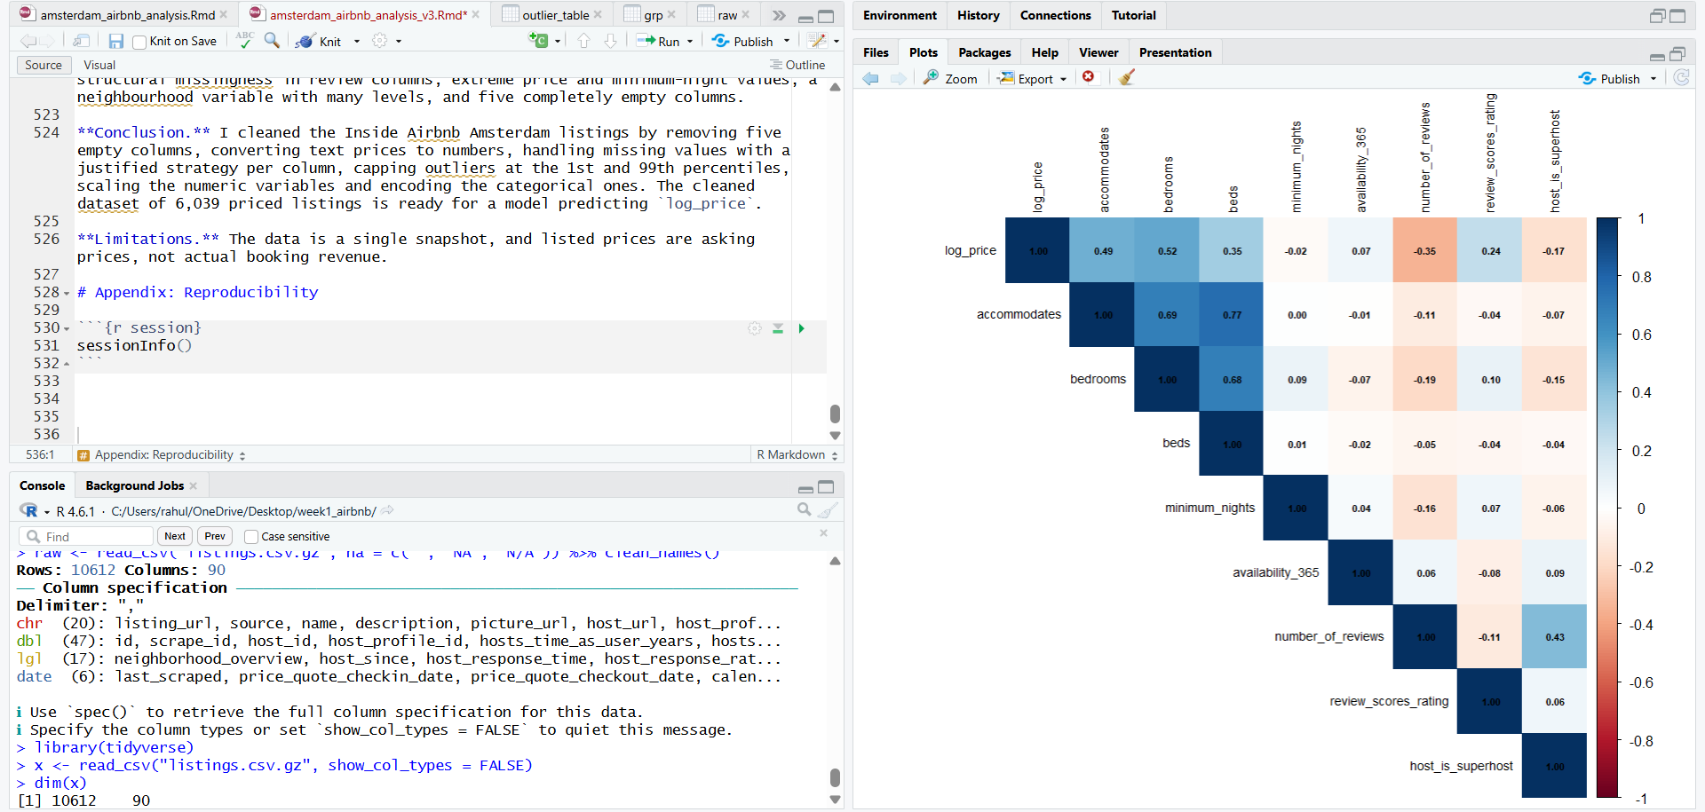
Figure B: Missing values by variable in RStudio. Price is the most incomplete column (43.1%).
set.seed(123)
vis_miss(df %>% slice_sample(n = min(1000, nrow(df))) %>% select(-id, -latitude, -longitude))
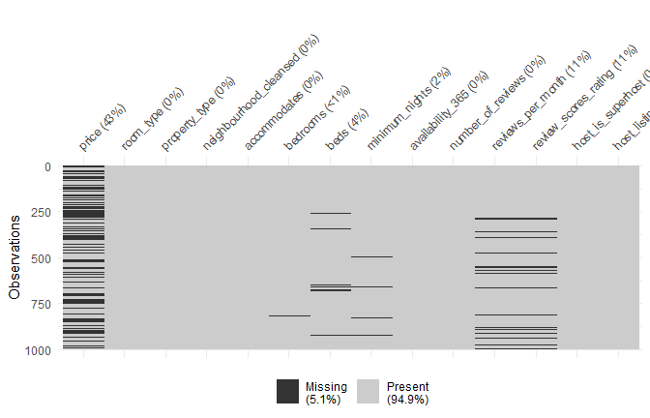
Missingness map (random sample of 1,000 listings)

5.3.2 Is the missingness random?
The rating columns look suspicious, so I tested whether they are missing for listings with no reviews.
table(rating_missing = is.na(df$review_scores_rating),
no_reviews = df$number_of_reviews == 0)
## no_reviews
## rating_missing FALSE TRUE
## FALSE 9610 0
## TRUE 0 1002
Interpretation. All 1,002 listings with a missing review score also have zero reviews, and no listing with at least one review is missing a score. The missingness is therefore structural rather than random: the value does not exist, rather than having been lost. Imputing it blindly would fabricate guest opinions, so I keep a binary flag, rating_missing, which preserves this information, and fill the rating with the median only so that numeric analysis can run.

5.3.3 Strategy per column
Column | Strategy | Reason
price (target) | Drop rows with missing price | Imputing the outcome I want to analyse would invent data
bedrooms, beds | Median by accommodates | A 4-guest listing is likely to have similar beds to other 4-guest listings
review_scores_rating | Median plus rating_missing flag | Structural gap, so the flag keeps the signal
reviews_per_month | Set to 0 when there are no reviews | Logically zero, not unknown
minimum_nights | Overall median | Small share missing and heavily skewed, so median is robust
host_is_superhost | Mode | Binary with few gaps
5 empty columns | Dropped (section 5.1) | 100% missing, so nothing to impute from

5.3.4 Experiment: which imputation is best?
To justify the choice for beds, I hid 5% of known values at random (a simulation on the real data, not real data loss), imputed them three ways, and compared with the truth.
set.seed(123)
known <- df %>% filter(!is.na(beds), !is.na(accommodates))
idx <- sample(nrow(known), size = round(0.05 * nrow(known)))
truth <- known$beds[idx]
tmp <- known
tmp$beds[idx] <- NA
imp_mean <- rep(mean(tmp$beds, na.rm = TRUE), length(idx))
imp_median <- rep(median(tmp$beds, na.rm = TRUE), length(idx))
grp <- tmp %>% group_by(accommodates) %>% summarise(gm = median(beds, na.rm = TRUE))
imp_group <- tmp[idx, ] %>% left_join(grp, by = "accommodates") %>% pull(gm)
imp_group[is.na(imp_group)] <- median(tmp$beds, na.rm = TRUE)
mae <- function(a, b) mean(abs(a - b))
rmse <- function(a, b) sqrt(mean((a - b)^2))
tibble(method = c("Overall mean", "Overall median", "Median by accommodates"),
MAE = c(mae(truth, imp_mean), mae(truth, imp_median), mae(truth, imp_group)),
RMSE = c(rmse(truth, imp_mean), rmse(truth, imp_median), rmse(truth, imp_group))) %>%
kable(digits = 3, caption = "Imputation error for beds (lower is better)")
Imputation error for beds (lower is better)
method | MAE | RMSE
Overall mean | 0.880 | 1.143
Overall median | 0.761 | 1.371
Median by accommodates | 0.405 | 0.814
Interpretation. Imputing beds with the median within each accommodates group roughly halved the average error compared with the overall mean (MAE 0.405 versus 0.880) and gave the lowest RMSE (0.814). The overall median had a lower MAE than the mean but a higher RMSE, so it recovers typical listings well but misses badly on large ones, because the distribution is right-skewed. Grouping by capacity works because the number of beds depends strongly on how many guests a listing sleeps. KNN (VIM::kNN) and multiple imputation (mice) were considered but are not needed, since only 3.6% of beds and 0.3% of bedrooms were missing.

5.3.5 Apply the strategy
n_before <- nrow(df)
df <- df %>% filter(!is.na(price))
cat("Rows dropped for missing price:", n_before - nrow(df), "| Remaining:", nrow(df), "\n")
## Rows dropped for missing price: 4573 | Remaining: 6039
get_mode <- function(x) { x <- x[!is.na(x)]; as.numeric(names(sort(table(x), decreasing = TRUE))[1]) }
df <- df %>%
mutate(
rating_missing = as.integer(is.na(review_scores_rating)),
reviews_per_month = ifelse(number_of_reviews == 0 & is.na(reviews_per_month), 0, reviews_per_month)
) %>%
group_by(accommodates) %>%
mutate(across(c(bedrooms, beds), ~ replace_na(., median(., na.rm = TRUE)))) %>%
ungroup() %>%
mutate(
across(c(bedrooms, beds, minimum_nights, review_scores_rating, reviews_per_month,
host_listings_count),
~ replace_na(., median(., na.rm = TRUE))),
host_is_superhost = replace_na(host_is_superhost, get_mode(host_is_superhost))
)
cat("Remaining NA values:", sum(is.na(df)), "\n")
## Remaining NA values: 0
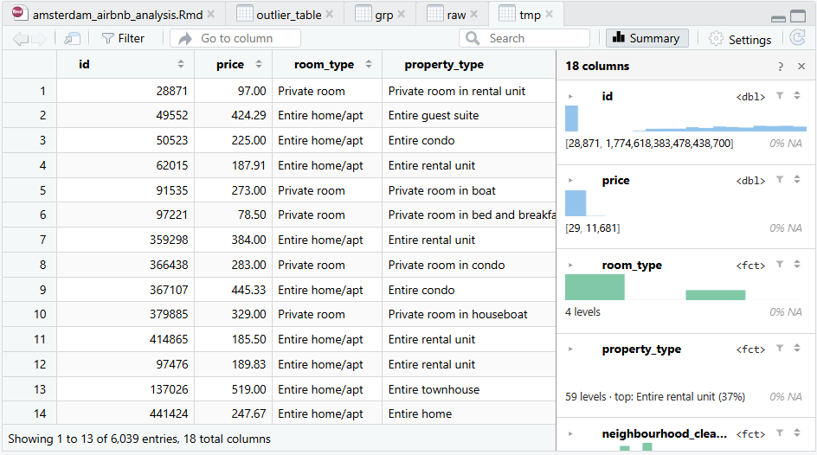
Figure C: Cleaned dataset in the RStudio data viewer after dropping rows without price and imputing missing values (6,039 rows, 0 NAs).

5.4 Outlier detection
Two methods: the IQR rule (1.5 x IQR beyond the quartiles) and Z-scores (|z| > 3).
num_vars <- c("price", "accommodates", "bedrooms", "beds", "minimum_nights",
"availability_365", "number_of_reviews", "review_scores_rating")
iqr_flag <- function(x) {
q <- quantile(x, c(.25, .75)); i <- q[2] - q[1]
x < q[1] - 1.5 * i | x > q[2] + 1.5 * i
}
tibble(variable = num_vars,
iqr_outliers = sapply(num_vars, function(v) sum(iqr_flag(df[[v]]))),
z_outliers = sapply(num_vars, function(v) sum(abs(scale(df[[v]])) > 3)),
max_value = sapply(num_vars, function(v) max(df[[v]]))) %>%
mutate(pct_iqr = round(100 * iqr_outliers / nrow(df), 1)) %>%
kable(caption = "Outliers by method")
Outliers by method
variable | iqr_outliers | z_outliers | max_value | pct_iqr
price | 333 | 41 | 11681 | 5.5
accommodates | 60 | 60 | 16 | 1.0
bedrooms | 195 | 34 | 17 | 3.2
beds | 544 | 54 | 33 | 9.0
minimum_nights | 306 | 44 | 365 | 5.1
availability_365 | 0 | 0 | 365 | 0.0
number_of_reviews | 906 | 104 | 5732 | 15.0
review_scores_rating | 352 | 120 | 5 | 5.8
df %>%
select(price, minimum_nights) %>%
pivot_longer(everything()) %>%
ggplot(aes(x = name, y = value)) +
geom_boxplot(fill = "steelblue", alpha = .6) +
scale_y_log10() +
labs(x = NULL, y = "Value (log scale)")
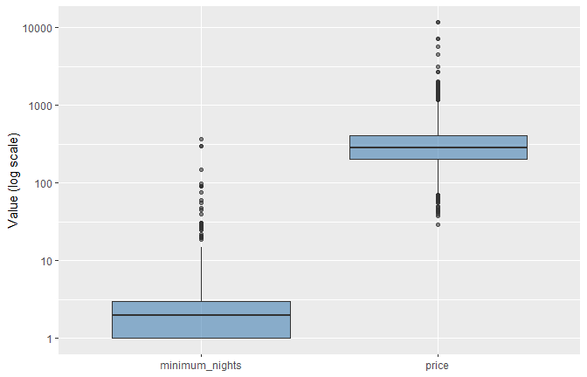
Price and minimum nights before treatment (log scale)
Interpretation. Both methods flag price, number of reviews, beds and bedrooms most heavily. The IQR rule flags many more points than the Z-score rule (333 versus 41 for price) because the variables are strongly right-skewed. The most expensive listings fall into two groups: very large properties (16 guests, up to 17 bedrooms) at about $7,200 per night, which are plausible group rentals, and a few 2-guest listings above $11,000, which are far more likely to be errors or placeholder prices. Low review scores were also flagged, but they are genuine guest ratings on a bounded scale, not errors. Deleting every flagged row would remove about 15% of listings for number of reviews alone and bias the sample, so I limit their influence by capping instead.

Treatment: winsorizing plus log transform
Why not delete? Extreme values may be real (a luxury houseboat, a monthly-stay rental), and deleting thousands of rows would bias the sample. Capping at the 1st and 99th percentiles limits their influence while keeping every listing. Price is also strongly right-skewed, so a log transform is added for analysis.
winsor <- function(x) { q <- quantile(x, c(.01, .99)); pmin(pmax(x, q[1]), q[2]) }
df <- df %>%
mutate(across(all_of(num_vars), winsor, .names = "{.col}_w"),
log_price = log(price_w))
tibble(variable = num_vars,
max_before = sapply(num_vars, function(v) max(df[[v]])),
max_after = sapply(paste0(num_vars, "_w"), function(v) max(df[[v]]))) %>%
kable(digits = 1, caption = "Maximum before and after capping")
Maximum before and after capping
variable | max_before | max_after
price | 11681 | 1173.0
accommodates | 16 | 7.0
bedrooms | 17 | 4.0
beds | 33 | 6.0
minimum_nights | 365 | 26.0
availability_365 | 365 | 364.6
number_of_reviews | 5732 | 733.0
review_scores_rating | 5 | 5.0
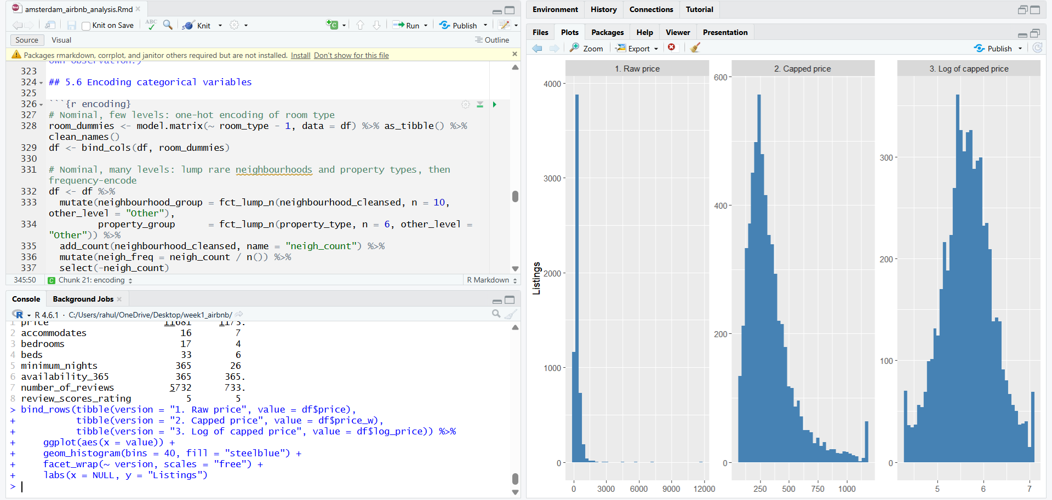
Figure D: Effect of winsorizing on price (histograms) and the maximum of each variable before and after capping (console).
bind_rows(tibble(version = "1. Raw price", value = df$price),
tibble(version = "2. Capped price", value = df$price_w),
tibble(version = "3. Log of capped price", value = df$log_price)) %>%
ggplot(aes(x = value)) +
geom_histogram(bins = 40, fill = "steelblue") +
facet_wrap(~ version, scales = "free") +
labs(x = NULL, y = "Listings")
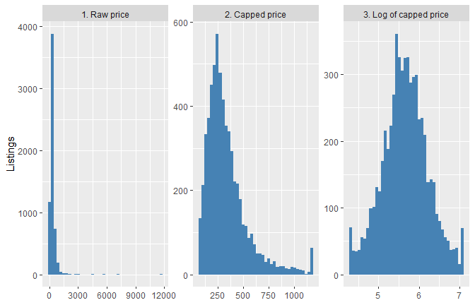
Price before and after capping and log transform

5.5 Normalization
Variables sit on very different scales (e.g. accommodates 1 to 16 versus availability_365 0 to 365).
min_max <- function(x) (x - min(x)) / (max(x) - min(x))
w_vars <- paste0(num_vars, "_w")
df <- df %>%
mutate(across(all_of(w_vars), min_max, .names = "{.col}_mm"),
across(all_of(w_vars), ~ as.numeric(scale(.)), .names = "{.col}_z"))
df %>%
summarise(across(c(price_w, price_w_mm, price_w_z), list(min = min, max = max, mean = mean, sd = sd))) %>%
pivot_longer(everything(), names_to = c("variable", "stat"), names_pattern = "(.*)_(min|max|mean|sd)$") %>%
pivot_wider(names_from = stat, values_from = value) %>%
kable(digits = 3, caption = "Effect of normalization on price")
Effect of normalization on price
variable | min | max | mean | sd
price_w | 75.000 | 1173.018 | 334.773 | 201.211
price_w_mm | 0.000 | 1.000 | 0.237 | 0.183
price_w_z | -1.291 | 4.166 | 0.000 | 1.000
When to use which. Min-max rescales to 0 to 1 and suits distance-based methods such as KNN. Z-score (mean 0, sd 1) suits regression and PCA. Scaling was applied to the capped columns, because min-max scaling is very sensitive to extremes: a single $11,681 listing would have squashed every other price into a narrow band near zero. After scaling, price_w_mm runs from 0 to 1 and price_w_z has a mean of about 0 and a standard deviation of 1.

5.6 Encoding categorical variables
# Nominal, few levels: one-hot encoding of room type
room_dummies <- model.matrix(~ room_type - 1, data = df) %>% as_tibble() %>% clean_names()
df <- bind_cols(df, room_dummies)
# Nominal, many levels: lump rare neighbourhoods and property types, then frequency-encode
df <- df %>%
mutate(neighbourhood_group = fct_lump_n(neighbourhood_cleansed, n = 10, other_level = "Other"),
property_group = fct_lump_n(property_type, n = 6, other_level = "Other")) %>%
add_count(neighbourhood_cleansed, name = "neigh_count") %>%
mutate(neigh_freq = neigh_count / n()) %>%
select(-neigh_count)
# Ordinal: price band built from quartiles of capped price
df <- df %>%
mutate(price_band = cut(price_w,
breaks = quantile(price_w, c(0, .25, .5, .75, 1)),
labels = c("Budget", "Standard", "Premium", "Luxury"),
include.lowest = TRUE, ordered_result = TRUE),
price_band_num = as.integer(price_band))
# Binary flag (host_is_superhost) was encoded as 0/1 in 5.1
df %>% select(room_type, starts_with("room_type_")) %>% head() %>% kable()
room_type | room_type_entire_home_apt | room_type_hotel_room | room_type_private_room | room_type_shared_room
Private room | 0 | 0 | 1 | 0
Entire home/apt | 1 | 0 | 0 | 0
Entire home/apt | 1 | 0 | 0 | 0
Entire home/apt | 1 | 0 | 0 | 0
Private room | 0 | 0 | 1 | 0
Private room | 0 | 0 | 1 | 0
count(df, price_band) %>% kable(caption = "Ordinal price band")
Ordinal price band
price_band | n
Budget | 1511
Standard | 1509
Premium | 1510
Luxury | 1509
Why. Room type has few levels, so one-hot is safe. Neighbourhood has about 22 levels, so one-hot would add many sparse columns. I lump the rare ones and also give a frequency encoding. Price band is genuinely ordered, so it gets integer codes that preserve the order.

6. Exploratory Analysis

6.1 Descriptive statistics
skewness <- function(x) mean(((x - mean(x)) / sd(x))^3)
df %>%
select(all_of(num_vars)) %>%
pivot_longer(everything(), names_to = "variable") %>%
group_by(variable) %>%
summarise(mean = mean(value), median = median(value), sd = sd(value),
min = min(value), max = max(value), skew = skewness(value)) %>%
kable(digits = 2, caption = "Descriptive statistics (after imputation, before capping)")
Descriptive statistics (after imputation, before capping)
variable | mean | median | sd | min | max | skew
accommodates | 2.96 | 2.00 | 1.37 | 1 | 16 | 2.67
availability_365 | 159.62 | 143.00 | 124.18 | 0 | 365 | 0.23
bedrooms | 1.48 | 1.00 | 0.88 | 0 | 17 | 2.68
beds | 1.85 | 1.00 | 1.51 | 1 | 33 | 7.13
minimum_nights | 3.03 | 2.00 | 8.77 | 1 | 365 | 27.05
number_of_reviews | 78.27 | 14.00 | 186.61 | 0 | 5732 | 9.48
price | 345.06 | 285.25 | 337.99 | 29 | 11681 | 16.83
review_scores_rating | 4.84 | 4.91 | 0.25 | 1 | 5 | -4.80

6.2 Price distribution
ggplot(df, aes(x = price_w)) +
geom_histogram(bins = 40, fill = "steelblue") +
geom_vline(xintercept = median(df$price_w), colour = "red", linetype = "dashed") +
labs(x = "Capped price (USD)", y = "Listings",
subtitle = "Dashed line = median")
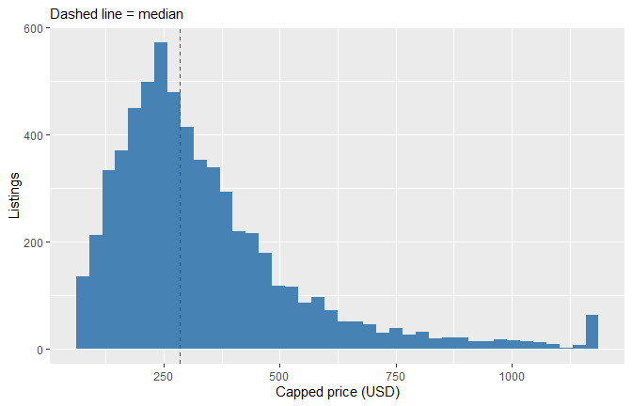
Distribution of nightly price

6.3 Listing mix
df %>% count(room_type) %>% mutate(pct = round(100 * n / sum(n), 1)) %>% kable()
room_type | n | pct
Entire home/apt | 4320 | 71.5
Hotel room | 23 | 0.4
Private room | 1674 | 27.7
Shared room | 22 | 0.4
ggplot(df, aes(x = fct_infreq(room_type), fill = room_type)) +
geom_bar(show.legend = FALSE) + labs(x = NULL, y = "Listings")
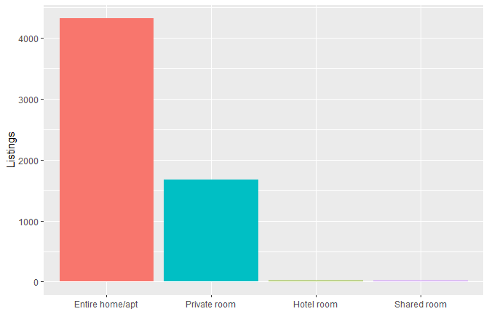
Listings by room type

6.4 Price by room type and neighbourhood
ggplot(df, aes(x = room_type, y = price_w, fill = room_type)) +
geom_boxplot(show.legend = FALSE) +
scale_y_log10() +
labs(x = NULL, y = "Price (USD, log scale)")
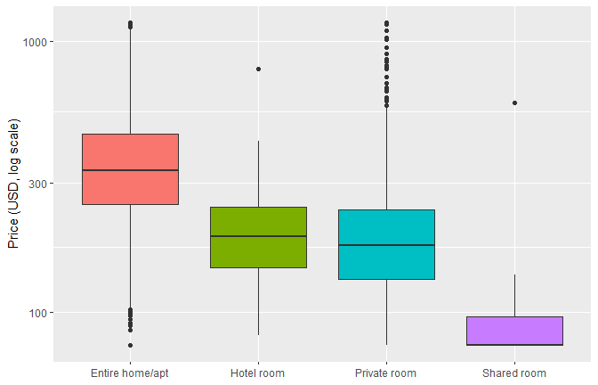
Price by room type (log scale)
df %>% group_by(room_type) %>%
summarise(listings = n(), median_price = median(price), mean_price = round(mean(price), 1)) %>%
kable(caption = "Price by room type")
Price by room type
room_type | listings | median_price | mean_price
Entire home/apt | 4320 | 332.0 | 401.1
Hotel room | 23 | 190.0 | 226.7
Private room | 1674 | 176.1 | 205.3
Shared room | 22 | 63.5 | 93.2
top10 <- df %>% count(neighbourhood_cleansed, sort = TRUE) %>% slice_head(n = 10) %>% pull(neighbourhood_cleansed)
df %>% filter(neighbourhood_cleansed %in% top10) %>%
group_by(neighbourhood_cleansed) %>%
summarise(median_price = median(price), listings = n()) %>%
ggplot(aes(x = reorder(neighbourhood_cleansed, median_price), y = median_price)) +
geom_col(fill = "steelblue") + coord_flip() +
labs(x = NULL, y = "Median price (USD)")
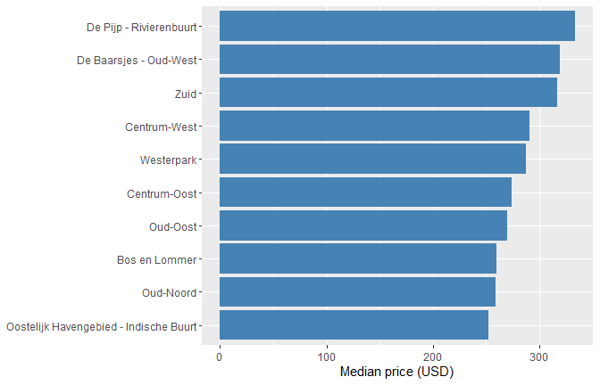
Median price of the ten largest neighbourhoods
df %>% filter(room_type == "Entire home/apt", neighbourhood_cleansed %in% top10) %>%
group_by(neighbourhood_cleansed) %>%
summarise(median_price = median(price), listings = n()) %>%
arrange(desc(median_price)) %>%
kable(caption = "Median price of entire homes by neighbourhood")
Median price of entire homes by neighbourhood
neighbourhood_cleansed | median_price | listings
Centrum-West | 402.625 | 440
De Pijp - Rivierenbuurt | 373.500 | 527
Centrum-Oost | 368.000 | 369
Zuid | 365.670 | 321
De Baarsjes - Oud-West | 354.265 | 794
Westerpark | 308.915 | 324
Oud-Oost | 299.170 | 272
Oud-Noord | 285.120 | 200
Bos en Lommer | 282.500 | 226
Oostelijk Havengebied - Indische Buurt | 265.085 | 166
df %>% filter(neighbourhood_cleansed %in% top10) %>%
group_by(neighbourhood_cleansed) %>%
summarise(pct_private_room = round(100 * mean(room_type == "Private room"), 1)) %>%
arrange(desc(pct_private_room)) %>%
kable(caption = "Share of private rooms by neighbourhood")
Share of private rooms by neighbourhood
neighbourhood_cleansed | pct_private_room
Centrum-West | 48.1
Centrum-Oost | 43.5
Oud-Noord | 24.6
Zuid | 23.8
Oostelijk Havengebied - Indische Buurt | 23.1
Oud-Oost | 20.1
De Pijp - Rivierenbuurt | 18.2
De Baarsjes - Oud-West | 17.4
Westerpark | 13.3
Bos en Lommer | 11.4
Interpretation. Across all listings the median price differs only modestly between the ten largest neighbourhoods ($252 to $334), and the central areas do not rank first. Among entire homes the picture changes: Centrum-West has the highest median ($403), followed by De Pijp ($374), Centrum-Oost ($368) and Zuid ($366). The reason is the mix of listings, since 48% of Centrum-West listings and 44% of Centrum-Oost listings are private rooms, compared with 11% to 25% in most other areas. Comparing neighbourhoods without accounting for room type is therefore misleading.

6.5 Price versus size and quality
ggplot(df, aes(x = accommodates, y = price_w)) +
geom_jitter(alpha = .15, width = .2) +
geom_smooth(method = "lm", colour = "red") +
scale_y_log10() +
labs(x = "Guests accommodated", y = "Price (USD, log scale)")
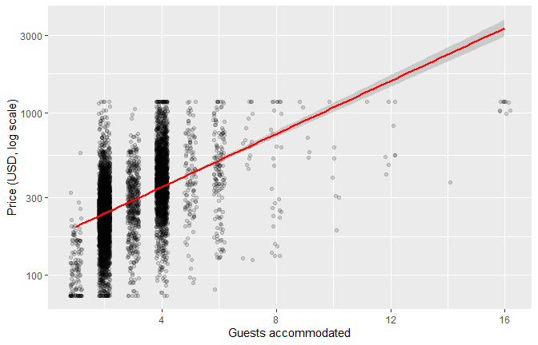
Price versus number of guests
df %>% filter(number_of_reviews > 0) %>%
ggplot(aes(x = review_scores_rating, y = price_w)) +
geom_point(alpha = .15) +
geom_smooth(colour = "red") +
scale_y_log10() +
labs(x = "Review score", y = "Price (USD, log scale)")
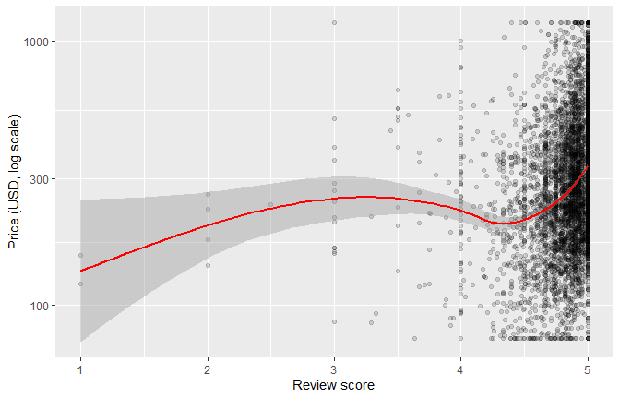
Price versus review rating (listings with at least one review)
df %>% group_by(host_is_superhost) %>%
summarise(listings = n(), median_price = median(price), mean_rating = round(mean(review_scores_rating), 2)) %>%
kable(caption = "Superhost (1) versus regular host (0)")
Superhost (1) versus regular host (0)
host_is_superhost | listings | median_price | mean_rating
0 | 4622 | 300.93 | 4.83
1 | 1417 | 230.00 | 4.87
df %>% count(room_type, host_is_superhost) %>%
group_by(host_is_superhost) %>% mutate(pct = round(100 * n / sum(n), 1)) %>%
kable(caption = "Room type mix by superhost status (pct is within each host group)")
Room type mix by superhost status (pct is within each host group)
room_type | host_is_superhost | n | pct
Entire home/apt | 0 | 3636 | 78.7
Entire home/apt | 1 | 684 | 48.3
Hotel room | 0 | 18 | 0.4
Hotel room | 1 | 5 | 0.4
Private room | 0 | 956 | 20.7
Private room | 1 | 718 | 50.7
Shared room | 0 | 12 | 0.3
Shared room | 1 | 10 | 0.7
df %>% group_by(room_type, host_is_superhost) %>%
summarise(n = n(), median_price = median(price), .groups = "drop") %>%
kable(caption = "Median price by room type and superhost status")
Median price by room type and superhost status
room_type | host_is_superhost | n | median_price
Entire home/apt | 0 | 3636 | 337.250
Entire home/apt | 1 | 684 | 308.500
Hotel room | 0 | 18 | 187.000
Hotel room | 1 | 5 | 268.000
Private room | 0 | 956 | 172.645
Private room | 1 | 718 | 183.000
Shared room | 0 | 12 | 68.000
Shared room | 1 | 10 | 61.500
Interpretation. Superhost listings have a lower median price overall ($230 versus $301), but this is largely a composition effect: about half of superhost listings are private rooms, compared with about a fifth of other listings. Within room types the picture is mixed. Superhost entire homes are about 9% cheaper ($308 versus $337), while superhost private rooms are slightly more expensive ($183 versus $173). The raw comparison therefore overstates any superhost discount.

6.6 Geography
ggplot(df, aes(x = longitude, y = latitude, colour = log_price)) +
geom_point(alpha = .5, size = .8) +
scale_colour_viridis_c() +
coord_quickmap() +
labs(colour = "Log price")
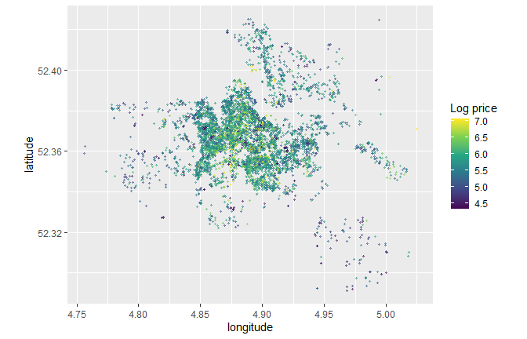
Listings are densely concentrated in the central and western parts of the city, and the highest-priced listings (yellow-green points) cluster in this dense core. The outer areas, such as the south-east, show mostly darker, lower-priced points. Because many points overlap in the centre, the map shows the general pattern but not exact price differences between neighbourhoods.

6.7 Correlations
The size variables are strongly correlated with each other (beds and accommodates r = 0.77, bedrooms and accommodates r = 0.69, bedrooms and beds r = 0.68), so they carry overlapping information and would be multicollinear in a regression.
cor_mat <- df %>%
select(log_price, accommodates_w, bedrooms_w, beds_w, minimum_nights_w,
availability_365_w, number_of_reviews_w, review_scores_rating_w,
host_is_superhost) %>%
rename_with(~ str_remove(., "_w$")) %>%
cor()
corrplot(cor_mat, method = "color", type = "upper", tl.cex = 0.7, tl.col = "black",
addCoef.col = "black", number.cex = 0.55)
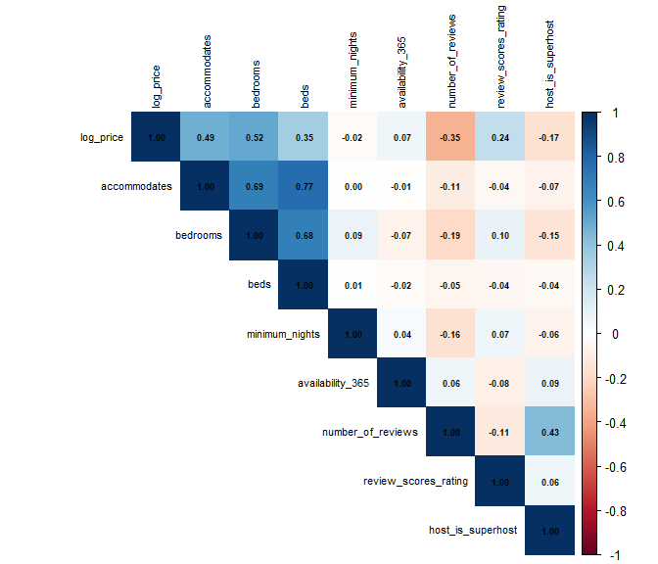
Correlation matrix
Interpretation. Log price is most strongly related to the size of the listing: bedrooms (r = 0.52) and guests accommodated (r = 0.49). Number of reviews is negatively correlated with price (r = -0.35), review score has a weak positive correlation (r = 0.24), and superhost status is weakly negative (r = -0.17). Minimum nights and availability show almost no relationship with price. These are correlations, not causal effects, and the size variables are correlated with each other, which matters as multicollinearity in any later model.

6.8 Statistical tests
# Does price differ across room types? (not normal, so Kruskal-Wallis)
kruskal.test(price ~ room_type, data = df)
##
## Kruskal-Wallis rank sum test
##
## data: price by room_type
## Kruskal-Wallis chi-squared = 1749.3, df = 3, p-value < 2.2e-16
# Do superhosts charge different prices?
wilcox.test(price ~ host_is_superhost, data = df)
##
## Wilcoxon rank sum test with continuity correction
##
## data: price by host_is_superhost
## W = 4097833, p-value < 2.2e-16
## alternative hypothesis: true location shift is not equal to 0
# Rank correlation between price and size
cor.test(df$price, df$accommodates, method = "spearman", exact = FALSE)
##
## Spearman's rank correlation rho
##
## data: df$price and df$accommodates
## S = 1.8283e+10, p-value < 2.2e-16
## alternative hypothesis: true rho is not equal to 0
## sample estimates:
## rho
## 0.5019238
Interpretation. A Kruskal-Wallis test shows that price differs significantly across room types (chi-squared = 1749.3, df = 3, p < 0.001), and a Wilcoxon rank-sum test shows a significant difference between superhosts and other hosts (p < 0.001). The Spearman correlation between price and capacity is 0.50. Non-parametric tests were used because price is strongly right-skewed. The very small p-values partly reflect the sample size, so the medians and correlations matter more than significance as a measure of effect size. The Wilcoxon test does not control for room type.

7. Key Insights
The findings below come from the cleaned data (6,039 listings with a price).
- Price is highly skewed. The median is $285 against a mean of $345 (skewness 16.8), and capping reduced the maximum price from $11,681 to $1,173.
- Room type is the clearest price driver. Median price is $332 for entire homes, $176 for private rooms and $63.5 for shared rooms.
- Size is the strongest numeric signal. Bedrooms (r = 0.52) and guests accommodated (r = 0.49) correlate most strongly with log price.
- Raw comparisons can mislead. Among entire homes, Centrum-West is the most expensive of the ten largest neighbourhoods (median $403), but across all listings it ranks fourth because 48% of its listings are private rooms.
- The superhost discount is mostly a mix effect. About half of superhost listings are private rooms (versus about a fifth for other hosts). Within entire homes superhosts are about 9% cheaper ($308 versus $337), while within private rooms they are slightly more expensive ($183 versus $173).
- Reviews: listings with many reviews tend to be cheaper (r = -0.35), and ratings sit near the ceiling (median 4.91), so they discriminate poorly between listings.
- Data quality: 43% of listings had no price, 598 of the 6,039 priced listings have no rating because they have no reviews, and five columns were entirely empty.

8. Challenges and Conclusion
Challenges. About 43% of listings have no price, numbers stored as text, structural missingness in review columns, extreme price and minimum-night values, a neighbourhood variable with many levels, and five completely empty columns.
Conclusion. I cleaned the Inside Airbnb Amsterdam listings by removing five empty columns, converting text prices to numbers, handling missing values with a justified strategy per column, capping outliers at the 1st and 99th percentiles, scaling the numeric variables and encoding the categorical ones. The cleaned dataset of 6,039 priced listings is ready for a model predicting log_price.
Limitations. The data is a single snapshot, and listed prices are asking prices, not actual booking revenue.

Appendix: Reproducibility
sessionInfo()
## R version 4.6.1 (2026-06-24 ucrt)
## Platform: x86_64-w64-mingw32/x64
## Running under: Windows 11 x64 (build 26100)
##
## Matrix products: default
## LAPACK version 3.12.1
##
## locale:
## [1] LC_COLLATE=English_India.utf8 LC_CTYPE=English_India.utf8
## [3] LC_MONETARY=English_India.utf8 LC_NUMERIC=C
## [5] LC_TIME=English_India.utf8
##
## time zone: Asia/Calcutta
## tzcode source: internal
##
## attached base packages:
## [1] stats graphics grDevices utils datasets methods base
##
## other attached packages:
## [1] knitr_1.52 corrplot_0.95 skimr_2.2.2 naniar_1.1.0
## [5] janitor_2.2.1 lubridate_1.9.5 forcats_1.0.1 stringr_1.6.0
## [9] dplyr_1.2.1 purrr_1.2.2 readr_2.2.0 tidyr_1.3.2
## [13] tibble_3.3.1 ggplot2_4.0.3 tidyverse_2.0.0
##
## loaded via a namespace (and not attached):
## [1] generics_0.1.4 lattice_0.22-9 stringi_1.8.9 hms_1.1.4
## [5] digest_0.6.39 magrittr_2.0.5 evaluate_1.0.5 grid_4.6.1
## [9] timechange_0.4.0 RColorBrewer_1.1-3 fastmap_1.2.0 Matrix_1.7-5
## [13] jsonlite_2.0.0 mgcv_1.9-4 viridisLite_0.4.3 scales_1.4.0
## [17] cli_3.6.6 crayon_1.5.3 rlang_1.3.0 splines_4.6.1
## [21] bit64_4.8.6 base64enc_0.1-6 withr_3.0.3 repr_1.1.7
## [25] yaml_2.3.12 otel_0.2.0 parallel_4.6.1 tools_4.6.1
## [29] tzdb_0.5.0 vctrs_0.7.3 R6_2.6.1 lifecycle_1.0.5
## [33] snakecase_0.11.1 bit_4.6.0 vroom_1.7.1 pkgconfig_2.0.3
## [37] pillar_1.11.1 gtable_0.3.6 glue_1.8.1 visdat_0.6.1
## [41] xfun_0.61 tidyselect_1.2.1 rstudioapi_0.19.0 farver_2.1.2
## [45] nlme_3.1-169 htmltools_0.5.9 labeling_0.4.3 rmarkdown_2.32
## [49] compiler_4.6.1 S7_0.2.2

