* The application is made by using ***Android Studio*** and ***Google Pixel*** emulator is used for testing purposes.
* First time opening the application will show 3 introduction skip slides, describing in very brief what the application can do.

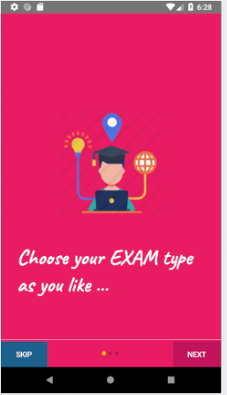

* The user can either choose to continue with the slides or skip it.

**Note** : **Once the user is done with the slides they will never appear again until he/she has reinstalled the application.**

* Once introduction is over,Login screen appears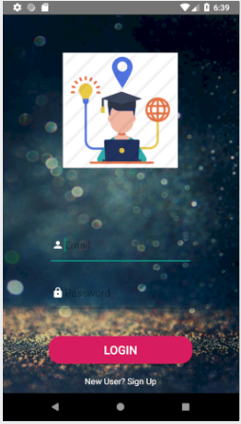
* If the user is logging in for the first time then he/she needs to sign up first. For that click on the” ***New User? Sign Up*** “ text in the bottom of the screen.
* Here is the sign up page where the user will have to give an email and password and then press ***Sign Up*** button.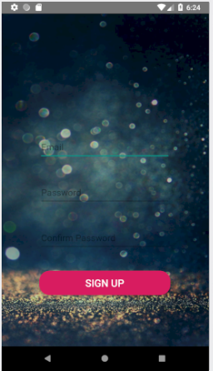
* Upon pressing it the user will be redirected to the login page where he/she has to provide his/her Email and Password.

**Note: Login credentials will include only email and password.**

* Upon successful login the Dashboard will be displayed with an empty recycler view or list.
* Now Goto the top right corner and click the “**three dots button**” in it. A popup will appear with 2 options:

1: Settings

2: Logout

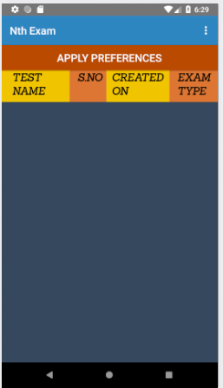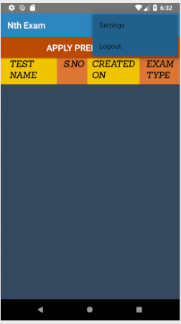

* On clicking settings , the user can select Multiple exams at a single time on the settings screen.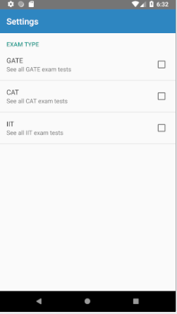

**Note: Multiple exam types can be selected.**

* Select checkboxes according to will.Now press the back button. 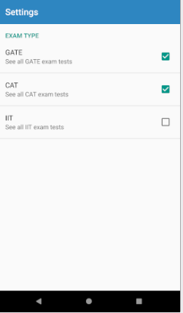 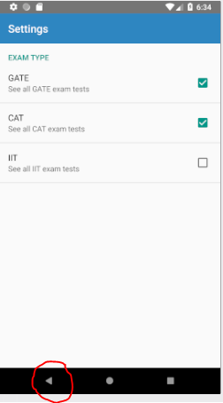
* Now click on ***APPLY PREFERENCES***. The dashboard will be updated. 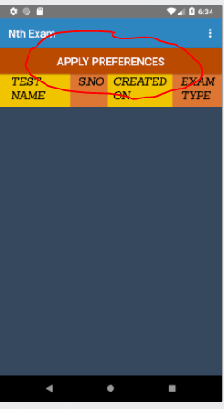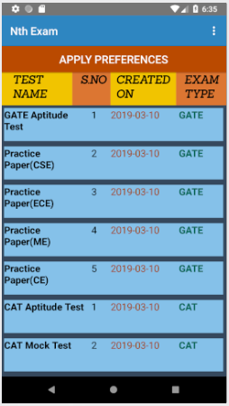

**NOTE : Here S.NO is not serial number, it is sequence number of the tests in a particular exam type and therefore it need not always continue in ascending order.**

* Now the user can choose to logout using the ***logout*** option in the dropdown menu. He/she will be asked to login again.