Internship

Semester – VIII

A PROJECT REPORT

Submitted by Meet Shah 210280107131

In partial fulfillment for the award of the degree of

BACHELOR OF ENGINEERING
in
Computer Engineering
L. D. COLLEGE OF ENGINEERING





Gujarat Technological University, Ahmedabad

[ 20th Jan 2025 to 20th April 2025]

L.D. COLLEGE OF ENGINEERING
AHMEDABAD, GUJARAT

CERTIFICATE
This is to certify that the project report submitted along with the project entitled Internship been carried out by Meet Shah under my guidance in partial fulfillment for the degree of Bachelor of Engineering in Computer Engineering, 8th Semester of Gujarat Technological University, Ahmedabad during the academic year 2025-26.

Prof. Bhoomi Trivedi

Internal Guide
Dr. Chirag. S. Thaker

Head of the Department

L.D. COLLEGE OF ENGINEERING
AHMEDABAD, GUJARAT

OFFER LETTER

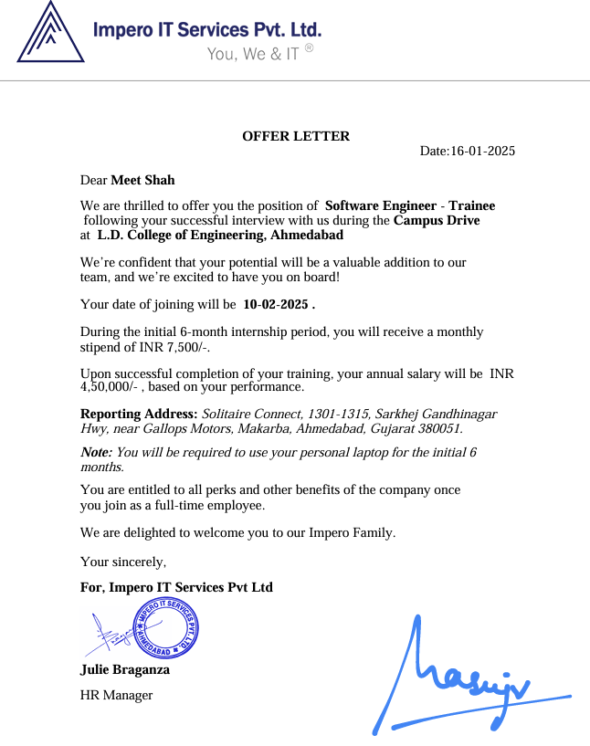

L.D. COLLEGE OF ENGINEERING
AHMEDABAD, GUJARAT

DECLARATION
We hereby declare that the Internship / Project report submitted along with the Internship entitled Internship submitted in partial fulfillment for the degree of Bachelor of Engineering in Computer Engineering to Gujarat Technological University, Ahmedabad, is a bonafide record of original project work carried out by me at Impero IT Services Pvt. Ltd. under the supervision of Prof. Bhoomi Trivedi and that no part of this report has been directly copied from any students‟ reports or taken from any other source, without providing due reference.

Name of the Student | Sign of Student
Meet Shah

ACKNOWLEDGEMENT

I would like to express my sincere gratitude to several individuals for supporting me throughout my internship project. First, I wish to express my sincere gratitude to my Internal Guide, Prof. Bhoomi Trivedi, for her enthusiasm, patience, insightful comments, helpful information, practical advice and unceasing ideas that have helped me tremendously at all times in my project. Without her support and guidance, this project would not have been possible.

I would like to express my endless thanks to my external guide Julie Braganza at Impero IT Services Pvt. Ltd. their sincere and dedicated guidance throughout the project development.

I am highly indebted to my institute guide Prof. Bhoomi Trivedi for the facilities provided to accomplish this internship. Also I would like to thank my Head of the Department Dr. Chirag Thaker for his constructive criticism throughout my internship. I am extremely grateful to my department staff members and friends who helped me in successful completion of this internship.

Thanks,
Meet Shah 210280107131

ABSTRACT

The Job Seeking Application Portal is a web-based platform designed to streamline the process of job searching, application management, and recruitment. It serves as a bridge between job seekers and employers, providing an intuitive and secure environment to post job listings, apply for jobs, and manage application records.
At its core, the system is built using the MERN stack (MongoDB, Express.js, React, Node.js), with Mongoose schemas to model and manage structured data. The portal offers role-based access, distinguishing between two primary user types: Job Seekers and Employers.
- Users are authenticated and registered with fields such as name, email, phone number, password (securely stored), and role. The role determines access privileges and interaction capabilities within the platform.
- Employers can create detailed Job postings specifying title, description, category, location, and salary details. Each job listing is associated with the employer who posted it and includes a timestamp for tracking.
- Job Seekers can browse available jobs and submit Applications, including personal information, a cover letter, phone number, address, and a resume (uploaded via Cloudinary and stored with public ID and URL). Each application maintains references to both the job seeker and the employer for clear traceability.
The data integrity is ensured using comprehensive validation logic within each schema, including field-specific requirements like length constraints, proper email formats, and enumerated role values.
This modular and scalable system enables efficient management of job postings and applications, ensuring a robust backend that supports real-time interaction and data consistency. It is tailored to modern recruitment needs and can be further enhanced with features such as real-time notifications, interview scheduling, and analytics dashboards.

Fig No. Description Page
Fig 1.1 Company Logo 8
Fig 2.1 Production Stage 13
Fig 3.1 Scrum Methodology 18
Fig 3.2 Gantt Chart 20
Fig 4.1 Use Case Diagram 24
Fig 4.3 Activity Diagram 26
Fig 4.4 Data Flow Diagram (Level 0, 1, 2) 27
Fig 5.1 Flowchart 32
Fig 5.4.1 Home Page (Employer) …............................................................................................29
Fig 5.4.2 Signup & Login Page ……...........................................................................................30
Fig 5.4.3 Posting New Job Page ..................................................................................................30
Fig 5.4.4 All Available Jobs Page …...........................................................................................31
Fig 5.4.5 Applicant’s Application Page ......................................................................................31
Fig 5.4.6 View Your Jobs Page...................................................................................................32
Fig 5.4.7 Home Page (Job Seeker)..............................................................................................32
Fig 5.4.8 All Available Jobs Page ...............................................................................................34
Fig 5.4.9 Job Details Page………………………………………………………………..………35
Fig 5.4.10 Application Form …………………….………………………………………….……35
Fig 5.4.11 My Applications Page…….……………………………………..……………………35

Table No. Table Name Page
Table 3.1 Project/Internship Summary 14
Table 5.1 Database Schema 31
Table 7.1 Test Levels 38
Table 7.2 Test Cases 39

Abbreviations

Docs | Documents
IDE | Integrated Development Environment
SQL | Structured Query Language
JS | JavaScript
HTML | Hyper Text Markup Language
CSS | Cascading Style Sheet
JSP | Java Server Pages
DBA | Database Administrator
DBMS | Database Management System
HR | Human resources
QA | Quality Assurance
SMS | Short Message Service
UI | User Interface
UX | User Experience

Table of Contents
Acknowledgement i
Abstract ii
List of Figures iii
List of Tables iv
List of Abbreviations v
Table of Contents vi
CHAPTER 1: OVERVIEW OF COMPANY 8
  - Company Introduction 8
  - Different Services 9
CHAPTER 2: OVERVIEW OF COMPANY DEPARTMENT 12
  - All Departments 12
  - Technical Specifications in Department 12
  - Sequence of Operators. 13
2.3 Product Stages 13
CHAPTER 3: INTRODUCTION TO INTERNSHIP 14

3.1 Internship Project Summary 14
3.2 Purpose 14
3.3 Objective 15
3.4 Scope 15
  - Technology and Literature Review 16
  - Planning 16
    - Project/Internship Development Approach and Justification 17
    - Roles and Responsibilities 18
    - Group Dependencies 19
  - Scheduling 20

CHAPTER 4: SYSTEM ANALYSIS 21

4.1 Study of Current System……...……………………………… | 21

4.2 Weakness of Current System 22
4.3 Requirements of New System 23
4.4 Activity System 24
4.4.1 Use Case Diagram… 25
4.4.2 Activity Diagram 25
4.5 Data Flow Diagram 26
4.6 Features of New System 27
4.7 Selection of Hardware and Software 28

CHAPTER 5: SYSTEM DESING 21
  - Database Design 21
  - Flowchart 31
  - Interface Desing 32
CHAPTER 6: IMPLEMENTATION 37
  - Implementation Platform 37
6.2 Admin…………………................................................................37
6.3 Employeer………………..............................................................37
6.4 Jobseeker………………................................................................37
CHAPTER 7: TESTING 39
  - Strategies 39
  - Testing Strategy… 39
  - Testing Method 40
    - Unit Testing….,. 42
  - Testing Case 44

CHAPTER 8: CONCLUSION AND DISCUSSION 41
  - Overall Analysis of Internship 41
  - Problem Encountered and Possible Solutions 46
  - Date Of Continuous Evaluation 46
  - Limitations 46
  - Future Enhancement 47

CHAPTER 1 – OVERVIEW OF COMPANY

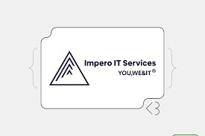

Figure1.1 Company Logo

Company Introduction

Impero is a software development company creating full-fledged smart mobility solutions for your business to make it a recognized brand. Our services include discovering your ideas to designing it and developing it to launching it in the market and ultimately making it a solution that your users will love to use and which will of course top the charts. That is why we term Impero as a tech kingdom. Through its commitment to excellence and innovation, Impero has earned a reputation as a trusted partner for businesses seeking to leverage technology to drive growth and success in today's digital landscape.

YOU, WE & IT
Impero is an Italian word which means KINGDOM, denoted by our logo. This empire consists of 3 Identities YOU,WE&IT with our clients on prime position served by us to accomplish their IT requirements. We would be really happy to welcome you in our empire as most valued identity.

Different Services

- Mobile application development
App development services that meet varied sets of requirements, from native application development to hybrid app development; based on your app idea, our UK app developers are ready to launch your app on different platforms and give your stunning idea a fantastic makeover.
- iOS app development
- Android app development
- Flutter app development
- React Native app development

- Web App Development
Creating web applications for more than 11+ years, we are adept at developing web applications for a variety of industries, providing feature-rich, flawless web apps. Whether you want a Content-Management-System (CMS) or eCommerce web development, at Impero IT, our maestros are great at curating web applications that give your business an up- front.
All-inclusive, if you’re looking for enterprise-ready, highly-responsiveness, efficient web applications, connect with our experts and get started!
- PWA - Progressive Web Apps

- eCommerce web solutions
- CMS development

- ERP solution
- Custom web development

- Web Designing

  - UI / UX design
At Impero IT Services swear by D’s in our approach - Design, Develop & Delight! Every company or business has one goal that is to make their app user-centred! And we exactly do that by designing your product that drives your users to have an excellent user experience! Result? A rise in your customers with your app's seamless experience E – Commerce Development

User Experience (UX)
Your app needs loyal users to top the charts! And for that, along with outstanding features, a beautiful & attractive design is also essential. We are a UI UX design agency that starts each project with thorough research of your app idea, ensuring we excel at understanding your users’ requirements.
Brilliant, easy to use, aesthetically pleasing designs - distinguish a successful app & the app which does not top the charts! Mobile Apps UX design is not only about having beautiful logos or including the latest trends but your users enjoying your app to its fullest.
With our specialised team, we‘re bound to create perfectly intuitive designs that raise the bar of your app. Because UX designing is all about anticipating what users’ really want in your app.

User Interface (UI)
While UX plays the role of laying the best experience, a good UI design ensures a 97% visually stimulating experience that guides your users to achieve the desired action you want.
And we know exactly how to evoke your users by designing a user interface that is intuitive, brilliant, and especially directed towards providing effective interaction. Throughout our journey, we have crafted 1000+ effortless, amusing interfaces.
We are a UI & UX design studio with a creative team of experts who dig deep into materialising visual strategies and tailoring them into a perfect end product. Understanding your user base is the key here, and we excel in providing a visual solution that your users will love to interact with.

  - AR/VR designs

at Impero, develop app & web solutions that augment unexciting tasks to an unbelievable exciting journey. With our twists of technology, we deliver solutions that incite excellent user satisfaction!
AR Apps
For every app owner, customer satisfaction is an enthralling process. AR apps have a very interactive experience; it especially appeals to high-end users because it creates computer- enhanced images which makes it look like they’re residing in the real world. And by integrating AR that is augmented reality technology in your app, your app is undoubtedly gonna be a customer favourite. With our team of experts, we excel in crafting AR-enhanced solutions that make every tedious task a user favourite. Not only that, we provide customised AR apps that suit your business needs, and your target audience can also adapt to it faster and get an immersive app experience.

VR Apps
With everything going virtual, a virtual reality app for your business is much needed. VR apps take a user to new heightened experience and are a great way to bring your business in front of many users. We craft VR apps that are impressive, highly visualised and mainly give a real-life feeling. individuals.

  - Flutter app development
Impero IT is the best choice to hire reliable Flutter developers. Being a renowned Flutter app development company, Impero leverage the many benefits; Flutter offers to create robust, natively compiled apps that can run on Android as well as iOS. Cross-platform development is best suited for startups & businesses looking to reach a larger audience. Based on your professional requirements, you can choose hiring our front-end Flutter experts and empower your business .

    - IOS app development
    - Android app development

CHAPTER 2 – OVERVIEW OF THE COMPANY DEPARTMENT
Impero IT services
Impero is a software development company creating full-fledged smart mobility solutions for your business to make it a recognised brand. Our services include discovering your ideas to designing it and developing it to launching it in the market and ultimately making it a solution that your users will love to use and which will of course top the charts

ALL DEPARTMENTS
    - HR Department
    - Development Department
    - Testing Department

TECHNICAL SPECIFICATIONS IN DEPARTMENT
    - HR Department
Our HR team is committed to finding the best talent and fostering a positive work environment that maximizes employee productivity. They handle everything from recruitment and compensation to training and development.

    - Development Department

Our development department is comprised of skilled professionals across various specialties, including web development, Android development, and iOS development. We use the latest technologies to create high-quality, user-friendly applications Our testing department plays a vital role in ensuring the quality of your software. They rigorously test all aspects of your application to identify and fix any bugs before it reaches the market.

SEQUENCE OF OPERATORS
- Requirement Gathering & Analysis: Our research team gathers your requirements, analyzes them, and defines the features to be developed. They also estimate the project's cost and timeline.
- Development & Team Allocation: We leverage expert teams like Node js MVC for backend and a modern UI framework for frontend, ensuring a tailored approach for each project.
- Testing & Quality Assurance: Once development is complete, our testing team meticulously tests the software to ensure it meets all requirements and functions flawlessly.

PRODUCT STAGES
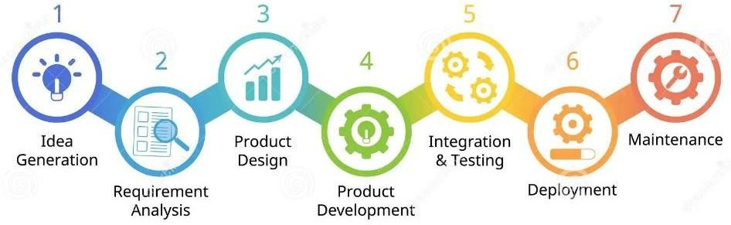
Fig 2.1 Production Stage

CHAPTER 3: INTRODUCTION TO INTERNSHIP

  - PROJECT SUMMARY

Table 3.1: Project Summary

Project Title | Job Seeking Application Portal
Aim | To design and develop a web-based Job Seeking Application Portal that connects job seekers with potential employers. The system aims to simplify job postings, application submissions, and recruitment tracking through a user-friendly and role-based platform.
Developed At | Impero IT Services Pvt. Ltd.
Project Category | Web-site
Tools | IDE | Visual Studio code
 | Languages/Frameworks | MERN Stack
 |  | Third party Api and packages
Duration | 3 Months (January 2025 to April 2025)

PURPOSE

The purpose of this project is to create an efficient and centralized platform that streamlines the job search and recruitment process for both job seekers and employers. It aims to reduce manual effort, enhance communication, and ensure a seamless experience by digitizing job applications, resume submissions, and job postings in a structured and accessible manner.

OBJECTIVE

The objective of this project is to develop a comprehensive web-based Job Seeking Application Portal that effectively bridges the gap between job seekers and employers. The platform aims to offer a seamless and intuitive experience for job seekers to search, explore, and apply for relevant job opportunities, while allowing employers to post vacancies, manage applications, and identify suitable candidates. It focuses on implementing secure, role-based access control to ensure personalized and protected interactions for both user types. The system is designed to manage structured data efficiently, including user details, job postings, and application records, with proper validation to maintain data accuracy and integrity. Ultimately, the objective is to streamline the recruitment process through digital automation, enhancing convenience, accessibility, and efficiency for all users involved.

SCOPE

The scope of the Job Seeking Application Portal encompasses the design and development of a dynamic web-based platform that facilitates end-to-end job application and recruitment management. It caters to two main user roles—Job Seekers and Employers—each with distinct functionalities. Job Seekers can register, browse job listings, submit applications along with resumes, and track their application status. Employers can post job vacancies, review applicant details, and manage hiring workflows.

Functional Scope:
The system includes robust backend validations, secure resume uploads via cloud storage, and a structured database using MongoDB to ensure reliability and scalability. The portal is designed to be scalable and extendable, allowing future enhancements such as real-time notifications, interview scheduling, analytics dashboards, and integration with third-party job boards. This project is limited to web-based access but can be extended to mobile platforms in the future for broader accessibility. Overall, the portal aims to simplify the hiring process while offering an efficient, secure, and user-friendly experience to all stakeholders.

TECHNOLOGY AND LITERATURE REVIEW
MERN Stack

PLANNING

    - Project / Internship Development Approach and Justification

The development of the Job Seeking Application Portal follows the Modular and Agile Development Approach to ensure flexibility, scalability, and timely delivery of the system. The project is divided into manageable modules such as User Management, Job Posting, Application Handling, Resume Uploading, and Role-Based Access Control. Each module is developed, tested, and integrated incrementally, allowing continuous feedback and improvement throughout the development lifecycle.

The backend is built using Node.js with Express.js for efficient API handling and server-side logic, while MongoDB with Mongoose is used for schema-based data modeling, enabling a flexible and scalable NoSQL database structure. The use of Cloudinary for secure and scalable resume storage justifies the need for third-party cloud integration. Validation and error handling are implemented at the schema level to maintain data integrity.

This approach is justified as it supports rapid development, simplifies debugging, and ensures that each component is fully functional and reliable before moving on to the next. It also allows adaptability to changing requirements and easier collaboration in a team development environment. The Agile methodology aligns with modern web development practices, making the system robust, maintainable, and prepared for future enhancements.

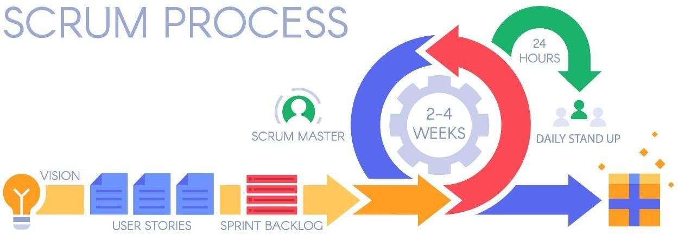

Fig 3.1 Scrum Methodology

The process has as a starting point, a list of objectives/ requirements that make up the project plan. It is the client of the project that prioritizes these objectives considering a balance the value and the cost thereof, that is how the iterations and consequent deliveries are determined.
On the other hand the market demands quality, fast delivery at lower costs, for which a company must be very agile and flexible in the development of products, to achieve short development cycles that can meet the demand of customers without undermining the quality of the result. It is a very easy methodology to implement and very popular for the quick results it gets.

Scrum methodology is used mainly for software development, but other sectors are also taking advantage of its benefits by implementing this methodology in their organizational models such as sales, marketing, & HR teams etc.
    - Roles and Responsibilities
      - Scrum Master
The person who leads the team guiding them to comply with the rules and processes of the methodology. Scrum master manages the reduction of impediments of the project and works with the Product Owner to maximize the ROI. The Scrum Master is in charge of keeping Scrum up to date, providing coaching, mentoring and training to the teams in case it needs it.
      - Product Owner
Product is the representative of the stakeholders and customers who use the software. They focus on the business part and is responsible for the ROI of the project. They translate the vision
of the project to the team, validate the benefits in stories to be incorporated into the Product Backlog and prioritize them on a regular basis.

      - Team
A group of professionals with the necessary technical knowledge who develop the project jointly carrying out the stories they commit to at the start of each sprint.

    - Group Dependencies
Group dependency refers to the reliance of individuals within a group on each other to achieve goals, make decisions, or function effectively. There are several types of group dependency:
      - Pooled interdependence
Individuals work independently on tasks, and the outcomes are then combined to create the final result.
      - Sequential interdependence
The output of one individual or group becomes the input for another, creating a sequential flow of work.

      - Reciprocal interdependence
Individuals or groups depend on each other for resources, information, or support to accomplish their tasks.

      - Comprehensive interdependence
All individuals or groups are highly dependent on each other to achieve common goals, requiring constant communication and coordination.

SCHEDULING

Week | 2 | 3 | 4 | 5 | 6 | 7 | 8 | 9 | 10 | 11 | 12 | 13 | 14
 | February |  |  |  | March |  |  |  | April |  |  |  | April
Domain
Understanding
Future Analysis
Learning Process
Design
Coding and Testing
Documentation
Final Documentation

Fig 3.2 Gantt Chart

CHAPTER 4: SYSTEM ANALYSIS

STUDY OF CURRENT SYSTEM

The study of the current system involves analyzing how job seekers and employers currently interact through traditional or existing digital recruitment platforms. In many cases, job seekers rely on multiple job portals or manual methods such as emailing resumes to employers, while employers use spreadsheets, emails, or separate HR tools to manage applications. These fragmented processes often result in inefficiencies such as lost applications, lack of tracking, delayed communication, and duplicate efforts.

Existing platforms may provide basic functionalities but often lack customized workflows, role-based access, or integrated application tracking features tailored for specific user needs. They may also suffer from limited resume management, minimal validation, poor user experience, or data security issues.

By studying these limitations, the need for a unified, role-specific, and intuitive system becomes clear—one that centralizes job postings, application submissions, and tracking under one platform. This research highlights the gaps in current solutions and serves as a foundation for designing a more efficient, user-friendly, and secure Job Seeking Application Portal.

WEAKNESS OF CURRENT SYSTEM
• Lack of Centralization:
Job seekers and employers often rely on multiple platforms or manual methods, leading to fragmented data and miscommunication.
• Poor Tracking Mechanism:
Existing systems may not provide effective tracking of application statuses, resulting in confusion for both applicants and employers.
• Limited Role-Based Access:
Many current systems do not differentiate features clearly between job seekers and employers, leading to a cluttered and confusing interface.
• Manual Resume Handling:
In some systems, resumes are handled manually via emails, increasing the chances of misplaced or overlooked applications.
• Data Inconsistency and Validation Issues:
Without strict validation, inaccurate or incomplete user data may be submitted, affecting the hiring process.

REQUIREMENT OF NEW SYSTEM
• User Authentication and Role Management:
The system must provide secure user authentication for two primary roles: Job Seekers and Employers. It should allow easy registration, login, and profile management, with role-based access control to ensure that each user only has access to relevant features.
• Job Posting and Management for Employers:
Employers should be able to post job vacancies with details such as title, description, category, location, salary, and other relevant information. They should also have the ability to edit or delete postings and manage applicants for each job listing.
• Job Search and Application for Job Seekers:
Job seekers should be able to search for jobs based on different filters (e.g., category, location, salary range) and submit applications with their resume, cover letter, and other required documents. Each application should be linked to a specific job and job seeker.
• Resume Upload and Cloud Storage:
The system must allow job seekers to upload their resumes securely. Cloud integration, such as Cloudinary, should be used for storing resumes, ensuring scalability, secure access, and efficient management.
• Application Tracking and Status Updates:
Both employers and job seekers should be able to track the status of applications in real-time. Employers should have the ability to update the application status (e.g., shortlisted, interview scheduled, rejected), and job seekers should be notified of these updates.
• Validation and Error Handling:
The system must have robust input validation for all fields to ensure data integrity. Errors or incomplete submissions should be clearly communicated to the user with descriptive messages, enhancing the user experience.
• Notifications and Alerts:
Real-time notifications (via email or in-app alerts) should be implemented for key actions such as job application submission, interview invitations, job posting, and application status updates.

ACTIVITY SYSTEM

    - Use Case Diagram
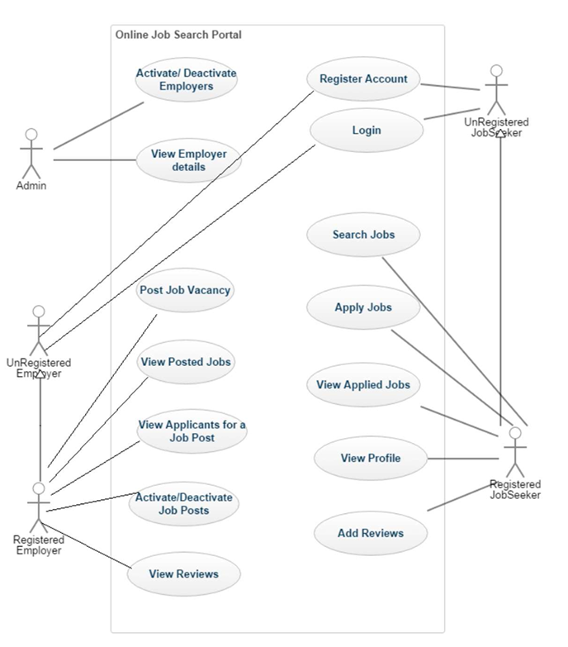

    - Activity Diagram

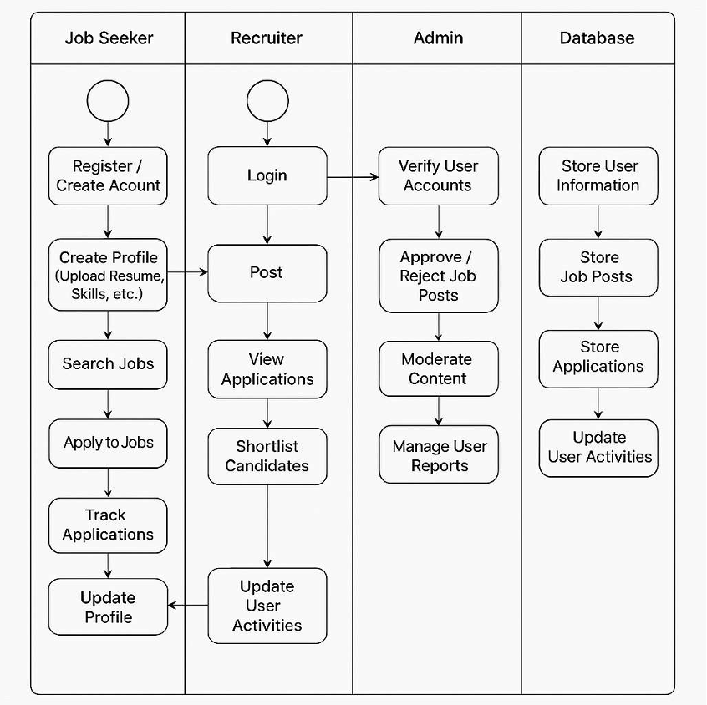

Fig 4.3 Activity diagram

DATA FLOW DIAGRAM

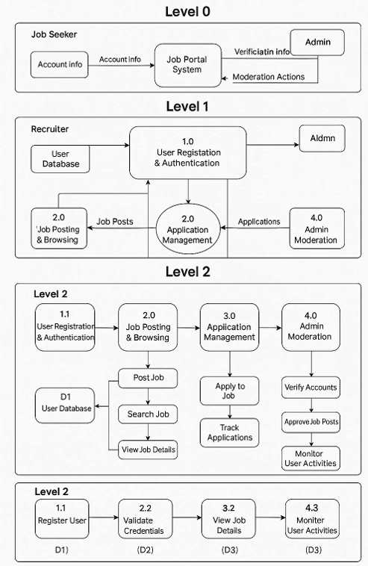

Fig 4.4 Data Flow Diagram

4.6 FEATURE OF NEW SYSTEM

User Authentication & Authorization
- Sign Up – New users can register with their email and password.
- Login – Users can log in using their credentials.
- Protected Routes – Users must be logged in to read, add, edit, or delete blogs.
- Logout – Users can securely log out.

Job & Application Management (CRUD)
1. Read Jobs:
• All users (logged-in or not) can view available job and internship listings on the
Home Page.
• Logged-in job seekers can view full job details and apply to positions.
2. Create Jobs:
• Only Admins can create new job postings by entering details like job title,
description, company name, required skills, and application deadline.
3. Edit Jobs:
• Admins can update existing job listings to change job details, update requirements, or extend deadlines.
4. Delete Jobs:
• Admins have the authority to delete outdated or irrelevant job listings from the
system.
5. Application Management:
• Job seekers can apply for jobs and view the status of their applications on their
dashboard.
• Admins can view all applications for a specific job and approve or reject them based on the candidate's profile.
6. User Management:
• Admins can add or update user details, such as role (job seeker or recruiter), name, and email.
7. User-Specific Dashboard:
• Job seekers have access to a personalized dashboard displaying their submitted
applications and status updates.
• Admins have access to a centralized dashboard for managing jobs, users, and applications

- Third-Party Libraries & Enhancements
- React Router – Handles navigation between pages.
- Redux Toolkit – Manages authentication and global state.
- React Toastify – Provides success/error notifications.
- Multer (Backend) – Handles image uploads.
- Axios – For making API requests.
- Tailwind CSS / Bootstrap – Enhances UI styling.

- UI & UX Enhancements
- Home Page – Displays all published blogs.
- Blog Details Page – Shows full details of a selected blog.
- Responsive Design – Works on mobile, tablet, and desktop.
- Loading Indicators – Shows loaders while fetching data.
- Toast Notifications – Displays messages on success or errors.
- Footer – Provides links to important pages or credits.

- Security & Performance
  - Password Hashing – Uses bcryptjs to secure passwords.
  - JWT Authentication – Secure user login sessions.
  - Route Protection – Prevents unauthorized access.
  - Backend Validation – Ensures data integrity.

CHAPTER 5: SYSTEM DESIGN

5.1 SYSTEM DESIGN:

Systems design is the process of defining the architecture, components, modules, interfaces, and data for a system to satisfy specified requirements. System designs are modelled using UML which is a standard object-oriented analysis and design language. The UML is a collection of diagrams and standard set of notations for specifying and visualizing various aspects such as requirements and design of software systems.

5.2 DATABASE DESIGN:

The database that is used to design the web application is MongoDB. MongoDB workbench is used to create tables and run queries. In this application development, we have used MongoDB to store employer details, jobseeker details, applied jobs by the applicants, jobs posted by the employer. Hence, we have identified four tables to achieve desired functionality.

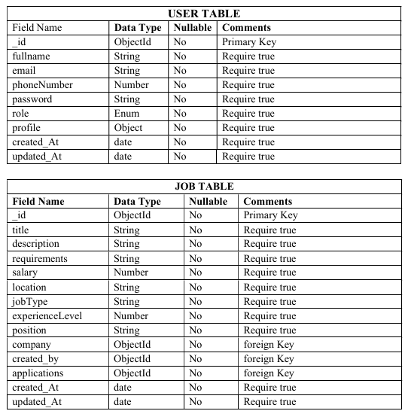

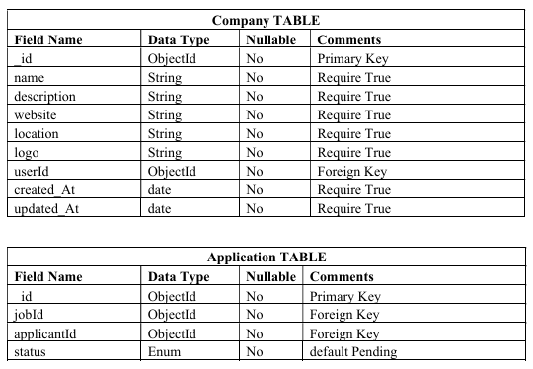

When employer registers with the application, the application inserts the details of the
employer into the Employer table. Similarly, when a jobseeker creates an account, his/her
details will be inserted into the Jobseeker table. When jobseeker searches for the available
job vacancies, the application queries the database to retrieve the job vacancies that are
posted by the employer from the Posted Jobs table. Similarly, when an employer wishes to
view the applicants for a particular job posting, the application queries the database to
retrieve the details of the job and job seeker from the Applied Jobs table. In addition, the
employer can activate or deactivate the job status thus updating the database. The jobseeker
can provide reviews about an organization and will be saved in the Reviews table

5.3 FLOWCHART:

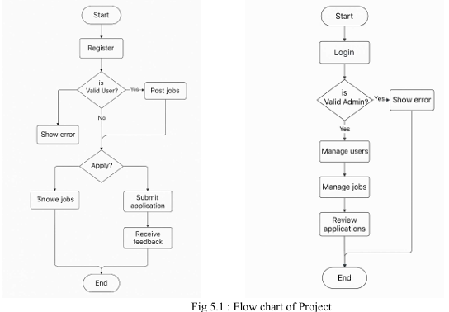

5.4 INTERFACE DESIGN:

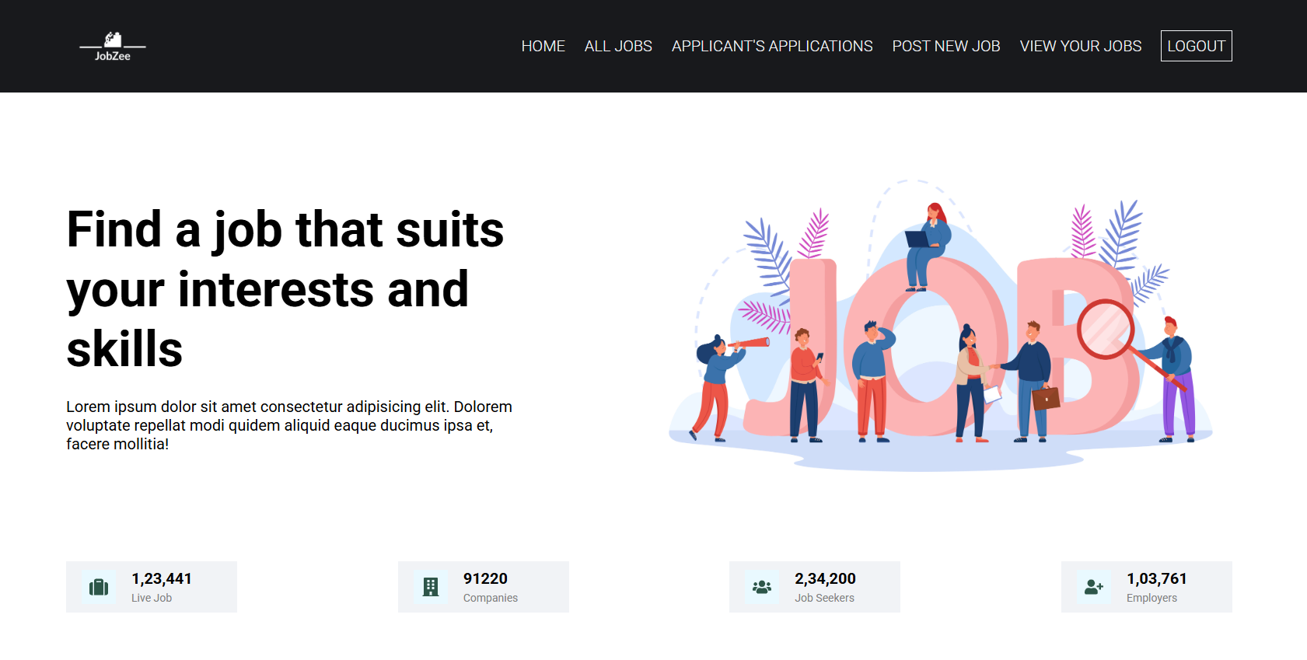
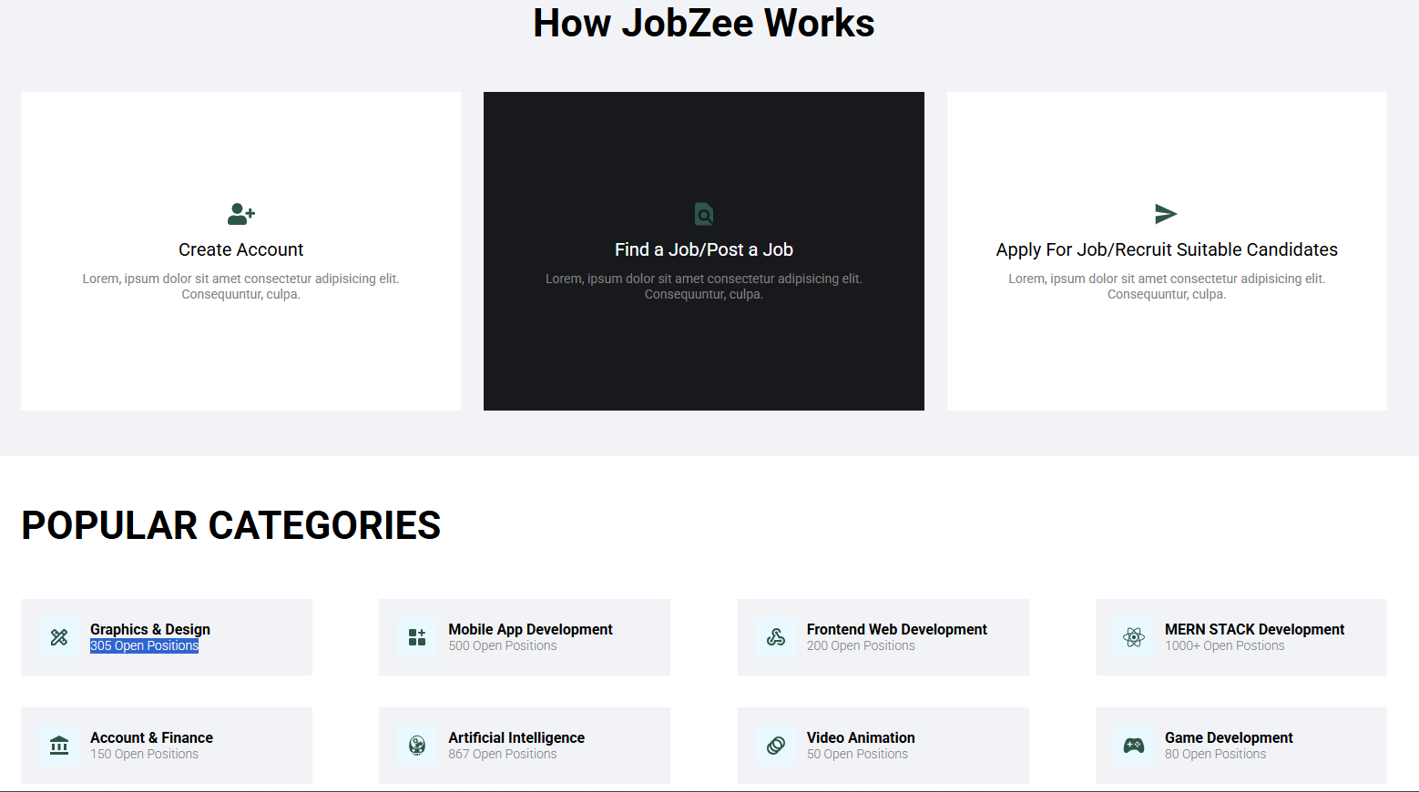
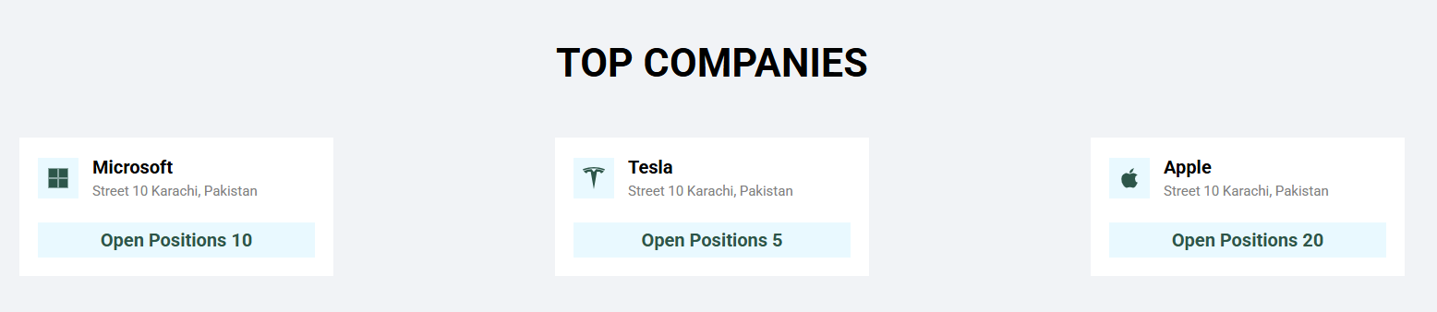

Figure 5.4.1 Home page for Employer

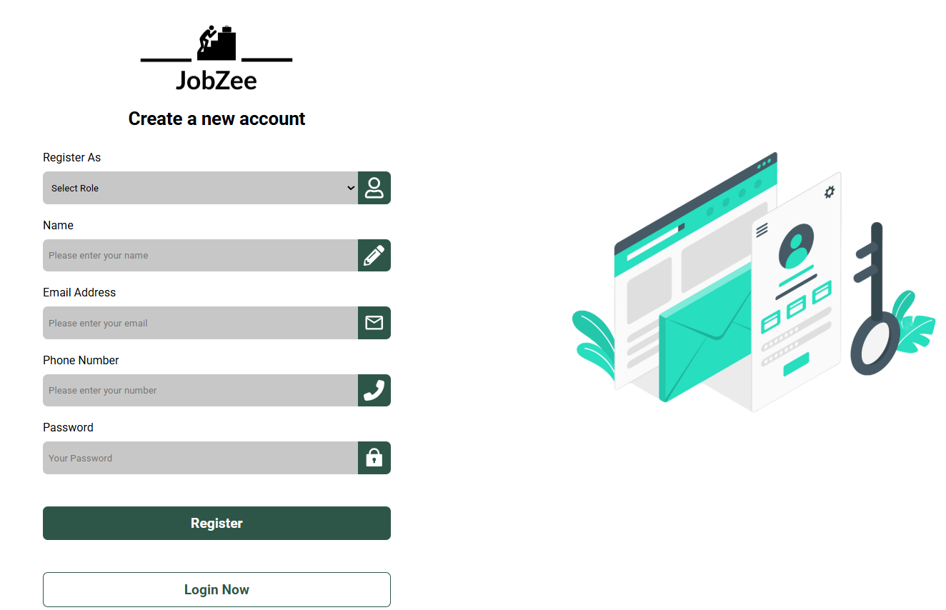

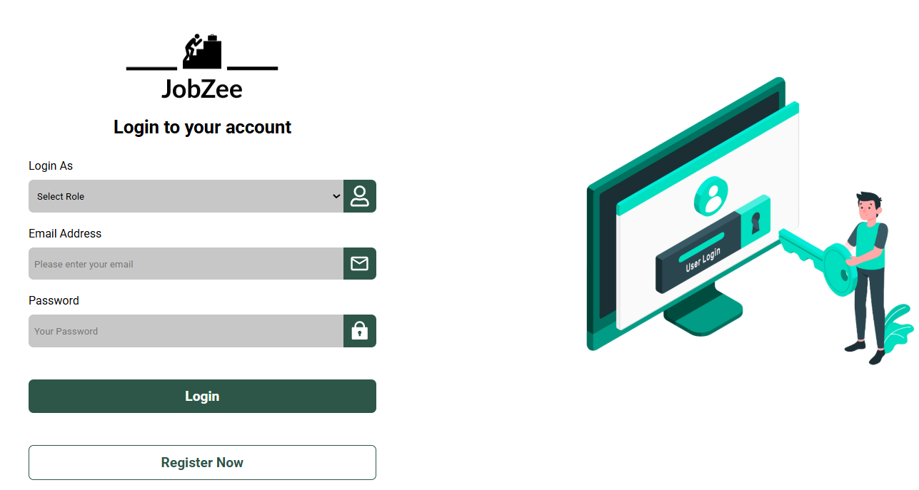

Figure 5.4.2 Sign Up & Login page

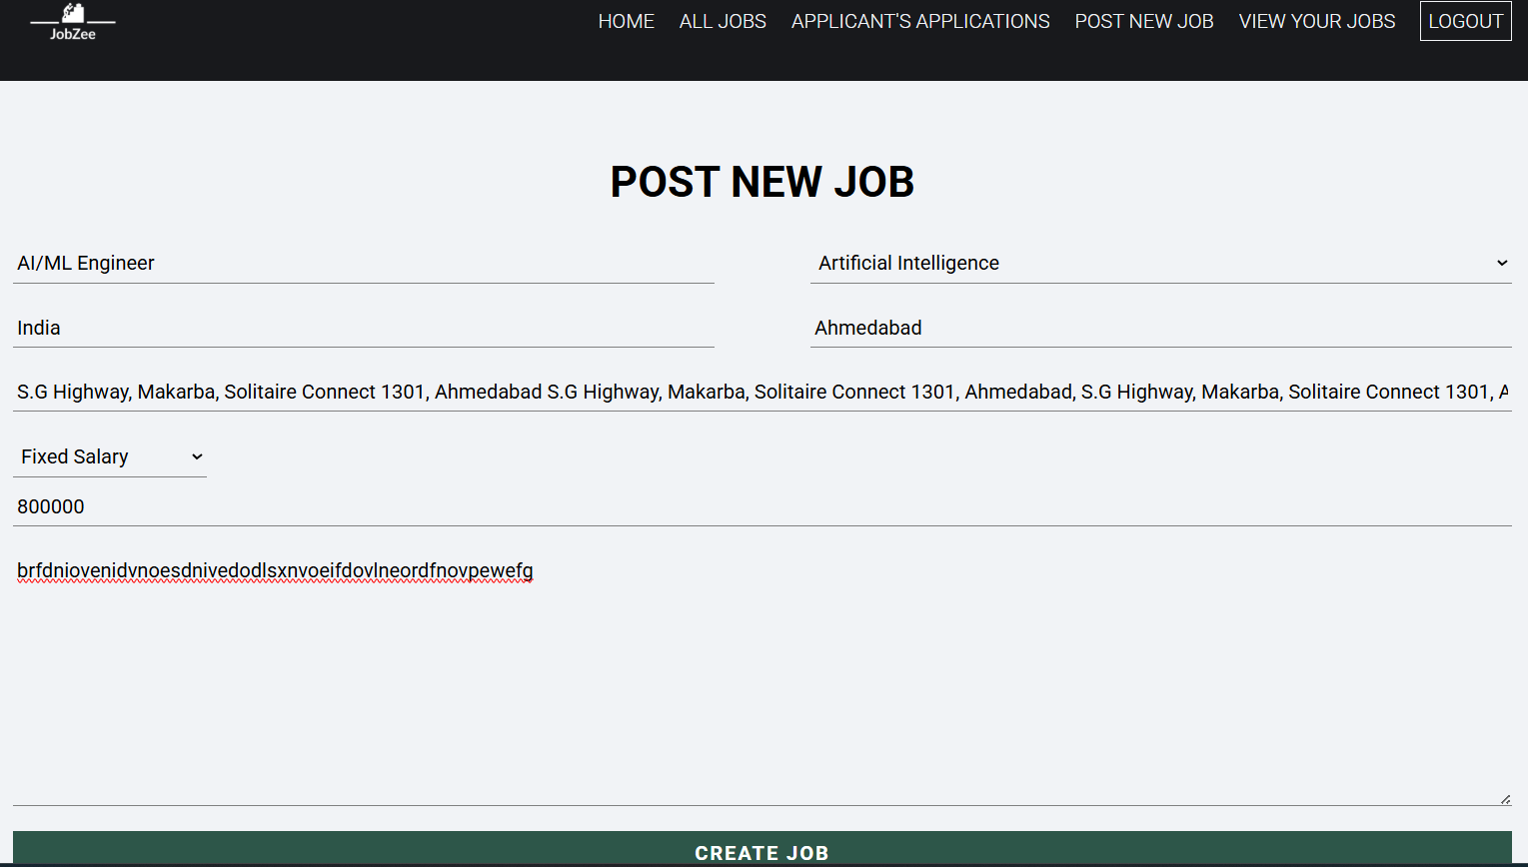

Figure 5.4.3 Posting New Job page

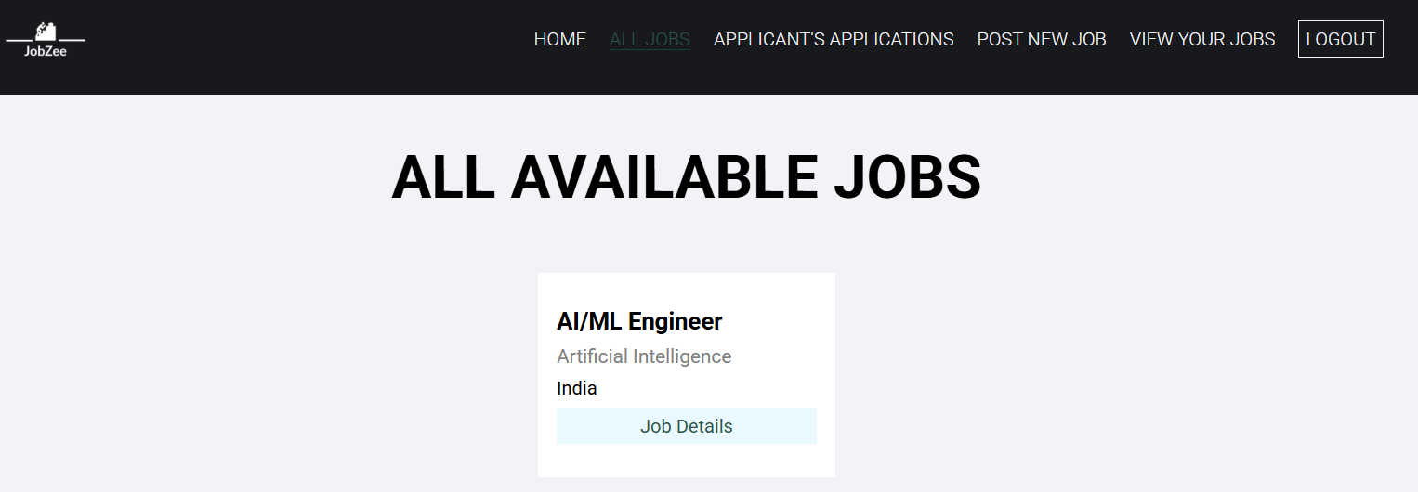

Figure 5.4.4 All Available Jobs page

Z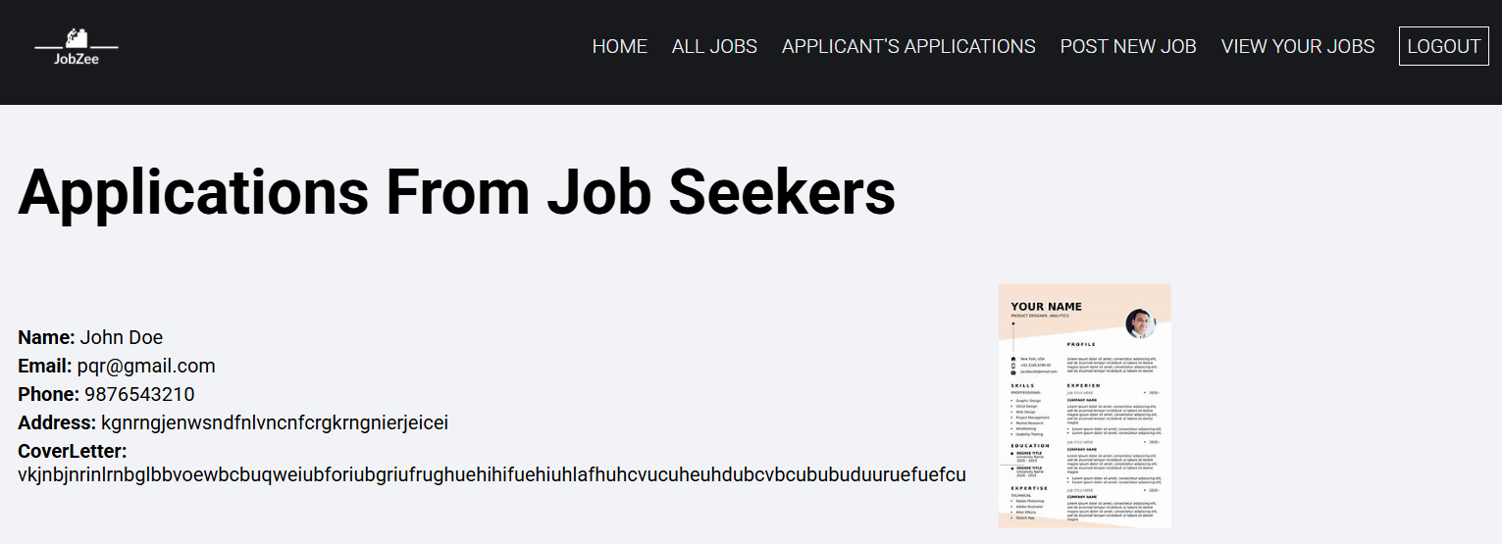

Figure 5.4.5 Applicant’s Application page

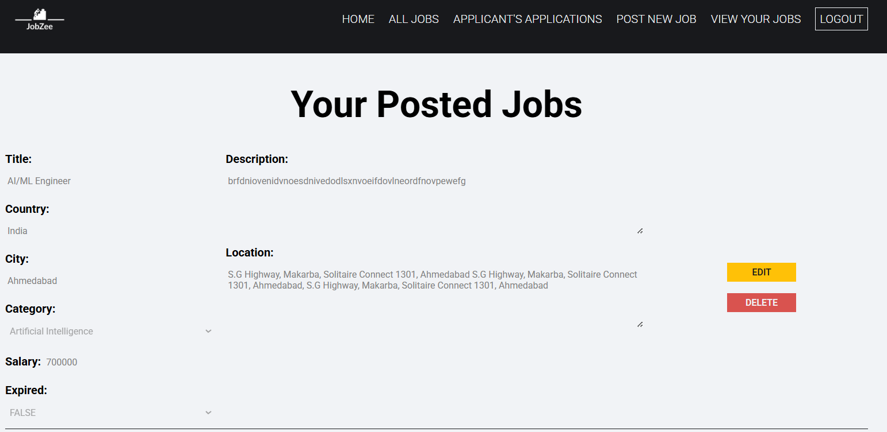

Figure 5.4.6 View Your Jobs page

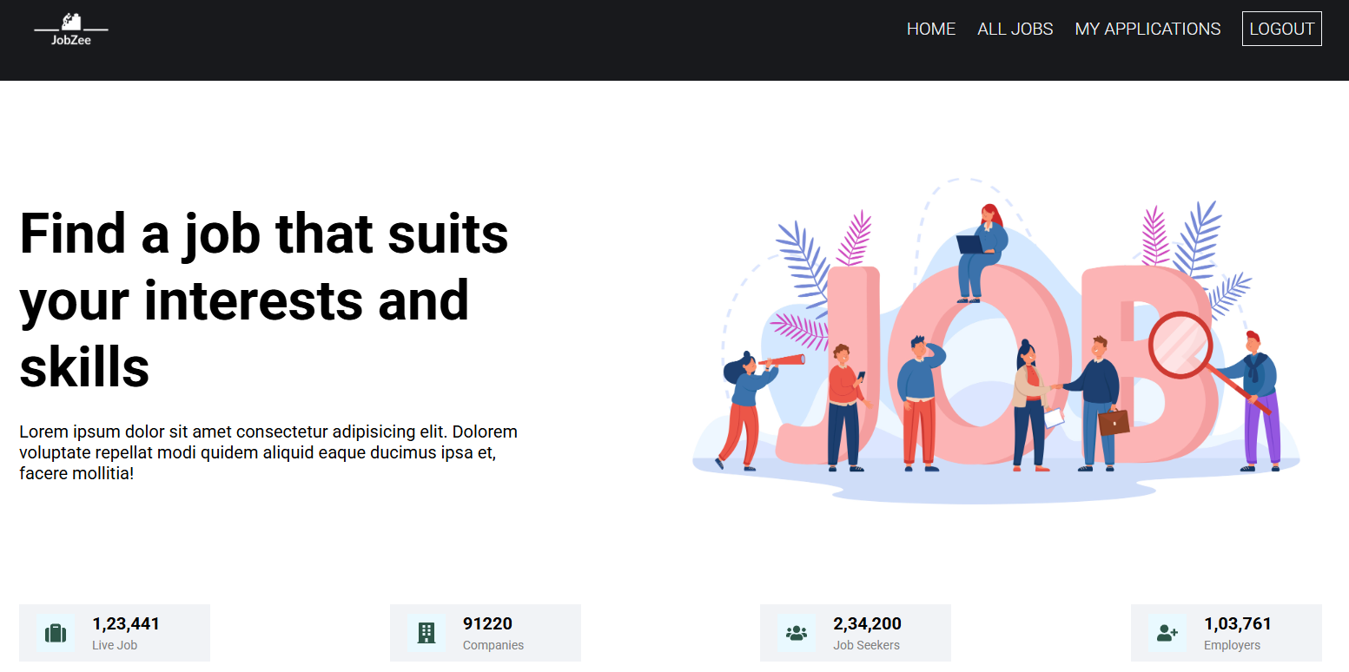

Figure 5.4.7 Home Page for Job Seeker

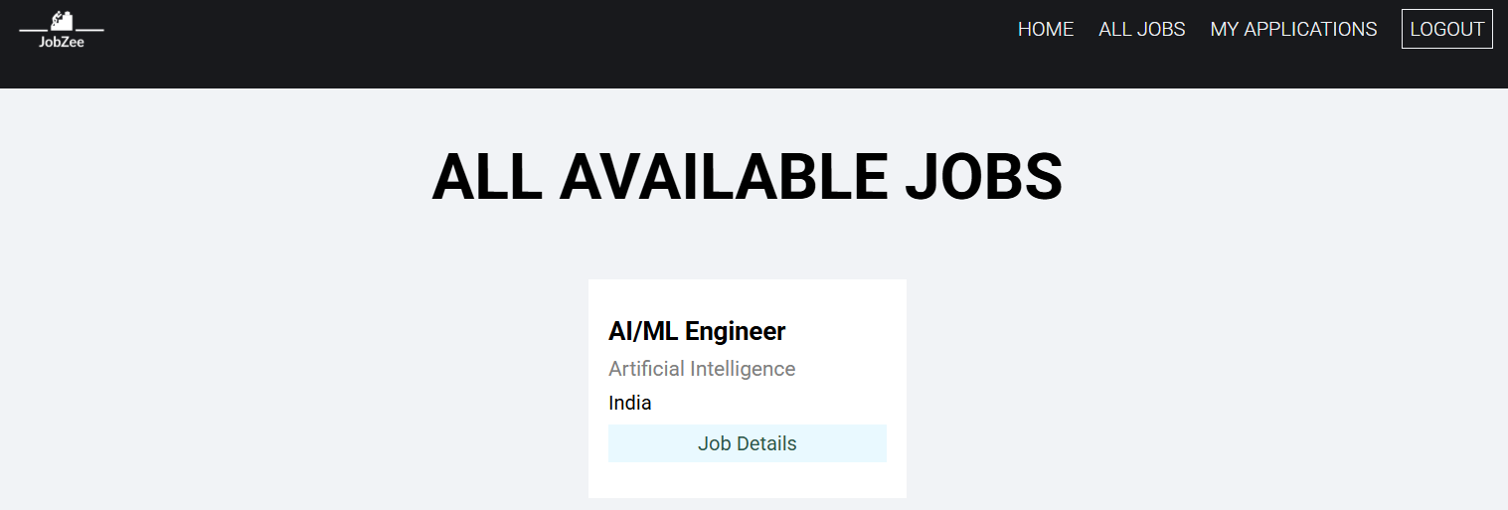

Figure 5.4.8 All Available Jobs for Job Seeker
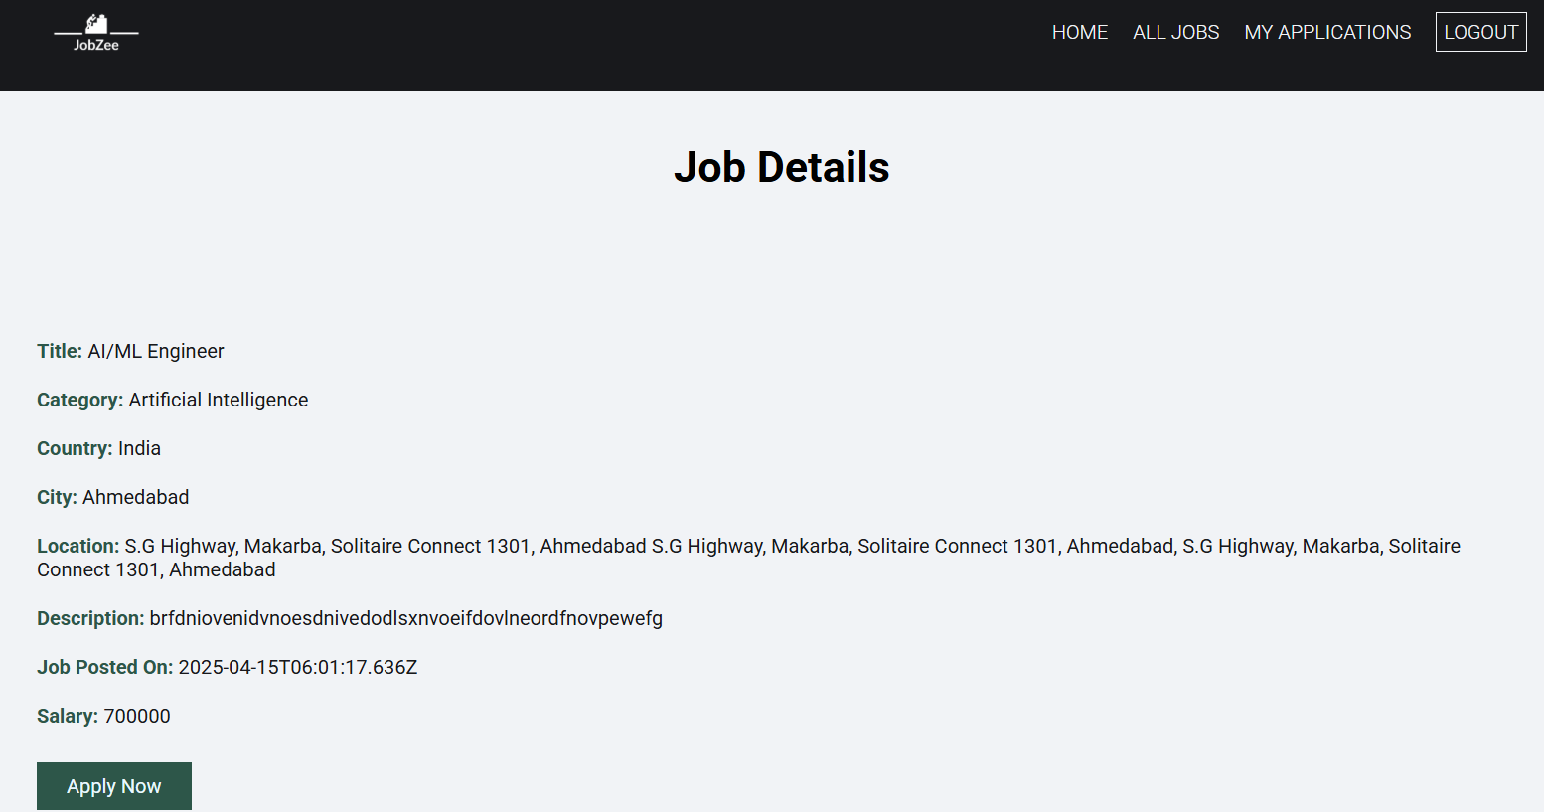

Figure 5.4.9 Job Details page

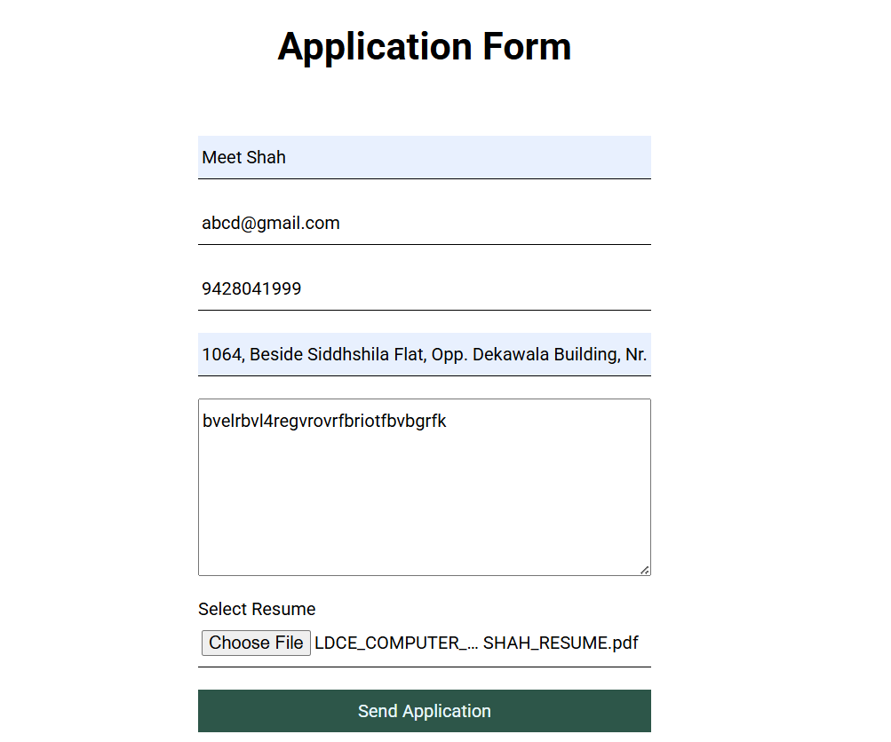

Figure 5.4.10 Application form for Applying Job

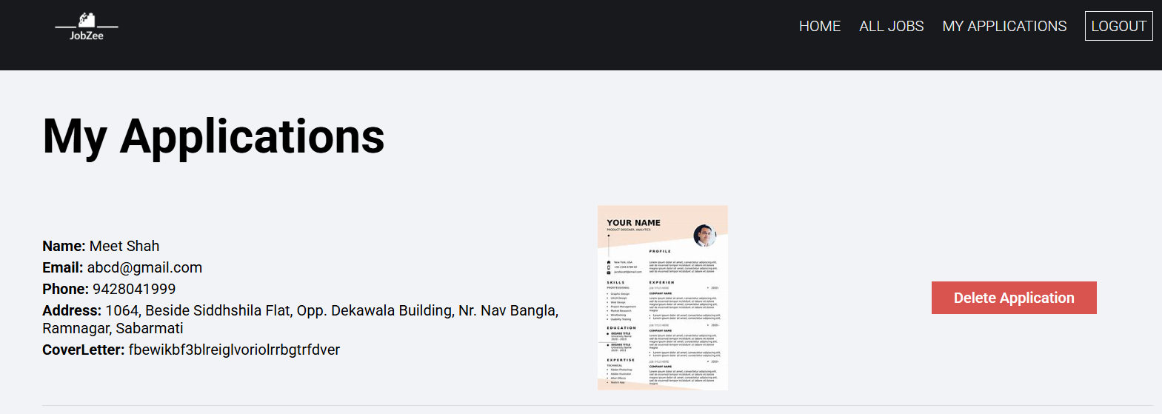

Figure 5.4.11 My Applications page

CHAPTER 6 : IMPLEMENTATION

  - IMPLEMENTATION PLATFORM

    - Visual Studio

Visual Studio is a comprehensive integrated development environment (IDE) developed by Microsoft. It offers advanced features for code editing, debugging, project management, version control integration, testing, and performance profiling. Visual Studio is available in different editions, including Community, Professional, and Enterprise, catering to various developer needs. It supports development for multiple platforms and seamlessly integrates with other Microsoft development tools and services, facilitating end-to-end application development and deployment workflows.

    - Print statement debugging is a thing of the past

Debug code right from the editor. Launch or attach to your running apps and debug with break points, call stacks, and an interactive console.

    - Git commands built-in

Working with Git and other SCM providers has never been easier. Review different, stage files, and make commits right from the editor. Push and pull from any hosted SCM service.
The Online Job Search Portal is a web-based and android application, which
revolutionizes the way companies hire the candidates and jobseekers search for job
vacancies. The employers can view reviews given by the jobseekers and make
improvements in their system accordingly. The application provides a flexible and easy
to use environment on desktops as well as portable devices like smart phones/tablets for
the users to achieve their respective objective The modules that I have implemented in
the Job Search Portal are as listed.
- Job Seeker
- Employer

  - EMPLOYER:
Employer users will be able to perform functions such as registering with the application and creating an account by providing the details of Employer Name, Employer Code, Address, Company E-mail, Mobile Number, Login Name, and Password that are stored in the Employer table of MongoDB database. Once the account is activated, this module allows employers to post jobs summarizing responsibilities and expected skills that will be saved in the Posted Jobs table of MongoDB database. The employer will also be given privilege to activate or deactivate jobs. He/she can view the list of job postings that are active. He/she can also view the applicant details that have applied for a particular job posting. The employer will be able to view reviews provided by the jobseeker.

  - JOB SEEKER
The Jobseeker users will be able to perform functions such as registering with the application and creating an account by providing the details of First Name, Last Name, E-mail, Password, Mobile Number, Primary Skill, and Experience that are stored in the Jobseeker table of MongoDB database. Once the account is activated, jobseekers can search, view, and apply for active job openings. All the applied jobs details are stored in the Applied Jobs table of MongoDB database. The applicants can also write/update reviews for the companies.

CHAPTER 7: TESTING

Testing is a process of executing a program with the intent of finding bugs that makes the
application fail to meet the expected behavior. Regardless of the development
methodology, the goal of testing is to make sure that what is created does what it is
supposed to do. Testing plays a critical role for assuring quality and reliability of the
software. I have included testing as a part of development process. The test cases should
be designed with maximum possibilities of finding the errors or bugs. Various level of
testing are as follows.

TESTING LEVELS
• Unit testing:
Unit testing tests the functionality of individual units of source code. It is the smallest component of a testable software that works in isolation with other parts of the code. I have done unit testing for various individual components of the source code to uncover errors within the boundary of the application.

• Integration testing:
Integration testing focuses on the design and construction of the software. Here the individual components that are tested using unit tests are combined and tested as a group. Its primary purpose is to expose the defects associated with the interfacing of modules. It checks if the modules perform the desired functionality when integrated together.

• System testing:
System testing is performed on a completely integrated system to see if it meets the requirements.

• Regression testing:
Regression testing aims at verifying the functionality of the software that is previously tested and to which changes are made. It is to ensure the old software still works with new changes.

• Acceptance testing:
Acceptance testing is conducted to verify if the system compliance the business requirements.

Adhering to the levels of testing, Unit testing is performed on individual components of
the system ensuring the expected behaviour. Later, I have integrated various components
together and performed Integration testing. Once the integration testing is done, I have
performed System testing and ensured the application works as per the requirements.
Finally, acceptance testing is performed to check if the client accepts the system.

TEST CASES

A test case is a set of rules or conditions to check if the system or one of its features works in accordance to the requirement. It is a document with a set of details which includes, set of test data, expected results, actual results, environment information and soon.

I have designed and executed a few test cases to check if the application meets the functional requirements.

Below are the test cases for the Job Search Portal web application.

TEST  MODULE | TEST CASE | EXPECTED RESULT | TEST RESULT
EMPLOYER | Provide details for registration | Employer successfully registered with the application | PASS
EMPLOYER | Upon successful login, click on ‘Post New Job’ tab | Employer posts jobs with the required details | PASS
EMPLOYER | Employer trying to post job with insufficient details | Prompts to fill in all the necessary details of the job | PASS
EMPLOYER | Employer clicks on the  ‘List Posted Jobs’ tab | All the jobs posted by the employer will be displayed. | PASS
EMPLOYER | Employer clicks on the ‘view’ tab under candidate’s column | The list of the details of applicants for a particular job posting are displayed. | PASS
JOBSEEKER | Provide details for registration | Jobseeker successfully registered with the application | PASS
JOBSEEKER | Enters invalid login credentials | Error message displayed | PASS
JOBSEEKER | Upon successful login, click on ‘My Profile’ tab | List details of jobseeker | PASS
JOBSEEKER | Upon successful login, click on ‘All Jobs’ Link | Details of the active job postings are displayed. | PASS
JOBSEEKER | Upon successful login, click on ‘Apply Now’ Button | Details of the jobs that are applied by the jobseeker are displayed | PASS
JOBSEEKER | Click on ‘Send Application’ Button | Displays a form to fill in the review details of the company | PASS
JOBSEEKER | Logout | Redirects to the Home page of the application | PASS

The test cases for the android application are as follows.

Test Objectives: Navigation from Splash screen to Jobs screen
TEST  CONDITION | INPUT  SPECIFICATION | OUTPUT  SPECIFICATION | PASS/FAIL
The user is currently on the Splash screen | User enters credentials and clicks on login button | Directs to Jobs screen | PASS
Table 2-Test Case for navigation to Jobs screen
Test Objectives: Navigation from Jobs Screen to Job details Screen
TEST  CONDITION | INPUT  SPECIFICATION | OUTPUT  SPECIFICATION | PASS/FAIL
The user is currently on the  Jobs screen | User clicks on the view against a particular job | Directs to Job details screen | PASS
Table 3-Test Case for navigation to job details screen
Test Objectives: User applies for the Job application
TEST  CONDITION | INPUT  SPECIFICATION | OUTPUT  SPECIFICATION | PASS/FAIL
The user is currently on the  Jobs page | User clicks on the ‘Apply Now’ Button against a job post | Directs to Application Form for sending Application | PASS
Table 4-Test Case for applying jobs
Test Objectives: User successfully submits his application for applied jobs
TEST  CONDITION | INPUT  SPECIFICATION | OUTPUT  SPECIFICATION | PASS/FAIL
The user is currently on the Jobs page | User clicks on ‘Send Application’ Button | Prompts a message as “Successfully applied to this job” | PASS
Table 5-Test Case for Sending Application

Test Objectives: User checks for applied jobs
TEST  CONDITION | INPUT  SPECIFICATION | OUTPUT  SPECIFICATION | PASS/FAIL
The user is currently on the Jobs page | User clicks on ‘My Applications’ Button | Lists all the jobs that are applied | PASS
Table 5-Test Case for listing all jobs

CHAPTER 8: CONCLUSION AND DISCUSSION

OVERALL ANALYSIS OF INTERNSHIP
    - Since the very first day of internship, I learned a lot of new things from the respected industry guides and fellow interns.
    - First of all, started from basics of HTML, CSS, Javascript, NodeJS.
    - Then learned Scrum methodology.
    - Overview of MVC – Entity Frame Work is given.
    - Bootstrap overview is also given.
    - Project work is assigned.
    - Project work is completed and report is prepared.

PROBLEM ENCOUNTERED AND POSSIBLE SOLUTIONS

Problem Encountered:
    - The website interface might not be intuitive or user-friendly.
    - Users may require separate installations for body measurement functionalities. Possible Solutions:
    - Revamp the website interface to prioritize user-friendliness and responsiveness.
    - Integrate body measurement features seamlessly within the platform, eliminating the need for separate installations.

DATE OF CONTINUES EVALUATION
    - Feb 20, 2025
    - March 15, 2025
    - April 20, 2025

LIMITATIONS
    - Limited physical examination capabilities.
    - Potential challenges with connectivity in remote areas.
    - Dependence on user's technological proficiency for effective use.

FUTURE ENHANCEMENT
    - Integration of AI for enhanced diagnostics.
    - Expansion of services to include specialist consultations.
    - Implementation of wearable technology for remote patient monitoring.

8.6 CONCLUSION

JobZee serves as a modern and efficient job and internship portal, bridging the gap between job seekers and recruiters. By leveraging the MERN stack (MongoDB, Express.js, React.js, and Node.js), the platform delivers a responsive, scalable, and user-friendly experience for both web and Android users. It provides job seekers with the flexibility to explore and apply for relevant opportunities, while offering administrators full control over job postings, user management, and application screening.
The application has successfully met all the functional and non-functional requirements defined during the planning and requirement gathering phase. Through this project, I gained hands-on experience with full-stack development using modern web technologies and implemented best practices in authentication, data handling, and UI/UX design. Working on JobZee has strengthened my skills in the MERN stack and deepened my understanding of building real-world applications from end to end, ultimately boosting my confidence in full-stack development and project execution.

REFERENCES:
Web Sites http://www.bestjobs.ph http://www.gopinoy.com http://www.jobsdb.com.ph http://www.jobsonline.com.ph http://www.jobstreet.com.ph http://www.phil-job.net http://www.workabroad.ph
http://www.kckcc.edu/services/studentServices/careerPlanningAndPlacement/generallnforma tion/activeVsTraditionalJobSearchMethods.aspx http://www.bls.gov/oco/oc020042.htm

