PIZZA STORE
Full Stack Application Documentation
MERN Stack Capstone Project
MongoDB · Express.js · React.js · Node.js

Table of Contents
1. Project Overview 3
2. System Architecture 5
Backend Folder Structure 6
Frontend Folder Structure 6
3. Database Design 8
3.1 ER Diagram 8
3.2 Class Diagram 9
3.3 Relationships Summary 9
4. API Documentation 10
4.1 Authentication APIs (/api/auth) 10
4.2 Menu Item APIs (/api/menu) 10
4.3 Category APIs (/api/categories) 11
4.4 Cart APIs (/api/cart) 11
4.5 Order APIs (/api/orders) 11
4.6 Payment APIs (/api/payments) 13
4.7 Message APIs (/api/messages) 13
4.8 Address APIs (/api/address) 13
4.9 User APIs (/api/users) 14
5. Authentication & Security 15
5.1 JWT Authentication Flow 15
5.2 Password Security 15
5.3 Route Protection 15
6. Application Features 16
6.1 Customer Features 16
6.2 Admin Features 17
7. User Interface Screenshots 18
7.1 Customer Interface 18
7.2 Admin Interface 18
8. Setup & Installation Guide 19
9. Conclusion 21

1. Project Overview

1.1 Introduction
Pizza Store is a full-stack web application developed using the MERN stack — MongoDB, Express.js, React.js, and Node.js. It is designed as an online food ordering platform that enables customers to browse a menu of pizzas and other items, manage a shopping cart, place orders with delivery or pickup options, and make payments. The application implements Role-Based Access Control (RBAC) with two distinct user roles: Customer and Admin.

1.2 Problem Statement
The application addresses the need for a centralized online pizza ordering system with the following capabilities:
- Customers should be able to register, log in, and manage their personal accounts with email and phone number.
- Customers should be able to browse the full menu, filtered by categories such as Pizza, Sides, Beverages, Combos, Veg, and Non-Veg.
- Customers should be able to view detailed information about each menu item including name, description, price, category, and availability.
- Customers should be able to search and filter menu items by category.
- Customers should be able to add or remove items from a cart, update quantities, and view the running total.
- Customers should be able to place orders with delivery or pickup, providing a saved delivery address.
- Customers should be able to make payments online (card) or choose Cash on Delivery.
- Customers should be able to view their order history and cancel pending orders.
- Customers should be able to manage multiple saved delivery addresses.
- Admins should be able to perform full CRUD operations on menu items and categories.
- Admins should be able to view all orders and update order statuses.
- Admins should be able to view monthly revenue analytics.
- Admins should be able to send broadcast messages to all customers regarding order updates.

1.3 Technology
The application is built on the following technologies:

MongoDB
MongoDB is used as the primary NoSQL document database. It stores all application data including users, menu items, categories, carts, orders, payments, messages, and addresses. Mongoose is used as the ODM (Object Document Mapper) to define schemas and interact with MongoDB from Node.js.

Express.js
Express.js serves as the backend web framework running on Node.js. It handles all REST API routing, middleware processing, and authentication checks. The application also integrates WebSocket support via the ws package for real-time communication.

React.js
React.js is used to build the frontend as a Single Page Application (SPA). React Router enables client-side navigation without full page reloads. Context API is used for global state management — AuthContext manages the JWT token and user session, while CartContext controls the shopping cart state.

Node.js
Node.js provides the JavaScript runtime environment for the backend server. It powers Express.js and all npm package integrations.

Additional packages
Additional packages include: bcryptjs for password hashing, jsonwebtoken for JWT creation and verification, dotenv for environment variable management, cors for cross-origin requests, ws for WebSocket support (real-time order updates), Axios for HTTP requests from the frontend, Mongoose for MongoDB object modeling, Mocha and Chai for backend testing.

1.4 User Roles
The application supports two roles. The Customer role is assigned automatically at registration and allows browsing the menu, managing a cart, placing orders, making payments, tracking order status, and receiving messages. The Admin role provides full control over the menu including adding, editing, and deleting items and categories, managing all orders and updating their statuses, viewing revenue analytics, and broadcasting messages to all customers. The default admin account uses the email admin@example.com with the password adminpassword.

2. System Architecture

2.1 Application Architecture
The Pizza Store application follows the standard MERN stack architecture. The browser runs a React Single Page Application which communicates exclusively with the backend through RESTful HTTP API calls using Axios. The backend is an Express.js server running on Node.js which connects to a MongoDB database. A WebSocket server (ws) is attached to the same HTTP server instance for real-time order status updates. JWT tokens handle stateless authentication between the client and server.

The data flow is as follows: the React frontend sends an HTTP request with an Authorization header containing the JWT token. The Express middleware (authMiddleware.js) intercepts the request, verifies the token using the JWT_SECRET, and attaches the decoded user object to the request. The route handler then calls the appropriate controller, which delegates business logic to a service function, which performs the MongoDB database operation and returns the result.

2.2 Folder Structure

Backend Folder Structure
The backend follows a layered MVC-style architecture separating routes, controllers, services, and models:

Folder / File | Purpose
config/db.js | MongoDB connection setup using Mongoose
controllers/ | Request handlers — parse req/res, delegate to services
services/ | Business logic — authService, orderService, paymentService, messageService, websocketService
routes/ | Express router definitions for all API endpoints
models/ | Mongoose schema and model definitions (User, MenuItem, Category, Cart, Order, Payment, Message, Address)
middleware/authMiddleware.js | JWT protect() and adminOnly() middleware
scripts/ | Utility scripts — createAdmin.js, seed scripts for categories and menu items
tests/ | Mocha + Chai test suites for auth, cart, menu, orders, payments, address, user, messages
server.js | Entry point — Express app setup, routes registration, WebSocket init, HTTP server start
seed.js | Database seeder for categories and menu items
.env | Environment variables — MONGO_URI, JWT_SECRET, PORT

Frontend Folder Structure
The frontend is a React Single Page Application. Key directories and files include:

Folder / File | Purpose
src/components/ | Reusable UI components (Navbar, CartItem, MenuCard, OrderCard, etc.)
src/pages/ | Full page components (Home, Menu, Cart, Orders, Profile, Admin pages)
src/context/ | React Context providers — AuthContext (session) and CartContext (cart state)
src/services/ | Axios API call functions grouped by resource (authAPI, menuAPI, orderAPI, etc.)
src/App.js | Root component with React Router route definitions and protected route wrappers
public/ | Static assets including index.html
.env | REACT_APP_API_URL environment variable pointing to backend

3. Database Design

3.1 ER Diagram
The following Entity Relationship Diagram shows all eight MongoDB collections and the relationships between them. Primary keys are marked with a key symbol. Foreign keys (ObjectId references) are shown with italic text.
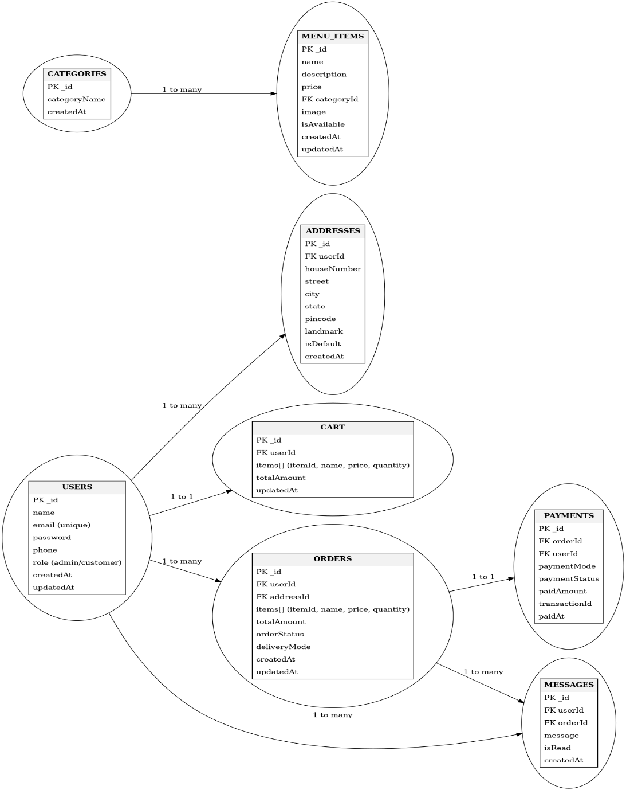
[Figure 1: ER Diagram — Pizza Store Database]

3.2 Class Diagram
The Class Diagram below illustrates the eight Mongoose schema classes, their attributes with visibility markers (+ public, - private), key methods, and the UML relationships between them.
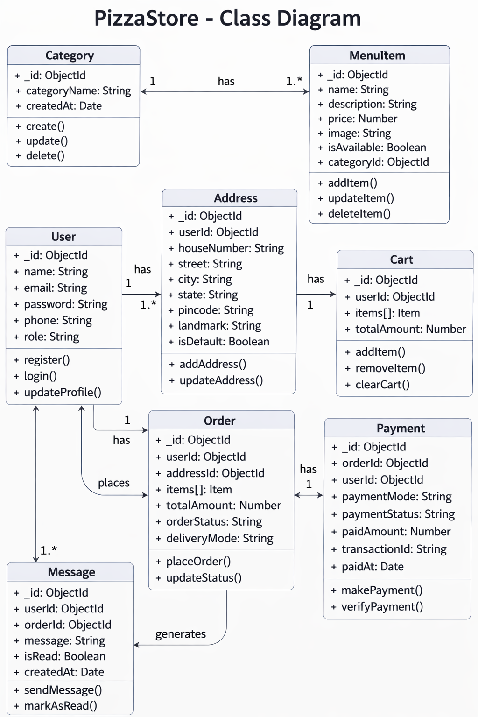
[Figure 2: Class Diagram — MongoDB Models & Relationships]

3.3 Relationships Summary
The database contains the following relationships between collections:
- USER to CART — One user has exactly one cart. The Cart document stores the userId as a foreign key.
- USER to ORDER — One user can place many orders. Each Order document has a userId field referencing the User collection.
- USER to ADDRESS — One user can save many delivery addresses. Each Address document has a userId field.
- USER to MESSAGE — One user can receive many messages. Each Message document has a userId field.
- CATEGORY to MENUITEM — One category contains many menu items. Each MenuItem has a categoryId field referencing the Category collection.
- CART to MENUITEM — A cart can contain many items. The Cart's items array stores itemId references to MenuItem documents.
- ORDER to MENUITEM — An order snapshot contains many items. The Order's items array stores itemId references.
- ORDER to PAYMENT — One order has at most one payment. The Payment document stores an orderId reference.
- ORDER to MESSAGE — An order update can trigger a message. The Message document stores an orderId reference.

4. API Documentation
The backend exposes a RESTful API at base URL http://localhost:5000. All protected routes require the Authorization: Bearer <token> header. The token is obtained from the login endpoint and must be included in every subsequent request.

4.1 Authentication APIs (/api/auth)

POST /api/auth/register
Registers a new customer account. No authentication required. The request body must include name, email, phone, and password. The backend automatically assigns the 'customer' role. The password is hashed using bcrypt before storage. Returns a JWT token and basic user information.

POST /api/auth/login
Authenticates a user with email and password. Returns a JWT token and basic user information { id, name, email, role }. The token must be stored by the frontend and attached to all future requests.

POST /api/auth/logout
Logs out the currently authenticated user. Requires authentication. Returns a success message. The frontend is responsible for clearing the stored token.

4.2 Menu Item APIs (/api/menu)

GET /api/menu
Returns all menu items. Public route — no authentication required. Supports optional query parameter categoryId to filter items by category. Returns an array of menu item documents with categoryId populated.

GET /api/menu/category/:categoryId
Returns all menu items belonging to the specified category. Public route.

POST /api/menu
Adds a new menu item to the store. Requires Admin role. Request body must include name, price, and categoryId. Optional fields: description, image, isAvailable.

PUT /api/menu/:id
Updates the details of an existing menu item. Requires Admin role. Accepts a JSON body with any combination of name, description, price, categoryId, image, and isAvailable.

DELETE /api/menu/:id
Permanently deletes a menu item from the database. Requires Admin role.

4.3 Category APIs (/api/categories)

GET /api/categories
Returns all categories in the database. Public route — no authentication required.

POST /api/categories
Adds a new menu category. Requires Admin role. Request body must include categoryName.

PUT /api/categories/:id
Updates an existing category name. Requires Admin role.

DELETE /api/categories/:id
Permanently deletes a category. Requires Admin role.

4.4 Cart APIs (/api/cart)

GET /api/cart
Returns the current cart for the logged-in user, with menu item details (name, price, image) populated for each cart item. Returns { items: [], totalAmount: 0 } if the user has no active cart. Requires authentication.

POST /api/cart
Adds a menu item to the cart. Requires authentication. Request body must include itemId, name, price, and quantity. If the item already exists in the cart, its quantity is incremented. The totalAmount is recalculated automatically.

PUT /api/cart/update-quantity
Updates the quantity of a specific item in the cart. Requires authentication. Recalculates the totalAmount after the update.

DELETE /api/cart/clear
Removes all items from the cart and deletes the cart document. Requires authentication.

DELETE /api/cart/:itemId
Removes a single item from the cart by itemId. Requires authentication. Recalculates the totalAmount after removal.

4.5 Order APIs (/api/orders)

POST /api/orders
Places a new order from the current user's cart. Requires authentication. Request body must include addressId, deliveryMode ('delivery' or 'pickup'), and paymentMethod ('card' or 'cod'). Calculates subtotal, 5% tax, delivery charge (Rs. 40 for delivery, Rs. 0 for pickup), and totalAmount. Clears the cart after order creation.

GET /api/orders/my-orders
Returns all orders placed by the currently logged-in customer, sorted by newest first. Requires authentication.

PUT /api/orders/cancel/:id
Cancels a pending order. Requires authentication. Only the order owner can cancel it, and only if the orderStatus is 'pending'.

GET /api/orders/all
Returns all orders from all customers. Requires Admin role. Used by the admin dashboard to manage and update order statuses.

PUT /api/orders/status/:id
Updates the status of any order. Requires Admin role. Accepts a JSON body with orderStatus. Valid values: 'pending', 'confirmed', 'preparing', 'out_for_delivery', 'delivered', 'cancelled'.

GET /api/orders/revenue
Returns monthly revenue analytics aggregated from delivered orders. Requires Admin role. Returns year, month, totalRevenue, totalOrders, and averageOrderValue for each month.

4.6 Payment APIs (/api/payments)

POST /api/payments
Records a payment for an order. Requires authentication. Request body must include orderId, paymentMode, and paidAmount. Optional transactionId for card payments. Returns 400 if payment already exists for the given order.

GET /api/payments/:orderId
Returns the payment details for a specific order, with full order and user information populated. Requires authentication.

4.7 Message APIs (/api/messages)

POST /api/messages
Sends a message to a specific user. Requires Admin role. Request body must include userId, orderId (optional), and message text.

GET /api/messages/my-messages
Returns all messages for the currently logged-in user, with order status and amount populated, sorted by newest first. Requires authentication.

GET /api/messages/unread-count
Returns the count of unread messages for the logged-in user. Requires authentication.

PUT /api/messages/mark-all-read
Marks all unread messages as read for the logged-in user. Requires authentication.

PUT /api/messages/:id/read
Marks a single message as read. Requires authentication.

4.8 Address APIs (/api/address)

GET /api/address
Returns all saved addresses for the currently logged-in user. Requires authentication.

POST /api/address
Saves a new delivery address for the logged-in user. Requires authentication. Request body must include houseNumber, street, city, state, and pincode. If isDefault is true, all other addresses for the user are set to isDefault: false automatically.

PUT /api/address/:id
Updates an existing address. Requires authentication. If isDefault is set to true, all other addresses are unset. Only the owner can update their address.

DELETE /api/address/:id
Permanently deletes a saved address. Requires authentication. Only the owner can delete their address.

4.9 User APIs (/api/users)

GET /api/users/profile
Returns the full profile of the currently logged-in user excluding the password. Requires authentication.

PUT /api/users/profile
Updates the profile of the currently logged-in user (name, phone). Requires authentication.

PUT /api/users/change-password
Changes the password for the logged-in user after verifying the current password. Requires authentication.

GET /api/users
Returns a list of all registered users. Requires Admin role.

DELETE /api/users/:id
Deletes a user account from the system. Requires Admin role.

5. Authentication & Security

5.1 JWT Authentication Flow
The application uses JSON Web Tokens (JWT) for stateless authentication. The flow works as follows:
- The user enters their email and password in the React login form and submits.
- The frontend sends a POST request to /api/auth/login with the credentials in the request body.
- The Express backend queries MongoDB for a user with the matching email address.
- bcrypt.compare() is called to verify the entered password against the stored hashed password.
- If the password matches, jwt.sign({ id, role }, JWT_SECRET, { expiresIn: '7d' }) creates a signed token.
- The token and basic user info { id, name, email, role } are returned to the frontend in the response.
- The frontend stores the token in localStorage and saves the user object in the React AuthContext.
- For every subsequent API call, an Axios request interceptor automatically adds: Authorization: Bearer <token>.
- The authMiddleware.js protect() function calls jwt.verify(token, JWT_SECRET) to decode and validate the token on every protected route.
- If valid, the decoded payload is attached to req.user and the request proceeds. If invalid or expired, 401 is returned.
- For admin-only routes, adminOnly() additionally checks req.user.role === 'admin', returning 403 Forbidden if not.

5.2 Password Security
Passwords are secured using the bcryptjs library. When a user registers, the plain text password is hashed with a salt factor of 10 using bcrypt.hash(password, salt) before being saved to MongoDB. The original password is never stored. During login, bcrypt.compare(enteredPassword, storedHash) is used to verify the password without ever decrypting the hash. This ensures that even if the database is compromised, user passwords cannot be recovered.

5.3 Route Protection
Two middleware functions are defined in middleware/authMiddleware.js. The protect() function is applied to all non-public routes. It extracts the JWT token from the Authorization header, verifies it using jwt.verify(), and attaches the decoded user payload to req.user. If no token is present or the token is invalid, it returns a 401 status. The adminOnly() function is applied in addition to protect() on admin-only routes. It reads req.user.role and returns a 403 status if the role is not 'admin'. Public routes (GET /api/menu, GET /api/categories) are exempt from authentication middleware.

6. Application Features

6.1 Customer Features

Authentication
Customers can register a new account by providing their full name, email address, phone number, and password. Email uniqueness is enforced at the database level. After registration, customers log in with email and password to receive a JWT token valid for 7 days. Logging out clears the token and user data from localStorage. Customers can view and update their profile (name, phone) and change their password from the profile page.

Menu Browsing
The menu page displays all available items. Customers can filter items by category (Pizza, Sides, Beverages, Combo, Bestsellers, Veg, Non-Veg) by clicking on category tabs. Each item card displays the name, description, price, and an image. Clicking the Add to Cart button on any item adds it to the customer's cart.

Shopping Cart
Customers can view their cart at any time. The cart displays all added items with their names, individual prices, and quantities. Customers can increase or decrease the quantity of each item, or remove items entirely using the remove button. The cart automatically recalculates and displays the running total. Once ready, customers proceed to checkout from the cart page.

Order Placement
During checkout, customers select a saved delivery address or add a new one, choose between delivery and pickup, and select a payment method (card or Cash on Delivery). The order summary displays the subtotal, 5% GST, delivery charge (Rs. 40 for delivery, waived for pickup), and the final total amount. On confirming the order, the cart is cleared and the order is placed with a 'pending' status.

Order History & Tracking
The orders page lists all past and current orders placed by the customer, sorted by newest first. Each order entry shows the list of items, order total, payment method, payment status, delivery mode, and the current order status. Customers can cancel any order that is still in 'pending' status by clicking the Cancel Order button.

Address Management
Customers can save multiple delivery addresses. Each address includes house number, street, city, state, pincode, and an optional landmark. One address can be designated as the default, which pre-selects during checkout. Addresses can be added, updated, or deleted from the addresses section of the profile page.

Messages & Notifications
The messages page lists all messages received from the admin regarding order updates. The number of unread messages is shown as a badge in the navigation. Customers can mark individual messages as read by clicking them, or mark all messages as read at once using the Mark All Read button.

6.2 Admin Features

Menu Management
The admin menu management page displays all menu items including unavailable ones in a table. Admins can add new items by filling in the name, description, price, selecting the category, providing an image URL, and setting availability. Admins can edit item details using the edit button on each row. Items can be deleted permanently, removing them from the database.

Category Management
Admins can create new menu categories by entering a category name. Existing categories can be renamed or deleted. Categories must exist before menu items can be assigned to them. The seeded categories are: Pizza, Sides, Beverages, Combo, Bestsellers, Veg, and Non-Veg.

Order Management
The admin orders page displays all orders from all customers in a table with customer name, items, total, payment method, payment status, delivery mode, and current order status. Admins can update the status of any order through its lifecycle: pending → confirmed → preparing → out_for_delivery → delivered. Orders can also be set to 'cancelled' by the admin.

Revenue Analytics
The revenue dashboard aggregates completed (delivered) orders by month and year, showing the total revenue, total number of orders, and average order value for each month. This data is calculated using MongoDB aggregation pipelines and displayed in a summary table or chart on the admin dashboard.

User Management
Admins can view a list of all registered users including their name, email, phone, and role. Admin accounts can delete user accounts from the system.

Broadcast Messages
The messaging page allows admins to write a custom message linked to a specific order and send it directly to the order's customer. The system creates a Message document for the target user, which appears in their messages inbox.

7. User Interface Screenshots

7.1 Customer Interface
(Insert customer-facing UI screenshots here: Menu page with category filters, Cart page, Checkout page, Order history page, Address management page, Messages page.)
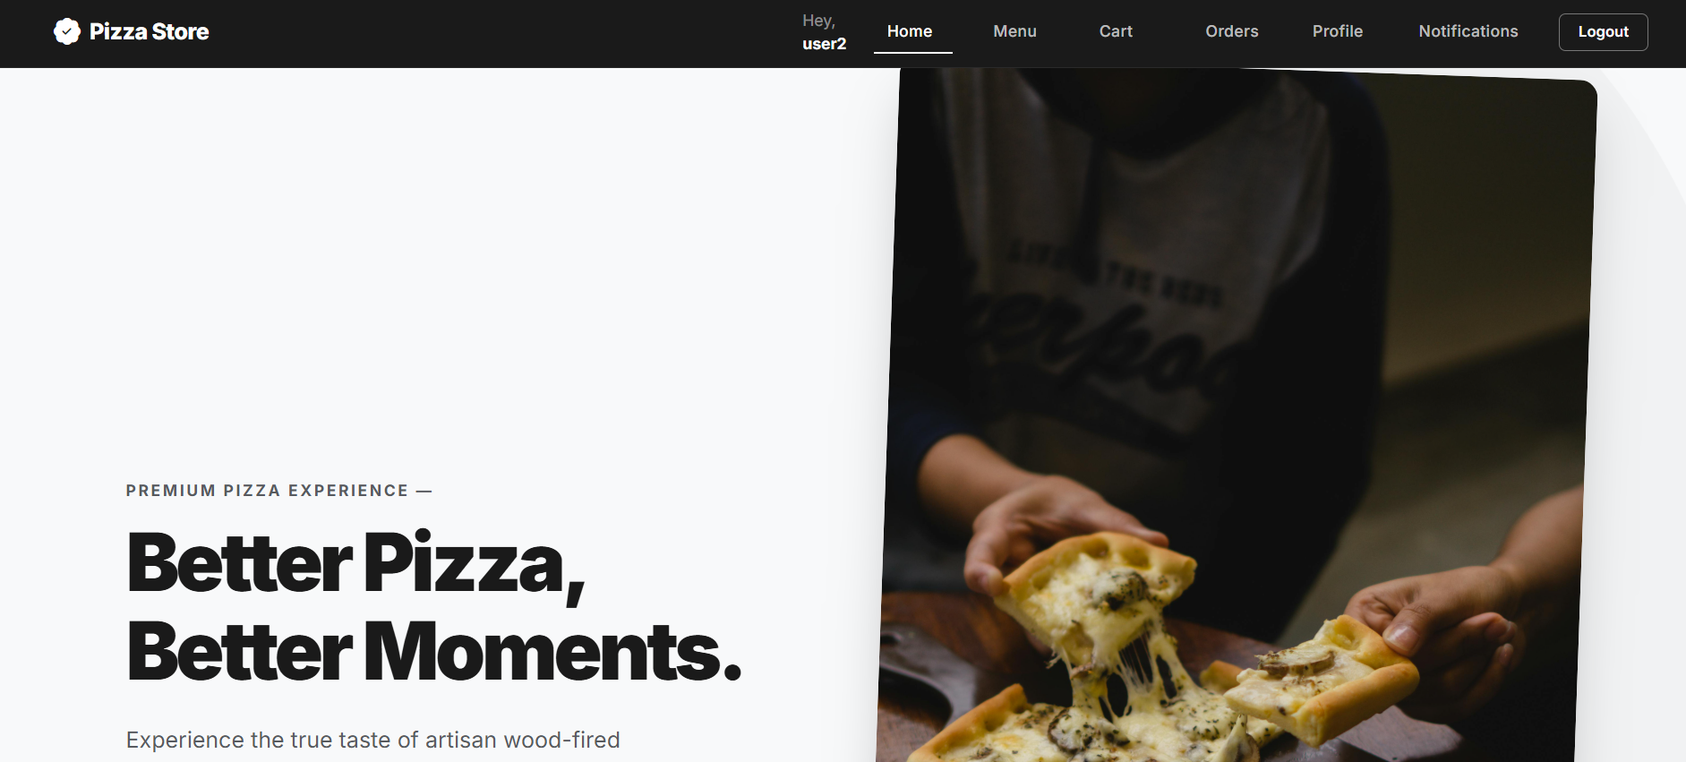

7.2 Admin Interface

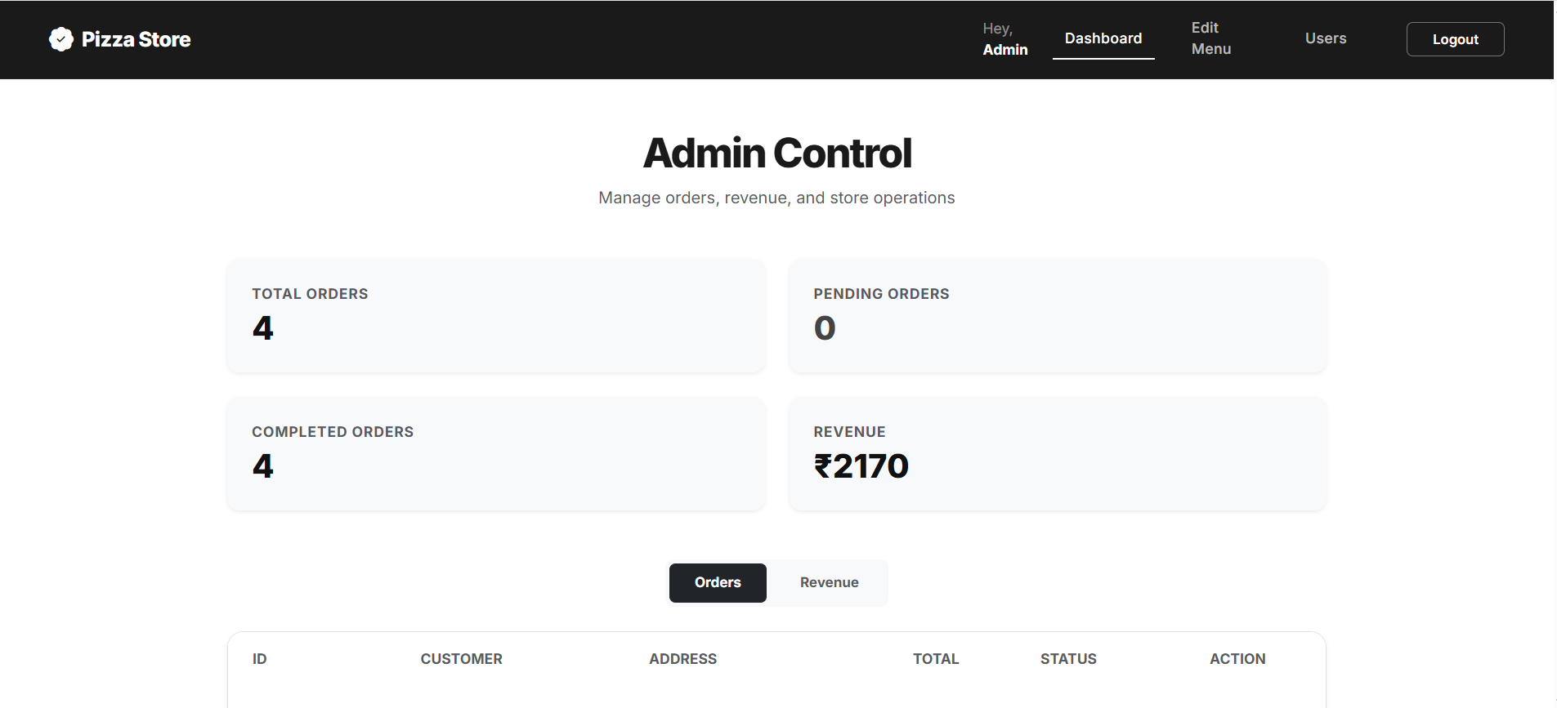
(Insert admin UI screenshots here: Admin dashboard, Menu management table, Category management, Order management table with status update controls, Revenue analytics dashboard, User management table.)

8. Setup & Installation Guide

8.1 Prerequisites
Before setting up the project, ensure the following software is installed. Node.js version 16 or higher is required and can be downloaded from nodejs.org. The LTS version is recommended. MongoDB version 5 or higher must be running locally. npm version 7 or higher is included with Node.js.

8.2 Environment Configuration
Create a file named .env in the backend folder and add the following configuration:

Variable | Example Value | Description
MONGO_URI | mongodb://localhost:27017/pizzastore | MongoDB connection string
JWT_SECRET | your_jwt_secret_key | Secret key used to sign JWT tokens
PORT | 5000 | Port number for the backend server

8.3 Backend Setup
Open a terminal and run the following commands in order:
- Navigate to the backend folder: cd backend
- Install all dependencies: npm install
- Create the default admin account (run only once): node scripts/createAdmin.js
- Seed the database with categories and menu items (run only once): node seed.js
- Start the backend server: node server.js

The backend will start on http://localhost:5000 and the WebSocket server on ws://localhost:5000. You should see 'Server is running on port 5000' and 'WebSocket server is ready' in the terminal.

8.4 Frontend Setup
Open a second terminal and run the following commands:
- Navigate to the frontend folder: cd frontend
- Install all dependencies: npm install
- Create the environment config file and set REACT_APP_API_URL=http://localhost:5000
- Start the React development server: npm start

The frontend will open automatically at http://localhost:3000. Both the backend and frontend must be running simultaneously for the application to work.

8.5 Running Tests
The backend includes a comprehensive test suite built with Mocha and Chai. To run the tests:
- Ensure a test MongoDB instance is available
- Navigate to the backend folder: cd backend
- Run the test suite: npm test

Test files cover authentication, cart, menu items, orders, payments, messages, addresses, and user management. All tests use a 10-second timeout.

8.6 Default Admin Credentials
After running scripts/createAdmin.js, the following admin account is available:

Field | Value
Email | admin@example.com
Password | adminpassword
Role | admin

9. Conclusion
The Pizza Store application successfully demonstrates a full-stack web application built using the MERN stack, integrating MongoDB, Express.js, React.js, and Node.js to create a modern online food ordering platform. The system provides a seamless experience for customers to browse menu items, manage their cart, store delivery addresses, place orders, and complete payments efficiently.
The application implements secure authentication using JWT and protects user data through encrypted password storage with bcrypt. Role-based access control ensures that customers and administrators have appropriate permissions within the system. Administrators can efficiently manage menu categories and menu items, while customers can interact with the platform to place and track their orders.
The project also demonstrates the implementation of key features such as cart management, order processing, payment tracking, and user notifications. Through its modular architecture and well-structured database design, the Pizza Store system provides a scalable and maintainable solution for an online food ordering service.
Overall, this project highlights practical full-stack development skills and showcases how modern web technologies can be used together to build a real-world e-commerce style application.

