Python Assignments

Assignment 1

Rahul Kumar Singh

2021

## **1.** In the below elements which of them are values or an expression? eg:- values can be integer or string and expressions will be mathematical operators.**\* ,'hello',-87.8,- ,/ ,6.**

**Answer:** In the above element –

‘hello’, -87.8 and 6 are values and

*, - and / are expressions.

## **2.** What is the difference between string and variable?

**Answer:** A variable is basically the name of the location in the primary memory of your computer. This can be chosen by developer. A variable can store everything from strings to numbers.

A string is the values inside the quotes (it can be single quotes or double quotes) assigned to a string.

## **3.** Describe three different data types.

**Answer**: Data Types can be defined as classification of data items. Python supports the following built in data types –   
1. Scalar Types.  
2. Sequence Types.  
3. Mapping Types  
4. Set Types

We can also categories the Data Type based on modification after creation of variable of the data type. This is Mutable and immutable types. Numbers, string and Tuples are immutable, and List and Dictionary are mutable.

1.***Scalar Data Type***: This category can have following data type –

1. int: Positive or negative whole numbers (without a fractional part) example: -10, 10, 456, 4654654.
2. float: Any real number with a floating-point representation in which a fractional component is denoted by a decimal symbol or scientific notation example: 1.23, 3.4556789e2.
3. complex: A number with a real and imaginary component represented as x + 2y.
4. bool: Data with one of two built-in values True or False. 'T' and 'F' are capital. It is case sensitive and true and false are not valid booleans and Python will throw an error for them.
5. None: The None represents the null object in Python. A None is returned by functions that don't explicitly return a value.

2. ***Sequence Data Type***: This category can have following data type –

String: A string value is a collection of one or more characters put in single, double or triple quotes.

For example:

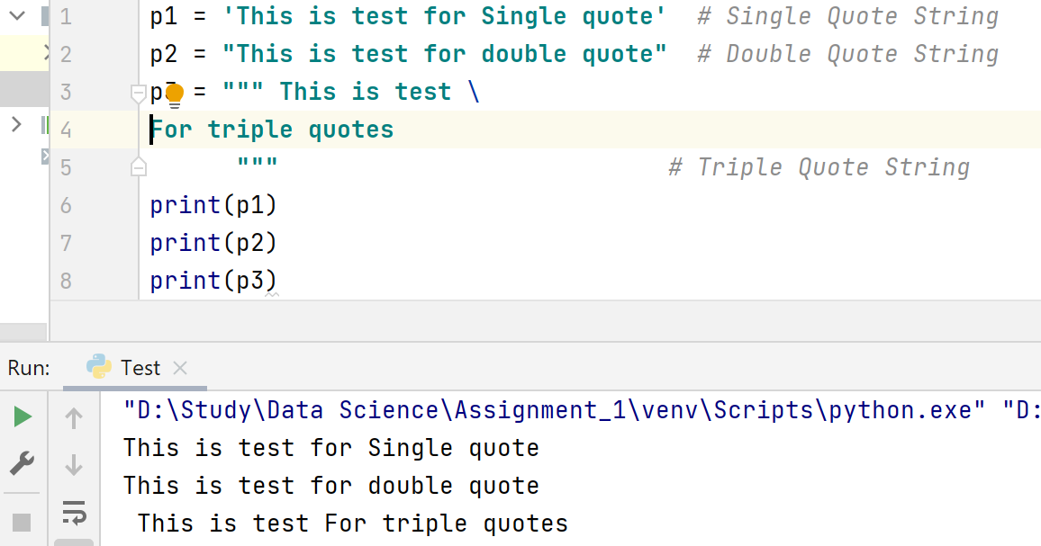

List: A list is a data type used to store multiple items in a single variable. It is one of four build-in data types in Python which are used to store collections of data. We can create list in following way –

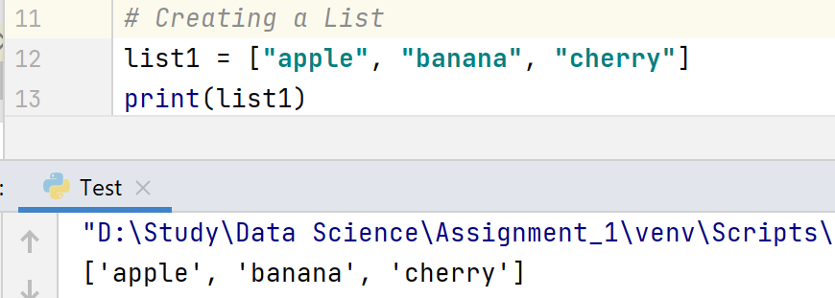

Items in a list are ordered, changeable, and allow duplicate values.

List items are indexed, the first item has index [0], the second item has index [1] etc.

Ordered list means that the items present in list are in a defined order and order will not change. If we add a new item to a list the new item will get placed at the end of list except some of built-in functions for list.

Changeable list means, we can change, add and remove the items from list after it’s creation.

Duplicate value means, a list can have duplicate items means having duplicate value.

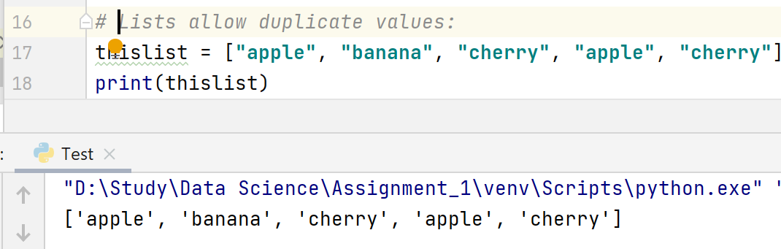

Tuple: A Tuple object is an ordered and unchangeable collection of one or more data items, not necessarily of the same type, put in parentheses having duplicate values.

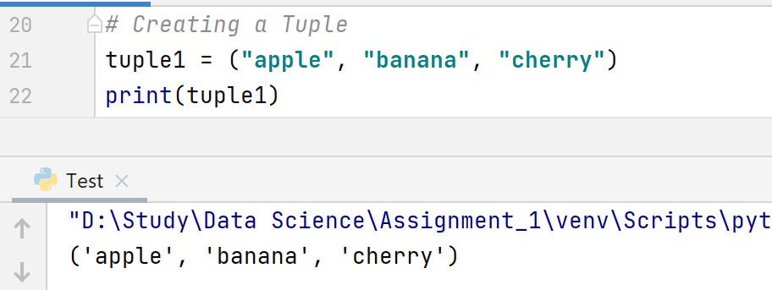

Tuple Items are having following characteristics –

1. Ordered: Tuples are ordered, it means that the items have a defined order, and that order will not change.
2. Unchangeable: Tuples are unchangeable it means the items added cannot be change (i.e. cannot add or remove items) after tuple has been created.
3. Allow Duplicates: Tuple are indexed and can have items with same value.
4. Indexed: Tuples items are indexed, the first item can be retrieved by index [0] and second one by [1] etc.

3. ***Mapping Data Type***: This category can have one data type –

* Dictionary: A dictionary Dict() object is an unordered collection of   
   data in a key: value pair form. A collection of such pairs is enclosed   
   in curly brackets. For example: {1:"Steve", 2:"Bill", 3:"Ram", 4:   
   "Farha"}.

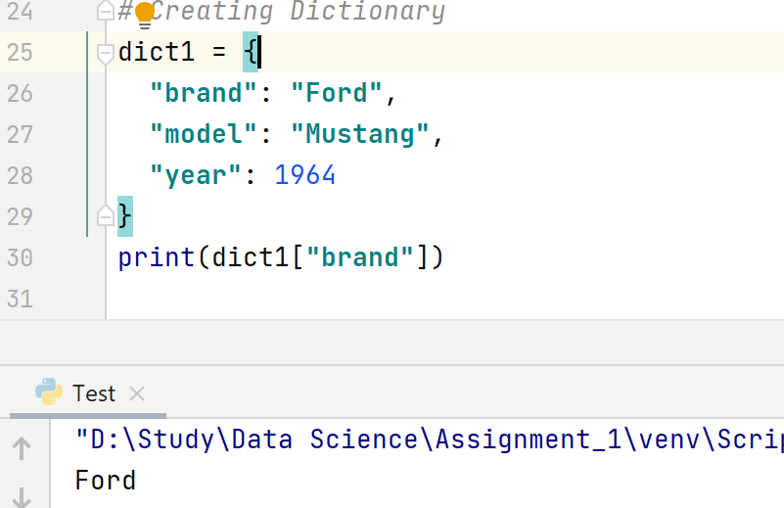

Dictionary items are represented in key : value pair.

Dictionary items are having following characteristics-  
 1) Ordered or Unordered: Python 3.7 onwards dictionary is   
 ordered, whereas earlier <=3.6 dictionaries are unordered.

Dictionaries are ordered, it means that the items have a   
 defined order and order will not change.

Dictionaries are unordered means items does not have a order   
 and we cannot refer to an item by using an index.

2) Changeable: Dictionaries are changeable, meaning that we can change, add or remove items after the dictionary has been   
created.

3) Duplicates are not allowed: Dictionaries cannot have two items with the same key, if this happen then last added duplicate key: value pair will override the existing key: value pair.

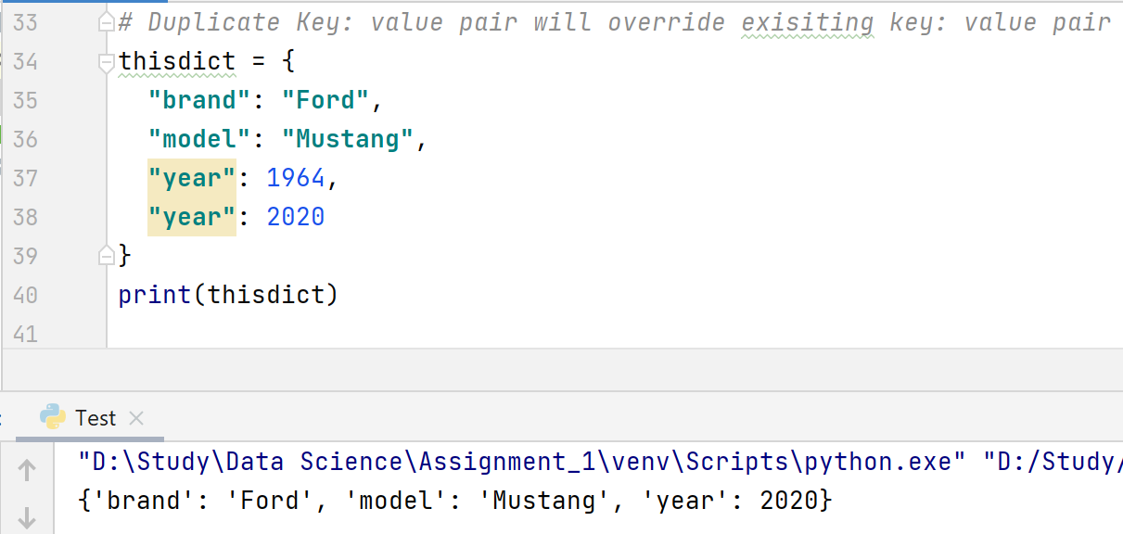

4. ***Set Data Type***: This category can have two data type –

set: Set is mutable, unordered collection of distinct hashable objects. The set is a Python implementation of the set in Mathematics. A set object has suitable methods to perform mathematical set operations like union, intersection, difference, etc.

**frozenset**: Frozenset is immutable version of set whose elements are added from other iterables.

## What is an expression made up of? What do all expressions do?

**Answer**: An expression is a combination of values, variables, operators, and calls to functions. All expression always evaluates down to a single value.

## **5.** This assignment statements, like spam = 10. What is the difference between an expression and a statement? **Answer**: Difference between Expression and Statement are follows:

|  |  |
| --- | --- |
| **Expression** | **Statement** |
| Expressions always returns a value. | A statement never returns a value |
| Functions are also expressions. Even a non-returning function will still return. | Functions are not statement. |
| Can print the result value. | Cannot print the result value. |
| Examples Of Python Expressions: “Hello” + “World”, 4 + 5 etc. | Examples Of Python Statements: Assignment statements, conditional branching, loops, classes, import, def, try, except, pass, del etc. |

## After running the following code, what does the variable bacon contain? bacon = 22 bacon + 1

**Answer:** 22

## What should be the values of following two terms be?

‘spam’ + ‘spamspam’  
 ‘spam’ * 3

**Answer:** spamspamspam

Spamspamspam

## Why egg is a valid variable name while 100 is invalid?

**Answer:** egg is valid variable because as per python rules, variable name   
 can be start with character and may contain the _ as special character   
 whereas 100 is invalid because variable name cannot start with number.

## What three function can be used to get the Integer, floating-point number, or string version of a value?

**Answer:** int(), float() and str().

## Why does this expression cause an error? How can you fix it?

‘I have eaten’ + 99 + ‘burritos.’

**Answer:** 99 is integer value and as per python rule only string can concatenate with other string.To fix this we need to convert 99 into string by using str() function.  
‘I have eaten’ + str(99) + ‘burritos.’