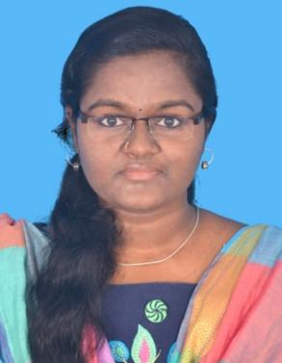
ABIRAMI MUTHARASAN
NO:35,kamatchi nagar,
Manojipatti,Thanjavur.
Mobile no: 6383110368
E-Mail:abiramimutharasan1999@gmail.com
CAREER OBJECTIVE:

Looking for a challenging role, which can widen my knowledge base and enhance my skills so that I can contribute fully to the growth of the organization, while working in an innovative and growth oriented environment.
EDUCATIONAL QUALIFICATION:

COURSE | UNIVERSITY/SCHOOL | YEAR OF PASSING | MARKS IN % CGPA
B.E (EEE) | Anjalai Ammal Mahalingam Engineering college,  Kovilvenni. | 2020 | 6.3 CGPA
HSC | P.V.Selvaraj Girls Higher Secondary School ,Thanjavur. | 2016 | 87.16%
SSLC | P.V.Selvaraj Girls Higher Secondary School ,Thanjavur. | 2014 | 91%
WORK EXPERIENCE:

- Company Name : CAD Macro Design and Solutions Pvt Ltd.Chennai.
- Designation : Software Developer (Full Stack)
- Duration : 1 year
- Responsibilities :

- Evaluate and develop accurate timeline for tasks and projects based on complexity,
Resources, completing priorities and time required to complete.
- Design,develop,test and deploy new and existing applications and configuration Satisfy defined requirements.
- Identify testing scenarios and ensure they are covered automated or manual test plans.
- Develop and utilize quality control measures such as code reviews,debugging
Procedures
- Develop and adhere to development standards that allow for the maintainability and test ability of code in a manner that supports team development.
- To maintain software architecture standards during development to ensure applications follow modern development and software security practices.
- Provide training and serve as a mentor for fresh developers
TECHNICAL SKILLS:

- Languages - C# ,JAVA ,C++,OOPS,SQL
- Framework - Dot Net,MVVM,MVC
- Tools - Eyeshot, WPF, Winform, IDE-Visual studio,XAML,Telerik,Svn tortoise, AUTOCAD.
- MS office

PROJECTS:

- CAD Drawing Application(WPF C#)
- Customer Details System (Winform C#)
- Renewable Energy Based Electric Vehicle
- Home Automation Using 8051 Microprocessor
WORKSHOPS/INTERSHIPS:

- Attended Workshop on “IOT”
- Attended Workshop on “Web Development”
- Presented Seminar on “CAD Applications” in NIT, Trichy.
- Presented Paper on “Renewable energy based E-vehicle” in International Conference.
PERSONAL SKILLS:

- Team player and good verbal skills
- Strong decision maker and easily adaptable
- Project management,Good leadership quality
PERSONAL PROFILE:

s

- Father’s name : P.Mutharasan
- Date of birth : 20/07/1999
- Gender : Female
- Nationality : Indian
- Blood group : B -ve
- Language Known : Tamil,English

Declaration,
I hereby declare that the above information are true to the best of my ability.
Date:
Place: ABIRAMI.M

