Syed Mhammad Afzal

About Me
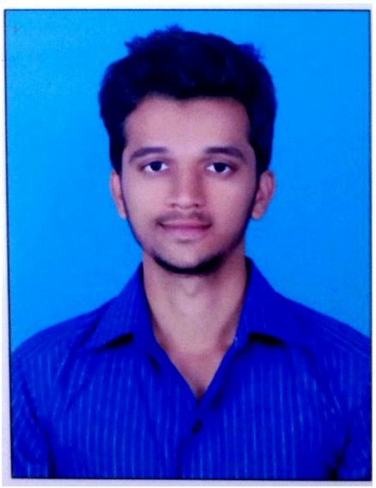




Adoni, Andhra Pradesh
+91 9502301141
syedafzal8082@gmail.com anwar.mba.hr@gmail.com
August, 10 1997

 Objective

To pursue a challenging and satisfying career in the industry and to be a part of a progressive organization that gives me a scope to enhance my knowledge and skills and contribute to the organization for its better growth.

Work Experience

Site Engineer at Residential buildings (Adoni, Andhra Pradesh) (2018-2021)
- To analyze the design and work accordingly.

Skills

- Able to effectively conduct presentations.
- Strong Communication, team leader and leadership skills, Quick learner.
- Ability to work independently and with the team in a diverse, fast-paced & collaborative environment.
- Problem solving decision making skills.
- Trouble shooting.

Computer Proficiency

- Knowledge on Linux.
- Proficient with various development, testing and deployment tools – Git, Jenkins, Docker, Ansible.
- Good understanding of DevOps key concept like infrastructure as code (IaC).
- Maintaining CI/CD pipelines.
- Intermediate in Mainframe.
- Basics of Revit
- Basics of C
- Billing and Estimation.
- AutoCAD.
- Unix.

- Microsoft Word, Excel and Power Point.

Awards & Achievements

- Seminar on “REPAIRING OF CONCRETE”.
- Cricket player won prizes at school level and university levels.
- Won prize in handball in state level.
- Won prize in volley ball district level.


Education

BOARD OF secondary education A.P (SSLC) March 2012
KIDDY’S GLOBAL & IIT SCHOOL Score 67%
Adoni, A.P

Pre-university education (PUC) March 2014
NARAYANA JUNIOR COLLEGE Score 81.83%
Adoni, A.P

Bachelor of Engineering June 2018
BALLARI INSTITUE OF TECHNOLOGY AND MANA GEMENT Score 65%
Ballari, Karnataka

Academic Research & Internship

Main project on “RECYCLING OF CONCRETE”
Brief description:
The main aim of this project is to illustrate the technology used these days. When structures made of concrete are demolished or renovated, concrete recycling is an increasingly common method of utilizing the rubble. Concrete was once routinely trucked to landfills for disposal, but recycling has a number of benefits that are made it a more attractive option. Concrete aggregate collected from demolition sites is put through a crushing machine. Crushing facilities accept only uncontaminated concrete, which may must be free of trash, wood, paper and other such materials. Metals such as rebar are accepted, since they can be removed with magnets and other sorting devices and melted down for recycling elsewhere. The remaining aggregate chunks are sorted by size. Larger chunks may go through the crusher again. After crushing has taken place, other particulars are filtered out through a variety of methods including hand-picking and water flotation, and comparing the slab material with the normal aggregate.


Personal Details

- Father’s Name: S Mohammed Yusuf
- Nationality: Indian
- Gender: Male
- Address: House no. 19/325 Fareed sahib street, Adoni, Karnool, Andra Pradesh

Syed Mohammad Afzal

