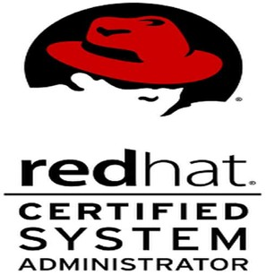
NAWAB DE
Permanent Address: 204, Mahesh Colony,Serampore, West Bengal Post: Mahesh, Pin: 712202
Contact No: (M) +91 7685848464 / 9123857598
Email: nawabde06@gmail.com linkedin.com/in/nawab-de-647b31140
OBJECTIVE
To seek and maintain a full-time position that oﬀers professional challenges utilizing interpersonal
skills, excellent time management and problem-solving skills.

B.Tech in Electrical Engineering (2018-2021) from Modern Institute of Engineering and Technology,
Bandel under Maulana Abul Kalam Azad University of Technology(WBUT).

CLASS | BOARD | INSTITUTE | MARKS | Year
B.TECH | MAKAUT | Modern Institute of Engineering and Technology. | 74% | 2021
DIPLOMA | WBSCTE | Engineering Institute for Junior  Executives. | 74.5% | 2017
X | WBBSE | Mahesh Sri Ramkrishna Ashram Vidyalaya | 73.85% | 2013

Have core system administration skills on RHEL7 & RHEL8 and Centos platform like managing and monitoring the processes, user groups, access control list, memory CPU and disk utilization services, system journals, and logs troubleshoot Conﬁguring the SELINUX and network ﬁrewalls Scheduling jobs, LVM, installing the OS and system packages & shell scripting.
AWS cloud platform: AWS (EC2, ELB, RDS, S3, Cloud watch)

Key Skills: SYSTEM ADMINISTRATION SKILLS IN REDHAT ENTERPRISE LINUX DISTRIBUTION.
Hands on knowledge in AWS cloud platform.
Programming Languages: PYTHON3, ShellScripting

Container tools: DOCKER AND PODMAN.

Red Hat Certiﬁed System Administrator (RHCSA) on RHEL8 issued by RED HAT (Sep,2021).
Certification ID: 210-149-530
AWS SOLUTION ARCHITECT from Aem technologies kolkata.
Python bootcamp online learning platform Udemy
UC-364ca6e2-fd69-4900-bff0-7a6b0d5b29ee

End To End Deployment of a website in AWS cloud. (05/2021)
Personal project.

Dates Employed
Employment Duration
Location
Linux System Administrator
at Hewlett Packard Enterprise(HP) under Aforeserve.com ltd payrole. Oct 2021 – Present

It’s a pan India project of LIC EDMS,monitoring the EDMS hp servers (RHEL 7.5),uploading daily data,monitoring the backups,check services through logs,maintain excel sheets and reports,Upgrade firmware packages,timely Vacuuming the servers,monitor and manage clusters. Performing the assign tasks timely through HP ILO’s.

