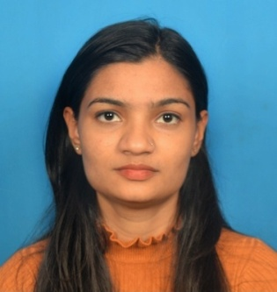
SIKHA SAHU
Sikha2276@gmail.com
Mobile no: 6901810203
Address : Halasaru, Bangalore, Karnataka

Career Objective
A result-oriented and motivational M.Com postgraduate graduate looking for an opportunity in a reputed organization where I can upgrade my knowledge and skills in the field of marketing.
Educational Qualifications:

Degree | Board/university | year | Percentage/CGPA
M.com | Dibrugarh university | 2021 | 7.08(CGPA)
B.com | Dibrugarh university | 2019 | 57.88
12th | AHSEC | 2016 | 50
10th | SEBA | 2014 | 66

Key skills:
- Good communication skill (both written and oral communication).
- Basic knowledge of accounts, taxation, and GST.
- Basic knowledge of using accounting software like Tally.
- Knowledge of MS Excel, Word, and Power point.

Core strengths:
- Self-motivated
- Active learning
- Time management
Certifications:
- Certificate in computer concepts with a duration of 3 months.
- Diploma in Financial Accounting with a duration of 6 months.
Academic Project: Preaparation of Business Model
Name of Business Model: Gift House
Nature of Business: Hand made gift items.
Introduction to Business Model: Handmade gifts are most precious as there is a lot of effort put into it.
- THE idea GIFT HOUSE is because Buying gifts for friends and family is an activity that millions of people undertake every year. Gift shops create huge amounts of revenue, especially at Christmas time.
- Gifts are a good business to get into because they are purchased by every group in society. They also cover an endless range of sectors, including toys, cards, home decor and jewelry.
Workshops attended:
- Attended a workshop on Artificial Intelligence with Digital Marketing organized by Kaziranga University held in Jagannath Barooah College 2020.

Personal details:

Name : Sikha Sahu
Date of Birth : 12th December 1998
Father name: : Parmeshwar Prasad Sahu
Permanent address: : Kacharipuria Gaon, Jorhat, Assam
Marital status : Unmarried
Religion : Hindu
Nationality : Indian
Languages Known : English, Hindi & Assamese

Declaration

I hereby affirm that all the above furnished details are true to the best of my belief and knowledge.
Place: Bangalore Signature
Date: 16th December 2021 Sikha Sahu

