**Power BI Assignment 2**

1. **Explain the advantages of Natural Queries in PowerBi with an example?**

1. Natural Language Query helps to use natural language expressions to explore and understand to find

1. It helps to bridge the gap between technical and non-technical users who may not understand which database.
2. More frequent questions can be put by deplore for ease of stakeholders
3. Example: “How many customers made a purchase this month. User without going deep in data can get few answers to have an insight on data.

**2 Explain Web Front End(WFE) cluster from Power BI Service Architecture?**

The web front-end cluster acts as an intermediary of client with back end. The front end services are used for

* 1. establishing an initial connection
  2. authenticating clients using Azure Active Directory.

After authentication, Azure Traffic Manager is used to direct user requests to the nearest data center . the Azure Content Delivery Network (CDN) distributes static Power BI content/files to users only after the authentication.

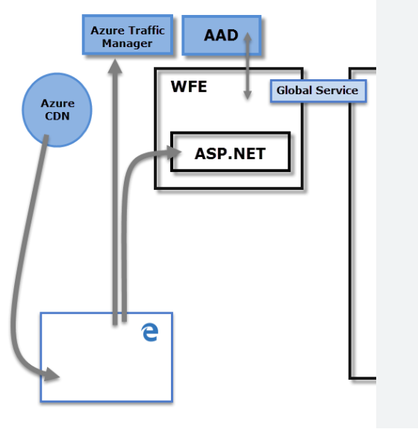

Reference: https://learn.microsoft.com/en-us/power-bi/enterprise/service-admin-power-bi-security

1. Explain Back End cluster from Power BI Service Architecture?

The Back-End cluster is about authenticated clients on how it interact with the Power BI service. It mainly manages visualizations, user dashboards, datasets, reports, data storage, data connections, data refresh, and all the aspects of interacting with the Power BI service.

At the back-end, a web client has only two direct points of interaction, Azure API Management, and Gateway Role which is responsible for load balancing, authentication, authorization, routing, etc.

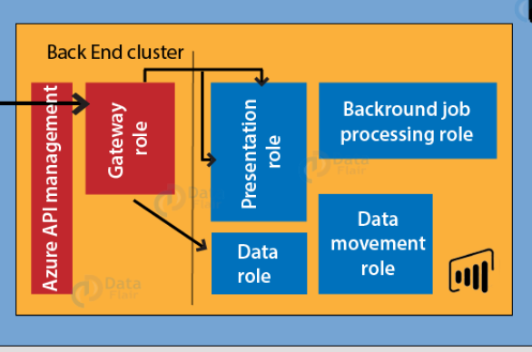

Reference: https://data-flair.training/blogs/power-bi-architecture/

1. **What ASP.NET component does in Power BI Service Architecture?**

Power BI report in an ASP.NET 5 Core web app.

ASP.NET is a web development platform, which provides a programming model, a comprehensive software infrastructure and various services required to build up robust web applications for PC, as well as mobile devices.

ASP.NET is used to produce interactive, data-driven web applications over the internet. It consists of a large number of controls such as text boxes, buttons, and labels for assembling, configuring, and manipulating code to create HTML pages.

ASP .NET Core web application interacts with the Power BI Service API and implements Power BI embedding.

1. Compare Microsoft Excel and PowerBi Desktop on the following features:

Data import : Sources from which data can be imported is much more than in excel. Also the size of data import is also more in powerBI.

Data transformation: When we load data, data transformation option comes as a option in Power BI. Data transformation using power query and function can be done in both. However option sof ower query and other user defined interface are more friendly to transform data in power BI. DAX is another advantage is power BI for transforming data by coding.

Modeling: Data Modelling can be done in both excel and power BI. In power BI we have dedicated option where model can be automatically or manuaaly created in power BI. In excel we can see this in Diagram view.

Reporting : Excel is flexible and also create summary reports in simple steps and formulas. Power BI has a wide variety of visualizations. It import many other visuals from the marketplace besides available built-in charts. Excel has only a few built-in charts with which we need to work to make dashboard.

Server Deployment: We can mange and store Power BI reports on premises in the Power BI Report Server web portal same as reports in the cloud in the Power BI service, and publish them to the web portal. Then report can be viewed in a browser or in a Power BI mobile app on a mobile device. The Office Deployment Tool (ODT) can be used to download and deploy Click-to-Run versions of Office (excel)

Cost : Power BI is costly in terms of licensing compared to excel application in an organ ization.

1. **List 20 data sources supported by Power Bi desktop.**
2. SQL Server database
3. Access database
4. SQL Server Analysis Services database
5. Oracle database
6. IBM Db2 database
7. IBM Informix database (Beta)
8. IBM Netezza
9. MySQL database
10. PostgreSQL database
11. Sybase database
12. Teradata database
13. SAP HANA database
14. SAP Business Warehouse Application Server
15. SAP Business Warehouse Message Server
16. Amazon Redshift
17. Impala
18. Google BigQuery
19. Vertica
20. Snowflake
21. Essbase