**Software Requirements Specifications**

**for**

**Academic Management System**

Prepared By:

Rahul Kumar (IIT2019109)

Aditya Singh Machhaiya (IIT2019111)

Khushi Gupta (IIT2019141)

Nandini Gupta (IIT2019149)

**Indian Institute of Information Technology, Allahabad**

Date created: 27th January, 2020

**TABLE OF CONTENTS**

1. Introduction …………………….…………………….……………..

1.1 Purpose …………………….……………………..……………..

1.2 Document Conventions …………………….…………………...

1.3 Scope …………………….……………………..……………….

1. System features …………………….……………………..………....
2. Use Case Model ………………….……………………..…………...
3. Non-functional requirements …….……………………..……………

1. Other requirements ……………….……………………..…………...

**1. Introduction**

This section gives a scope description and overview of everything included in this SRS document. Also, the purpose of this document is described and a list of abbreviations and definitions is provided.

**1.1 Purpose**

The purpose of this document is to give a detailed description of the requirements for the AMS software. Via this portal, It will be easier for the dean/ registrar to view the academic performance of any student and also some personal details like address,contact number etc. The dean/registrar can also modify it based on the request from the student . Can also view dropped courses current courses/electives of any student.

**1.2 Document Conventions**

**Main Section Title**

Font Style: Times New Roman , Bold

Font size: 18

**Subsection Title**

Font Style: Times New Roman , Bold

Font size: 14

**1.3 Scope**

The AMS is a web based application based on some web technologies which helps the dean / registrar to view academic details and some other details of any student .

**In Scope**

1. Using this web portal, the dean can easily view academic details of any student and see how the student is processing in academics.
2. Can view details of course coordinators and the no. of students registered for that course.
3. Can change the data in the db of any student on request.
4. Can view the exam schedule and time table of any batch of any year.
5. Can view academic calendar.
6. Can view attendance status, opted/dropped courses of any student.

**Out of scope**

1. The dean/registrar can only view all the things but can edit only on request.
2. There is no scope for the dean/registrar to communicate with any student/professor through the portal.

**1.3 Acronym**

|  |  |
| --- | --- |
| TERM | DEFINITION |
| DB | Database |
| AMS | Academic Management System |
| OTP | One Time Password |

**1.4 References**

1.https://www.perforce.com/blog/alm/how-write-software-requirements-specification-srs-document

2. https://www.geeksforgeeks.org/how-to-write-a-good-srs-for-your-project/

**2. System features**

We describe the functional requirements using various use cases.

Use Case 1: Dean/admin Login

Primary Actor: dean/registrar

Pre-Condition: To run this web portal the technology required in your laptop is xampp,mysql,any text editor(VS code,Sublime Text editor).

Main Scenario:

1. Dean/admin logged in with correct credentials.
2. Navigate to the main home screen.

Alternate Scenario:

1. Login credentials are wrong .
   1. Prompt the Dean/admin that he/she typed the wrong password.
   2. Prompt to re-enter the password.

Use Case 2: Change Password

Primary Actor: Dean/admin

Pre-Condition: Dean/admin must have logged on the portal.

Main Scenario:

1. To change the password or to generate new password if Dean/admin forgot the password.
2. Send OTP to registered email of Dean/admin.
3. Confirmation Mail.

Alternate Scenario:

1. Mail failure due to server error
   1. Prompt to try again.
2. OTP entered by the Dean/admin may be wrong.
   1. Prompt to send OTP once again.

Use Case 3: View Student Profile

Primary Actor: Dean/admin

Pre-Condition: Dean/admins must be logged on the portal.

Main Scenario:

1. Can view student details both personal and academic.
2. Can modify based on requests raised by students.

Alternate Scenario:

1. Enrollment Number may be invalid.Maybe the student with that enrolment no. has withdrawn their name or rusticated from college.
   1. Prompt to wrong id.

Use Case 4: View Student Progress

Primary Actor: Dean/admin

Pre-Condition: Dean/admin must have logged on the portal.

Main Scenario:

1. Can see their semester wise and course wise marks.
2. Can view attendance record,dropped courses.
3. Can also view any penalty on students by faculty.

Alternate Scenario:

1. 1. Unable to view due to db crash or missing any requires technology.
   1. Prompt to try again.
2. 2. Unable to detect location of required query in db.

Use Case 5: View General Information

Primary Actor: Dean/admin

Pre-Condition: Dean/admin must have logged on the portal.

Main Scenario:

1. Can view public documents like academic calendar,time table for examination,class schedule.
2. Can view the profile of any course coordinator,registered student for that course or elective.
3. Can view the details of ongoing project under the faculty.

Alternate Scenario:

1. 1. Maybe the data is not available in db because of any reason like db crash or last submission of details to the portal handler.
   1. Prompt to contact the host of the portal.

Use Case 6: Fee/Exam Details of any Student

Primary Actor: Dean/admin

Pre-Condition: Dean/admin must be logged on the portal.

Main Scenario:

1. Can view whether the student paid the exam fee or not.
2. Can view whether the student appeared in the exam or not.

Alternate Scenario:

1. Maybe there is no data in db because the student forgot to register for the examination.
2. Maybe there is an error in the server connection.

Use Case 7: Student Login

Primary Actor: Student

Pre-Condition: To run this web portal the technology required in your laptop is xampp,mysql,any text editor(VS code,Sublime Text editor).

Main Scenario:

1. Students must fill correctly assigned LDAP credentials for successful login.
2. Navigate to the main home screen after successful login.

Alternate Scenario:

1. Login credentials are wrong .
   1. Prompt the Dean/admin that he/she typed the wrong password.
   2. Prompt to re-enter the password.

Use Case 8: Change Password

Primary Actor: Student

Pre-Condition: Dean/admin must have logged on the portal.

Main Scenario:

1. To change the password or to generate new password if Dean/admin forgot the password.
2. Send OTP to registered email of Dean/admin.
3. Confirmation Mail.

Alternate Scenario:

1. Mail failure due to server error
   1. Prompt to try again.
2. OTP entered by the Dean/admin may be wrong.
   1. Prompt to send OTP once again.

Use Case 9: View Own Profile

Primary Actor: Student

Pre-Condition: Dean/admins must be logged on the portal.

Main Scenario:

1. Can view both it’s personal details and academic performance.
2. Can raise a request for modification in it’s personal profile.

Alternate Scenario:

1. Maybe there is login error no data is shown
2. Maybe Db crashed due to any reason.

Use Case 10: View Own Progress

Primary Actor: Student

Pre-Condition: Students must have logged on the portal.

Main Scenario:

1. Can see their semester wise and course wise marks.
2. Can view attendance record,dropped courses.
3. Can also view any kind of penalty posted by the professor.

Alternate Scenario:

1. Unable to view due to db crash or missing any required technology.
   1. Prompt to try again.
2. Unable to detect location of required query in db.

Use Case 11: View General Information

Primary Actor: Student

Pre-Condition: Students must have logged on the portal.

Main Scenario:

1. Can view public documents like academic calendar,time table for examination,class schedule.
2. Can view the profile of any course coordinator,registered student for that course or elective.
3. Can view the details of ongoing projects under the faculty.

Alternate Scenario:

1. 1. Maybe the data is not available in db because of any reason like db crash or last submission of details to the portal handler.
   1. Prompt to contact the host of the portal.

Use Case 12: Fee/Exam Details of logged in Student

Primary Actor: Student

Pre-Condition: Students must be logged on the portal.

Main Scenario:

1. Can view whether the fees is paid by the student or not.
2. Can view it’s exam attendance.

Alternate Scenario:

1. Maybe there is no data in db because the student forgot to register for the examination.
2. Maybe there is an error in the server connection.

Use Case 13: Edit exam schedule

Primary Actor: Dean/admin

Pre-Condition: Dean/admin must have logged on the portal.

Main Scenario:

1. Can edit public documents like academic calendar,time table for examination,class schedule.

Alternate Scenario:

1. 1. Maybe the data is not available in db because of any reason like db crash or last submission of details to the portal handler.
   1. Prompt to contact the host of the portal.

Use Case 14: Edit status

Primary Actor: Dean/admin

Pre-Condition: Dean/admin must have logged on the portal.

Main Scenario:

1. Can edit documents like attendance, dropped courses, penalty, etc.

Alternate Scenario:

1. 1. Maybe the data is not available in db because of any reason like db crash or last submission of details to the portal handler.
2. Prompt to contact the host of the portal.

Use Case 15: Edit profile

Primary Actor: Dean/admin

Pre-Condition: Dean/admin must have logged on the portal.

Main Scenario:

1. Can edit the profile of any student on request.

Alternate Scenario:

1. 1. Maybe the data is not available in db because of any reason like db crash or last submission of details to the portal handler.
2. Prompt to contact the host of the portal.

Use Case 16: Logout

Primary Actor:Dean/registrar/student

Pre-Condition: To run this web portal the technology required in your laptop is xampp,mysql,any text editor(VS code,Sublime Text editor).

Main Scenario:

1. Dean/admin/student needs to click on the logout option.

**3. Use Case Model**

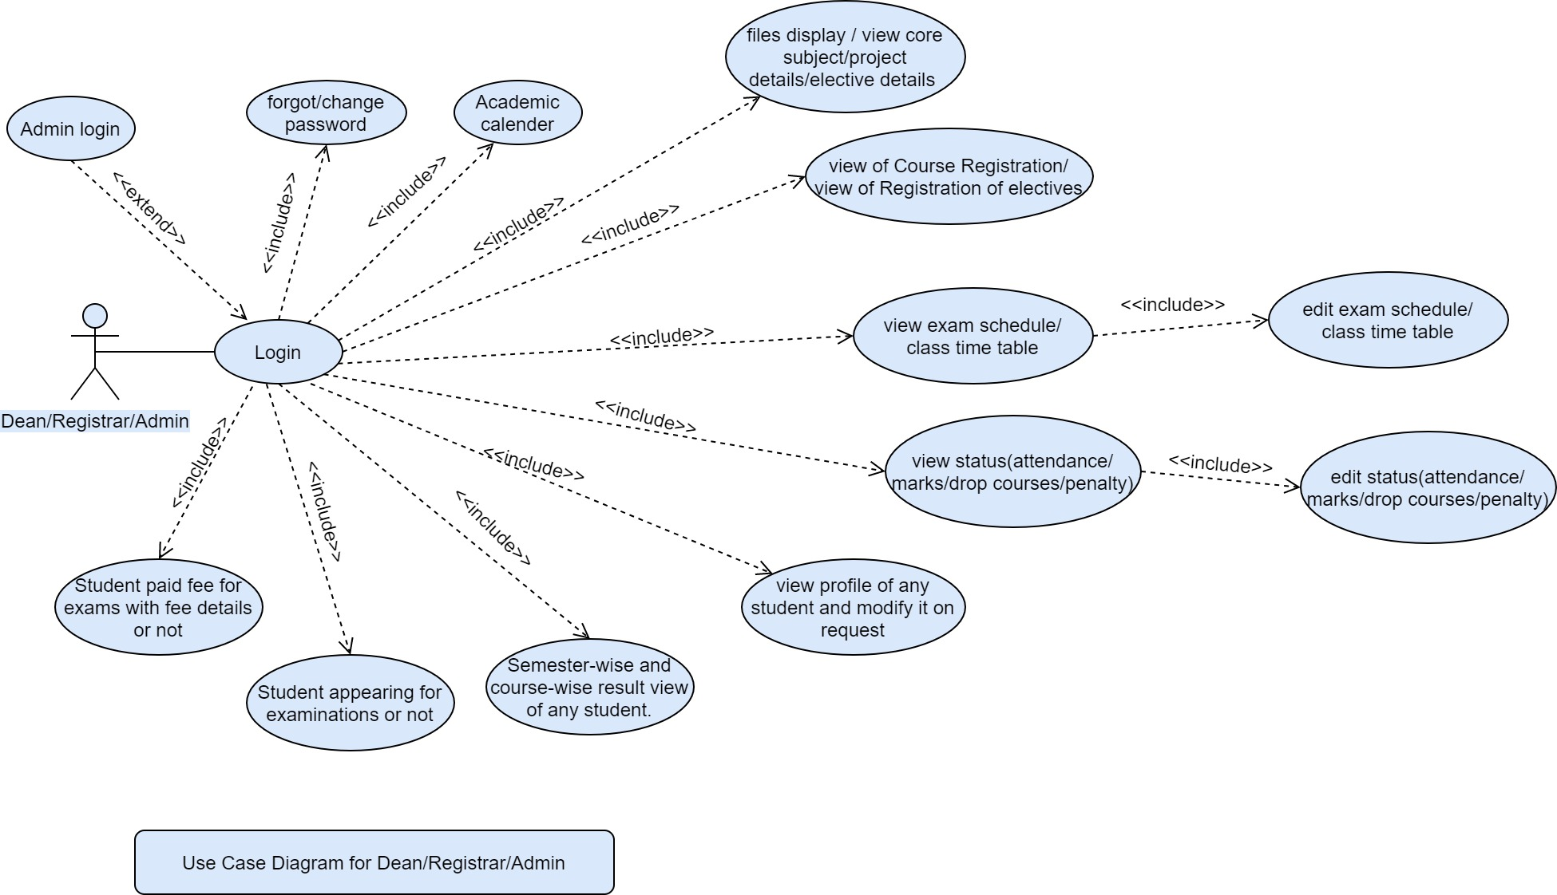

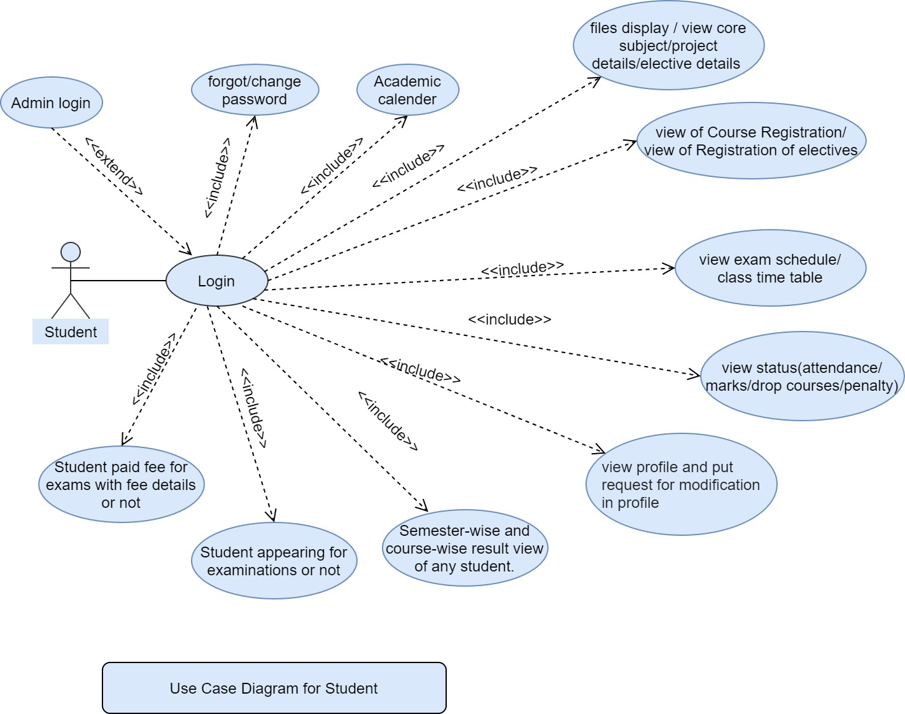

**4. Non-functional requirements**

* **Performance**: The Academic Management System shall be built on the basis of web development techniques. In case of any failure from the server, it will be immediately handled to ensure system safety.
* **Reliability**: If there exists any failure, the system shall come out of the normal operation mode and the problem shall be solved as soon as possible. This behaviour can occur in case of any emergency only.
* **Availability**: If the system is working under normal conditions, any problem faced by the Dean/admin shall be handled within a short duration of time. Feedback provided by the Dean/admins shall be communicated and worked upon. Product will be available for 24*7.
* **Security**: As far as the security is concerned, Dean/admins can provide their personal information that is privacy related. A security system shall exist to prevent the system from being hacked. This system can be accessed online, so it requires a strong security mechanism.

* **Maintainability**: There shall be design documents describing maintenance of the software and database used to save the Dean/admin details.

1. Product should have a simple UI (User Interface).
2. The software shall be functional for 24*7 .
3. The portal should be able to handle traffic.
4. A Security alert should also be made when at one time there are 2 Dean/admins who have logged in via the same Identity.
5. Portal should have less graphics so that the loading time is decreased and the main functionality remains intact.
6. The portal should be designed in such a way that it should need less access to sources from the client side.
7. Only the Students should be able to change his details after logging in the portal.
8. Portal should have wide scalability and should work across all the leading web browsers.
9. The system must automatically log out all Dean/admins after a period of inactivity or after closing the tab . The system should not leave any cookies on the customer’s computer containing the Dean/admin’s password.
10. The nav-bar shall allow the Dean/admin to reach to their own profile page from any point in the page.
11. Portal should be all the time connected to the database server for hassle free functionality.

**5. Other Requirements**

**5.1 Hardware requirements:**

To run this web portal the technology required in your laptop is xampp,mysql,any text editor(VS code,Sublime Text editor).