"SCHOOL MANAGEMENT SYSTEM"
A

Project Report

Submitted in partial fulfillment of the requirement for the award of Degree of

Bachelor of Science in Information Technology

Submitted to

445 – Catalyst College, Patna




Submitted By | Under Joint Guidance of
<Your Name>  Registration No.<your reg. no>  B.Sc.IT-3rd Year  Session-2023-2026 | Ravi Kumar Soni &  Prof. Murali Manohar  [Asst. Professor]  Computer Science & Applications


Catalyst College, Patna

Department of Computer Science & Applications

Session 2023-2026

DATE: 17/04/2026

CERTIFICATE

This is to certify that the work embodies in this project entitled, "School Management System", being submitted by Rahul Kumar (202344500285) in partial fulfillment of the requirement for the award of "Bachelor of Science in Information Technology" to PATLIPUTRA UNIVERSITY, PATNA during the academic year 2023-2026 is a record of bonafide piece of work, carried out by him under our/my supervision and guidance in the "Department of Computer Science & Applications", Catalyst College, Patna.

Dr. Neeraj Agrawal | Dr. Neeraj Kumar | Dr. Amit Kumar Shukla
Director cum Principal | Dean- Academics | Head of Department


Catalyst College, Patna

Department of Computer Science & Applications

Session 2023-2026

Date: 17/04/2026

APPROVAL CERTIFICATE

The project report entitled "School Management System", being submitted by
Rahul Kumar (202344500285) has been examined by us and is hereby approved for the award of degree "Bachelor of Science in Information Technology", for which it has been submitted. It is understood that by this approval the undersigned do not necessarily endorse or approve any statement made, the opinion expressed or conclusion drawn therein, but approve the project only for the purpose for which it has been submitted.

(Internal Examiner) (External Examiner)

Date: Date:


Catalyst College, Patna

Department of Computer Science & Applications

Session 2023-2026

Date: 17/04/2026

DECLARATION

I, Rahul Kumar hereby declare that the work, which is being presented in the project report entitled "School Management System", partial fulfillment of the requirements for the award of degree of "Bachelor of Science in Information Technology" submitted in the department of Computer Science & Applications (Catalyst College) is an authentic record of my own work carried under the guidance of my teachers. I have not submitted the matter embodied in this report for the award of any other degree.

Rahul Kumar Registration No : 202344500285 B.Sc.IT 3rd Year
Session-2023-2026
ACKNOWLEDGEMENT

“A journey is easier when you travel together. Interdependence is certainly more valuable than
independence.”

I would like to express my sincere thanks to my teachers and guides for their valuable guidance and support during the development of this project.

I am thankful to the Department of Computer Science & Applications, Catalyst College, Patna, for providing the opportunity to work on this project.

“The completion of any project depends upon the cooperation, coordination, and combined efforts of several resources of knowledge, inspiration, and energy”.

I also thank Patliputra University, Patna and all faculty members for their encouragement and academic support.

My gratitude also goes to my friends and classmates who helped me during testing and feedback.

Finally, I thank my parents and family members for their constant motivation and support.

With sincere gratitude, I acknowledge everyone who contributed directly or indirectly to the successful completion of this project.

(Rahul Kumar)

Registration No : 202344500285

B.Sc.IT 3rd Year
Session-2023-2026

INTRODUCTION 8
OBJECTIVE 9
PROJECT CATEGORY JAVA 10
ADVANTAGES OF JAVA 11
TOOLS/PLATFORM required 13
HARDWARE & SOFTWARE REQUIREMENTS 13
PROBLEM DEFINITION 14
REQUIREMENT SPECIFICATIONS 14
PROJECT PLANNING & SCHEDULING 14
GANTT CHART 16
PERT CHART 18
SYSTEM ANALYSIS 1
IDENTIFICATION OF NEED 1
FEASIBILITY STUDY 6
TECHNICAL FEASIBILITY: 7
ECONOMICAL FEASIBILITY: 7
OPERATIONAL FEASIBILITY: 8
ANALYSIS 10
DFD 10
MODULE DESCRIPTION 16
DATA STRUCTURE Snap shot 17
LIST OF REPORTS 22
SCOPE AND FUTURE ENHANCEMENT 23
IMPLEMENTATION METHODOLOGY 23
TESTING 25
LIMITATIONS AND FURTHER ENHANCEMENTS 28
SECURITY MECHANISM 29
SNAPSHOTS 30

CONTENTS

INTRODUCTION

OBJECTIVE

TOOLS/PLATFORM REQUIRED

HARDWARE & SOFTWARE REQUIREMENTS

PROBLEM DEFINITION

MODULE DESCRIPTION

TESTING

CONCLUSION

SNAPSHOTS

INTRODUCTION

The School Management System is a web-based application developed to manage daily school operations in a simple and organized manner.

It helps in maintaining student records, attendance, marks, fees, admissions, notifications, and role-based access for admin, teacher, parent, and student users.

The system reduces manual paperwork, improves data accuracy, and provides quick access to important school information.

OBJECTIVE

To maintain student, teacher, and school records digitally.

To manage attendance, marks, and fee details efficiently.

To provide separate login access for different types of users.

To improve reporting, monitoring, and overall school administration.

TOOLS/PLATFORM REQUIRED

Frontend: React

Backend: Node.js and Express.js

Database: MySQL

Charts/Reports: Chart.js

Platform: Web Browser

HARDWARE & SOFTWARE REQUIREMENTS

Hardware Requirements: Computer/Laptop, minimum 4 GB RAM, internet connection.

Software Requirements: Windows OS, Node.js, MySQL Server, and modern web browser.

PROBLEM DEFINITION

Manual school record management takes more time, causes duplication, and increases the chance of errors.

A digital system is required to manage admissions, attendance, marks, fees, and communication in a reliable way.

MODULE DESCRIPTION

Admin Module: manages school records, classes, fees, and admissions.

Teacher Module: manages attendance and marks entry.

Student Module: shows personal details, marks, attendance, and fee status.

Parent Module: provides visibility into student progress and updates.

Notification Module: sends important school information to users.

TESTING

The project was tested for login flow, dashboard access, admission form, attendance entries, fee tracking, and student information display.

The system was found suitable for basic school management operations.

CONCLUSION

The School Management System is a practical and useful application for digital school administration.

It saves time, improves accuracy, and helps different users access information from one platform.

STUDENT DETAILS

Name: Rahul Kumar

Registration Number: 202344500285

Student ID: 445-12425

Mobile Number: 9006347510

University: Patliputra University, Patna

College: Catalyst College, Patna

SNAPSHOTS

The following screenshots show the main interfaces and database used in the School Management System project.

Home Page
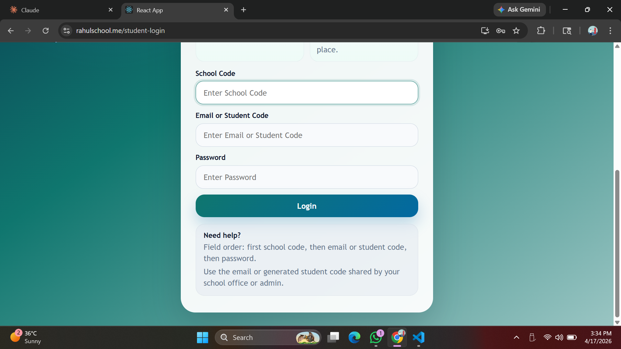

Student Login Page
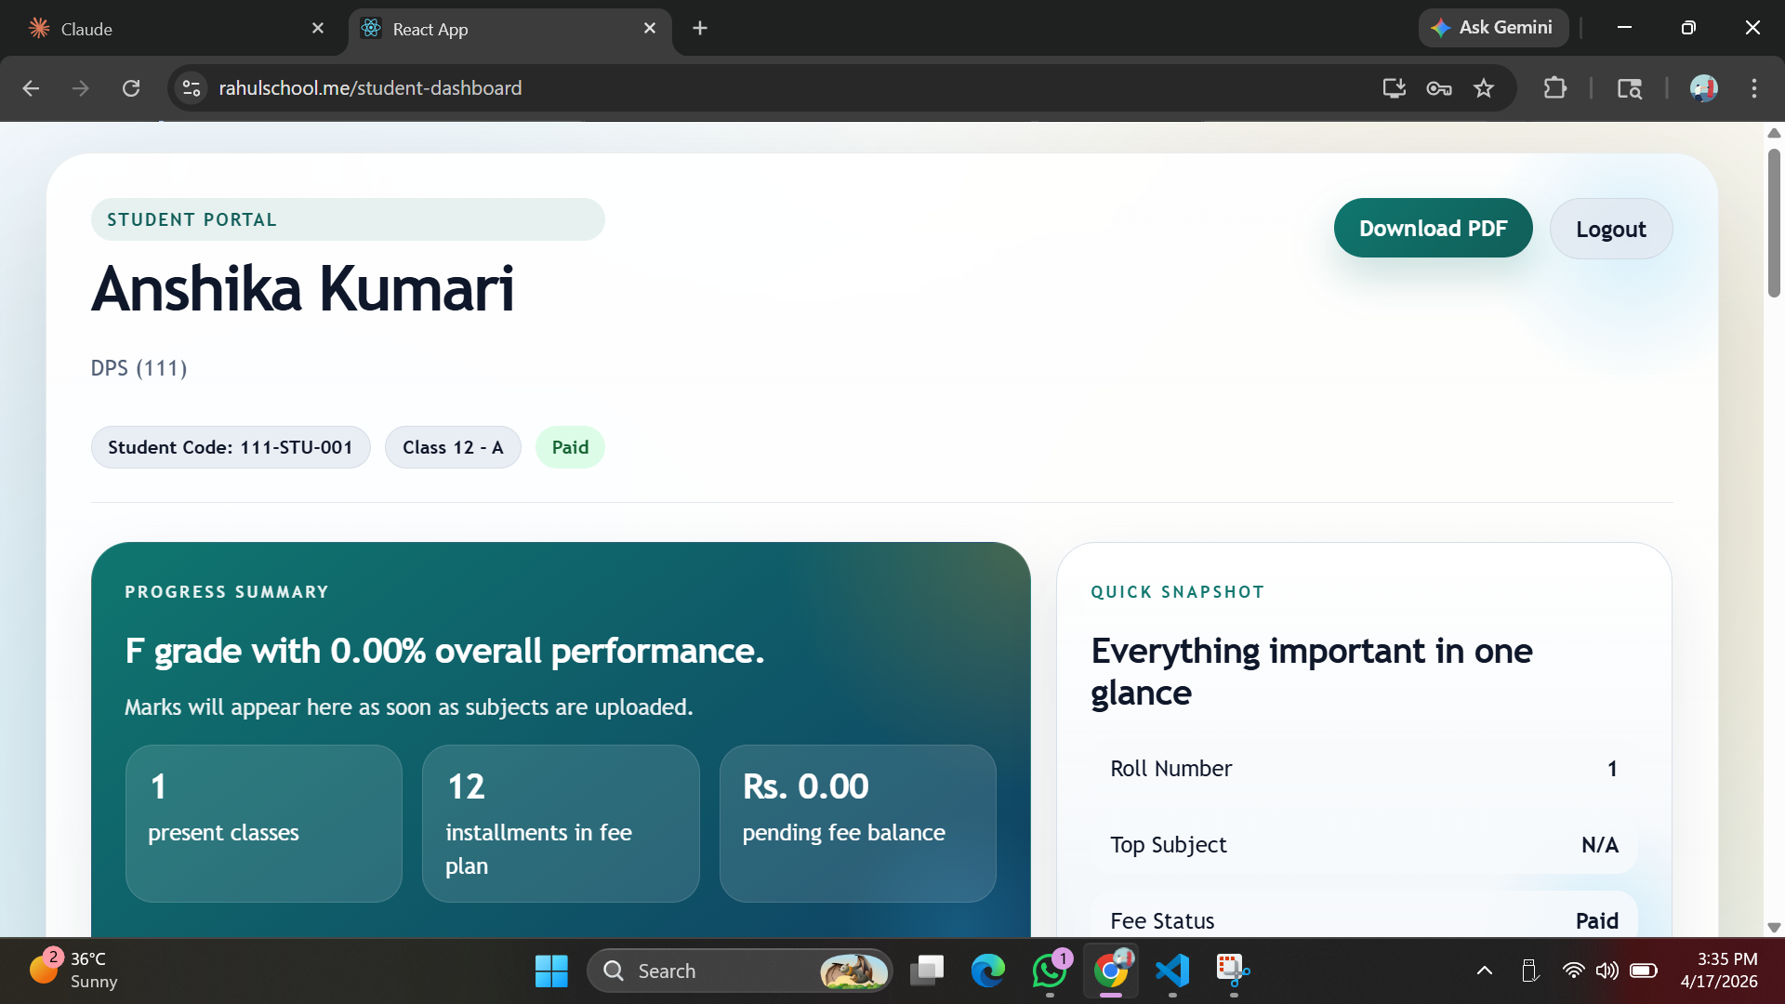

Student Dashboard
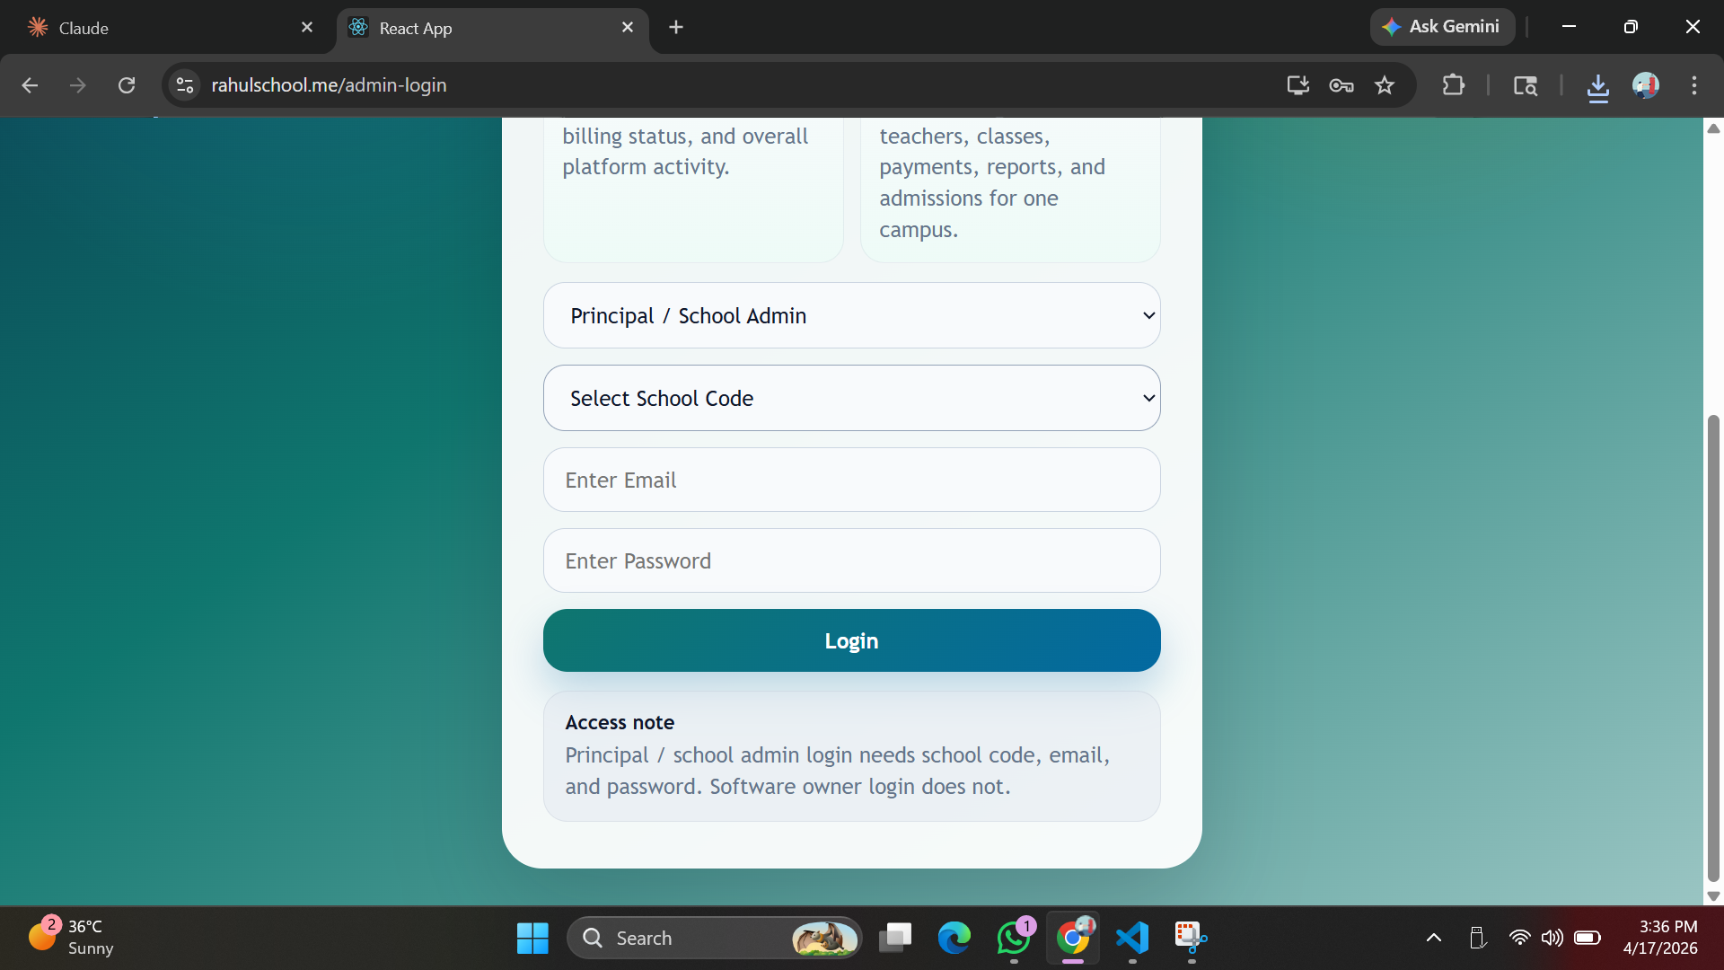

Admin Login Page
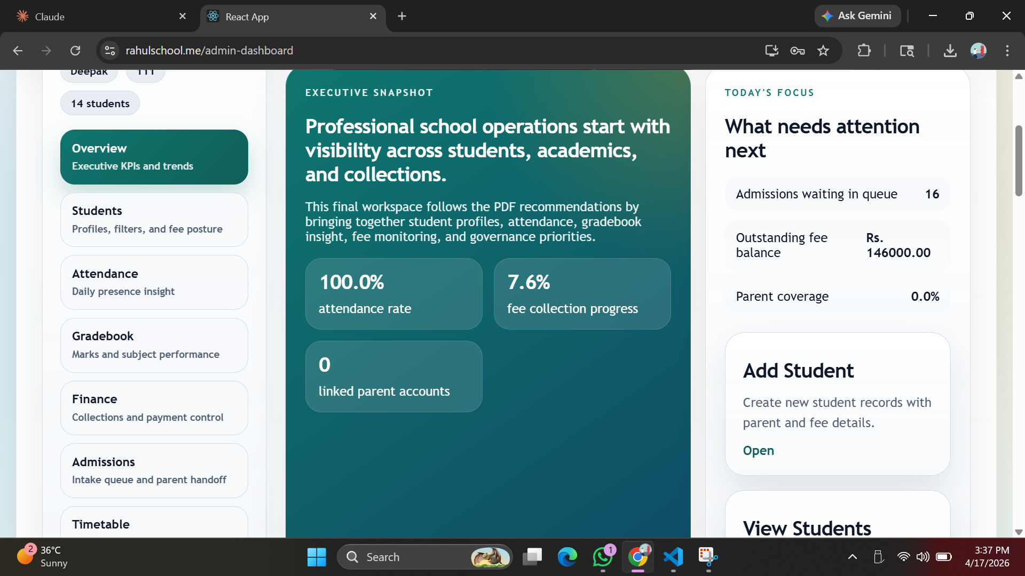

Admin Dashboard
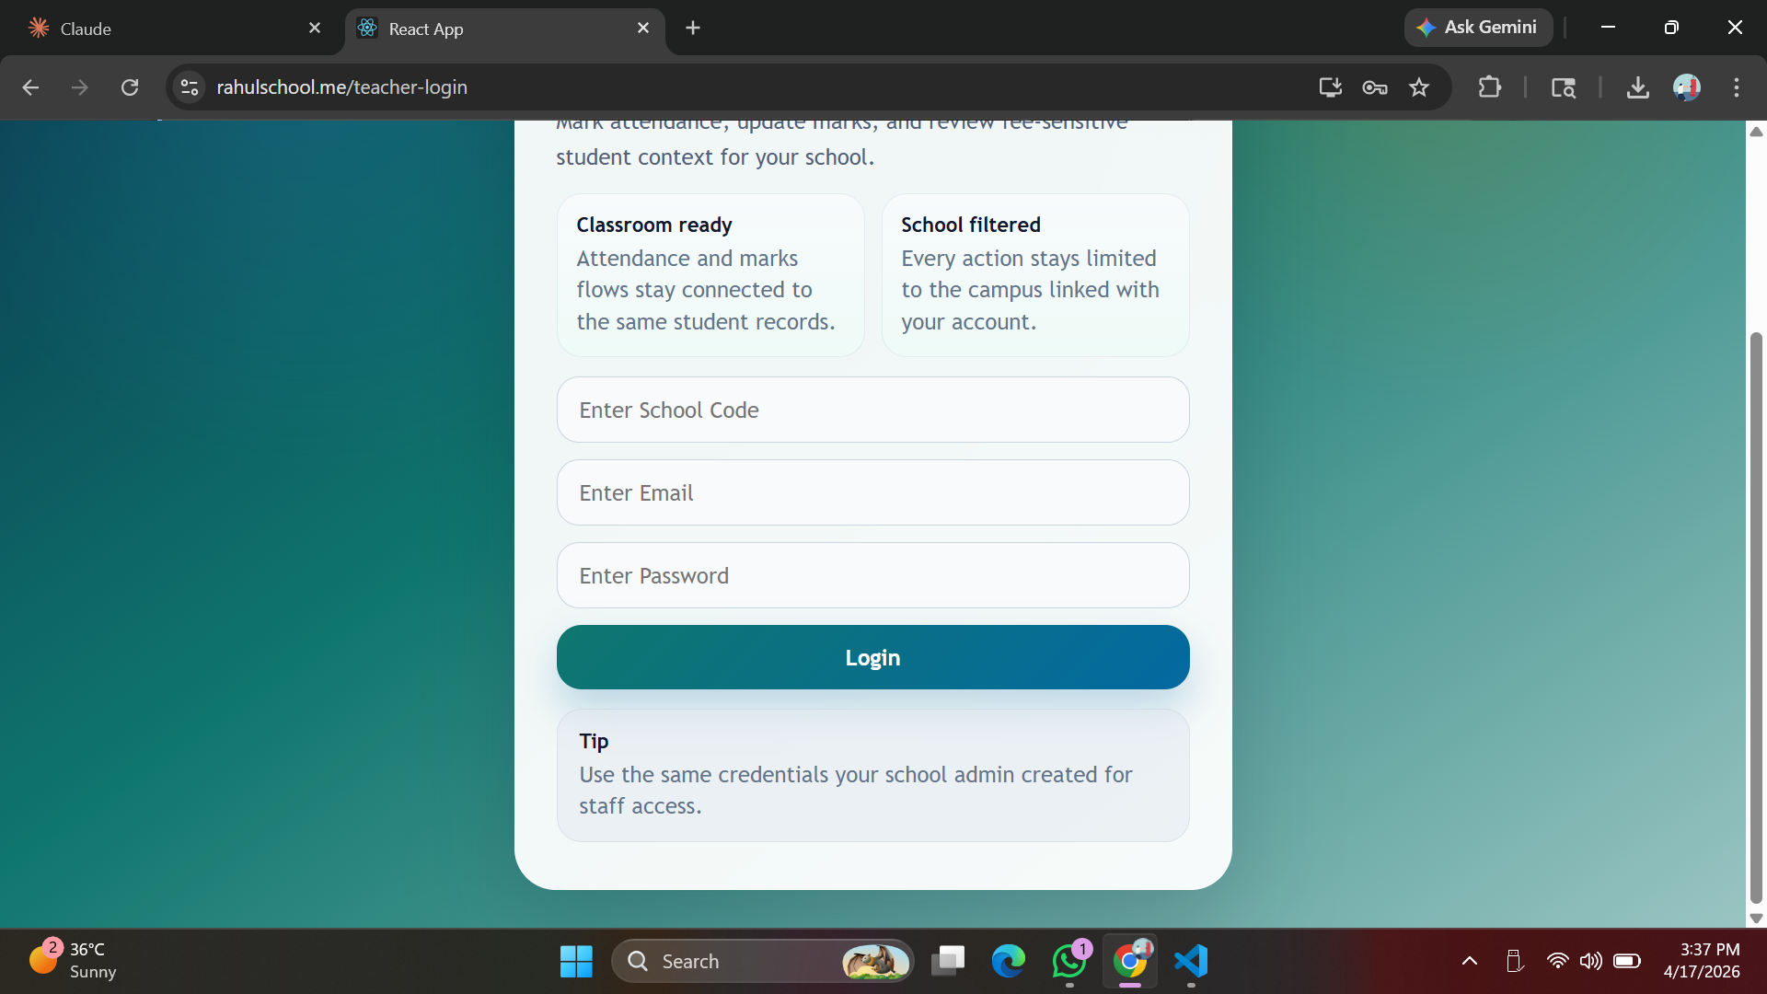

MySQL Database Tables
