SCHOOL MANAGEMENT SYSTEM
Project Report

Submitted in partial fulfillment of the requirement for the award of
Bachelor of Science in Information Technology

Submitted By
Rahul Kumar
Registration Number: 202344500285
Student ID: 445-12425
Mobile Number: 9006347510
Patliputra University, Patna
Catalyst College, Patna
Session: 2023-2026

Certificate
This is to certify that the project report entitled "School Management System" submitted by Rahul Kumar bearing Registration Number 202344500285 is a bonafide work carried out for the partial fulfillment of the degree of Bachelor of Science in Information Technology at Patliputra University, Patna through Catalyst College, Patna.
Declaration
I, Rahul Kumar, hereby declare that the project report entitled "School Management System" is my original work. This report has been prepared by me for academic purpose and has not been submitted earlier for the award of any other degree or diploma.
Acknowledgement
I would like to express my sincere thanks to my teachers and guides for their support and guidance during the completion of this project. I am also thankful to Catalyst College, Patna, for providing the learning environment and resources needed for this work. I also thank my family and friends for their support.
Introduction
School Management System is a web-based application developed to manage important school activities in a simple and organized way. The system helps in maintaining student records, teacher details, attendance, marks, fee information, notifications, and basic administration work. It reduces manual paperwork and improves the speed and accuracy of daily school operations.
Objective
- Store student and teacher records in one place.
- Manage attendance and marks efficiently.
- Handle fee-related information.
- Provide separate access for admin, teacher, student, and parent.
- Improve communication and reporting.
Problem Definition
In many schools, records are maintained manually, which takes more time and can lead to errors, duplication, and difficulty in searching data. A computerized system is needed to manage school information efficiently and securely.
Tools and Technologies Used
- Frontend: React
- Backend: Node.js and Express.js
- Database: MySQL
- Charts and Reports: Chart.js
- Platform: Web Browser
Modules of the System
- Admin module for managing school data.
- Teacher module for attendance and marks entry.
- Student module for viewing academic details.
- Parent module for monitoring student information.
- Fee and report module for financial and academic reports.
- Notification module for important updates.
Hardware and Software Requirements
Hardware Requirements: Computer or laptop, minimum 4 GB RAM, and internet connection.
Software Requirements: Windows operating system, web browser, Node.js, and MySQL Server.
System Features
- Login system for multiple users.
- Student profile management.
- Attendance management.
- Marks and result management.
- Fee tracking.
- Dashboard with basic reports.
- Notification support.
Testing
The project was tested by checking login, dashboard access, record management, attendance entry, marks update, and fee-related functions. The system was found suitable for basic school management operations.
Conclusion
The School Management System is a useful web application for maintaining school records in a digital form. It saves time, improves accuracy, and makes administration easier. This project is simple, practical, and helpful for modern school management.
Future Scope
- SMS and email alerts.
- Online fee payment.
- Timetable automation.
- Mobile app support.
- Advanced analytics and report export.
Snapshots
The following screenshots show the main pages and database structure of the School Management System.
Home Page
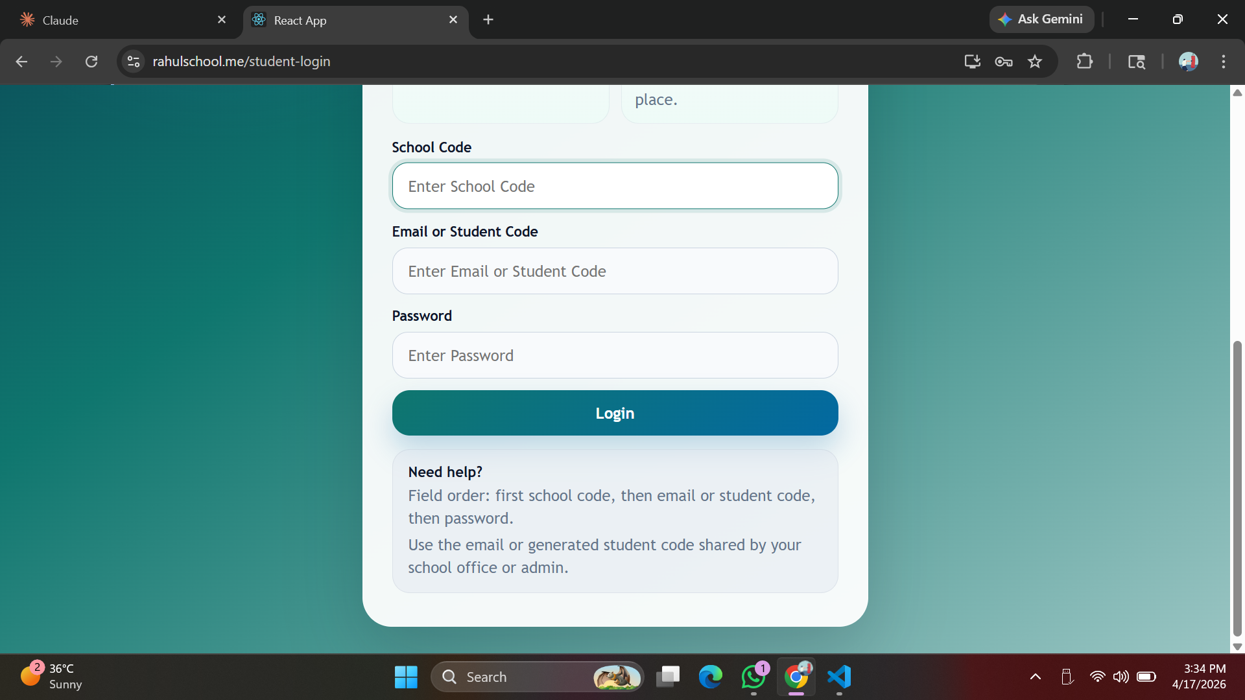

Student Login Page
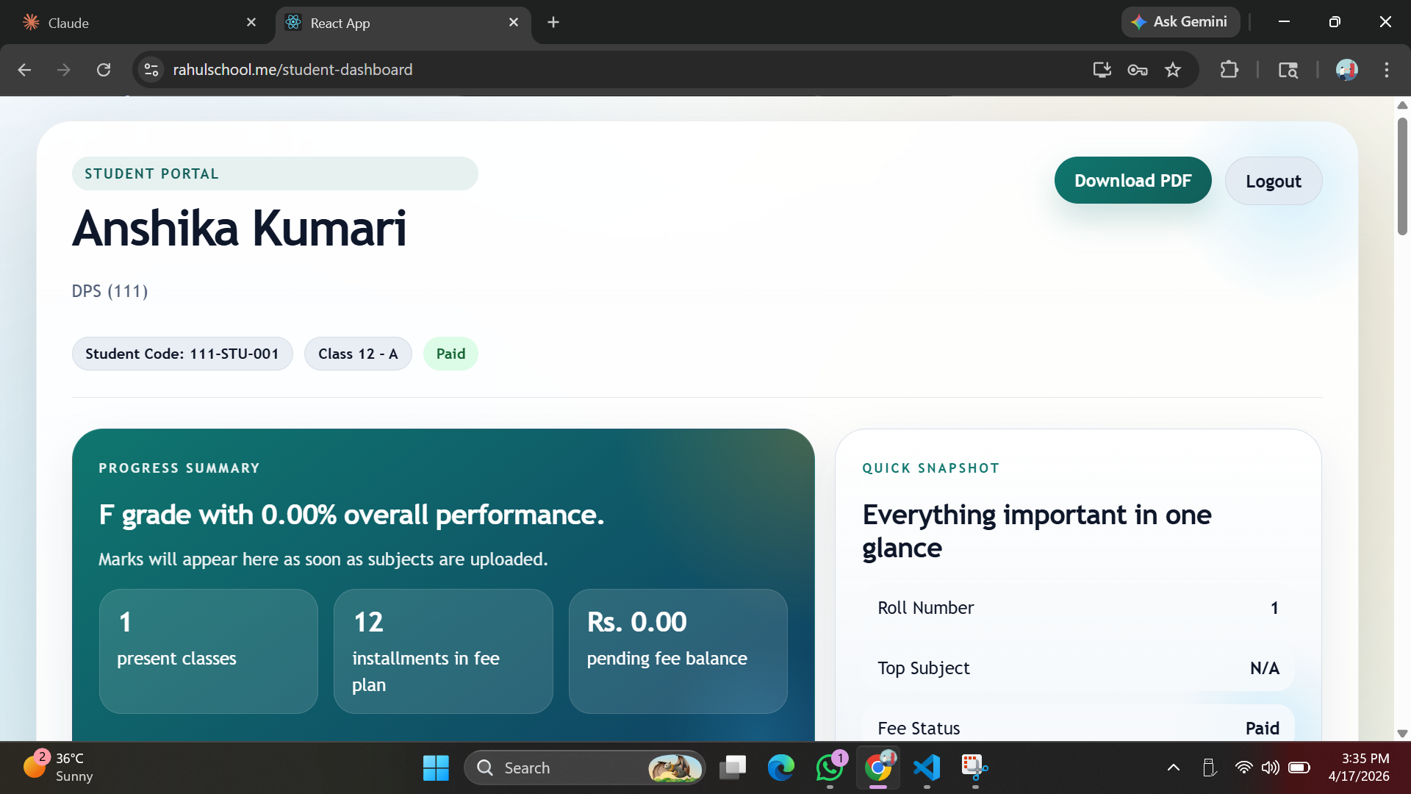

Student Dashboard
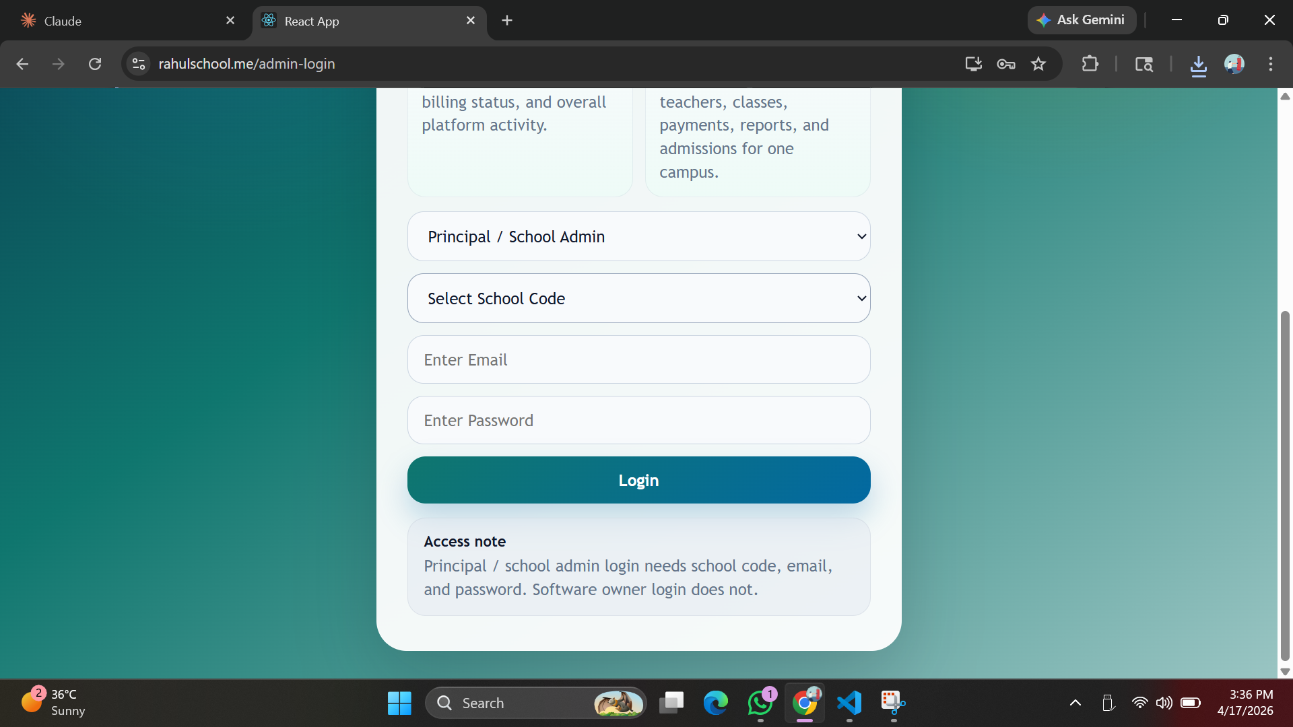

Admin Login Page
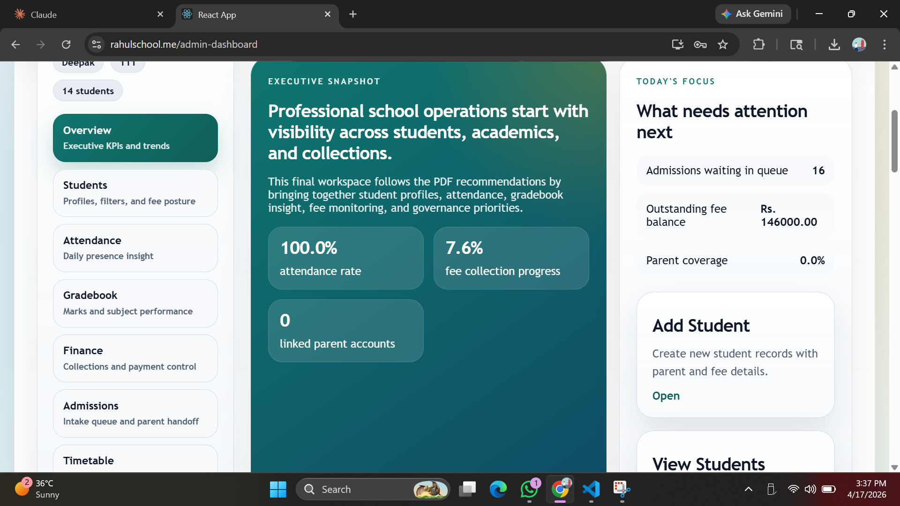

Admin Dashboard
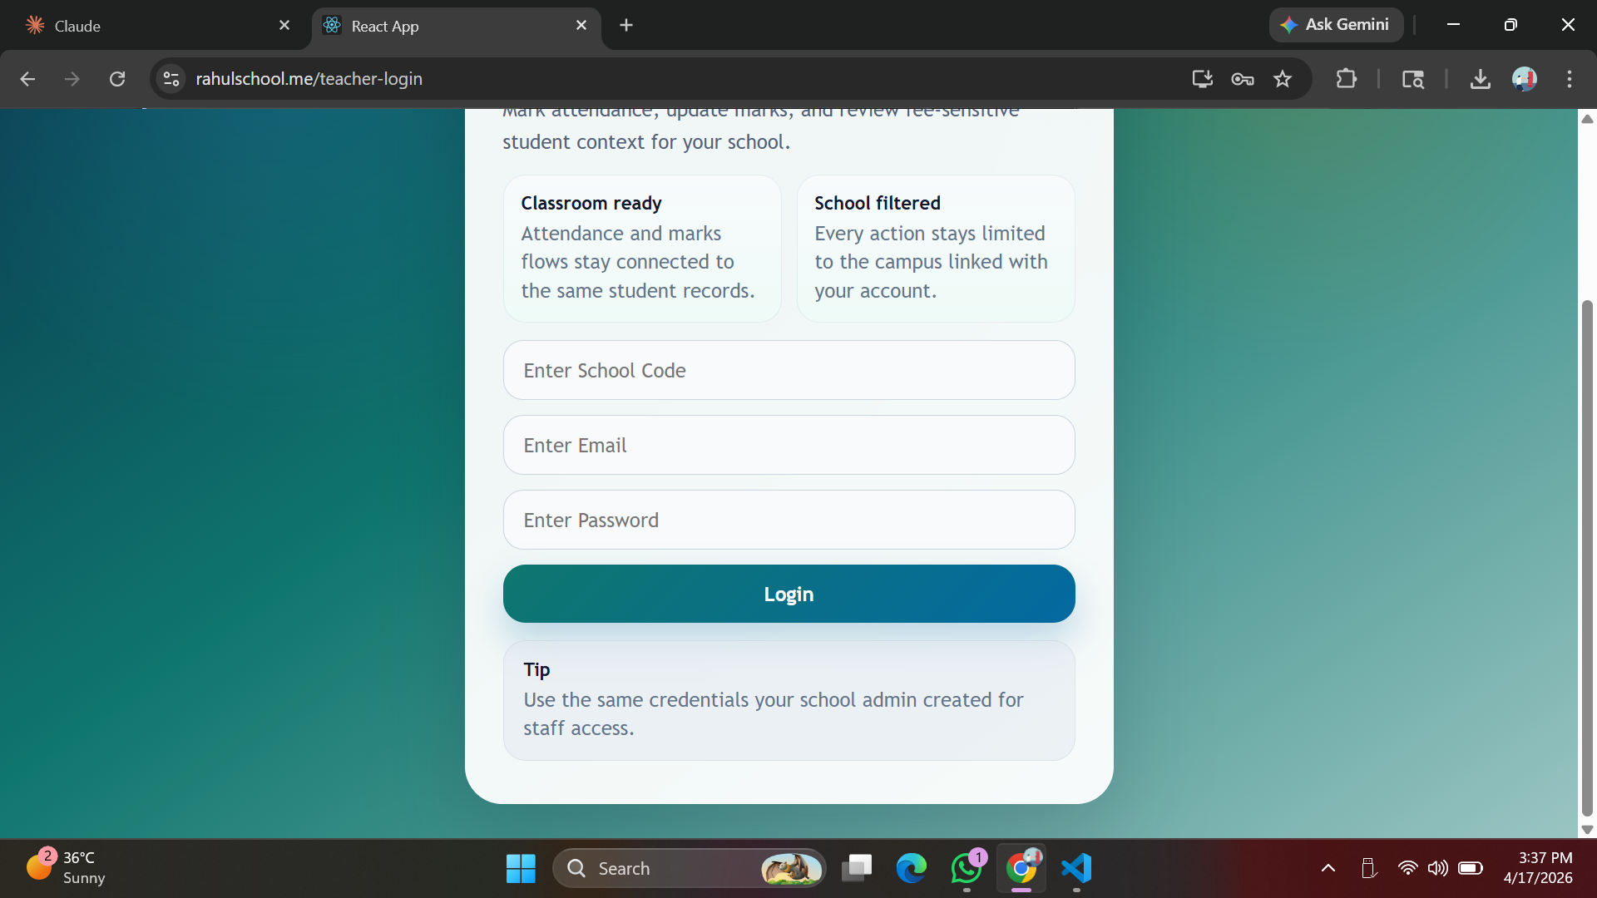

MySQL Database Tables
