Guardian Alert: A Wearable SOS Safety Device for Emergencies

Dr. C.M. Nalayini¹ Assistant Professor Dept. of Information Technology Velammal Engineering College Chennai,India nalayini@velammal.edu.in
Shailesh Arunkumar²
Dept.of Information Technology
Velammal Engineering College
Chennai, India
shailesharunk@gmail.com
Tharunkumar M³
Dept.of Information Technology
Velammal Engineering College
Chennai, India
tharunkumar1146@gmail.com

Madesh S⁴
Dept. of Information Technology
Velammal Engineering College
Chennai, India
madeshs1007@gmail.com
Rahul Kumaran R⁵
Dept. of Information Technology
Velammal Engineering College
Chennai. India
rahulprajith005@gmail.com

Abstract: In an increasingly unpredictable world, personal safety has become a significant concern for individuals, especially women and children, who often face challenging and unsafe situations. While there are numerous safety apps and devices available for smartphones, relying on a smartphone in emergencies isn't always practical. In this paper, a smart lightweight and efficient device is designed for individuals to ensure their safety to provide rapid assistance during emergencies. It features a button that, when pressed, triggers a series of safety actions. On the first press, the gadget activates a buzzer to alert nearby people and simultaneously retrieves the wearer's location using an inbuilt GPS module. It then sends the location along with an emergency notification to predefined trusted contacts via a GSM module. This ensures that help is mobilized promptly. Moreover, the second press of the button stops the buzzer, and sends a notification that the user is not in trouble in case the situation is under control. This wearable solution ensures a fast and efficient response system, guaranteeing a safer and more secured environment for all.
Keywords: SOS safety device, Wearable technology, Emergency alert system, Personal security, GPS tracking, Real-time location, Emergency SMS notification, Buzzer alert, Panic button, Trusted contact alert system.
I. INTRODUCTION
Personal safety is a fundamental concern for every individual in today’s unpredictable world. The increasing number of unsafe situations highlights the need for effective and reliable safety measures. However, depending solely on smartphones during emergencies may not always be feasible. Individuals often face circumstances where immediate assistance is crucial but inaccessible due to the limitations of existing solutions. Proper precautions should be taken to build the best solution to this problem. This paper proposes an IoT based smart wearable for the safety of individuals. The device is designed to help individuals navigate critical situations effectively while ensuring timely assistance and intervention, fostering a safer and more secure environment for everyone.
Recent studies underline the efficiency of wearable devices in emergency situations. For example, Mansi Kashyap, Shuchita Saxena, Shivani Agarwal, Rohini Singh (2020) underline the integration of real-time location tracking and communication features to increase the safety of users. The authors also discuss how GPS and GSM technologies could be applied to provide effective tracking systems that are very vital for personal security. In addition, audible alarms have been used to increase the responsiveness of safety devices.In our design, we utilize the ESP32 c3 microcontroller, which is quite a powerful microcontroller for its size and cost with wide applications as displayed in the work of Vivek, Y. Venkat, Sai Sriharika, T. Venkata, Nikesh, R, Rupesh, G,Umamaheswari K.
The device is enclosed in a 3D-printed casing, designed to be worn comfortably to ensure ease of use in any emergency. Moreover, it is equipped with the capability of sending real-time alerts and location data to trusted contacts, which is very important for an effective response during emergencies.
II. LITERATURE SURVEY
In recent years, wearable safety device development has taken huge strides forward, driven by the requirement felt in many sectors for a means of fast and efficient emergency response systems. Technological advancement has made the integration of sensors, GPS modules, GSM modules, and compact microcontrollers in wearable devices revolutionize the way personal safety solutions are addressed. The literature review here surveys key studies and developments related to wearable emergency response systems, SOS devices, and related technologies.
Wearable Technology and Personal Safety
Anand M, Naseem Z, Trivedi S, Abhishek, Garg P(2023) and Pramod Kumar P, Ankitha Katkar, Manyatha Kanukuntla, Jeevana Bodakunta, Karthik Yarraboina, Srinath Jamalapuri (2024) investigated the effectiveness of wearable devices in emergency situations. Wearables, being always accessible and unobtrusive, are an enormous benefit compared to smartphones during critical situations, as stressed by the study. It was also pointed out in the research that simplicity and reliability are crucial, noting that the user interface must be minimal to ensure easiness of use in high-stress situations. This supports the design philosophy of "Guardian Alert", which is centered around a one-press SOS system with minimal user interaction.
GPS-Based Emergency Solutions
The use of GPS in emergency devices is explored in detail by Shashikala H.K, Madhumala RB, Chanchani keerthana, Yarragunta Thanmai, Rangareddygari Meghana, Priyanka.S (2022) and Bannuru Ranjeeth, B. Srinivasa Reddy, Y. Manoj Kumar Reddy, S. Suchitra, B. Pavithra (2020) in their work on the development of real-time tracking systems for personal security. Their research highlighted the importance of accurately tracing the location of wearers of safety devices and swiftly seeking help in real-time during emergencies. Thus, they concluded that a feature of integration with infrastructure already in place, including GSM networks, is mandatory to alert contacts in real-time. The "Guardian Alert" device, on this premise, utilizes an inbuilt GPS module to automatically send real-time locations through SMS to pre-registrants.

Buzzer and Audible Alarms in Wearable Devices
Dhiraj Sunehra, V. Sai Sreshta, V. Shashank, B. Uday Kumar Goud (2020) and Sahil Ashok Sawant, Samiksha Gurakhe, Tayyab Salim Shaikh, Sandesh Bagmare, Chanchal Rathad, Shital Sobale (2023) studied the role of sound-based alerts in wearable safety systems. Their research on audio alarms in personal safety devices showed that audible cues significantly increase the likelihood of nearby individuals recognizing that someone is in distress. Their study concluded that an audible alarm system can serve both as a deterrent to potential threats and as a call for help in public spaces. Inspired by this research, the "Guardian Alert" device incorporates a loud buzzer to immediately alert anyone in the vicinity, thus amplifying the user's chance of receiving immediate assistance.
SMS-Based Emergency Alerts
Sunita Malaj (2023) and Shweta Wandekar, Dr. Pratibha M. Deshmukh (2020) compared different kinds of communication methods for alert systems in emergencies, more precisely based on SMS notifications. According to their case study, SMS-based alerts work quite effectively because of their simplicity and ability to reach receivers even without the internet in many locations. They emphasized that the SMS system is quite reliable and does not require any internet connectivity, thus the best fit for wearable devices. The "Guardian Alert" device follows this practice as it sends emergency messages through GSM networks, ensuring the alert reaches the trusted contact, regardless of data or internet availability.
Ref no | Methodology
[1] | Buzzer to alert nearby people
[4] | SMS alert sent to family members and police station
[5] | GPS to send location details to Guardians
[7] | A discrete smart wearable device
[8] | GPS to find location after abduction
[13] | Sending the location via SMS to parents
[14] | Wearable wrist band device
[16] | A buzzer that activates on push of a button
Table 1: Summary of existing techniques
III. PROPOSED WORK
The proposed project entails the development of a wearable SOS Safety Device, designed to provide real-time emergency assistance by sending the wearer's location to a trusted contact and activating an audible buzzer when the SOS button is pressed. This device uses an ESP32-C3 microcontroller for core functions such as GPS tracking, GSM-based SMS alerts, and buzzer activation. The final device will be enclosed in a 3D-printed casing and attached to a wearable strap to make it compact, durable, and readily accessible. (Fig:2 Shows all the components of the proposed work)
Key Components and Features
ESP32-C3 Microcontroller
The core of the system is the ESP32-C3, a low-power, cost-effective microcontroller with built-in Bluetooth and Wi-Fi capabilities, which has more than enough processing power to handle the operations of the device. The ESP32-C3 will read input from the button, drive the buzzer, interface with the GPS module to obtain location data, and communicate with the GSM module to send SMS alerts. Its energy efficiency is important to ensure the wearable device has a long battery life.

Buzzer
The system incorporates an audible buzzer as a means of local alarm in the case of SOS. A very loud sound is initiated by the buzzer once it is activated to notify others within its surroundings. It is driven by ESP32-C3, making it easier to switch on and off with a second click of the button.
SOS Button
The system has a switch that acts as the interface for the user, SOS button; upon pressing, the switch activates the buzzer and starts both the GPS and GSM modules to send an emergency SMS. On the second press, the button switches off the buzzer. The design ensures that the button is large enough for easy access, especially in high-stress situations.
GPS Module
The integrated GPS module provides the most accurate, real-time location data when the SOS button is pressed. The ESP32-C3 retrieves coordinates from the GPS module and includes them in the emergency SMS. This way, the trusted contact receiving the alert will have the precise location of the wearer and can provide help as needed without delay. The GPS module is selected for its low power consumption and rapid location fix capabilities.
GSM Module
The GSM module takes care of sending the emergency SMS to a contact pre-defined. Using the SOS button, the ESP32-C3 communicates with the GSM module to send a message containing the current GPS coordinates of the wearer and a preprogrammed distress signal. Since this system is independent of an internet connection, it can be relied upon even when there is no cellular data coverage but just the presence of GSM signals.
3D-Printed Casing and Wearable Strap
The device will be housed within a custom-designed 3D-printed casing in order to make it as durable and portable as possible. It will also host a wearable strap, with which the device can easily be attached to the wrist, belt, or bag of the wearer. So, the casing design will stress durability, water resistance, and comfort—all of these factors combined so that the device becomes a practical tool for everyday application.
Operation flow
First Press (SOS Trigger): When the user presses the SOS button, it triggers the ESP32-C3 to turn on the buzzer. Then, it sends a request to the GPS module for getting the current coordinates. On obtaining the coordinates from GPS, the ESP32-C3 will send a distress SMS containing those coordinates to a pre-set trusted contact number using the GSM module. It will keep the buzzer on until the button is pressed again.
Second Press (Deactivation): A second press of the SOS button will deactivate the buzzer and halt any further alerts to allow the user to stop the system once the emergency is resolved (Fig:1 shows the operational work flow).
Advantages of the Proposed System
Real-Time GPS Location: With the GPS module, the wearer's accurate location is relayed to the trusted contact, making it easier for them to respond quickly.
Reliable Communication: The GSM module used for SMS alerts ensures that the device will work even without an internet connection, using only basic cellular signals.
Compact and Wearable Design: The 3D-printed casing and strap make it lightweight and comfortable, but above all, it is discreet enough to be worn at all times without hindrance of user's daily activities.
Low Power Consumption: The ESP32-C3 microcontroller, along with the energy-efficient GPS and GSM modules, makes sure that the device has a long battery life, thereby reducing the need for frequent recharging.

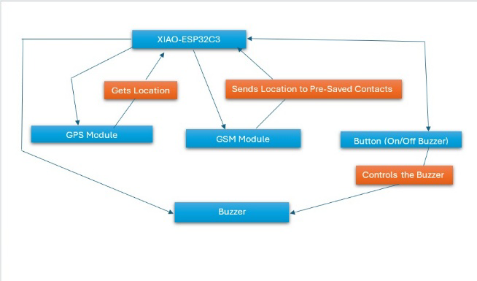
Fig 1: Operational flow

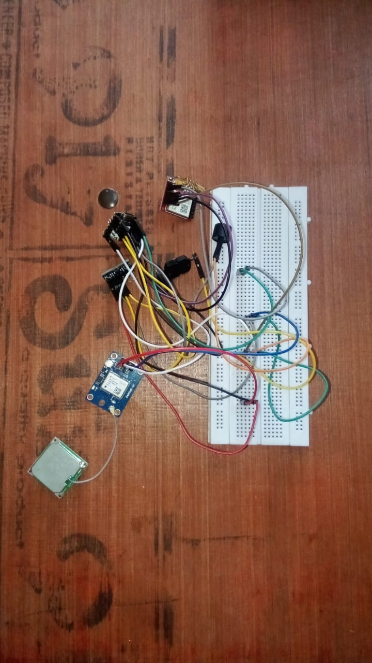
Fig 2: Snapshot

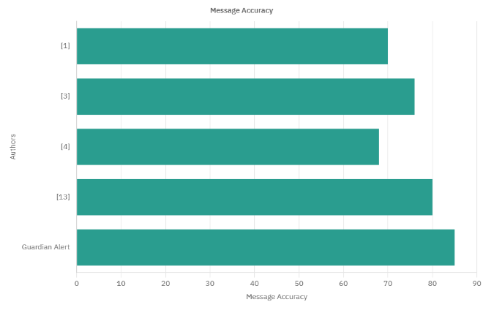
Fig: 3 Message Accuracy Graph

From all the studies (Fig:3) we can observe that Guardian alert has a more accurate messaging system as it relies on GSM unlike wi-fi used in certain studies. Its accuracy is also lauded as it has no middle man application between the Guardian alert and the receiver device (the device of the trusted contact). Hence, we conclude that the Guardian alert is far superior in accuracy for the message alert.
III. CONCLUSION AND FUTURE IMPROVEMENTS
The proposed wearable SOS safety device is a personal safety technology, combining real-time GPS tracking, GSM communication, and an audible alarm system in a compact, user-friendly design powered by the ESP32-C3 microcontroller for efficient and reliable emergency response. Future enhancements include the development of a customizable mobile application to manage trusted emergency contacts, automated voice alerts for real-time location sharing and pre-recorded danger notifications, and advanced fall detection capabilities tailored for elderly care, ensuring immediate assistance during accidental falls. Additionally, the device is envisioned to integrate vehicle accident detection functionality, transforming it into a comprehensive safety module for bikes and cars that automatically triggers collision alerts with precise location details sent to emergency services and designated contacts. By continuously evolving to address diverse safety needs, this wearable solution significantly enhances personal security, promotes well-being, and underscores the transformative potential of technology in safeguarding lives and ensuring timely assistance in critical situations.

IV. REFERENCES
[1] Dhiraj Sunehra, V. Sai Sreshta, V. Shashank and B. Uday Kumar Goud., "Raspberry Pi Based Smart Wearable Device for Women Safety using GPS and GSM Technology". 2020 IEEE International Conference for Innovation in Technology (INOCON) Bengaluru, India. Nov 6-8, 2020,
DOI: 10.1109/INOCON50539.2020.9298449

[2] Vivek, Y. Venkat, Sai Sriharika, T. Venkata,Nikesh, R, Rupesh, G.; Umamaheswari, K."IoT Based ESP32-C3 Driven Smart Energy Meter".Grenze International Journal of Engineering & Technology (GIJET), 2024, Vol 10, Issue 1, Part 3, p2138

[3] S.K Anisha ,S.Chandana, J.J. Teresa, S.Varma .” Women’s Wearable Security and Safety Device”. November 2020 International Journal of Recent Technology and Engineering (IJRTE) 9(4):171177
DOI:10.35940/ijrte.D4894.119420.
[4] Sunita Malaj. “IOT BASED SMART WEARABLE DEVICE FOR WOMEN SAFETY”. International Journal of Engineering Technology and Management Sciences Website: ijetms.in Issue: 6 Volume No.7 November - December – 2023 DOI:10.46647/ijetms.2023.v07i06.039
ISSN: 2581-4621.
[5] Shashikala H.K, Madhumala RB, Chanchani keerthana, Yarragunta Thanmai, Rangareddygari Meghana, Priyanka.S, "Smart Reminder SOS & Emergency Detection
Device", IEEE International Conference on Distributed Computing and Electrical Circuits and Electronics (ICDCECE 2022),
DOI: 10.1109 ,June 2022
[6] Mansi Kashyap, Shuchita Saxena, Shivani Agarwal, Rohini Singh, "REVIEW ON CHILD SAFETY WEARABLE DEVICES". 2020 International Journal of Scientific Research and Management Studies (IJSRMS),
ISSN: 2349-3771 Volume 4 Issue 3.
[7] Pramod Kumar P, Ankitha Katkar,Manyatha Kanukuntla, Jeevana Bodakunta, Karthik Yarraboina, Srinath Jamalapuri, "Smart Device for Child Safety with Parental Alerts", 2024 2nd International Conference on Intelligent Data Communication Technologies and Internet of Things (IDCIoT),
DOI: 10.1109/IDCIoT59759.2024.10467637

[8] Bannuru Ranjeeth, B. Srinivasa Reddy, Y. Manoj Kumar Reddy, S. Suchitra, B. Pavithra, " Smart Child Safety Wearable Device", Proceedings of the International Conference on Electronics and Sustainable Communication Systems (ICESC 2020) IEEE Xplore Part Number: CFP20V66-ART;
ISBN: 978-1-7281-4108-4.
DOI: 10.1109/ICESC48915.2020.9156001
[9] Shivani Basargi, Pranita Veer, Swapnali Tomke, Mrinalini Ghewari. “WOMEN SAFETY DEVICE WITH GPS TRACKING AND ALERTS”.International Research Journal of Engineering and Technology (IRJET) e-ISSN: 2395-0056 Volume: 07 Issue: 02 | Feb 2020 www.irjet.net
p-ISSN: 2395-0072.

[10] Nisha D. Wanjari, Shailaja. C. Patil. “Wearable devices”. 2016 IEEE International Conference on Advances in Electronics, Communication and Computer Technology (ICAECCT). DOI: 10.1109/ICAECCT.2016.7942600.
[11] V. Hyndavi; N. Sai Nikhita; S. Rakesh. “SmartWearable Device for Women Safety Using IoT”. 2020 5th International Conference on Communication and Electronics Systems (ICCES).
DOI: 10.1109/ICCES48766.2020.9138047.

[12] Tejonidhi M. R; Aishwarya; Chaithra K. S; Dayana M. K; Nagamma H. “IoT Based Smart Security Gadget for Women’s Safety”. 2019 1st International Conference on Advances in Information Technology (ICAIT). DOI: 10.1109/ICAIT47043.2019.8987242
[13] Shweta Wandekar, Dr. Pratibha M. Deshmukh, "CHILD SAFETY WEARABLE DEVICE", SHODH SARITA vol-6, Issue 26-April - June 2020 page nos. 62-65,
ISSN: 2348-2397
[14] Anand, M., Naseem, Z., Trivedi, S., Abhishek, Garg, P. (2023). “Design of a Novel Smart Device for Human Safety”. In: Jain, S., Marriwala, N., Tripathi, C.C., Kumar, D. (eds) Emergent Converging Technologies and Biomedical Systems. ETBS 2022. Lecture Notes in Electrical Engineering, vol 1040. Springer, Singapore. https://doi.org/10.1007/978-981-99-2271-0_52,
DOI: https://doi.org/10.1007/978-981-99-2271-0_52

[15] Dhruvil Parikh, Pallavi Kapoor, Shital Karnani, Prof. Sudhir Kadam. “IoT based Wearable Safety Device for Women”. International Journal of Engineering Research & Technology (IJERT).
ISSN: 2278-0181. Vol. 9 Issue 05, May-2020.
[16] Sahil Ashok Sawant, Samiksha Gurakhe, Tayyab Salim Shaikh, Sandesh Bagmare, Chanchal Rathad,Shital Sobale,"Safety with Technology: A Smart SOS Device", 2023 7th International Conference On Computing, Communication, Control And Automation (ICCUBEA),
DOI: 10.1109/ICCUBEA58933.2023.10392200

[17] Internet of things. https://en.wikipedia.org/wiki/Internet_of_things

[18] GSM services. https://en.wikipedia.org/wiki/GSM_services

