Tribhuvan University

Department of Science and Technology

**Muncha.com**



Under the supervision of

Diwakar Upadhyaya

Submitted by:

Rahul Gole

Ramesh Devkota

Priyanka Dhami

Pukar Panta

Submitted to:

# **ACKNOWLEDGEMENT**

We would like to take this opportunity to express our sincere thanks to the Department of Computer Science and Information Technology, Kathmandu College of Technology for providing us this opportunity to explore our interest and ideas.

In addition, it gives us immense pleasure to express our deepest sense of gratitude and sincere thanks to our highly respected and esteemed guide Diwakar Upadhyaya, Supervisor, Kathmandu College of Technology, for his valuable guidance, encouragement and help for completing this work. His useful suggestions for this whole work and cooperative behavior are sincerely acknowledged.

Equally, we are grateful and feel indebted to all our dear friends for their frequent and everlasting support in the completion of this report. Similarly, we extend our sincere thanks to all other seen and unseen personalities involved in the preparation of the project work.

# **Abstract**

[Muncha**.com**](https://www.muncha.com/) is the most prominent name in gifting among Nepalese all over the world. It was launched by the Muncha House with the sole motto of reaching out broadly to its customers around the globe, [www.muncha.com](http://www.muncha.com/) is the Muncha Internet Venture that went live in April 2000.

It started as Muncha House in the 1920s, the first department store in Nepal, and ventured into online shopping in 2000 to offer a gifts gallery to non-resident Nepalese looking to surprise family and friends back home. [Muncha.com](http://muncha.com/?fbclid=IwAR2hfqr_sdFjglIW_lQFglRqtaToa8LzX2OhrGxodhn3ozo7D9aVSTz8Y5E) is the most prominent name in gifting among Nepalese all over the world. We are carrying on a legacy of over 90 years to offer our customers - curated gifts, reliable delivery service and 24x7 customer care

Table of Contents

**ACKNOWLEDGEMENT** 1

**Introduction** 5

**Problem Statement** 7

**Objectives** 8

Festival Gifting 8

Reliability 8

Curating Gifts 9

Special Delivery 9

Customer Service 9

**Services** 9

2. Online remittance - www.money.muncha.com 9

3. Online payment gateway for Nepal - www.iPay.com.np 10

6. Muncha Bill Payment Services: 11

**How to order items in Muncha.com??** 12

New Registration: 12

Shopping at Muncha.com 12

**Findings** 13

**Conclusion** 14

**References** 14

**Muncha.com**

# **Introduction**

Muncha.com is Launched by the Muncha House with the sole motto of reaching out broadly to its customers around the globe, [www.muncha.com](http://www.muncha.com/) is the Muncha Internet Venture that went live in April 2000. For reasons of conciseness, it later changed to [MUNCHA.COM](http://www.muncha.com/), however, it has been providing the same services as before and is committed to improve its services.

Our values lie in curating gifts, delivering with care and being available 24x7.

It started with the vision of forging life-long relationships with our customers and take pride in being reliable and undertaking special deliveries every day.

Our customers remember us to send gifts for birthdays, anniversaries, Nepalese festivals, occasions, rituals, internationally celebrated festivals, weddings, celebrations for achievements, when missing family and friends, and for numerous other reasons.

It seek to serve and delight each customer where in the world they may be, and stick to our roots even as we are technologically innovative.

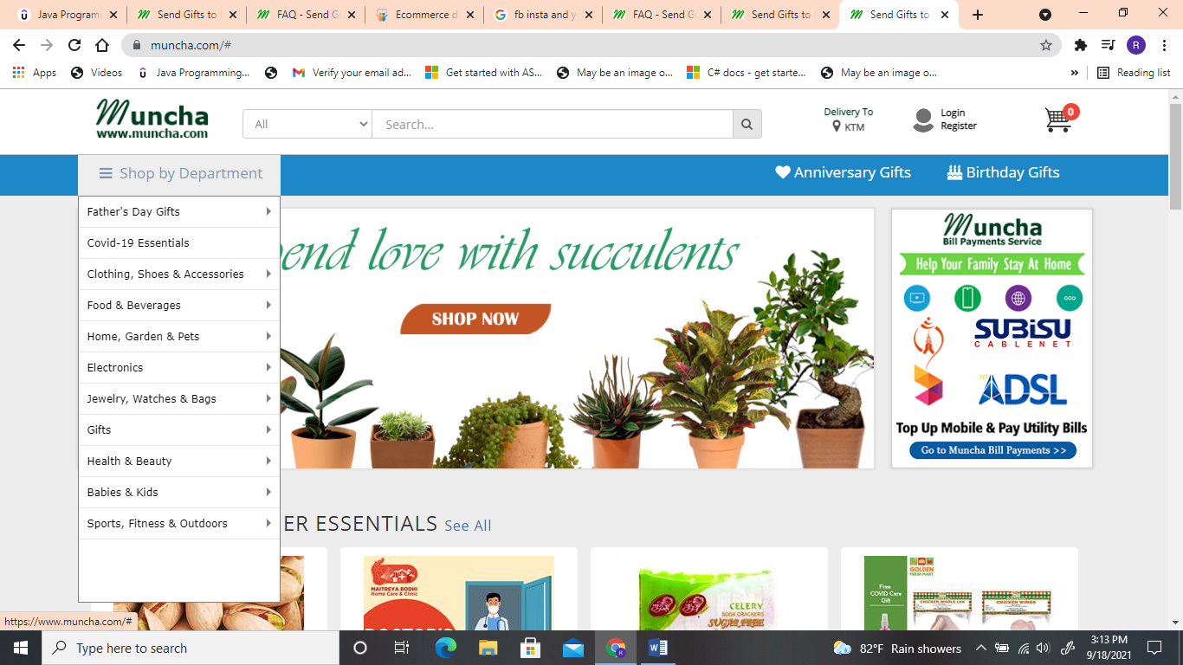

# **Problem Statement**

Muncha values lie in curating gifts, delivering with care and being available 24x7. It started with the vision of forging life-long relationships with our customers and take pride in being reliable and undertaking special deliveries every day.

The main objectives of this study is to find out whether the product delivery is as good as they promised or not, how the security is being maintained to assure reliability, how their customer services works and how they are impacting social values and norms in the society as their common goal is to make the gifting process a lot easier for the people living abroad and within the nation.

# **Objectives**

🡺Our Objectives are clearly mentioned in below figure whether the company objectives has been meet with the actual environment or not.

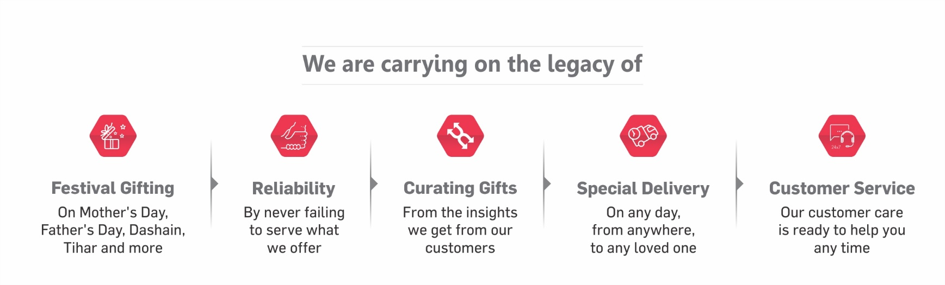

## Festival Gifting

🡺On Mother’s Day,

🡺Father’s Day

🡺Dashain

🡺Tihar and More

## Reliability

🡺By never failing to serve what we offer

🡺By Pursuing on-time Delivery with Care and Reliable Means

## Curating Gifts

🡺From the insights we get from the customer,the gift are created specifically with the gifted and a purpose in mind.

🡺It means that the gift or gifts were not randomly picked but that they were all carefully thought out to have a specific meaning or purpose for the person/gifted.

## Special Delivery

🡺On any day , from anywhere to any loved one with the purpose to share happiness.

## Customer Service

🡺Our services are ready to help you anytime for convenience and support.

# **Services**

Company dealing with ecommerce activities based in Nepal for the Nepalese community whether they are living abroad or within Nepal. Ecommerce activities involve the following:  
  
1. Online shopping - [www.shop.muncha.com](http://www.shop.muncha.com)

🡺Our customers remember us to send gifts for birthdays, anniversaries, Nepalese festivals, occasions, rituals, internationally celebrated festivals, weddings, celebrations for achievements, when missing family and friends, and for numerous other reasons.

## 2. Online remittance - [www.money.muncha.com](http://www.money.muncha.com)

🡺Muncha Money Transfer is an online platform to send money from US, Canada and Europe to Nepal powered by Lalit Money Transfer. It is the most easy and compliant service for online money transfer. Customer needs to follow three simple steps to send money to Nepal

1. Register on Muncha Money Transfer site by providing elementary details.
2. Provide beneficiary's details in Nepal.
3. Transfer money from Online Bank

## 3. Online payment gateway for Nepal - [www.iPay.com.np](http://www.iPay.com.np)

🡺[iPay](https://www.ipay.com.np/) serves its customers to pay telephone bill, electricity bill, internet bill and other utility bills using iPay service. Further, one can buy recharge cards, top mobile phone in just few clicks. Flights booking for domestic airlines such as Buddha Air, Yeti Airlines, Simrik Air and Saurya Airlines are also available in iPay. Our Customers can also buy movie tickets, travel tickets of buses and manakamana darshan tickets with us. iPay also allows to pay the bills of various online shopping stores.

There are just 3 simple steps; Registration, Add Fund and Payment.  
4. Online business directory - [www.uno.com.np](http://www.uno.com.np)

🡺Uno card is a Commercial Discount Card which entitles it's subscribers to exclusive discounts in growing list of various Uno Partner Merchant outlets.

🡺Uno Discount Card, a product of Uno CARDS is the ultimate and the only commercial Discount Card in Nepal, that entitles you to the best deals, bargains and special offers at exclusive outlets ranging from shopping, dining, medical, travel and lots more. This is the only card you will ever need and will replace all the other discount cards you carry. Our extensive connection with various merchants ensures that you will find the best deals on any products in Nepal  
5. Online Banner Ad Network - [www.iAds.com.np](http://www.iAds.com.np)

🡺iAds, a service of [Muncha.com](http://www.shop.muncha.com/). Muncha.com is the predominant ecommerce venture in Nepal with footprints in many ecommerce sectors such as shopping, remittance, payment gateway, ebooks, emovies, emusic, games, business directory, online news, etc.

iAds offers a range of internet based promotion opportunities to you. It provides full service. Our launch service is the placement of banner advertisements in key locations on key periods and obtaining best results.

## 6. Muncha Bill Payment Services:

🡺Muncha Bill Payments Services **(**www.billpayments.muncha.com**)**, is a service from [Muncha.com](http://shop.muncha.com/) where you can pay various bills for yourself or for your family, friends, or someone else.The services of which the bill payments are being done are for Nepali institutions only. Most payments happen in real time. Hence, as soon as your payment is cleared, the person whose bill you are paying, e.g. their mobile phone, will be instantly recharged and they will receive a notification informing them about this.

# **How to order items in Muncha.com??**

### New Registration:

* **Step 1:** Click in “New Users” on your left hand side as shown below:
* **Step 2:** Fill up the form as shown below accurately and click on “Register” Button
* **Step 3:** You will receive an email on your respective registered email address about your registration

### Shopping at [Muncha.com](https://www.muncha.com/)

* **Step 1:** Log In
* **Step 2:** Selection of preferred city of delivery
* **Step 3:** Selection of products and adding to your cart
* **Step 4:** Check out
* **Step 5:** Product Finalization
* **Step 6:** Adding Recipient
* **Step 7:** Selecting Recipient and Other special option
* **Step 8:** Choosing Payment Option
* **Step 9:** Confirmation of your Package
* **Step 10:** Receiving email

# **Findings**

1. What is Muncha Money Transfer?

Muncha Money Transfer is an online platform to send money from US, Canada and Europe to Nepal powered by Lalit Money Transfer. It is the most easy and compliant service for online money transfer. Customer needs to follow three simple steps to send money to Nepal

Register on Muncha Money Transfer site by providing elementary details.

Provide beneficiary's details in Nepal.

Transfer money from Online Bank

2. Who can use Muncha Money Transfer?

Any person who wishes to send money to an individual in Nepal can use Muncha Money Transfer.

3. Which currencies can you use to make a remittance?

Presently, you can make a remittance in U.S Dollars for USA and Canada and in Euro for Europe. The remittance will be delivered to your beneficiary's in below way in Nepalese Rupees.

Bank Deposit

Wallet Deposit

4. Which countries does Muncha Money Transfer Platform serve from?

Presently you can send money from USA, Canada and Europe. We will soon introduce this platform to other countries as well.

5. Why should a user trust Muncha Money Transfer?

Muncha Money Transfer an online money transfer platform is brought to you by Muncha Money Transfer Pvt. Ltd. powered by Lalit Money Transfer. Muncha Money Transfer is in remittance business from more than 15 years. Muncha Money Transfer Pvt. Ltd is a sister company of Muncha.com. The founding principles laid by the promoters and partners of Muncha Money Transfer are to provide value, convenience and more importantly, transparency and security to customers.

9. How long does it take for a beneficiary to receive money?

Funds will be delivered to the beneficiary (direct bank deposit) within 48 hrs. once the fund is cleared from Sending Country. However the Deposit may be delayed due to Public Holiday and Weekend in Both Sending Country and Receiving country.

10. How are you informed of your transaction status?

Once you book a remittance on Muncha Money Transfer website or APP, we keep you informed on the status of your remittance through regular email updates and reminders. The various statuses display and their explanation is as follows:

**SUBMITTED:**Remit order received, awaiting fund into account.

**WAITING_FUND:**Waiting fund into account.

**ON_HOLD:**Remittance on-hold. Please, contact care center.

**REJECTED:**Remittance rejected. Please, contact care center.

**IN_PROGRESS:**Remittance sent to beneficiary.

**PAID:**Remittance deposited into beneficiary-account

**CANCELLED:** Remittance canceled. Please, contact care center.

# **Conclusion**

Inspite of being the leading of Nepal, Muncha still needs to make improvements in various sectors such as drawbacks in e-payments service, inefficient delivery within a nation , unavailability of its own mobile application etc. As Muncha has emerged itself into a giant e-commerce platform now the services and values need to provided in more efficient way to compete in this ever-growing market of e-commerce. Therefore, it can be said that is still in its developing stages. It has yet to reach its maturity level. It is still growing and has a huge opportunity to improve more and more as they have potential and resources.

# **References**

<https://money.muncha.com/faq.html>

<https://www.muncha.com/>

<http://bossnepal.com/muncha-com/>

<https://www.nepalyp.com/company/46012/MUNCHA_HOUSE>