**MES’s INSTITUTE OF MANAGEMENT AND CAREER COURSES**



**“Fixitwala”**

A home services app

Submitted By

**Rahul Kumar 2201110**

Guided By

**Dr. Apurwa Karandikar Barve**

Submitted To

**MES’s IMCC**

131, Mayur Colony, Kothrud, Pune-411 038, MH, INDIA

2022-2023

**1. Introduction**

**1.1 Institute Profile**

Maharashtra Education Society’s Institute of Management and Career Courses (MES’s IMCC), Pune Maharashtra

**1.2 Abstract**

Now a days for any services like Cleaning, Plumbing, Electrical, Carpentry, Home Paint and Machine Repairing, if any customer wants to use this type of services then they can go through a personal meeting or mobile call. It is difficult for customer to find any service in emergency at any time and place.

So with this project I am going to develop Android and iOS app which will help customers to find out solution for any problems related to Cleaning, Plumbing, Electrical and Carpentry. This application will provide a platform for the above house hold services at any time and place. The project will also provide the facilities like security, online payment, map navigation and also Notification.

**1.3 Existing System and Need for System**

I have observed limitations in existing system:

* Existing system is offline.
* Difficult to manage records.
* No time limit for service to be provided.
* No guarantied service.
* Difficult to find service provider.
* 24 hours service is not available.
* No security.

So, my purpose is to overcome these limitations with following features:

* Household services easily available.
* To provide house hold services any time.
* Easy online payment.
* Saving of time.
* Make available household services through mobile application.

**1.4 Scope of System**

The scope of our project is to designing a complete environment to provide a safe and user friendly environment for online service booking. The main aim of the project is to provide an easy to use application for services provided for customers.

We often get frustrated while taking the appointment of service provider because there many problems occur, like the service provider is busy at somewhere else or is not receiving our call or the cost is very high according to problem. So in this project we will remove this headache.

**1.5 Operating Environment**

**Hardware**:

* Processor: Intel Core i3 and above
* RAM: 4 GB or more
* Hard disk: 250 GB and more
* Android Phone:
  + RAM: 4GB and more
  + Storage: 16GB and more
* iPhone:
  + RAM: 2GB and more
  + Storage: 8GB and more

**Software:**

* Editor: Project IDX
* Operating System:
  + Windows 7 and above
  + Android Marshmallow (6.0) and above
  + iOS 8 and above

**Web Browser:**

* Microsoft Edge, Google Chrome, Mozilla Firefox, Brave browser

**Documentation:**

* Microsoft Word 2010 and above

**1.6 Brief Description of Technologies Used**

* Frontend: Flutter
* Backend: Dart
* State management: BLoC
* Database: FireStore (cloud firebase storage)
* Authentication: Firestore phone authentication

**2. Proposed System**

2.1 Study of Similar Systems (If required research paper can be included)

**2.2 Feasibility Study**

Feasibility study is carried out when there is a complex problem or opportunity. It is considered as the primary investigation which emphasizes on “Look before You Loop” approach to any project .A Feasibility study is undertaken to determine the possibility of either improving the existing system or developing a completely new system.

I am going to develop the new system which is feasible as our application is very user friendly and easy to understand.

#### 2.2.1 Technical Feasibility

In this type of study the current technology in used in an organization is checked such as the existing software, hardware, and personnel staff to determine whether it will work for the proposed system or completely new ones is to be used. The technology that was important in developing a new system such as Development tools, back-end database system were available from within the organization. The proposed system is capable of adding, changing, enhancing functionality, features etc. The proposed system is capable of handling large storage of data. The back-end and front-end technology has greater important for providing an accurate, error-free, frequencies of data to be used.

My project is technically feasible in terms of current technology. It will provide latest platform like android and iOS technology.

#### 2.2.2 Economical Feasibility

For proving that system developed is economical, the economical feasibility study takes place to check the cost of developing a system against the benefits that it provides. If the cost is less and benefits are more then we can define our system to be economically developed. User saves time in searching for a particular product to be purchased by simply few clicks. The registration process is speedier than the registered manually. The saving of papers as all data are stored computerized. The record is of free of human errors as there is less chance of mistakes. The above benefits are in terms of saving time, minimize errors and provide efficiency in work done.

In terms of economical feasibility this application is very reasonable in cost. So application is economically feasible.

#### 2.2.3 Operational Feasibility

The operational feasibility is concerned with the operability of the system after it has been installed. That is, some programmer may not like changes in their routine method of work or has fear that they will lose their peer group .The following areas will have the operational feasibility in the proposed project

* The organization has approved this system as their working system.
* The User of the system has accepted the proposed system as their new working system and realized the benefits of it.
* The system will work in a proper way after it has been installed and the installation process is easy to use.

**2.3 Objectives of Proposed System**

Following are the objectives:

* Efficient Service Booking System
* Real-time Availability Check
* Transparent Service Information
* Timely and Reliable Services
* Customer Convenience
* User-Friendly Interface
* Use of Latest Technologies

**2.4 Users of the System (app)**

1. **Admin**

Administrator has maximum privileges to access the system. He maintains user login details, can assign access rights to a user, can manipulate data and do all the transactions. Administrator is the super-user of the system.

Following are the tasks that Admin performs:

* Verify service provider and customer.
* Manage all categories of service.
* Take the payment from the customer.
* Can send notification to the customer and service provider.
* Can also comment to user.
* View services and feedback

1. **Service Provider**

In this application, the initial step involves registration, followed by a login process. Upon completion, the service provider gains access to a dashboard displaying the services ordered by users. Subsequently, the service provider sends a positive acknowledgement to the user.

Upon confirmation, the service provider obtains a unique QR code, which corresponds to the customer's QR code. The application features a map for locating the customer's address. Once at the customer's location, the service provider verifies the QR code, ensuring a secure match with the customer's code, before proceeding with the designated service.

1. **Customer**

In this application, the customer begins by completing the registration process, followed by logging into the system. Once logged in, the user can search for a specific service, leading to the retrieval of a list of available services via our Android application. After choosing a desired service, the user initiates a service request.

Upon making the request, the customer receives an acknowledgement in the form of a reply. Additionally, a unique QR code is generated for each user as part of the confirmation process. This QR code serves as an exclusive identifier for the user and is pivotal for subsequent interactions within the application.

**3. Analysis and Design**

3.1 System Requirements (Functional and Non-Functional requirements)

**3.2** **Entity Relationship Diagram (ERD)**

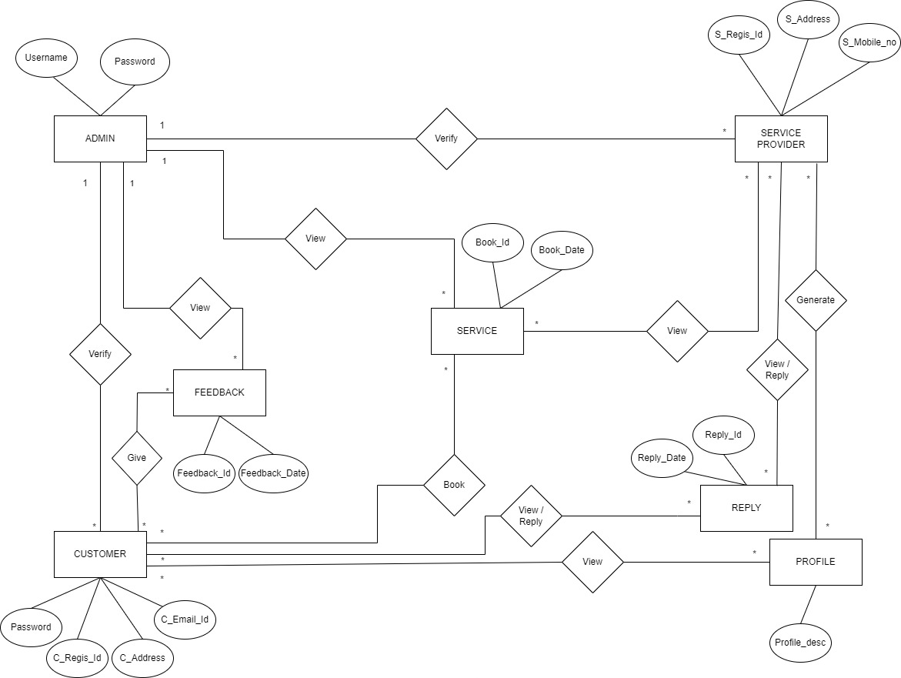

**3.3 Table Structure**

1. **ADMIN_LOGIN TABLE:**

|  |  |  |
| --- | --- | --- |
| **COLUMN** | **DATATYPE** | **INDEXES** |
| USERNAME | VARCHAR(50) | PRIMARY KEY |
| PASSWORD | VARCHAR(10) |  |

1. **SERVICE_PROVIDER_REGISTRATION TABLE:**

|  |  |  |
| --- | --- | --- |
| **COLUMN** | **DATATYPE** | **INDEXES** |
| S_REGIS_ID | INT(10) | PRIMARY KEY |
| S_NAME | VARCHAR(50) |  |
| ADDRESS | VARCHAR(255) |  |
| CITY | VARCHAR(50) |  |
| STATE | VARCHAR(50) |  |
| MOBILE NO | VARCHAR(10) |  |
| EMAIL ID | VARCHAR(50) |  |
| PASSWORD | VARCHAR(10) |  |
| CAT_ID | INT(10) | FOREIGN KEY |
| S_LICENSE | VARCHAR(50) |  |
| PROFILE_DESCRIPTION | VARCHAR(255) |  |
| SERVICE_RATE | INT(10) |  |
| STATUS | INT(1) |  |

1. **CUSTOMER_REGISTRATION TABLE:**

|  |  |  |
| --- | --- | --- |
| **COLUMN** | **DATA TYPE** | **INDEXES** |
| C_REGIS_ID | INT(10) | PRIMARY KEY |
| C_NAME | VARCHAR(50) |  |
| ADDRESS | VARCHAR(255) |  |
| CITY | VARCHAR(50) |  |
| STATE | VARCHAR(50) |  |
| MOBILE_NO | VARCHAR(10) |  |
| EMAIL_ID | VARCHAR(50) |  |
| PASSWORD | VARCHAR(10) |  |
| AADHAR_IMAGE | VARCHAR(50) |  |
| STATUS | INT(1) |  |

1. **ORDER_SERVICE TABLE:**

|  |  |  |
| --- | --- | --- |
| **COLUMN** | **DATA TYPE** | **INDEXES** |
| ORDER_ID | INT(10) | PRIMARY KEY |
| C_REGIS_ID | INT(10) | FOREIGN KEY |
| S_REGIS_ID | INT(10) | FOREIGN KEY |
| DESCRIPTION | INT(10) |  |
| ADDRESS | VARCHAR(255) |  |
| CITY | VARCHAR(50) |  |
| MOBILE_NO | VARCHAR(10) |  |
| BOOK_DATE | DATE |  |
| QR CODE | VARCHAR(20) |  |
| STATUS | INT(1) |  |

1. **CATEGORY TABLE:**

|  |  |  |
| --- | --- | --- |
| **COLUMN** | **DATA TYPE** | **INDEXES** |
| CAT_ID | INT(10) | PRIMARY KEY |
| CATEGORY | VARCHAR(50) |  |
| CAT_IMAGE | VARCHAR(50) |  |

1. **REPLY_DETAIL TABLE:**

|  |  |  |
| --- | --- | --- |
| **COLUMN** | **DATA TYPE** | **INDEXES** |
| REPLY_ID | INT(10) | PRIMARY KEY |
| REPLY_DATE | DATE |  |
| S_REGIS_ID | INT(10) | FOREIGN KEY |
| C_REGIS_ID | INT(10) | FOREIGN KEY |
| REPLY_MSG | VARCHAR(255) |  |
| SENDER_TYPE | VARCHAR(50) |  |

1. **FEEDBACK TABLE:**

|  |  |  |
| --- | --- | --- |
| **COLUMN** | **DATA TYPE** | **INDEXES** |
| FEEDBACK_ID | INT(10) | PRIMARY KEY |
| S_REGIS_ID | INT(10) | FOREIGN KEY |
| DESCRIPTION | VARCHAR(255) |  |
| FEEDBACK_DATE | DATE |  |

**3.4 Use Case Diagrams**

**Service Provider**

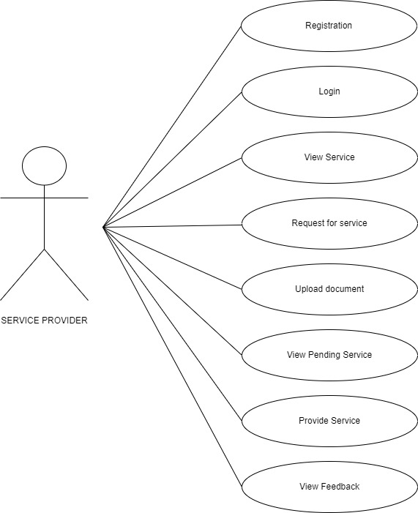

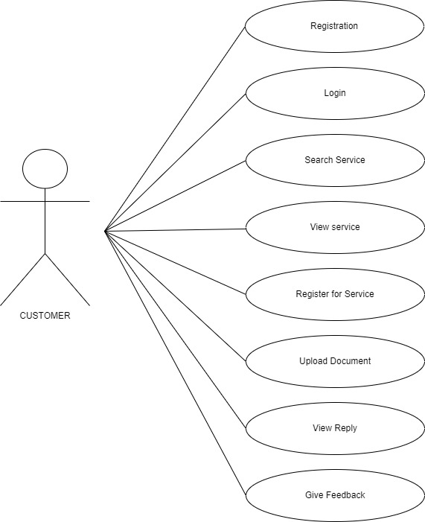**Customer**

**Admin**

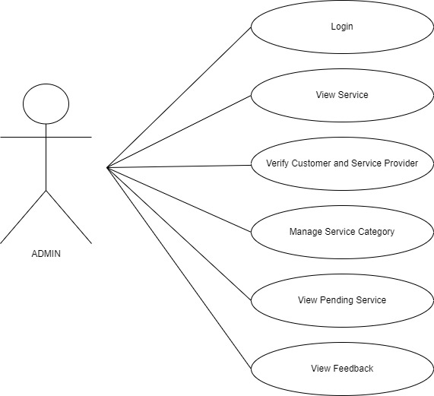

3.5 Class Diagram

**3.6 Activity Diagram**

**Login & Registration**

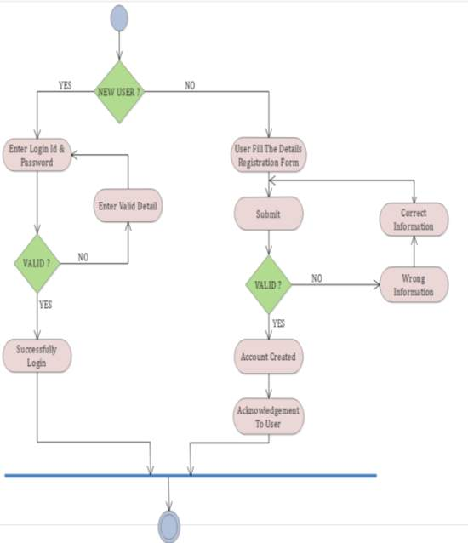

**Admin**

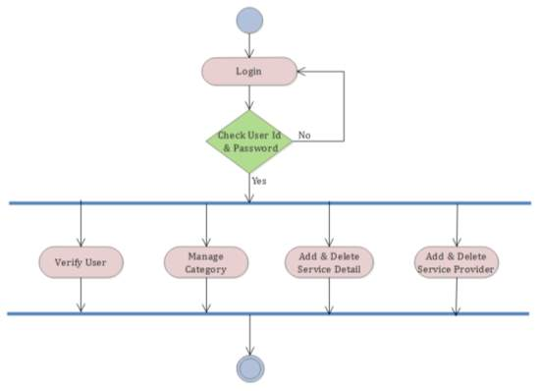

**Service Provider**

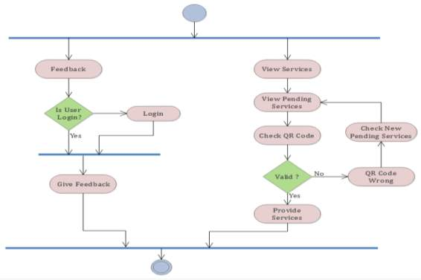

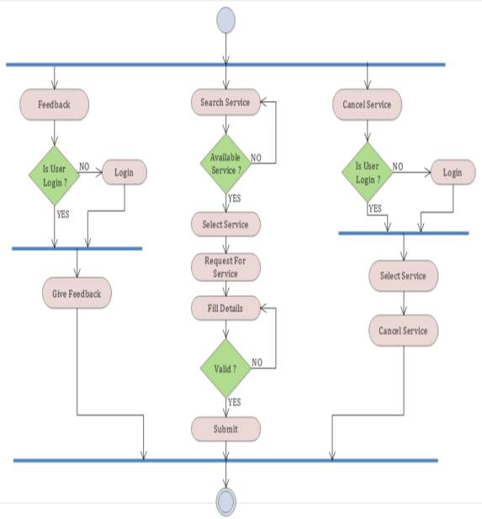**Customer**

3.7 Deployment Diagram

3.8 Module Hierarchy Diagram

3.9 Sample Input and Output Screens (Screens must have valid data.