**Integration of AWS with Snowflake**

Step1:

Login into snowflake account

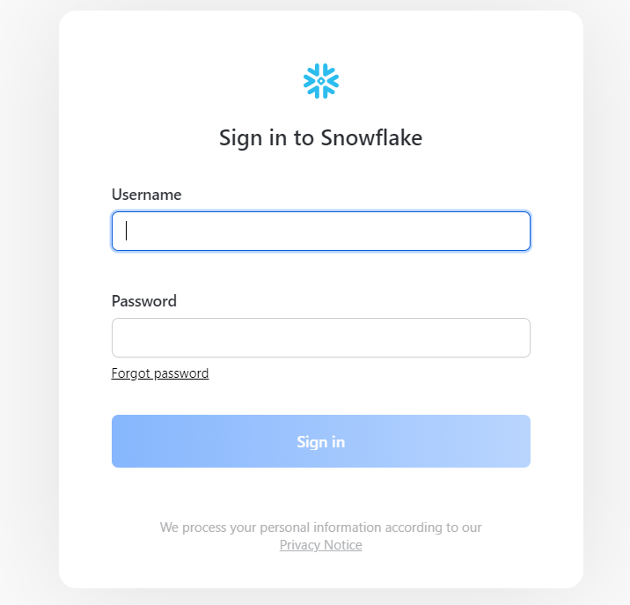

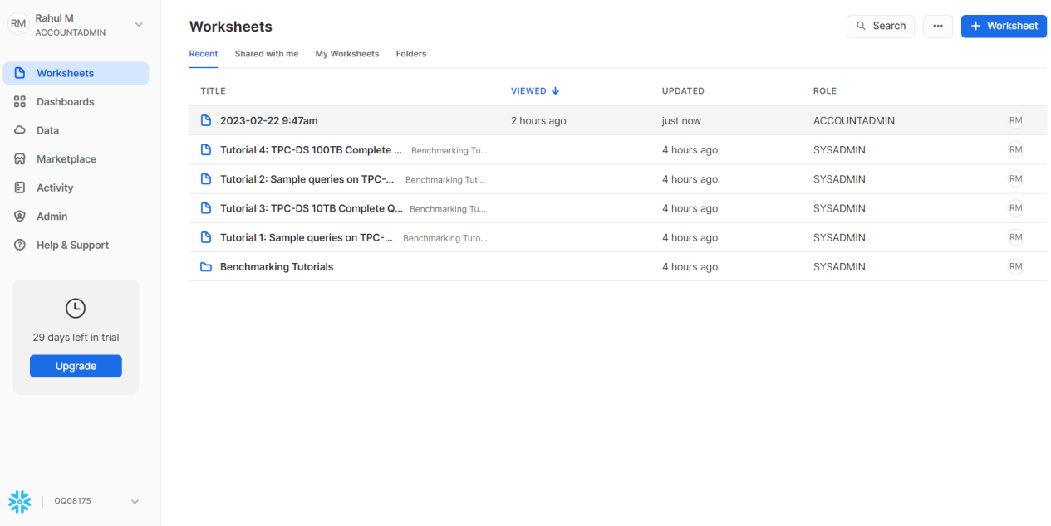

Step2 :

Login into AWS account

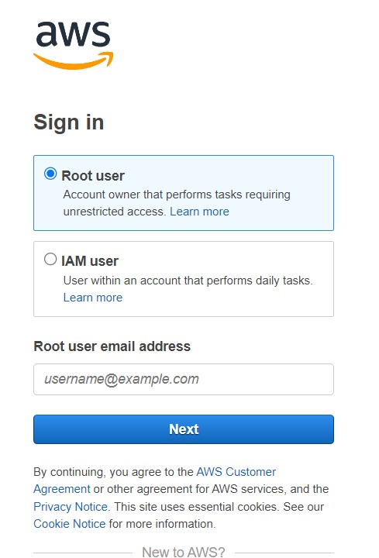

Step 2.1:

Create S3 Bucket:

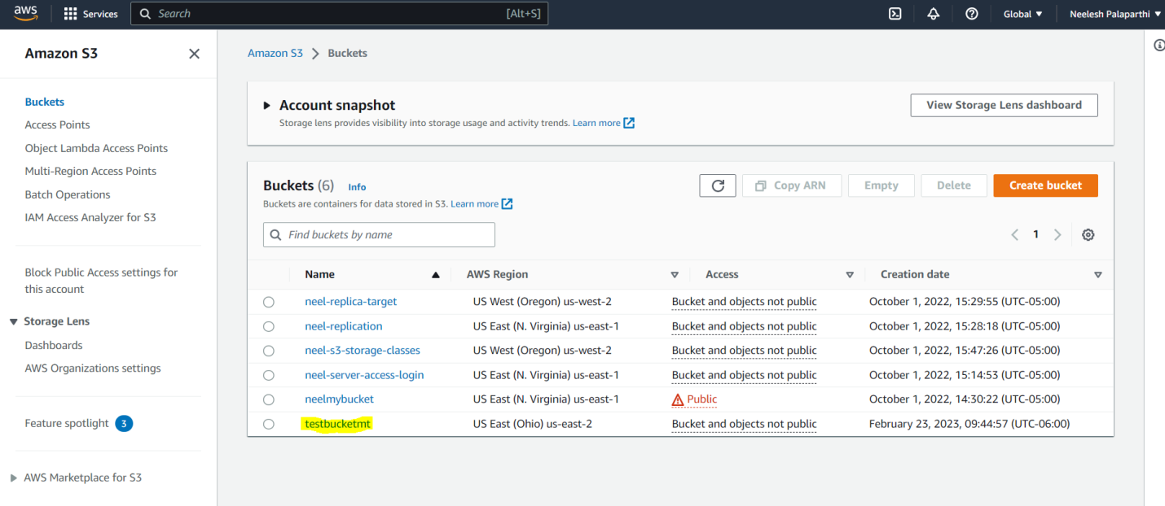

Step 2.2:

Create a new folder inside S3 Bucket:

Chose relevant region and check ACLs disabled:

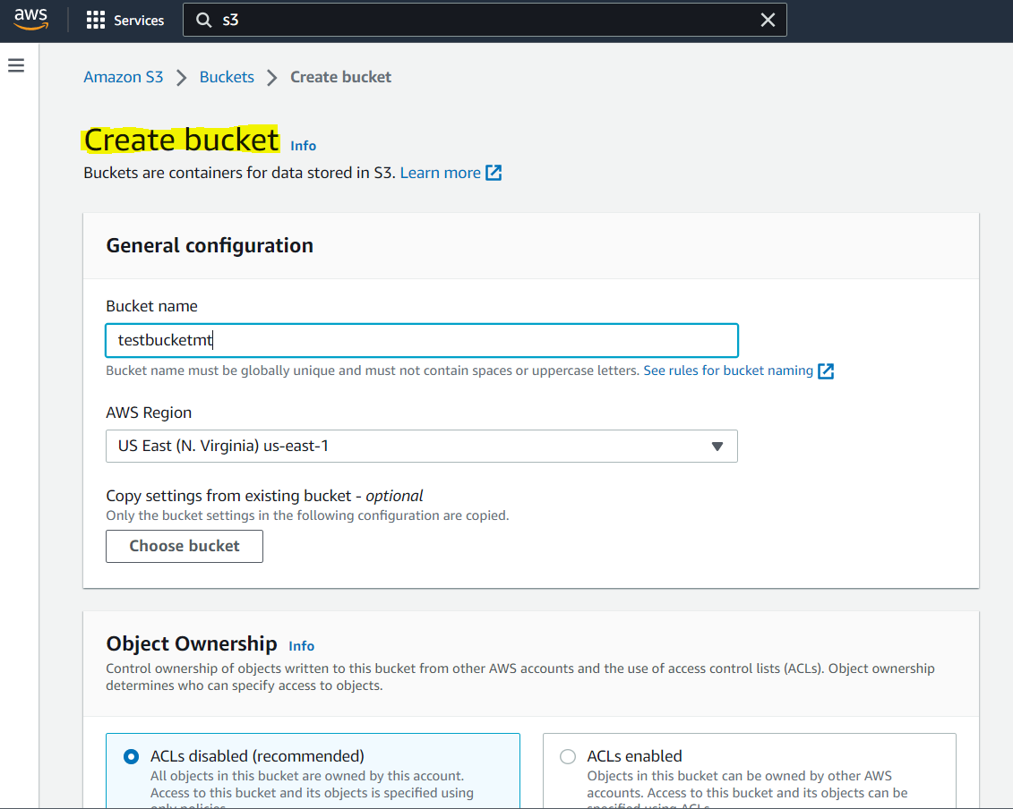

Chose default encryption, disable bucket version and enable bucket key:

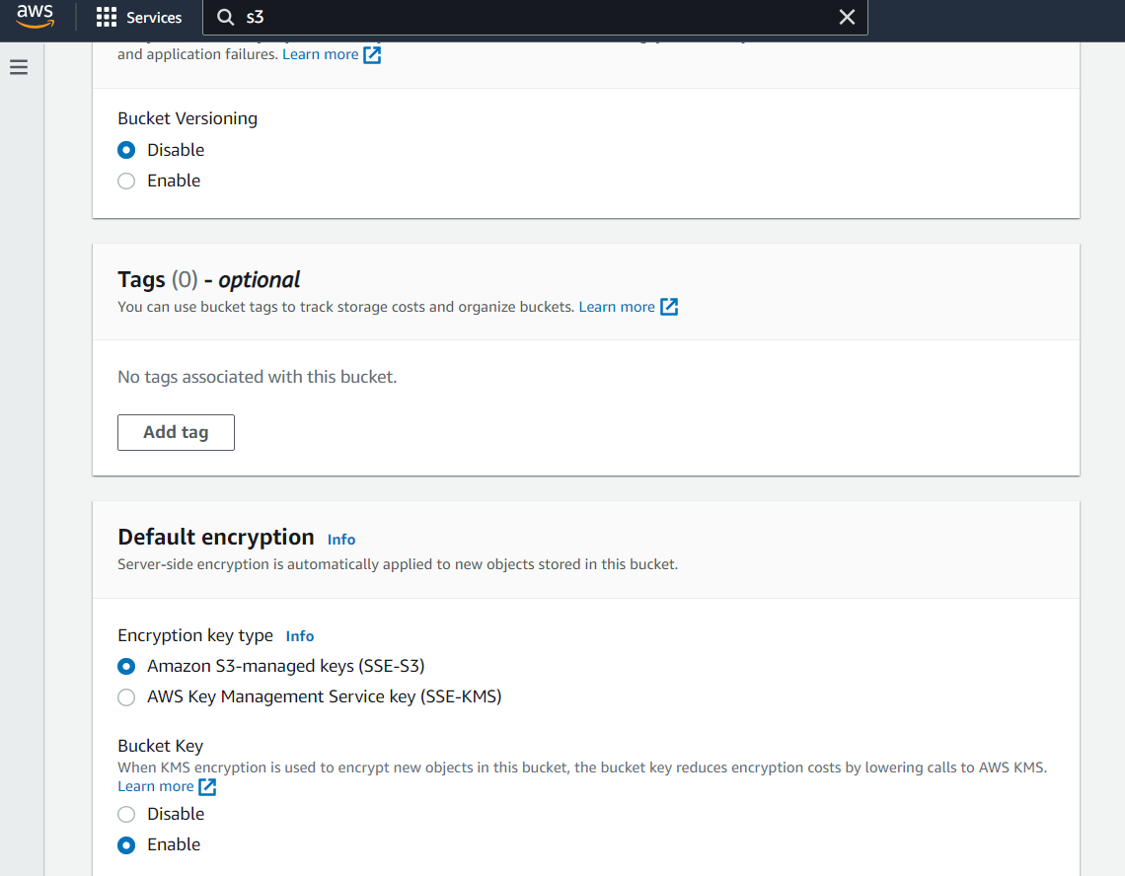

Step 2.3:

Create folder inside the S3 Bucket:

🡪Click on the created bucket ‘testbucketmt’.

🡪Click on create folder inside the bucket

🡪Check Amazon S3-manged keys(SSE-S3) Encryption key type

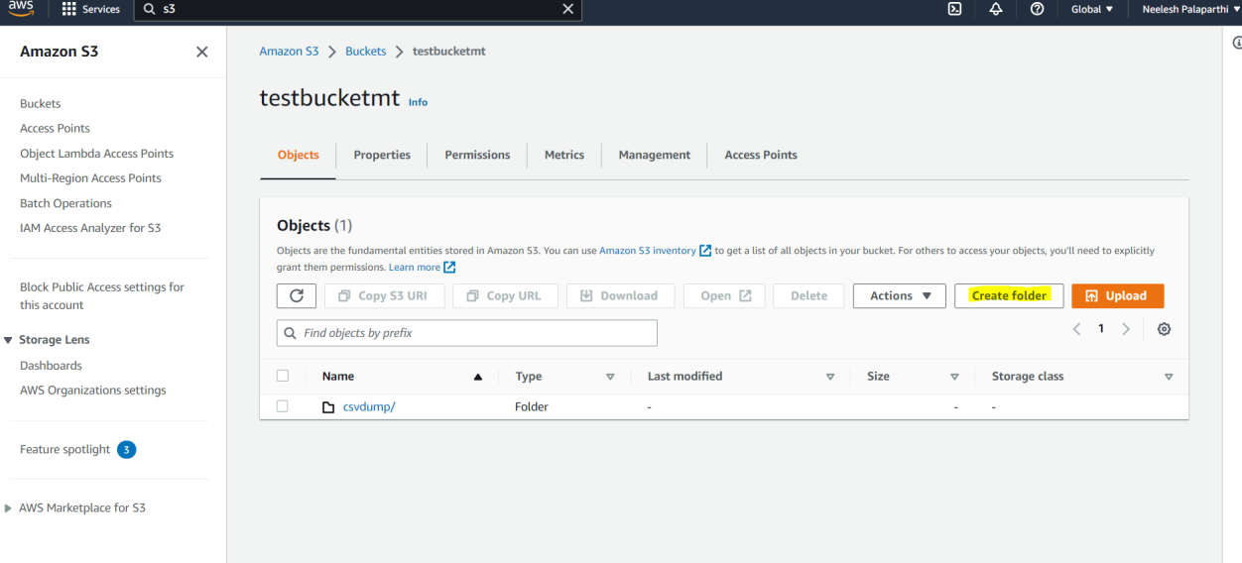

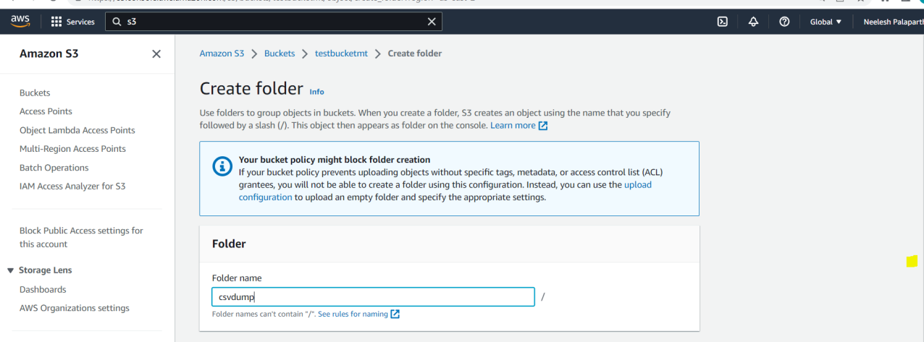

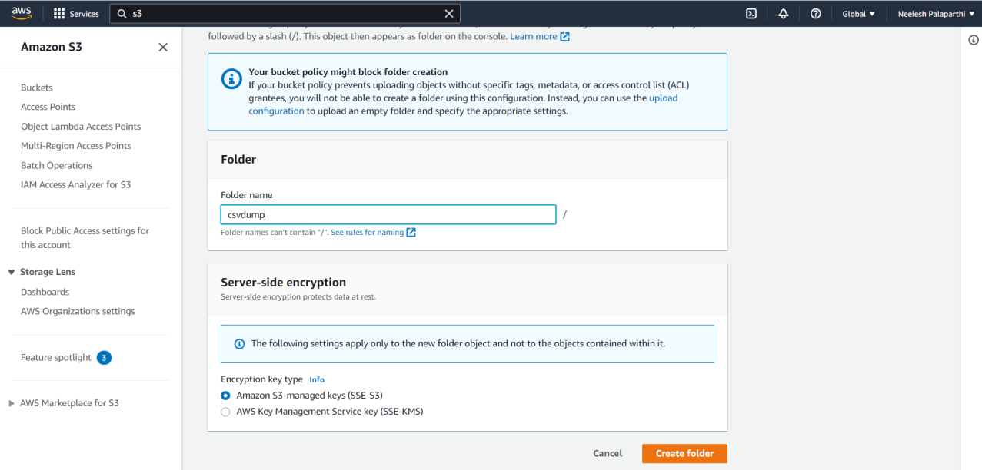

Step 3:

Create IAM role:

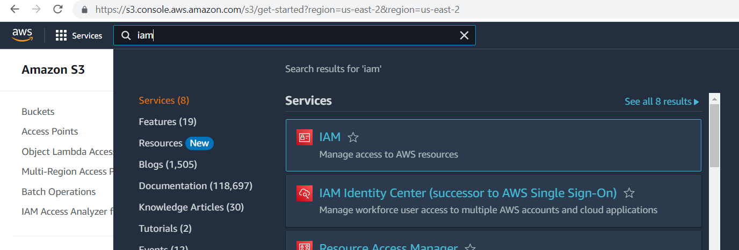

Select Roles which is present on left pane of the window:

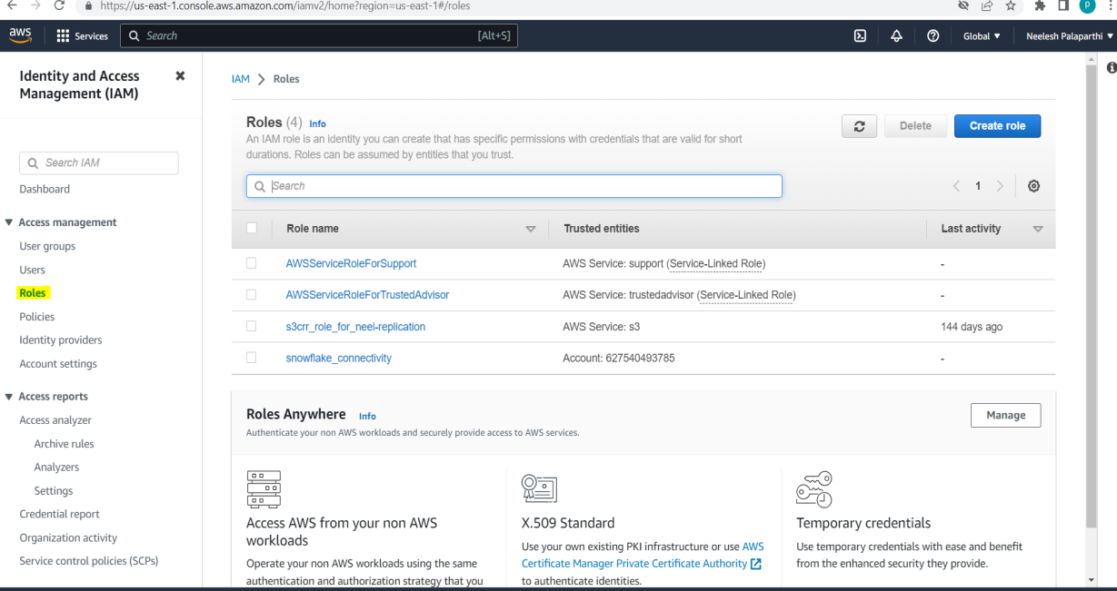

We need to create roles by selecting create roles

🡪Select AWS account

🡪Input 00000 as external ID

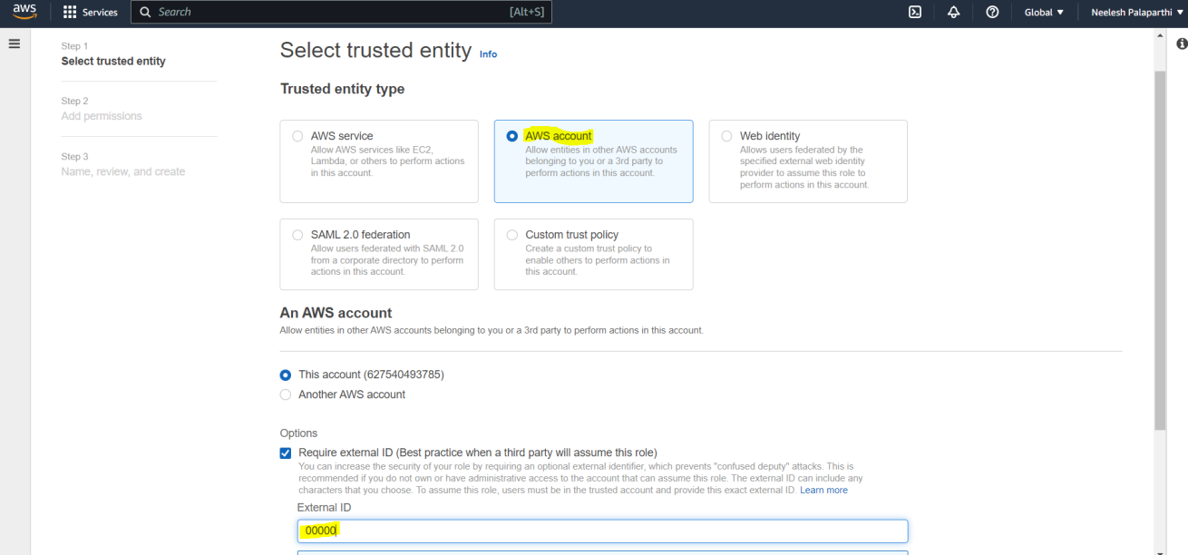

We need to chose AmazonS3FullAcess policy :

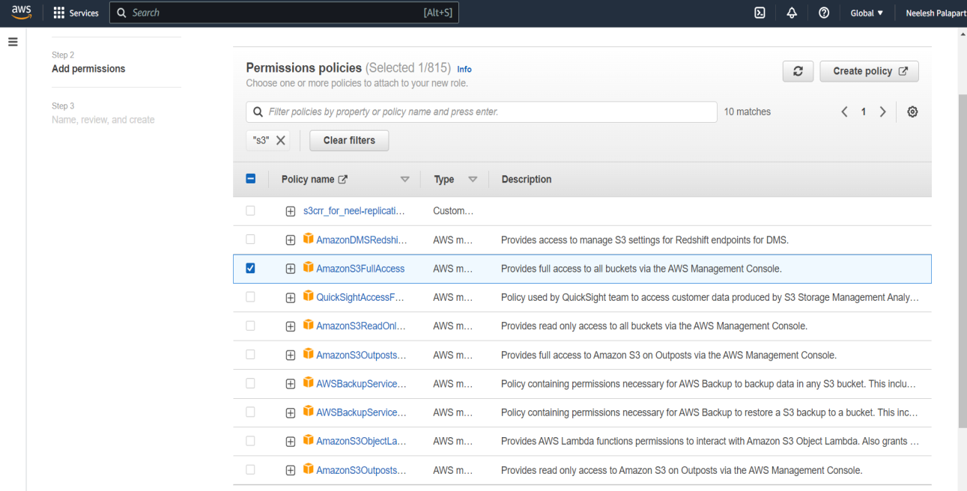

Write Role name and description:

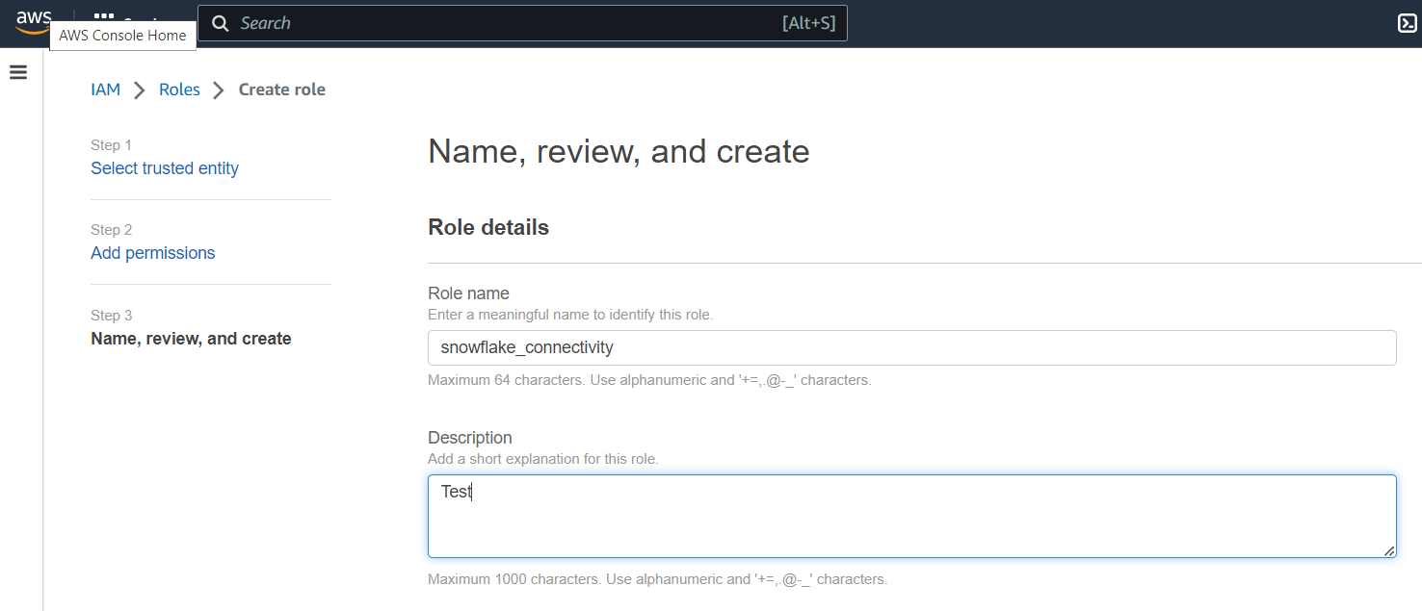

Now we need to select create role:

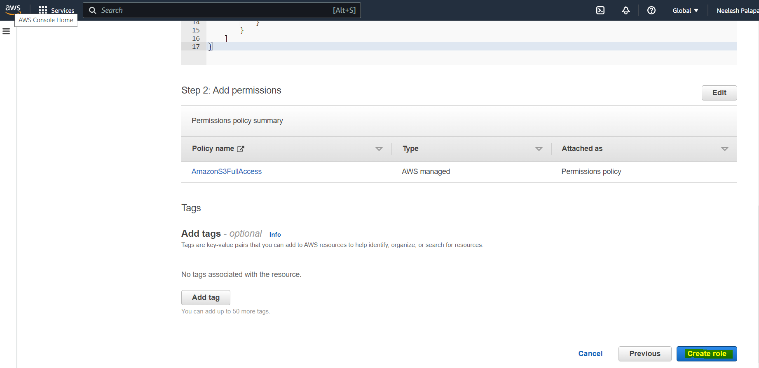

Snowflake_connectivity is the new role created:

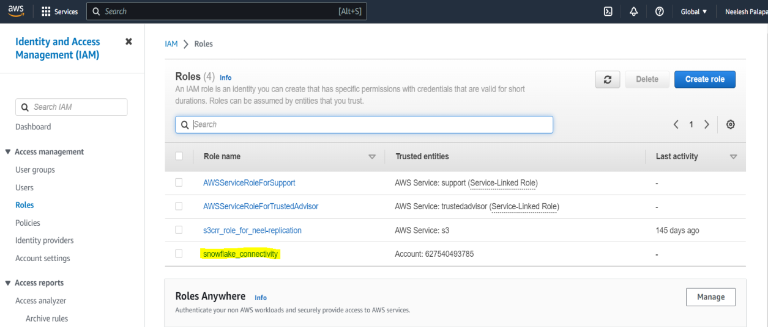

Step 4:

Integration AWS with Snowflake

🡪Set role as Account Admin in Snowflake worksheet

🡪Type following command in worksheet and run it.

CREATE STORAGE INTEGRATION name  
TYPE = EXTERNAL_STAGE  
STORAGE_PROVIDER = S3  
ENABLED = TRUE  
STORAGE_AWS_ROLE_ARN =  
''  
STORAGE_ALLOWED_LOCATIONS = ('');

STORAGE_AWS_ROLE_ARN – For this navigate to IAM service click on IAM role select snowflake_connectivity 🡪 copy ARN link

STORAGE_ALLOWED_LOCATIONS – For this select the folder inside S3 bucket and copy the s3 url.

