SE Lab-2 (Jira)
Name | Rahul M S
SRN | PES1UG24CS359
Class | 5-F

Epics and Burndown Chart
3 epics have been created:
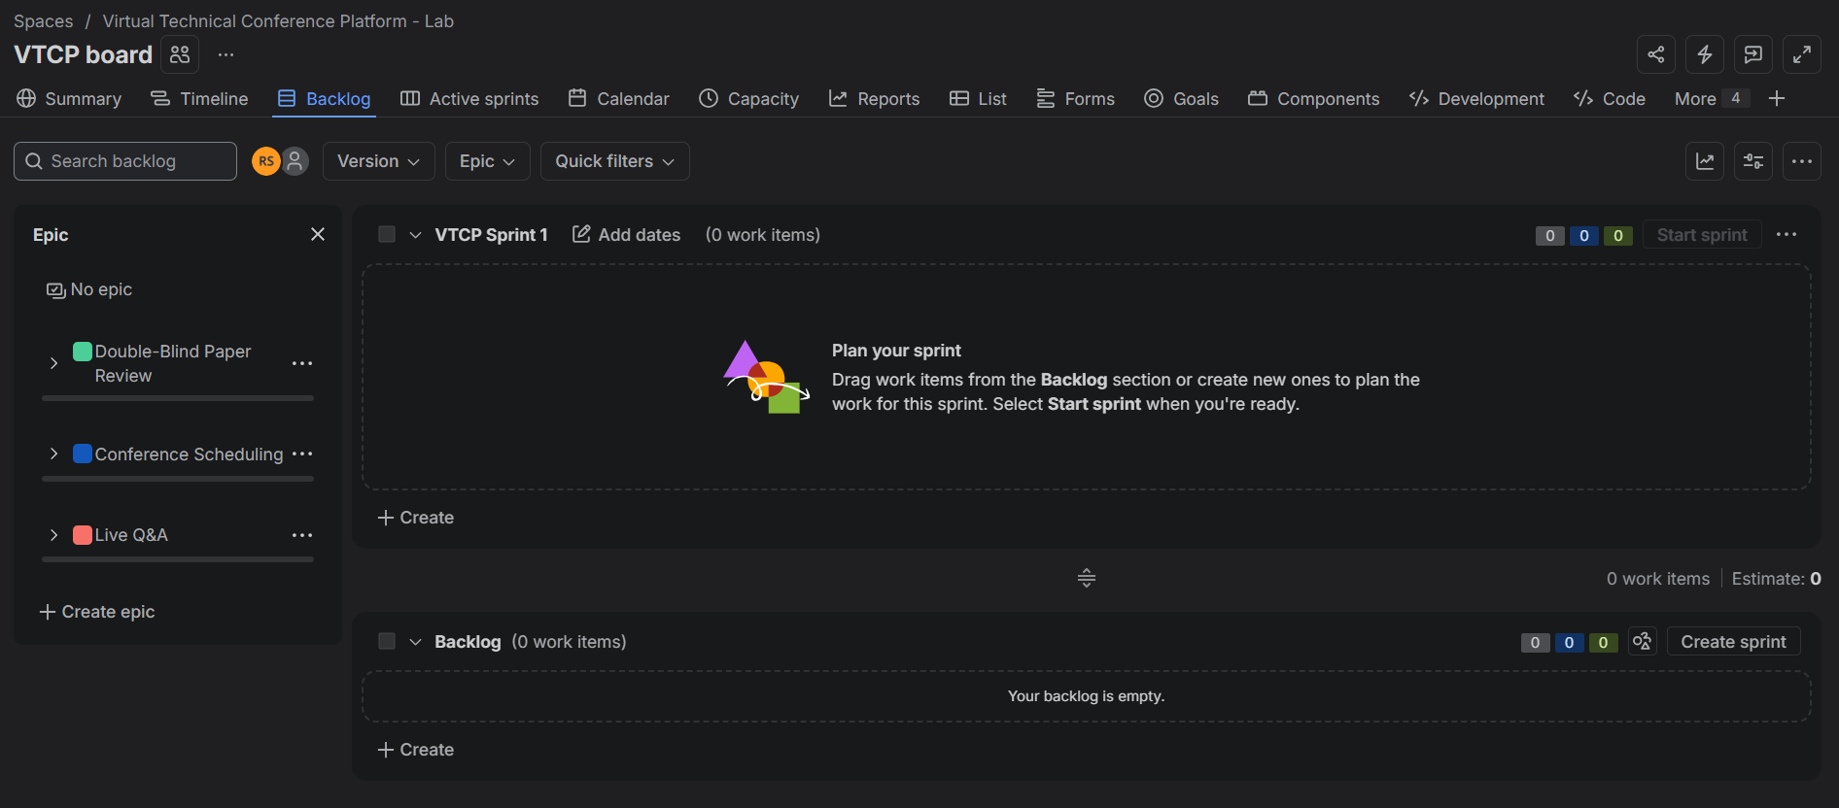
9 stories have been added along with the story points:
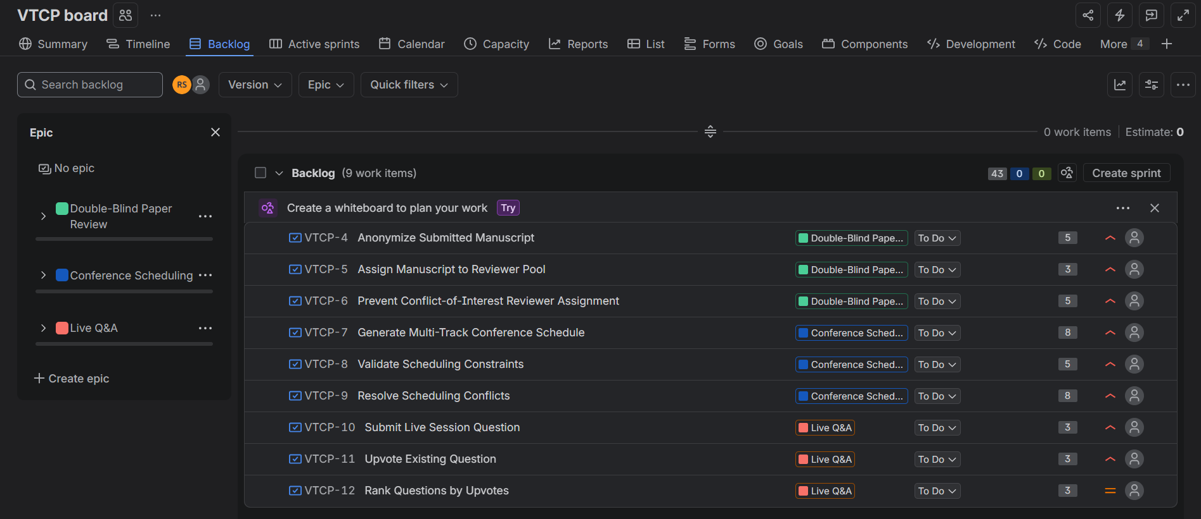
6 stories have been added to the sprint:
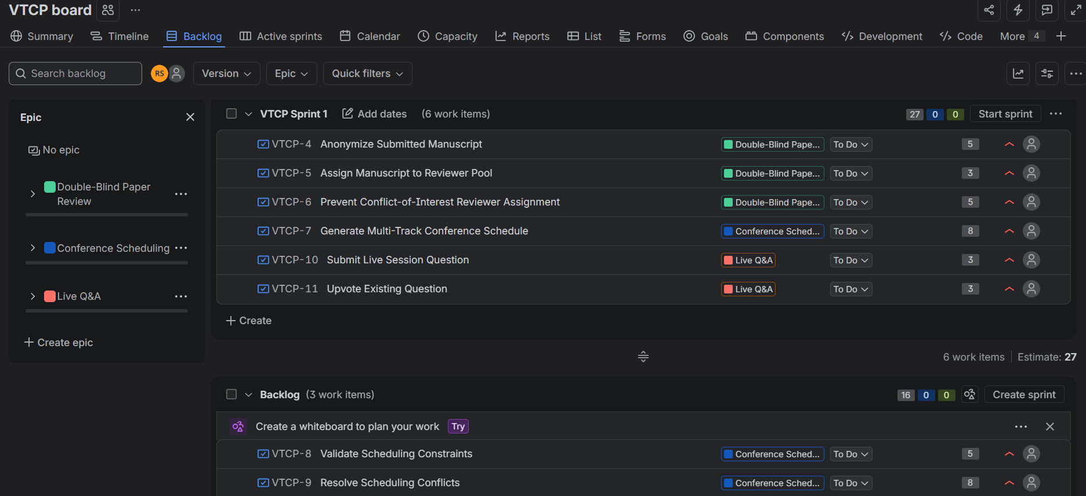
Sprint with selected stories and 1 week duration
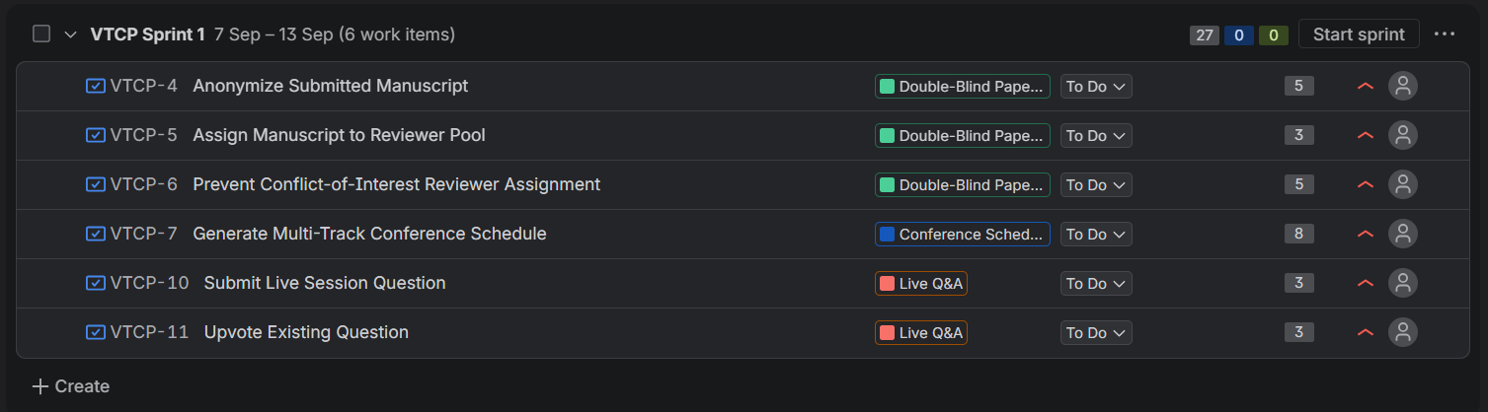
Sprint has been started:
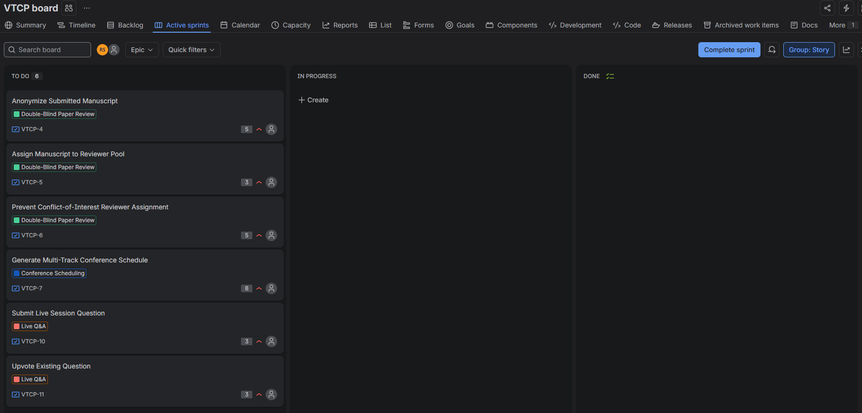
We move the sprint to in progress and a few minutes later we move it to done
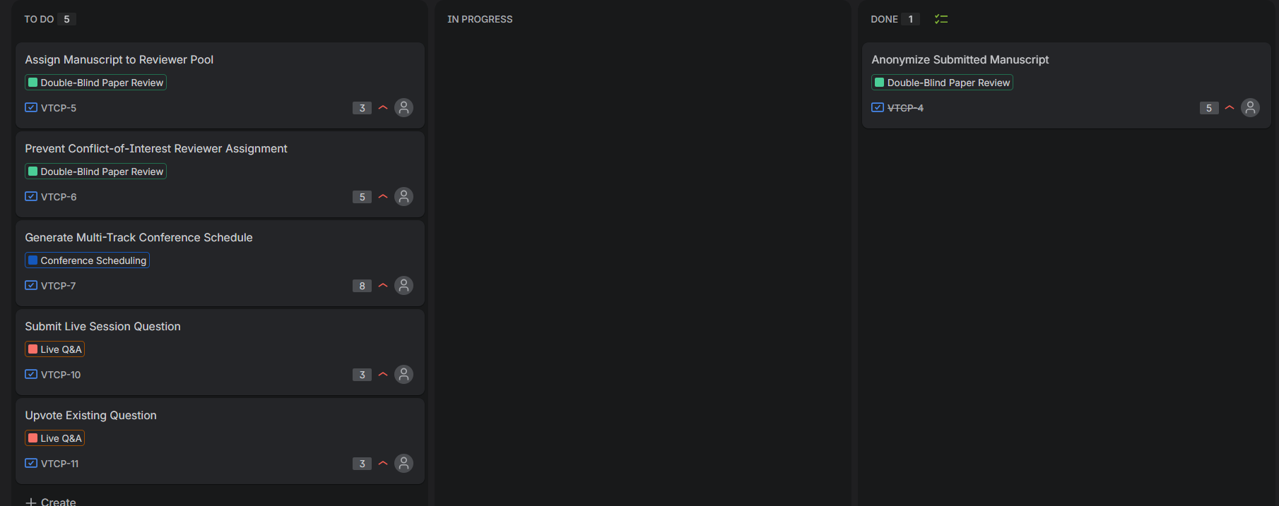
Similarly, we do this for the rest of the 5 tasks.
Once, all the 6 tasks have been done, we will have all the tasks in the “Done” section:
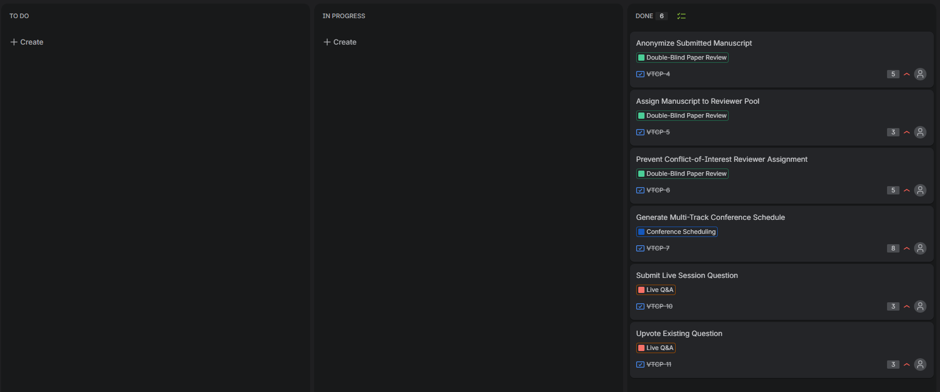
The burndown chart looks like this:
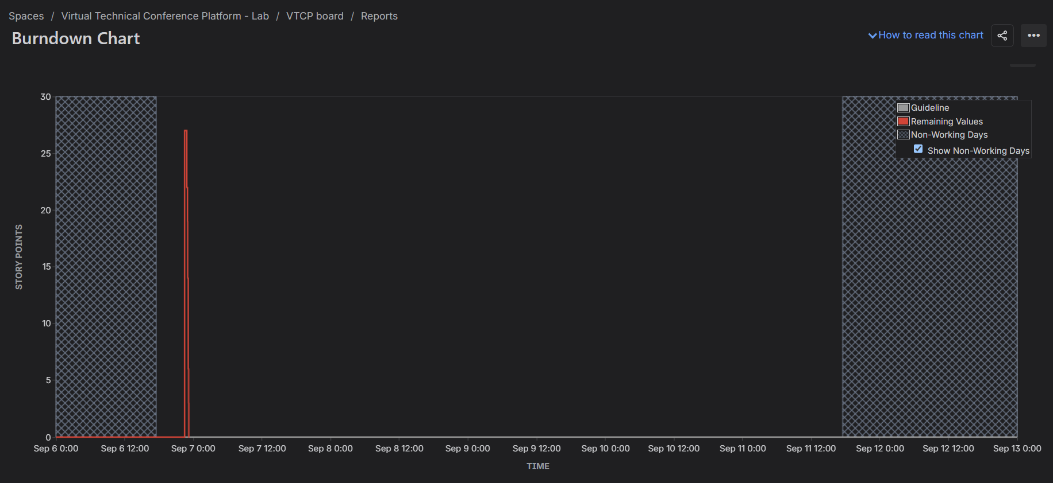
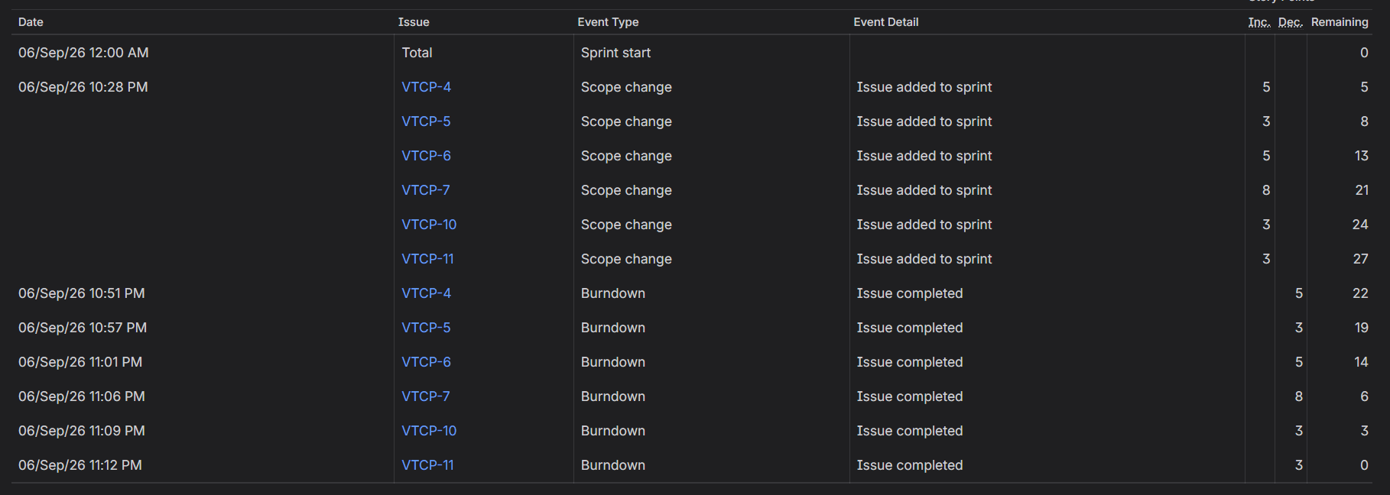
Once, we click on complete sprint, it shows this in the backlog section of the project:
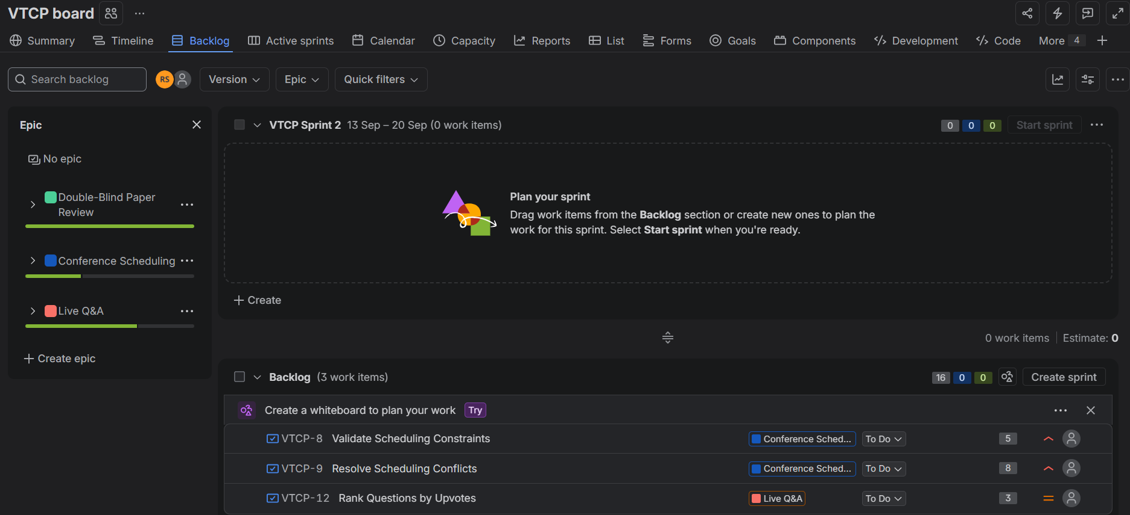
We have created 2nd sprint:
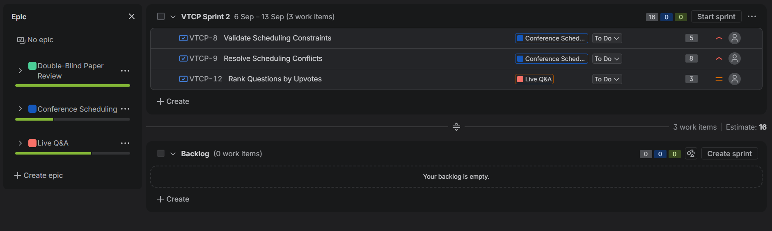
We repeat the steps that we have done for sprint 1:
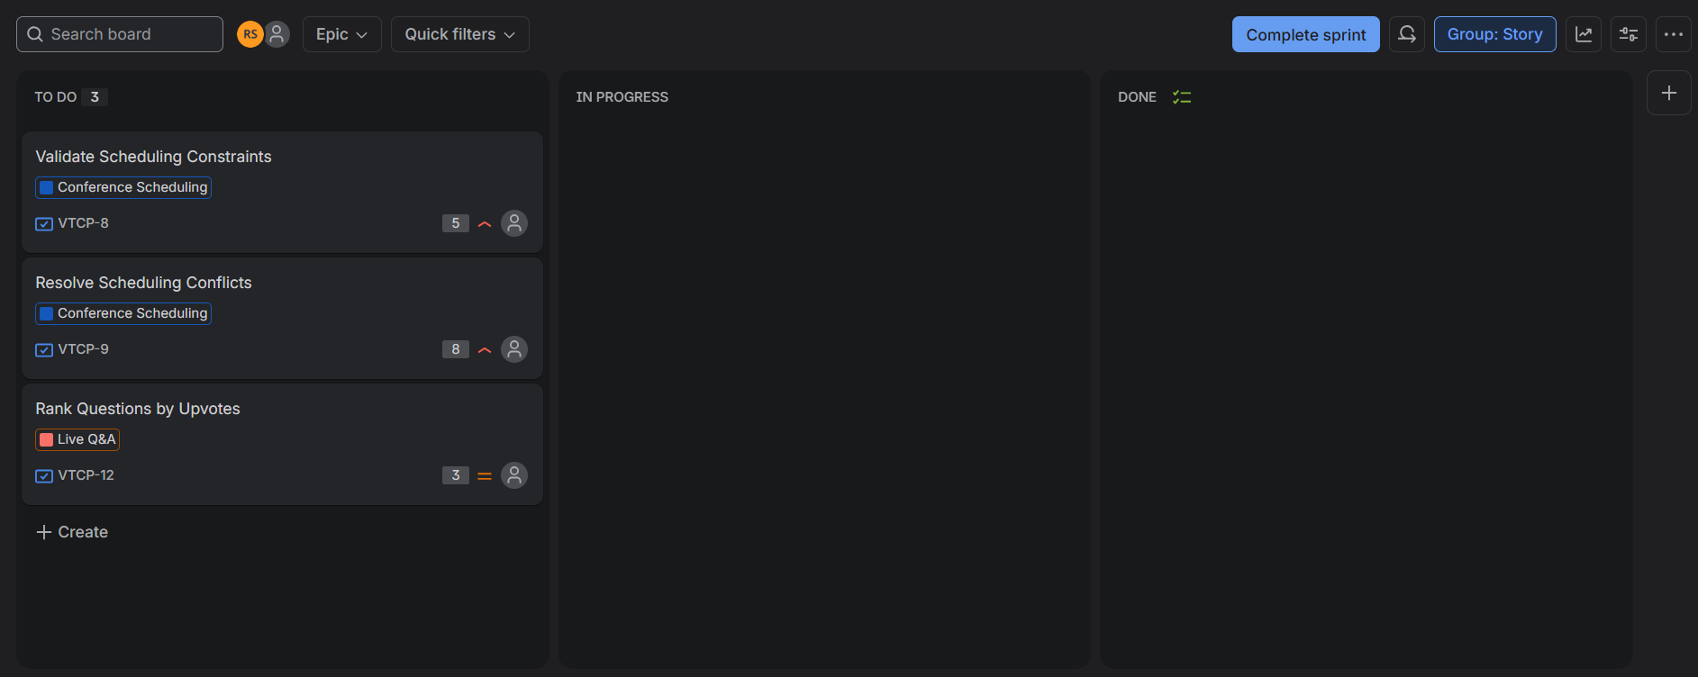
We move the tasks one by one from “in progress” to “Done” and for every transfer, we wait a few minutes.
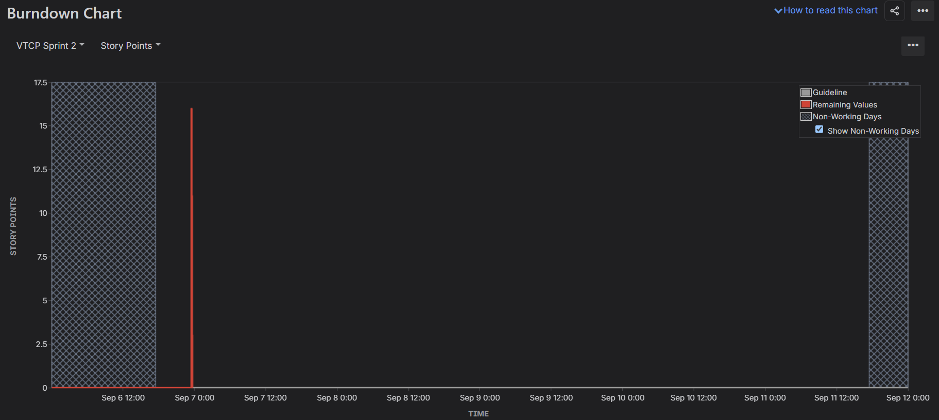
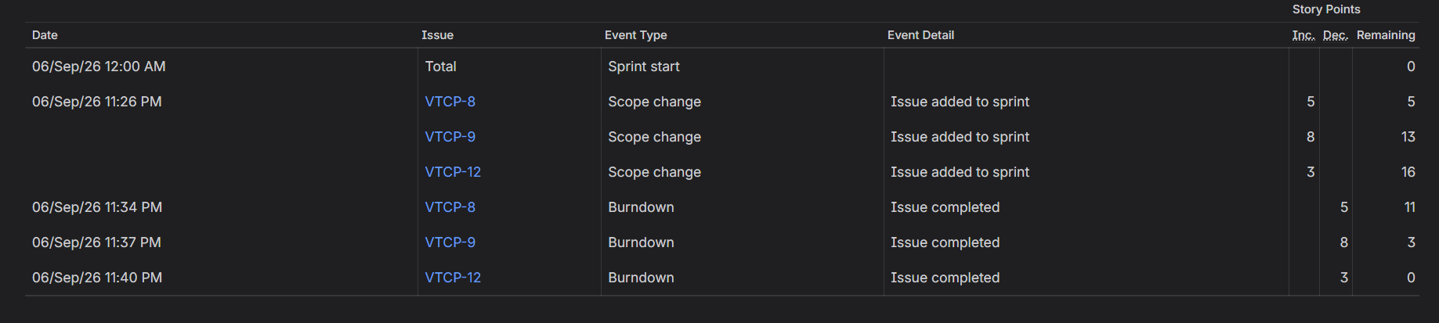
Once, we are done with all the 3 remaining tasks, we see in the backlog that all the tasks are completed.
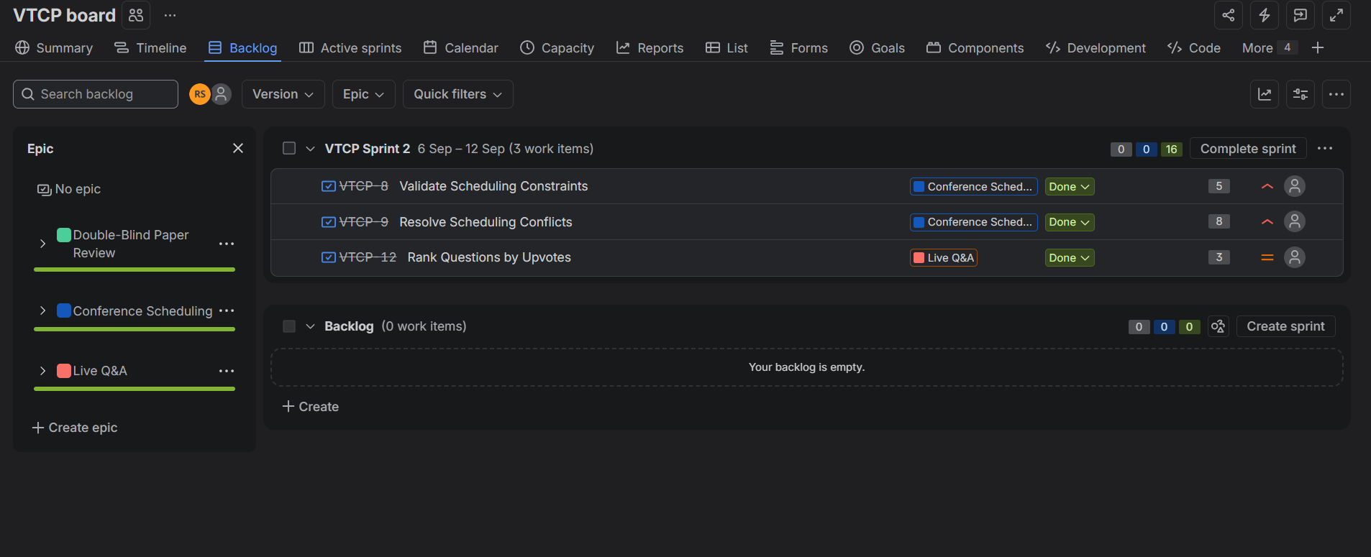

Reflection
- Did your estimations reflect the actual effort?
Yes. The story points generally reflected the difficulty of the tasks. More complex tasks were given higher points, while simpler tasks were given fewer points.
- Was your backlog well-prioritized?
Yes. The important core functionalities were given High priority, while less critical functionality was given Medium priority. This helped us decide which stories to include in each sprint.
- How did your simulated sprint align with your plan?
The sprints aligned well with our plan. We completed the selected 6 stories in Sprint 1 and the remaining 3 stories in Sprint 2. All planned stories were completed.
- What insights did the burndown chart give about your team’s capacity?
The burndown chart showed that the team was able to complete all the planned work. It also showed that work was completed quickly during the simulation, giving us an idea of how much work could be handled within a sprint.

