CN Mini Project
Name | Pulkit Bhardwaj  Vedanta  Rahul M S
SRN | PES1UG24CS346  PES1UG24CS920  PES1UG24CS359
Class | 4-F

Remote System Health Monitoring Service
1. Introduction
Modern distributed systems often consist of multiple machines running across different networks. Monitoring the health of these systems is critical to ensure reliability, performance, and availability.
A Remote System Health Monitoring Service is a network-based system that periodically collects system health metrics from multiple remote nodes and aggregates them at a central monitoring server.
The system uses UDP socket communication to transmit system metrics such as CPU usage, memory usage and disk utilization from client machines to the server.
The central server receives the metrics, analyses them, and generates alerts when predefined thresholds are exceeded. This allows administrators to detect potential system failures or resource bottlenecks early.
This project demonstrates the use of low-level socket programming, multi-client communication, and distributed monitoring architecture.

2. Objectives
The main objectives of this project are:
• Implement a UDP socket-based monitoring system
• Periodically collect system health metrics from remote nodes
• Aggregate metrics at a central monitoring server
• Support multiple concurrent client nodes sending data
• Generate threshold-based alerts for abnormal system behaviour
• Demonstrate client-server communication using socket programming

3. System Architecture
The system follows a Client–Server architecture.
Components
Monitoring Clients (Remote Nodes)
- Collect system health metrics periodically
- Send metrics to the central server via UDP sockets
Monitoring Server (Central Node)
- Listens for incoming UDP packets
- Receives system metrics from multiple clients
- Processes the data
- Generates alerts if thresholds are exceeded
Communication Protocol
UDP sockets are used to transmit monitoring data between clients and the server.

Architecture Diagram
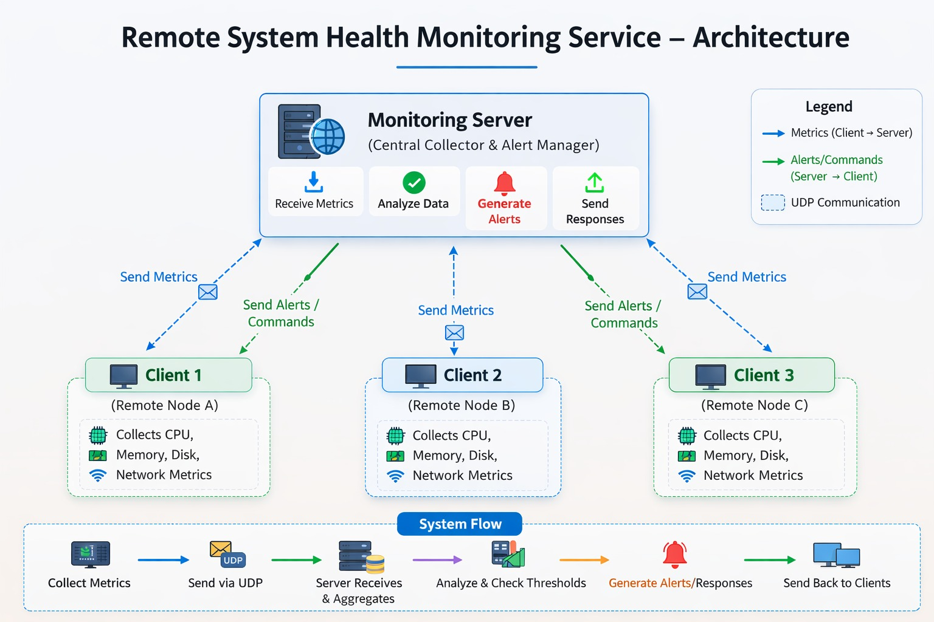
4. Implementation
4.1 Client Monitoring Agent
The client program runs on each monitored system.
Responsibilities:
- Collect system health metrics using Python libraries such as psutil
- Create a UDP socket
- Send system statistics periodically to the monitoring server
Example metrics collected:
• CPU usage
• Memory usage
• Disk usage
The client serializes the data and transmits it to the server.

4.2 Monitoring Server
The server program acts as the central data collector.
Responsibilities:
• Create a UDP socket
• Bind to a specific port
• Continuously listen for incoming monitoring data
• Parse received metrics
• Display or log the data
The server can receive metrics from multiple clients simultaneously.

4.3 Multi-Client Handling
Since UDP is connectionless, the server can receive packets from multiple clients without maintaining persistent connections.
Each packet contains:
• Client identifier
• System metrics
• Timestamp
The server processes packets independently as they arrive.

4.4 Alert Generation
The server compares received metrics with predefined thresholds.
Example thresholds:
CPU Usage > 80%
Memory Usage > 85%
Disk Usage > 90%
If a threshold is exceeded, the server generates an alert message such as:
[ALERT] High CPU usage detected from Client 192.168.1.5

