Existing ATS Checkers
ResumeChecker
- Allow users to upload their resume
- After uploading scans resume and generate ats score with issues and suggestions to improve resumes.
- Content section checks ATS parse rate, Quantifying impact, Repetition of words , Spelling and grammar.
- Sections analyze issues related to essential sections like education, summary, experience and contact information like phone number, email address, and linkedIn.
- ATS Essentials checks file format & size, design, email address hyperlinks in header
- Tailoring section analyze resume for job description.
- Improve resume to make it ats friendly.
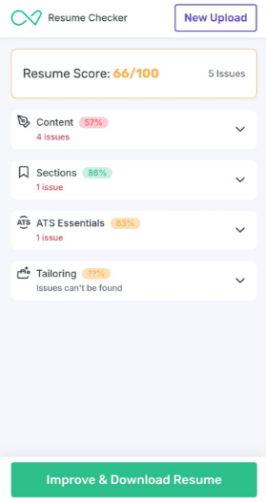
MyPerfectResume
- Uploading Resume gives score provides an option to improve resume
- Suggestions
- Contact information must contain phone number, email, city, country, zipcode , linkedin etc.
- Professional summary should not be complex
- Skills section contains relevant skills , keyworkds.
- Work history is mandatory.
- Education information include school city, state etc.
- Templates to customize resumes also check spelling & grammar, summary statement, measurable results and optimal length.

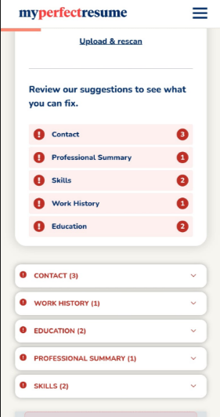
1MillionResume
- Gives score , suggestions
- Contact information like email, contact nmber, linkedIn data
- Personal information checks ->Avoid using personal information
- Spelling and grammar check
- Personal pronoun checks ->Avoid uisng personal pronoun like I, my, me, myself etc.
- Passive ponits ->write sentence only in active voice
- Skills and keyword targetting ->check resume against target roles
- Avoid complex and lengthy sentences , repeated action verbs like “managed” , “led”
- AI language test.
.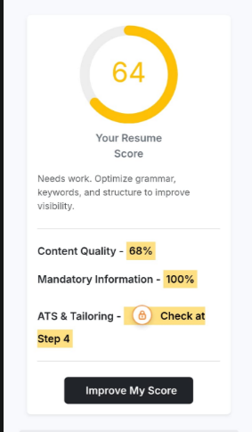
Zety
- Optimal length test 1 page resume only
- Fix typos
- Comprehensiveness
- Measurable results ->stand out with results that show real impact
- Word choice->use powerful action verbs to show your value
- Formatting ->clean consistent formatting helps your resume pass ATS and impress employers.
- Clear contact information ->phone number, email id, linkedIn profile etc.
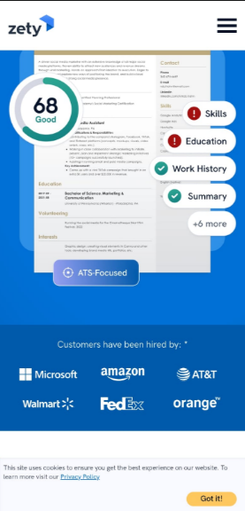
JobHero
- Gives score and strength
- Templates to imprive resume
- Suggestions
- Contact information
- Professional summary
- Relevant skills
- Work history
- Education
