TECHNICAL PORTFOLIO CASE STUDY
Transportation Exception
Management API
Runtime validation, transportation workflow modelling, persistence, reporting, testing, and CI
Project type | Independent C#/.NET portfolio project
Validation date | 11 August 2026 - Windows
Evidence | 10 public operations, SQLite persistence, 36 integration tests
Data boundary | Deterministic synthetic transportation data only

SUPPLY CHAIN -> ANALYTICS -> AUTOMATION -> SYSTEMS
Not an employer system or production deployment. No real carrier or customer data.

Executive Summary
Transportation Exception Management API models how delayed, constrained, disrupted, or documentation-blocked movements can be recorded, assigned, progressed, explained, reported, and exported through a consistent backend workflow. The solution uses ASP.NET Core, application services, a domain state machine, EF Core, and SQLite. It is deliberately self-contained and reproducible.
The validation session exercised every public operation in the existing Swagger UI. A new synthetic case was created, rejected from active work while unassigned, assigned, noted, transitioned, re-read, included in aggregate reports, and exported to CSV. Read-only SQLite inspection confirmed the migration, relationship, case row, and note row. The automated suite passed all 36 tests.
Runtime surface | Persistence | Automated tests | Remote CI
10 operations tested | 37 cases / 13 notes | 36 passed / 0 failed | Latest checked run: success

Evidence boundary
All cases, movements, nodes, carriers, analysts, timestamps, due-time thresholds, and report values are fabricated. The project demonstrates engineering discipline without claiming professional production C#/.NET experience or real-world business impact.

What the project proves
- Transportation concepts translated into entities, lifecycle rules, and due-time reporting.
- A layered .NET solution whose references match the claimed dependency direction.
- Relational persistence, migrations, deterministic seed data, API validation, tests, and CI working together.
- Limitations and synthetic-data boundaries documented as carefully as successful behaviours.

System Architecture
The domain is the dependency root; API is the composition root; Infrastructure implements the Application repository contract.
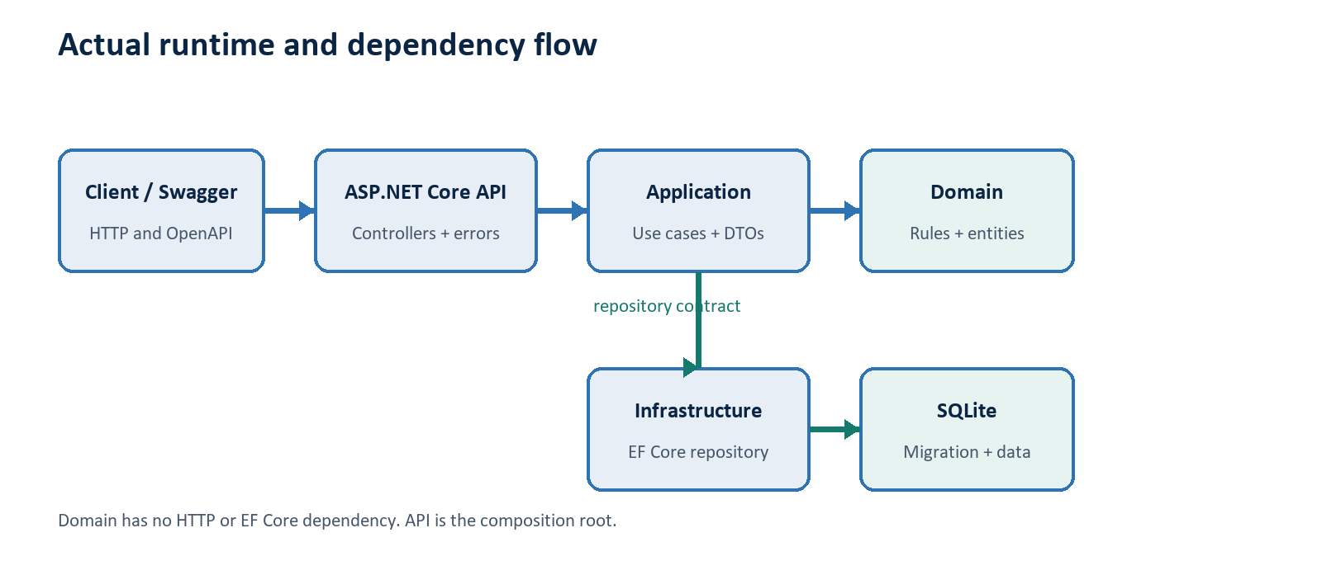
Layer | Confirmed responsibility
Domain | Entities, enums, invariants, status graph, field limits, and illustrative SLA policy.
Application | DTOs, queries, services, reports, CSV export, mappings, and ICaseRepository.
Infrastructure | EF Core context and mappings, SQLite repository, migration, initializer, and seed.
API | Controllers, dependency composition, validation, ProblemDetails, health, and Swagger.
Tests | Hosted HTTP pipeline, in-memory SQLite, fixed clock, and migration-backed scenarios.

The design intentionally avoids MediatR, AutoMapper, and generic-repository ceremony. Direct application services and an explicit repository contract keep the important rules visible.

Transportation Domain and Lifecycle
A case connects a fictional movement, route nodes, carrier code, exception category, severity, status, ownership, timestamps, description, resolution data, and notes. Origin and destination must differ; assignment is required before active work; resolution requires a summary; reopening clears stale resolution fields.
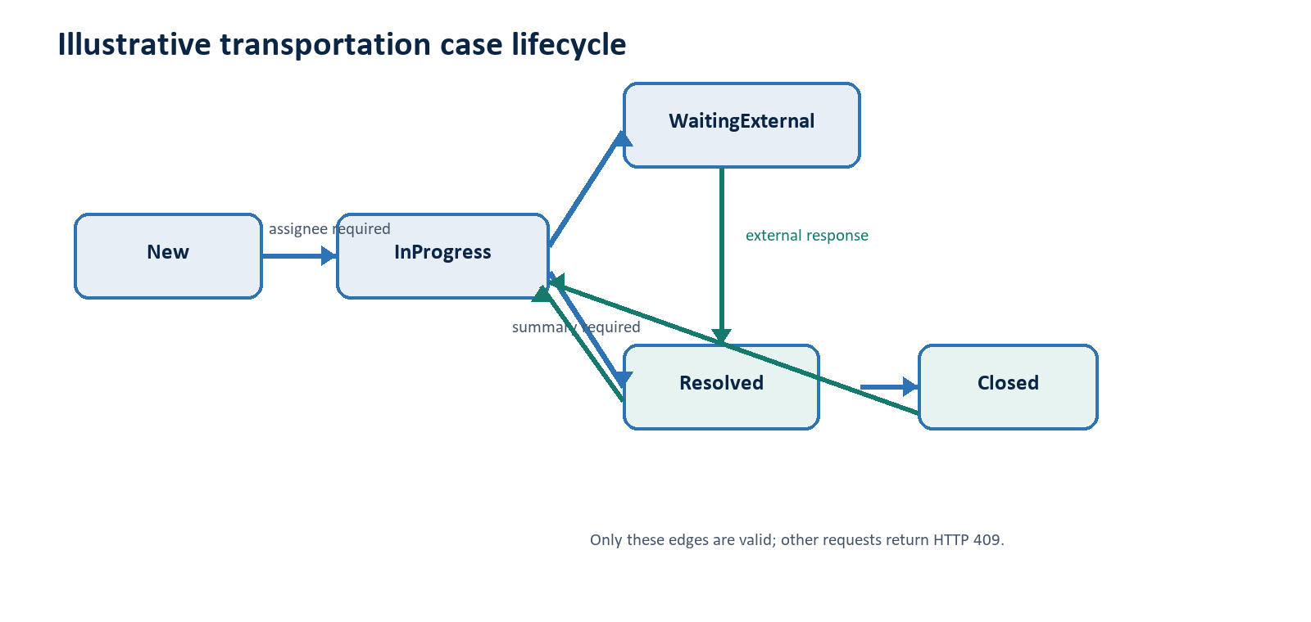
Severity | Illustrative target | Purpose
Critical | 2 hours | Highest synthetic urgency
High | 4 hours | Validation case severity
Medium | 8 hours | Moderate synthetic urgency
Low | 24 hours | Lowest synthetic urgency

These thresholds are invented portfolio rules, not carrier commitments or operational standards.

API Surface
Method | Route | Purpose
GET | /health | Process health
GET | /api/cases | Filtered, sorted, paginated list
POST | /api/cases | Validated case creation
GET | /api/cases/export.csv | Filtered CSV export
GET | /api/cases/{id} | Detail and notes
PATCH | /api/cases/{id}/assignment | Set ownership
PATCH | /api/cases/{id}/status | Validated lifecycle command
POST | /api/cases/{id}/notes | Append context
GET | /api/reports/summary | Workload aggregates
GET | /api/reports/sla | Illustrative due-time outcomes

Swagger contract overview
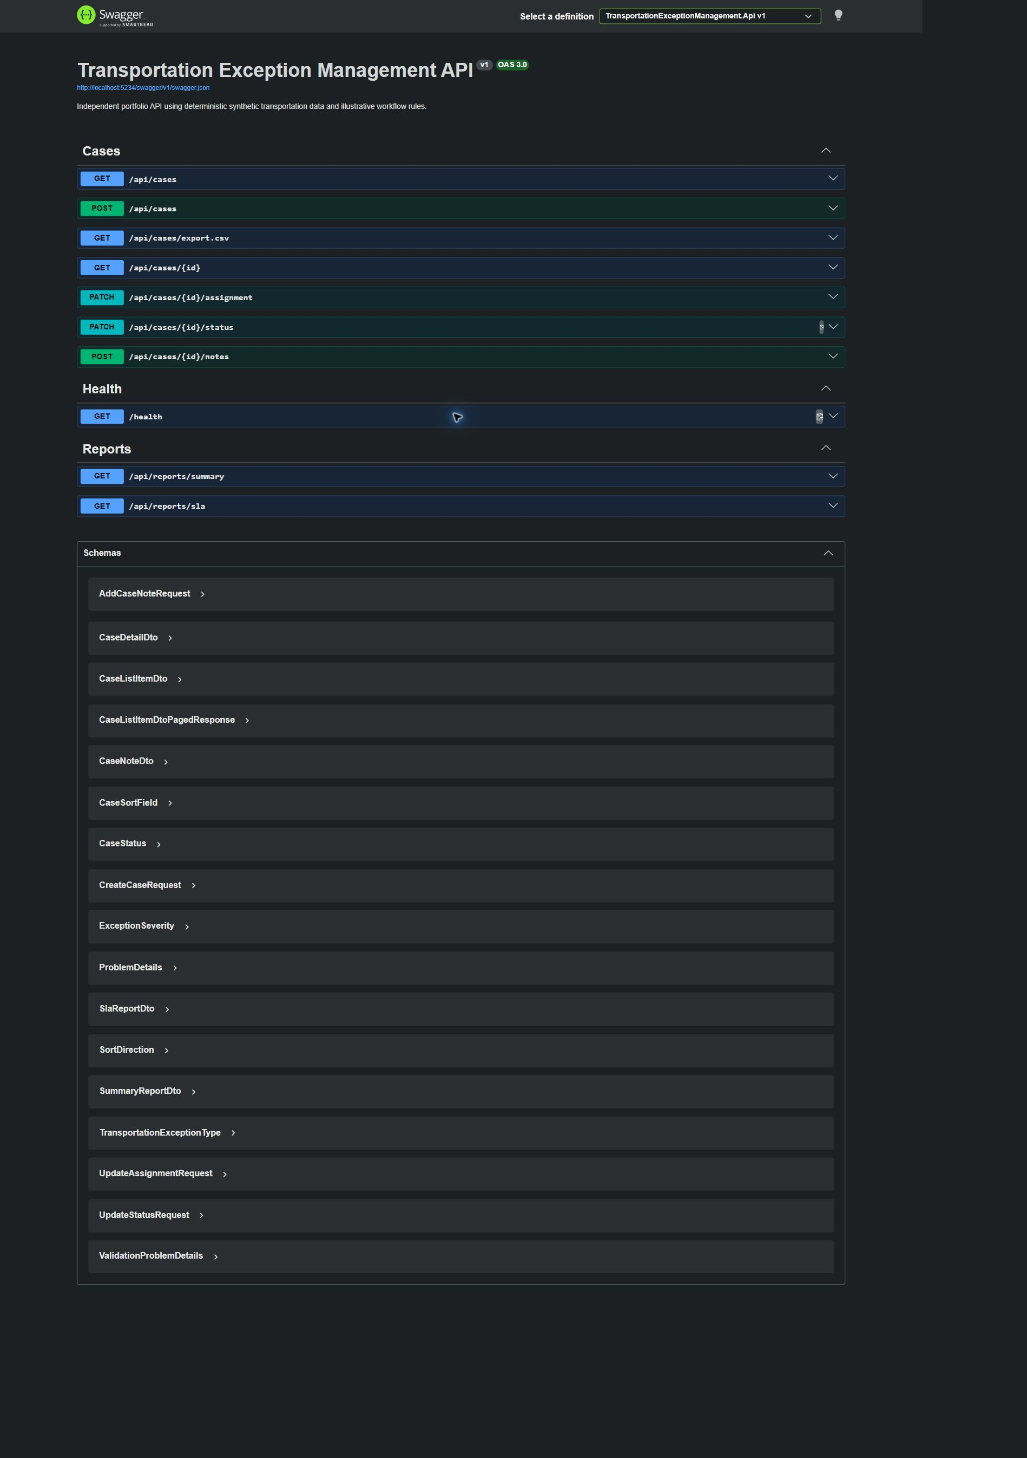
The live OpenAPI surface matched the controllers: ten operations across Cases, Health, and Reports.

Runtime Workflow - Case 37
CASE-VALIDATION-20260811-01 used fabricated values only.
Step | Request | Status | Evidence
1 | GET /health | 200 | Healthy
2 | GET /api/cases?pageSize=3 | 200 | 36 seeded cases before mutation
3 | POST /api/cases | 201 | ID 37, New, four-hour High due time
4 | PATCH status -> InProgress | 409 | assignee_required
5 | PATCH assignment | 200 | Analyst-Portfolio
6 | POST note | 201 | Note 13
7 | PATCH status -> InProgress | 200 | Valid edge
8 | GET /api/cases/37 | 200 | Assignee, status, and note persisted
9 | PATCH status -> Closed | 409 | invalid_transition; no mutation

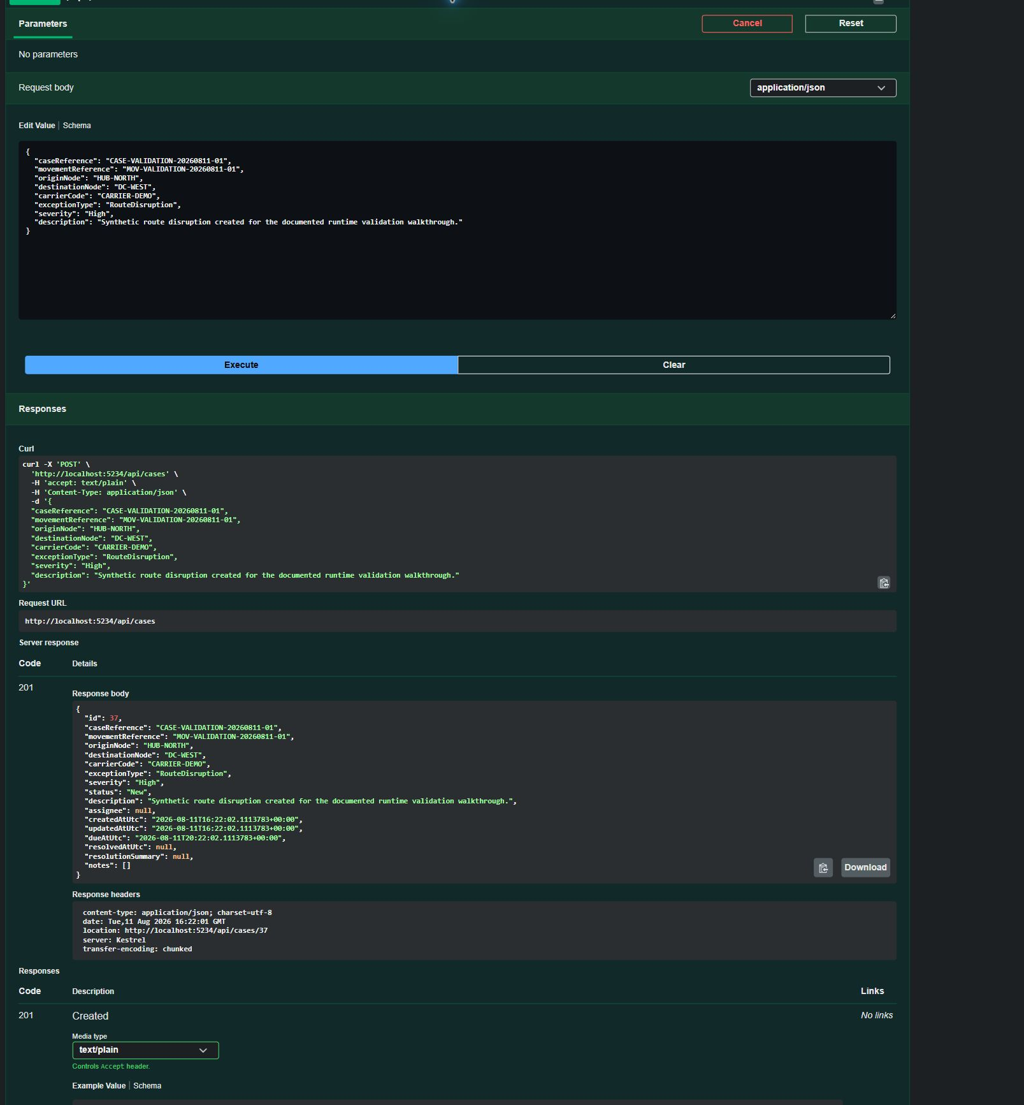
Swagger returned 201 Created, a detail Location header, New status, and the calculated due time.

Persistence and Workflow Evidence
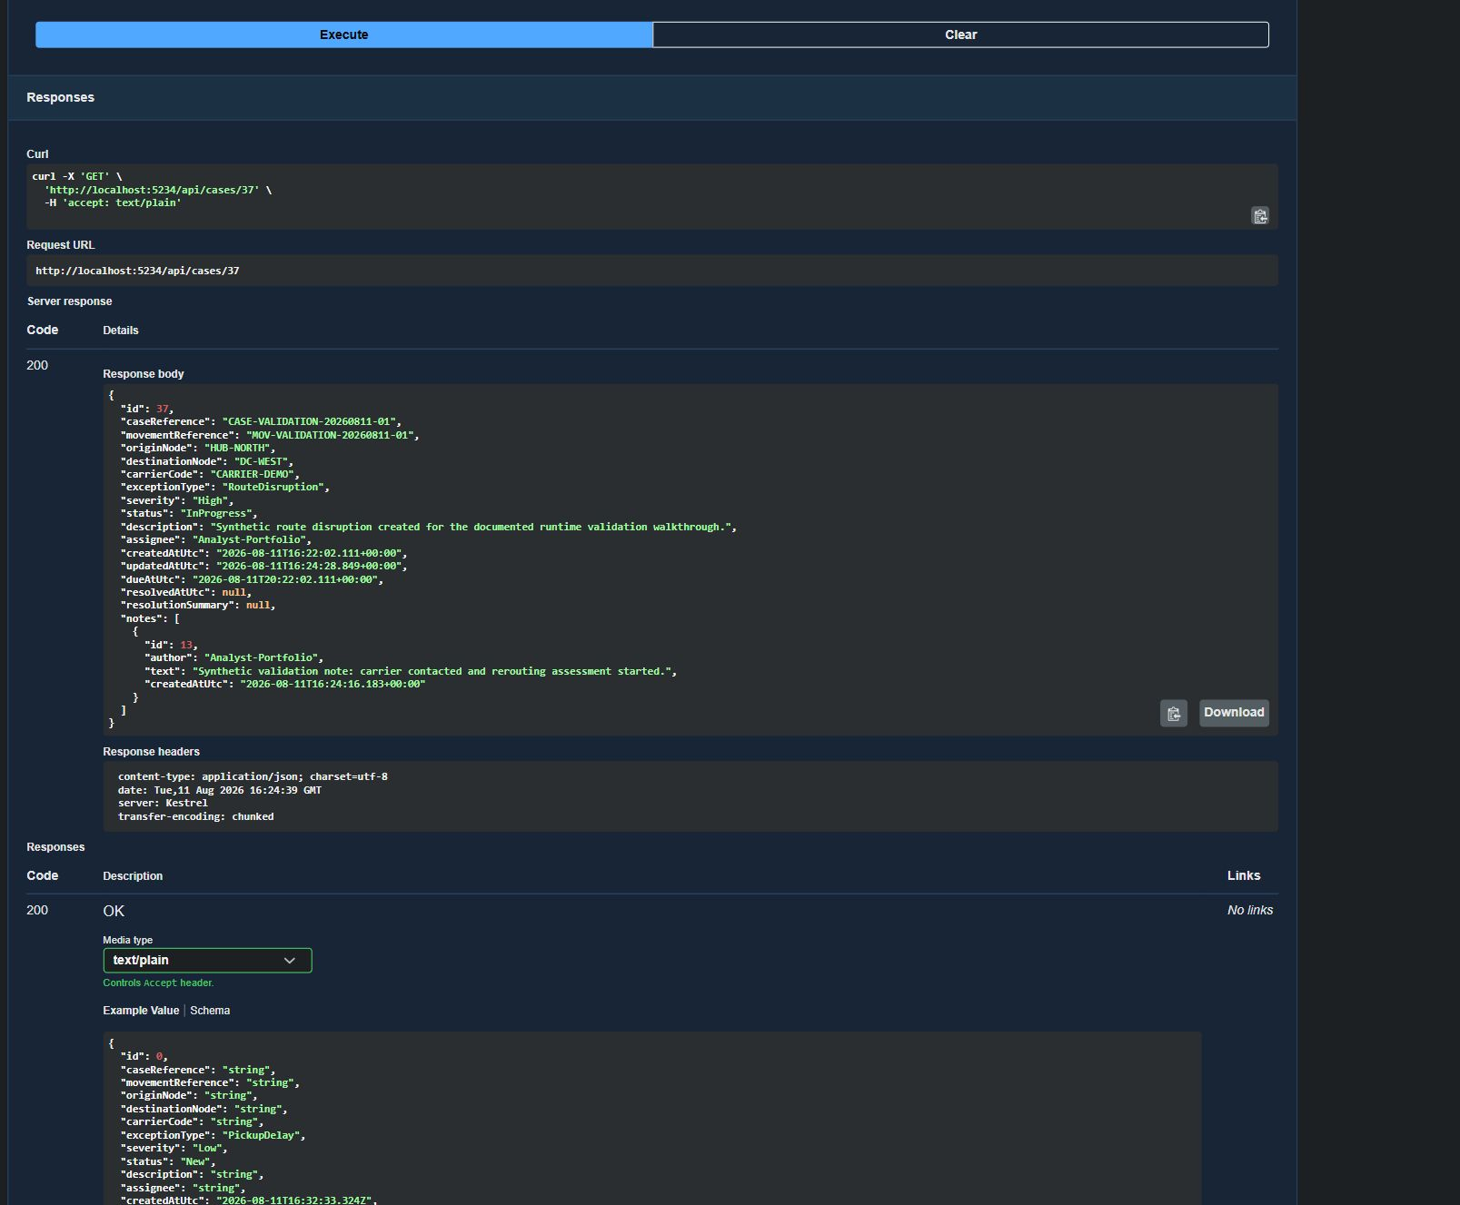
A later GET returned the persisted InProgress state, Analyst-Portfolio ownership, and note 13.
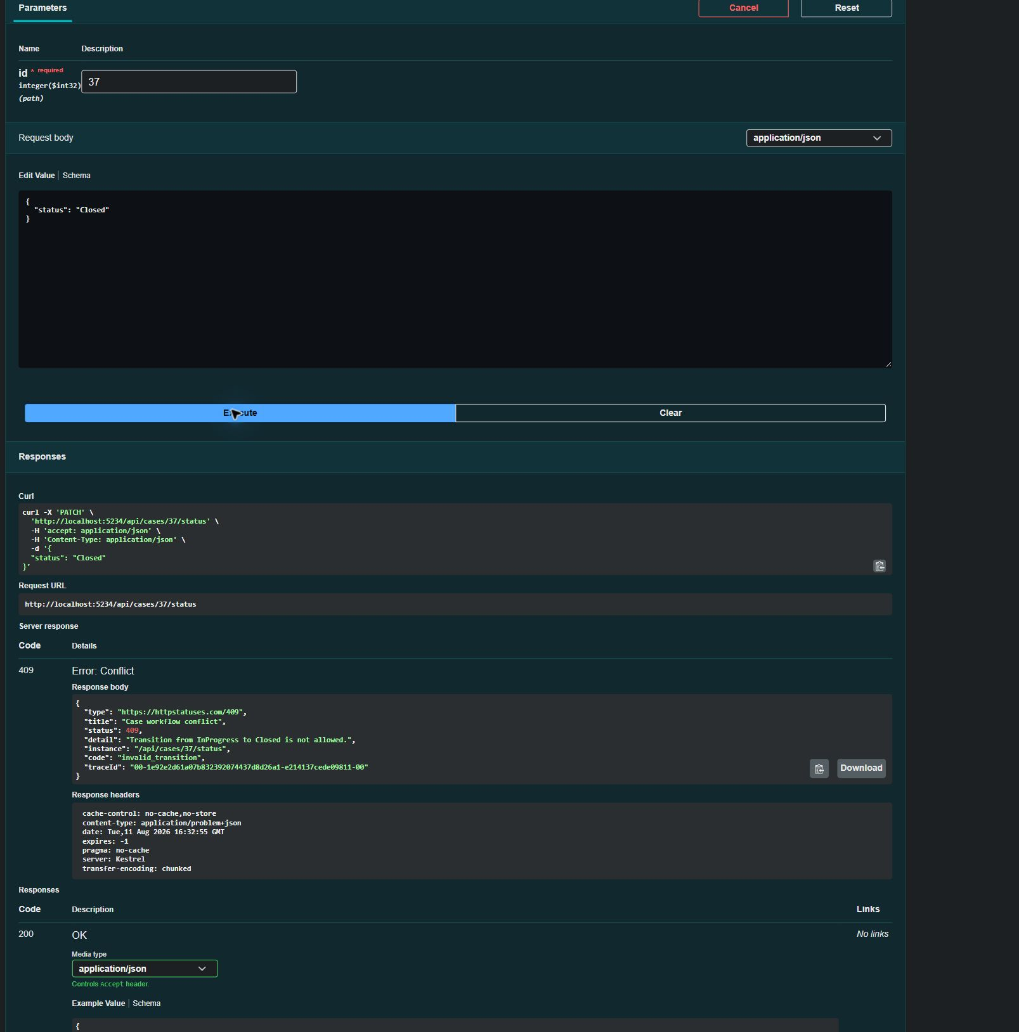
InProgress to Closed was rejected with invalid_transition; a later GET still showed InProgress.

Database and EF Core Validation
Evidence | Observed result
Database | SQLite file configured through DefaultConnection
Migration | 20260810125518_InitialCreate; EF product version 10.0.10
Tables | TransportationExceptionCases, CaseNotes, EF migration history
Relationship | CaseNotes -> cases; required FK; ON DELETE CASCADE
Indexes | Unique case reference plus status, severity, type, assignee, and timestamps
Post-walkthrough | 37 cases, 13 notes, case 37 and note 13 present

Startup sequence
- Create a scoped TransportationExceptionsDbContext.
- Apply pending migrations with Database.MigrateAsync.
- Run the deterministic seeder only after migration.
- Exit when any case exists; otherwise insert exactly 36 deterministic cases.
EF Core stores enums as readable strings and converts UTC DateTimeOffset values to Unix-millisecond integers for consistent SQLite comparison and sorting.
Post-walkthrough read-only inspection verified the migration, cascading foreign key, 37 cases, 13 notes, case 37, and note 13.

Reporting and Export
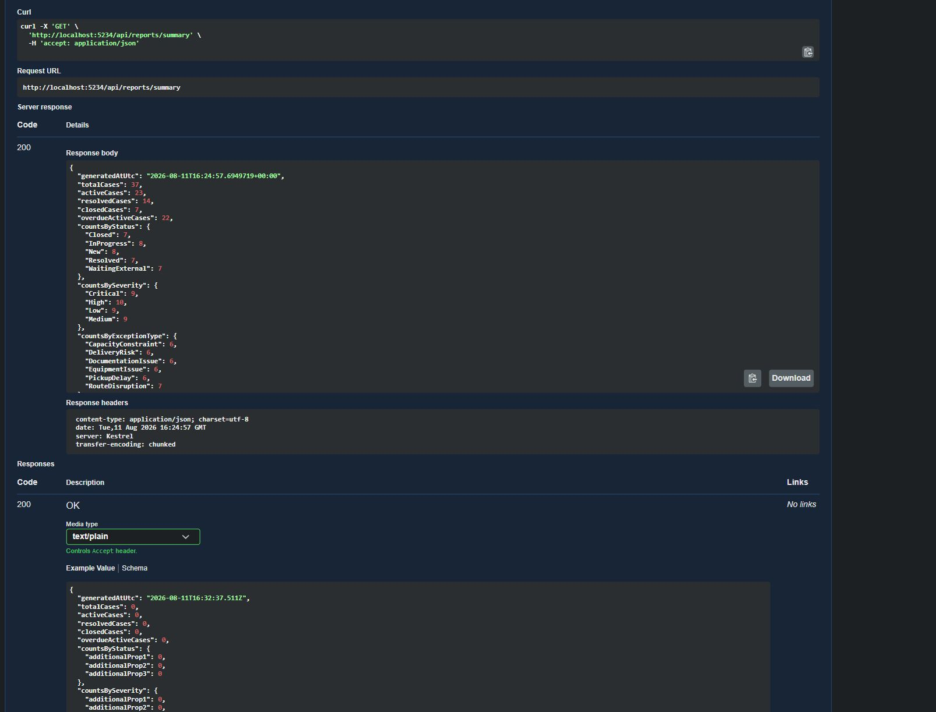
Summary after mutation: 37 total, 23 active, 14 resolved, 7 closed, 22 overdue active.
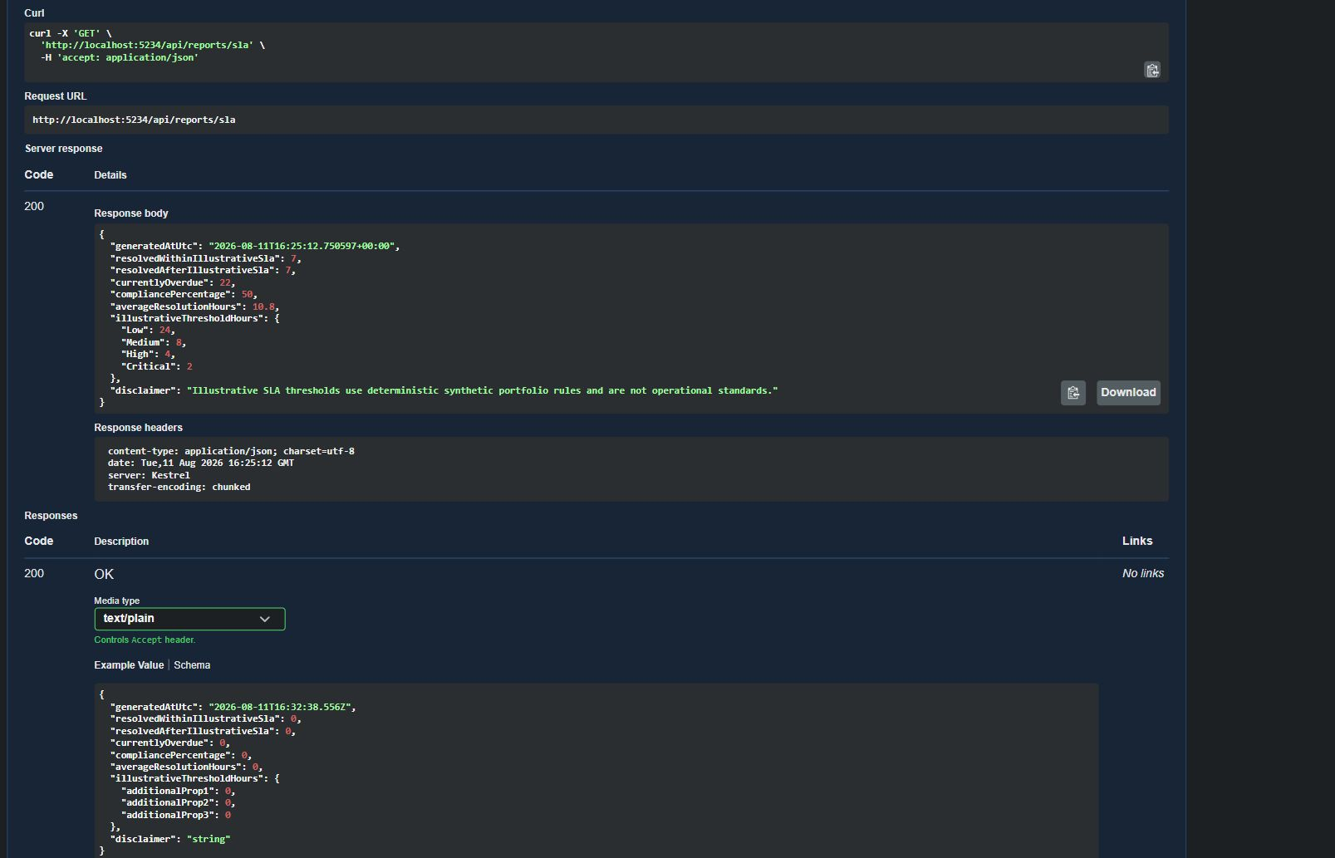
Illustrative SLA report: 7 within, 7 after, 50% compliance, 10.8 average resolution hours.
The filtered CSV response contained the 12-column header and one Analyst-Portfolio row. Export uses invariant timestamps, deterministic ordering, correct CSV quoting, and a prefix for formula-like values.

Testing Strategy
The 36-test xUnit suite uses WebApplicationFactory<Program> to exercise the real HTTP pipeline. It replaces file persistence with one open SQLite in-memory connection and replaces TimeProvider.System with a fixed clock. The test boundary includes request binding, controllers, services, domain rules, EF Core translation, migrations, and relational persistence.
Representative scenario | Behaviour protected
Creation and due time | 201 + Location + New + Critical two-hour due time
Assignment guard | Unassigned New cannot enter InProgress
Resolve / close / reopen | Summary required; resolution retained or cleared correctly
Notes | 201 note is returned by a later detail GET
Reports | Totals and grouped dimensions reconcile to 36
Migration startup | Initial migration applied; seed exactly 36; no duplicate seed

Automated result
Passed 36 | Failed 0 | Skipped 0 | Total 36

Representative ownership test
var response = await ChangeStatusAsync(created.Id, CaseStatus.InProgress);
Assert.Equal(HttpStatusCode.Conflict, response.StatusCode);
Assert.Equal("assignee_required", await response.ReadProblemCodeAsync());
This is observable HTTP behaviour: the stable conflict code is asserted through the hosted API, not by calling the entity directly.

Selected Implementation Highlights

Domain transition graph
private static bool IsTransitionAllowed(CaseStatus current, CaseStatus requested) =>
(current, requested) switch
{
(CaseStatus.New, CaseStatus.InProgress) => true,
(CaseStatus.InProgress, CaseStatus.WaitingExternal or CaseStatus.Resolved) => true,
(CaseStatus.WaitingExternal, CaseStatus.InProgress or CaseStatus.Resolved) => true,
(CaseStatus.Resolved, CaseStatus.Closed or CaseStatus.InProgress) => true,
(CaseStatus.Closed, CaseStatus.InProgress) => true,
_ => false,
};
The entity owns the lifecycle graph, keeping it independent of HTTP and EF Core.

SLA calculation
var resolved = cases.Where(item => item.ResolvedAtUtc.HasValue).ToArray();
var within = resolved.Count(item => item.ResolvedAtUtc <= item.DueAtUtc);
var after = resolved.Length - within;
decimal? compliance = resolved.Length == 0
? null
: Math.Round(within * 100m / resolved.Length, 2);
Empty datasets return null instead of a misleading zero percentage; active overdue work remains a separate measure.

CSV defensive escaping
if (value.Length > 0 && value[0] is '=' or '+' or '-' or '@')
value = $"'{value}";
if (value.Contains(',') || value.Contains('"') ||
value.Contains('\r') || value.Contains('\n'))
return $"\"{value.Replace("\"", "\"\"")}\"";

CI and Engineering Discipline
CI stage | Defined behaviour
Triggers | All pull requests and pushes to main
SDK | actions/setup-dotnet@v5 using global.json
Quality | Restore; dotnet format --verify-no-changes
Build / test | Release build and tests without duplicate work
Smoke | Temporary SQLite; bounded /health and OpenAPI checks; cleanup trap
Latest verified | Run #2 on commit 8710758 completed successfully

Engineering choices
- Layered but compact dependency direction without framework ceremony.
- SQLite relational realism without an external database server.
- DTO public contract so persistence entities do not leak into HTTP.
- String enums and ProblemDetails for readable Swagger and machine-readable errors.
- Fixed TimeProvider for predictable due-time and lifecycle tests.
- Warnings as errors and deterministic builds configured centrally.
Latest remotely checked run: CI #2 on commit 8710758 completed successfully on 10 August 2026.

Limitations and Issue Found
- No authentication, authorization, or authenticated audit identity.
- No optimistic concurrency for simultaneous editors.
- No carrier/customer integration, EDI, telematics, message broker, or event stream.
- No notifications, background workers, cloud deployment, or infrastructure as code.
- No production observability stack, high availability, or scale claim.
- No frontend beyond Swagger and no real-world SLA validation.

Runtime API-description issue
Observed | Swagger selects text/plain first for many JSON responses; exception detail can fall back to a generic body.
Expected path | Selecting application/json returns detail, instance, and stable workflow codes.
Action | Documented only; no application source code was modified.

The issue does not invalidate the workflow rule. The live JSON request returned 409 with the expected code, and the test suite asserts the same contract.

Run, Test, and Inspect

Run locally
git clone https://github.com/Rahulnanduri/transportation-exception-management-api.git
cd transportation-exception-management-api
dotnet tool restore
dotnet restore TransportationExceptionManagement.sln
dotnet run --project src/TransportationExceptionManagement.Api

Test locally
dotnet clean TransportationExceptionManagement.sln
dotnet build TransportationExceptionManagement.sln
dotnet test TransportationExceptionManagement.sln --no-build
Swagger: http://localhost:5234/swagger/index.html
OpenAPI: http://localhost:5234/swagger/v1/swagger.json

What this portfolio evidence communicates
Audience | Signal
Recruiter | A functioning independent project with clear stack, tests, and evidence.
Supply-chain hiring manager | Ownership, lifecycle, exception context, due-time reasoning, reports, and export.
Technical interviewer | Domain rules, project dependencies, EF migrations, relational tests, runtime errors, and honest limits.

SUPPLY CHAIN -> ANALYTICS -> AUTOMATION -> SYSTEMS
Independent engineering evidence. Deterministic synthetic data. Illustrative workflow rules.

