**Screenshot of the Face Detection In Image**

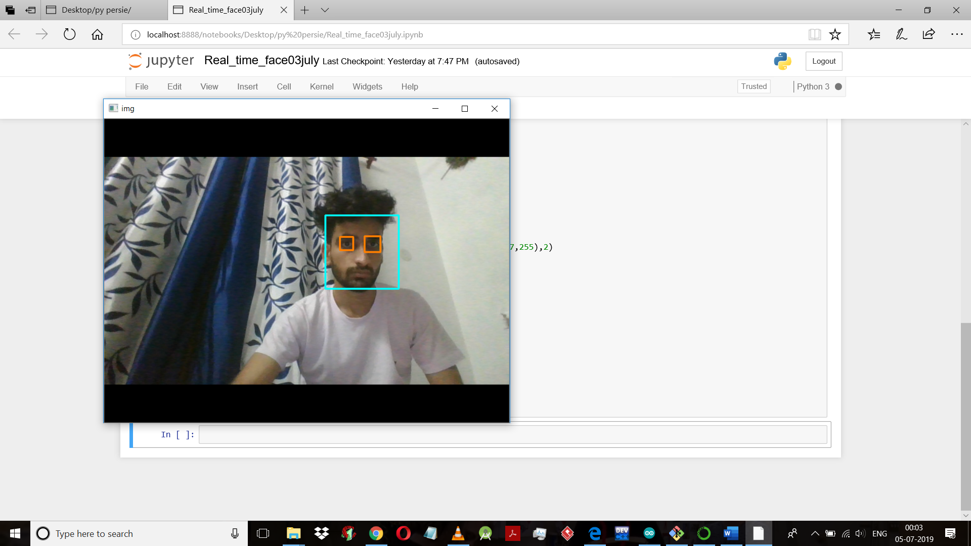

* This Image is real time click face and eye detection Proof.
* Programming done by Ananconda Using Jupyter notebook and Haarscade cLassifier.
* It work for clicked or downloaded photos also for detecting multiface in image.

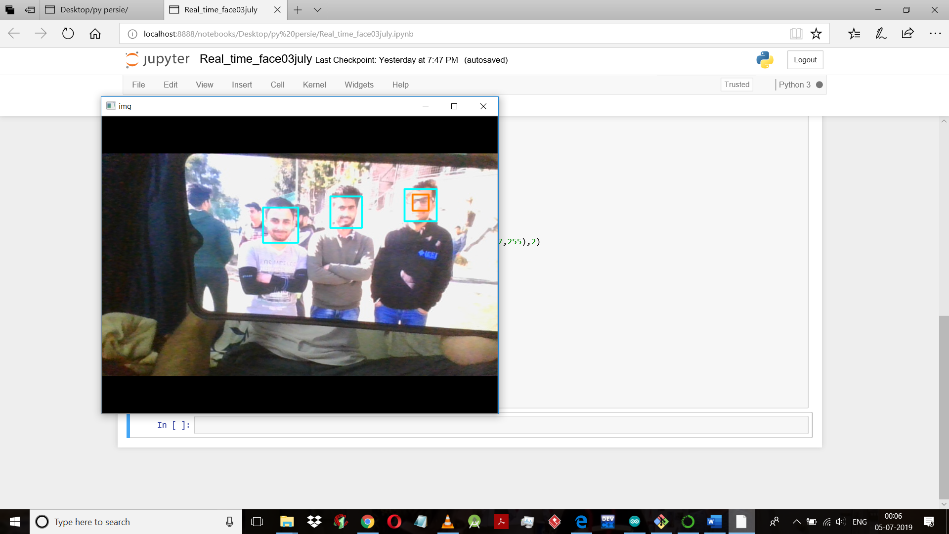

* Another screenshot bcs I look good in it.

