The Screenshot Of Jarvis working

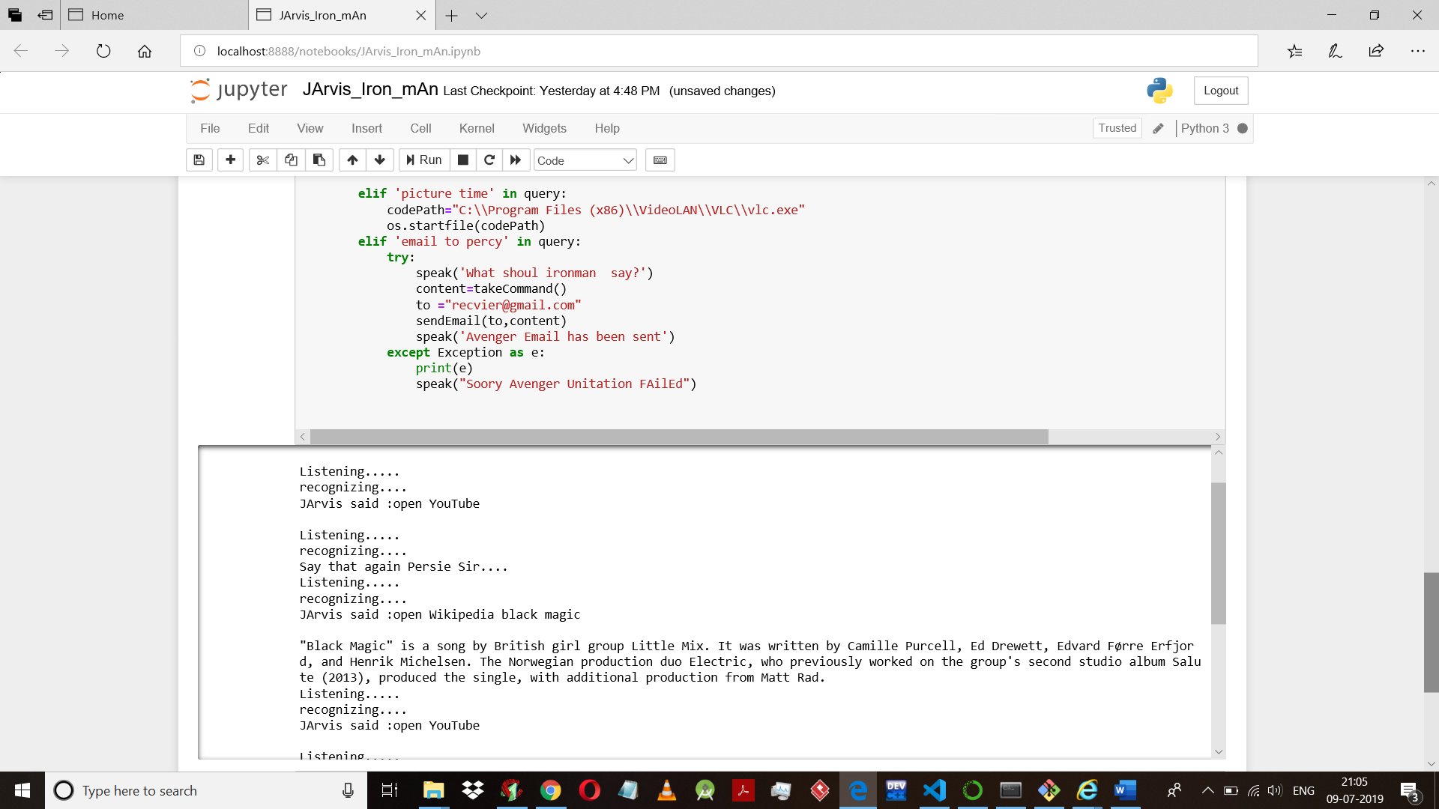

* It can do multiple work search wiki, open music,play video, open youtube,open google.
* It can also send email and tell the time.
* Totally a speech reco. program.
* When Jarvis open youtube

