**React.js**

**Introduction**

- React is a Javascript library for building User Interfaces(UI)

- UI refers to the screens , buttons , toggles , icons and other visual elements that you interact with when using a website , app , or other device

- React was designed by Jorden Walke , a software engineer at Facebook and it was first deployed for Facebook News Feed around 2011

- In 2013 React was open sourced at JS conference

**Advantages**

a . It Uses Component based approach

- A component is one of the core building blocks of a React app

- In React everything is a component or Components are independent and reusable bits of code

- These components split up the entire UI into small independent and reusable pieces

- Components make the task of building UIs much easier

- We can reuse the same component at multiple places and instead of updating every one we need to only update just one component

b . Uses declarative approach

- Declarative approach is mainly used by frameworks but react is the only library that uses it

- Declarative programming is a programming paradigm that expresses the logic of computation without describing its control flow

- In this approach you don’t have to take care of all the background process and algorithms done to achieve a task instead you just need to instruct the program that what you want and the task is done and taken care by the library or technology only , like in CSS and SQL we just write the codes and simple queries and our task is done

- In the same way , as React is declarative we don’t need to interact with DOM , the UI is updated when we change the state .

- Or , React is declarative because we write the code for the stuff that we want and React gets our desired result done by performing all the Javascript/DOM steps and processes.

c . DOM updates are handled gracefully

d . Reusable code (by components)

e . React is designed for speed of implementing the application , simplicity and scalability

**Why React**

- Created and maintained by Facebook which is a leading organisation

- Huge community on github

- Has Component based architecture

**Folder Structure**

**node_modules :** All the dependencies of React app are stored in it or it stores all the npm modules used in the react project

**package.json** : It holds the information regarding the react app or the meta-data of the app like , react version , used dependencies information and versions , name of the project etc.

**manifest.json** : it stores the info of project in json format

**<noscript >** : it defines an alternate content to be displayed to users screen that have disabled scripts in their browser or have a browser that doesn’t support script .

<noscript> YOU NEED TO ENABLE JAVASCRIPT TO SEE THIS APP</noscript>

**DOM(Document Object Model)**

- When a web-page is loaded the browser creates DOM of the page by which the programming languages like Javascript can access and change all the elements of an HTML doc .

- The HTML DOM model is constructed as a tree of Objects

**HTML DOM tree of Obects**

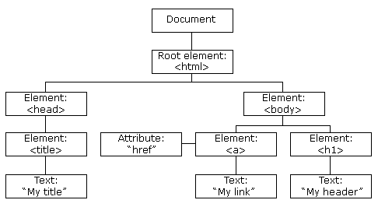

**Basic Hello World program**

*//var react = require('react'); //importing modules //old Javascript*

*//var ReactDOM = require('react-dom');*

*import React from 'react' // modern Javascript*

*import ReactDOM from 'react-dom'*

*ReactDOM.****render****(<h1>Hello World</h1>(****what to show****) , document.getElementByIde('root')(****where to show******), call back function****);*

- **react-dom** module is used to interact and manipulate with the **DOM**

- if we need to write a HTML like stuff in our project we need **react** module

- render means to display or to show

- The HTML that we have mentioned above in the code is actually **JSX**

**- JSX stands for Javascript XML and it is a syntax extension to Javascript**

**- JSX allows us to write HTML React**

**- Babel** is a Javascript compiler which compiles ECMASript or modern Javascript into browser understable Javascript

**- Webpack** is a module bundling tool built on top of Nodejs that lets you compile Javascript modules and it makes and keeps a bundle of files , folders and modules so that we don’t need wander here and there to find them and use them

- Babel and Webpack are auto-installed with React