**Algorithms**

**1 . Searching**

1. **Linear Search**

* It is also known as sequential search

Approach :-

* Start from the leftmost element of the array and one by one compare the key(to find) with each element of the array .
* If the key matches with any element return the index
* In any other case of not finding return -1

***Algorithm linearSearch(A , key , n)(iterative)***

*Input : A – the array with number of n elements*

*key – the element to search*

**Improve Linear Search Worst-Case Complexity**

1. if element Found at last  O(n) to O(1)
2. if element Not found O(n) to O(n/2)

**Head to GFG and for better Time-complexity explanation head to the class notes**

*1 . for i <- 0 to n do*

*2 . if A[i] = key then*

*3 . return i*

*4 . end if*

*5 . return -1*

***Time-comlexity = O(n) (Worst-case and Average Case)***

***Recursive approach***:-

- We will pass 4 arguments to the recursive function from the main , array , 1st index , last index and the key

- Compare x in 1st and the last element of the array and if found return the indices .

- Else call the recursive function by passing the decreamented last by 1 index and increamented first by 1 index .

- we will call the recursive function till r >= l , else will return -1 .

**int linearSearchRecursive(int * a , int l ,int r ,int x)**

{

if(r<l)

return -1 ;

if(a[l]==x)

return l ;

if(a[r]==x)

return r ;

return linearSearchRecursive(a , l+1 , r-1 , x) ;

}

1. **Binary Search**

Intro and Approach:-

- This algorithm search an item in a sorted array by repeatedly dividing the search interval in half .

- Begin with the interval covering the whole array , if the search key is less than the middle item of the interval , narrow the interval to the lower half else narrow it to the upper half .

- Repeatedly check until the value is found or the interval is empty .

Procedure :-

- get the middle index(mid) of the whole array first

- Compare item with the middle element , if it matches return the middle index

- else if item is greater than middle element , it means item lies on the right half subarray , so

we reset lower-bound(l) to mid + 1 and begin the search again

- else if , item < mid element , it must be at left half sub-array , and we will reset upper-bound(r)

to mid-1.

- If element is not found return -1 .

**int binarySearch(int *a , int l , int r ,int item)**

{

int mid ;

while(l<=r)

{

mid = (l+r)/2 ;

if(item == a[mid])

return mid ;

if(item < a[mid])

r = mid-1 ;

else

l = mid+1 ;

}

return -1 ;

}

***Average Time-complexity : O(log2n)***

**int binarySearchRecursive(int *a , int l , int r ,int item)**

{

int mid ;

if(l<=r)

{

mid = (l+r)/2 ;

if(a[mid] == item)

return mid ;

if(a[mid] < item)

return binarySearchRecursive(a , mid+1 , r , item);

return binarySearchRecursive(a , l , mid-1 , item);

}

return -1 ;

}

**2 . Sorting**

1. **. Selection Sort**

Intro and Approach :-

- This algorithm sorts an array , by repeatedly finding the minimum element from unsorted part an putting it at the beginning

- The algorithm maintains two subarrays in a given array

1 . The array which is already sorted

2 . Remaining array which is unsorted

- Find the minimum element in the unsorted array and swap it with element at beginning of that unsorted array OR

- In every iteration of selection sort , the minimum element from the unsorted subarray is picked and moved to the sorted subarray

**void selectionSort(int * array , int n)** // n is the length of the array

{

int i , j , temp ;

for(i=0 ; i<n-1 ; i++)

{

for(j= i + 1 ; j < n ; j++)

{

if(a[j]<a[i])

{

temp = array[i] ;

array[i] = array[j] ;

array[j] = temp ;

}

}

}

print(array)

}

**Time-complexity = O(n2)**

**2) . Bubble Sort**

- Repeatedly swap two adjacent elements if they are in wrong order(left elements > right element)

- We get the sorted array after n - 1 iterations , if not optimized

**void bubbleSort(int *a , int n)**

{

int count = 1 , i ,temp;

while(count < n)

{

for(i = 0 ; i < n-1 ; i++)

{

if(a[i] > a[i+1])

{

temp = a[i] ;

a[i] = a[i+1];

a[i+1] = temp ;

}

}

count++;

}

return;

}

- The above function always runs O(n2) times , even if the array is sorted

- It can be optimized by stopping the algorithm if the inner loop didn’t cause any swap on the first go

**void bubbleOpt(int *a , int n)** **// Optimized technique , as if the array would be already sorted then it won't make further outer iteration after first one**

{

int count = 1 , i ,temp , **swapped;**

while(count < n)

{

**swapped = 0 ;**

for(i = 0 ; i < n-1 ; i++)

{

if(a[i] > a[i+1])

{

temp = a[i] ;

a[i] = a[i+1];

a[i+1] = temp ;

**swapped = 1 ;**

}

}

**if(swapped == 0)**

{

cout << "Already Sorted" <<endl;

break ;

}

count++;

}

return;

}

**Worst Case : O(n2) , when array is reverse sorted**

**Best Case : O(n) , when array is already sorted**

**3) . Insertion Sort**

- Compare the current element to its predecessors until smaller element than the current element is found while moving the greater elements one position up and finally swapping the key before all its greater elements .

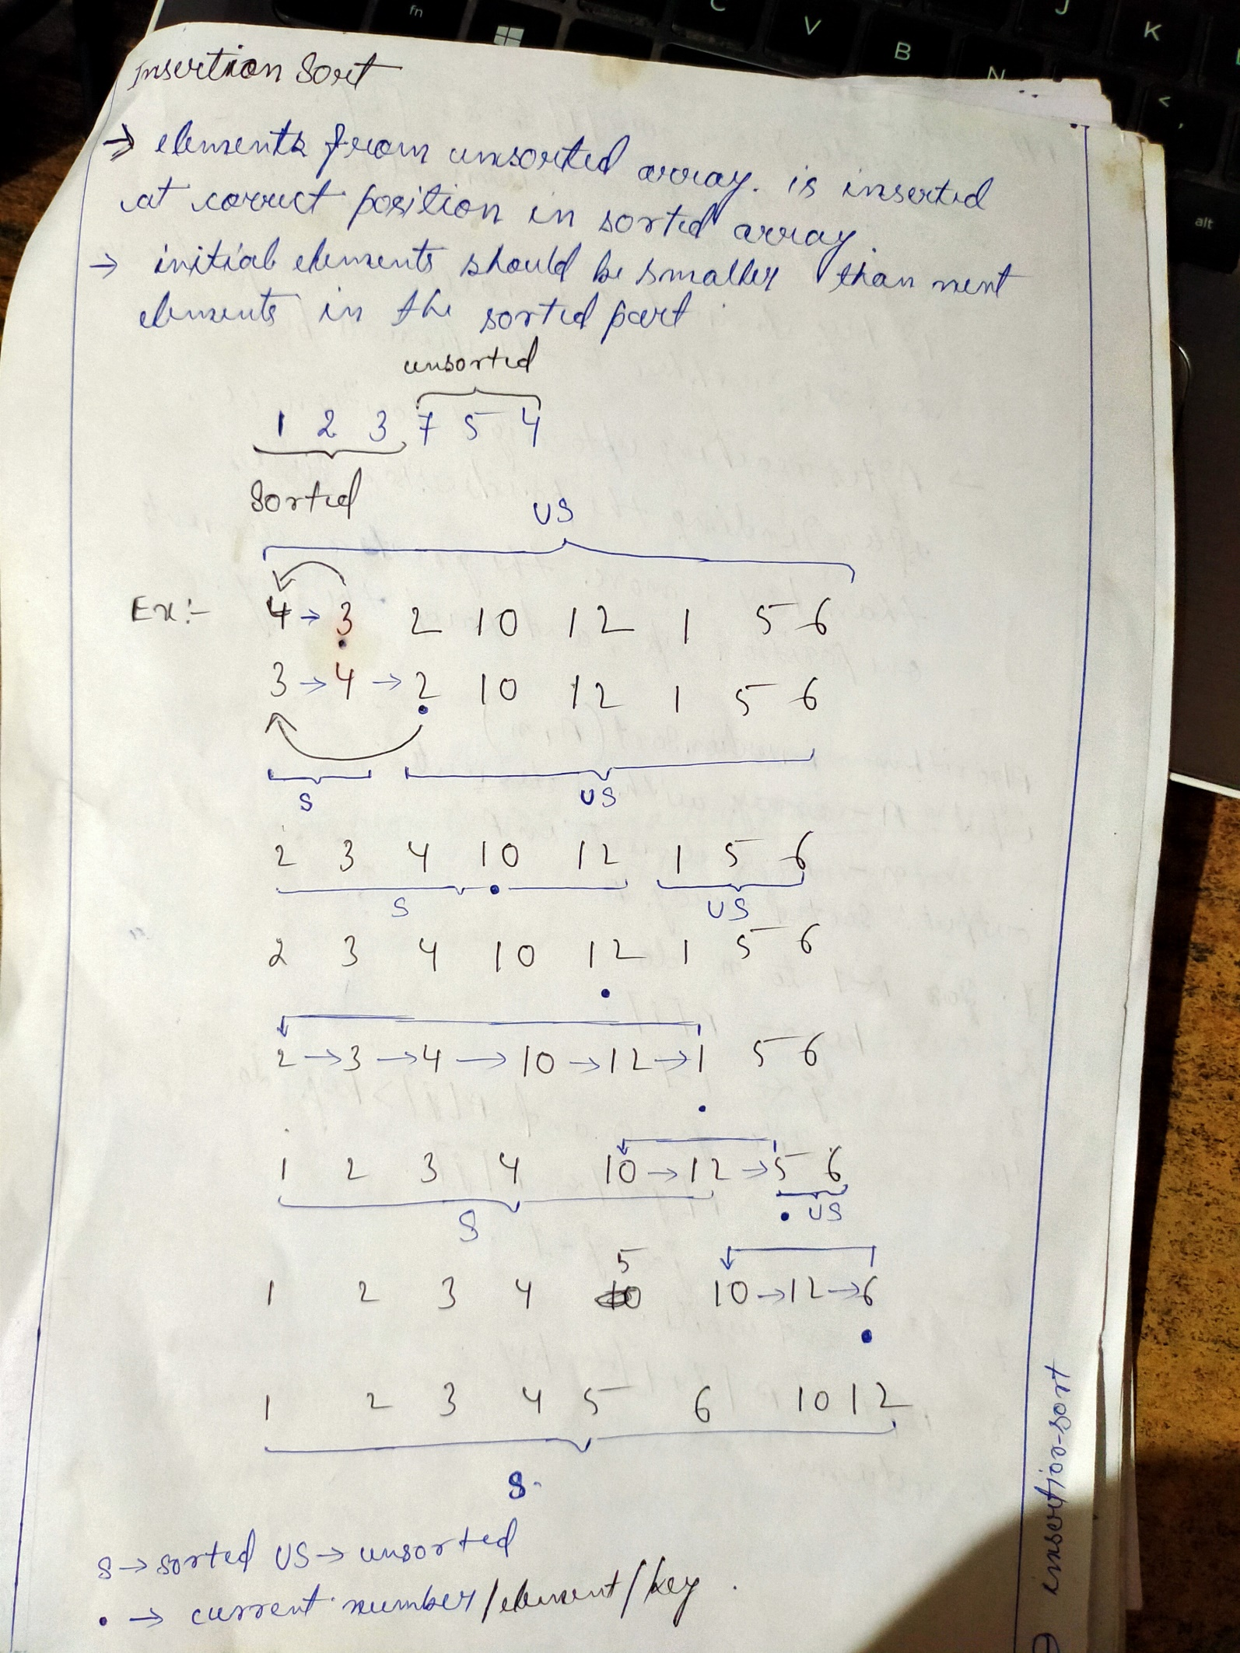

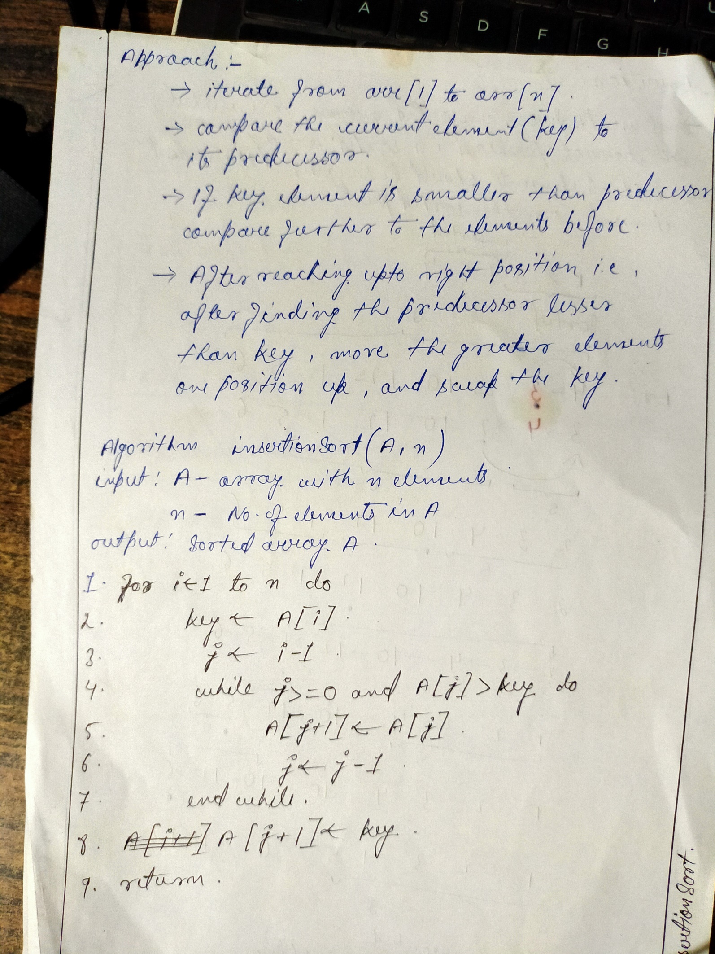

**Time-complexity : O(n2)**

**4) . Merge Sort**

Intro and Approach :-

**-** It uses Divide and Conquer technique

- array will be recursively divide into two halves till the size becomes 1

- then , the merge action takes place and start merging arrays back , till the complete array is merged

Procedure:-

- get the middle point index (m) to divide the array into two subarrays

- call mergeSort() for the first half (from l to m)

- call mergeSort() for the second half(from m+1 to r)

- merge the two halves in sorted manner by calling merge()

**void mergeSort(int *a , int l , int r)**

{

int m ;

if(l<r)

{

m = (l+r)/2 ;

mergeSort(a , l , m);

**Divide and Conquer Paradigm**

Steps involved to solve a particular

1 . Divide : Break the given problem into subproblems of same type

2 . Conquer : Recursively solve these subproblems

3 . Combine : Appropriately combine the answers

mergeSort(a , m+1 , r);

merge(a , l , m , r) ;

}

return ;

}

**void merge(int *a , int l , int m , int r)**

{

int n1 , n2 , i , j , k ;

n1 = m – l + 1 ;

n2 = r – m ;

int left[n1] ;

int right[n2] ;

for(i=0 ; i<n1 ; i++)

{

left[i] = a[l+i];

}

for(i=0 ; i<n2 ; i++)

{

right[i] = a[m+1+i] ;

}

i = 0 ; j = 0 ; k = l ;

while(i<n1 && j<n2)

{

if(left[i]<right[j])

{

a[k] = left[i] ;

k++ ; i++ ;

}

else

{

a[k] = right[j] ;

k++ ; j++ ;

}

}

while(i<n1)

{

a[k] = left[i] ;

k++ ; i++ ;

}

while(j<n2)

{

a[k] = right[j];

k++ ; j++ ;

Head to GFG for more description regarding applications , drawbacks , DAA rest infos .

}

return ;

}

***Time-complexity mergeSort() : O(nlog2n) [worst , best and average]***

**5) . Quick Sort**

Intro and Approach :-

- Uses Divide and Conquer technique

- This algorithm picks an element as pivot(middle) and puts it at the right positon in the sorted array by putting all smaller elements than pivot before it and all the greater elements after it .

- quicksort() and partition() are the two main functions

- partition() function takes last element as pivot and places it at the right position and places all the smaller at left and the greater element at right of pivot

**void swap(int*a , int i , int j)**

{

int temp;

Head to GFG for more information and algo-analysis

temp = a[i] ;

a[i] = a[j];

a[j] = temp ;

return ;

}

**void partition(int *a , int l , int r)**

{

int pivot = a[r] ;

int i , j ;

i = l – 1 ; // i stores index of the current last smaller element than the pivot , after which pivot will be placed

for(j=l ; j<r;j++)

{

if(a[j] < pivot)

{

i++ ;

swap(a , i , j);

}

}

swap(a , i+1 , r) ;

return(i+1) ;

}

**void quickSort(int *a , int l , int r)**

{

int pi ;

if(l<r)

{

pi = partition(a , l , r) ;

quickSort(a , l , pi-1);

quickSort(a , pi+1 , r);

}

return ;

}

***Time-complexities :-***

***Best Case : O(nlog2n)*** , when middle element element as pivot

***Average Case : O(nlog2n)***

***Worst Case : O(n2)*** , when last element is picked as pivot