**20BCE1001**

**Rahul Sandireddy**

**Capstone Project**

**Agri-Bot model preparation methodology (outline)**

* The proposed system answers queries related to weather, plant protection, animal husbandry, market price, fertilizers uses, government schemes etc.
* Using **Llama-2-7b-chat** for the chat bot model

**Llama-2-70b-chat**

**Got the Llama 2 commercial license (2023 model)**

**Model weights available:**

* Llama-2-7b
* Llama-2-7b-chat
* Llama-2-13b
* Llama-2-13b-chat
* Llama-2-70b

**About Llama-2:**

* **Llama-2-7b** is a base model meant for next token generation, such as sentence completion.
* **Llama-2-7b-chat** is a fine-tuned model meant for back-and-forth dialogue, such as chat applications.
* Training Data: Llama-2-7b is trained on a new mix of publicly available online data, totalling 2 trillion tokens.
* Llama-2-7b-chat is fine-tuned on publicly available instruction datasets and over 1 million human annotations.
* Performance: Llama-2-7b-chat outperforms Llama-2-7b on dialogue benchmarks and human evaluations for helpfulness and safety. Llama-2-7b-chat also outperforms other open-source chat models, such as ChatGPT and PaLM, on most metrics.
* Llama-2-7b-chat can be used for **building chatbots** that can handle diverse and engaging conversations with users

**Architecture of the Application:**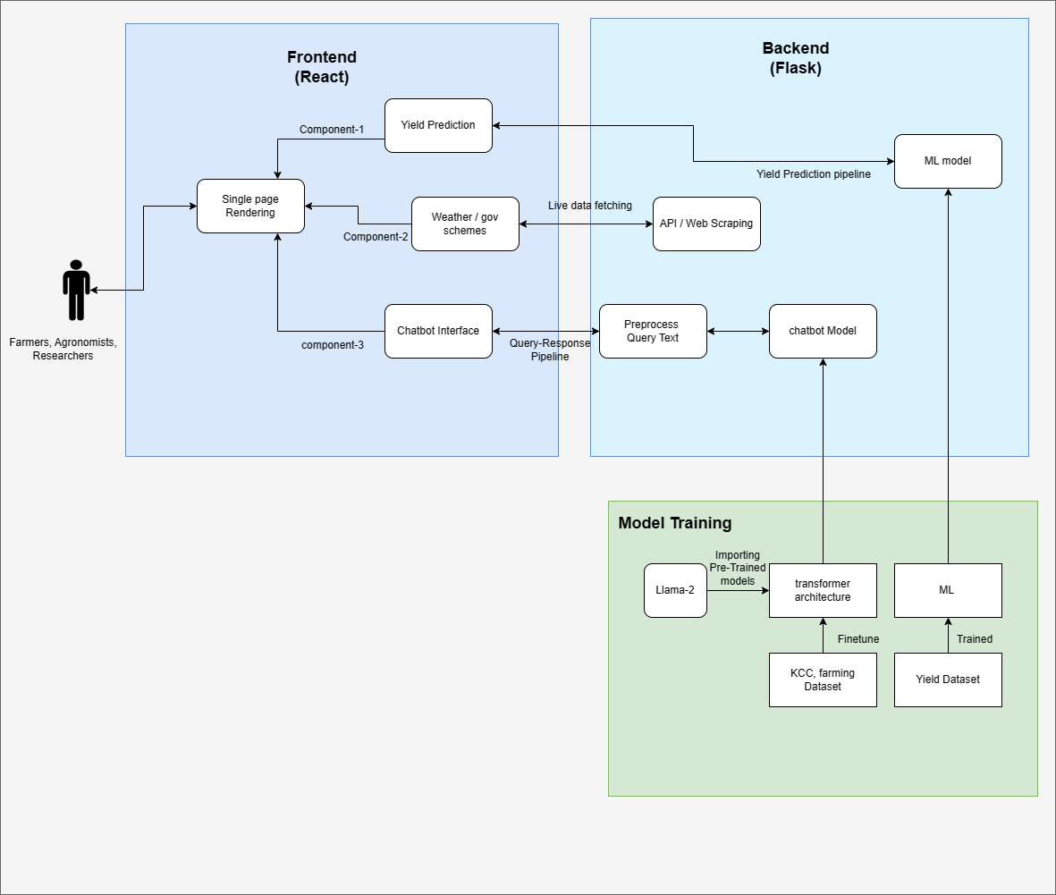

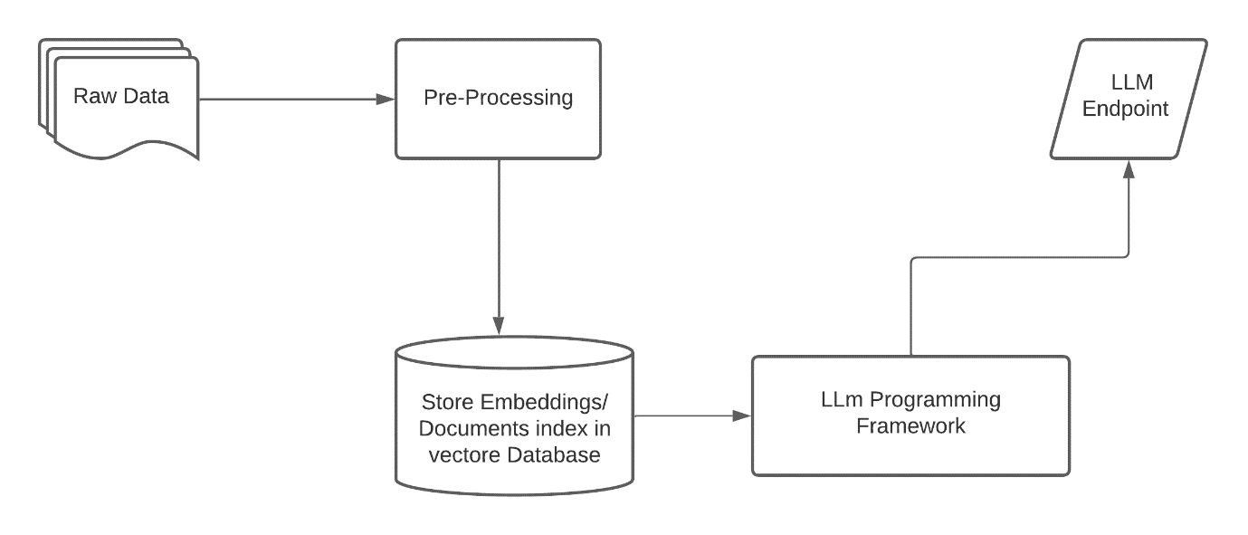

**References:**

1. Touvron, H., Martin, L., Stone, K., Albert, P., Almahairi, A., Babaei, Y., ... & Scialom, T. (2023). Llama 2: Open foundation and fine-tuned chat models. *arXiv preprint arXiv:2307.09288*.
2. Balachandran, A. (2023). Tamil-Llama: A New Tamil Language Model Based on Llama 2. *arXiv preprint arXiv:2311.05845*.
3. Montagna, S., Ferretti, S., Klopfenstein, L. C., Florio, A., & Pengo, M. F. (2023, September). Data decentralisation of llm-based chatbot systems in chronic disease self-management. In *Proceedings of the 2023 ACM Conference on Information Technology for Social Good* (pp. 205-212).
4. Godara, S., Toshniwal, D., Parsad, R., Bana, R. S., Singh, D., Bedi, J., ... & Marwaha, S. (2022). AgriMine: A Deep Learning integrated Spatio-temporal analytics framework for diagnosing nationwide agricultural issues using farmers’ helpline data. *Computers and Electronics in Agriculture*, *201*, 107308.
5. Yager, K. G. (2023). Domain-specific chatbots for science using embeddings. *Digital Discovery*, *2*(6), 1850-1861.
6. Bill, D., & Eriksson, T. (2023). Fine-tuning a LLM using Reinforcement Learning from Human Feedback for a Therapy Chatbot Application.
7. Koopman, B., Zuccon, G., Chapman, S., Dang, Y., & Lawrence, D. (2020). How a Conversational Agent Might Help Farmers in the Field. In *SIGIR 3th International Workshop on Conversational Approaches to Information Retrieval (CAIR’20)*.
8. Nayak, V., & Sowmya, N. H. (2021). Agroxpert-Farmer assistant. *Global Transitions Proceedings*, *2*(2), 506-512.
9. Bhattacharyay, D., Maitra, S., Pine, S., Shankar, T., & Pedda Ghouse Peera, S. K. (2020). Future of precision agriculture in India. *Protected Cultivation and Smart Agriculture*, *1*, 289-299.
10. Paudel, D., Boogaard, H., de Wit, A., Janssen, S., Osinga, S., Pylianidis, C., & Athanasiadis, I. N. (2021). Machine learning for large-scale crop yield forecasting. *Agricultural Systems*, *187*, 103016.
11. Elavarasan, D., & Vincent, P. D. (2020). Crop yield prediction using deep reinforcement learning model for sustainable agrarian applications. *IEEE access*, *8*, 86886-86901.
12. Abbas, F., Afzaal, H., Farooque, A. A., & Tang, S. (2020). Crop yield prediction through proximal sensing and machine learning algorithms. *Agronomy*, *10*(7), 1046.
13. Sharifi, A. (2021). Yield prediction with machine learning algorithms and satellite images. *Journal of the Science of Food and Agriculture*, *101*(3), 891-896.
14. Hoffmann, J., Borgeaud, S., Mensch, A., Buchatskaya, E., Cai, T., Rutherford, E., ... & Sifre, L. (2022). Training compute-optimal large language models. *arXiv preprint arXiv:2203.15556*.
15. Chuang, J. H., Wang, J. H., & Liou, Y. C. (2020). Farmers’ knowledge, attitude, and adoption of smart agriculture technology in Taiwan. *International Journal of Environmental Research and Public Health*, *17*(19), 7236.