1. In the below elements which of them are values or an expression? eg:- values can be integer or string and expressions will be mathematical operators.

*

'hello'

-87.8

-

/

6

**Ans:-** Values = -87.8, 6, 'hello'

Expression = (*), ( - ), ( / ), ( + )

2. What is the difference between string and variable?

**Ans:-** A Variable is a store of information, and a String is a type of information you would store in a Variable

3. Describe three different data types.

**Ans:-**

* In Text Data type we have **“string”**
* In Numeric data type we have 1) Integer’s 2) Float & 3) Complex Numbers
* In Sequence data type we have 1) List 2) Range & 3) Tuple

4. What is an expression made up of? What do all expressions do?

**Ans:-**

An expression is a combination of **operators, constants and variables**. An expression may consist of one or more operands, and zero or more operators to produce a value .

An expression interpreted to **produce some other value.**

5. This assignment statements, like spam = 10. What is the difference between an expression and a statement?

**Ans:-**

In this assignment The Expression (=) is evaluating a value 10 whereas spam is a statement or a variable which is Displaying a value

Main difference between Expression & statement is, Expression is a combination of operators and operands that is interpreted to produce some other value.

And Statement so, in simple words, we can say **anything written in Python** is a statement or a statement is a programming instruction.

6. After running the following code, what does the variable bacon contain?

bacon = 22

bacon + 1

**Ans:-**

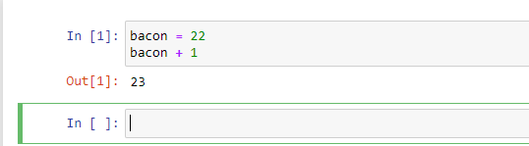

7. What should the values of the following two terms be?

'spam' + 'spamspam'

'spam' * 3

**Ans:-**

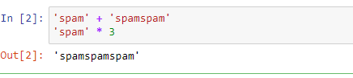

8. Why is eggs a valid variable name while 100 is invalid?

**Ans:-**

Because variable names cannot begin with a number hence eggs is a valid variable name instead of 100.

9. What three functions can be used to get the integer, floating-point number, or string version of a value?

**Ans:-** Int(), float(), str()

10. Why does this expression cause an error? How can you fix it?

'I have eaten ' + 99 + ' burritos.'

**Ans:-** we can concatenate only string values Not Integers Hence expression mentioned above is invalid

We can Fix it as below

