1.What are the two values of the Boolean data type? How do you write them?

**ANS:- There Are Two Boolean Data Types They are “True” & “False”.**

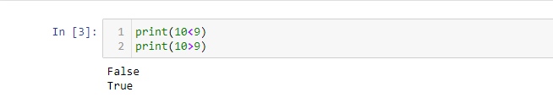

2. What are the three different types of Boolean operators?

**ANS:-** Three different types of Boolean operators are, **Lesser Than(<),Greater Than(>), & Equals To (==).**

3. Make a list of each Boolean operator's truth tables (i.e. every possible combination of Boolean values for the operator and what it evaluate ).

**ANS:-** 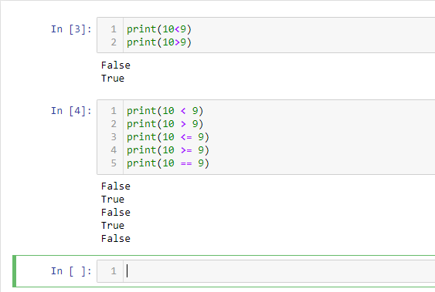

4. What are the values of the following expressions?

(5 > 4) and (3 == 5)

not (5 > 4)

(5 > 4) or (3 == 5)

not ((5 > 4) or (3 == 5))

(True and True) and (True == False)

(not False) or (not True).

**ANS:-**

**1)** (5 > 4) and (3 == 5) :- False

2) not (5 > 4) :- False

3) (5 > 4) or (3 == 5) :- True

4) not ((5 > 4) or (3 == 5)):- False

5)(True and True) and (True == False):- False

6) (not False) or (not True):- True

5. What are the six comparison operators?

**ANS:-**

1. Less Then ()
2. Less Then or equals to (<=)
3. Greater Then ( > )
4. Greater Than or equals to ( >= )
5. Equals to ( == )
6. Not Equals to ( != )

6. How do you tell the difference between the equal to and assignment operators?Describe a condition and when you would use one.

**ANS:-**

Main Difference between equals to assignment operator is both have different application in python.

1. Equals to is a comparison function in which we will be comparing a variable or value .

EX:- (**a == 24)**

1. Where as in assignment operator we can assign value to variable .
2. EX:- (a = 24)

7. Identify the three blocks in this code:

spam = 0

if spam == 10:

print('eggs')

if spam > 5:

print('bacon')

else:

print('ham')

print('spam')

print('spam')

**ANS:-**

**In this code 1)First block is in line number 3 there were no** indented available

2)Second block in 5 as above reason

3)Third block is in line 7

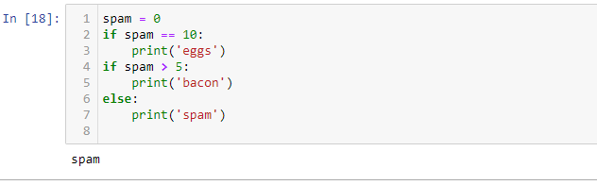

8. Write code that prints Hello if 1 is stored in spam, prints Howdy if 2 is stored in spam, and prints Greetings! if anything else is stored in spam.

**ANS:-**

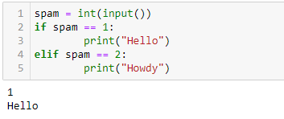

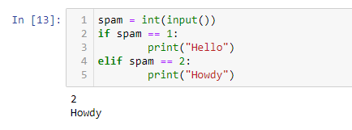x

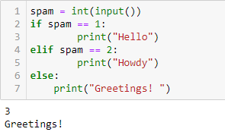

9.If your programme is stuck in an endless loop, what keys you’ll press?

**ANS:-**

**If programme got in endless loops, I will have to restart my kernel in jupyter book**

10. How can you tell the difference between break and continue?

**ANS:-**

**Basically we use “brake” to discontinue the Loop & “continue” to rerun the loop or return command to “for” or “While” Loop.**

11. In a for loop, what is the difference between range(10), range(0, 10), and range(0, 10, 1)?

ANS:-

Range (10):- When we call range (10) it means it will print the values starting from 0 to 10.

Range (0, 10):- When we call range (10) it means it will print the values starting from 0 to 10.

Range (0,10,1):- When We call range this way it simply means value fro 0 to 10 will be called with difference of 1.

12. Write a short program that prints the numbers 1 to 10 using a for loop. Then write an equivalent program that prints the numbers 1 to 10 using a while loop.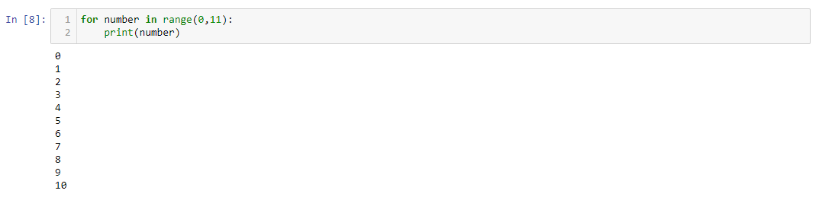

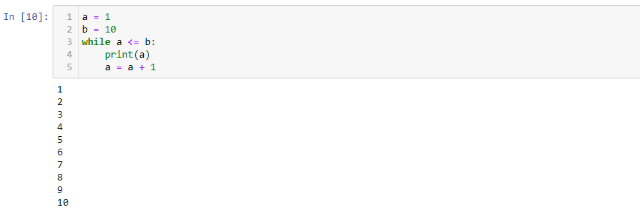

13. If you had a function named bacon() inside a module named spam, how would you call it after importing spam?

