

**Vital Monitoring Patch**

*A Patent Filing Document*

**Inventors:**

Manitha Rahul Sree

Jatin Prasad

Aman Sikarwar

Abhijeet Kumar

Vishnu

Sia Mittal

**Under the Guidance of:**

Dr. Gajendra Singh IIT MANDI

Date: July 8, 2024

# Vital Monitoring Patch

**Rahul, Sia, Jatin, Vishnu, Abhijeet, Aman**

Under the guidance of Dr. Gajendra Singh

April 2024

## 1 Problem

In incubators, it is essential to keep track of the vital signs of neonate patients, especially in cases of severe premature birth. To observe newborns’ growth and their body condition, various vital signs such as **heart rate**, **body temperature**, and **SpO2** are monitored in neonatal rooms of hospitals. At present, these vital signs require to be measured by sensors with cables from large or handheld devices. As a result, the measurement puts a burden on newborns and medical staff. In particular, it is difficult for most newborns to maintain homeostasis of their body including the heart, lung, and liver. Their acute deteriorations in body functionalities lead to serious sequelae such as brain dysfunctions. In the vital signs of the newborns, heart rate, and SpO2 are crucial for monitoring body condition.

For some parents it gets very overwhelming to see their baby in NICU with all the different wired sensors on them and not being able to be with their baby, this poses a perceived barrier of physical contact with the child. Due to the wires attached to the babies, the skin to skin contact with their parents which is the most critical in positively encouraging their physiological and psychological development is not possible.

Thus, the concept of making the neonatal intensive care unit sensors wireless will increase the physical contact of the parent and the premature baby which could lead to better development of the child.

### 1.1 Invention Overview

Our project focuses on the development of a Neonatal Vital Monitoring Device, a compact solution for real-time tracking of crucial neonatal parameters—SpO2, heart rate, and skin temperature. Designed with a specialized adhesive for gentle skin attachment, the device wirelessly transmits data using WiFi. A corresponding smartphone app interfaces with the monitoring device, enabling healthcare professionals and parents to access timely and accurate information.

This report outlines the key aspects of our device, including its design, adhesive material, and the user-friendly smartphone application.

### 1.2 Positioning of sensors

The meticulous strategy of positioning the sensors in direct contact with the delicate skin of the neonate represents a deliberate and judicious design approach that underscores the pursuit of unparalleled accuracy and reliability in monitoring vital signs. By establishing this direct interface, the sensors can effectively capture and interpret nuanced physiological cues, ensuring precise measurements of critical parameters such as SpO2, heart rate, and temperature. This design philosophy is not merely a technical consideration but a conscious effort to optimize the sensor-skin interface. The intent is to create a symbiotic relationship that harmonizes technological functionality with the paramount need for the neonate’s comfort. The direct contact method seeks to minimize any potential discomfort or disruption for the infant, acknowledging the sensitivity of their skin and overall well-being. A noteworthy outcome of this meticulous approach is the mitigation of external factors that might otherwise interfere with sensor readings. By eliminating barriers between the sensors and the baby’s skin, the design minimizes the likelihood of inaccuracies stemming from ambient conditions or external influences. This, in turn, fortifies the reliability of the collected data, providing healthcare professionals with a trustworthy foundation for making timely and informed decisions regarding intervention and care. In essence, the conscious decision to place sensors in direct contact with the neonate’s skin transcends mere technical optimization; it embodies a commitment to precision, comfort, and the generation of reliable data. This comprehensive approach aligns seamlessly with the imperative in neonatal care to balance technological advancements with the delicate needs of the infant, ultimately fostering a framework for vigilant and compassionate healthcare practices.

### 1.3 Reason for design without a band

The selection of medical adhesive tape as the means of affixing the device is pivotal, ensuring a secure yet gentle attachment that adheres to stringent medical standards. This approach, characterized by its non-invasiveness, is particularly crucial in neonatal care settings, where the utmost sensitivity and caution are paramount. This method is deemed not only practicable but also profoundly non-intrusive, mitigating any concerns related to potential damage to the infant’s fragile skeletal structure. Furthermore, the emphasis on the lightweight design of the monitoring device amplifies its utility. The intrinsic characteristic of being lightweight contributes significantly to the ease of application and user-friendly experience. This facet is of paramount importance in neonatal care, where the fragility of the patients and the need for precision demand tools that are both efficient and minimally disruptive. In summary, the comprehensive methodology involves not only the strategic application of medical adhesive

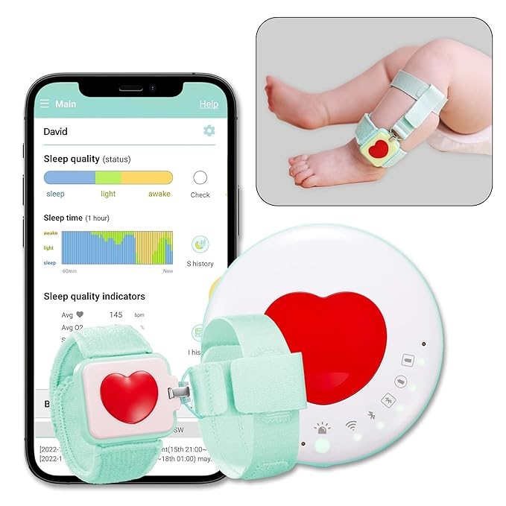

Figure 1:

tape but also underscores the significance of the device’s lightweight construction. This amalgamation of considerations not only ensures the efficacy of vital monitoring but also prioritizes the well-being and comfort of the neonate in the healthcare continuum.

## 2 Existing Solutions

To gain insights into the current landscape of neonatal vital sign monitoring, we conducted extensive research on products available in the market. This involved a thorough analysis of both established and emerging solutions. Our focus was on understanding the pros and cons of these existing products

### 2.1 AIMON Smart band Baby Monitor Oxygen, Heart Rate, °C, Fall Crying

Pros:

* Great Monitoring capabilities and various data collecting functions being saved. • Easy to use and data is accessible in a wide range of minute intervals (ie. 1 min, 30 min, more) that is easy to understand.

Cons:

* Device would only stay connected if it was close to the router.
* Costly.

### 2.2 BEMPU Health Monitor Pumpkin Bracelet

Pros:

* Continuous monitoring with a built in battery which lasts an entire month.
* Easy, Safe to use and trusted across the world.

Cons:

* Battery replacement is not possible.
* Does not monitor Spo2 and heart rate.

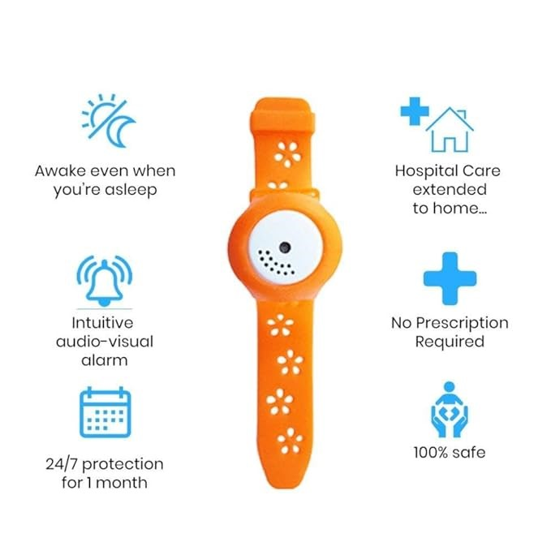

Figure 2:

### 2.3 Mon Baby(A) Baby Monitor with Sensor Alarm That Monitors Temperature, Breathing and Body Movement

Pros:

* Wearable monitor that continuously tracks baby’s skin temperature plus the ambient temperature around baby’s sleeping space: Notifies you when temperature goes outside of preset zones.
* Pause in breathing movement will be detected by a sensitive smart breathing sensor and an alarm will be sent to your smartphone.

Cons:

* Battery not rechargeable • Costly

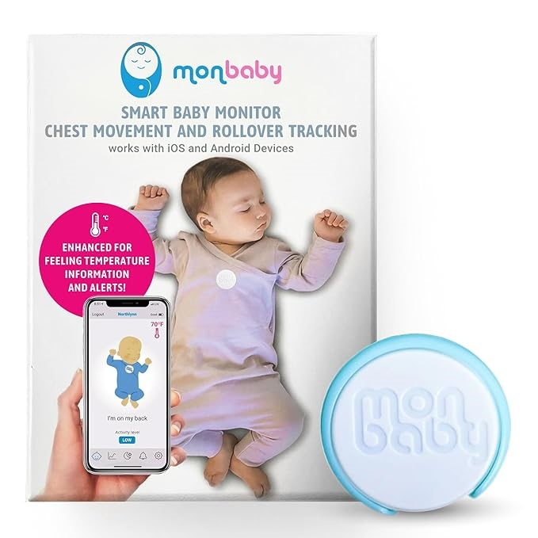

Figure 3:

## 3 Improvement Over Existing Solution

### 3.1 Battery Replacement

Our product would have a replaceable battery, ensuring continuous usage and reducing long-term costs for parents.

### 3.2 Cost-Effectiveness

We would design the product with an emphasis on affordability without compromising on essential features. Our commitment is to provide high-quality baby monitoring at a reasonable price.

### 3.3 Comprehensive Monitoring and Data Accessibility

Our product excels in offering extensive monitoring capabilities, including Spo2, heart rate and skin temperature. The collected data is seamlessly stored on a secure cloud server, allowing parents to access detailed information which is easy to understand, providing a holistic overview of their baby’s well-being.

### 3.4 Positioning of Temperature Sensor

The Max30205 body temperature sensor is a key component of our vital monitoring band for neonates, offering unique advantages as a USP. This sensor utilizes cutting-edge technology to accurately measure body temperature anywhere on the neonate’s body using its wired probe. Its high precision and reliability ensure accurate monitoring.

## 4 Steps and Correlation with other Parts Involved in the Invention

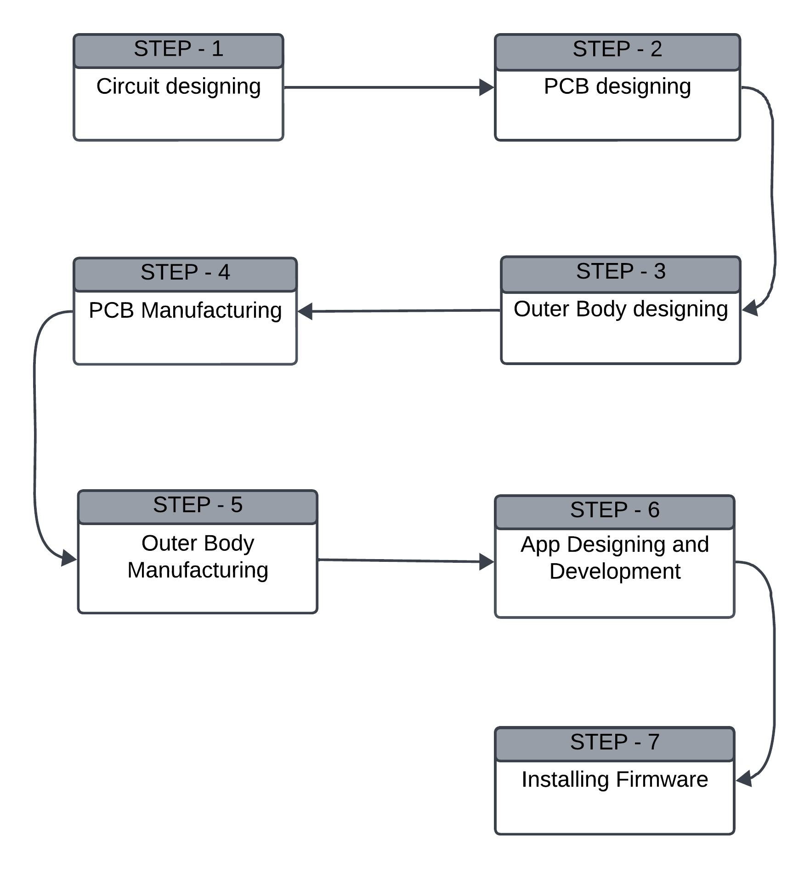

Figure 4:

### 4.1 Design Schema

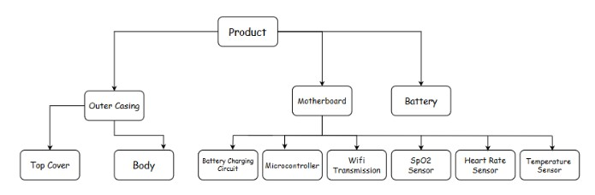This Smart Vital monitoring device is broken into several components. The outer casing and body protect the delicate inner workings, while the battery keeps everything powered. A tiny computer called a microcontroller runs the show, and sensors like heart rate and SpO2 measure your health metrics.

Figure 5:

### 4.2 Dataflow

The burgeoning need for accessible and efficient remote healthcare solutions propels the development of the Smart Vital Monitoring Band. This wearable device stands as a beacon of innovation, continuously monitoring essential health parameters to enhance patient care and well-being. The architectural framework is a symphony of interconnected components. Specialized sensors for temperature, SpO2, and heart rate form the sensory core, while a microcontroller with

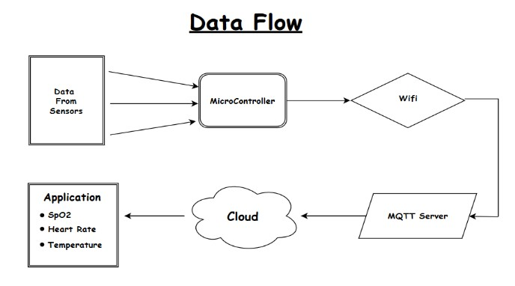

Figure 6:

an integrated Bluetooth module serves as the processing hub. This data is seamlessly related to a Raspberry Pi, acting as a central conduit for cloud integration, culminating in a comprehensive and scalable solution.

**4.2.1 Sensor Integration**

The heart of the system lies in the meticulous integration of temperature, SpO2, and heart rate sensors into the band’s design. Calibration and synchronization processes are rigorously executed to ensure precision and reliability in data acquisition, establishing the foundation for accurate health monitoring.

**Cloud Connectivity:** Health data is securely transmitted to the cloud infrastructure, allowing for real-time monitoring and historical data analysis. This robust cloud connectivity ensures data availability, enabling healthcare professionals and users to access comprehensive health information remotely.

**Mobile Application Interface:** The culmination of this integrated system is a user-friendly mobile application interface. This application offers users realtime insights into their vital signs, historical trends, and personalized health recommendations.

The intuitive interface enhances user engagement and empowerment in managing their health proactively.

The Smart Vital Monitoring Band emerges not only as a sophisticated solution for remote health monitoring but as a testament to the synergy of sensor technology, microcontroller with integrated Bluetooth, Raspberry Pi integration, cloud connectivity, and a user-centric mobile application. This holistic approach is poised to revolutionize the landscape of remote healthcare, setting a precedent for innovative and accessible patient care solutions.

**6.2.3** WiFi and MQTT Communication**:**

While Bluetooth Low Energy (BLE) offers power efficiency, our Neonatal Vital Monitoring Device prioritizes higher data rates and broader network range for real-time data transmission and robust cloud integration. For these reasons, we have opted for WiFi communication utilizing the MQTT protocol.

**4.2.2 Available options for Wireless Transmission**

|  |  |  |
| --- | --- | --- |
| Technology | Advantages | Disadvantages |
| BLE (Bluetooth Low Energy) | Very Low Power  Consumption | Low Data Rate: Not suitable for highbandwidth applications. |
| Wi-Fi | High Data Rate | Moderate Power Consumption: Requires more power than BLE.  Security Concerns: Vulnerable to hacking if not properly secured. |
| ZigBee | Low Power Consumption: Suitable for devices in mesh networks. | Low Data Rate:  Limited to simple data transmission. Complexity: Setting up mesh networks can be more complex. |
| UWB (Ultra-Wideband) | High Data Rate: Offers faster data transfer compared to BLE and ZigBee. Precise Localization: Excellent for applications requiring accurate positioning. | Moderate Power Consumption: Uses more power than BLE but less than  Wi-Fi.  Limited Device  Compatibility:  Requires specific UWB-enabled devices. |

Table 1: Comparison of Wireless Technologies

**Why Choose Wifi over BLE?**

* **Higher Data Rates:** WiFi provides significantly higher data rates compared to BLE, enabling rapid and efficient transmission of comprehensive vital sign data. This is crucial for real-time monitoring and analysis, particularly in critical neonatal care situations.

**Broader Network Range:** WiFi’s wider network range allows for flexible device placement within the neonatal care setting, ensuring reliable connectivity even at larger distances from the central monitoring system.

* **MQTT’s Efficient Data Exchange:** The MQTT protocol’s lightweight nature and publish-subscribe model facilitate efficient data exchange between the device and the cloud server. MQTT’s message queuing and topic-based filtering enable selective data delivery, optimizing bandwidth utilization and system responsiveness.
* **Always-on Connectivity: Unlike BLE, which often relies on userinitiated connections, WiFi provides continuous, always-on connectivity. This is vital for uninterrupted monitoring of neonatal vitals, ensuring no data is missed.**

**System Implementation Plan**

Our MQTT implementation leverages a broker-client architecture. The vital monitoring device acts as the client, publishing sensor data to specific topics on the MQTT broker. The cloud server, also a client, subscribes to these topics to receive real-time updates. This structure ensures unidirectional data flow from the device to the server, optimizing for efficiency and scalability.

**MQTT Broker:** At the heart of our system lies a dedicated MQTT broker, acting as a central message hub. This broker is responsible for receiving data published by the monitoring device, filtering it based on topic subscriptions, and delivering it to subscribed clients – in this case, our cloud server. This centralized architecture ensures reliable data handling and efficient distribution.

**Client: Neonatal Monitoring Device:** The vital monitoring device functions as an MQTT client, constantly gathering sensor readings (temperature, SpO2, heart rate). This data is packaged into messages and published to specific topics on the broker. Each topic represents a distinct data stream, enabling granular control over data organization and access.

**Client: Cloud Server:** Our secure cloud server acts as a subscribing client to the MQTT broker. It subscribes to the relevant topics corresponding to the sensor data it needs to receive. Whenever the monitoring device publishes new data to these topics, the broker instantly forwards it to the server, enabling real-time monitoring and analysis.

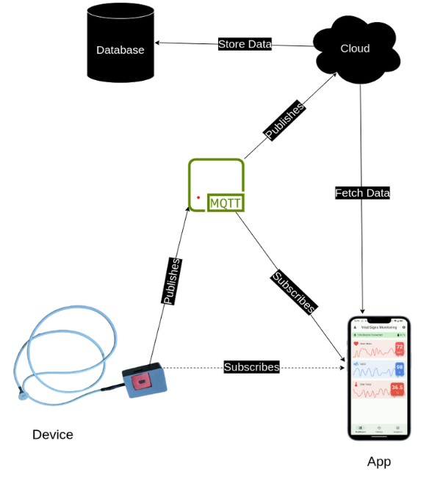Figure 7:

**4.2.3 Benefits of This Architecture:**

* **Decoupled Communication:** The broker acts as an intermediary, decoupling the monitoring device and the cloud server. This means they

don’t need to be directly aware of each other, enhancing flexibility and scalability.

* **Efficient Data Routing:** The publish-subscribe model eliminates unnecessary data transmission. The server receives only the data it specifically subscribes to, optimizing network bandwidth.
* **Asynchronous Data Flow:** The device can publish data without waiting for confirmation from the server. The broker buffers messages ensuring no data loss, even if the server is temporarily unavailable.

**6.2.3.4** Leveraging WiFi Advantages:

* **Integration with Hospital Networks:** Seamlessly connect the device to existing hospital WiFi networks for centralized monitoring of multiple neonates, streamlining data management and improving overall care coordination.
* **Over-the-Air Updates:** Utilize WiFi for convenient over-the-air updates of device firmware and software, ensuring optimal performance and the latest functionalities without requiring physical intervention.
* **Enhanced Data Analysis and Cloud Services:** Leverage the power of cloud computing for advanced data analytics, enabling long-term trend analysis, personalized health reports, and research collaborations to improve neonatal care protocols

**5 CAD Model**

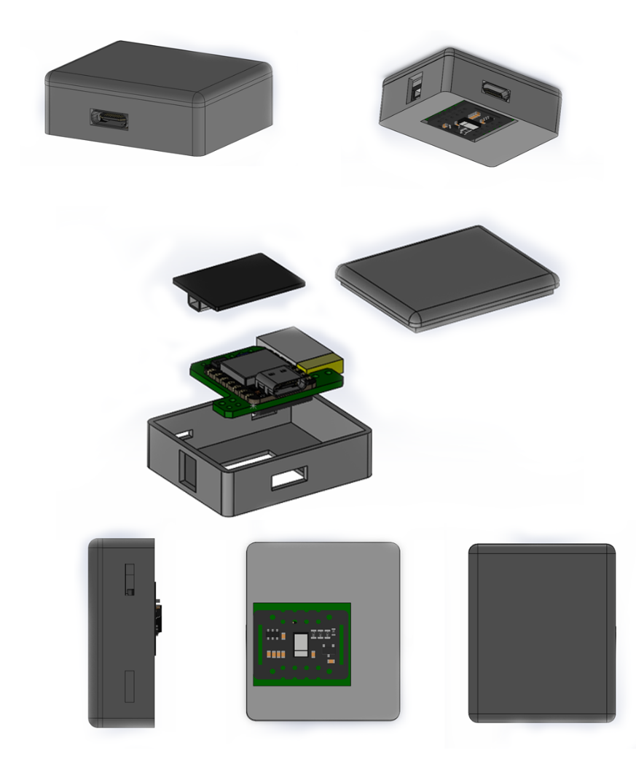

## 6 The App

We are developing a smartphone app that connects with Vital Monitoring Device and receives the sensor data. The app is built in Flutter Framework and supports both Android and IOS Platforms. The app can show live sensor data in real time, and access pass sensor data and analytics data. The app will notify when readings of certain parameters go beyond the threshold limit.

### 6.1 App Features

* Real time Sensor Data Monitoring
* Access Past Sensor Readings
* Alerts when readings reach at critical point
* Cloud Sync

**6.1.1 App User Interface (UI)**

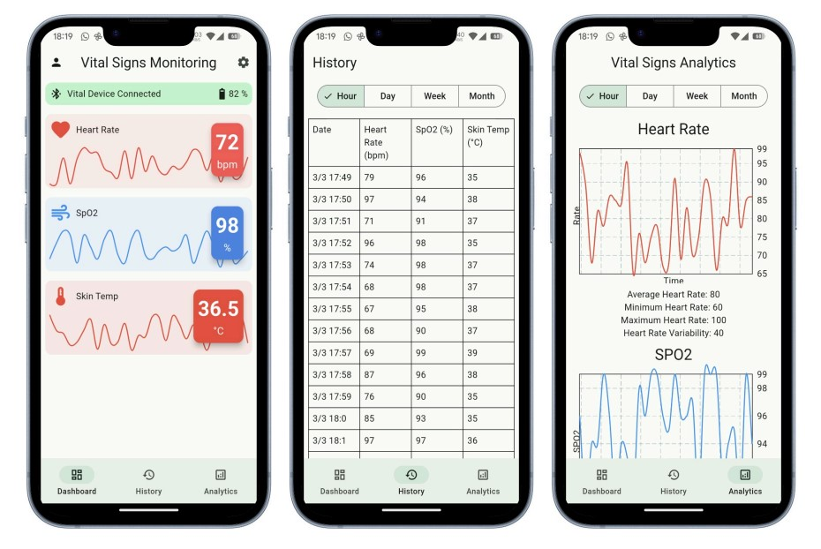

Figure 8:

## 7 Disclosure of Invention

During 4th sem Design Practicum Project on ’Vital Monitoring Patch for Neonates,’ We disclosed the concept of a vital monitoring device to our professor, Dr. Gajendra Singh. We presented a high-level overview of the device’s functionalities and its potential benefits for neonatal intensive care units. The purpose of this disclosure was to receive feedback on the feasibility of the concept and explore its potential as the focus of our DP project.

### 7.1 Publication and Presentation of Invention

No, We haven’t published or presented information about the invention on any public platform yet. The project is relatively new, and we are currently focusing on developing the prototype further.

### 7.2 Offering of Invention for Sale

At this stage, We haven’t offered the invention for sale. Our DP project is focused on developing a prototype and exploring the concept’s viability. Further development and testing would be necessary before considering commercialization.

## 8 Foreseen Social Impact of the Invention

* Improved Neonatal Outcomes: Earlier detection of complications can lead to faster treatment interventions, potentially reducing long-term health problems for newborns. This could benefit the babies themselves, their families, and society as a whole.
* Reduced Healthcare Costs: Early detection and treatment of neonatal issues can lower the need for more intensive and expensive interventions later. This can benefit healthcare systems by reducing overall costs. • Enhanced Parental Confidence: Real-time monitoring can provide peace of mind to parents concerned about their newborn’s health. This can lead to reduced stress and anxiety for parents, allowing them to focus on bonding with their babies.

**9 Commercial Potential and Potential End Users**

## Potential End Users

* **Hospitals**: NICUs in hospitals would be primary users, potentially integrating the device with existing monitoring systems.
* **Neonatal Specialists**: Pediatricians and neonatologists could use the device for remote consultations or monitoring.
* **Clinics and Birthing Centers**: Facilities with limited NICU resources could benefit from the device for initial monitoring.
* **Home Care**: For certain stable newborns requiring monitoring after leaving the NICU, home use could be an option. (Regulations and medical supervision would apply.)

## Possible Uses

* **Continuous Monitoring**: The device could track vital signs like heart rate, respiration, oxygen saturation, temperature, and blood pressure, providing a comprehensive picture of the baby’s health.
* **Early Detection**: The device could detect subtle changes in vital signs, potentially alerting medical staff to potential problems before they become critical.
* **Data Analytics**: The device could collect and analyze data over time, helping healthcare professionals identify trends and make informed decisions about treatment.
* **Remote Monitoring**: The device could allow for remote monitoring of newborns, potentially reducing the need for frequent physical checks and minimizing handling.

## Potential

* **High Demand**: Neonatal Intensive Care Units (NICUs) require constant monitoring of premature or critically ill newborns. Existing solutions might have limitations, and a new device offering improved features could be highly sought-after.
* **Improved Outcomes**: A more efficient monitoring system could lead to faster detection of complications, allowing for earlier intervention and potentially improving patient outcomes.
* **Reduced Costs**: Early detection and treatment can minimize the need for more intensive interventions, lowering overall healthcare costs.
* **Increased Parental Comfort**: Real-time monitoring can provide peace of mind to parents concerned about their newborn’s health.

## Certification and Signature

We, the undersigned, (Manitha Rahul Sree, Jatin Prasad, Aman Sikarwar, Abhijeet Kumar, Vishnu, Sia Mittal) hereby certify that all the mentioned details are accurate as per our knowledge. We agree that the Institute will be the applicant for the patent application. We agree to abide by the Institute’s IPR policy.

**Name and affiliation of the In- Signature of inventor(s) with ventor(s): date:**

Inventor 1 - Manitha Rahul Sree

Inventor 2 - Jatin Prasad

Inventor 3 - Aman Sikarwar

Inventor 4 - Abhijeet Kumar

Inventor 5 - Vishnu Inventor 6 - Sia Mittal **Affiliation:**

IIT Mandi