PROFESSIONAL PORTFOLIO | GAME TESTING | EDITION SEPTEMBER 2026
Rahul Sharma
Project Lead | Game Testing, QA & Project Management
I lead PC game QA and project delivery end to end — scope, schedule, staffing and stakeholder sign-off — from test strategy through release. I run the Jira process and keep the daily numbers honest, even when that’s inconvenient.

Delhi, India | +91-7217704787 | mrrahulsharma@yahoo.com | linkedin.com/in/rahul-sharma-9a4661133
364  defects managed across two PC projects | 204  documented test cases in 14 modules | 31  build versions tested on Project A | 576 h  structured test effort in 43 days | 25  requirements audited in the RTM

Why this portfolio is different
- Evidence, not adjectives. Every figure traces to a source file: a Jira export, a daily log or a signed-off report. Where the source documents disagreed, I reconciled them and show the reconciled number.
- Decisions, not just execution. On Project B I called the build not ready for release from the data (15 of 24 Highest/High defects unresolved) and set out a P0/P1 fix plan.
- Ownership of mistakes. On Project A a client-side user found issues my team missed. The incident report, root cause and the process changes that followed are in this portfolio.
- Team goals I monitor. The yearly Team Pivot goals for my QA team (FY 2026) and the evidence I use to track them are on page 20.

Contents
Section | Page | Section | Page
Cover and headline results | 1 | Jira administration and configuration evidence | 13
Profile and capability matrix | 2 | Jira administration: further configuration evidence | 14
Career journey: game QA across platforms and genres | 3 | Test design and coverage | 15
Games shipped: a public release timeline | 4 | Test scenarios and test cases: proof | 16
Types of testing: start to end | 5 | Edge-case and negative test design | 17
Delivery framework: QA roadmap, stages, entry and exit criteria | 6 | Requirements traceability (RTM audit) | 18
Reporting schedule and risk tracking | 7 | Team leadership, enablement and research | 19
Case study A: casual card-puzzle PC title (2024), results | 8 | Team Pivot: yearly goals I monitor (FY 2026) | 20
Case study A: an escape, owned and fixed | 9 | Analytics event validation: schema and QA method | 21
Case study A: evidence from the daily report | 10 | Document evidence: primary source excerpts | 22
Case study B: action campaign PC title (2023), release assessment | 11 | Project management: how a project runs start to finish | 23
Bug reporting standard and bug lifecycle | 12 | What I bring to a new studio, and evidence index | 24

Confidentiality. Client, studio, game and colleague names are anonymised (Project A, Project B). Redacted originals are available to a hiring team on request. Project dates are the real delivery dates.

Profile and capability matrix
What I do, where the proof is, and what I am still building
Game QA Project Lead who has planned, executed and delivered PC game testing end to end, as both QA lead and project manager, across functional, progression, compatibility, interrupt and live-environment cycles. I am comfortable on both sides of the release decision: finding and writing up the defect, and deciding whether the build can ship. I administer Jira (workflows, screens, custom fields, permissions) so that the data coming out of a project is trustworthy, and I am extending the team into automation through proof-of-concept work in Unity and Appium.
Capability | How it shows up in my work | Page
Test strategy and planning | Test plan with scope, exclusions, entry/exit criteria, risks with mitigations, schedule and approvals; QA roadmap and plan set up for client sign-off before a project starts | 6-7
Project management and delivery | Schedule, scope, staffing and stakeholder management from kickoff to sign-off on two fixed-deadline PC releases; re-scoping under deadline pressure and staffing changes without losing coverage | 6-9
Test design and traceability | Scenarios (6 areas), 204 module-wise test cases, requirements traceability matrix, interrupt and compatibility suites, mobile checklist | 15-18
Execution and playtesting | Progression runs in every game mode and difficulty, aggressive/exploratory playtesting, aspect-ratio and resolution sweeps, live-environment testing | 8-10
Defect management | Tag + Problem-Action-Location summaries, severity vs priority rules, lifecycle with developer resolutions, triage into P0/P1/P2 buckets | 11-12
Reporting and stakeholder communication | 19-sheet daily report workbook, weekly status report, incident report, postmortem, closure and handover | 7, 9
Jira administration | Work types, workflows and schemes, screens, custom fields, priorities, permission schemes | 13-14
Team leadership and goal monitoring | Resource management, test planning, team training, knowledge-transfer sessions, yearly Team Pivot goals tracked against evidence | 19-20
Automation (in progress) | Proof-of-concept level: Unity game automation, Appium on mobile games. Not yet production-scale, and I say so | 19

Toolbox
Area | Tools and methods
Planning and tracking | Jira (project lead and administrator), Microsoft Excel (dashboards, pivots, RTM), test plan / procedure / closure templates
Test types | Functional, progression, exploratory and rule-breaking playtesting, compatibility (OS, hardware, resolution, aspect ratio), interrupt, regression, live-build verification, UX observation
Platforms | PC (Windows 10 and 11, low-to-high-end hardware) in depth on Projects A and B; console (PS4, Xbox) and mobile (iOS/Android) production experience from earlier roles (page 3); AR/VR and Web exposure
Learning and POCs | Unity + C#, Appium and Appium Inspector, Selenium WebDriver, TestNG / JUnit, Alt Unity Tester, Android Studio; ISTQB certification is a stated FY 2026 goal

Projects covered. Project A, casual card-puzzle PC title with a Collector's Edition (Jun-Sep 2024, Project Lead). Project B, action campaign PC title (May-Aug 2023, Jira project lead and QA lead). Both were delivered to external clients from an India-based test team.

Career journey: game QA across platforms and genres
From console at Ubisoft to PC and iGaming, to leading QA at scale today
The two deep-dive case studies later in this portfolio (Project A and Project B) are anonymised under client confidentiality. This page is not: it is my professional employment history, presented here to show testing depth across console, mobile, PC and emerging platforms that the deep-dives alone do not.
Company | Role | Status | Platform / genre | Highlight
IGT Solutions Pvt Ltd, Gurgaon | Project Lead, Game Testing & QA | Current | PC / Steam — casual, puzzle, strategy, action, iGaming | Leads a QA team of 8+ engineers; shipped 70+ live Steam titles for European and US studios; manages QA for 19+ UAE indie-studio titles per month
Passage.io, USA (Remote) | Senior QA Analyst (Freelance) | Past | PC — Blockchain / NFT metaverse | Shipped Passage World Building, a real-time metaverse title with virtual land, IAP commerce and social collaboration
Passion Gaming Pvt Ltd, Gurgaon | Senior Quality Analyst | Past | PC — real-money iGaming | Led QA for Rummy Passion across Cash, Sit-N-Go, Pool, Points and Deals modes; validated IAP, KYC and tournament back-office flows
Indium Software Pvt Ltd, Bengaluru | Testing Engineer, Level 2 | Past | Mobile — PvP/PvE racing, iGaming slots | Owned end-to-end quality for CSR 2 (mobile drag-racing) and iGaming slot titles; found critical crash scenarios through edge-case analysis
Ubisoft Entertainment Pvt Ltd, Pune | Game Tester, QA/QC | Past | PS4 / Xbox / PC — cross-platform | Owned QA delivery for For Honor (hack-and-slash); multiplayer, network and fight-mechanics validation; DLC, VFX/SFX and cinematics testing
U2opia Mobile, Gurgaon | Game Tester (Intern) | Past | Mobile — iOS / Android | Tested 5 mobile titles on Google Play and iOS; tracked KPIs via Firebase, IronSource and Google Analytics
I-Tuple Technologies, Gurgaon | Software QA Analyst (Intern) | Past | Web / API | API testing on an e-commerce app using Postman; designed and executed test cases
B.Tech, Computer Science, Manav Rachna International University, Faridabad (2017).

Achievements and certificates
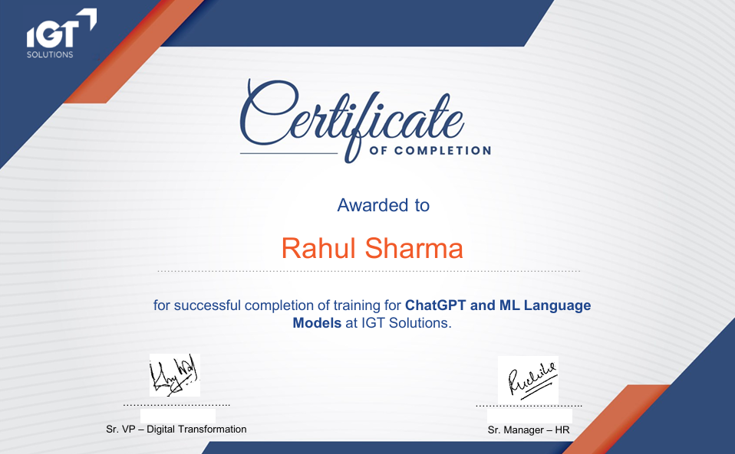  ChatGPT and ML Language Models — completion certificate, IGT Solutions | 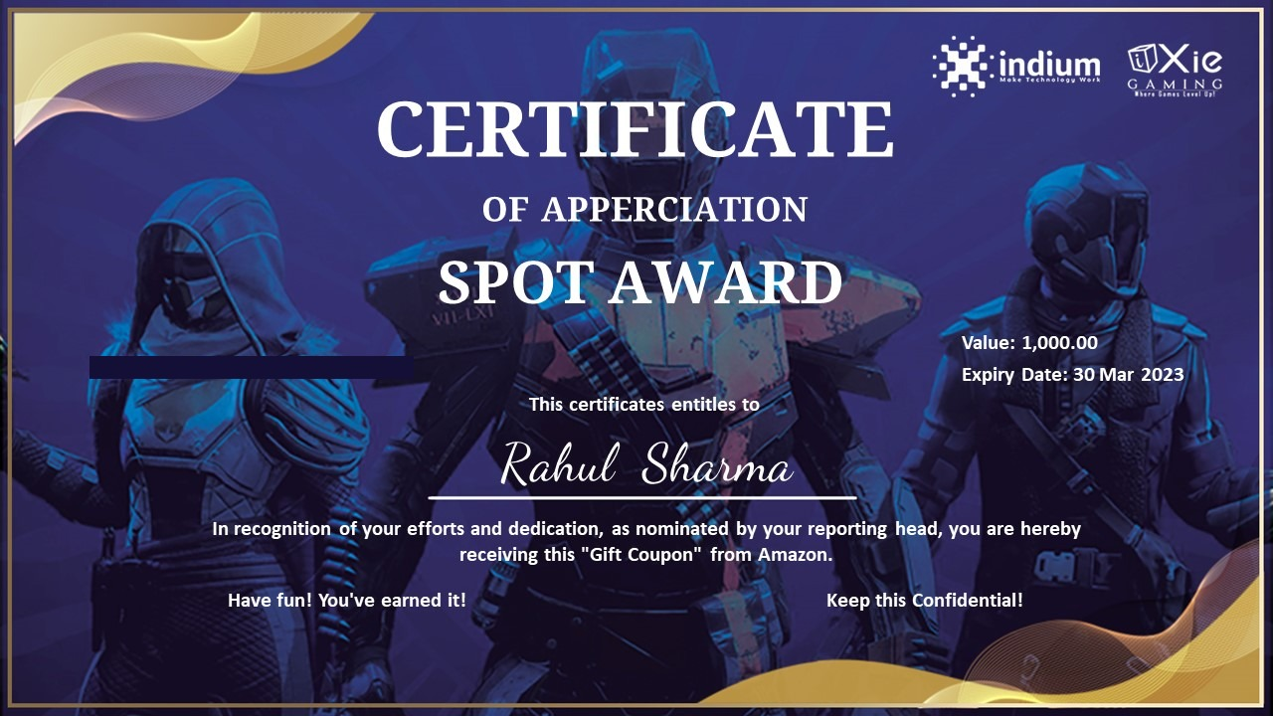  Spot Award for Active Testing Excellence — Indium Software

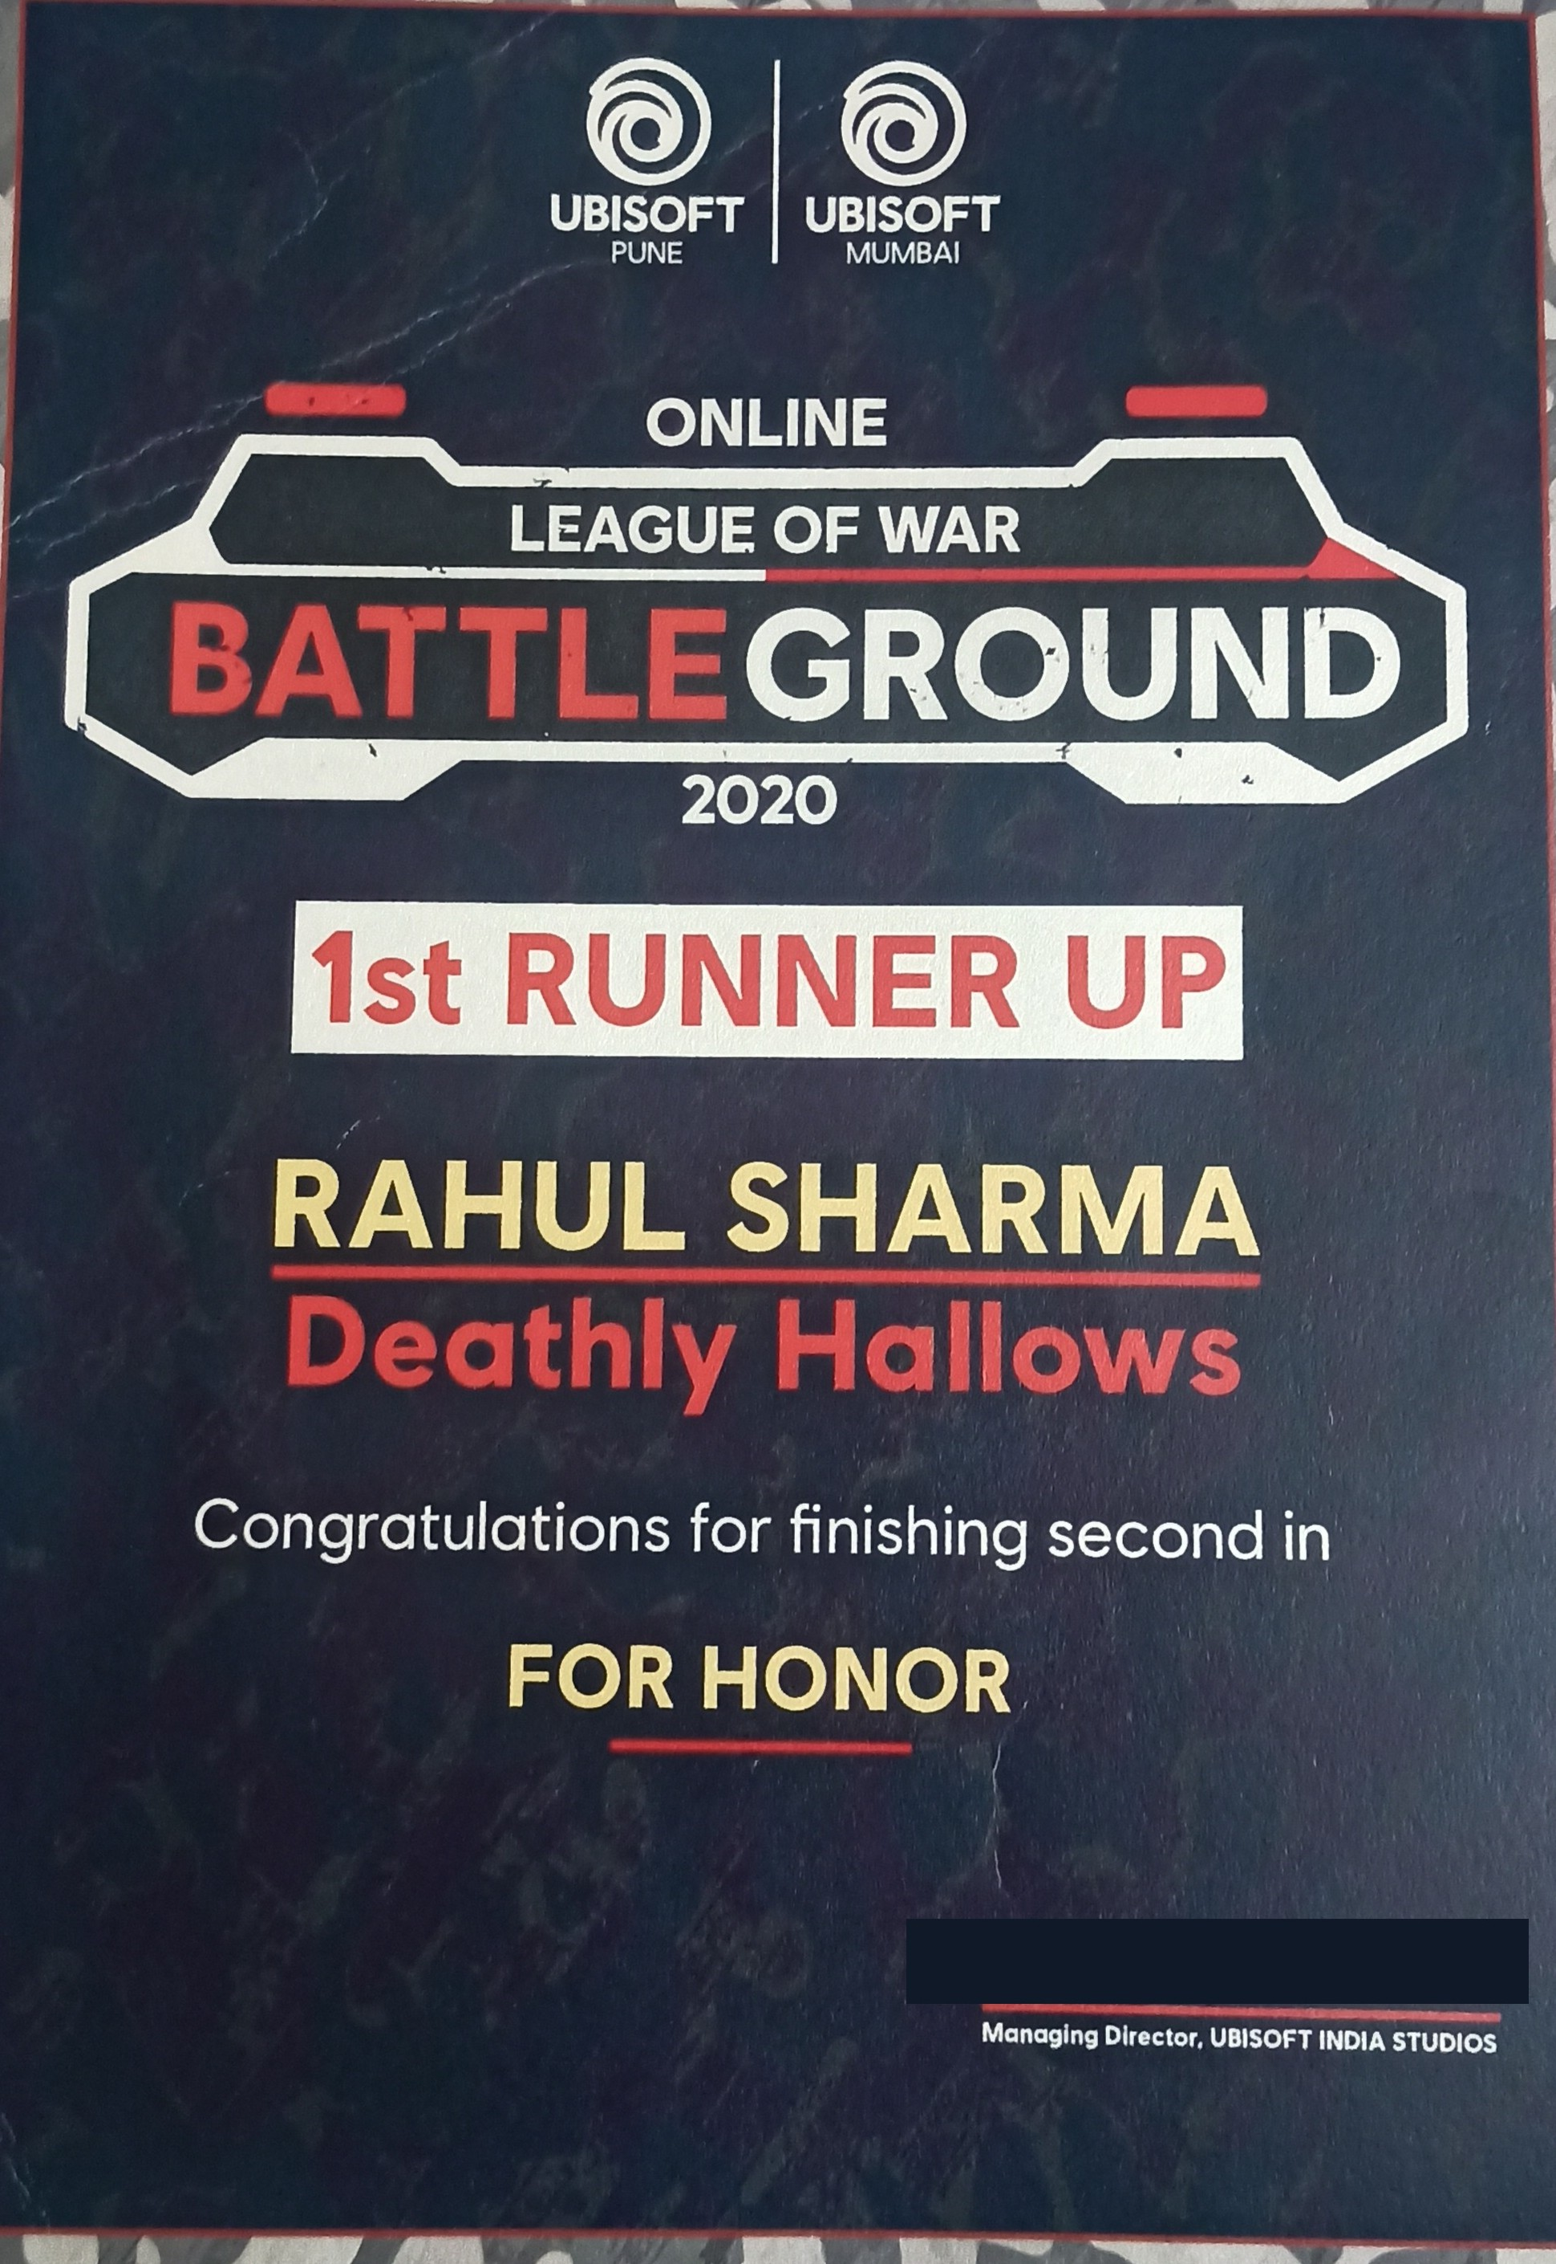
1st Runner-Up, Online League of War Battleground QA Event 2020 (For Honor) — Ubisoft Entertainment

Games shipped: a public release timeline
Selected titles I tested through to public release, most recent first
These are real, publicly released titles — live today on Steam, mobile app stores or the web — not anonymised case studies. Belote Bistro is the most recent: tested on mobile and released publicly within the last few weeks.

2023 – Present, IGT Solutions Pvt Ltd (PC / Steam, Mobile, Web)
Title | Platform
Belote Bistro (most recent release) | Mobile
Chronicles of Albian — The Magic Convention | PC / Steam
Chronicles of Albian 3 | PC / Steam
Jewel Match Origins 3 | PC / Steam
Jewel Match Royale Solitaire (3 releases across platforms) | PC / Steam, Mobile
Jewel Match Solitaire Fantasy | PC / Steam
Jewel Match Solitaire L'Amour | PC / Steam
Jewel Match Solitaire Seasons, Standard and Collector's Editions | PC / Steam
Jewel Match Solitaire Winterscape 1, 2 and 3 | PC / Steam
Jewel Match Solitaire X | PC / Steam
Jewel Solitaire Tripeaks | Web
JM Solitaire HTML5 | Web
Match Venture 4 | PC / Steam
Runefall 3 | PC / Steam
Solitaire Dreamscapes | PC / Steam
Tales of Lagoona — Orphans of the Ocean | PC / Steam
Zen Quest Garden | PC / Steam

Earlier roles: cross-platform and cross-genre releases
Title | Studio / period | Platform
For Honor | Ubisoft Entertainment, 2019–2021 | PS4 / Xbox / PC
CSR 2 | Indium Software, 2021–2022 | Mobile
Rummy Passion | Passion Gaming, 2022–2023 | PC / Web (real-money iGaming)
Passage World Building | Passage.io, 2023 | PC (blockchain / NFT metaverse)

Types of testing: start to end
The test types I run across a project, in the order they show up, explained in plain terms
Different test types answer different questions, and they show up at different points in a project. Below is the order I actually use them in, from the moment a new build lands to the moment it goes live.
Stage | Test type | Build / environment | In plain terms
1. New build arrives | Smoke testing | Dev build | A fast, shallow pass to check the build even launches and the core loop works. If smoke testing fails, the build goes back untested — there is no point testing further.
2. Core pass | Functional testing | Dev build | Does each feature do what it is supposed to: buttons, menus, saving, the core mechanics. This is the main body of testing.
3. Core pass | Progression testing | Beta build | Play the game start to finish, in every mode and difficulty, the way a real player would. Confirms the whole journey works, not just individual pieces.
4. Core pass | Exploratory testing | Beta build | Deliberately unscripted: click things in the wrong order, try to break the game the way a curious or impatient player might. Finds the bugs a written test case would never think to check.
5. After every fix | Regression testing | Same build, retested after fix | Re-run the tests around whatever changed, to check the fix did not break something that used to work. This runs continuously, not just once.
6. Before sign-off | Compatibility testing | Release-candidate build | Same build, different hardware, operating system, screen resolution and aspect ratio. Catches the "works on my machine" problem.
7. Before sign-off | Interrupt testing | Release-candidate build | What happens to the game when a phone call comes in, a notification pops up, the device sleeps, or the charger is plugged in mid-session.
8. Before sign-off | Localization testing | Release-candidate build | Text, dates and currency display correctly in every supported language, with nothing cut off, mistranslated or left in a placeholder state.
9. Before sign-off | Usability / UX testing | Release-candidate build | Is the game intuitive without a manual; where do new players get stuck or confused. Feeds design feedback, not just bug reports.
10. After go-live | Live-build testing | LIVE / production build | One more pass on the real, published build once it is live, to confirm what players are actually getting matches what was signed off.
Regression testing (row 5) is not a one-time stage: it repeats after every fix, all the way through a project, which is why it sits in the middle of this list rather than at the end.

Delivery framework
The 8-stage QA roadmap I use, and what gets produced at each stage
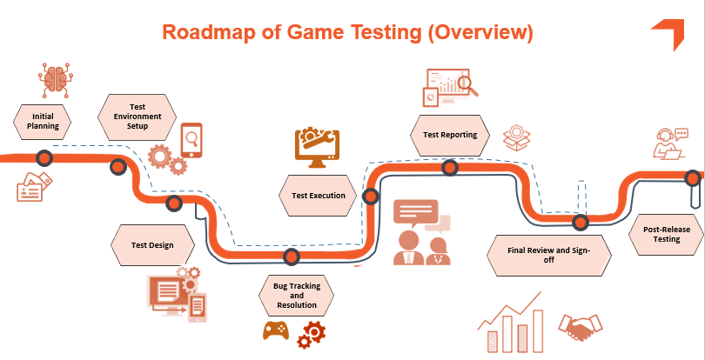
Figure 1. QA roadmap presented to clients (from the QA Roadmap deck)
Stage | Produced | Checkpoint
1 Initial planning | Test plan, scope, risks | Plan approved by lead, PM and stakeholders
2 Environment setup | Hardware matrix (low to high end), build access, Jira project and permissions | Entry criteria met
3 Test design | Scenarios, cases, RTM, checklists, game guide for self-use | Cases reviewed and approved
4 Test execution | Daily runs on dev, validation and beta builds; progression, compatibility, interrupt | Daily report issued
5 Bug tracking and resolution | Jira lifecycle (incl. Pending Retest), triage meetings, retest and verification | No unverified fixes
6 Test reporting | Daily and weekly reports, dashboards, defect dump | Stakeholders informed
7 Final review and sign-off | Closure report, exit-criteria check, handover documents | Closure report approved
8 Post-release testing | Live-build verification after go-live | Live sign-off

Entry and exit criteria
Entry criteria | Exit criteria
Test environments set up; test plan prepared and approved; Jira project and permissions configured; test cases reviewed and approved; test data and scenarios prepared | All planned test cases executed; all critical and high-priority defects resolved (or waived in writing); test completion report reviewed and approved; test closure report prepared and approved

How I plan the work: Waterfall and Agile together
Two common ways of organising a project: Waterfall does one phase at a time, in order — planning finishes, then design, then execution, then closure — with a review at the end of each. It suits a project that needs one fixed schedule and one fixed budget agreed before work starts. Agile instead works in short, repeated cycles, with regular feedback and room to adjust as new information comes in — it suits work where priorities can shift.
My projects use both, for different parts of the same project. The 8 stages above are Waterfall: one fixed order, approved up front, so the client knows the schedule and budget from day one. The daily work inside stage 4 (test execution) is Agile: a short cycle around each new build, a daily report standing in for a team stand-up, and continuous retesting rather than one long test pass saved for the end. The outer shape is fixed for the client; the inner work stays flexible enough to react to what each new build actually shows.

Reporting schedule and risk tracking
How often I report, and how known risks are tracked and handled, from day one

How often I report
Rhythm | Artifact | Purpose
Every session | Daily report workbook (19 sheets): checklist, bug log, mode-by-mode runs, compatibility, observations | Shows what was tested, on which build, OS and hardware, and how long it took
Every build | Retest of fixes plus regression; build version stamped on every log line | Confirms fixes without new breakage
Weekly | Weekly status report: plan, progress, challenges, notes | A written progress record before the next milestone
Per incident | Incident report: timeline, root cause, SLA, impact, corrective action | Names what was missed, why, and what changed afterward
At milestones and closure | Postmortem, closure and handover report, defect dump | Client signs off in writing; the record outlives the project

Known risks and how I handle them (from the test plan)
Risk | Mitigation
Tight deadlines | Prioritise critical tests; risk-based testing
Limited resource availability | Allocate resources by risk; bring in temporary testers if needed
Incomplete requirements | Work with the client to clarify requirements; request the game design document
Tool limitations | Use alternative tools or manual testing where necessary

Crunch time and team churn
- Crunch (deadline pressure): re-scope to a risk-based critical path in writing, not silently — the client sees exactly what is deferred and why. Regression testing is never compressed, even when everything else tightens, since a new bug under deadline pressure costs more than a known one. The full step-by-step process, with a worked example from Project A, is on page 8.
- Churn (testers joining or leaving mid-project): the documented test cases, scenarios and checklists (pages 15-17) are the actual handover mechanism, not tribal knowledge — a new tester can pick up real coverage within a day. A new tester's first build cycle is paired with an existing one before they run solo, and knowledge-transfer sessions (page 19) cover anything the documents do not.

Scope discipline
The test plan lists backend, database, network and performance testing as out of scope, so the client cannot assume coverage that was never agreed. In practice, interrupt testing (incoming calls, messages, app notifications, PC lock/unlock, battery and charging state, system updates) and basic network-condition checks (using the network simulators set up for the project) were both run and are reflected in the interrupt and compatibility suites on page 9. Lightweight performance signals, such as completion time per level tracked across hardware tiers in the daily report, were also captured, though a full frame-rate or load-testing pass was not. Backend and database testing remained genuinely out of scope, since neither project gave testers server-side or database access.

Roles and responsibilities (from the test plan)
Role | Responsibilities
Project Lead (me) | Daily report, resource management, test planning, test case development, team training, triage, client and stakeholder communication
Test engineers | Test execution and defect logging; retest and verification of fixes
IT support | Set up and maintain the test environment
Development team | Fix identified defects; unit and integration testing at the developer end

Case study A: casual card-puzzle PC title
Collector's Edition with bonus levels | Jun-Sep 2024 | Role: Project Lead
Platform and environments | PC, Windows 10 and 11, from Core i5 / 8 GB laptops to Ryzen 9 / 32 GB machines. Pre-production, then LIVE in September
Team and effort | Lead plus one QA engineer (2 testers Jun-Aug, 1 in the live phase): 43 days, 576 hours
Scope | Four game modes (Normal, Timed, Hard, Relaxed), map and level progression, shop and power-ups, scene rebuild, bonus-level series, collector extras, settings, exit and interrupts, compatibility
Output | 212 defects logged, 31 build versions tested, 204 documented test cases, 197 executed with 186 passed at the July checkpoint (94.4%)

Challenge
A feature-rich edition with four game modes, a long bonus-level series and frequent beta builds, tested by a two-person team. Coverage had to be broad enough to satisfy the client and disciplined enough to be repeatable build after build.

Approach
- Learn the game first. Wrote a game guide for self-use before designing tests; test cases are designed around the real mechanics.
- Plan, then design. Test plan, test procedure, scenarios, 204 test cases and a requirements matrix.
- Log everything. One daily-report workbook: every level played, with mode, difficulty, build, OS, hardware and time to complete; a separate observation sheet for design and UX recommendations.
- Play it like a player, then like a rule-breaker. Full progression in each mode, aggressive and exploratory playtesting, bonus-level rounds repeated on new builds (seven rounds), interrupt tests, live-game testing.

Results
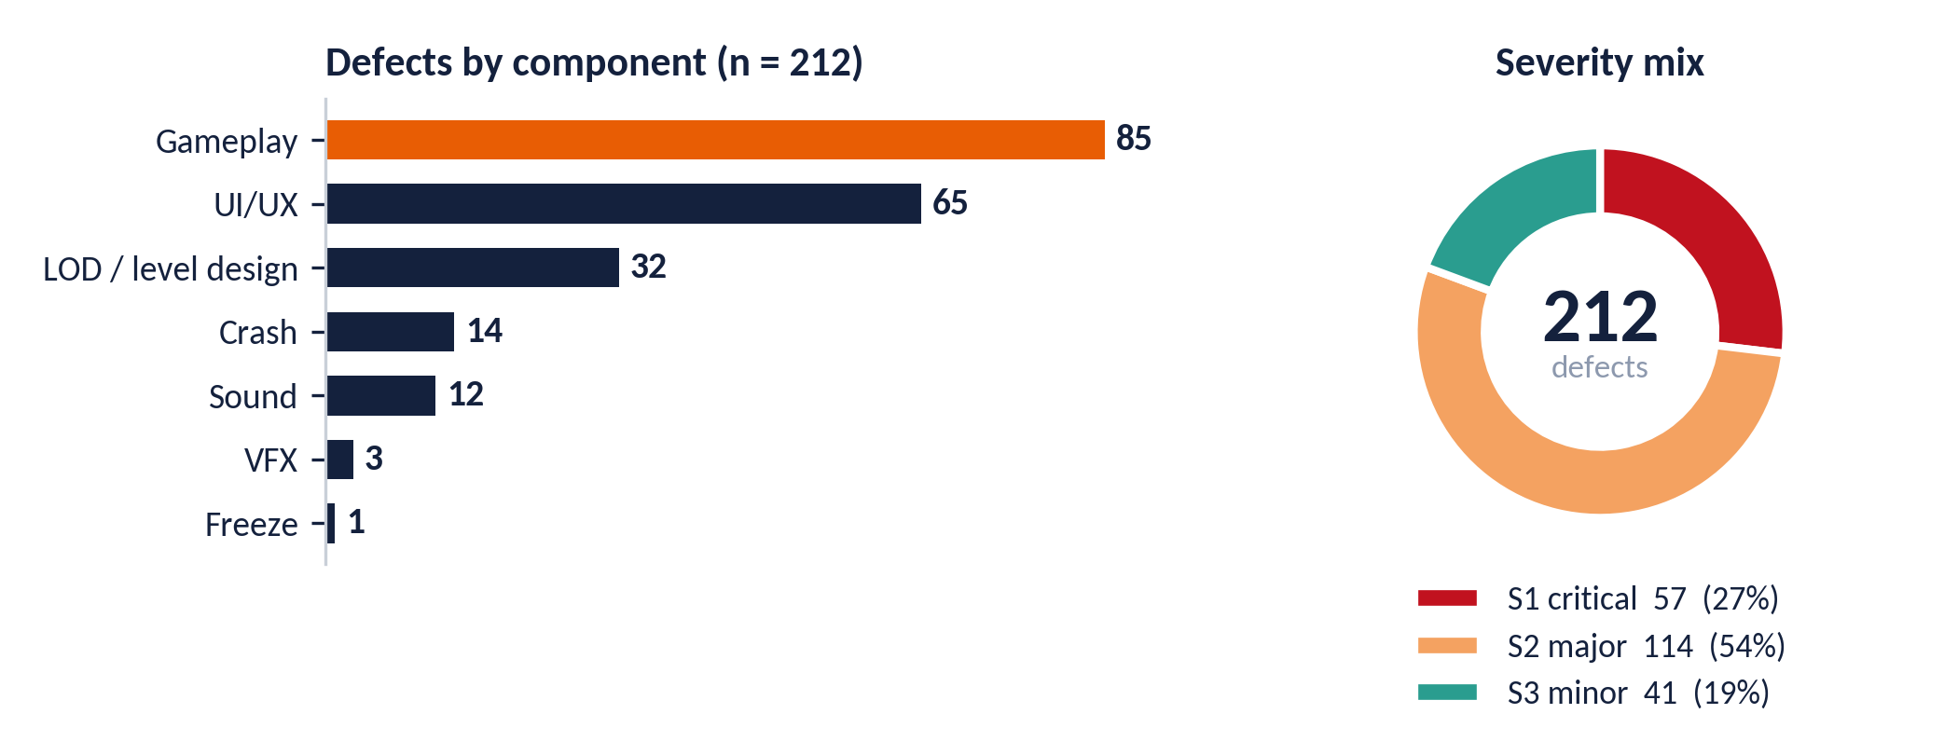
Figure 2. Source: daily report bug log, 212 unique tickets, final recorded severity. S1: 26 gameplay, 17 level-design (LOD/collision), 14 crash.
What the data said. Gameplay and UI/UX account for 150 of 212 defects (71%). More than a quarter of all defects (27%) were S1, and all 14 crash defects (show-stoppers) were among them. The highest-severity risk sat in the flow of the game and in level behaviour rather than in isolated screens, which supports the emphasis on full progression runs and repeated bonus-level rounds.

What I do, step by step, during crunch time
- 1. Freeze scope in writing. Confirm with the client exactly what stays in scope; anything cut is agreed and documented, not silently dropped.
- 2. Re-triage by risk, not ticket age. P0/P1 defects get resourced first; low-severity items get a written waiver, not silence.
- 3. Protect regression testing. Last-minute fixes still get regressed — a new bug under deadline pressure costs more than a known one.
- 4. Increase reporting cadence. Daily moves to per-build or twice-daily, so risk is visible as it builds, not after.
- 5. Clear volume before any staffing change. If the team is set to shrink, close and verify the backlog first, not carry it forward.
- 6. Get an explicit, written sign-off. Closure is a documented decision — fixed, deferred, accepted risk — not just “time ran out.”

Case study A: an escape, owned and fixed
What a client-side user found, why we missed it, and what changed

The incident
Date | Event | Handling
13 Jul 2024 | A client-side user on the beta build reported screen-resolution and aspect-ratio problems, help-file content that no longer matched the game, a misplaced "Scene complete" text at high resolution, overflowing piles in a bonus game and a missing confirmation on "Try Again" (severity S2). | Testers reviewed each report and raised new tickets the same day; escalated to leadership; resolution time recorded as 1 day.
26 Jul 2024 | Bonus levels de-synchronised and crashed between the standard and Collector's editions. | Recorded as missed by the team in testing. My analysis: the cross-edition bonus path was not a regular part of the test flow.

Root cause. Recorded: a screen-resolution defect that appears when the player changes resolution while playing. My analysis: the compatibility matrix did not yet include a full resolution and aspect-ratio sweep or the cross-edition bonus path, so a mid-game resolution change was never exercised in standard testing. Impact recorded: medium reputational risk, no penalty, rework required.

Corrective actions and follow-through
- Recorded action: a new roadmap, checklist, scenarios and test cases issued as part of the test plan, to be signed off by the client before a project starts.
- By project close: a dedicated compatibility suite (29 cases), an interrupt suite (7 cases), and resolution / aspect-ratio sweeps logged in the daily report from 27 Aug 2024.
- Follow-through: the bonus-level series was re-run in seven rounds on successive beta builds (Jul-Aug), and a live-environment pass followed in September.

Postmortem: interim checkpoint, July 2024
Measure | Result | Reading
Test cases executed / passed / failed | 197 / 186 / 11 | 94.4% pass rate at the checkpoint
Defects logged at checkpoint | 114 (S1 31, S2 63, S3 20) | Consistent with the daily bug log (115 by end of July); final count was 212
Recurring themes | Crash, screen resolution, synchronisation | Drove the extra retest and sync coverage

Lessons I carried forward
- Agree the compatibility matrix up front. Resolution, aspect ratio and older hardware belong in the plan, not in the postmortem.
- Ask for the game design document early. It widens bug coverage and sharpens the test plan; this was the first recommendation in the closure report.
- Add a low-end performance baseline. Performance was outside the agreed scope, and the postmortem recommends including it, especially for older devices.
- Automate the repetitive mechanics. Documented cases made regression cheap; the next step is automating routine mechanics and interactions.

Case study A: evidence from the daily report
Screenshots of the working files, with the coverage they demonstrate
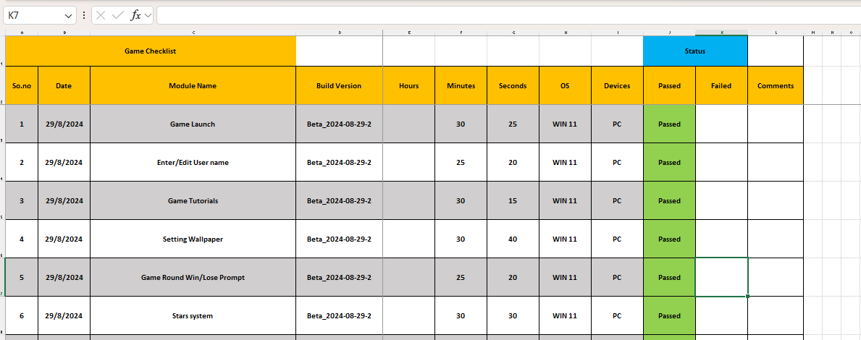
Figure 3. Game checklist run on each beta build (build version, OS, device, time and result per module)
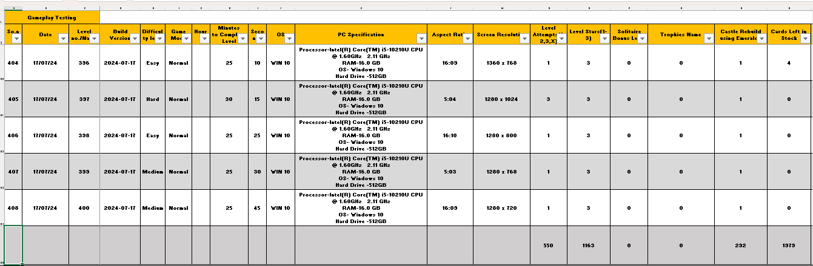
Figure 4. Progression log: level, difficulty, mode, hardware, aspect ratio, resolution, attempts, stars and cards left

Coverage snapshot
Dimension | Covered
Game modes | Normal, Timed, Hard, Relaxed, each with its own run sheet; extra emerald-play runs
Bonus levels | Seven rounds across successive beta builds, easy to hard difficulty sets
Display | Aspect ratios 4:3, 16:9, 16:10; resolutions from 800x900 to 1600x900
Systems | Windows 10 and 11; laptops and desktops from Core i5 / 8 GB to Ryzen 9 / 32 GB
Environments | Pre-production builds (Jun-Aug) and LIVE (Sep)

Case study B: action campaign PC title
Release assessment from a 152-defect Jira export | May-Aug 2023 | Role: Jira project lead and QA lead
152  defects, 5 test cycles | 59%  closed (90 of 152) | 15 / 24  Highest and High still unresolved | 0 / 5  crash defects open | 84%  of defects with one developer

Verdict: not ready for release sign-off. Stability is good (all 5 crashes and every blocker closed). The risk is functional and concentrated in late-game boss and AI behaviour, level-progression exploits and save-data integrity. The newest build had 32 of its 36 defects unresolved, so its fix and verify phase had not started.
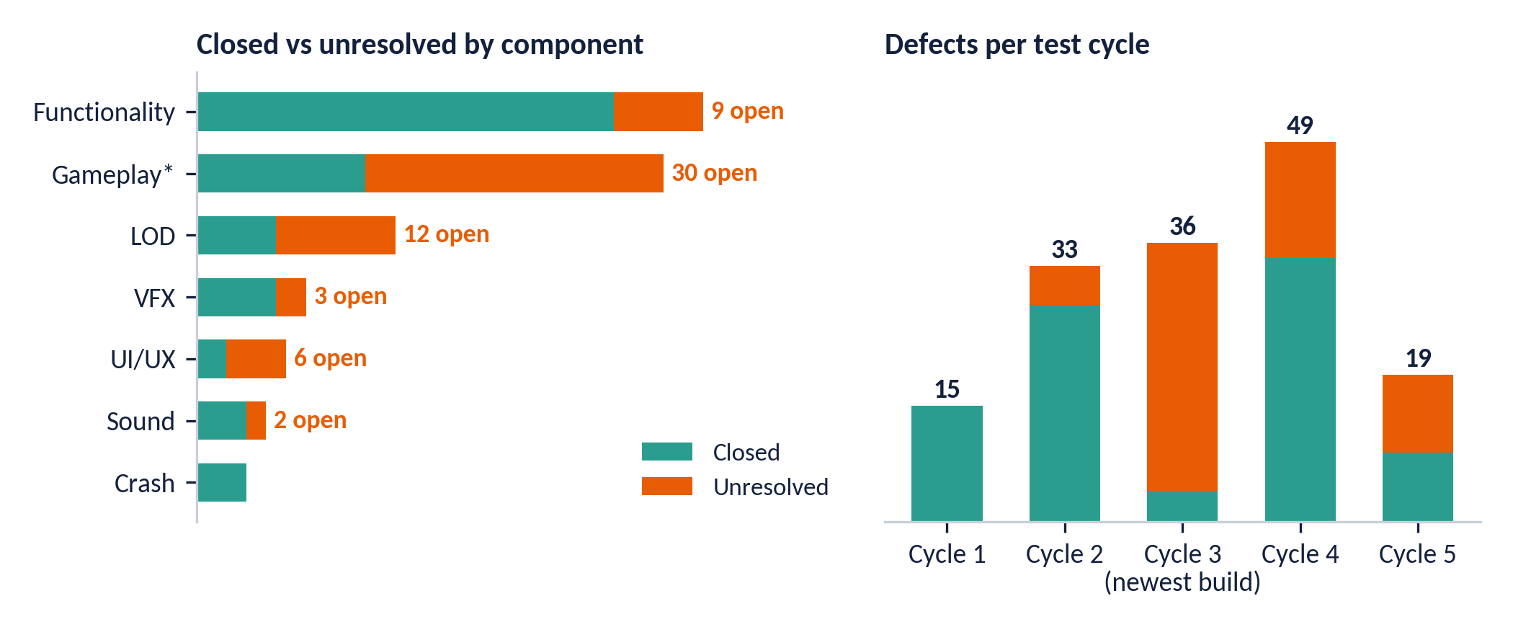
Figure 5. *Includes 3C-Gameplay. Cycles ordered by first defect logged; Cycle 3 is the newest build. Two defects with no component or an installation tag are not shown.

Exit-criteria check
Criterion | Status | Evidence
Zero open Highest defects | FAIL | 2 open (one reopened)
No open High defects, or an agreed waiver | FAIL | 13 open, mostly gameplay and AI
No open crash or blocker defects | PASS | All crash defects closed
At least 90% of defects closed | FAIL | 59.2% closed
No reopened defects left unverified | FAIL | 6 reopened
Test-case pass rate reported | NOT ASSESSABLE | Jira export holds defects, not test-case results
Thresholds are common industry defaults, flagged in the report as illustrative until replaced by the project's agreed exit criteria.

Triage decisions
Bucket | Scope | Action
P0: show-stoppers, fix now | 4 defects: post-level flow sends the player to the start page (reopened); save data destroyed on new game; two level-skip exploits | Fix and verify before the next candidate build; add regression for progression and save data
P1: boss and AI combat | 9 defects: idle bots, boss standing still, enemies dying without attack, cannons reactivating after checkpoint reload | Find the shared enemy-AI state root cause; likely few fixes close many tickets
P2: reopened and open backlog | 5 reopened, 8 open or new | Re-verify why fixes failed retest; assign owners; group 11 collision/LOD issues into one pass
Process findings beyond the bugs: one developer held 127 of 152 defects and all 62 unresolved ones (single point of failure); 82% of defects sat at Medium priority; 84 of 90 closed defects had no resolution value; one duplicate, one missing component and two feature requests filed as bugs. These map to the Jira configuration on page 13.

Bug reporting standard and bug lifecycle
One standard for writing a bug, one lifecycle for handling it

The bug report standard
Field | Standard
Summary | [TAG] + Problem-Action-Location. Example shape: [Gameplay] Enemy does not attack when the player strikes from behind in level X
Steps to reproduce | Prerequisites plus numbered steps, including what the tester did to isolate the issue
Description | What happened and when; system specification; expected and actual (observed) behaviour, kept concise
Severity | By effect on the game. S1 crash, stuck or freeze (show-stopper); S2 gameplay feature or mechanic; S3 UI/UX and localisation
Priority | By urgency of the fix: Highest, High, Medium, Low
Component and labels | Issue-specific only; platform tag when relevant
Attachments | Screenshots and video named with the ticket ID, for example ID_1, ID_2
Tag taxonomy: Gameplay (mechanics, AI, exploits), LOD (collision, ragdoll, out-of-map, missing textures), Sound/SFX, LOC (localisation), Crash/Error/Freeze, VFX, UI/UX, Network/Online, 3C (camera, collision, character), Leaderboard, plus platform tags PC, Xbox, PS5, Android, iOS.

Bug lifecycle and developer resolutions
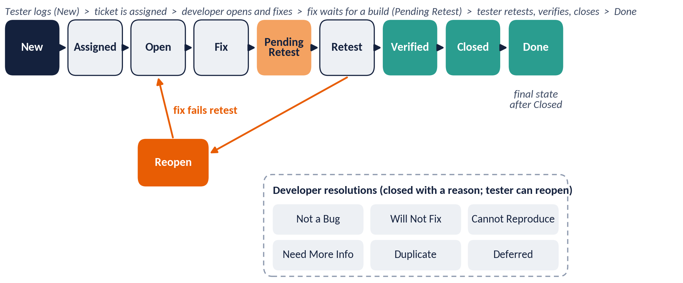
Figure 6. Current lifecycle: New, Assigned, Open, Fix, Pending Retest, Retest, Verified, Closed, Done. A failed retest goes to Reopen. Resolutions close a ticket with a reason; the tester can reopen any of them if the reasoning does not hold.
Status | Meaning | Owner
Assigned | Triaged and handed to a developer; work has not started yet | Developer (queue)
Pending Retest | Fix delivered by the developer; waiting for a build the tester can verify on | Tester (queue)
Retest | Tester is actively verifying the fix on the build | Tester
Closed / Done | Verified and closed; Done is the final state after Closed | Tester

Why it matters. Project B’s export showed what happens without one lifecycle: free-text reproducibility in mixed formats, empty resolutions, and 47 of 62 unresolved defects sitting at Assigned — the single largest bucket, larger than Open itself. Tracking Assigned and Pending Retest as distinct states makes both ends of the backlog visible before they become a release risk.

How I run triage
Triage is a standing meeting, not an ad hoc conversation: it ran daily during active cycles, with the lead, test engineers and, where available, a developer. Every bug leaves with a severity (tester-set, by effect), a priority (set jointly, by urgency) and an owner — kept separate on purpose, since a low-severity bug can still be high priority against a deadline.
- Worked example: the P0/P1/P2 buckets on page 11 are triage output — four defects bucketed P0 because they blocked progression or corrupted save data, nine bucketed P1 for sharing one root cause, the rest re-verified or reassigned in P2.

Jira administration and configuration evidence
What I configured, with screenshots from the Jira admin console
Area | What I configured
Work types and schemes | Bug, Epic and other issue types; which types each project can use
Workflows and schemes | Custom bug workflow with the lifecycle statuses on page 12; different workflows per issue type; workflow schemes shared across projects
Screens and screen schemes | Which fields appear when logging a Bug versus an Epic; adding and removing sections per issue type
Custom fields and field configuration | Custom fields (the export shows Reproducibility, Steps to Reproduce and Type) created, added to the Bug screen and made compulsory
Priorities and priority schemes | Priority levels created; priority schemes applied per project
Permission schemes | Group-based and project-based access with default settings for new projects

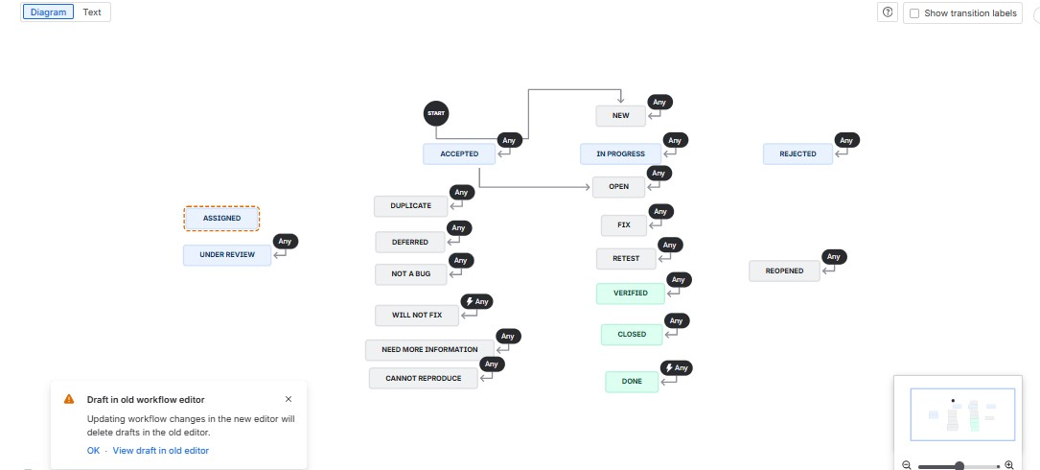  Figure 7. Bug workflow as built in Jira admin. This earlier build predates the Pending Retest step described on page 12. | 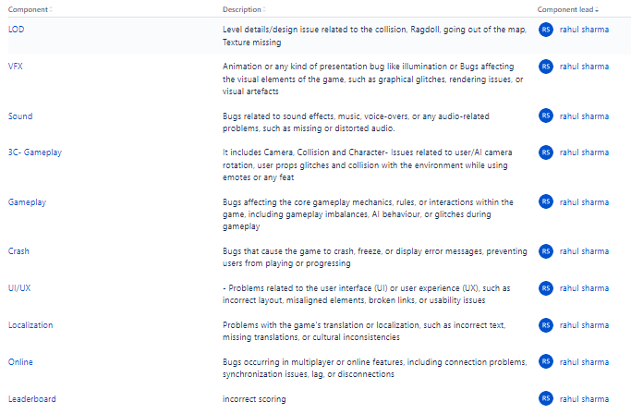  Figure 8. Component list with definitions used for triage. Each component has an owner, so a new bug routes to the right person immediately.
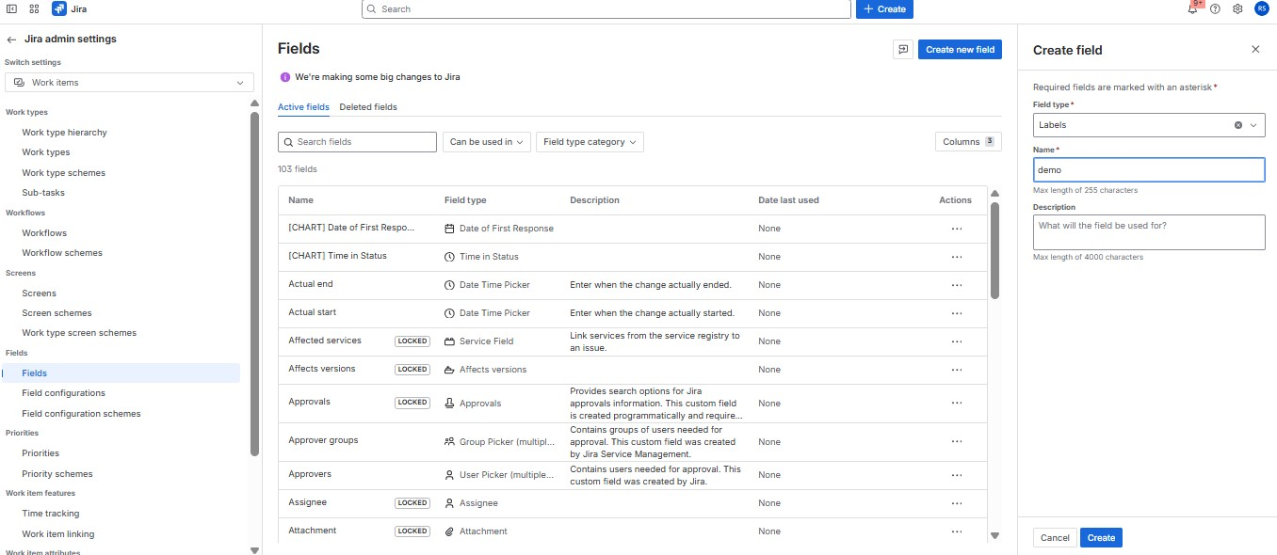  Figure 9. Creating a custom field. The same screen is used to add real fields such as Reproducibility and Severity to the Bug screen. | 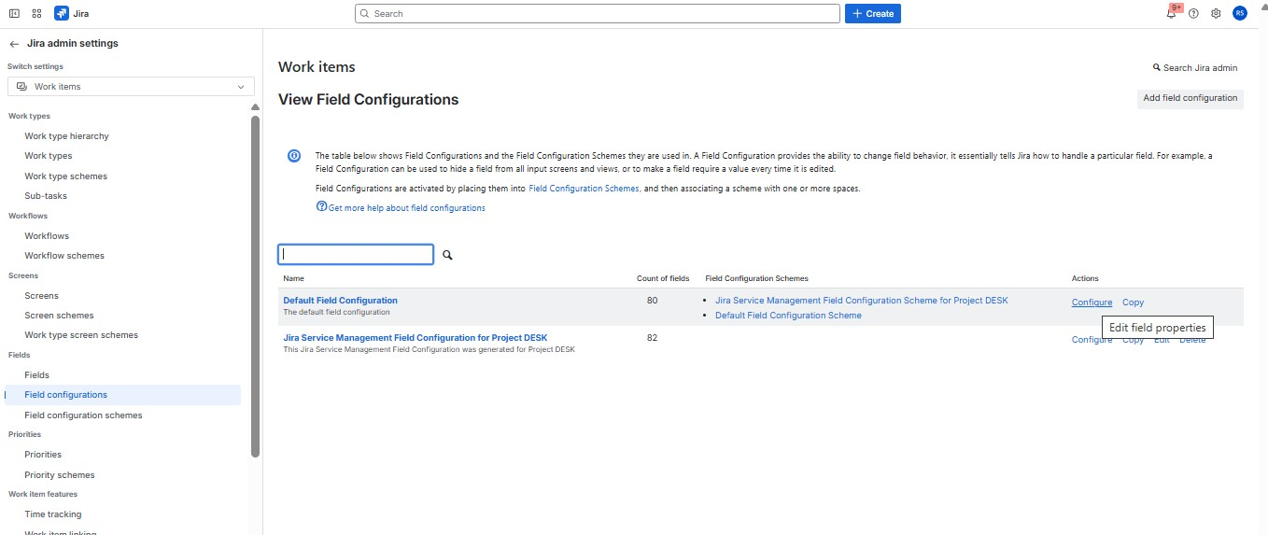  Figure 10. Field configuration. Toggling Required here stops a bug being saved without that field filled in.

Jira administration: further configuration evidence
More proof from the admin console: priorities, screens, work types, workflow schemes and permissions
The previous page listed what I configure. These screenshots are the proof, pulled directly from the Jira admin console I administered.
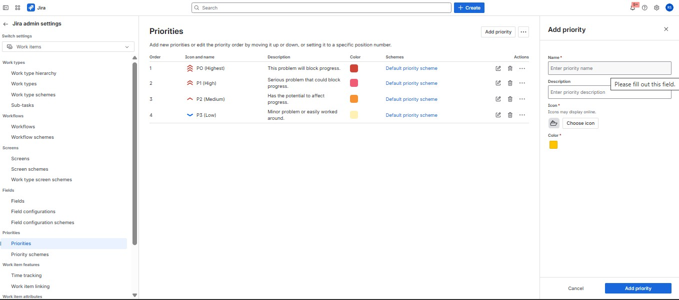  Figure 15. Priorities created with descriptions and colour coding. Priority drives triage order and is kept separate from severity. | 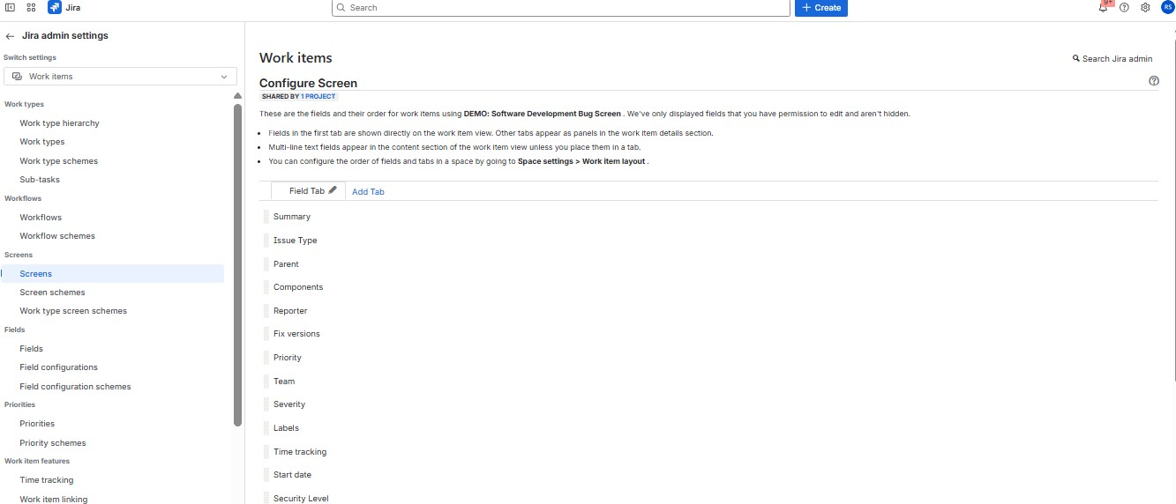  Figure 16. Screen configuration: fields and order shown on the Bug screen. This is exactly what a tester sees while logging a bug. | 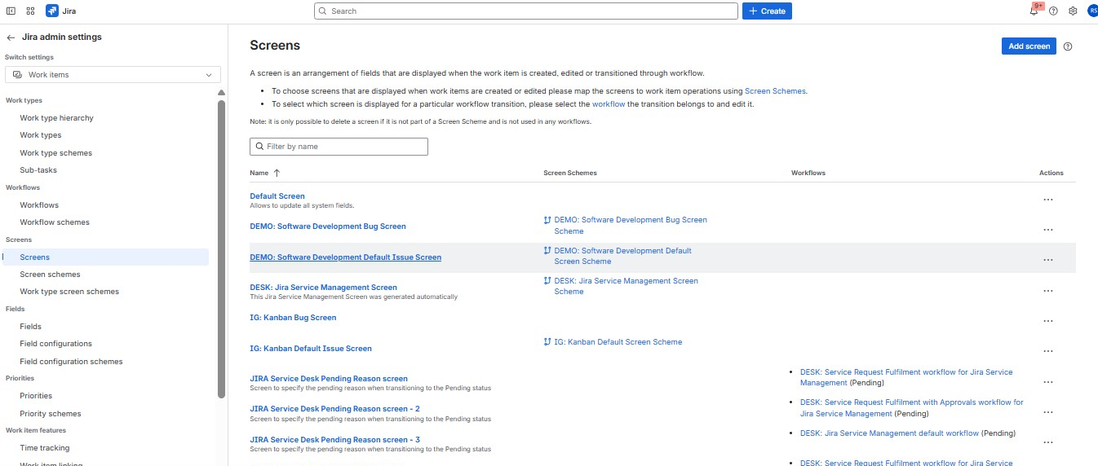  Figure 17. Screens list: a separate screen per work item type, so a Bug screen never shows Epic-only fields.
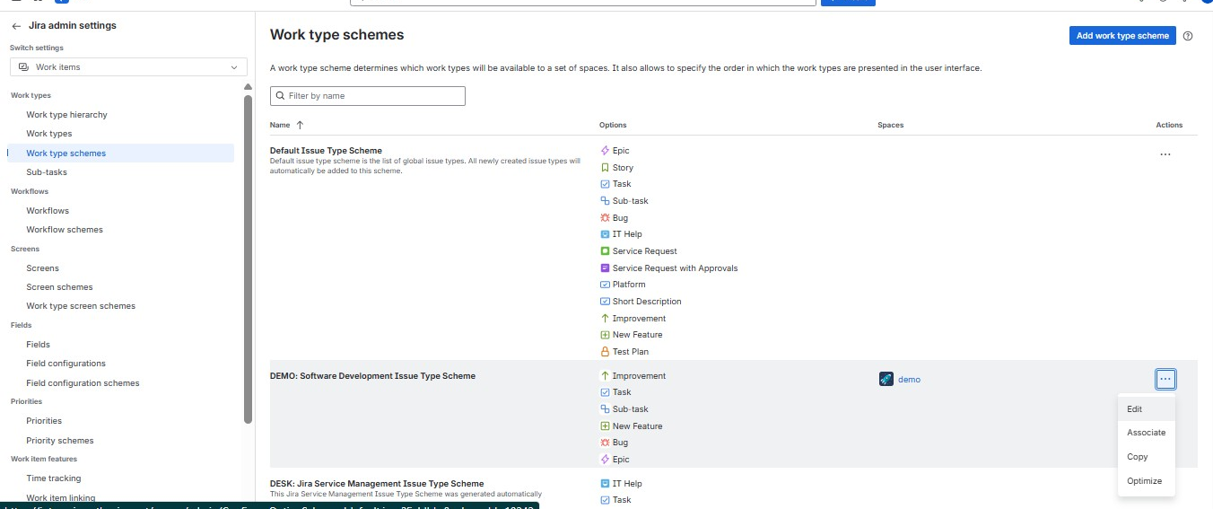  Figure 18. Work type schemes: which issue types (Bug, Epic, Task) a given project is allowed to create. | 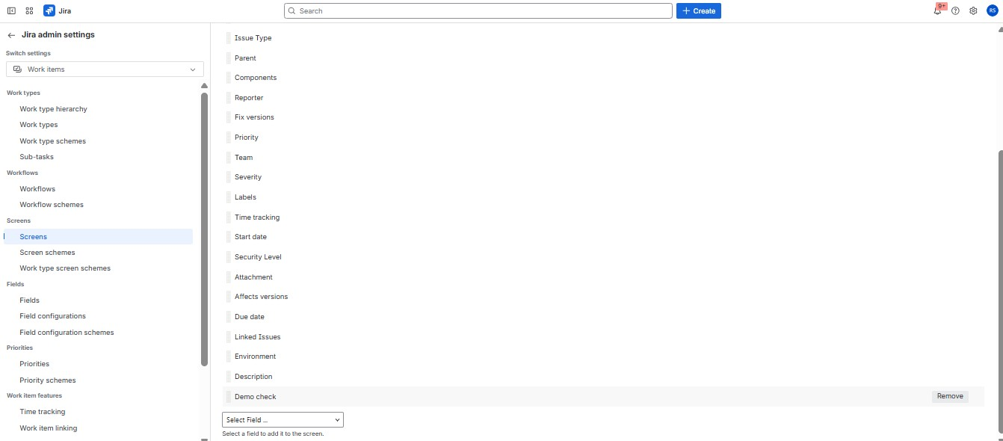  Figure 19. The full field list on the Bug screen, including a custom field (Demo check) added and ready to use. | 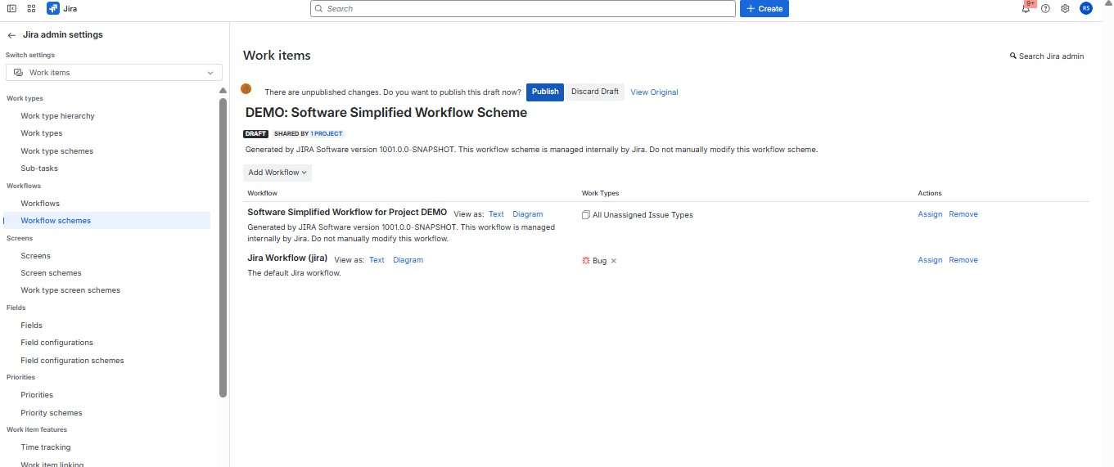  Figure 20. Workflow scheme: a workflow assigned per work type, so Bug and Epic can follow different lifecycles in one project.
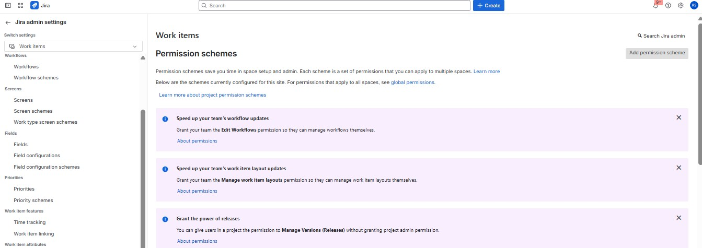  Figure 21. Permission schemes: built once and reused, so a new project inherits the right access from day one. | 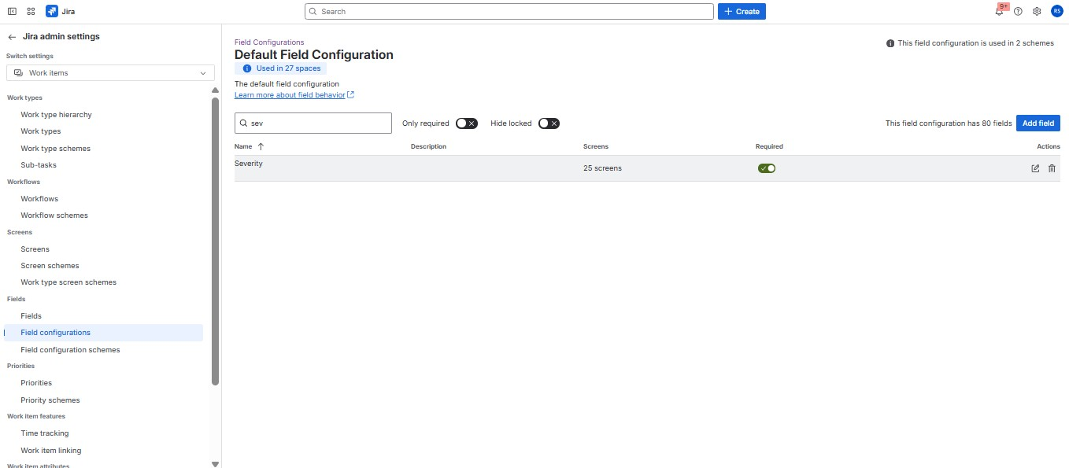  Figure 22. Making Severity compulsory in the field configuration, so a bug cannot be logged without one.
Screenshots are cropped to remove project, game and colleague names; only generic Jira admin structure is shown.

Test design and coverage
From scenarios to test cases, and the traceability matrix as I first built it
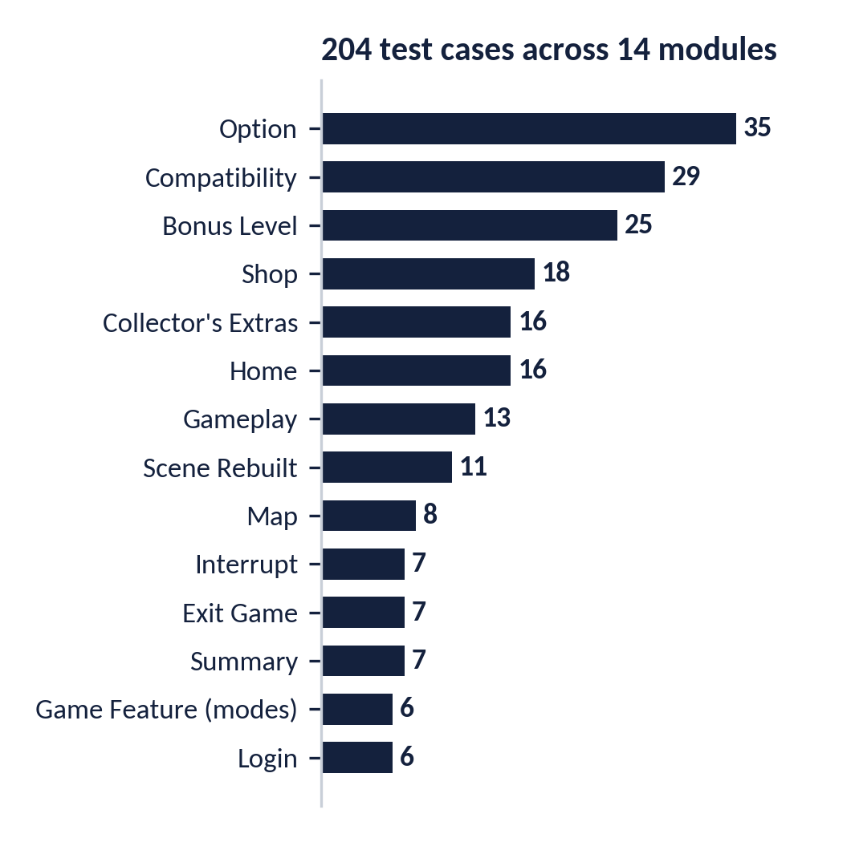  Figure 11. 204 test cases across 14 modules | What each artifact shows  - Test scenarios (6 areas): installation and uninstallation, functional, compatibility, localisation, GUI, interrupt.  - Test cases (204, 14 modules): pre-requisites, steps, expected and actual result, status, comments.  - Checklist: 53 module-level checks logged against build versions in the daily report.  - Mobile checklist: 68 checks across device, network, app and UI, referencing Android and Apple platform guidelines.  - Test procedure: step-by-step, per feature, with roles for logging, triage and reporting.

The original RTM, before my audit
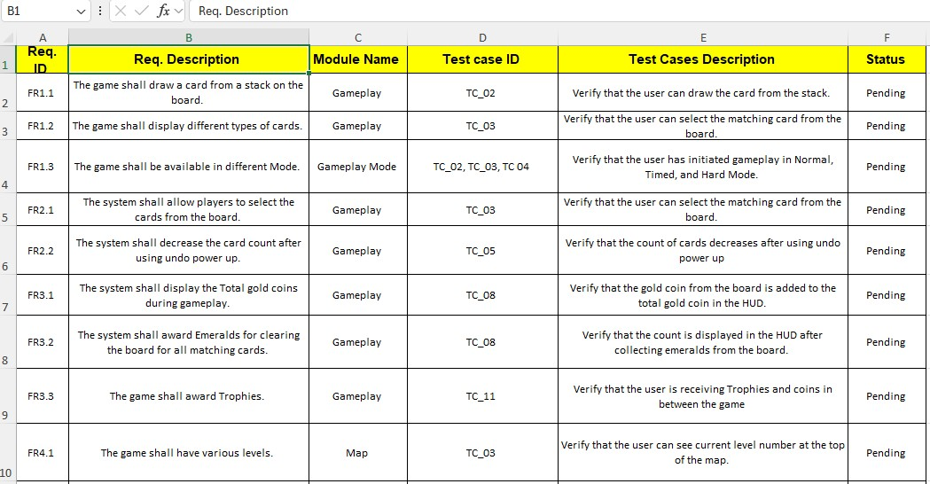
Figure 12. Original requirements traceability matrix: requirement, module, test case IDs, description, status
What the audit found (detail on page 18): several requirements pointed at the wrong test case; test-case IDs repeat across sheets (every sheet has its own TC_01); three requirements were carried over from a mobile project into a PC-only scope; and every status read Pending.

Test scenarios and test cases: proof
Real excerpts from the 6-area scenario workbook and the 204-case workbook, game title redacted
These are the two working documents that everything on the previous page was counted from: the scenario workbook (6 areas, one tab per area) and the module-wise test case workbook (204 cases across 14 modules). Both are shown here with the real game title replaced.

Test scenarios: Installation and Login modules
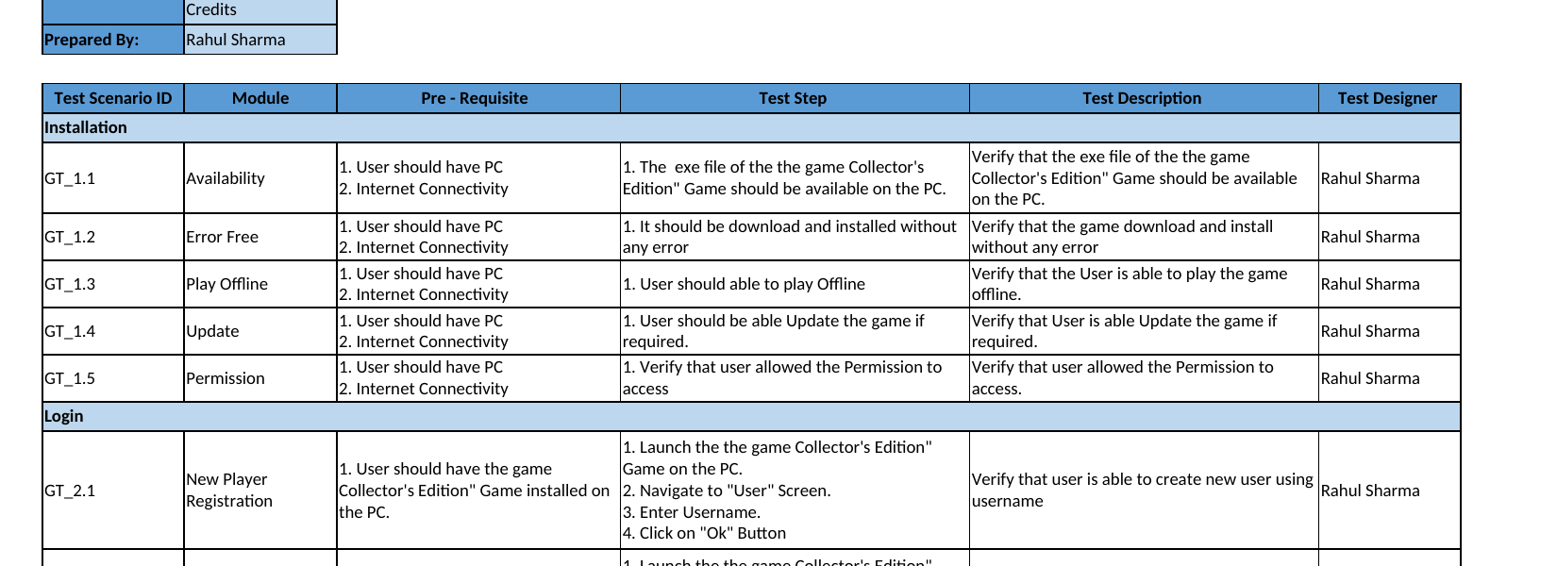
Figure 12a. Test Scenarios workbook: Installation module (5 scenarios) and the start of Login, with pre-requisite, test step and description columns.

Test cases: Gameplay module
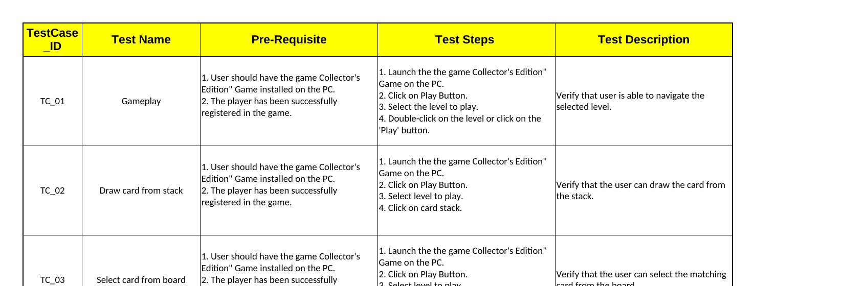
Figure 12b. Test Cases workbook: the first six cases of the Gameplay module (TC_01-TC_06), in the pre-requisite / steps / expected-result format used across all 14 modules.
Both workbooks use the same structure throughout: a module cover block naming the areas covered and who prepared it, then one row per scenario or case. The game title is replaced with "the game Collector's Edition" throughout; everything else, including the wording of each step, is unchanged.

Edge-case and negative test design
Boundary, race-condition and failure-mode cases, beyond the happy path
Documented test cases prove a feature works when used as intended. Edge cases are where I go looking for where it breaks: boundary values, rapid or conflicting input, and the network or app-state conditions a player will eventually hit by accident. Two excerpts below, redacted, from the edge-case workbooks I maintain alongside the main test-case set.

Common edge cases: network, input and account state
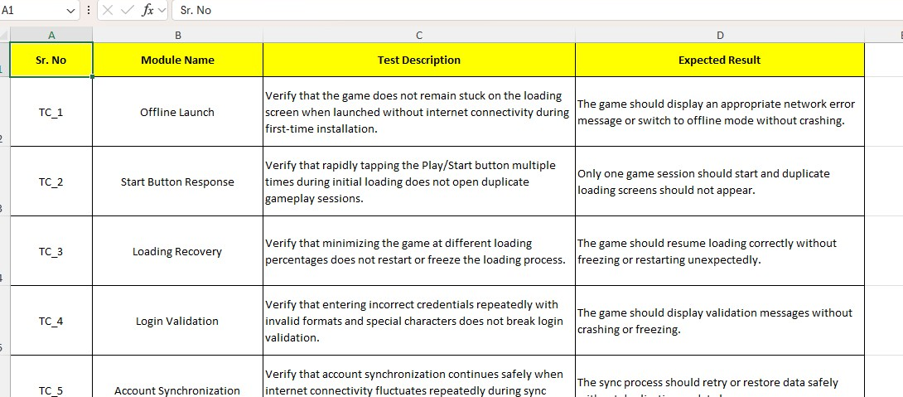
Figure 34. Offline launch, rapid input, background/resume and account sync, the kind of edge case that applies to almost any PC or mobile title.

Genre-specific edge cases: a tower-defense example
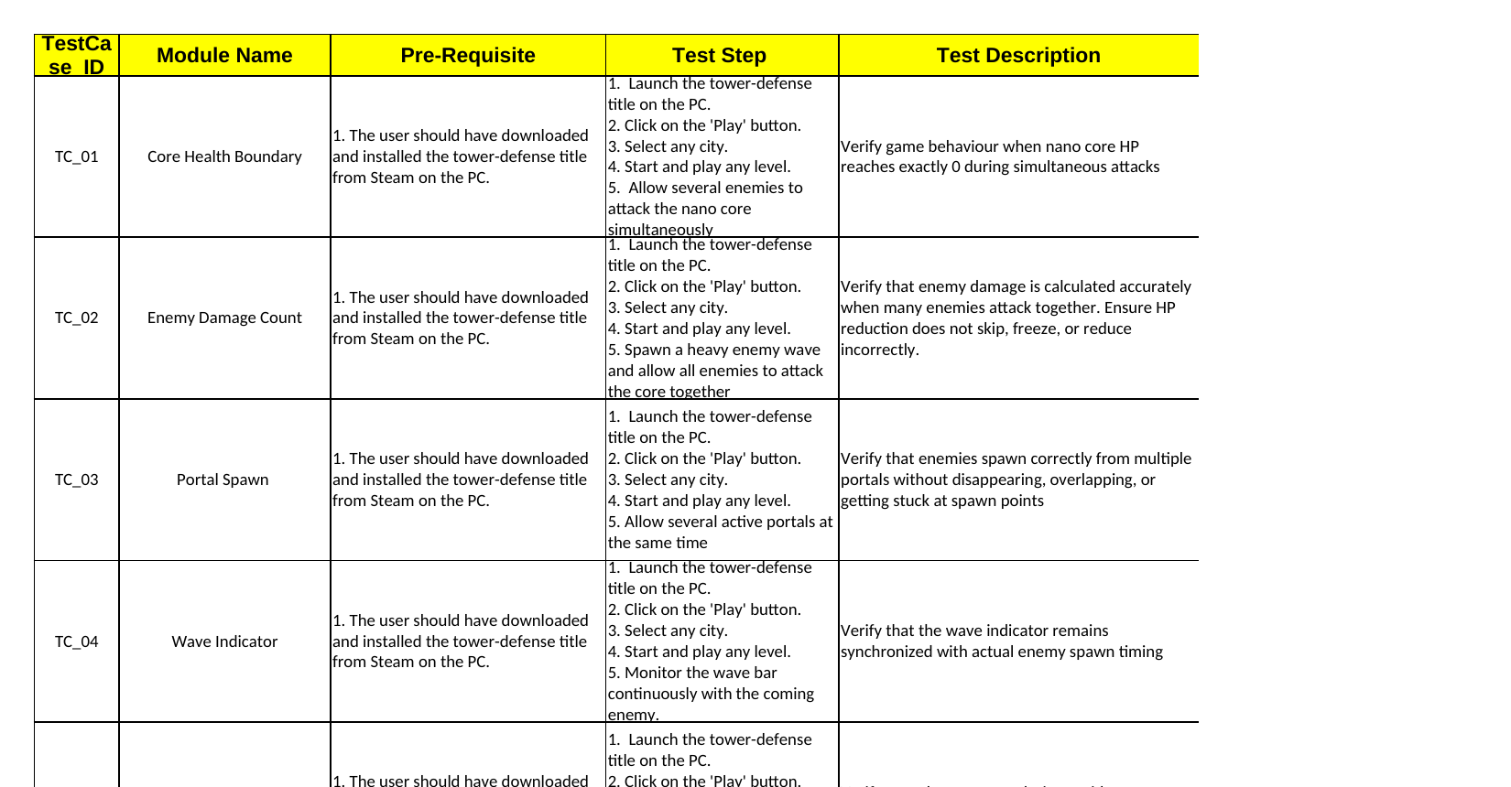
Figure 35. Boundary and concurrency cases from a separate tower-defense engagement: core HP at exactly zero, simultaneous multi-portal spawns, wave-indicator sync under load.
Both workbooks follow the same shape as the main test-case set (pre-requisite, steps, expected result) so they slot into the same triage and regression process, rather than living as a separate, easily-forgotten list.

Requirements traceability (RTM audit)
25 requirements checked against the 204-case workbook, and an honest view of my own matrix
I re-checked every mapping in the original matrix. The corrected view uses module-prefixed IDs (for example GP-TC02, SHOP-TC05) and classifies each requirement by how directly it is tested. Statuses show coverage, not execution results, and are my classification of the workbook.
Req. | Requirement (short) | Corrected test link | Coverage
FR1.1 | Draw a card from the stack | GP-TC02 Draw card from stack | Direct
FR1.3 | Game available in different modes | GF-TC01, 03, 05, 06 (Relaxed, Timed, Normal, Hard) | Direct
FR2.2 | Undo reduces the undo count | GP-TC04 Undo (was mapped to TC_05) | Direct
FR3.1 | Show total gold coins | GP-TC09 Total gold coin (was TC_08) | Direct
FR4.2 | Next level unlocks on completion | SUM-TC07 Continue (was Map TC_02, Stars) | Partial
FR5.2 | Buy power-ups during gameplay | SHOP-TC02 to TC15 (tested from the shop page) | Partial
FR1.2 | Display different card types | No dedicated case | Gap
NFR3.1 | Progress saved automatically | No dedicated case (was mapped to a Play test) | Gap
NFR4.2 | Layout adapts to landscape screen sizes | Re-scoped: COMPAT-TC01 to TC29 (resolutions, aspect ratios) | Direct
NFR1.1, NFR4.1 | Load time on mobile; available on Android | Out of scope for a PC title | N/A
Representative subset shown. All 25 requirements were re-read against the test-case workbook.

15  Direct (incl. one re-scoped to PC) | 5  Partial | 3  Gap | 2  Mobile carry-over, N/A

Finding that mattered. The unlock rule for the next level had no dedicated case, and three of the first nine defects logged on the project (in the first two days) were level-unlock errors. Coverage gaps and defects clustered in the same place, which is the argument for keeping the RTM alive rather than filing it once.

What I improved
- Every requirement mapped to a module-prefixed test-case ID, so IDs are unique across sheets.
- Two mobile-only requirements marked out of scope for the PC title; one re-scoped to the compatibility suite.
- Three gaps raised as new test cases to write: card types, auto-save, and next-level unlock rule.

Team leadership, enablement and research
How I run a team, grow it, and keep the knowledge base current
Team size and rhythm: Project A ran with a lead plus one QA engineer (two testers from June to August); Project B had three QA reporters plus the lead. Weekly status reports carried plan, progress, challenges and risks to the client, and the team held knowledge-transfer sessions on new defect classes such as game exploits.

Weekly status report: proof
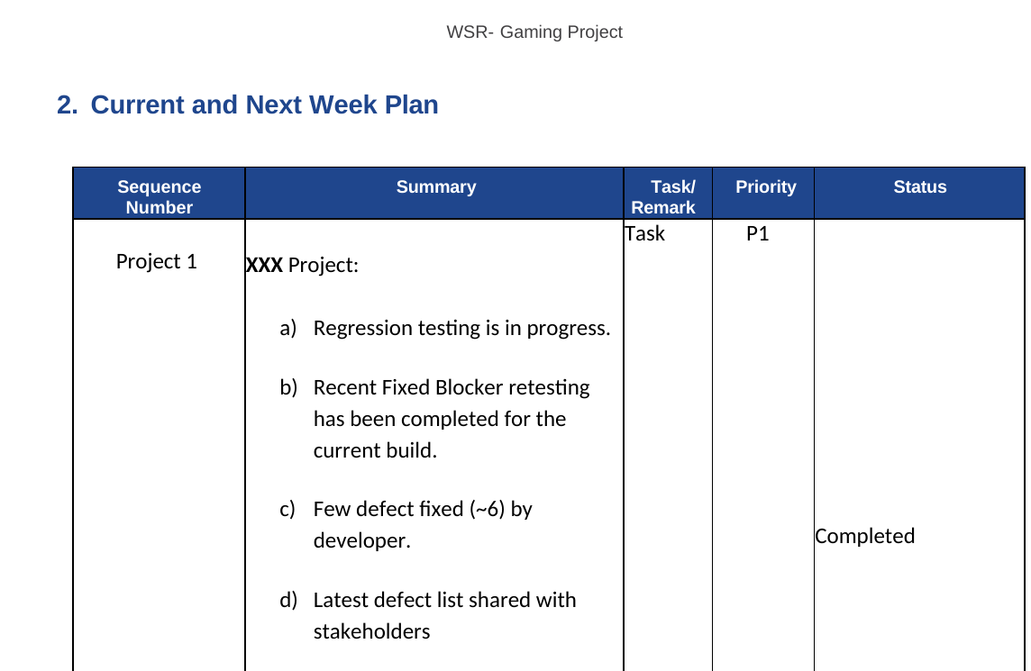  Figure 23. Current and next-week plan: task, priority and % complete tracked weekly | 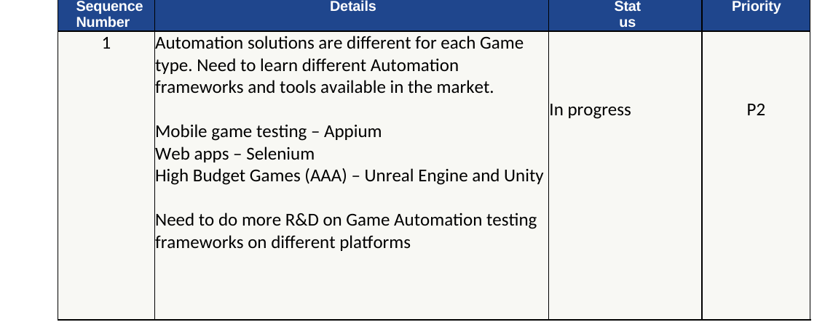  Figure 24. Challenges section: automation tooling gaps raised and tracked to resolution

Enablement and automation R&D
- Team learning plan: Selenium WebDriver, Appium, TestNG / JUnit, C#, Alt Unity Tester, Android Studio and Appium Inspector, plus preparation for the ISTQB game-testing syllabus.
- Proofs of concept: automation of a small Unity game and of Android mobile games; a master framework adapted for web and mobile game automation. These are POC-stage and I describe them that way.
- Key learning: automation differs by game type (Appium for mobile, Selenium for web, Unity or Unreal tooling for AAA), so tool choice starts from the game, not the other way round.
- Playtesting range: hands-on MMORPG playtesting and open-source game testing to build genre knowledge before client work.

Research and knowledge assets
Asset | What it contains | Use in a project
Game bug taxonomy | 15 bug classes (gameplay, collision, visual, audio, UI, save/load, performance, compatibility, localisation, quest logic, memory leaks, network, exploits, crashes, balance) and 27 game areas to check | Shapes test design and Jira tags
Mobile game testing phases | Device performance, network performance and API/server performance; interrupts, battery, background state, jitter, network switching | Seeds the mobile checklist
Test-tool assessment | Four frameworks (T-Plan Robot, Robotium, Calabash, Appium) compared on platform support, Jira and CI integration, reporting, licence and more | Tool selection; Appium is the one explored in POCs
Testing mindset and techniques | Five ways to hunt bugs (follow rules, break rules, unconventional, use everything, extreme inputs) and 12 techniques (combinatorial, soak, recovery, play testing and others) | Briefs new testers before their first exploratory pass
Analytics validation | Event/attribute schema and QA checks; see page 21 for the corrected version and worked example | Verifies telemetry before release
Help-text and content review | Rule descriptions and help text checked against actual game behaviour across 11 solitaire variants | Caught rule and wording mismatches
E-sports technology brief | Landscape of 16 esports solution categories, from hardware to anti-cheat | Background reading, not yet applied on a live project
Several notes are compiled from public sources and are offered as reference material, not original research. Robotium and Calabash are largely legacy today, so the tool assessment is best read as a method for choosing tools, not a current recommendation.

Team Pivot: yearly goals I monitor (FY 2026)
The team's five-pillar scorecard, how each goal is tracked, and the proof behind it
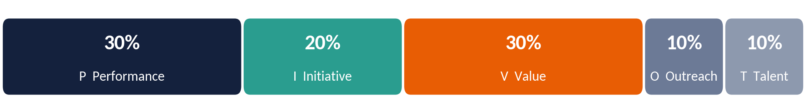
Figure 13. Weightage by pillar (sums to 100%): Performance 30, Initiative 20, Value 30, Outreach 10, Talent 10
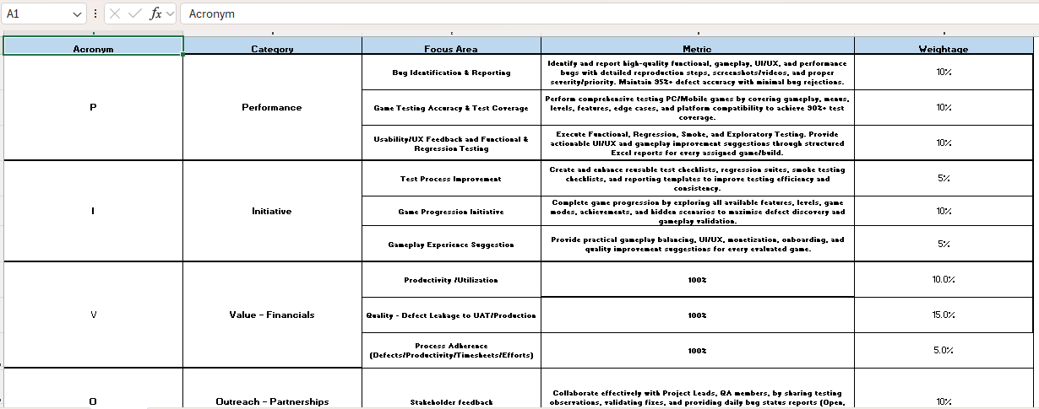
Figure 14. Proof: Team Pivot framework as issued (screenshot of the yearly goals workbook; Talent pillar is further down the sheet)
Pillar | Focus area (weight) | How I monitor it | Proof in this portfolio
P Performance 30% | Bug identification and reporting (10%) | Review logged bugs against the reporting standard; watch rejected, duplicate and Not-a-Bug resolutions per tester | Page 12; Jira exports
 | Test accuracy and coverage (10%) | RTM and test-case coverage reviews (Direct, Partial, Gap) | Page 18
 | Usability/UX feedback, functional and regression testing (10%) | Structured Excel reports per game and build; observation sheet | Pages 8, 10
I Initiative 20% | Test process improvement (5%) | Reusable checklists, suites, templates reviewed after each project | Pages 9, 15-16
 | Game progression initiative (10%) | Level-by-level progression log across modes and difficulties | Page 10
 | Gameplay experience suggestions (5%) | Observation sheet: balancing, UI/UX, onboarding, monetisation ideas | Page 8
V Value 30% | Productivity / utilisation (10%) | Time logged per module and level in the daily report | Pages 8, 10
 | Defect leakage to UAT/production (15%) | Escapes tracked through incident reports and postmortem | Page 9
 | Process adherence (5%) | Mandatory Jira fields; timesheet and effort entries checked | Pages 12, 13
O Outreach 10% | Stakeholder feedback (10%) | Daily bug status reports (Open, Closed, Reopened, New); weekly report | Pages 7, 19
T Talent 10% | Annual certifications (5%): ISTQB QA, N8N AI | Goal set for the year; status tracked per tester | Page 19
 | Career development (5%) | Learning plan in game QA, exploratory testing, defect analysis, automation basics | Page 19
Weights and focus areas are taken from the yearly goals workbook. Scores are not shown here; results are shared with the hiring team as evidence on request.

Analytics event validation: schema and QA method
How I verify that a game's analytics events fire with the right data, using a Unity example
Part of release sign-off is confirming that a game's own analytics are trustworthy: that progression, monetisation and error events actually fire, with the fields a product or LiveOps team will query later. The table below is the event/attribute schema I check against, generalised from Unity's event categories (Business, Ad Resource, Progression, Error, Design, Custom).
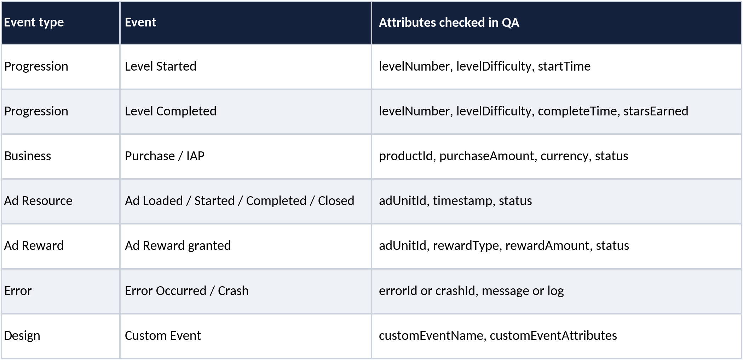
Figure 33. Reference schema used to brief testers on what each event should carry before a build is verified.

How I verified this example
My working notes included a Unity code sample for a rewarded-ad callback. On review, its field names (for example rewardedAdPlacement, rewardedAdStartDateTime) do not match any Unity Ads API I can verify, so the sample was not reliable as a real integration reference. I have not reproduced that code here: I would rather show a corrected, honestly-scoped schema than a plausible-looking snippet I cannot stand behind.

What I actually check in QA
- Functional verification (positive test case): trigger the action (complete a level, watch a rewarded ad, hit an error state) and confirm the event fires and appears in the analytics dashboard or debug console within an expected window.
- Data validation: each event's payload is checked field by field against the schema; for example a Level Completed event must carry the level number, difficulty and stars earned, not just a bare timestamp.
- Negative and duplicate-event testing: confirm the event fires exactly once, not zero times (a missed event) and not twice (a duplicate). Both are common regressions after a refactor, so this runs as part of every regression cycle, not as a one-off check.
- Interrupt testing: confirm an event triggered just before a call, notification or app backgrounding still reports correctly, consistent with the interrupt testing defined on page 5.
- Boundary value analysis: check numeric fields at their edges, not just typical values — level 1 and the final level, zero stars and the maximum stars, a zero-value purchase and the highest-priced item. Off-by-one errors in event data usually show up at these edges, not in the middle of the range.
- Exploratory testing: go off-script and try to fire events in unexpected combinations or orders, for example backing out mid-purchase or completing a level twice in quick succession, to see whether the event still logs cleanly or logs something misleading.
- Progression testing: play a full level sequence start to finish and confirm every Level Started / Level Completed pair fires in the right order, rather than checking the first and last level in isolation.

Document evidence: primary source excerpts
Redacted screenshots from the underlying Word documents, not just the summaries
Every claim earlier in this portfolio traces to one of these documents. Screenshots below are taken directly from the real files, with the game title, studio name, ticket-key prefixes, level names and the one developer name redacted.
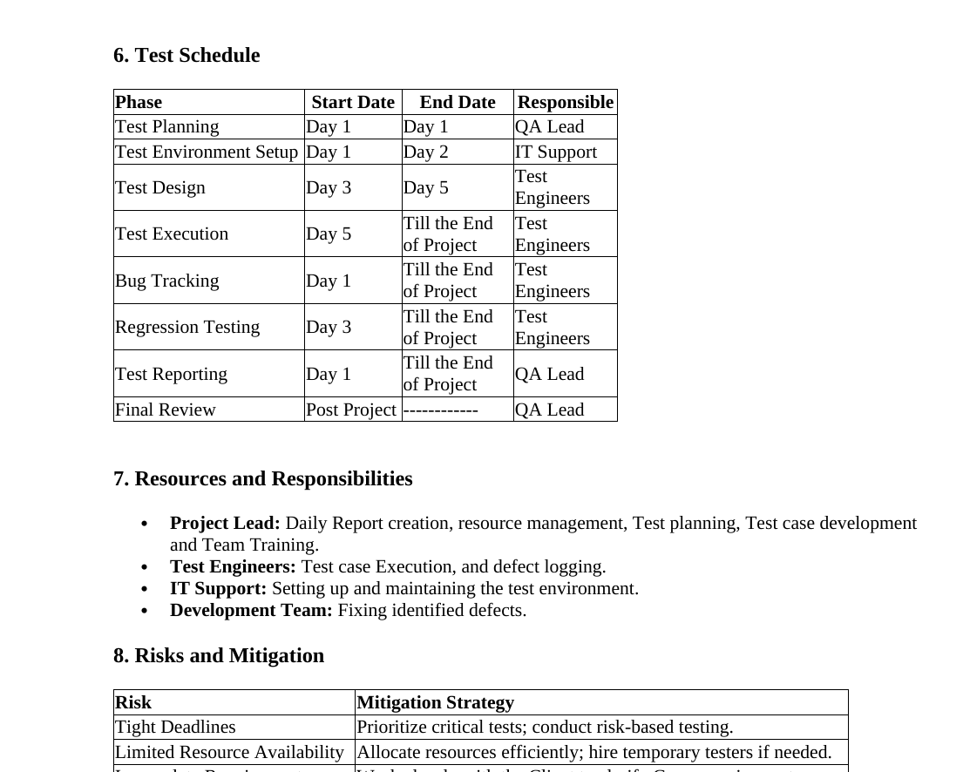  Figure 25. Test Plan: schedule and risk register | 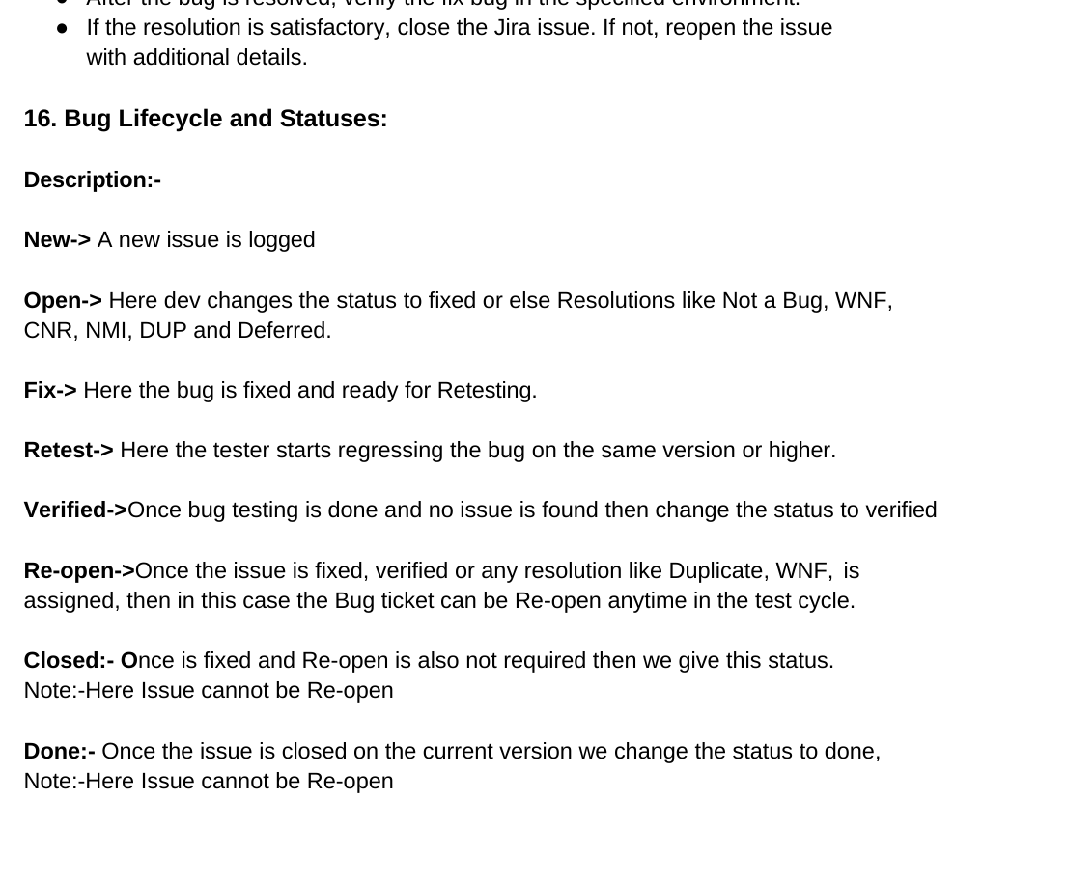  Figure 26. Bug Reporting SOP: the lifecycle statuses as originally written | 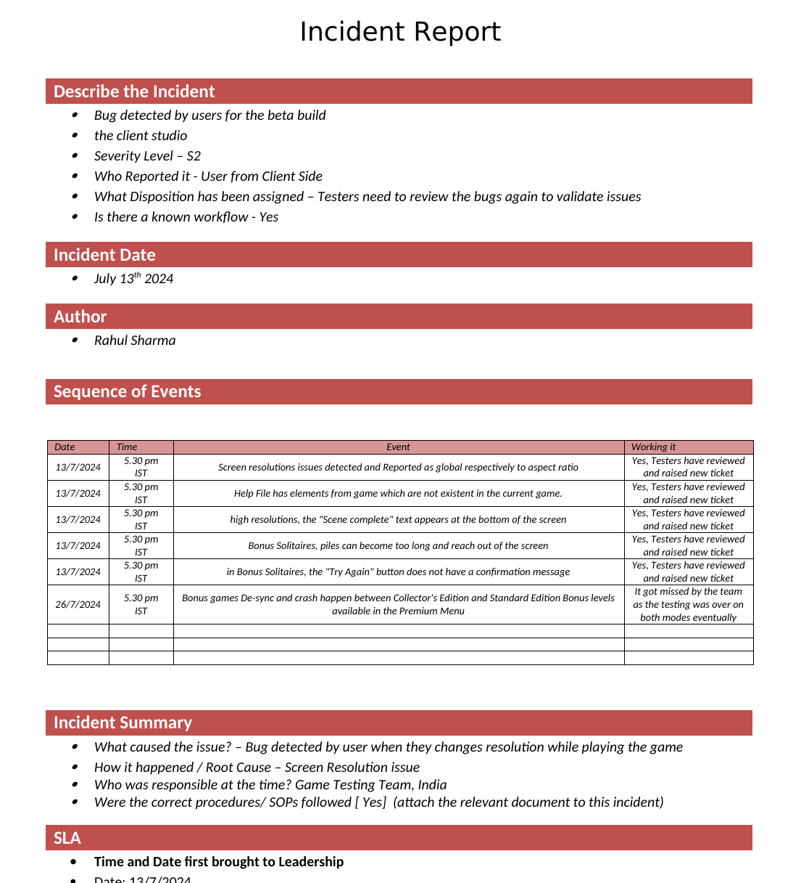  Figure 27. Incident Report: the 13-26 Jul 2024 event log
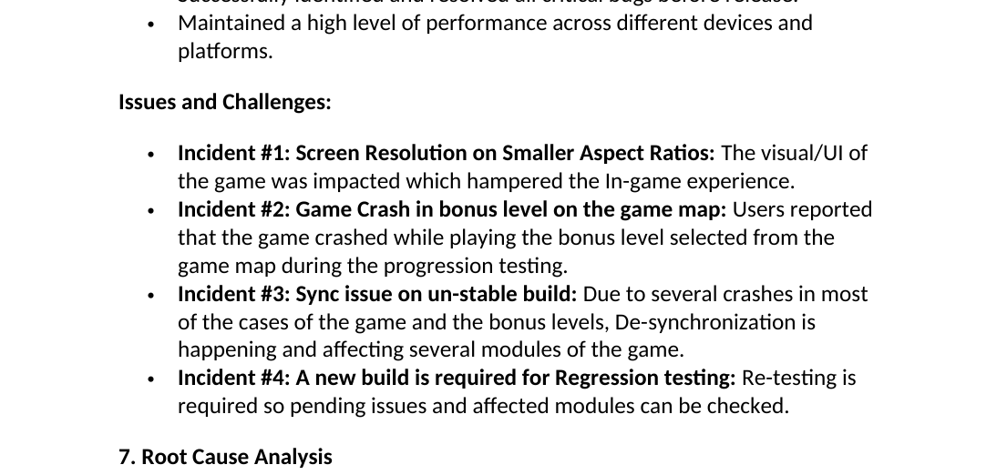  Figure 28. Postmortem: issues and root-cause analysis | 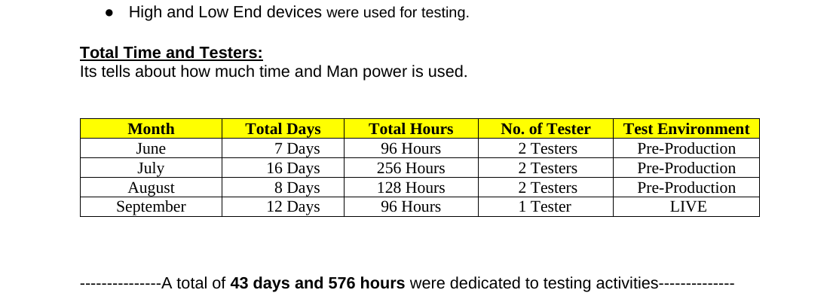  Figure 29. Testing Closure & Handover: total time and testers | 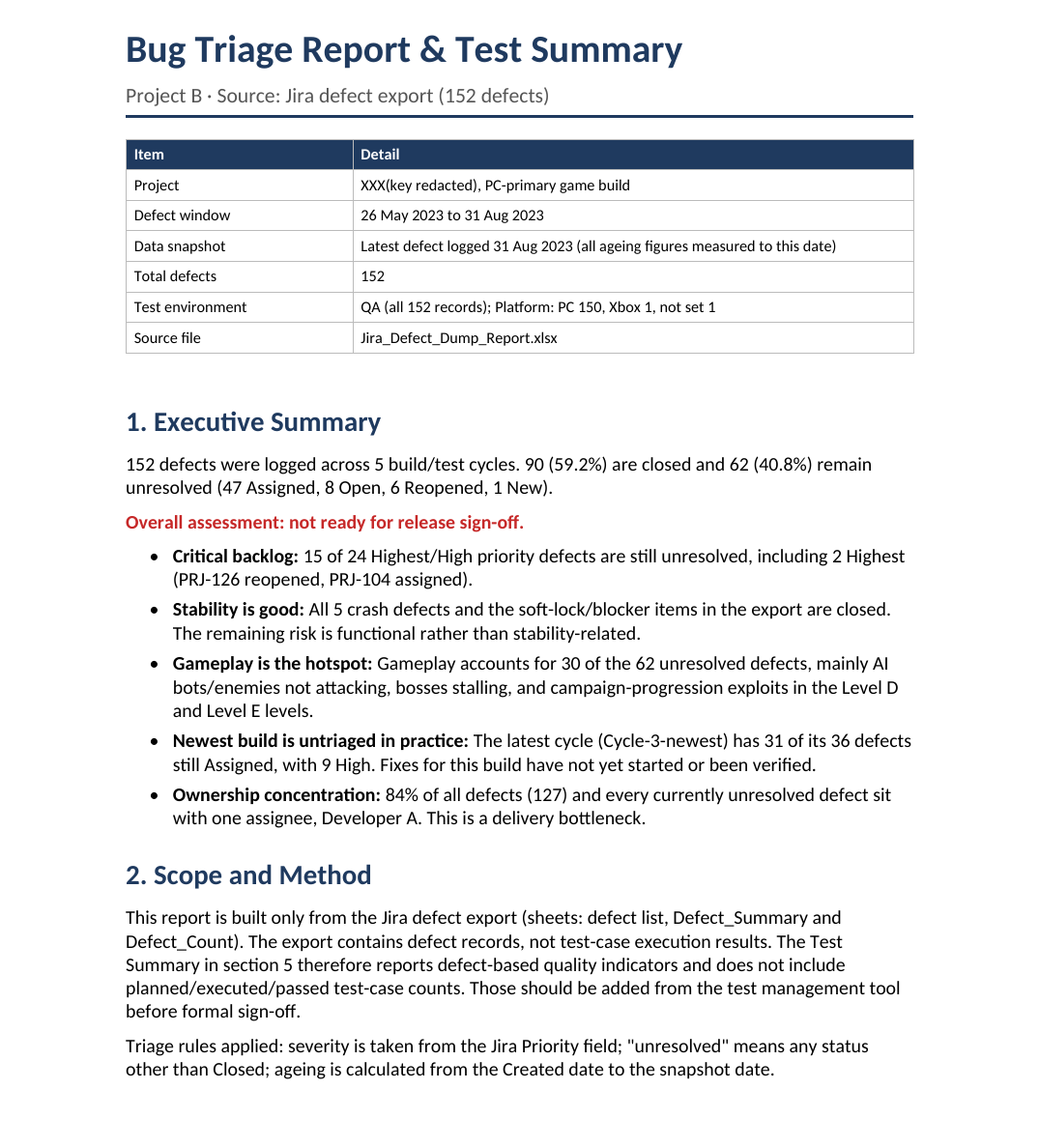  Figure 30. Bug Triage & Test Summary: executive summary (Project B)
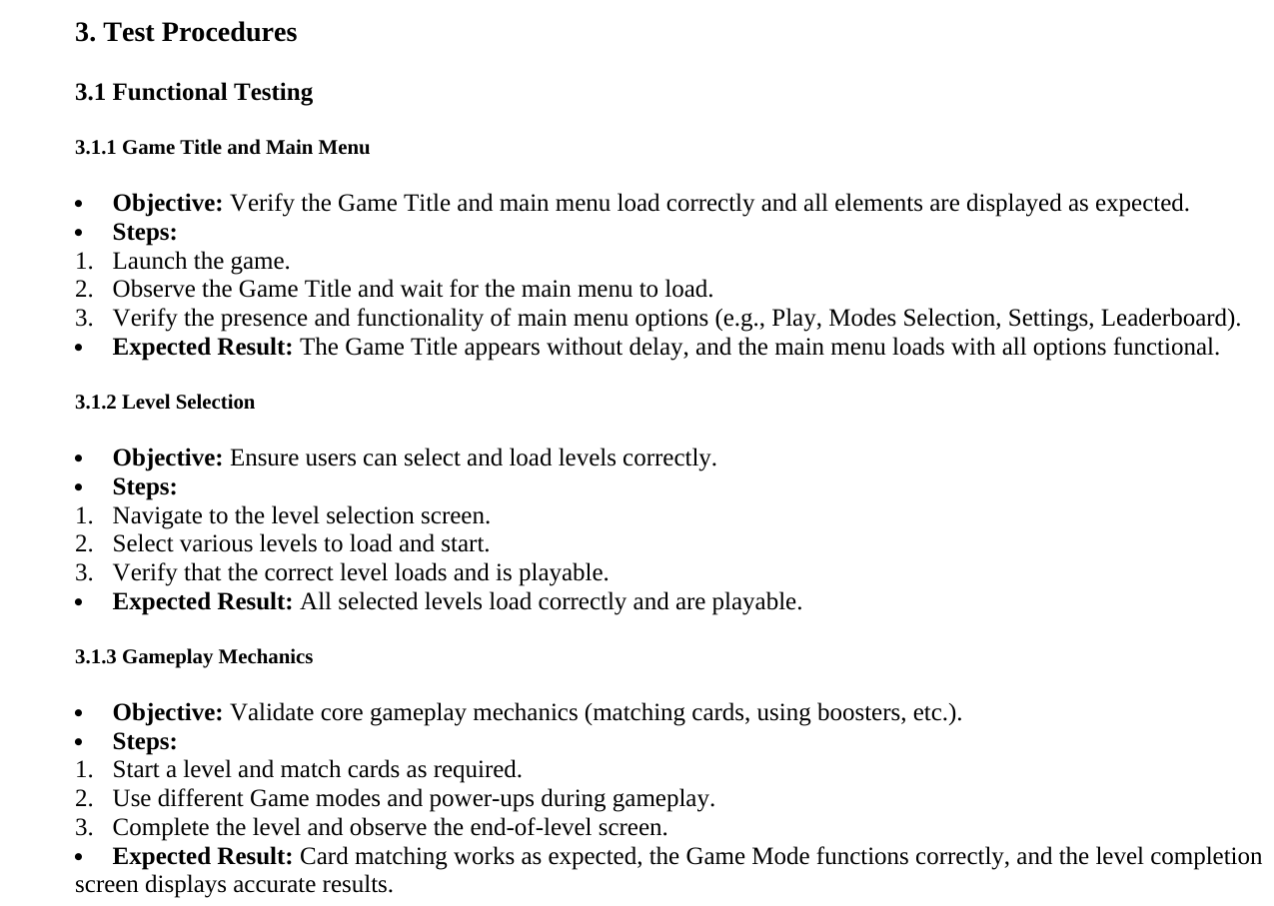  Figure 31. Testing Procedure: objective, steps and expected result per feature | 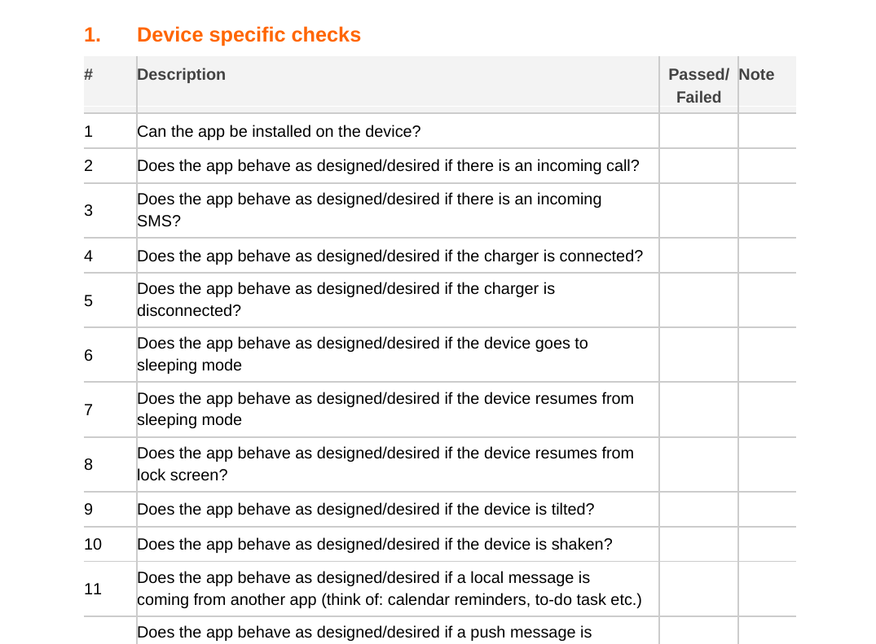  Figure 32. Mobile checklist: device-specific checks
Two source tables are deliberately left out here: the Closure Report's own bug-severity count (S1 62/S2 92/S3 58) disagrees with the daily-log figures used on page 8 (S1 57/S2 114/S3 41); this portfolio uses the log because it reconciles to individual tickets. The Postmortem's "97% coverage / zero critical bugs" claim also sits unreconciled against 31 S1 bugs logged in the same document, so it is not reproduced as a claim anywhere in this portfolio.

Project management: how a project runs start to finish
The same two deliveries, seen through project management practice, not just QA process
Every case study in this portfolio is also a project management record: two fixed-deadline client engagements I ran from initiation through to closure. This page sets out that discipline directly, drawing on the evidence presented in full elsewhere.
Discipline | What I actually did | Evidence
Project delivery | Staged delivery from initiation to closure against the 8-stage roadmap, with a written plan, entry/exit criteria, and a closure report signed off at the end of each engagement | Pages 6, 7
Client and stakeholder communication | Weekly status reports; incidents escalated to leadership and reported to the client within 1 day of discovery; closure signed off in writing, not assumed | Page 7
Resource allocation | Headcount matched to project phase, not fixed for the whole project: two testers through pre-production, scaled to one for the September live-monitoring phase; three reporters plus the lead on Project B | Pages 7, 8
People management | Daily task allocation across the team; each new tester's first build cycle paired with an experienced one before working solo; knowledge-transfer sessions run whenever a new defect class emerged | Pages 7, 19
Team training | A structured learning plan covering Selenium WebDriver, Appium, TestNG/JUnit, C#, and Alt Unity Tester, alongside ISTQB exam preparation and hands-on proof-of-concept automation work | Page 19
Release management | Builds promoted through dev, beta and release-candidate stages before a go/no-go call against written exit criteria; a further verification pass on the live build after go-live | Pages 5, 6, 8
Budgeting | Hours and days tracked per month against the plan (576 hours across 43 days on Project A); a staffing change is made as an explicit, written trade-off against schedule and cost, not a silent cut | Page 8
Environment setup | Hardware matrix from low to high-end machines, Jira project and permissions configured before testing starts, network simulators for connectivity conditions — all agreed before day one of execution | Pages 6, 13
SOP creation | Bug Reporting SOP, Testing Procedure and the bug lifecycle itself written down, so execution is repeatable and does not depend on one person's memory | Pages 12, 19
This page introduces no new claims. It presents the project management discipline behind work documented in full detail on the pages referenced.

What I bring to a new studio
First 90 days, the metrics I would track, and where the evidence lives

First 90 days
Window | Focus | Outcome
Days 1-30: understand | Read the game design document, map the build pipeline, review existing defect data and Jira set-up, play the game in every mode | A baseline: closure rate, reopen rate, defect ageing, escape history
Days 31-60: standardise | Bug report standard, severity and priority as separate mandatory fields, one lifecycle, hardware and resolution matrix, entry and exit criteria | One trusted defect dataset and a signed-off test plan
Days 61-90: scale | Reusable regression suites for progression, save/load and AI; a daily and weekly reporting rhythm; first automation candidates | Faster build verification and a repeatable go/no-go report

Metrics I would put on the dashboard
Metric | Why | My baseline
Defect closure rate and ageing | Shows whether the backlog is shrinking | Project B: 59.2% closed, median unresolved age 35 days
Reopen rate | Fix quality | Project B: 3.9%
Escaped defects (found after handover) | Real measure of test effectiveness | Project A: two escapes (July 2024), both analysed
Test-case pass rate per build | Build health | Project A checkpoint: 94.4%
Ownership spread | Delivery risk | Project B: 84% of defects with one developer

Evidence index
Artifact | Page | Available as
Test Plan, Testing Procedure, Test Scenarios, Test Cases (204), RTM | 6, 15-18, 22 | Redacted originals
Daily Report workbook (19 sheets), Game Checklist, Observation log | 8-10 | Redacted original
Bug triage and test summary (Project B), Jira defect export (152) | 11, 22 | Anonymised original
Incident report, Postmortem, Testing closure and handover (Project A) | 9, 22 | Redacted originals
Bug Reporting SOP, Jira reporting structure, Jira admin screenshots | 12-14, 22 | Redacted originals
Mobile checklist (Android/iOS) | 22 | Redacted original
Edge-case workbooks (common + genre-specific) | 17 | Redacted originals
Team Pivot yearly goals workbook | 20 | Original screenshot and workbook
QA roadmap, weekly report, research notes, tool assessment | 6-7, 19, 21 | Redacted originals

How these numbers were checked. Project A: the 466 status lines in the daily bug log were de-duplicated to 212 unique tickets. Project B: status, priority, component, reporter, assignee and ageing figures were recomputed from the Jira export and matched the triage report. RTM: all 25 mappings re-read against the test-case workbook. Where sources disagreed, this portfolio uses the figure that can be reproduced.

Next step. Full CV, references and redacted originals are available on request; I am glad to walk through any page of this portfolio, including the parts that did not go to plan. Reach me at mrrahulsharma@yahoo.com or +91-7217704787.

